* **Endpoint 1:** @app.route(**'/weaponwarehouse/weapons'**, methods=[**'POST'**])
* **Success**

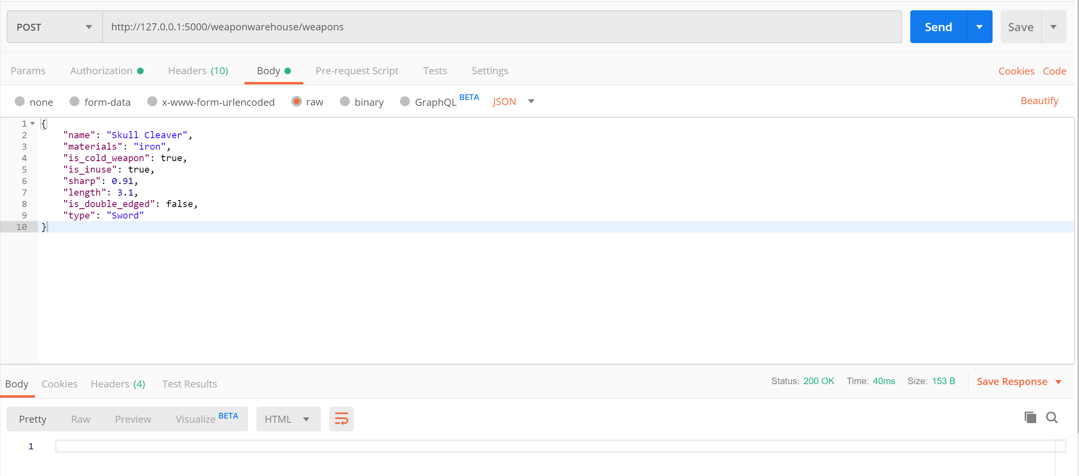

* **Failure – invalid entity object**

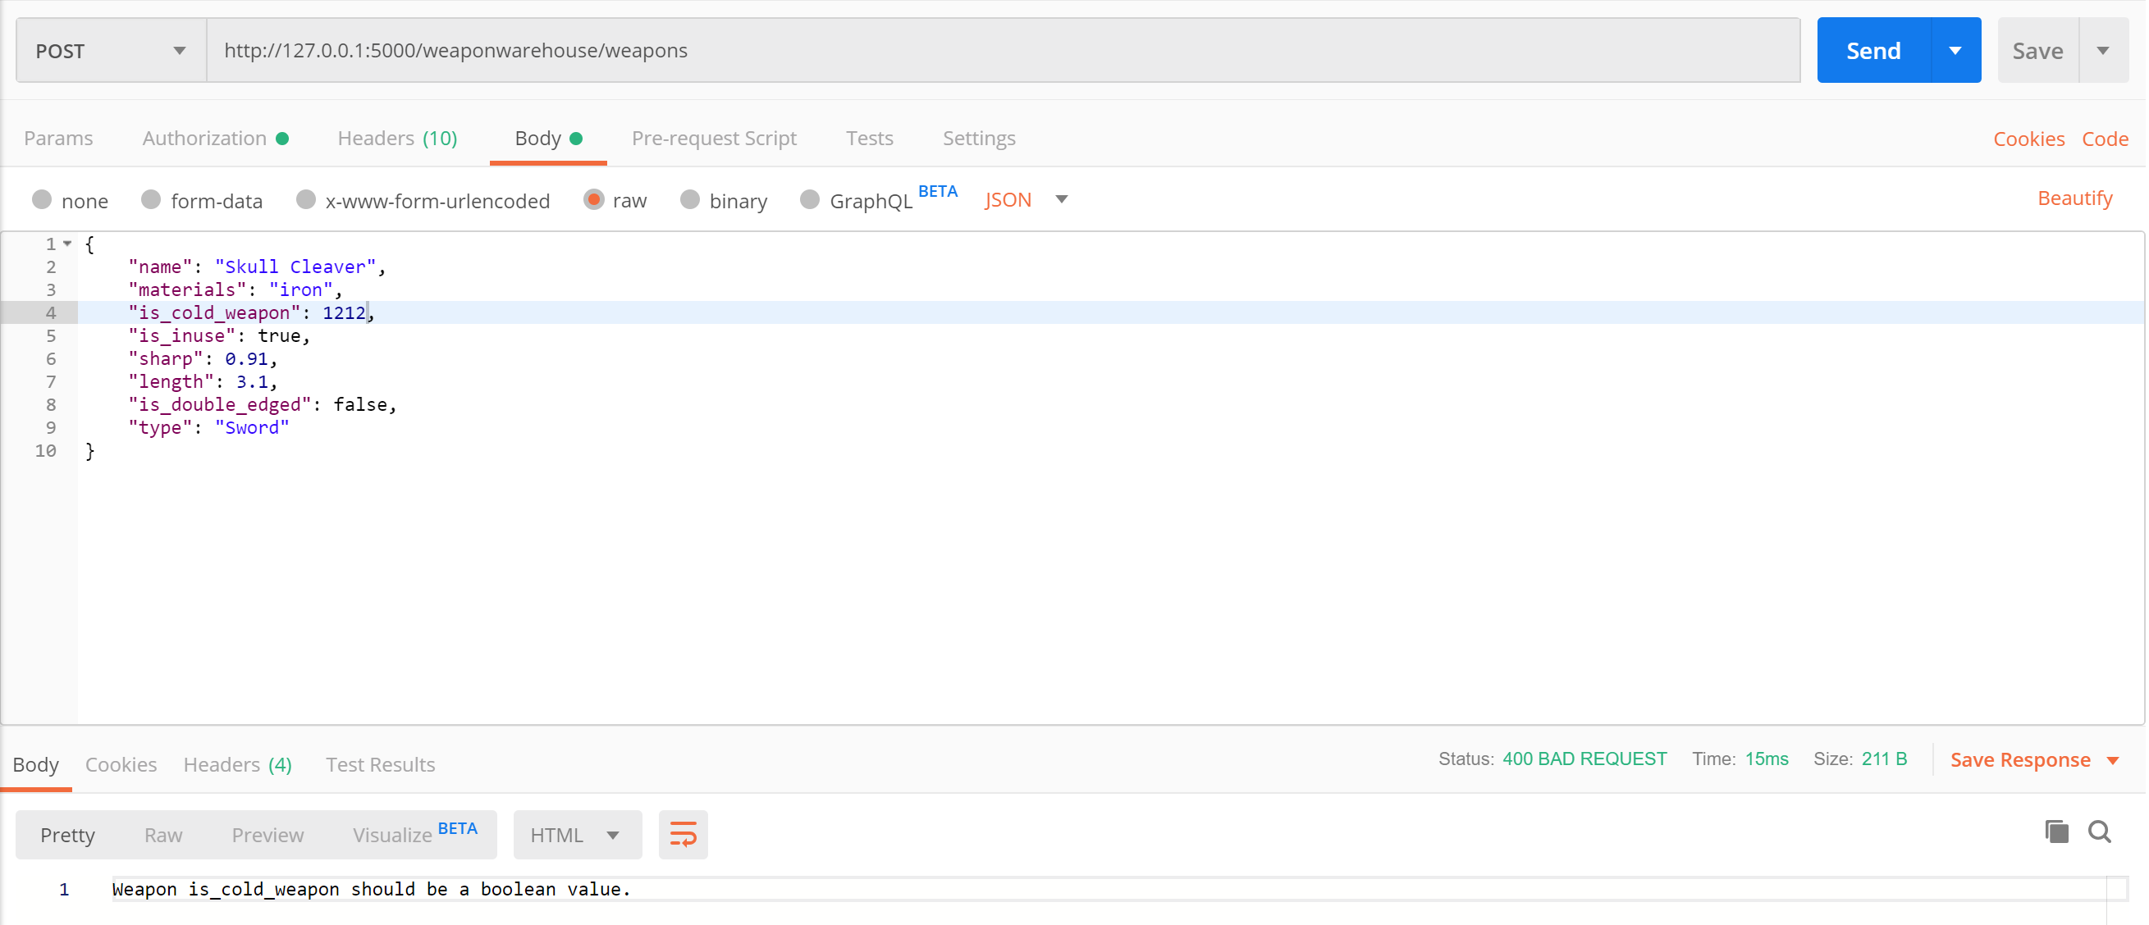

* **Endpoint 2:** @app.route(**'/weaponwarehouse/weapons/<id>'**, methods=[**'PUT'**])
* **Success**

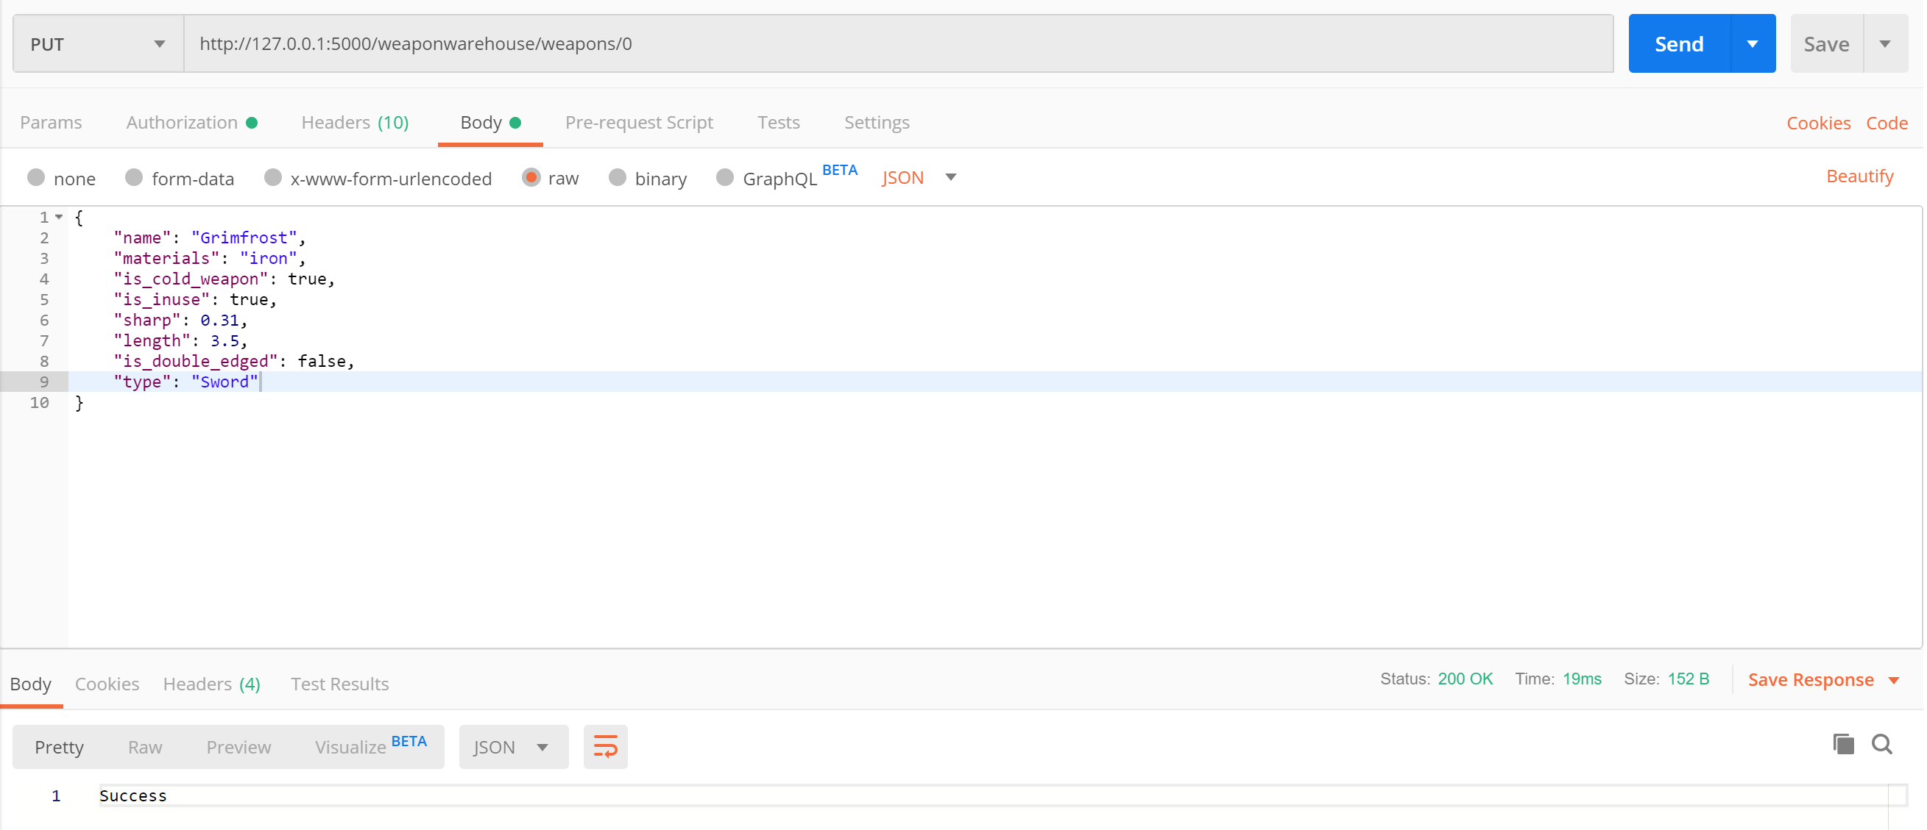

* **Failure – if the entity object does not exist**

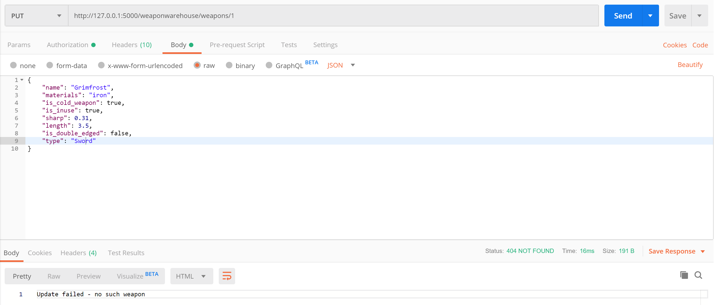

* **Endpoint 3:** @app.route(**'/weaponwarehouse/weapons/<id>'**, methods=[**'DELETE'**])
* **Success**

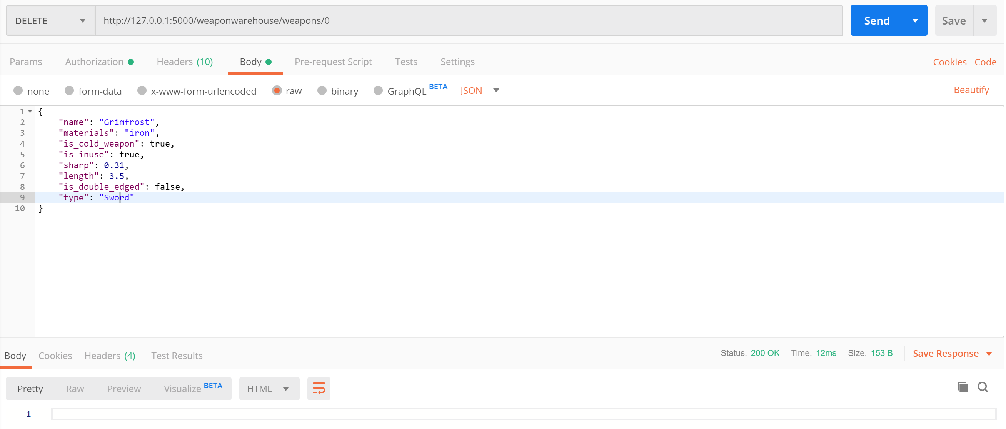

* **Failure - if the entity object does not exist**

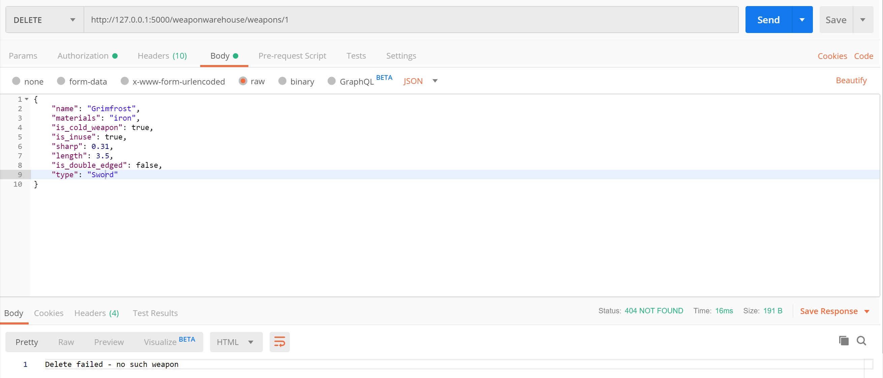

* **Endpoint 4:** @app.route(**'/weaponwarehouse/weapons/<id>'**, methods=[**'GET'**])
* **Success**

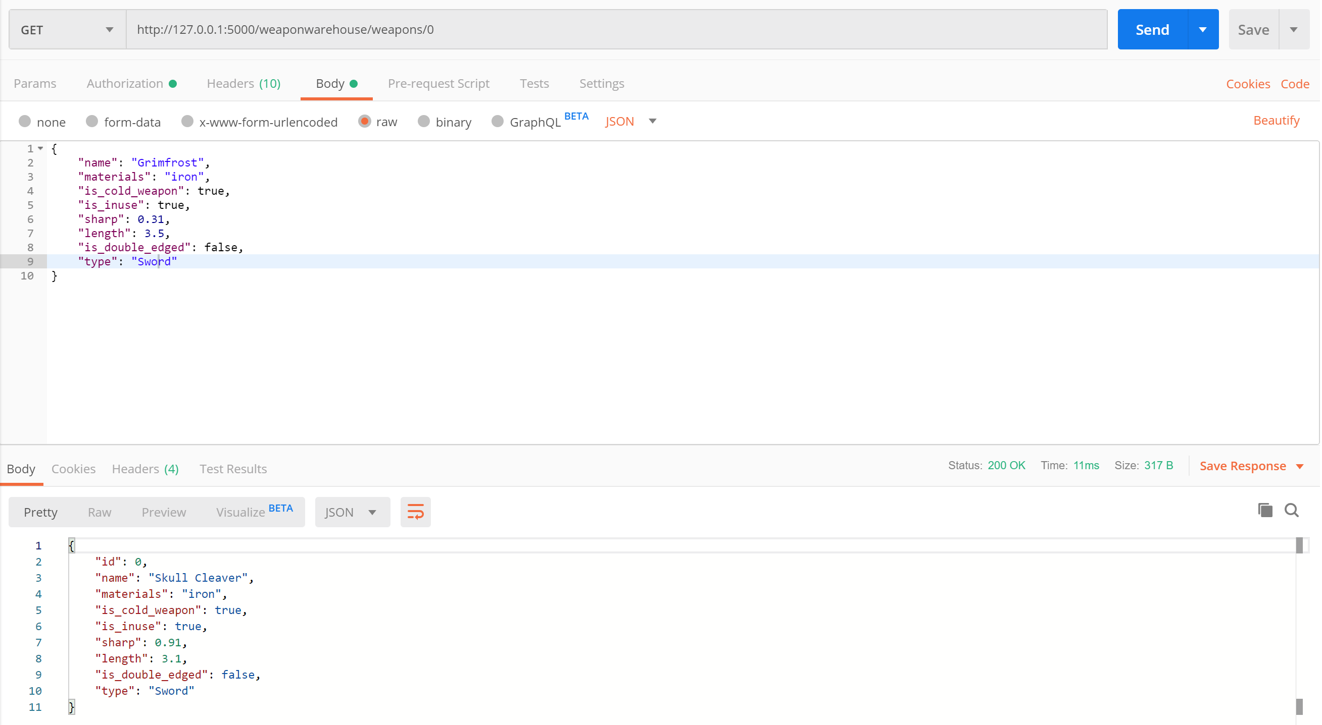

* **Failure - if the entity object does not exist**

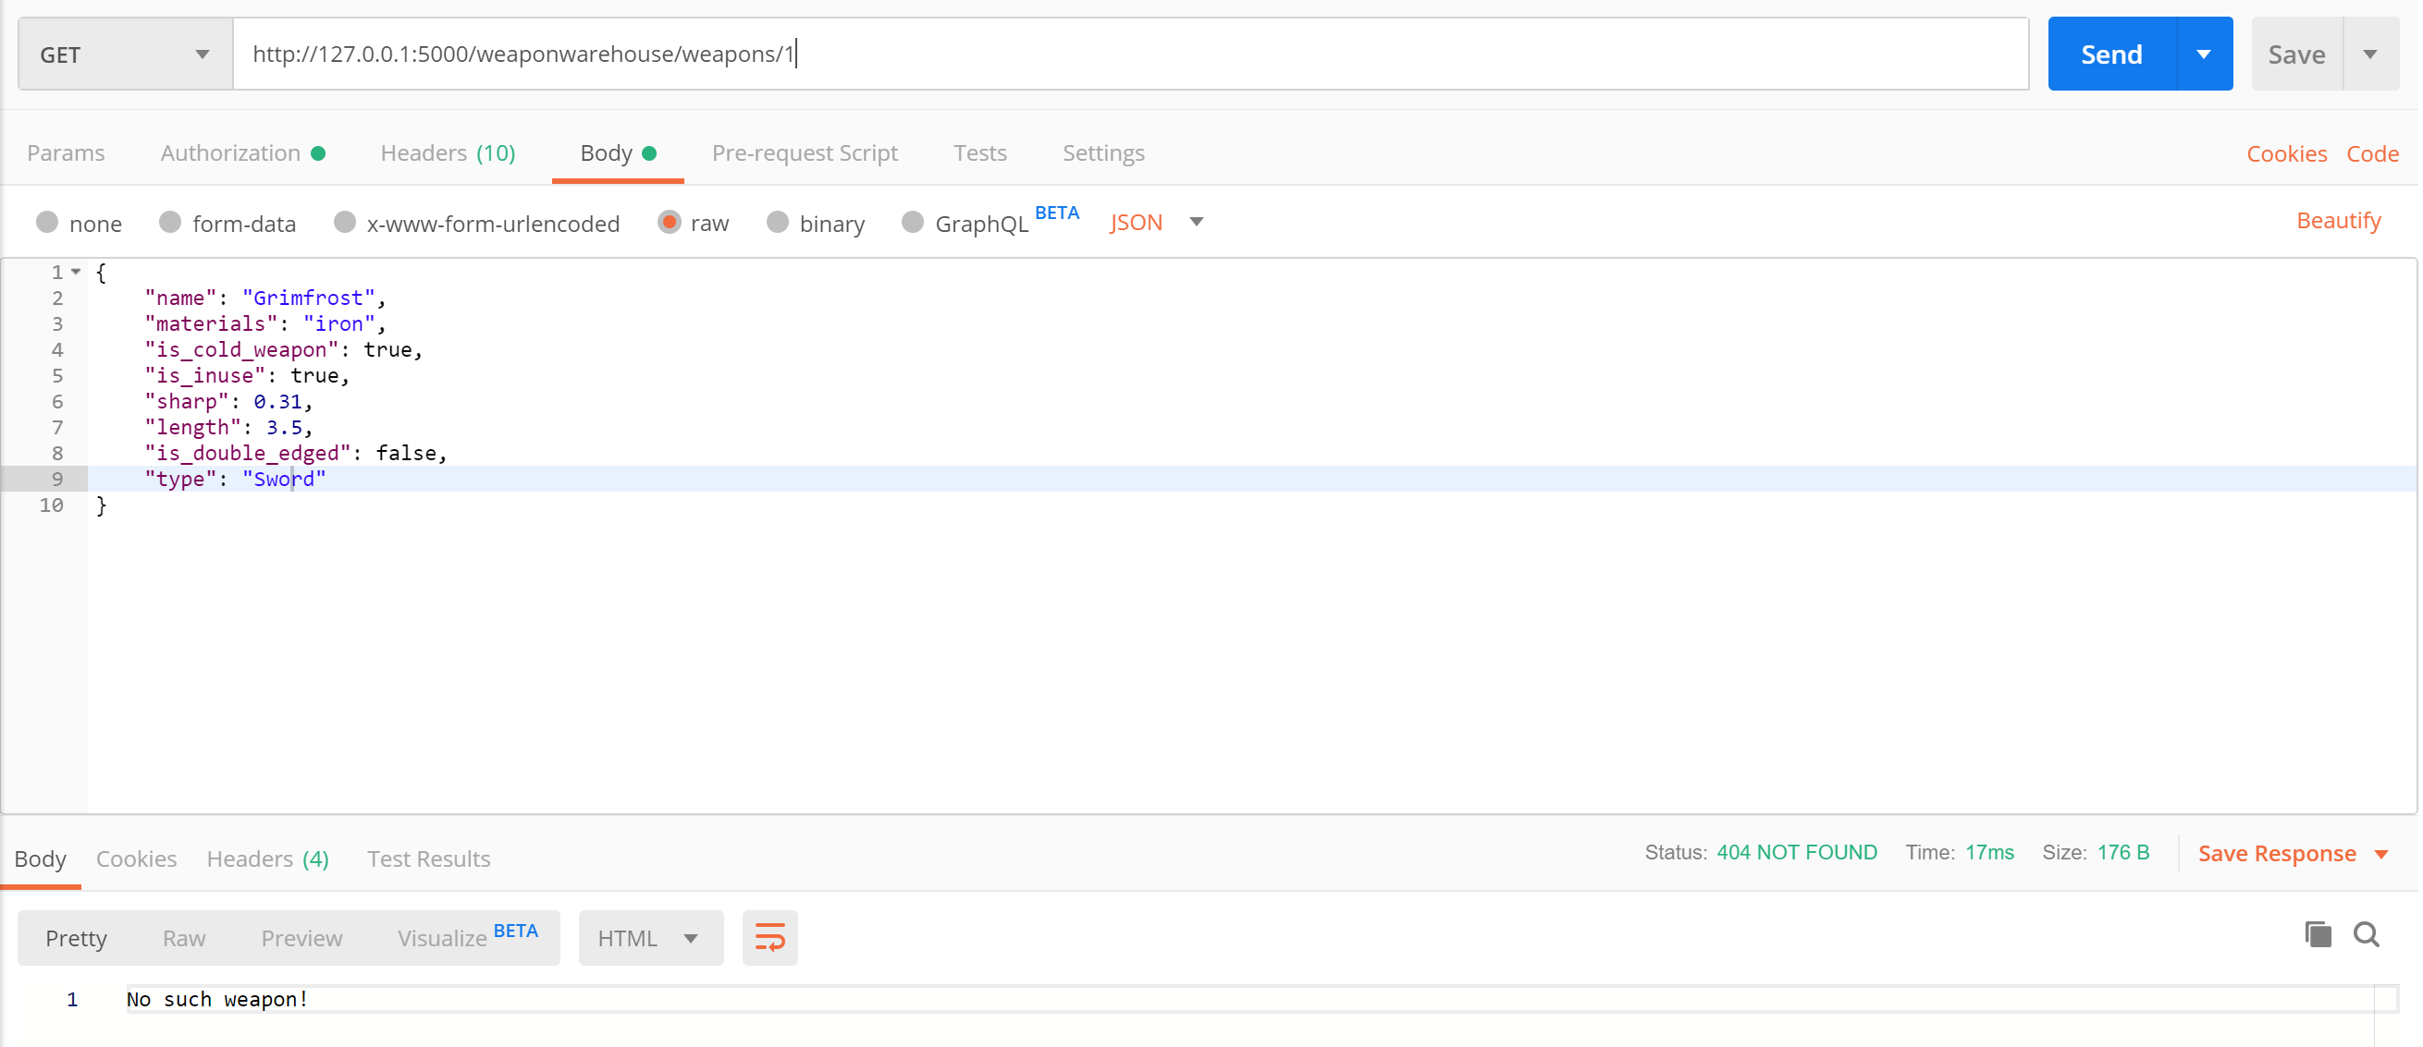

* **Endpoint 5:** @app.route(**'/weaponwarehouse/weapons/all'**, methods=[**'GET'**])
* **Success**

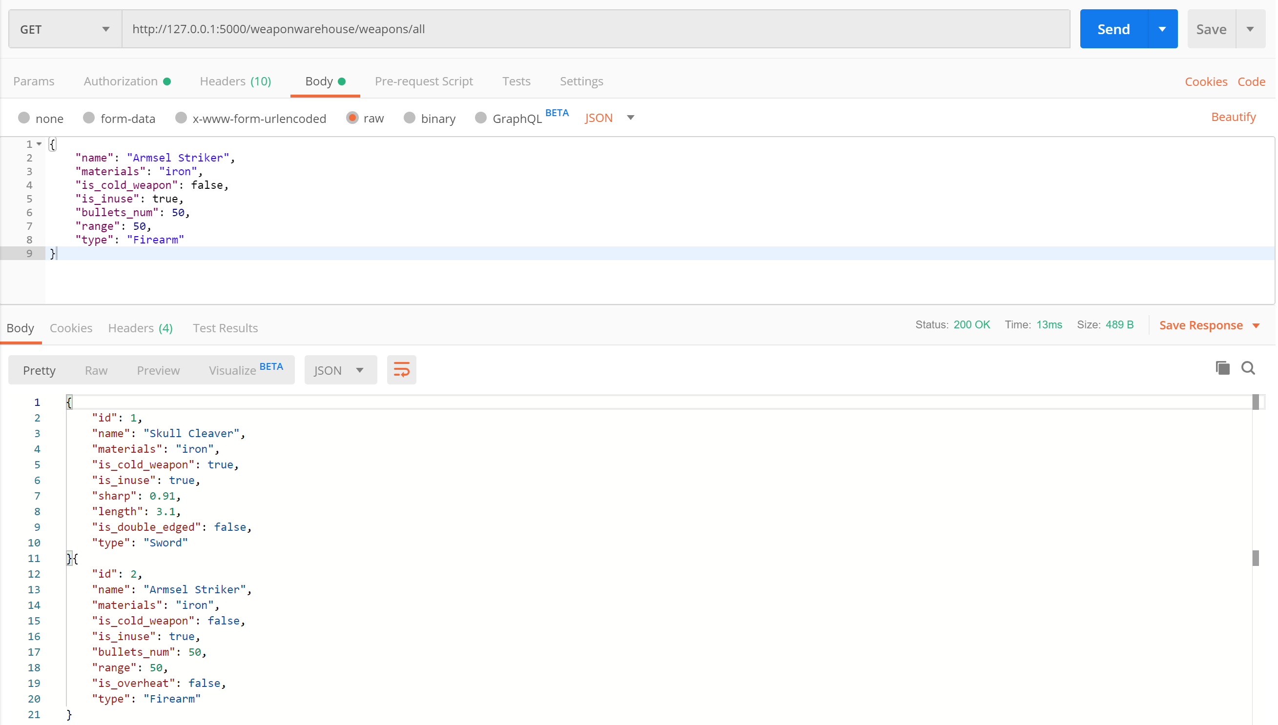

* **Endpoint 6:** @app.route(**'/weaponwarehouse/weapons/all/<type>'**, methods=[**'GET'**])
* **Success**

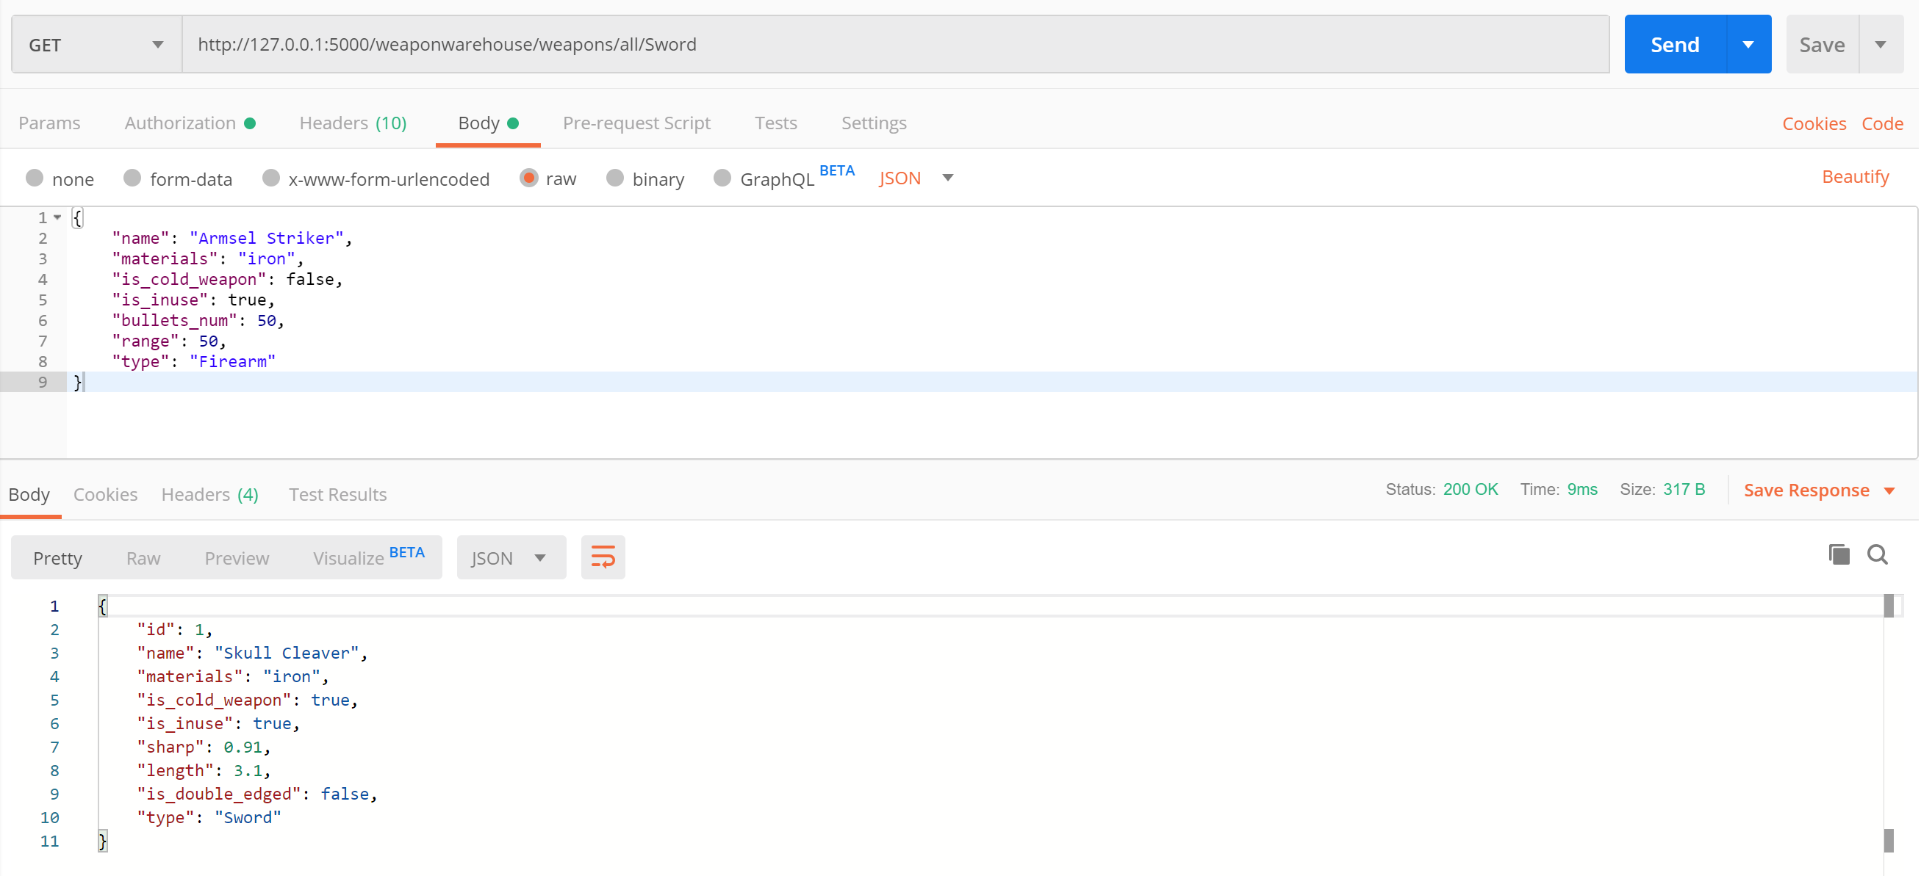

* **Failure - if the type is not supported**

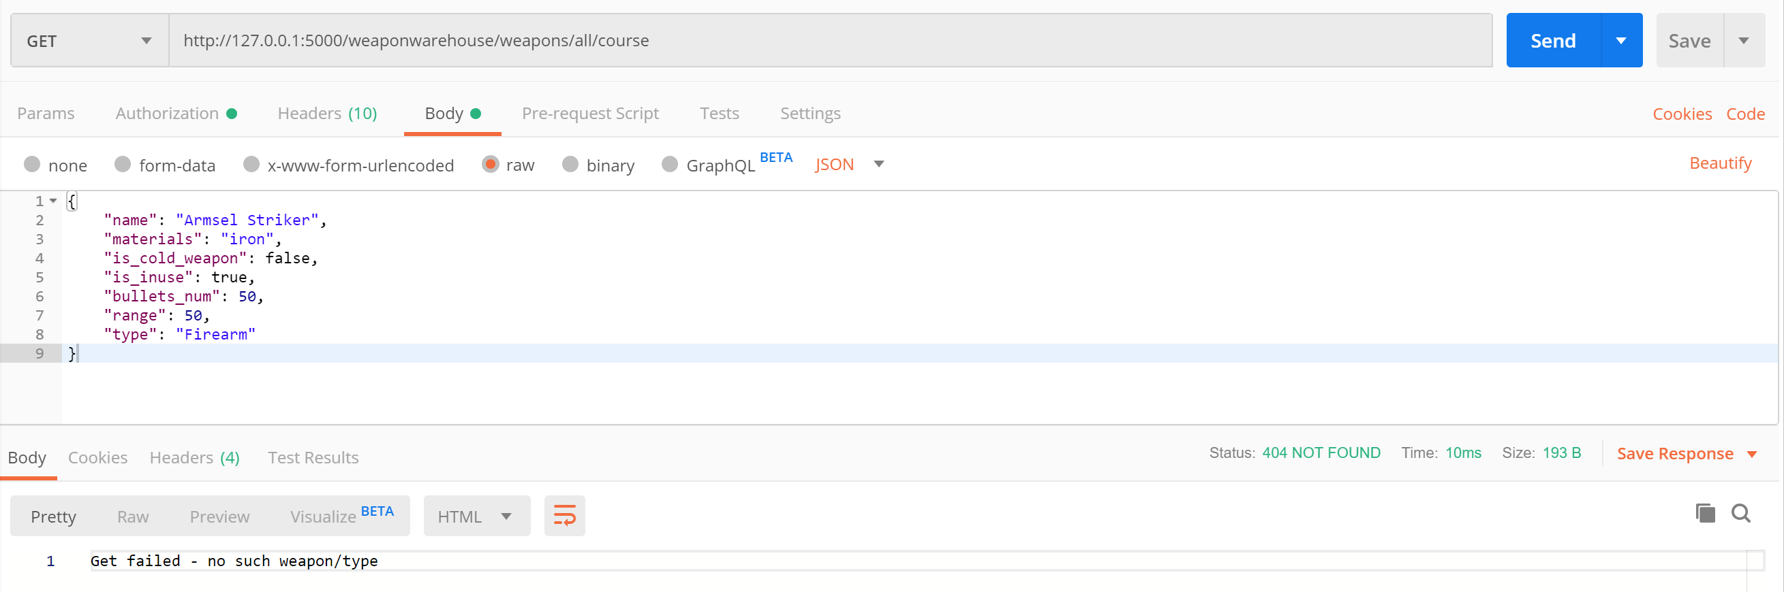

* **Endpoint 7:** @app.route(**'/weaponwarehouse/weapons/stats'**, methods=[**'GET'**])
* **Success**

