全球校园人工智能算法精英大赛
大模型技术创新赛 · 技术文档

作品名称：快速且稳定车
学校名称：________________
团队名称：快速且稳定车
队长：________
队员：________ / ________ / ________
2026年10月

摘 要
本作品「快速且稳定车」面向大模型技术创新赛取放任务，在 ROS2 Humble + Gazebo + Nav2 平台上构建「大模型解题—最短巡回规划—稳定导航—近场视觉伺服—区内投放」完整闭环。针对赛场动态障碍、字母投放区几何约束与多物块空驶成本三大难题，提出五项关键创新：（1）DeepSeek 与本地正则求解器双通道交叉校验，并正确处理「都需要」人数倍增；（2）route_planner 联合优化物块编号绑定与访问顺序，最小化取放巡回长度；（3）Nav2 软成功（early_xy）+ MODE_NAV/MODE_LOCAL 权杖切换，避免物块旁爬行与空转；（4）按物块编号强制接近扇区与 standoff，保证前置相机 FOV 先看到目标；（5）投放区 zone_keepout 点云与已放块永久禁入，以及绿垫长边/短边非对称进区判定。整机不盲目抬高 max_vel，而以少空驶、少恢复行为、一次对准成功换取「快且稳」。
关键词：ROS2；Nav2；OpenCV IBVS；最短巡回；区禁入；大模型解题；软成功切换

第一章 项目概述

1.1 项目背景与目标

1.1.1 背景介绍
全球校园人工智能算法精英大赛「大模型技术创新赛」要求机器人根据自然语言应用题解析出 红/蓝物块数量与投放区（A/B/C），并在含动态障碍的室内地图中完成最多 5 块取放。仿真平台基于 Gazebo 与 Nav2，评分同时约束正确性、区内投放与总用时。作品名「快速且稳定车」体现设计原则：在定位可靠前提下压缩空驶与空等，同时保证抓取与投放一次成功。

1.1.2 核心问题
核心难题包括：（1）题面表述多样，「都需要」易漏乘人数；（2）多块任务组合爆炸，随意顺序空驶长；（3）动态杆与膨胀层导致到点爬行、GoalAlign 空转；（4）特殊物块靠近墙/区时导航路径压块，相机看不到；（5）绿垫 1.0×0.5 m 长边/短边几何不同，垂直拧航向与进区平移易相互打架，块常落在短边外侧不得分。

1.1.3 项目目标
目标1：题面→结构化任务 [颜色,数量,区] 准确率高，DeepSeek 失败可本地兜底。
目标2：在 5 分钟量级内完成典型 5 块任务，空驶短、恢复行为少。
目标3：抓取可靠、投放必须落入绿垫长方形内，且不碾压已放物块。

1.2 技术路线

1.2.1 任务分析
系统任务按层级拆分：指令层解题与映射；任务层编号绑定与巡回排序；导航层 AMCL+Navfn+DWB；作业层 OpenCV HSV 近场对准 + LinkAttacher 吸附；投放层区内收与 keepout 反馈。大模型只输出符号计划，不进入控制环。

1.2.2 功能模块
1. local_solver / llm_solver：自然语言 → (x,y) → /task_command
2. route_planner：物块编号分配 + 最短访问顺序
3. task_sm：状态机，调度取放腿与 MODE 切换
4. motion：Nav2 封装、软成功、keepout、视觉 creep
5. vision_align / vision_pose：HSV 检测与分区接近几何
6. viz_bridge + coStudio：进度与状态面板

1.2.3 程序流程设计
数据流：题面 → DeepSeek∥本地求解 → 任务表 → route_planner → task_sm → Nav2(AMCL+Navfn+DWB) → early_xy 软成功 → MODE_LOCAL → OpenCV IBVS → 吸附 → 区内收投放 → zone_keepout/placed_keepout 更新 → 下一腿。
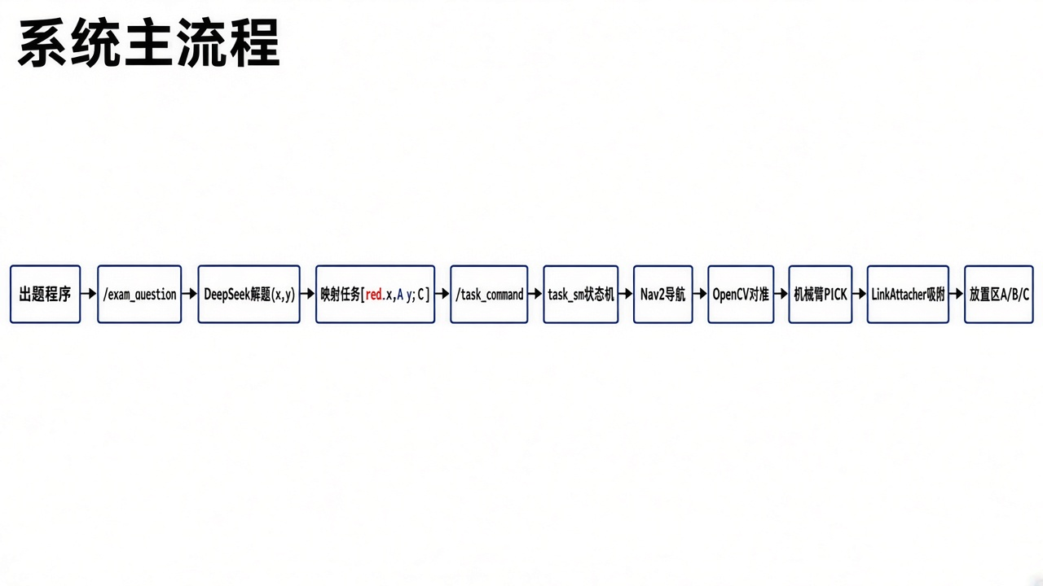
图1 任务管线与状态机

第二章 功能设计

2.1 系统总体架构
分层误差预算：全局用 known_coords 先验定位物块；中程用 AMCL 与代价地图；近场用像素偏差闭环；末端用距离门禁与吸附约束。速度方面保持 max_vel_x=1.35 m/s、max_vel_theta=0.80 rad/s，不把盲目提速作为主优化手段，避免定位未收敛时粒子发散。

2.2 关键技术详解（创新点）
本节展开五项创新。对应完整实装代码见第三章、第四章【创新代码】高亮块。

2.2.1 双通道解题与「都需要」倍增
官方规则：容量 5，x=ceil(类型1总量/5)，y=ceil(类型2总量/5)；数量≥3→高区 A，否则→低区 C。创新点：本地正则先处理「小帅、小丽都需要 N 件」按人数倍增，再剥离该子句避免重复累加；DeepSeek 与本地结果交叉校验，冲突时优先可执行的本地命令，保证赛场弱网仍可出题执行。
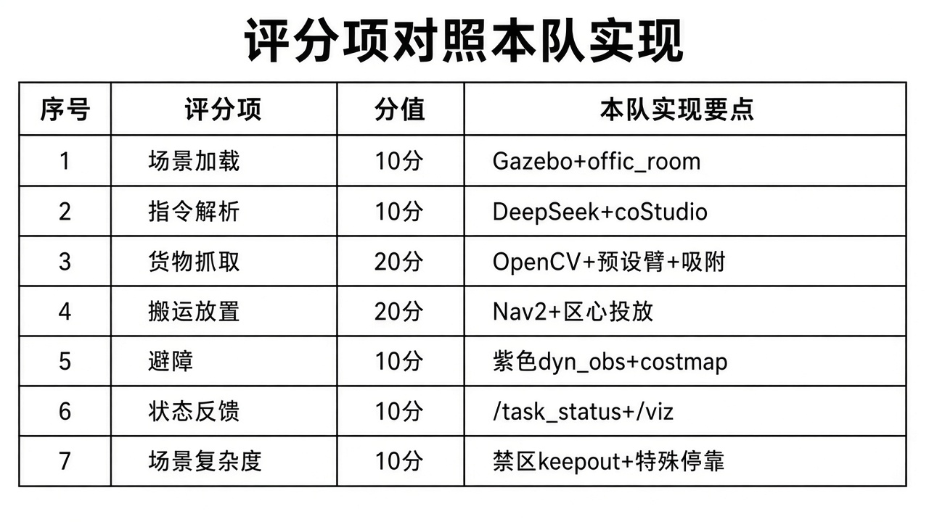
图2 题面到数量映射

2.2.2 联合编号绑定与最短巡回
route_planner 不只排序，还在可用立方块编号集合上枚举绑定，并对每组绑定求最短访问置换（N≤8 全排列，更大则最近邻）。代价函数计入 red#1→A/B 的门洞 via，从源头减少空驶与恢复。

2.2.3 软成功与 MODE 权杖
取放接近段设置 early_xy：XY 进入邻域即 cancel NavigateToPose，切入 MODE_LOCAL 由视觉/开环完成厘米级对准。避免 GoalChecker 过严导致超时重规划，也避免 DWB 在高代价缝反复 GoalAlign 空转。作业结束再 exit_local 交回 Nav2。
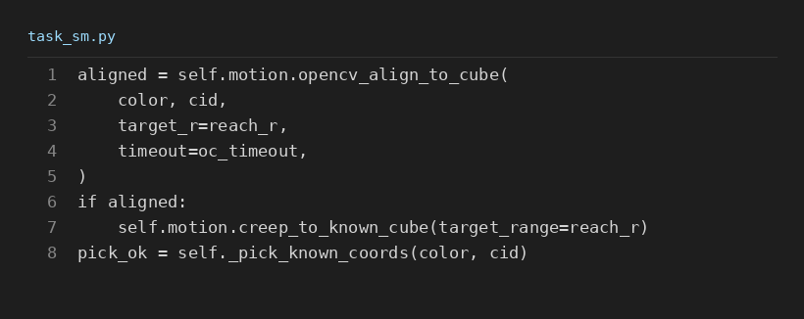
图3 取物：软成功 → 视觉对准 → 吸附门禁

2.2.4 分区强制接近几何
取物目标不是物块坐标，而是保证 FOV 的 standoff 停靠点。对 red#2/#4、blue#4/#5 等危险编号强制西/东/北侧接近，禁止「为抄近路从对侧绕行压块」。yaw=atan2(块−车)，保证前置相机朝向目标。
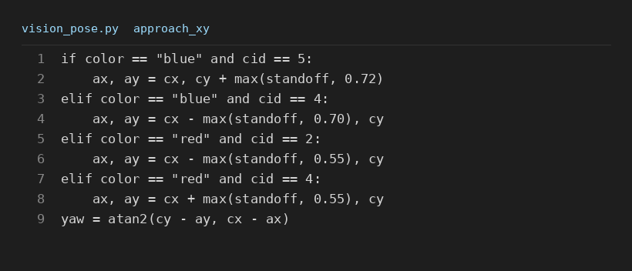
图4 特殊物块接近策略
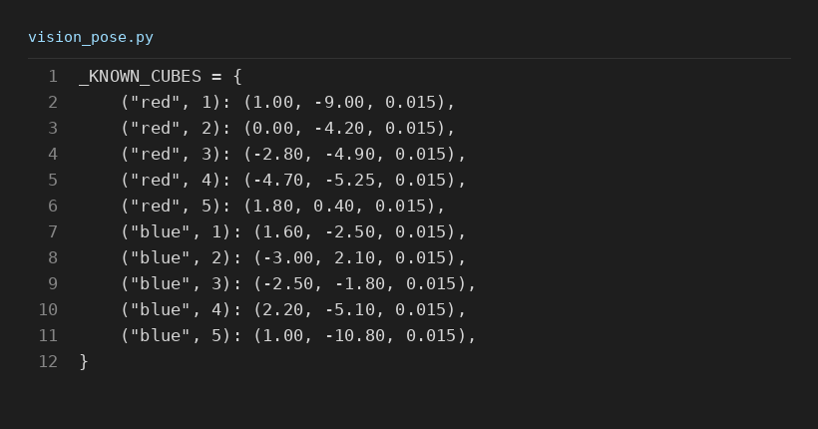
图5 物块坐标先验

2.2.5 区禁入反馈与长/短边投放
投放改变可通行空间：字母垫注入 zone_keepout 点云；当前区 set_keepout_except 允许进入，其他区保持禁入；已放块 add_placed_keepout 永久抬高代价。绿垫长边(X≈1.0m)/短边(Y≈0.5m) 非对称判定：从 ±X 接近面对短边，必须沿长边越过短边进入垫内，避免落在短边外侧不得分；朝向大致对准即可，不与进区平移死磕垂直。

第三章 功能实现

3.1 模块实现细节（创新代码精选）
下列代码均直接摘自本队工程实装源文件，为评审突出「快且稳」相关创新点。

3.1.1 本地求解器
【创新代码】local_solver.py — 都需要倍增 + ceil(/5) + 区映射
def solve_xy_from_question(question: str) -> Tuple[int, int]:
"""Sum needs for type1/type2 then ceil(/5).
Supports T恤/裤子 and 猫/狗 style official templates.
Handles 'A、B都需要N件X' by multiplying N by subject count.
"""
text = _normalize(question)
type1 = 0
type2 = 0
# 「小帅、小丽都需要7件T恤」/「都领养2只猫」→ subjects * N
# names may include ASCII (小A) in practice banks
_name = r"([\u4e00-\u9fffA-Za-z0-9、]{2,}?)"
for m in re.finditer(_name + r"都(?:需要|领养)(\d+)件T恤", text):
subjects = [s for s in m.group(1).split("、") if s]
type1 += int(m.group(2)) * max(len(subjects), 1)
for m in re.finditer(_name + r"都(?:需要|领养)(\d+)条裤子", text):
subjects = [s for s in m.group(1).split("、") if s]
type2 += int(m.group(2)) * max(len(subjects), 1)
for m in re.finditer(_name + r"都(?:需要|领养)(\d+)只?猫", text):
subjects = [s for s in m.group(1).split("、") if s]
type1 += int(m.group(2)) * max(len(subjects), 1)
for m in re.finditer(_name + r"都(?:需要|领养)(\d+)只?狗", text):
subjects = [s for s in m.group(1).split("、") if s]
type2 += int(m.group(2)) * max(len(subjects), 1)
# Strip dou-* clauses so they are not double-counted below
text2 = re.sub(_name + r"都(?:需要|领养)\d+件T恤", "", text)
text2 = re.sub(_name + r"都(?:需要|领养)\d+条裤子", "", text2)
text2 = re.sub(_name + r"都(?:需要|领养)\d+只?猫", "", text2)
text2 = re.sub(_name + r"都(?:需要|领养)\d+只?狗", "", text2)
for m in re.finditer(r"(\d+)件T恤", text2):
type1 += int(m.group(1))
for m in re.finditer(r"(\d+)只?猫", text2):
type1 += int(m.group(1))
for m in re.finditer(r"(\d+)条裤子", text2):
type2 += int(m.group(1))
for m in re.finditer(r"(\d+)只?狗", text2):
type2 += int(m.group(1))
if type1 == 0 and type2 == 0:
type1 = sum(int(m.group(1)) for m in re.finditer(r"(\d+)件", text))
type2 = sum(int(m.group(1)) for m in re.finditer(r"(\d+)条", text))
if type1 == 0 and type2 == 0:
raise ValueError(f"cannot extract totals from question: {question[:100]}")
x = int(math.ceil(type1 / 5.0))
y = int(math.ceil(type2 / 5.0))
return x, y
def map_xy_to_tasks(
x: int,
y: int,
*,
x_color: str = "red",
y_color: str = "blue",
threshold: int = 3,
high_zone: str = "A",
low_zone: str = "C",
) -> List[PickTask]:
def zone_for(n: int) -> str:
return high_zone if n >= threshold else low_zone
tasks: List[PickTask] = []
if x > 0:
tasks.append(PickTask(x_color.lower(), x, zone_for(x)))
if y > 0:
tasks.append(PickTask(y_color.lower(), y, zone_for(y)))
return tasks
def question_to_command(question: str, mapping: Dict | None = None) -> str:
mapping = mapping or {}
x, y = solve_xy_from_question(question)
tasks = map_xy_to_tasks(
x,
y,
x_color=mapping.get("x_color", "red"),
y_color=mapping.get("y_color", "blue"),
threshold=int(mapping.get("threshold", 3)),
high_zone=mapping.get("high_zone", "A"),
low_zone=mapping.get("low_zone", "C"),
)
return format_command(tasks)

3.1.2 最短巡回规划
【创新代码】route_planner.py — _leg_cost 含门洞 via
def _leg_cost(
pos: Point,
color: str,
cid: int,
zone: str,
zones: Dict[str, Point],
*,
use_door_via: bool = True,
) -> Tuple[float, Point, str]:
"""Cost of one pick→place: pos → (vias) → cube → zone. End pose = zone."""
cube = _cube_xy(color, cid)
zxy = zones[zone.upper()]
pts: List[Point] = [pos]
note = ""
if (
use_door_via
and color.lower() == "red"
and int(cid) == 1
and zone.upper() in ("A", "B")
):
vias = list(_door_vias())
dx, dy = cube[0] - pos[0], cube[1] - pos[1]
L = math.hypot(dx, dy) or 1.0
def _along(v: Point) -> float:
return ((v[0] - pos[0]) * dx + (v[1] - pos[1]) * dy) / L
pts.extend(sorted(vias, key=_along))
note = "+door_via"
pts.append(cube)
pts.append(zxy)
cost = sum(_dist(a, b) for a, b in zip(pts, pts[1:]))
return cost, zxy, note
【创新代码】route_planner.py — 编号绑定枚举 + 最短置换
def _materialize_assignments(
jobs: List[JobSpec], max_cubes: int
) -> List[List[Leg]]:
"""All ways to bind free jobs to unused cube ids (fixed ids locked)."""
fixed = {"red": set(), "blue": set()}
for j in jobs:
if j.fixed_id is not None:
fixed[j.color].add(int(j.fixed_id))
free_idx = {"red": [], "blue": []}
for i, j in enumerate(jobs):
if j.fixed_id is None:
free_idx[j.color].append(i)
avail = {
c: [i for i in range(1, max_cubes + 1) if i not in fixed[c]]
for c in ("red", "blue")
}
# Choose which free ids to use, then assign them to free job slots
red_need = len(free_idx["red"])
blue_need = len(free_idx["blue"])
if red_need > len(avail["red"]) or blue_need > len(avail["blue"]):
return []
out: List[List[Leg]] = []
for red_pick in itertools.combinations(avail["red"], red_need):
for blue_pick in itertools.combinations(avail["blue"], blue_need):
for red_perm in itertools.permutations(red_pick):
for blue_perm in itertools.permutations(blue_pick):
legs: List[Optional[Leg]] = [None] * len(jobs)
ri = bi = 0
ok = True
for i, j in enumerate(jobs):
if j.fixed_id is not None:
legs[i] = (j.color, int(j.fixed_id), j.zone)
elif j.color == "red":
legs[i] = (j.color, int(red_perm[ri]), j.zone)
ri += 1
else:
legs[i] = (j.color, int(blue_perm[bi]), j.zone)
bi += 1
if not ok or any(x is None for x in legs):
continue
out.append([x for x in legs if x is not None]) # type: ignore
return out
def _best_order(
legs: List[Leg],
start: Point,
zones: Dict[str, Point],
use_door_via: bool,
) -> Tuple[float, List[Leg], List[str]]:
"""Shortest visit order for a fully assigned set of legs."""
n = len(legs)
if n == 0:
return 0.0, [], []
if n == 1:
total, detail = _tour_cost(legs, start, zones, use_door_via)
return total, list(legs), detail
best_total = float("inf")
best_legs: List[Leg] = list(legs)
best_detail: List[str] = []
if n <= 8:
for perm in itertools.permutations(legs):
total, detail = _tour_cost(perm, start, zones, use_door_via)
if total < best_total:
best_total = total
best_legs = list(perm)
best_detail = detail
return best_total, best_legs, best_detail
# Greedy NN fallback for large N
remaining = list(legs)
built: List[Leg] = []
pos = start
while remaining:
best_i = 0
best_d = float("inf")
for i, (c, cid, z) in enumerate(remaining):
d, _, _ = _leg_cost(pos, c, cid, z, zones, use_door_via=use_door_via)
if d < best_d:
best_d, best_i = d, i
leg = remaining.pop(best_i)
built.append(leg)
_, pos, _ = _leg_cost(
pos, leg[0], leg[1], leg[2], zones, use_door_via=use_door_via
# ... (后续逻辑同工程源码)
【创新代码】route_planner.py — plan_route 主入口
def plan_route(
command: str,
*,
start: Point = (0.0, 0.0),
max_cubes: int = 5,
use_door_via: bool = True,
poses_yaml: Optional[Path] = None,
) -> PlanResult:
"""Parse command → assign cubes + reorder for shortest Euclidean tour."""
tasks = parse_command(command, max_cubes=max_cubes)
jobs = expand_jobs(tasks, max_cubes=max_cubes)
if not jobs:
raise ValueError("no jobs to plan")
zones = _load_zones(poses_yaml)
assignments = _materialize_assignments(jobs, max_cubes)
if not assignments:
raise RuntimeError("route planning failed (cube conflict?)")
# Cap combinatorial blow-up: if too many assignments, sample via greedy ids
# then only optimize order. Typical contest: ≤5 legs → fine.
MAX_ASSIGN = 1200
if len(assignments) > MAX_ASSIGN:
# Prefer assignments that use cubes nearest to their zone (cheap filter)
def _assign_score(legs: List[Leg]) -> float:
s = 0.0
for c, cid, z in legs:
s += _dist(_cube_xy(c, cid), zones[z.upper()])
return s
assignments = sorted(assignments, key=_assign_score)[:MAX_ASSIGN]
best_total = float("inf")
best_legs: List[Leg] = []
best_detail: List[str] = []
for legs in assignments:
total, ordered, detail = _best_order(
legs, start, zones, use_door_via
)
if total < best_total:
best_total = total
best_legs = ordered
best_detail = detail
if not best_legs:
raise RuntimeError("route planning failed (empty)")

3.1.3 Nav2 软成功 early_xy 与 MODE 权杖
【创新代码】motion.py — navigate() 中 early_xy 软成功
x: float,
y: float,
yaw: float,
timeout: float = 180.0,
*,
early_xy_tol: Optional[float] = None,
soft_start: bool = False,
) -> bool:
if self.drive_owner != "nav":
self.node.get_logger().warn("navigate blocked until MODE_NAV; forcing exit_local")
self.exit_local_mode()
# 取消上一次目标，避免「第二次发目标车不动 / 旧 BT 卡死」
self.cancel_nav()
if soft_start:
# Chain via→final without hard brake (keeps AMCL smoother)
time.sleep(0.02)
else:
self.stop_chassis()
time.sleep(0.06)
pose = PoseStamped()
pose.header.frame_id = "map"
pose.header.stamp = self.node.get_clock().now().to_msg()
pose.pose.position.x = float(x)
pose.pose.position.y = float(y)
qx, qy, qz, qw = yaw_to_quat(yaw)
pose.pose.orientation.x = qx
pose.pose.orientation.y = qy
pose.pose.orientation.z = qz
pose.pose.orientation.w = qw
goal = NavigateToPose.Goal()
goal.pose = pose
early_s = (
f" early_xy≤{early_xy_tol:.2f}"
if early_xy_tol is not None
else ""
)
self.node.get_logger().info(
f"NAV → ({x:.2f}, {y:.2f}, yaw={yaw:.2f}){early_s}"
)
# If localization is dead, Nav2 accepts nothing useful / no path in RViz
if self.get_base_xy_yaw_map() is None:
self.node.get_logger().error(
"NAV abort: no map→base TF (先 2D Pose Estimate)"
)
return False
send = self.nav.send_goal_async(goal)
if not self._spin_until(send, 30.0):
self.node.get_logger().error("nav send_goal timeout")
return False
goal_handle = send.result()
if not goal_handle.accepted:
self.node.get_logger().error("nav goal rejected")
return False
self._nav_goal_handle = goal_handle
result_fut = goal_handle.get_result_async()
t0 = time.time()
while not result_fut.done():
if time.time() - t0 > timeout:
self.node.get_logger().error("nav result timeout")
self.cancel_nav()
return False
# Place / via soft-disk: XY close enough → cancel (no yaw spin / no return)
if early_xy_tol is not None:
cur = self.get_base_xy_yaw_map()
if cur is not None:
dxy = math.hypot(cur[0] - float(x), cur[1] - float(y))
if dxy <= float(early_xy_tol):
self.node.get_logger().info(
f"NAV_EARLY_XY dxy={dxy:.3f}≤{early_xy_tol:.2f} → continue"
)
self.cancel_nav()
if not soft_start:
self.stop_chassis()
time.sleep(0.06)
else:
time.sleep(0.02)
self._nav_goal_handle = None
return True
time.sleep(0.05)
self._nav_goal_handle = None
from action_msgs.msg import GoalStatus
wrapped = result_fut.result()
status = int(getattr(wrapped, "status", GoalStatus.STATUS_UNKNOWN))
# Early cancel returns CANCELED — still OK if we already accepted above
if status != GoalStatus.STATUS_SUCCEEDED:
# If XY already good after cancel race, treat as success
# ... (后续逻辑同工程源码)
【创新代码】motion.py — enter_local_mode / exit_local_mode
"""Cancel Nav ownership of wheels; task_sm may publish cmd_vel."""
self.cancel_nav()
self.stop_chassis(n=2)
# Cap settle — callers often pass legacy 0.08~1.5; contest wants snappy handoff
time.sleep(min(0.06, max(float(settle_sec), 0.0)))
self.drive_owner = "local"
self.stop_chassis(n=1)
self.node.get_logger().info("MODE_LOCAL (task owns cmd_vel)")
def exit_local_mode(self) -> None:
"""Hand wheels back to Nav2 for NavigateToPose."""
self.stop_chassis(n=1)
self.drive_owner = "nav"
self.node.get_logger().info("MODE_NAV (Nav2 owns cmd_vel)")

3.1.4 特殊物块强制接近几何
【创新代码】vision_pose.py — approach_xy_for_cube 保 FOV
def approach_xy_for_cube(
color: str,
cube_id: int,
*,
standoff_m: float = 0.35,
robot_xy: Optional[Tuple[float, float]] = None,
robot_yaw: Optional[float] = None,
) -> Tuple[float, float, float]:
"""Park axis-aligned with base +X facing the cube (camera must see it).
Blue#2: EAST of cube (map x > cube x) — stand on +X side.
Other blue: WEST of cube (map x < cube x).
Red: prefer same-Y (±x); N/S only if clearly nearer.
Yaw is always atan2(cube − park) so the front camera looks at the cube.
"""
cx, cy, _z = known_cube_xy(color, cube_id)
so = float(standoff_m)
def _face(ax: float, ay: float) -> float:
return float(np.arctan2(cy - ay, cx - ax))
if str(color).lower() == "blue":
# Farther park so Nav2 / creep do not sit on the cube (FOV miss).
so_b = max(so, 0.60)
cid = int(cube_id)
# blue#5 southern corridor. Park NORTH (farther) face south — never drive
# over the cube (under-chassis FOV miss). Leave space to reverse after pick.
if cid == 5:
so5 = max(so_b, 0.72)
ax, ay = float(cx), float(cy) + so5
return ax, ay, _face(ax, ay)
# blue#4 at (2.2,-5.1) SE of zone B. South park forces a path that
# crosses the cube (from B) → cube ends under the chassis / FOV dead.
# Always park WEST, face +X — approach from B goes south, cube stays ahead.
if cid == 4:
so4 = max(so_b, 0.70)
ax, ay = float(cx) - so4, float(cy)
return ax, ay, _face(ax, ay)
# Park on the SAME side of the cube as the robot — never force west
# when the car is east (that path drives over the block).
if robot_xy is not None:
rx = float(robot_xy[0])
if rx >= float(cx):
ax, ay = float(cx + so_b), float(cy) # east, face −X
else:
ax, ay = float(cx - so_b), float(cy) # west, face +X
elif cid == 2:
ax, ay = float(cx + so_b), float(cy)
else:
ax, ay = float(cx - so_b), float(cy)
return ax, ay, _face(ax, ay)
# Red: ALWAYS park on the robot's side (never cross over the cube).
# Prefer ±X (side) docks — N/S parks often sit in the lower dyn_obs lane
# and the first-red approach from start then never puts the cube in FOV.
# All reds use the same standoff (no 0.70 special — that caused far-grab).
so_r = max(float(standoff_m), 0.55)
cid = int(cube_id)
# red#2 at (0,-4.2) sits next to zone B (1.5,-4). East park lands in B
# keepout/inflation → Nav stops wrong / cam misses. Always park WEST.
if cid == 2:
ax, ay = float(cx) - so_r, float(cy)
return ax, ay, _face(ax, ay)
# red#4 leftmost (x≈-4.7): west park hugs wall → FOV drift. Always park EAST.
# Same distance as others (was 0.70 → “离很远才夹”).
if cid == 4:
ax, ay = float(cx) + so_r, float(cy)
return ax, ay, _face(ax, ay)
if robot_xy is None:
ax, ay = float(cx + so_r), float(cy)
return ax, ay, _face(ax, ay)
rx, ry = float(robot_xy[0]), float(robot_xy[1])
dx, dy = rx - float(cx), ry - float(cy)
# Bias to lateral park (keeps camera aimed at cube, clear of obs2)
use_side = abs(dx) + 0.40 >= abs(dy)
if use_side:
if abs(dx) < 0.30:
ax = float(cx + so_r) # nearly aligned → stand east (open corridor)
else:
ax = float(cx + so_r) if dx >= 0.0 else float(cx - so_r)
ay = float(cy)
else:
ax = float(cx)
# ... (后续逻辑同工程源码)

3.1.5 HSV 与伪目标拒识
【创新代码】vision_align.py — HSV 高饱和色门禁 + cube_like
def _hsv_mask(hsv: np.ndarray, color: str) -> np.ndarray:
"""Strict masks: cubes are saturated pure color; walls/paint are duller."""
c = color.lower()
if c == "red":
# High S/V → pure red plastic cube; reject brick / faded panels
m1 = cv2.inRange(hsv, (0, 145, 85), (10, 255, 255))
m2 = cv2.inRange(hsv, (170, 145, 85), (180, 255, 255))
return cv2.bitwise_or(m1, m2)
if c == "blue":
# 远距蓝块 S/V 更低，略放宽
return cv2.inRange(hsv, (92, 85, 45), (132, 255, 255))
raise ValueError(f"unsupported color: {color}")
def _cube_like(
area: float,
bw: int,
bh: int,
cx: float,
cy: float,
w: int,
h: int,
mask: np.ndarray,
x: int,
y: int,
*,
min_cy_frac: float = 0.28,
) -> bool:
"""Reject wall patches: too big, elongated, low fill, or too high in image.
Front cam: floor cubes sit mid/lower; high cy-reject = ignore tall/wall blobs.
"""
img_a = float(max(w * h, 1))
frac = area / img_a
# 3cm cube at ~0.4–1.5m is small; wall patches are huge
if frac > 0.06:
return False
# 远距小块面积更小，仍须通过（原 14 易漏远处物块）
if area < 8:
return False
aspect = float(bw) / float(max(bh, 1))
if aspect < 0.45 or aspect > 2.2:
return False
# extent: contour area vs bbox
extent = area / float(max(bw * bh, 1))
if extent < 0.30:
return False
# Height gate (image row ≈ camera "height"): too high → not a floor cube
if cy < float(min_cy_frac) * h:
return False
if float(y) < 0.18 * h:
return False
roi = mask[y : min(h, y + bh), x : min(w, x + bw)]
if roi.size < 4:

3.1.6 投放区点云禁入
【创新代码】motion.py — configure_zone_keepouts / add_placed_keepout
def configure_zone_keepouts(
self,
zones: dict,
*,
half_x: float = 0.48,
half_y: float = 0.28,
step: float = 0.06,
) -> None:
"""Register place-zone rectangles (map frame) as virtual obstacles.
Sized to cover letter pad + margin so chassis cannot climb cubes.
"""
self._zone_keepout = {}
for letter, xy in zones.items():
key = str(letter).strip().upper()
cx, cy = float(xy[0]), float(xy[1])
pts = []
x0, x1 = cx - half_x, cx + half_x
y0, y1 = cy - half_y, cy + half_y
x = x0
while x <= x1 + 1e-9:
y = y0
while y <= y1 + 1e-9:
pts.append((x, y, 0.05))
y += step
x += step
self._zone_keepout[key] = pts
self.node.get_logger().info(
f"ZONE_KEEPOUT A/B/C half=({half_x:.2f},{half_y:.2f}) "
f"keys={list(self._zone_keepout.keys())}"
)
self._publish_zone_keepout()
def clear_placed_keepouts(self) -> None:
self._placed_keepout = []
self._publish_zone_keepout()
def add_placed_keepout(
self, x: float, y: float, *, radius: float = 0.22, step: float = 0.06
) -> None:
"""Mark a dropped cube so Nav2 never plans over it (even if zone is open)."""
r = max(0.12, float(radius))
s = max(0.05, float(step))
pts = []
x0, x1 = float(x) - r, float(x) + r
y0, y1 = float(y) - r, float(y) + r
xi = x0
while xi <= x1 + 1e-9:
yi = y0
while yi <= y1 + 1e-9:
if (xi - float(x)) ** 2 + (yi - float(y)) ** 2 <= r * r + 1e-9:
pts.append((xi, yi, 0.06))
yi += s
xi += s
self._placed_keepout.extend(pts)
self.node.get_logger().info(
f"PLACED_KEEPOUT +({x:.2f},{y:.2f}) r={r:.2f} "
f"n={len(self._placed_keepout)}"
)
self._publish_zone_keepout()
def set_keepout_except(self, zone: Optional[str], *, clear_maps: bool = True) -> None:
"""Exclude one letter pad while docking; placed-cube marks stay always on."""
self._keepout_except = (
None if zone is None else str(zone).strip().upper()
)
self._publish_zone_keepout()
if clear_maps:
self.clear_costmaps(timeout=1.0)

3.1.7 绿垫长边/短边非对称进区
【创新代码】task_sm.py — _place_drop_inward
def _place_drop_inward(
self, tx: float, ty: float, zx: float, zy: float, *, zone: str = ""
) -> Tuple[float, float, float]:
"""Bias drop along approach into pad.
绿垫：长边沿 X≈1.0m，短边沿 Y≈0.5m。
从 ±X 接近时面对的是短边——目标沿长边往区心收，短边容差更紧。
"""
inward = float(self.get_parameter("place_inward_m").value)
if str(zone).strip().upper() == "B":
inward = max(inward, 0.0) + 0.05
# 长边半长 0.5 → 夹 ±0.32；短边半宽 0.25 → 夹 ±0.12
max_dx, max_dy = 0.32, 0.12
cur = self.motion.get_base_xy_yaw_map()
rx = float(cur[0]) if cur is not None else float(tx) - 1.0
from_west = (rx - (tx - 0.1)) ** 2 <= (rx - (tx + 0.1)) ** 2
yaw = 0.0 if from_west else math.pi
if abs(inward) >= 1e-4:
if from_west:
tx = float(tx) + inward
else:
tx = float(tx) - inward
# 略向区心，仍保持矩形区（长边可偏，短边更贴中）
tx = 0.75 * float(tx) + 0.25 * float(zx)
ty = 0.70 * float(ty) + 0.30 * float(zy)
tx = float(zx) + max(-max_dx, min(max_dx, float(tx) - float(zx)))
ty = float(zy) + max(-max_dy, min(max_dy, float(ty) - float(zy)))
return float(tx), float(ty), yaw
【创新代码】task_sm.py — _drop_inside_pad 区内门禁
def _drop_inside_pad(
self,
fx: float,
fy: float,
zx: float,
zy: float,
*,
from_west: Optional[bool] = None,
) -> bool:
"""绿垫 长边X≈1.0m × 短边Y≈0.5m；长/短轴容差不同。
从 ±X 接近时面对短边：不能停在短边外侧/贴边，要沿长边进到区内。
"""
# 长边(X)半长 0.5，留边 → ±0.40；短边(Y)半宽 0.25，留边 → ±0.14
if abs(float(fy) - float(zy)) > 0.14:
return False
if abs(float(fx) - float(zx)) > 0.40:
return False
# 禁止停在靠近侧的短边外缘：至少越过短边、靠近区心一侧
if from_west is True and float(fx) < float(zx) - 0.18:
return False
if from_west is False and float(fx) > float(zx) + 0.18:
return False
return True
【创新代码】task_sm.py — _dock_place_front 沿长边推进
self,
zx: float,
zy: float,
*,
front_m: float = 0.38,
park_m: Optional[float] = None,
) -> None:
"""沿长边推进绿垫；短边只允许很小侧偏。朝向大致对着即可。"""
settle = float(self.get_parameter("local_settle_sec").value)
arm_m = float(front_m)
so = max(0.28, float(park_m) if park_m is not None else arm_m)
cur = self.motion.get_base_xy_yaw_map()
if cur is None:
return
rx, ry = float(cur[0]), float(cur[1])
from_west = (rx - (float(zx) - 0.1)) ** 2 <= (
rx - (float(zx) + 0.1)
) ** 2
cands = [
(float(zx) - so, float(zy), 0.0),
(float(zx) + so, float(zy), math.pi),
]
px, py, pyaw = min(
cands, key=lambda p: (p[0] - rx) ** 2 + (p[1] - ry) ** 2
)
from_west = abs(px - (float(zx) - so)) < abs(px - (float(zx) + so))
self._pub_status(
f"PLACE_DOCK 长边进区/短边对齐 → park=({px:.2f},{py:.2f}) "
f"目标=({zx:.2f},{zy:.2f}) from={'W' if from_west else 'E'}"
)
self.motion.exit_local_mode()
d_park = math.hypot(px - rx, py - ry)
if d_park > 0.12:
hold = float(cur[2])
self.motion.navigate(
px,
py,
hold,
timeout=22.0,
early_xy_tol=0.18,
soft_start=True,
)
time.sleep(0.03)
self.motion.stop_chassis()

3.2 系统集成与调试
模块通信：/exam_question、/task_command、/task_status、/yzbot/zone_keepout、Nav2 action、cmd_vel。
一键启动：cd ~/dev_ws/yzbot && ./run.sh（避开 conda，使用 /usr/bin/python3）。
调试要点：RViz 2D Pose Estimate → coStudio 导入 costudio_yzbot.json → 6-Exam 空格出题。
关键参数：max_vel_x=1.35，inflation_radius=0.55，grasp_standoff_m=0.55，place_inward_m=0.18。

第四章 创新代码汇编与优化说明
本章按模板「其他内容」继续收录创新代码，并说明与「快速/稳定」两条主线的对应关系。所有片段均摘自作品实装仓库。

4.1 AMCL 再锚定（稳定定位）
【创新代码】motion.py — reanchor_amcl 到点后钉粒子
def reanchor_amcl(
self,
x: float,
y: float,
yaw: float,
*,
settle_sec: float = 0.8,
xy_var: float = 0.04,
yaw_var: float = 0.03,
) -> None:
"""Re-seed AMCL at a known map pose (like RViz 2D Pose Estimate).
Call after Nav2 arrives at a verified park/zone, and after local yaw
align, so the next NavigateToPose does not start from a skewed cloud.
Tight covariance + chassis stop first: office walls are ambiguous and
a spinning base right after /initialpose pulls the cloud away again.
"""
self.stop_chassis(n=4)
time.sleep(0.05)
msg = PoseWithCovarianceStamped()
msg.header.frame_id = "map"
msg.header.stamp = self.node.get_clock().now().to_msg()
msg.pose.pose.position.x = float(x)
msg.pose.pose.position.y = float(y)
msg.pose.pose.position.z = 0.0
qz, qw = math.sin(yaw / 2.0), math.cos(yaw / 2.0)
msg.pose.pose.orientation.z = float(qz)
msg.pose.pose.orientation.w = float(qw)
cov = [0.0] * 36
cov[0] = float(xy_var)
cov[7] = float(xy_var)
cov[35] = float(yaw_var)
msg.pose.covariance = cov
for _ in range(3):
msg.header.stamp = self.node.get_clock().now().to_msg()
self.initialpose_pub.publish(msg)
time.sleep(0.03)
self.stop_chassis(n=2)
self.node.get_logger().info(
f"AMCL_REANCHOR ({x:.2f},{y:.2f},yaw={yaw:.2f}) → /initialpose"
)
time.sleep(max(float(settle_sec), 0.0))

4.2 投放导航软接近
【创新代码】motion.py — navigate_place_zone 软 early_xy
def navigate_place_zone(
self,
x: float,
y: float,
*,
xy_tol: float = 0.45,
timeout: float = 120.0,
approach_standoff: float = 0.38,
) -> bool:
"""Nav to a point ~PLACE_FRONT_M behind drop (arm EE ≈ 0.38m ahead).
Drop XY stays ~0.38m ahead of base on +X; Nav2 goal is offset on ±X.
"""
cur = self.get_base_xy_yaw_map()
rx = float(cur[0]) if cur is not None else float(x) - 1.0
# Prefer ±X dock (same as PLACE_DOCK): base behind center, face toward it
so = max(0.15, float(approach_standoff))
cands = [
(float(x) - so, float(y), 0.0), # west of zone, face +X
(float(x) + so, float(y), math.pi), # east of zone, face -X
]
gx, gy, yaw = min(
cands, key=lambda p: (p[0] - rx) ** 2 + (p[1] - float(y)) ** 2
)
self.node.get_logger().info(
f"NAV_PLACE zone=({x:.2f},{y:.2f}) park=({gx:.2f},{gy:.2f}) "
f"behind={so:.2f}m yaw={yaw:.2f} (区心在车前，不压区心)"
)
# 软 early：区前膨胀/急停易卡死；到附近后由 PLACE_DOCK 正对+补进
soft_early = max(0.18, float(xy_tol))
old_yaw_tol = self._set_follow_yaw_tol(3.0)
try:
ok = self.navigate(
float(gx),
float(gy),
yaw,
timeout=timeout,
early_xy_tol=soft_early,
)
finally:
if old_yaw_tol is not None:
self._set_follow_yaw_tol(old_yaw_tol)
time.sleep(0.04)
self.stop_chassis()
cur_n = self.get_base_xy_yaw_map()
dxy = (
math.hypot(float(cur_n[0]) - gx, float(cur_n[1]) - gy)
if cur_n is not None
else 99.0
)
if (not ok) or dxy > soft_early * 1.4:
ok2 = self.navigate(
float(gx),
float(gy),
yaw,
timeout=min(40.0, timeout),
early_xy_tol=soft_early * 1.15,
)
time.sleep(0.04)
self.stop_chassis()
cur_n = self.get_base_xy_yaw_map()
dxy = (
math.hypot(float(cur_n[0]) - gx, float(cur_n[1]) - gy)
if cur_n is not None
else 99.0
)
if not ok2 and dxy > 0.55:
self.node.get_logger().error(
f"NAV_PLACE too far dxy={dxy:.2f}m"
)
return False
# 稍远也交给 DOCK，避免区前死等
cur2 = self.get_base_xy_yaw_map()
use_yaw = float(cur2[2]) if cur2 is not None else yaw
pin_x = float(cur2[0]) if cur2 is not None else float(gx)
pin_y = float(cur2[1]) if cur2 is not None else float(gy)
self.reanchor_amcl(pin_x, pin_y, use_yaw, settle_sec=0.03)
return True

4.3 门洞 via 与跳过逻辑
【创新代码】task_sm.py — red#1 门洞 via 与西侧跳过
def _door_via_points(self) -> List[Tuple[float, float]]:
"""Fixed mid-path points for red,1 → A/B (no visualization)."""
return [(-4.2, 0.0), (-3.2, 0.0)]
def _ordered_door_vias(
self, fx: float, fy: float
) -> List[Tuple[float, float]]:
"""Visit vias in order along current robot → final goal."""
vias = list(self._door_via_points())
cur = self.motion.get_base_xy_yaw_map()
rx, ry = (float(cur[0]), float(cur[1])) if cur is not None else (0.0, 0.0)
dx, dy = float(fx) - rx, float(fy) - ry
L = math.hypot(dx, dy) or 1.0
def _along(v: Tuple[float, float]) -> float:
return ((v[0] - rx) * dx + (v[1] - ry) * dy) / L
return sorted(vias, key=_along)
def _via_point_still_needed(
self, vx: float, vy: float, fx: float, fy: float, tol: float
) -> bool:
"""Skip only if already at/past this fixed point toward the goal."""
cur = self.motion.get_base_xy_yaw_map()
if cur is None:
return True
rx, ry = float(cur[0]), float(cur[1])
if math.hypot(rx - vx, ry - vy) <= tol:
return False
gx, gy = float(fx) - vx, float(fy) - vy
gl = math.hypot(gx, gy)
if gl < 1e-3:
return False
along = ((rx - vx) * gx + (ry - vy) * gy) / gl
# Past the point toward goal by more than tol → don't turn back
return along <= tol
def _door_vias_needed_for_goal(self, fx: float, fy: float) -> bool:
"""Only use door vias when the robot is still east of the corridor.
Pick red#1 park is near (-6.5,-2.8); stopping at (-3.2,0) looks 'far
from cube + idle' if the final leg never runs. Skip vias when already
on the west side (x ≲ -3.5) or goal does not need the door.
"""
cur = self.motion.get_base_xy_yaw_map()
if cur is None:
return True
rx = float(cur[0])
# Already past / at door corridor toward western reds
if rx <= -3.5:
return False

4.4 导航参数一览
【创新代码】稳定优先的参数选择
Nav2:
max_vel_x=1.35, max_vel_theta=0.80, controller_frequency=15Hz
planner=NavfnPlanner, controller=DWBLocalPlanner
inflation_radius=0.55, BaseObstacle.scale≈36
作业:
grasp_standoff_m=0.55 / retry=0.62
place_inward_m=0.18, placed_keepout_radius≈0.22
MODE_NAV / MODE_LOCAL 权杖, early_xy 软成功
动态障碍: 正弦周期约 35s（原速），以代价地图+DWB 绕行
原则: 不拿 max_vel 换虚快，用结构换真快

4.5 创新点小结
1. 双通道解题 +「都需要」倍增，弱网可跑。
2. 编号绑定与最短巡回，显著砍空驶。
3. early_xy + MODE 切换，去爬行/空转。
4. 特殊块强制接近几何，先看见再抓。
5. keepout 闭环 + 长/短边区内门禁，投放可得分且不碾块。

参考文献
[1] ROS 2 Documentation — Humble. https://docs.ros.org/en/humble/
[2] Nav2 — Navigation Framework for ROS 2. https://navigation.ros.org/
[3] Fox D. et al. Monte Carlo Localization (AMCL).
[4] Fox D., Burgard W., Thrun S. The Dynamic Window Approach to Collision Avoidance.
[5] OpenCV Tutorials — Image Processing (HSV thresholding, contours).
[6] 全球校园人工智能算法精英大赛 · 大模型技术创新赛 比赛指导资料（2026）.

