Part I: Story Telling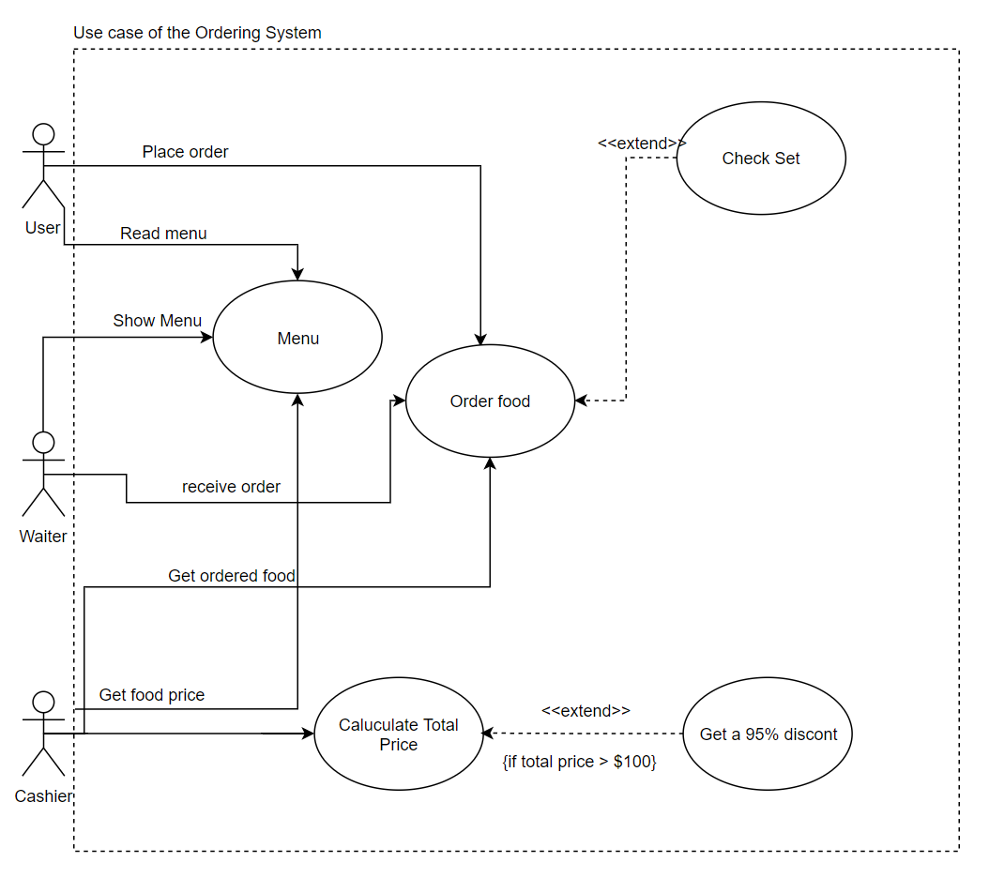

Part II: Storyboard

NOTICE: **Characters in BLUE means system output.**

**Characters in Black means User’s input**

**Characters in Red means Annotation**

1. System entrance 2. Get OIS

**Command OIS (Order Identification String)**

**0: Exit system**

**1: Start Ordering**

**Please enter your command : 2 Please input your OIS (in one word): Cpp**

**WRONG COMMAND Hi! Cpp**

**Try again (Please input 1 or 0):** **1 (Next enter Menu Part)**

**(Next enter OIS part)**

3. menu

**Menu**

**CODE NAME PRICE**

**A1 Cheese veggie sandwich $30.00**

**A2 Salmon & cheese sandwich $34.00**

**… …… ……**

**S1 Refreshing Breakfast $48.00**

**-Coffee**

**-Bagel with Cream Cheese**

**S2 Best Value Breakfast $60.00**

**…… …… ……**

**Please input food code: A0**

**INVALIDE CODE**

**Please input again:** **A1**

**Successfully ordered: Cheese veggie sandwich**

4. continue order?

Command: | 0: Check Out | 1: Continue this order

**Please enter your command: a**

**WRONG COMMAND**

**Try again (Please input 1 or 0):** **0**

**(Next turn to check out phase)**

5. check out

**Order finished**

**Hi! Cpp foods that you ordered**

**CODE NAME PRICE**

**A1 Cheese veggie sandwich $30.00**

**A2 Bagel with Cream Cheese $36.00**

**C2 Green Tea $28.00**

**S3 Veggie Lunch $50.00**

**Original Price $144.00**

**Price after 95% discount $136.80**

**Bye! Cpp**

**(5. cont.**

**Next Costumer? | 0: Exit System | 1: Start Ordering**

**Please enter your command: 0**

System Exited. Good Bye!