# Report for Q3 and Q4

RuixiangJIANG 19079662d

## Q3

### Q3(1)

The probability that he do not run out of money after 100,1,000,10,000 , and 100,000 times are 1, 0.99，0.085, 0 respectively.

(This answer is obtained using Monte Carol Simulation, so may have minor error to the accurate value.)

### Q3(2)

This graph (see R script q4.r) is based on expected value of binominal distribution.

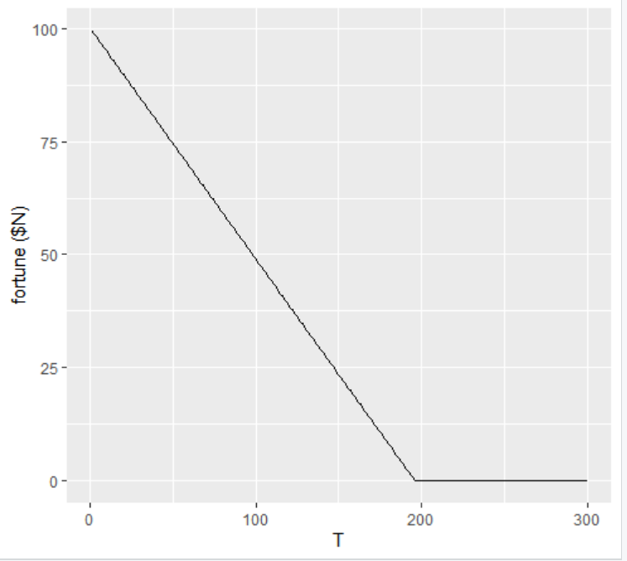

**My observation**: The more he gambles, the less money he will have on average. (i.e. the money he have is a decreasing liner function to the gamble times until he run out of money)

Moreover, if he gambles infinitely, he will (always) eventually end up with bankrupt.

## Q4

### Q4(1)

x denotes age, y denotes height.

So, applying the least square algorithm, the regression line is

### Q4(2)

the regression line is

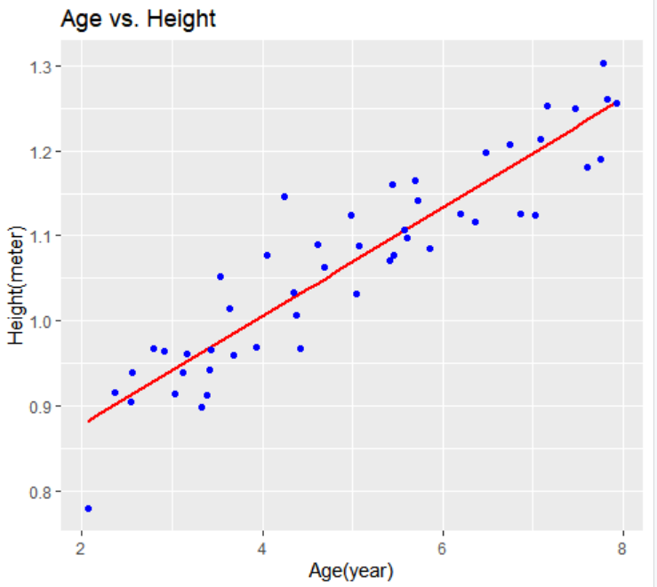

### Q4(3)

the model we get in Q4(2) is .  
So, for a 3.5-yr-old boy, his expected height is meters  
and for an 8-yr-old boy, it’s meters