# Report for Q3 and Q4

Ruixiang JIANG 19079662d

## Q3

### Q3(1)

The probability that he do not run out of money after 100,1,000,10,000 , and 100,000 times are (approximately) 1, 0.99, 0.085, 0 respectively.

(This answer is obtained by Monte Carol Simulation, so may have minor error to the accurate value.)

**Q3(2)**

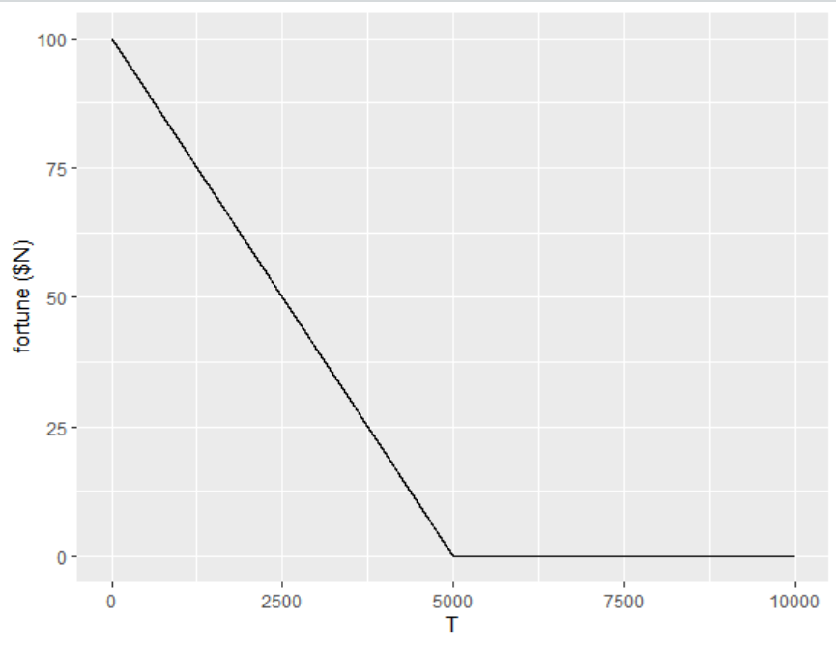

**My observation**: The more he gamble, the less money he will have on average.(i.e. the money he have is a decreasing liner function to the gamble times $T$ until he run out of money. He will eventually end up with no money.)

## Q4

### Q4(1)

Our sample looks like this,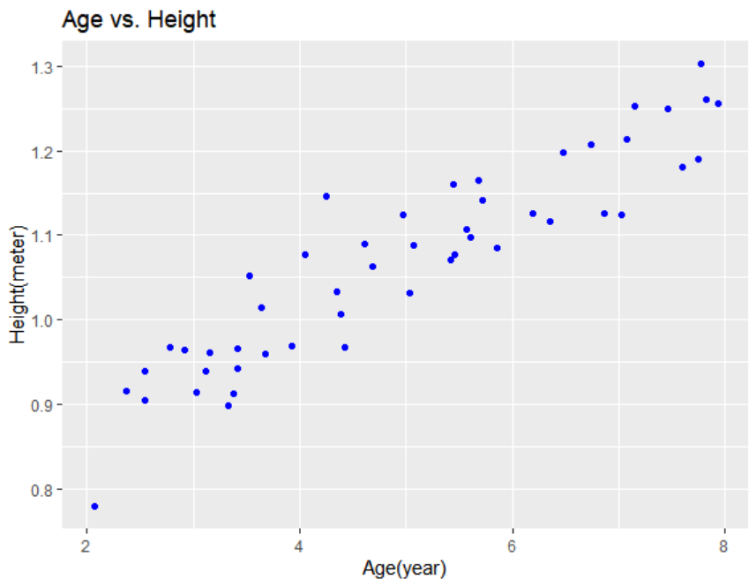

to find the linear regression line is to find a line which minimize the sum of errors.

for each point, error $d_{i}=y_{i}-(\hat{β_{1}}x_{i}+\hat{β_{0}})$.

Sum of error square $D=(y_{i}-(\hat{β_{1}}x_{i}+\hat{β_{0}}))^{2}$

To minimize D, we shall use calculus.  
Find the partial derivate of $\hat{β_{0}}$ and $\hat{β_{1}}$

$$\frac{∂D}{∂\hat{β_{0}}}=\sum_{i=1}^{n}{-}2(y_{i}-\hat{β_{0}}-\hat{β_{1}}x_{i})$$

$$\frac{∂D}{∂\hat{β_{1}}}=-2(\sum_{i=1}^{n}{x_{i}}y_{i}-\hat{β_{0}}\sum_{i=1}^{n}{x_{i}}-\hat{β_{1}}x_{i}^{2})$$

let $\frac{∂D}{∂\hat{β_{0}}}$ and $\frac{∂D}{∂\hat{β_{1}}}$ be 0, $n\overset{‾}{x}=\sum_{i=1}^{n}{x_{i}}$ and $n\overset{‾}{y}=\sum_{i=1}^{n}{y_{i}}$. (I think unbiased estimation is also ok here (as slides shows), anyway it do not affect the result)

We have:

$$\sum_{i=1}^{n}{x_{i}}y_{i}-\overset{‾}{y}\sum_{i=1}^{n}{x_{i}}+\hat{β_{1}}\overset{‾}{x}\sum_{i=1}^{n}{x_{i}}-\hat{β_{1}}\sum_{i=1}^{n}{x_{i}^{2}}=0$$

and $\hat{β_{0}}=\overset{‾}{y}-\hat{β_{1}}\overset{‾}{x}$

Finally, we can get： $\hat{β_{0}}=\overset{‾}{y}-\hat{β_{1}}\overset{‾}{x}$

and $\hat{β_{1}}=\frac{\sum_{i}^{n}{=}1(x_{i}-\overset{‾}{x})(y_{i}-\overset{‾}{y})}{\sum_{i}^{n}{=}1(x_{1}-\overset{‾}{x})^{2}}$

### Q4(2)

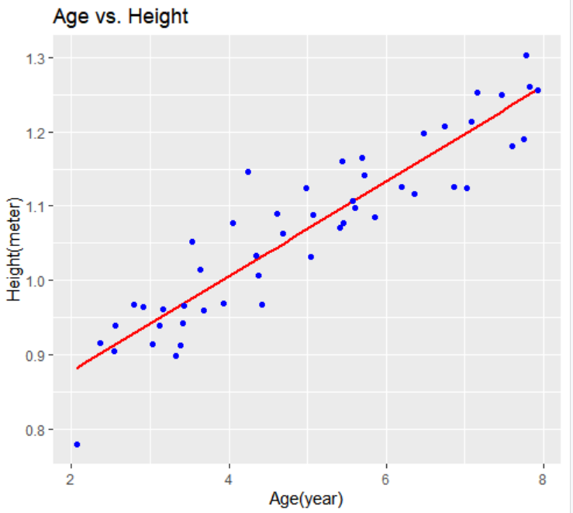

### Q4(3)

the model we get in Q4(2) is $y=0.75016+0.06388x$.

To predict height, just simply use this model with different x value.  
So, for a 3.5-yr-old boy, his expected height is $0.75016+0.06388*3.5=0.97374$ meters.  
and for an 8-yr-old boy, it’s $0.75016+0.06388*8=1.2612$ meters