Comment:
Experiment7 | Setting
Mutation type | 0: Uniform  1: Normal
Crossover type | 0: probabilistic crossover  1: Single point crossover  2: linear combination crossover
Local search type  Local search pattern | 0: Uniform  1: Normal  0: best of genotype and multiple phenotypes  1: best of genotype and phenotype

SSGA (N, Pc)
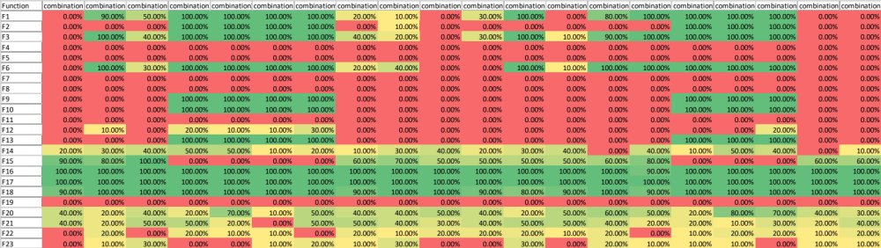
Lamarck (N, Pc, Nls, 1)
This table is generated by mutation type: normal, crossover type: probabilistic crossover and local search type: normal. The final phenotype is min (1 genotype, 1 phenotype).
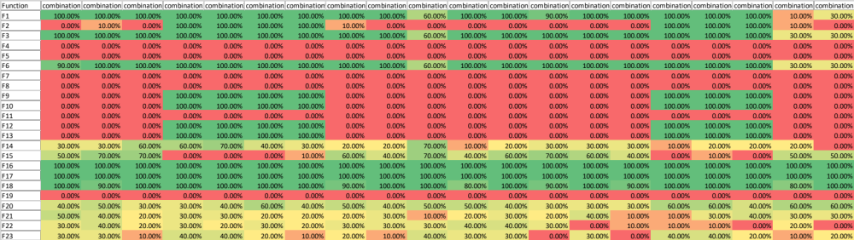
Lamarck (N, Pc, Nls, N)
This table is generated by mutation type: normal, crossover type: probabilistic crossover and local search type: normal. The final phenotype is min (1 genotype, 3 phenotypes).
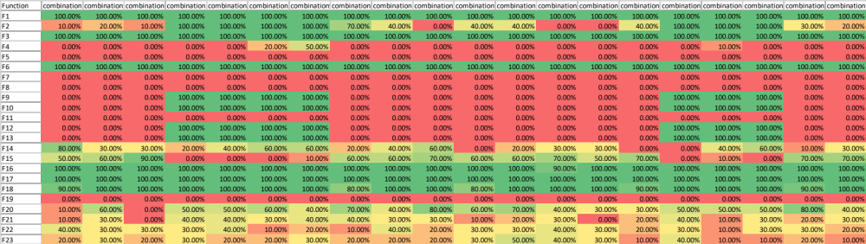

Lamarck (N, Pc, Nls, 1)- SSGA (N, Pc)
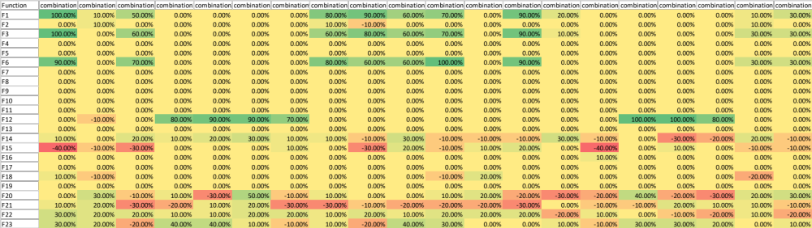

Lamarck (N, Pc, Nls, N)- SSGA (N, Pc)
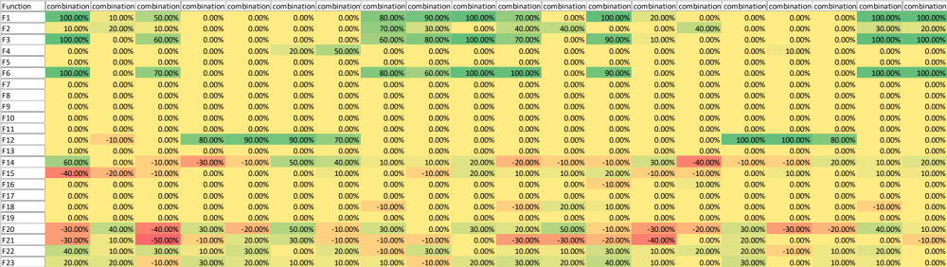

Lamarck (N, Pc, Nls, N)- Lamarck (N, Pc, Nls, 1)
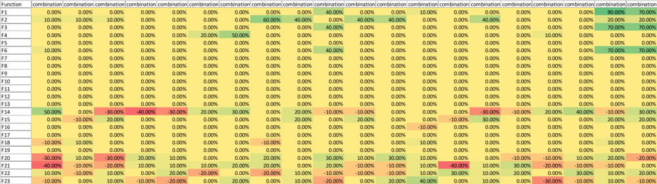

SSGA (N, SPc)
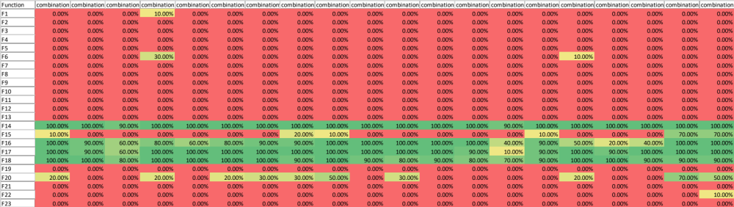
Lamarck (N, SPc, Nls, 1)
This table is generated by mutation type: normal, crossover type: single point crossover and local search type: normal. The final phenotype is min (1 genotype, 1 phenotype).
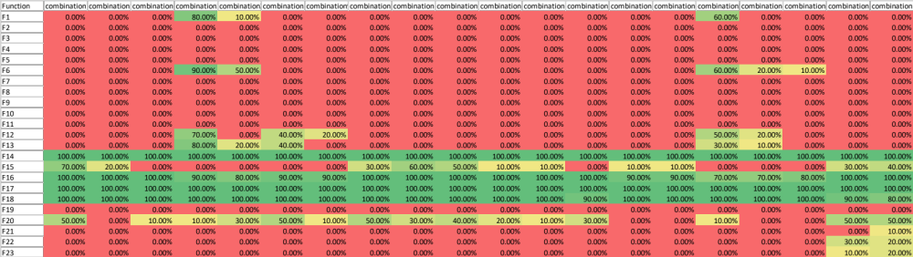
Lamarck (N, SPc, Nls, N)
This table is generated by mutation type: normal, crossover type: single point crossover and local search type: normal. The final phenotype is min (1 genotype, 3 phenotypes).
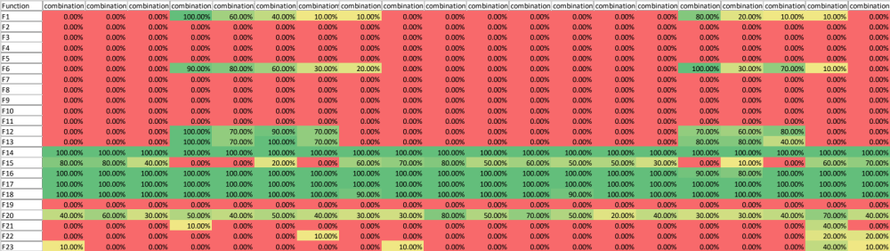

Lamarck (N, SPc, Nls, 1)- SSGA (N, SPc)
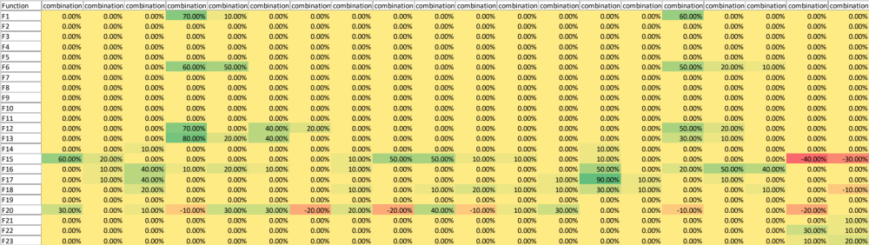

Lamarck (N, SPc, Nls, N)- SSGA (N, SPc)
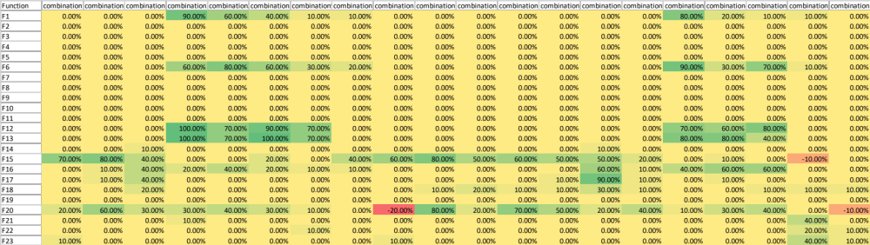

Lamarck (N, SPc, Nls, N)- Lamarck (N, SPc, Nls, 1)
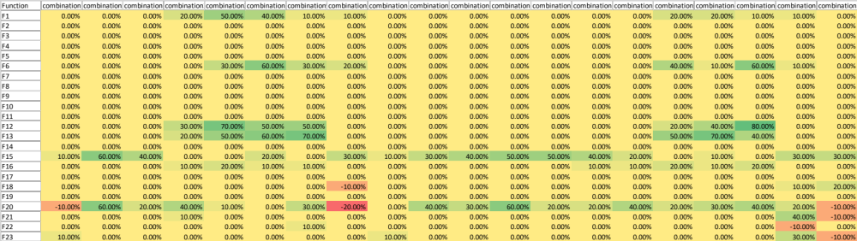

SSGA (N, LCc)
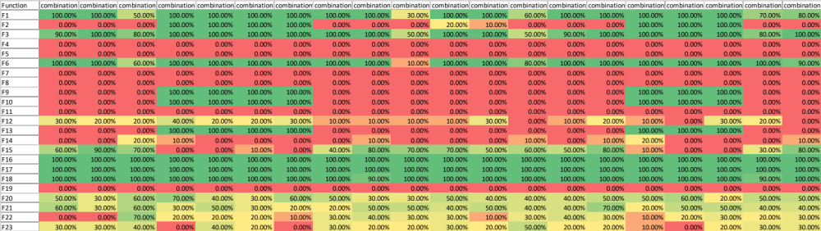
Lamarck (N, LCc, Nls, 1)
This table is generated by mutation type: normal, crossover type: linear combination crossover and local search type: normal. The final phenotype is min (1 genotype, 1 phenotype).
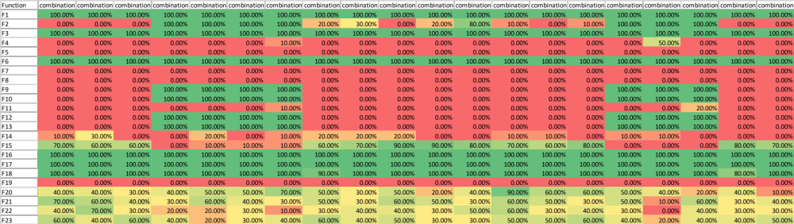

Lamarck (N, LCc, Nls, N)
This table is generated by mutation type: normal, crossover type: linear combination crossover and local search type: normal. The final phenotype is min (1 genotype, 3 phenotypes).
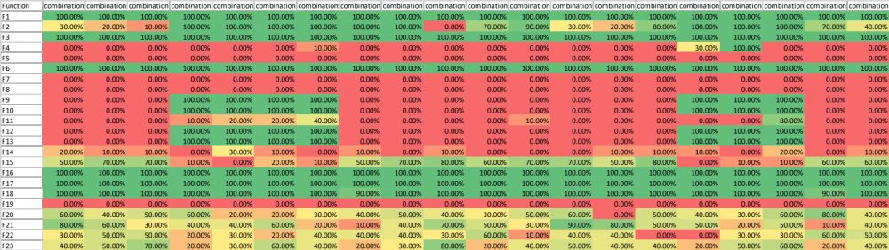

Lamarck (N, LCc, Nls, 1)- SSGA (N, LCc)
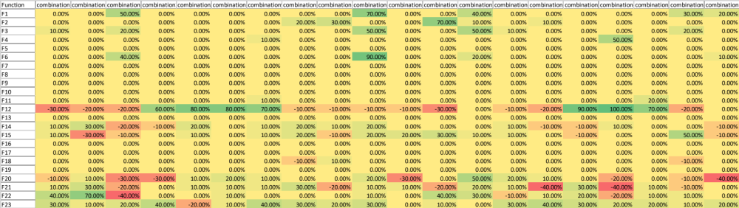

Lamarck (N, LCc, Nls, N)- SSGA (N, LCc)
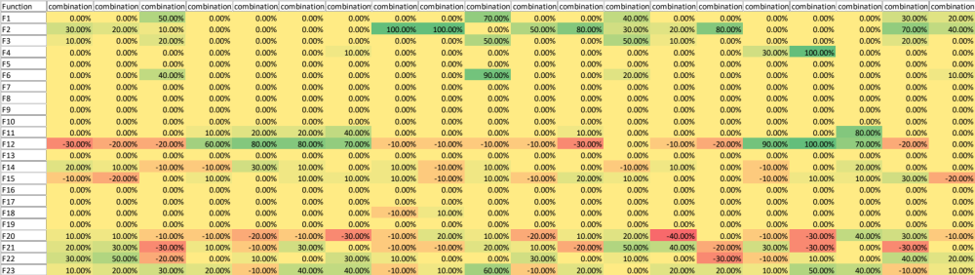

Lamarck (N, LCc, Nls, N)- Lamarck (N, LCc, Nls, 1)
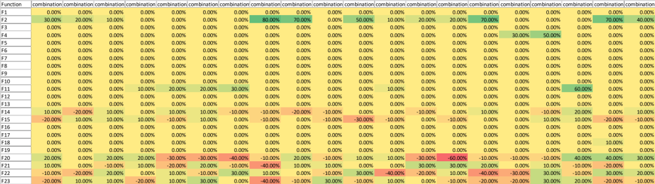

SSGA (U, Pc)
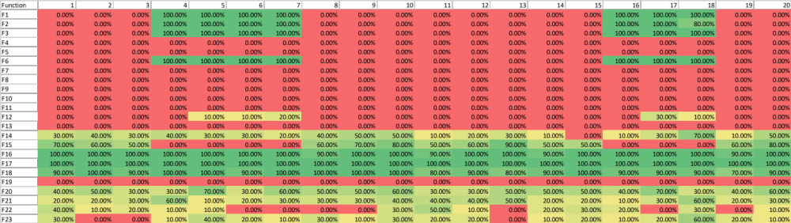

Lamarck (U, Pc, Uls, N)
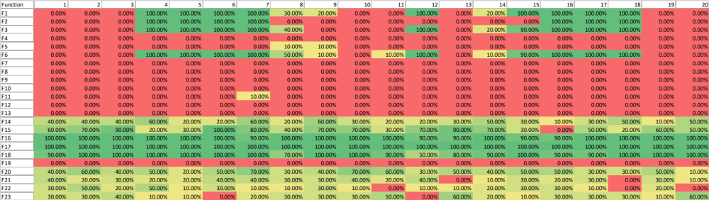

Lamarck (U, Pc, Uls, N)-SSGA (U, Pc)
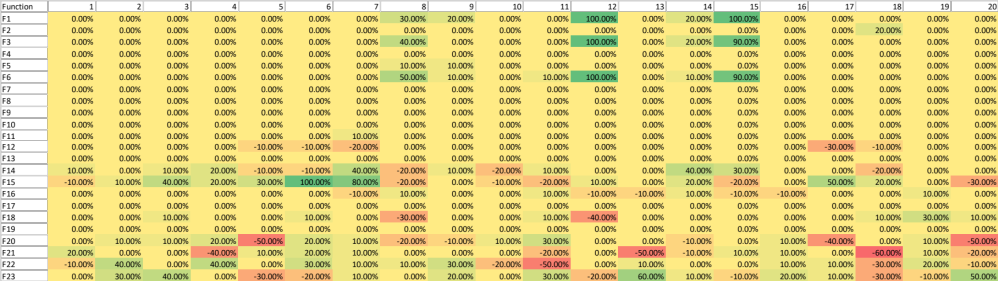

SSGA (U, SPc)
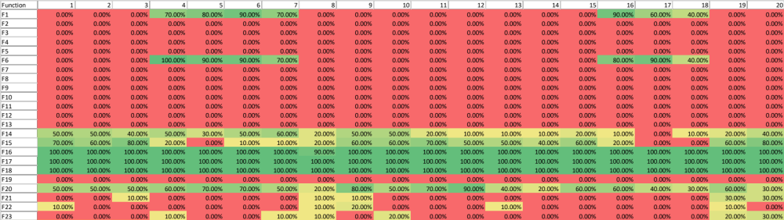

Lamarck (U, SPc, Uls, N)
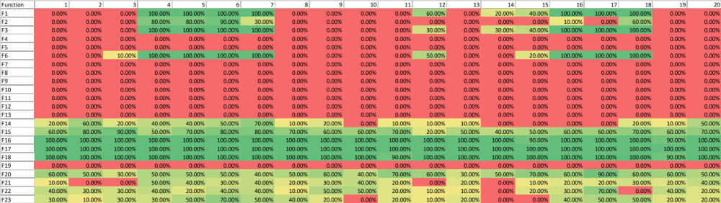

Lamarck (U, SPc, Uls, N)-SSGA (U, SPc)
