Capstone Exercise: PIVOT – Track

The goal of Track is to measure what matters for your new initiative—and this will require different KPIs than the rest of the organization.

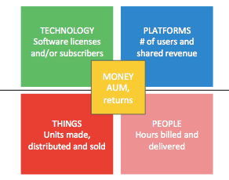

Companies that focus on different assets naturally measure different thing in order to gauge their success. What are five new key performance indicators that will be essential in order to track the success of a new strategy initiative, using platforms, AI, and data, in your organization?

KPI 1:

KPI 2:

KPI 3:

KPI 4:

KPI 5: