Capstone Exercise: PIVOT – Validate

The purpose of Validate is to build out and begin testing a business plan that leverages a platform strategy.

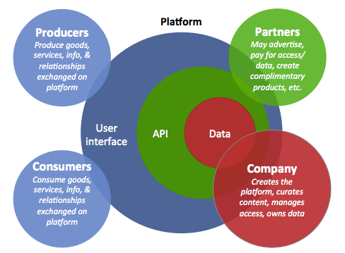

Building a business plan is an iterative process. Consider how you can combine your organizations data and IP with internal or external networks to create a two-sided revenue model. Begin by brainstorming the right combination of data, producers, and consumers. Focus more on value than on revenue. Then, begin layering on potential revenue models, which may involve a third group: Partners. After you brainstorm, pick one model to focus on and answer the following questions.

**Producers**

*Who will product the good, service, or ideas shared on the platform, and what will they produce?*

**Consumers**

*Who will be the “buyer” on the platform? What will bring them?*

**Data**

*What data will lay beneath the platform? How will this data contribute value to the users of the network?*

**Partners**

*Would your business case benefit from external partners? What value will they provide? Are they a part of the revenue model?*

***Company***

*Your company will maintain the platform. How will you regulate and curate the content? What role do you need to play in interactions between producers, consumers, and partners?*