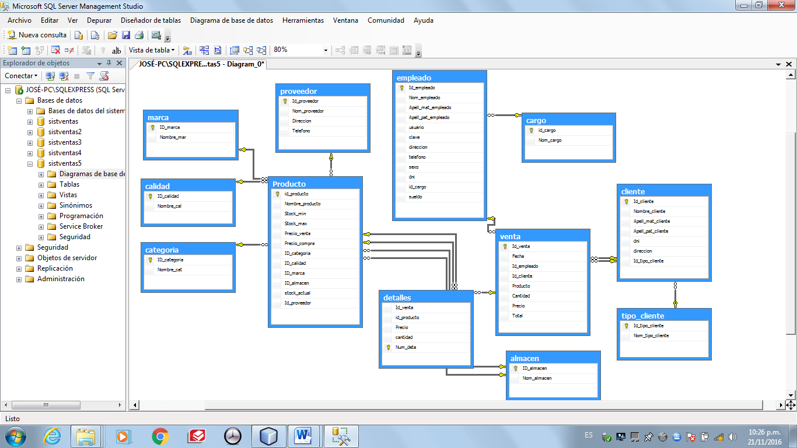**DISEÑO DELA BD**

**1. Sólo copiar este código en un nuevo query (nueva consulta) en el SQL   
 SERVER y ejecutarlo. Para visualizarlo eso si no sé.**

**CREAR PROCEDIMIENTO ALMACENADO**

CREATE PROCEDURE PRO1

@IDTIPO nvarchar (50),

@NOMTIPO nvarchar (50)

AS

SET NOCOUNT ON

SELECT Nom_tipo_cliente

FROM tipo_cliente

WHERE Nom_tipo_cliente=@NOMTIPO

GO

**2. Para ver el diagrama de base datos (BD) seguir estos pasos.**

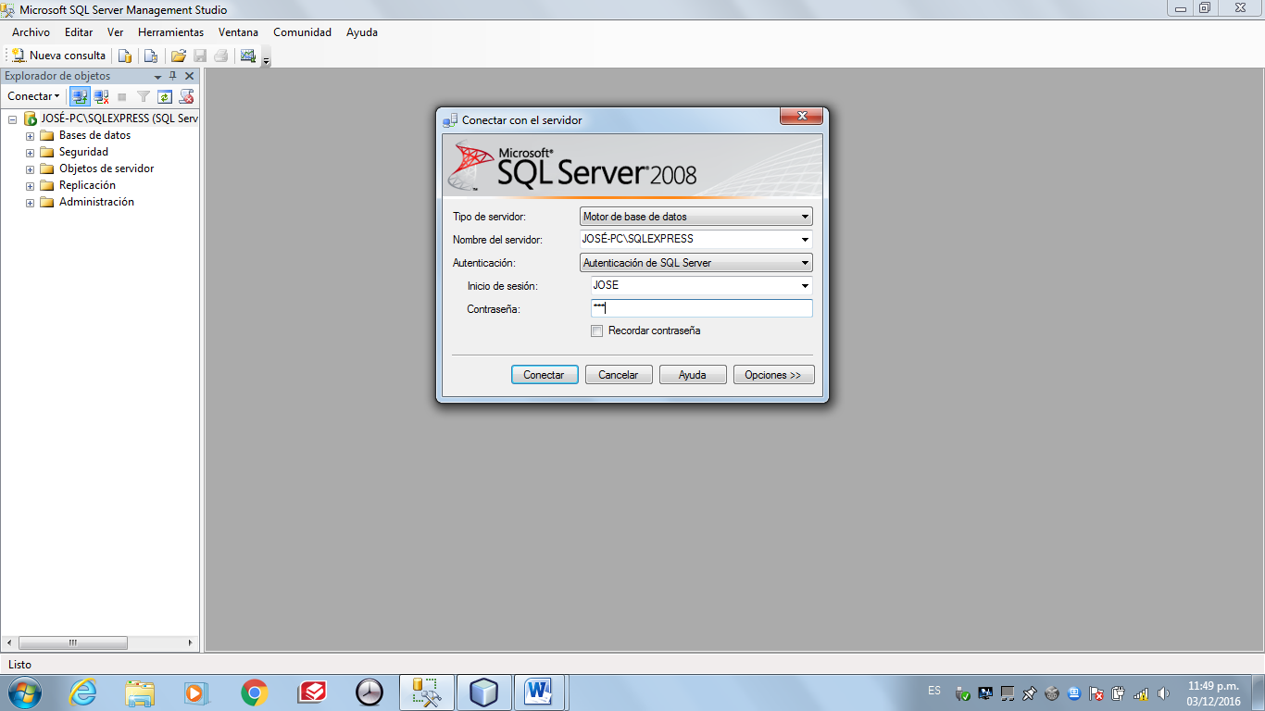 **Conectarse a SQL SERVER con tu usuario y contraseña propia.**

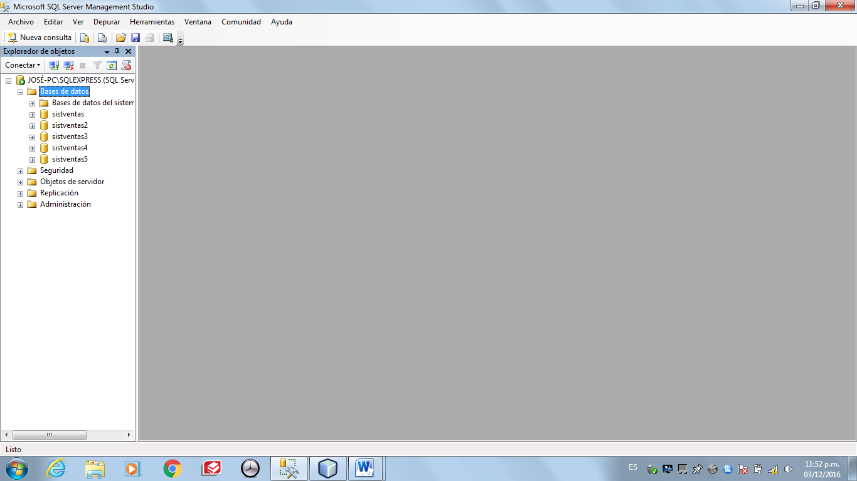

**Hacer doble click en base de datos para expandir o darle en el (+) y luego buscar la base de datos que se quiera usar.**

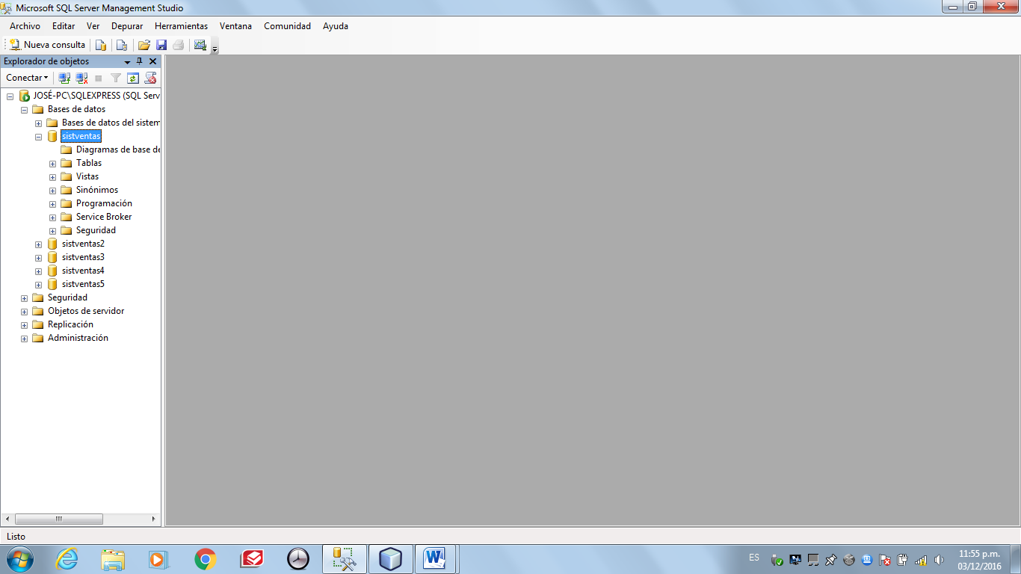

**Hacer doble click en la base de datos que se desea usar para poder visualizar las carpetas o darle en el (+).**

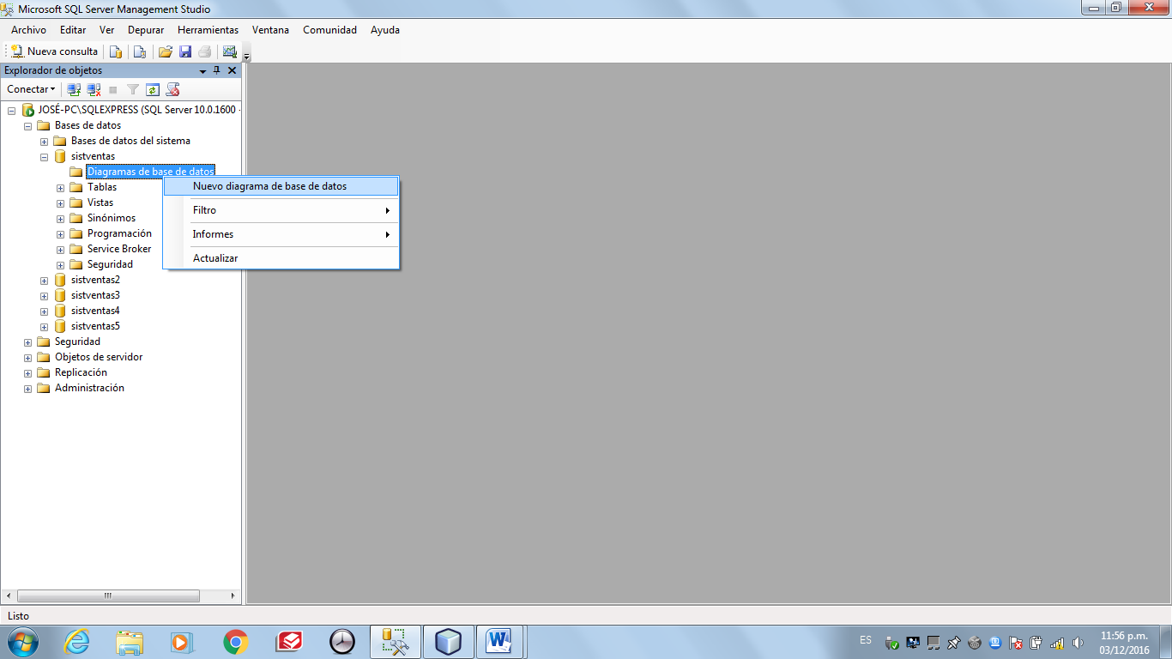

**Hacer click derecho en “Diagrama de base de datos” y escoger la opción “Nuevo diagrama de base de datos”.**

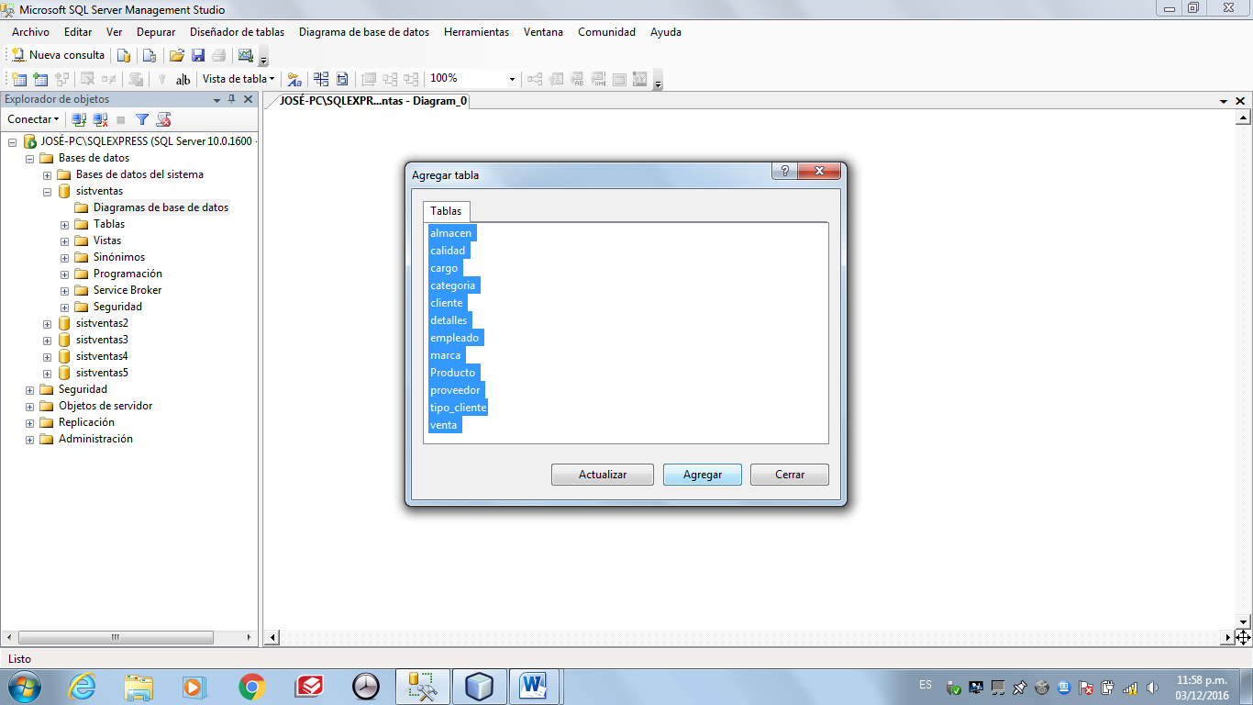

**Seleccionar todas las tablas y darle en el botón “Agregar”, esperar a que cargue y luego darle en el botón “cerrar”.**

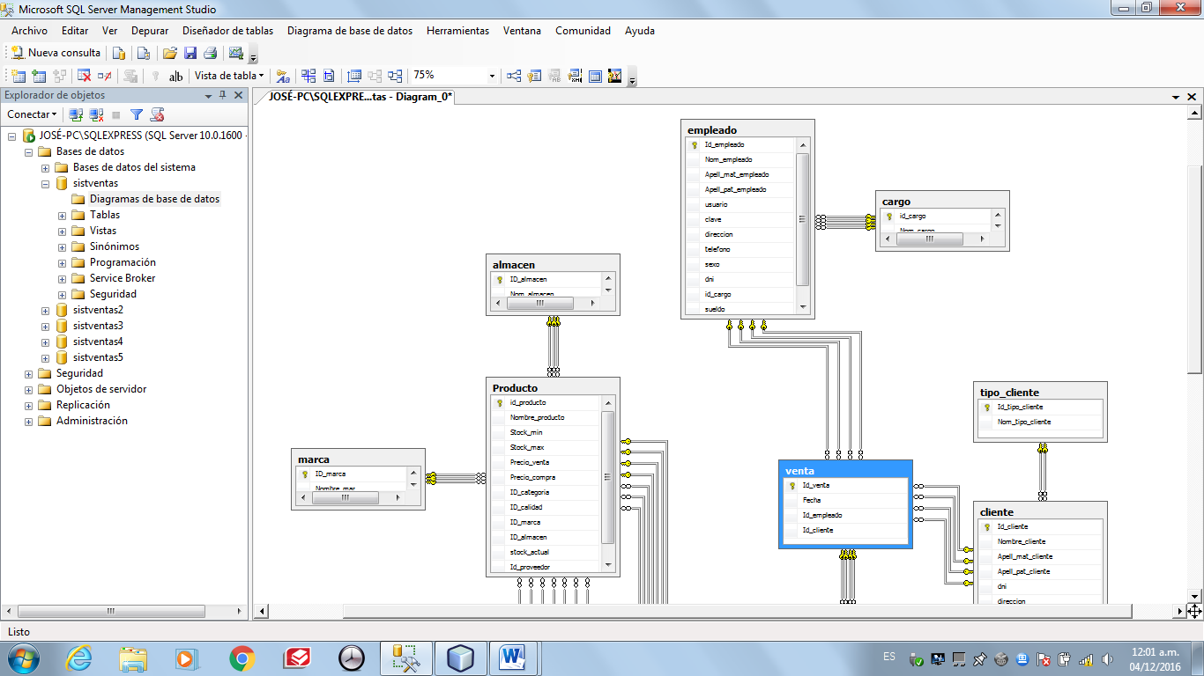

**Se procede a visualizar el diagrama de la base de datos (BD).**

**3. Consultas.**

CONSULTAS PARA VISUALIZAR LOS REGISTROS POR TABLA

LA TABLA DETALLE Y VENTA NO CUENTA CON REGISTROS.

SELECT * FROM almacen;

SELECT * FROM calidad;

SELECT * FROM cargo;

SELECT * FROM categoria;

SELECT * FROM cliente;

SELECT * FROM detalles;

SELECT * FROM empleado;

SELECT * FROM marca;

SELECT * FROM Producto;

SELECT * FROM proveedor;

SELECT * FROM tipo_cliente;

SELECT * FROM venta;

CONSULTA PARA VISUALIZAR LA CANTIDAD

COUNT -🡪 REALIZA LA SUMATORIA DEL #DE VARIABLES ENTRE ().  
AS -🡪 SE USA PARA COLOCAR UN ALIAS EN LA VISUALIZACIÓN.

SELECT COUNT(ID_almacen) AS CANTIDAD_DE_ALMACENES FROM almacen;

SELECT COUNT(ID_calidad) AS CANTIDAD_DE_TIPOS_DE_CALIDAD FROM calidad;

SELECT COUNT(id_cargo)AS CANTIDAD_DE_CARGOS FROM cargo;

SELECT COUNT(ID_categoria) CANTIDAD_DE_TIPOS_DE_CATEGORÍA FROM categoria;

CONSULTAS PARA VISUALIZAR DE FORMA ORDENADA.

ORDER BY -🡪 LO ORDENA DE ACUERDO A LA VARIABLE DESEADA.] ASC -🡪 LO ORDENA DE FORMA ASCENDENTE.  
 DESC -🡪 LO ORDENA DE FORMA ASCENDENTE.

SELECT * FROM cliente ORDER BY Apell_pat_cliente;

SELECT * FROM empleado ORDER BY sueldo ASC;

SELECT * FROM empleado ORDER BY sueldo DESC;

SELECT * FROM proveedor ORDER BY Nom_proveedor;

CONSULTAS PARA VISUALIZAR SUMATORIA

SUM -🡪 SUMA LA VARIABLE EN ().  
AS -🡪 SE USA PARA COLOCAR UN ALIAS EN LA VISUALIZACIÓN.

SELECT SUM(sueldo) AS SUELDO_DE_EMPLEADOS FROM empleado;

CONSULTAS PARA VISUALIZAR UNA CONDICIÓN

WHERE -🡪 ASIGNA LA CONDICIÓN DESEADA.

SELECT * FROM marca WHERE ID_marca = 'MAR03';

SELECT * FROM Producto WHERE stock_actual < 15;

**4. APLICATIVO**

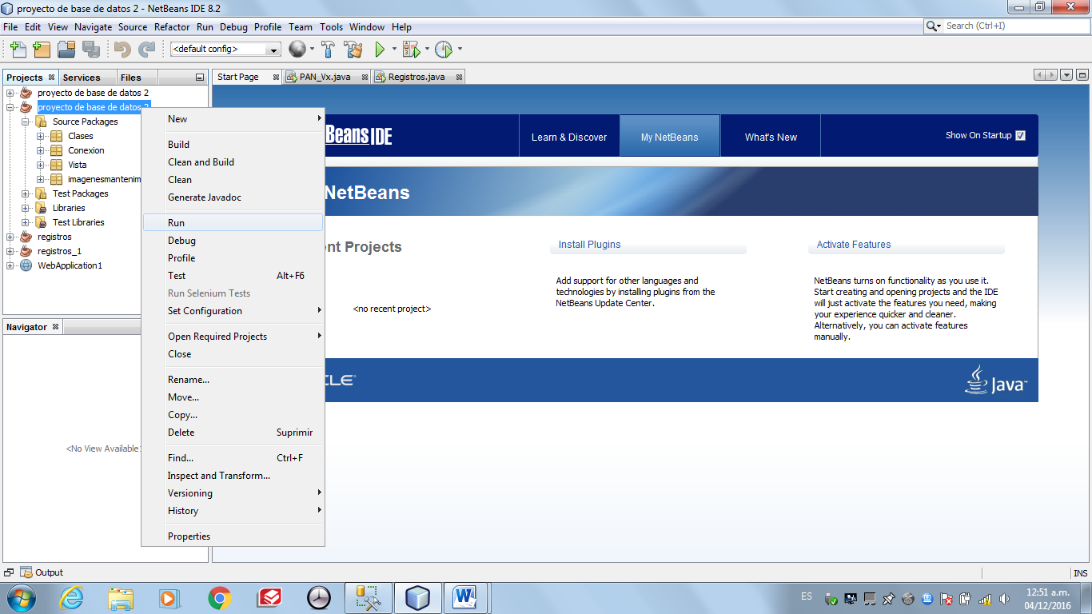 **Abrir el proyecto en Netbeans, por consiguiente darle click derecho en el mismo y hacer click en “RUN” o “EJECUTAR”.**

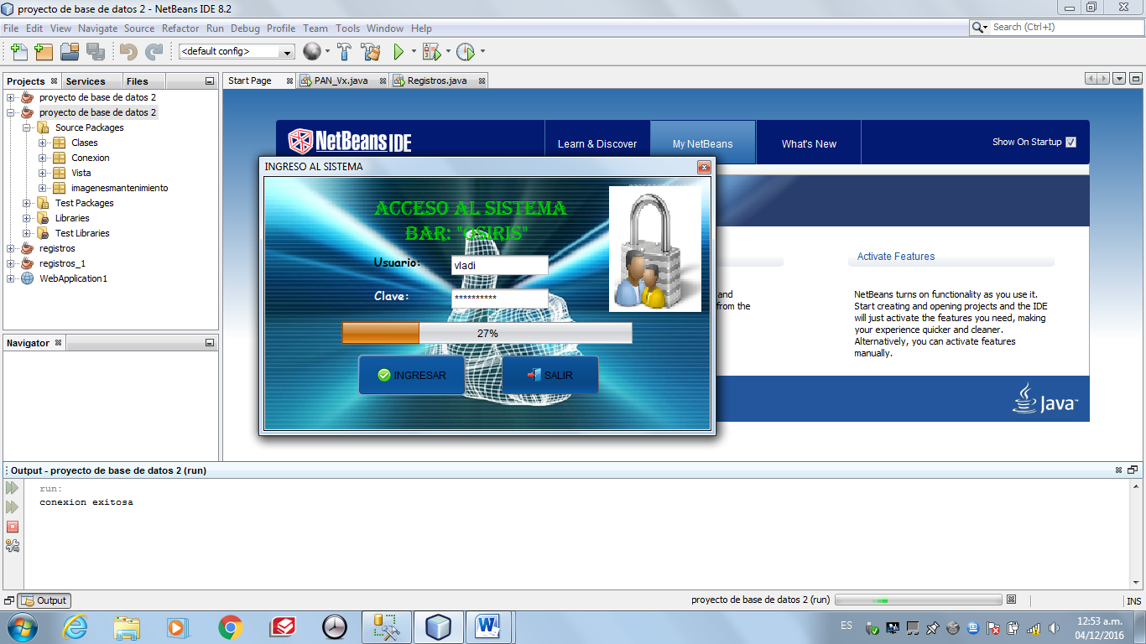 **Ingresar usuario y contraseña y dar en “Ingresar”. En caso haya olvidado su usuario o contraseña entrar al SQL Server y ejecutar la consulta**SELECT * FROM empleado; **Visualizar los usuarios y contraseñas e intentar ingresar nuevamente.**

**CREACCIÓN DE LA BASE DE DATOS**

create database sistventas

USE [sistventas]

GO

CREATE TABLE [dbo].[almacen](

[ID_almacen] [char](8) NOT NULL,

[Nom_almacen] [varchar](30) NULL DEFAULT (NULL),

PRIMARY KEY CLUSTERED

(

[ID_almacen] ASC

)WITH (PAD_INDEX = OFF, STATISTICS_NORECOMPUTE = OFF, IGNORE_DUP_KEY = OFF, ALLOW_ROW_LOCKS = ON, ALLOW_PAGE_LOCKS = ON) ON [PRIMARY]

) ON [PRIMARY]

GO

SET ANSI_PADDING OFF

GO

/****** Object: Table [dbo].[calidad] Script Date: 30/06/2016 13:22:18 ******/

SET ANSI_NULLS ON

GO

SET QUOTED_IDENTIFIER ON

GO

SET ANSI_PADDING ON

GO

IF NOT EXISTS (SELECT * FROM sys.objects WHERE object_id = OBJECT_ID(N'[dbo].[calidad]') AND type in (N'U'))

BEGIN

CREATE TABLE [dbo].[calidad](

[ID_calidad] [char](8) NOT NULL,

[Nombre_cal] [varchar](20) NULL DEFAULT (NULL),

PRIMARY KEY CLUSTERED

(

[ID_calidad] ASC

)WITH (PAD_INDEX = OFF, STATISTICS_NORECOMPUTE = OFF, IGNORE_DUP_KEY = OFF, ALLOW_ROW_LOCKS = ON, ALLOW_PAGE_LOCKS = ON) ON [PRIMARY]

) ON [PRIMARY]

END

GO

SET ANSI_PADDING OFF

GO

/****** Object: Table [dbo].[cargo] Script Date: 30/06/2016 13:22:18 ******/

SET ANSI_NULLS ON

GO

SET QUOTED_IDENTIFIER ON

GO

SET ANSI_PADDING ON

GO

IF NOT EXISTS (SELECT * FROM sys.objects WHERE object_id = OBJECT_ID(N'[dbo].[cargo]') AND type in (N'U'))

BEGIN

CREATE TABLE [dbo].[cargo](

[id_cargo] [char](8) NOT NULL,

[Nom_cargo] [varchar](20) NULL DEFAULT (NULL),

PRIMARY KEY CLUSTERED

(

[id_cargo] ASC

)WITH (PAD_INDEX = OFF, STATISTICS_NORECOMPUTE = OFF, IGNORE_DUP_KEY = OFF, ALLOW_ROW_LOCKS = ON, ALLOW_PAGE_LOCKS = ON) ON [PRIMARY]

) ON [PRIMARY]

END

GO

SET ANSI_PADDING OFF

GO

/****** Object: Table [dbo].[categoria] Script Date: 30/06/2016 13:22:18 ******/

SET ANSI_NULLS ON

GO

SET QUOTED_IDENTIFIER ON

GO

SET ANSI_PADDING ON

GO

IF NOT EXISTS (SELECT * FROM sys.objects WHERE object_id = OBJECT_ID(N'[dbo].[categoria]') AND type in (N'U'))

BEGIN

CREATE TABLE [dbo].[categoria](

[ID_categoria] [char](8) NOT NULL,

[Nombre_cat] [varchar](20) NULL DEFAULT (NULL),

PRIMARY KEY CLUSTERED

(

[ID_categoria] ASC

)WITH (PAD_INDEX = OFF, STATISTICS_NORECOMPUTE = OFF, IGNORE_DUP_KEY = OFF, ALLOW_ROW_LOCKS = ON, ALLOW_PAGE_LOCKS = ON) ON [PRIMARY]

) ON [PRIMARY]

END

GO

SET ANSI_PADDING OFF

GO

/****** Object: Table [dbo].[cliente] Script Date: 30/06/2016 13:22:18 ******/

SET ANSI_NULLS ON

GO

SET QUOTED_IDENTIFIER ON

GO

SET ANSI_PADDING ON

GO

IF NOT EXISTS (SELECT * FROM sys.objects WHERE object_id = OBJECT_ID(N'[dbo].[cliente]') AND type in (N'U'))

BEGIN

CREATE TABLE [dbo].[cliente](

[Id_cliente] [char](8) NOT NULL,

[Nombre_cliente] [varchar](30) NULL DEFAULT (NULL),

[Apell_mat_cliente] [varchar](20) NULL DEFAULT (NULL),

[Apell_pat_cliente] [varchar](20) NULL DEFAULT (NULL),

[dni] [char](8) NULL DEFAULT (NULL),

[direccion] [varchar](50) NULL DEFAULT (NULL),

[Id_tipo_cliente] [char](8) NOT NULL,

PRIMARY KEY CLUSTERED

(

[Id_cliente] ASC

)WITH (PAD_INDEX = OFF, STATISTICS_NORECOMPUTE = OFF, IGNORE_DUP_KEY = OFF, ALLOW_ROW_LOCKS = ON, ALLOW_PAGE_LOCKS = ON) ON [PRIMARY]

) ON [PRIMARY]

END

GO

SET ANSI_PADDING OFF

GO

/****** Object: Table [dbo].[detalles] Script Date: 30/06/2016 13:22:18 ******/

SET ANSI_NULLS ON

GO

SET QUOTED_IDENTIFIER ON

GO

SET ANSI_PADDING ON

GO

IF NOT EXISTS (SELECT * FROM sys.objects WHERE object_id = OBJECT_ID(N'[dbo].[detalles]') AND type in (N'U'))

BEGIN

CREATE TABLE [dbo].[detalles](

[Id_venta] [char](8) NOT NULL,

[id_producto] [char](8) NOT NULL,

[Precio] [decimal](8, 2) NULL,

[cantidad] [int] NULL,

[Num_deta] [int] IDENTITY(1,1) NOT NULL,

PRIMARY KEY CLUSTERED

(

[Num_deta] ASC

)WITH (PAD_INDEX = OFF, STATISTICS_NORECOMPUTE = OFF, IGNORE_DUP_KEY = OFF, ALLOW_ROW_LOCKS = ON, ALLOW_PAGE_LOCKS = ON) ON [PRIMARY]

) ON [PRIMARY]

END

GO

SET ANSI_PADDING OFF

GO

/****** Object: Table [dbo].[empleado] Script Date: 30/06/2016 13:22:18 ******/

SET ANSI_NULLS ON

GO

SET QUOTED_IDENTIFIER ON

GO

SET ANSI_PADDING ON

GO

IF NOT EXISTS (SELECT * FROM sys.objects WHERE object_id = OBJECT_ID(N'[dbo].[empleado]') AND type in (N'U'))

BEGIN

CREATE TABLE [dbo].[empleado](

[Id_empleado] [char](8) NOT NULL,

[Nom_empleado] [varchar](30) NULL DEFAULT (NULL),

[Apell_mat_empleado] [varchar](20) NULL DEFAULT (NULL),

[Apell_pat_empleado] [varchar](20) NULL DEFAULT (NULL),

[usuario] [varchar](20) NULL DEFAULT (NULL),

[clave] [varchar](20) NULL DEFAULT (NULL),

[direccion] [varchar](50) NULL DEFAULT (NULL),

[telefono] [char](9) NULL DEFAULT (NULL),

[sexo] [varchar](10) NULL DEFAULT (NULL),

[dni] [char](8) NULL DEFAULT (NULL),

[id_cargo] [char](8) NOT NULL,

[sueldo] [decimal](8, 2) NULL DEFAULT (NULL),

PRIMARY KEY CLUSTERED

(

[Id_empleado] ASC

)WITH (PAD_INDEX = OFF, STATISTICS_NORECOMPUTE = OFF, IGNORE_DUP_KEY = OFF, ALLOW_ROW_LOCKS = ON, ALLOW_PAGE_LOCKS = ON) ON [PRIMARY]

) ON [PRIMARY]

END

GO

SET ANSI_PADDING OFF

GO

/****** Object: Table [dbo].[marca] Script Date: 30/06/2016 13:22:18 ******/

SET ANSI_NULLS ON

GO

SET QUOTED_IDENTIFIER ON

GO

SET ANSI_PADDING ON

GO

IF NOT EXISTS (SELECT * FROM sys.objects WHERE object_id = OBJECT_ID(N'[dbo].[marca]') AND type in (N'U'))

BEGIN

CREATE TABLE [dbo].[marca](

[ID_marca] [char](8) NOT NULL,

[Nombre_mar] [varchar](15) NULL DEFAULT (NULL),

PRIMARY KEY CLUSTERED

(

[ID_marca] ASC

)WITH (PAD_INDEX = OFF, STATISTICS_NORECOMPUTE = OFF, IGNORE_DUP_KEY = OFF, ALLOW_ROW_LOCKS = ON, ALLOW_PAGE_LOCKS = ON) ON [PRIMARY]

) ON [PRIMARY]

END

GO

SET ANSI_PADDING OFF

GO

/****** Object: Table [dbo].[Producto] Script Date: 30/06/2016 13:22:18 ******/

SET ANSI_NULLS ON

GO

SET QUOTED_IDENTIFIER ON

GO

SET ANSI_PADDING ON

GO

IF NOT EXISTS (SELECT * FROM sys.objects WHERE object_id = OBJECT_ID(N'[dbo].[Producto]') AND type in (N'U'))

BEGIN

CREATE TABLE [dbo].[Producto](

[id_producto] [char](8) NOT NULL,

[Nombre_producto] [varchar](20) NULL DEFAULT (NULL),

[Stock_min] [int] NULL DEFAULT (NULL),

[Stock_max] [int] NULL DEFAULT (NULL),

[Precio_venta] [decimal](8, 2) NULL DEFAULT (NULL),

[Precio_compra] [decimal](8, 2) NULL DEFAULT (NULL),

[ID_categoria] [char](8) NOT NULL,

[ID_calidad] [char](8) NOT NULL,

[ID_marca] [char](8) NOT NULL,

[ID_almacen] [char](8) NOT NULL,

[stock_actual] [int] NULL DEFAULT (NULL),

[Id_proveedor] [char](8) NOT NULL,

PRIMARY KEY CLUSTERED

(

[id_producto] ASC

)WITH (PAD_INDEX = OFF, STATISTICS_NORECOMPUTE = OFF, IGNORE_DUP_KEY = OFF, ALLOW_ROW_LOCKS = ON, ALLOW_PAGE_LOCKS = ON) ON [PRIMARY]

) ON [PRIMARY]

END

GO

SET ANSI_PADDING OFF

GO

/****** Object: Table [dbo].[proveedor] Script Date: 30/06/2016 13:22:18 ******/

SET ANSI_NULLS ON

GO

SET QUOTED_IDENTIFIER ON

GO

SET ANSI_PADDING ON

GO

IF NOT EXISTS (SELECT * FROM sys.objects WHERE object_id = OBJECT_ID(N'[dbo].[proveedor]') AND type in (N'U'))

BEGIN

CREATE TABLE [dbo].[proveedor](

[Id_proveedor] [char](8) NOT NULL,

[Nom_proveedor] [varchar](50) NULL DEFAULT (NULL),

[Direccion] [varchar](50) NULL DEFAULT (NULL),

[Telefono] [char](9) NULL DEFAULT (NULL),

PRIMARY KEY CLUSTERED

(

[Id_proveedor] ASC

)WITH (PAD_INDEX = OFF, STATISTICS_NORECOMPUTE = OFF, IGNORE_DUP_KEY = OFF, ALLOW_ROW_LOCKS = ON, ALLOW_PAGE_LOCKS = ON) ON [PRIMARY]

) ON [PRIMARY]

END

GO

SET ANSI_PADDING OFF

GO

/****** Object: Table [dbo].[tipo_cliente] Script Date: 30/06/2016 13:22:18 ******/

SET ANSI_NULLS ON

GO

SET QUOTED_IDENTIFIER ON

GO

SET ANSI_PADDING ON

GO

IF NOT EXISTS (SELECT * FROM sys.objects WHERE object_id = OBJECT_ID(N'[dbo].[tipo_cliente]') AND type in (N'U'))

BEGIN

CREATE TABLE [dbo].[tipo_cliente](

[Id_tipo_cliente] [char](8) NOT NULL,

[Nom_tipo_cliente] [varchar](15) NULL DEFAULT (NULL),

PRIMARY KEY CLUSTERED

(

[Id_tipo_cliente] ASC

)WITH (PAD_INDEX = OFF, STATISTICS_NORECOMPUTE = OFF, IGNORE_DUP_KEY = OFF, ALLOW_ROW_LOCKS = ON, ALLOW_PAGE_LOCKS = ON) ON [PRIMARY]

) ON [PRIMARY]

END

GO

SET ANSI_PADDING OFF

GO

/****** Object: Table [dbo].[venta] Script Date: 30/06/2016 13:22:18 ******/

SET ANSI_NULLS ON

GO

SET QUOTED_IDENTIFIER ON

GO

SET ANSI_PADDING ON

GO

IF NOT EXISTS (SELECT * FROM sys.objects WHERE object_id = OBJECT_ID(N'[dbo].[venta]') AND type in (N'U'))

BEGIN

CREATE TABLE [dbo].[venta](

[Id_venta] [char](8) NOT NULL,

[Fecha] [varchar](20) NULL,

[Id_empleado] [char](8) NOT NULL,

[Id_cliente] [char](8) NOT NULL,

[Producto] [varchar](50) NOT NULL,

[Cantidad] [int] NOT NULL,

[Precio] [decimal](8,2) NOT NULL,

[Total] [decimal](8,2) NOT NULL,

PRIMARY KEY CLUSTERED

(

[Id_venta] ASC

)WITH (PAD_INDEX = OFF, STATISTICS_NORECOMPUTE = OFF, IGNORE_DUP_KEY = OFF, ALLOW_ROW_LOCKS = ON, ALLOW_PAGE_LOCKS = ON) ON [PRIMARY]

) ON [PRIMARY]

END

GO

SET ANSI_PADDING OFF

GO

INSERT [dbo].[almacen] ([ID_almacen], [Nom_almacen]) VALUES (N'ALM01', N'Pro- Los Olivos ')

GO

INSERT [dbo].[almacen] ([ID_almacen], [Nom_almacen]) VALUES (N'ALM02', N'La Ensenada')

GO

INSERT [dbo].[calidad] ([ID_calidad], [Nombre_cal]) VALUES (N'CAL01', N'Excelente')

GO

INSERT [dbo].[calidad] ([ID_calidad], [Nombre_cal]) VALUES (N'CAL02', N'por vencer')

GO

INSERT [dbo].[calidad] ([ID_calidad], [Nombre_cal]) VALUES (N'CAL03', N'vencido')

GO

INSERT [dbo].[cargo] ([id_cargo], [Nom_cargo]) VALUES (N'car01', N'administrador')

GO

INSERT [dbo].[cargo] ([id_cargo], [Nom_cargo]) VALUES (N'car02', N'vendedor')

GO

INSERT [dbo].[cargo] ([id_cargo], [Nom_cargo]) VALUES (N'car03', N'contador')

GO

INSERT [dbo].[cargo] ([id_cargo], [Nom_cargo]) VALUES (N'car04', N'azafata')

GO

INSERT [dbo].[categoria] ([ID_categoria], [Nombre_cat]) VALUES (N'CAT01', N'GASEOSAS')

GO

INSERT [dbo].[categoria] ([ID_categoria], [Nombre_cat]) VALUES (N'CAT02', N'BEBIDAS ALCOHOLICAS')

GO

INSERT [dbo].[categoria] ([ID_categoria], [Nombre_cat]) VALUES (N'CAT03', N'CIGARROS')

GO

INSERT [dbo].[categoria] ([ID_categoria], [Nombre_cat]) VALUES (N'CAT04', N'GOLOSINAS')

GO

INSERT [dbo].[categoria] ([ID_categoria], [Nombre_cat]) VALUES (N'CAT05', N'PIQUEOS')

GO

INSERT [dbo].[cliente] ([Id_cliente], [Nombre_cliente], [Apell_mat_cliente], [Apell_pat_cliente], [dni], [direccion], [Id_tipo_cliente]) VALUES (N'C0001', N'pedro ', N'chavez', N'soriano ', N'21405687', N'lima', N'TIP01')

GO

INSERT [dbo].[cliente] ([Id_cliente], [Nombre_cliente], [Apell_mat_cliente], [Apell_pat_cliente], [dni], [direccion], [Id_tipo_cliente]) VALUES (N'C0002', N'jose antonio', N'vilca', N'marquez', N'70204152', N'callao_lima', N'TIP01')

GO

INSERT [dbo].[cliente] ([Id_cliente], [Nombre_cliente], [Apell_mat_cliente], [Apell_pat_cliente], [dni], [direccion], [Id_tipo_cliente]) VALUES (N'C0003', N'Cristian Camilo', N'Castañeda', N'Martínez', N'79963138', N'Av. Tulipan 236', N'TIP01')

GO

INSERT [dbo].[cliente] ([Id_cliente], [Nombre_cliente], [Apell_mat_cliente], [Apell_pat_cliente], [dni], [direccion], [Id_tipo_cliente]) VALUES (N'C0004', N'María Antonia', N'Rocha', N'Borda', N'80802838', N'Av. Tulipan 237', N'TIP01')

GO

INSERT [dbo].[cliente] ([Id_cliente], [Nombre_cliente], [Apell_mat_cliente], [Apell_pat_cliente], [dni], [direccion], [Id_tipo_cliente]) VALUES (N'C0005', N'Andrés Camilo', N'Gutiérrez', N'Cortes', N'81642538', N'Av. Tulipan 238', N'TIP01')

GO

INSERT [dbo].[cliente] ([Id_cliente], [Nombre_cliente], [Apell_mat_cliente], [Apell_pat_cliente], [dni], [direccion], [Id_tipo_cliente]) VALUES (N'C0006', N'Lorenzo', N'Martínez', N' Alvarado', N'82482238', N'Av. Tulipan 239', N'TIP01')

GO

INSERT [dbo].[cliente] ([Id_cliente], [Nombre_cliente], [Apell_mat_cliente], [Apell_pat_cliente], [dni], [direccion], [Id_tipo_cliente]) VALUES (N'C0007', N'Sebastián Felipe', N'Avellaneda', N'Trujillo', N'83321938', N'Av. Girasol 532', N'TIP01')

GO

INSERT [dbo].[cliente] ([Id_cliente], [Nombre_cliente], [Apell_mat_cliente], [Apell_pat_cliente], [dni], [direccion], [Id_tipo_cliente]) VALUES (N'C0008', N'Samuel Jeronimo', N'Quiceno', N' Hernández', N'84161638', N'Av. Girasol 533', N'TIP02')

GO

INSERT [dbo].[cliente] ([Id_cliente], [Nombre_cliente], [Apell_mat_cliente], [Apell_pat_cliente], [dni], [direccion], [Id_tipo_cliente]) VALUES (N'C0009', N'Juan David', N'Barahona ', N'Jiménez', N'85001338', N'Av. Girasol 534', N'TIP02')

GO

INSERT [dbo].[cliente] ([Id_cliente], [Nombre_cliente], [Apell_mat_cliente], [Apell_pat_cliente], [dni], [direccion], [Id_tipo_cliente]) VALUES (N'C0010', N'Karol Tatiana', N'Quevedo', N' Rincón', N'85841038', N'Av. Girasol 535', N'TIP02')

GO

INSERT [dbo].[cliente] ([Id_cliente], [Nombre_cliente], [Apell_mat_cliente], [Apell_pat_cliente], [dni], [direccion], [Id_tipo_cliente]) VALUES (N'C0011', N'Valentina', N'Garzón', N' Zipagauta', N'86680738', N'Av. Girasol 536', N'TIP02')

GO

INSERT [dbo].[cliente] ([Id_cliente], [Nombre_cliente], [Apell_mat_cliente], [Apell_pat_cliente], [dni], [direccion], [Id_tipo_cliente]) VALUES (N'C0012', N'José Alejandro', N'Rincón ', N'Arredondo', N'87520438', N'Av. Proceres 542', N'TIP02')

GO

INSERT [dbo].[cliente] ([Id_cliente], [Nombre_cliente], [Apell_mat_cliente], [Apell_pat_cliente], [dni], [direccion], [Id_tipo_cliente]) VALUES (N'C0013', N'Erick Matías', N'González ', N'Veloza', N'88360138', N'Av. Proceres 543', N'TIP02')

GO

INSERT [dbo].[cliente] ([Id_cliente], [Nombre_cliente], [Apell_mat_cliente], [Apell_pat_cliente], [dni], [direccion], [Id_tipo_cliente]) VALUES (N'C0014', N'Carlos Andrés', N'Ramos', N' Ayala', N'89199838', N'Av. Proceres 544', N'TIP02')

GO

INSERT [dbo].[cliente] ([Id_cliente], [Nombre_cliente], [Apell_mat_cliente], [Apell_pat_cliente], [dni], [direccion], [Id_tipo_cliente]) VALUES (N'C0015', N'Luna Carolina', N'Jiménez ', N'Álvarez', N'90039538', N'Av. Proceres 545', N'TIP02')

GO

INSERT [dbo].[cliente] ([Id_cliente], [Nombre_cliente], [Apell_mat_cliente], [Apell_pat_cliente], [dni], [direccion], [Id_tipo_cliente]) VALUES (N'C0016', N'Sara Sofía', N'Ramírez', N' reyes', N'90879238', N'Av. Proceres 546', N'TIP02')

GO

INSERT [dbo].[cliente] ([Id_cliente], [Nombre_cliente], [Apell_mat_cliente], [Apell_pat_cliente], [dni], [direccion], [Id_tipo_cliente]) VALUES (N'C0017', N'Julieta', N'Castro ', N'Ramírez', N'91718938', N'Av. Changrira 124', N'TIP02')

GO

INSERT [dbo].[cliente] ([Id_cliente], [Nombre_cliente], [Apell_mat_cliente], [Apell_pat_cliente], [dni], [direccion], [Id_tipo_cliente]) VALUES (N'C0018', N'Danna Isabela', N'Franco ', N'Venegas', N'92558638', N'Av. Changrira 125', N'TIP02')

GO

INSERT [dbo].[cliente] ([Id_cliente], [Nombre_cliente], [Apell_mat_cliente], [Apell_pat_cliente], [dni], [direccion], [Id_tipo_cliente]) VALUES (N'C0019', N'Junior David', N'Atencia', N' campo', N'93398338', N'Av. Changrira 126', N'TIP01')

GO

INSERT [dbo].[cliente] ([Id_cliente], [Nombre_cliente], [Apell_mat_cliente], [Apell_pat_cliente], [dni], [direccion], [Id_tipo_cliente]) VALUES (N'C0020', N'David Alejandro', N'Motta ', N'Puentes', N'94238038', N'Av. Changrira 127', N'TIP01')

GO

INSERT [dbo].[cliente] ([Id_cliente], [Nombre_cliente], [Apell_mat_cliente], [Apell_pat_cliente], [dni], [direccion], [Id_tipo_cliente]) VALUES (N'C0021', N'Sofía', N'Soler ', N'Cortes', N'95077738', N'Av. Changrira 128', N'TIP01')

GO

INSERT [dbo].[cliente] ([Id_cliente], [Nombre_cliente], [Apell_mat_cliente], [Apell_pat_cliente], [dni], [direccion], [Id_tipo_cliente]) VALUES (N'C0022', N'Cristian Leonardo', N'Ramírez', N' Guerrero', N'10382914', N'Av. La Marina 382', N'TIP01')

GO

INSERT [dbo].[cliente] ([Id_cliente], [Nombre_cliente], [Apell_mat_cliente], [Apell_pat_cliente], [dni], [direccion], [Id_tipo_cliente]) VALUES (N'C0023', N'Sara Lucia', N'Cruz ', N'Cortes', N'38294752', N'Av. La Marina 383', N'TIP01')

GO

INSERT [dbo].[cliente] ([Id_cliente], [Nombre_cliente], [Apell_mat_cliente], [Apell_pat_cliente], [dni], [direccion], [Id_tipo_cliente]) VALUES (N'C0024', N'Yeralddinne', N'Quitian', N'Paez', N'66206590', N'Av. La Marina 384', N'TIP01')

GO

INSERT [dbo].[cliente] ([Id_cliente], [Nombre_cliente], [Apell_mat_cliente], [Apell_pat_cliente], [dni], [direccion], [Id_tipo_cliente]) VALUES (N'C0025', N'Sara Yahanny', N'Garzón ', N'Rivera', N'94118428', N'Av. La Marina 385', N'TIP01')

GO

INSERT [dbo].[cliente] ([Id_cliente], [Nombre_cliente], [Apell_mat_cliente], [Apell_pat_cliente], [dni], [direccion], [Id_tipo_cliente]) VALUES (N'C0026', N'Luis Jeronimo', N'Rocha ', N'Borda', N'11938422', N'Av. Arequipa 8282', N'TIP01')

GO

INSERT [dbo].[cliente] ([Id_cliente], [Nombre_cliente], [Apell_mat_cliente], [Apell_pat_cliente], [dni], [direccion], [Id_tipo_cliente]) VALUES (N'C0027', N'Juliana', N'Herrera ', N'Ramírez', N'20231921', N'Av. Arequipa 8283', N'TIP01')

GO

INSERT [dbo].[cliente] ([Id_cliente], [Nombre_cliente], [Apell_mat_cliente], [Apell_pat_cliente], [dni], [direccion], [Id_tipo_cliente]) VALUES (N'C0028', N'Miguel Ángel', N'Ramírez ', N'Pardo', N'28525420', N'Av. Arequipa 8284', N'TIP01')

GO

INSERT [dbo].[cliente] ([Id_cliente], [Nombre_cliente], [Apell_mat_cliente], [Apell_pat_cliente], [dni], [direccion], [Id_tipo_cliente]) VALUES (N'C0029', N'María Alejandra', N'Escobar ', N'Sáez', N'36818919', N'Av. Arequipa 8285', N'TIP01')

GO

INSERT [dbo].[cliente] ([Id_cliente], [Nombre_cliente], [Apell_mat_cliente], [Apell_pat_cliente], [dni], [direccion], [Id_tipo_cliente]) VALUES (N'C0030', N'Evelin Dayana', N'Orjuela ', N'Franco', N'45112418', N'Av. Venezuela 4822', N'TIP01')

GO

INSERT [dbo].[cliente] ([Id_cliente], [Nombre_cliente], [Apell_mat_cliente], [Apell_pat_cliente], [dni], [direccion], [Id_tipo_cliente]) VALUES (N'C0031', N'Daniela', N'Ayala', N' Mora', N'53405917', N'Av. Venezuela 4823', N'TIP01')

GO

INSERT [dbo].[cliente] ([Id_cliente], [Nombre_cliente], [Apell_mat_cliente], [Apell_pat_cliente], [dni], [direccion], [Id_tipo_cliente]) VALUES (N'C0032', N'Jhon Alexander', N'Ibáñez', N' Quiroga', N'61699416', N'Av. Venezuela 4824', N'TIP01')

GO

INSERT [dbo].[cliente] ([Id_cliente], [Nombre_cliente], [Apell_mat_cliente], [Apell_pat_cliente], [dni], [direccion], [Id_tipo_cliente]) VALUES (N'C0033', N'Yeimi Julieth', N'Guerrero ', N'Ramos', N'69992915', N'Av. Venezuela 4825', N'TIP01')

GO

INSERT [dbo].[cliente] ([Id_cliente], [Nombre_cliente], [Apell_mat_cliente], [Apell_pat_cliente], [dni], [direccion], [Id_tipo_cliente]) VALUES (N'C0034', N'Mathew Alexander', N'Rodríguez', N' Cárdenas', N'78286414', N'Av. Venezuela 4826', N'TIP01')

GO

INSERT [dbo].[cliente] ([Id_cliente], [Nombre_cliente], [Apell_mat_cliente], [Apell_pat_cliente], [dni], [direccion], [Id_tipo_cliente]) VALUES (N'C0035', N'Mateo', N'Vargas ', N'León', N'86579913', N'Av. Arenales 822', N'TIP01')

GO

INSERT [dbo].[cliente] ([Id_cliente], [Nombre_cliente], [Apell_mat_cliente], [Apell_pat_cliente], [dni], [direccion], [Id_tipo_cliente]) VALUES (N'C0036', N'Ana Sofía', N'Adrada ', N'Martínez', N'94873412', N'Av. Arenales 823', N'TIP01')

GO

INSERT [dbo].[cliente] ([Id_cliente], [Nombre_cliente], [Apell_mat_cliente], [Apell_pat_cliente], [dni], [direccion], [Id_tipo_cliente]) VALUES (N'C0037', N'Keiner Sebastián', N'Redondo ', N'García', N'13422933', N'Av. Arenales 824', N'TIP01')

GO

INSERT [dbo].[cliente] ([Id_cliente], [Nombre_cliente], [Apell_mat_cliente], [Apell_pat_cliente], [dni], [direccion], [Id_tipo_cliente]) VALUES (N'C0038', N'Yeison Steven', N'Suarez ', N'Pesca', N'13572829', N'Av. Arenales 825', N'TIP01')

GO

INSERT [dbo].[cliente] ([Id_cliente], [Nombre_cliente], [Apell_mat_cliente], [Apell_pat_cliente], [dni], [direccion], [Id_tipo_cliente]) VALUES (N'C0039', N'Gabriel Orlando', N'Tuta', N' Pinzón', N'13722725', N'Av. Arenales 826', N'TIP01')

GO

INSERT [dbo].[cliente] ([Id_cliente], [Nombre_cliente], [Apell_mat_cliente], [Apell_pat_cliente], [dni], [direccion], [Id_tipo_cliente]) VALUES (N'C0040', N'Juan David', N'Adrada', N' Martínez', N'13872621', N'Av. Arenales 827', N'TIP01')

GO

INSERT [dbo].[cliente] ([Id_cliente], [Nombre_cliente], [Apell_mat_cliente], [Apell_pat_cliente], [dni], [direccion], [Id_tipo_cliente]) VALUES (N'C0041', N'Danna Isabela', N'Jiménez ', N'Álvarez', N'14022517', N'Av. Colmena 811', N'TIP01')

GO

INSERT [dbo].[cliente] ([Id_cliente], [Nombre_cliente], [Apell_mat_cliente], [Apell_pat_cliente], [dni], [direccion], [Id_tipo_cliente]) VALUES (N'C0042', N'Junior David', N'Ramírez', N' reyes', N'14172413', N'Av. Colmena 812', N'TIP01')

GO

INSERT [dbo].[cliente] ([Id_cliente], [Nombre_cliente], [Apell_mat_cliente], [Apell_pat_cliente], [dni], [direccion], [Id_tipo_cliente]) VALUES (N'C0043', N'David Alejandro', N'Castro', N' Ramírez', N'14322309', N'Av. Colmena 813', N'TIP01')

GO

INSERT [dbo].[cliente] ([Id_cliente], [Nombre_cliente], [Apell_mat_cliente], [Apell_pat_cliente], [dni], [direccion], [Id_tipo_cliente]) VALUES (N'C0044', N'Sofía', N'Franco ', N'Venegas', N'14472205', N'Av. Colmena 814', N'TIP01')

GO

INSERT [dbo].[cliente] ([Id_cliente], [Nombre_cliente], [Apell_mat_cliente], [Apell_pat_cliente], [dni], [direccion], [Id_tipo_cliente]) VALUES (N'C0045', N'Cristian Leonardo', N'Atencia ', N'campo', N'14622101', N'Av. Colmena 815', N'TIP01')

GO

INSERT [dbo].[cliente] ([Id_cliente], [Nombre_cliente], [Apell_mat_cliente], [Apell_pat_cliente], [dni], [direccion], [Id_tipo_cliente]) VALUES (N'C0046', N'Sara Lucia', N'Motta ', N'Puentes', N'14771997', N'Av. Nicolas de Pierola 282', N'TIP01')

GO

INSERT [dbo].[cliente] ([Id_cliente], [Nombre_cliente], [Apell_mat_cliente], [Apell_pat_cliente], [dni], [direccion], [Id_tipo_cliente]) VALUES (N'C0047', N'Yeralddinne', N'Soler ', N'Cortes', N'14921893', N'Av. Nicolas de Pierola 283', N'TIP01')

GO

INSERT [dbo].[cliente] ([Id_cliente], [Nombre_cliente], [Apell_mat_cliente], [Apell_pat_cliente], [dni], [direccion], [Id_tipo_cliente]) VALUES (N'C0048', N'Sara Yahanny', N'Ramírez', N' Guerrero', N'15071789', N'Av. Nicolas de Pierola 284', N'TIP01')

GO

INSERT [dbo].[cliente] ([Id_cliente], [Nombre_cliente], [Apell_mat_cliente], [Apell_pat_cliente], [dni], [direccion], [Id_tipo_cliente]) VALUES (N'C0049', N'Luis Jeronimo', N'Cruz ', N'Cortes', N'15221685', N'Av. Nicolas de Pierola 285', N'TIP01')

GO

INSERT [dbo].[cliente] ([Id_cliente], [Nombre_cliente], [Apell_mat_cliente], [Apell_pat_cliente], [dni], [direccion], [Id_tipo_cliente]) VALUES (N'C0050', N'Juliana', N'Quitian', N'Paez', N'15371581', N'Av. Nicolas de Pierola 286', N'TIP01')

GO

INSERT [dbo].[cliente] ([Id_cliente], [Nombre_cliente], [Apell_mat_cliente], [Apell_pat_cliente], [dni], [direccion], [Id_tipo_cliente]) VALUES (N'C0051', N'Miguel Ángel', N'Garzón', N' Rivera', N'15521477', N'Av. Nicolas de Pierola 287', N'TIP02')

GO

INSERT [dbo].[cliente] ([Id_cliente], [Nombre_cliente], [Apell_mat_cliente], [Apell_pat_cliente], [dni], [direccion], [Id_tipo_cliente]) VALUES (N'C0052', N'María Alejandra', N'Rocha', N' Borda', N'15671373', N'Av. Abancay 2819', N'TIP02')

GO

INSERT [dbo].[cliente] ([Id_cliente], [Nombre_cliente], [Apell_mat_cliente], [Apell_pat_cliente], [dni], [direccion], [Id_tipo_cliente]) VALUES (N'C0053', N'Evelin Dayana', N'Herrera ', N'Ramírez', N'15821269', N'Av. Abancay 2820', N'TIP02')

GO

INSERT [dbo].[cliente] ([Id_cliente], [Nombre_cliente], [Apell_mat_cliente], [Apell_pat_cliente], [dni], [direccion], [Id_tipo_cliente]) VALUES (N'C0054', N'Daniela', N'Ramírez ', N'Pardo', N'15971165', N'Av. Abancay 2821', N'TIP02')

GO

INSERT [dbo].[cliente] ([Id_cliente], [Nombre_cliente], [Apell_mat_cliente], [Apell_pat_cliente], [dni], [direccion], [Id_tipo_cliente]) VALUES (N'C0055', N'Jhon Alexander', N'Gutiérrez', N' Cortes', N'16121061', N'Av. Abancay 2822', N'TIP02')

GO

INSERT [dbo].[cliente] ([Id_cliente], [Nombre_cliente], [Apell_mat_cliente], [Apell_pat_cliente], [dni], [direccion], [Id_tipo_cliente]) VALUES (N'C0056', N'Yeimi Julieth', N'Martínez ', N'Alvarado', N'16270957', N'Av. Abancay 2823', N'TIP02')

GO

INSERT [dbo].[cliente] ([Id_cliente], [Nombre_cliente], [Apell_mat_cliente], [Apell_pat_cliente], [dni], [direccion], [Id_tipo_cliente]) VALUES (N'C0057', N'Mathew Alexander', N'Avellaneda', N'Trujillo', N'16420853', N'Av. Alfonso Ugarte 2771', N'TIP02')

GO

INSERT [dbo].[cliente] ([Id_cliente], [Nombre_cliente], [Apell_mat_cliente], [Apell_pat_cliente], [dni], [direccion], [Id_tipo_cliente]) VALUES (N'C0058', N'Mateo', N'Quiceno', N' Hernández', N'16570749', N'Av. Alfonso Ugarte 2772', N'TIP02')

GO

INSERT [dbo].[cliente] ([Id_cliente], [Nombre_cliente], [Apell_mat_cliente], [Apell_pat_cliente], [dni], [direccion], [Id_tipo_cliente]) VALUES (N'C0059', N'Ana Sofía', N'Barahona ', N'Jiménez', N'16720645', N'Av. Alfonso Ugarte 2773', N'TIP02')

GO

INSERT [dbo].[cliente] ([Id_cliente], [Nombre_cliente], [Apell_mat_cliente], [Apell_pat_cliente], [dni], [direccion], [Id_tipo_cliente]) VALUES (N'C0060', N'Keiner Sebastián', N'Quevedo', N' Rincón', N'16870541', N'Av. Alfonso Ugarte 2774', N'TIP02')

GO

INSERT [dbo].[cliente] ([Id_cliente], [Nombre_cliente], [Apell_mat_cliente], [Apell_pat_cliente], [dni], [direccion], [Id_tipo_cliente]) VALUES (N'C0061', N'Yeison Steven', N'Vargas ', N'León', N'17020437', N'Av. Alfonso Ugarte 2775', N'TIP01')

GO

INSERT [dbo].[cliente] ([Id_cliente], [Nombre_cliente], [Apell_mat_cliente], [Apell_pat_cliente], [dni], [direccion], [Id_tipo_cliente]) VALUES (N'C0062', N'Gabriel Orlando', N'Adrada', N' Martínez', N'17170333', N'Av. Alfonso Ugarte 2776', N'TIP01')

GO

INSERT [dbo].[cliente] ([Id_cliente], [Nombre_cliente], [Apell_mat_cliente], [Apell_pat_cliente], [dni], [direccion], [Id_tipo_cliente]) VALUES (N'C0063', N'Juan David', N'Redondo', N' García', N'17320229', N'Av. Alfonso Ugarte 2777', N'TIP01')

GO

INSERT [dbo].[cliente] ([Id_cliente], [Nombre_cliente], [Apell_mat_cliente], [Apell_pat_cliente], [dni], [direccion], [Id_tipo_cliente]) VALUES (N'C0064', N'Danna Isabela', N'Suarez ', N'Pesca', N'17470125', N'Av. Alisos 2711', N'TIP01')

GO

INSERT [dbo].[cliente] ([Id_cliente], [Nombre_cliente], [Apell_mat_cliente], [Apell_pat_cliente], [dni], [direccion], [Id_tipo_cliente]) VALUES (N'C0065', N'Junior David', N'Tuta ', N'Pinzón', N'17620021', N'Av. Alisos 2712', N'TIP01')

GO

INSERT [dbo].[cliente] ([Id_cliente], [Nombre_cliente], [Apell_mat_cliente], [Apell_pat_cliente], [dni], [direccion], [Id_tipo_cliente]) VALUES (N'C0066', N'Lyanne ', N'Acosta', N'del valle', N'17769917', N'Av. Alisos 2713', N'TIP01')

GO

INSERT [dbo].[cliente] ([Id_cliente], [Nombre_cliente], [Apell_mat_cliente], [Apell_pat_cliente], [dni], [direccion], [Id_tipo_cliente]) VALUES (N'C0067', N'Valeria', N'Alvarado', N'del soto', N'17919813', N'Av. Alisos 2714', N'TIP01')

GO

INSERT [dbo].[cliente] ([Id_cliente], [Nombre_cliente], [Apell_mat_cliente], [Apell_pat_cliente], [dni], [direccion], [Id_tipo_cliente]) VALUES (N'C0068', N'Mabel ', N'Alvidrez', N'vizcarra', N'18069709', N'Av. Alisos 2715', N'TIP01')

GO

INSERT [dbo].[cliente] ([Id_cliente], [Nombre_cliente], [Apell_mat_cliente], [Apell_pat_cliente], [dni], [direccion], [Id_tipo_cliente]) VALUES (N'C0069', N'Cecilia ', N'Baeza', N'rivera', N'18219605', N'Av. Alisos 2716', N'TIP01')

GO

INSERT [dbo].[cliente] ([Id_cliente], [Nombre_cliente], [Apell_mat_cliente], [Apell_pat_cliente], [dni], [direccion], [Id_tipo_cliente]) VALUES (N'C0070', N'Rúben', N'Blanco', N'del valle', N'18369501', N'Av. Antunez de Mayolo 221', N'TIP01')

GO

INSERT [dbo].[cliente] ([Id_cliente], [Nombre_cliente], [Apell_mat_cliente], [Apell_pat_cliente], [dni], [direccion], [Id_tipo_cliente]) VALUES (N'C0071', N'Jenny', N'Borrego', N'cajahuanca', N'18519397', N'Av. Antunez de Mayolo 222', N'TIP01')

GO

INSERT [dbo].[cliente] ([Id_cliente], [Nombre_cliente], [Apell_mat_cliente], [Apell_pat_cliente], [dni], [direccion], [Id_tipo_cliente]) VALUES (N'C0072', N'Javier', N'Carrete', N'huanca', N'18669293', N'Av. Antunez de Mayolo 223', N'TIP01')

GO

INSERT [dbo].[cliente] ([Id_cliente], [Nombre_cliente], [Apell_mat_cliente], [Apell_pat_cliente], [dni], [direccion], [Id_tipo_cliente]) VALUES (N'C0073', N'Manuel ', N'Flores', N'del valle', N'18819189', N'Av. Antunez de Mayolo 224', N'TIP01')

GO

INSERT [dbo].[cliente] ([Id_cliente], [Nombre_cliente], [Apell_mat_cliente], [Apell_pat_cliente], [dni], [direccion], [Id_tipo_cliente]) VALUES (N'C0074', N'Eber', N'Holguin', N'cozo', N'18969085', N'Av. Antunez de Mayolo 225', N'TIP01')

GO

INSERT [dbo].[cliente] ([Id_cliente], [Nombre_cliente], [Apell_mat_cliente], [Apell_pat_cliente], [dni], [direccion], [Id_tipo_cliente]) VALUES (N'C0075', N'José ', N'Holguin', N'Balvin', N'19118981', N'Av. Antunez de Mayolo 226', N'TIP01')

GO

INSERT [dbo].[cliente] ([Id_cliente], [Nombre_cliente], [Apell_mat_cliente], [Apell_pat_cliente], [dni], [direccion], [Id_tipo_cliente]) VALUES (N'C0076', N'Sara Sofía', N'Barrera', N'Sulca', N'19268877', N'Av. Antunez de Mayolo 227', N'TIP01')

GO

INSERT [dbo].[cliente] ([Id_cliente], [Nombre_cliente], [Apell_mat_cliente], [Apell_pat_cliente], [dni], [direccion], [Id_tipo_cliente]) VALUES (N'C0077', N'Julieta', N'Sosa', N'perez', N'19418773', N'Av. Naranjal 2711', N'TIP01')

GO

INSERT [dbo].[cliente] ([Id_cliente], [Nombre_cliente], [Apell_mat_cliente], [Apell_pat_cliente], [dni], [direccion], [Id_tipo_cliente]) VALUES (N'C0078', N'Danna Isabela', N'Gutierrez', N'saenz', N'19568669', N'Av. Naranjal 2712', N'TIP01')

GO

INSERT [dbo].[cliente] ([Id_cliente], [Nombre_cliente], [Apell_mat_cliente], [Apell_pat_cliente], [dni], [direccion], [Id_tipo_cliente]) VALUES (N'C0079', N'Junior David', N'Cervantes', N'tulia', N'19718565', N'Av. Naranjal 2713', N'TIP01')

GO

INSERT [dbo].[cliente] ([Id_cliente], [Nombre_cliente], [Apell_mat_cliente], [Apell_pat_cliente], [dni], [direccion], [Id_tipo_cliente]) VALUES (N'C0080', N'David Alejandro', N'Moreno', N'delgado', N'19868461', N'Av. Naranjal 2714', N'TIP01')

GO

INSERT [dbo].[cliente] ([Id_cliente], [Nombre_cliente], [Apell_mat_cliente], [Apell_pat_cliente], [dni], [direccion], [Id_tipo_cliente]) VALUES (N'C0081', N'Sofía', N'Mares', N'Colque', N'20018357', N'Av. Naranjal 2715', N'TIP01')

GO

INSERT [dbo].[cliente] ([Id_cliente], [Nombre_cliente], [Apell_mat_cliente], [Apell_pat_cliente], [dni], [direccion], [Id_tipo_cliente]) VALUES (N'C0082', N'Cristian', N'Ogaz', N'Mujia', N'20168253', N'Av. Naranjal 2716', N'TIP01')

GO

INSERT [dbo].[cliente] ([Id_cliente], [Nombre_cliente], [Apell_mat_cliente], [Apell_pat_cliente], [dni], [direccion], [Id_tipo_cliente]) VALUES (N'C0083', N'Sara Lucia', N'Nuñez', N'pedroso', N'20318149', N'Av. Pilas 211', N'TIP01')

GO

INSERT [dbo].[cliente] ([Id_cliente], [Nombre_cliente], [Apell_mat_cliente], [Apell_pat_cliente], [dni], [direccion], [Id_tipo_cliente]) VALUES (N'C0084', N'Yeralddinne', N'Alvarado', N'quiñones', N'20468045', N'Av. Pilas 212', N'TIP01')

GO

INSERT [dbo].[cliente] ([Id_cliente], [Nombre_cliente], [Apell_mat_cliente], [Apell_pat_cliente], [dni], [direccion], [Id_tipo_cliente]) VALUES (N'C0085', N'Sara Yahanny', N'Barraza', N'del valle', N'20617941', N'Av. Pilas 213', N'TIP01')

GO

INSERT [dbo].[cliente] ([Id_cliente], [Nombre_cliente], [Apell_mat_cliente], [Apell_pat_cliente], [dni], [direccion], [Id_tipo_cliente]) VALUES (N'C0086', N'Luis Jeronimo', N'Redondo', N'García', N'20767837', N'Av. Pilas 214', N'TIP01')

GO

INSERT [dbo].[cliente] ([Id_cliente], [Nombre_cliente], [Apell_mat_cliente], [Apell_pat_cliente], [dni], [direccion], [Id_tipo_cliente]) VALUES (N'C0087', N'Juliana', N'Suarez', N' Pesca', N'20917733', N'Av. Pilas 215', N'TIP01')

GO

INSERT [dbo].[cliente] ([Id_cliente], [Nombre_cliente], [Apell_mat_cliente], [Apell_pat_cliente], [dni], [direccion], [Id_tipo_cliente]) VALUES (N'C0088', N'Danna Isabela', N'Tuta ', N'Pinzón', N'21067629', N'Av. Jose Granda 2242', N'TIP01')

GO

INSERT [dbo].[cliente] ([Id_cliente], [Nombre_cliente], [Apell_mat_cliente], [Apell_pat_cliente], [dni], [direccion], [Id_tipo_cliente]) VALUES (N'C0089', N'Junior David', N'Acosta', N'Mendez', N'21217525', N'Av. Jose Granda 2243', N'TIP01')

GO

INSERT [dbo].[cliente] ([Id_cliente], [Nombre_cliente], [Apell_mat_cliente], [Apell_pat_cliente], [dni], [direccion], [Id_tipo_cliente]) VALUES (N'C0090', N'Cristian Leonardo', N'Ramírez ', N'Guerrero', N'21367421', N'Av. Jose Granda 2244', N'TIP01')

GO

INSERT [dbo].[cliente] ([Id_cliente], [Nombre_cliente], [Apell_mat_cliente], [Apell_pat_cliente], [dni], [direccion], [Id_tipo_cliente]) VALUES (N'C0091', N'Sara Lucia', N'Cruz', N' Cortes', N'21517317', N'Av. Jose Granda 2245', N'TIP01')

GO

INSERT [dbo].[cliente] ([Id_cliente], [Nombre_cliente], [Apell_mat_cliente], [Apell_pat_cliente], [dni], [direccion], [Id_tipo_cliente]) VALUES (N'C0092', N'Sara Yahanny', N'Quitian', N'Paez', N'21667213', N'Av. Jose Granda 2246', N'TIP01')

GO

INSERT [dbo].[cliente] ([Id_cliente], [Nombre_cliente], [Apell_mat_cliente], [Apell_pat_cliente], [dni], [direccion], [Id_tipo_cliente]) VALUES (N'C0093', N'Juliana', N'Garzón ', N'Rivera', N'21817109', N'Av. Lima 814', N'TIP01')

GO

INSERT [dbo].[cliente] ([Id_cliente], [Nombre_cliente], [Apell_mat_cliente], [Apell_pat_cliente], [dni], [direccion], [Id_tipo_cliente]) VALUES (N'C0094', N'Miguel Ángel', N'Martínez ', N'Alvarado', N'21967005', N'Av. Lima 815', N'TIP01')

GO

INSERT [dbo].[cliente] ([Id_cliente], [Nombre_cliente], [Apell_mat_cliente], [Apell_pat_cliente], [dni], [direccion], [Id_tipo_cliente]) VALUES (N'C0095', N'Jhon Alexander', N'Avellaneda', N'Trujillo', N'22116901', N'Av. Lima 816', N'TIP01')

GO

INSERT [dbo].[cliente] ([Id_cliente], [Nombre_cliente], [Apell_mat_cliente], [Apell_pat_cliente], [dni], [direccion], [Id_tipo_cliente]) VALUES (N'C0096', N'Yeimi Julieth', N'Quiceno ', N'Hernández', N'22266797', N'Av. Lima 817', N'TIP01')

GO

INSERT [dbo].[cliente] ([Id_cliente], [Nombre_cliente], [Apell_mat_cliente], [Apell_pat_cliente], [dni], [direccion], [Id_tipo_cliente]) VALUES (N'C0097', N'Mathew Alexander', N'Barahona ', N'Jiménez', N'22416693', N'Av. Benavides 5211', N'TIP01')

GO

INSERT [dbo].[cliente] ([Id_cliente], [Nombre_cliente], [Apell_mat_cliente], [Apell_pat_cliente], [dni], [direccion], [Id_tipo_cliente]) VALUES (N'C0098', N'Mateo', N'Rodríguez ', N'Cárdenas', N'22566589', N'Av. Benavides 5212', N'TIP01')

GO

INSERT [dbo].[cliente] ([Id_cliente], [Nombre_cliente], [Apell_mat_cliente], [Apell_pat_cliente], [dni], [direccion], [Id_tipo_cliente]) VALUES (N'C0099', N'Ana Sofía', N'Redondo ', N'García', N'22716485', N'Av. Benavides 5213', N'TIP01')

GO

INSERT [dbo].[cliente] ([Id_cliente], [Nombre_cliente], [Apell_mat_cliente], [Apell_pat_cliente], [dni], [direccion], [Id_tipo_cliente]) VALUES (N'C0100', N'Keiner Sebastián', N'Tuta ', N'Pinzón', N'22866381', N'Av. Benavides 5214', N'TIP01')

GO

INSERT [dbo].[cliente] ([Id_cliente], [Nombre_cliente], [Apell_mat_cliente], [Apell_pat_cliente], [dni], [direccion], [Id_tipo_cliente]) VALUES (N'C0101', N'Juan Alberto', N'Muete', N'Camargo', N'78283738', N'Av. Tulipan 234', N'TIP01')

GO

INSERT [dbo].[cliente] ([Id_cliente], [Nombre_cliente], [Apell_mat_cliente], [Apell_pat_cliente], [dni], [direccion], [Id_tipo_cliente]) VALUES (N'C0102', N'Isabela', N'Aldana ', N'Cristancho', N'79123438', N'Av. Tulipan 235', N'TIP01')

GO

INSERT [dbo].[cliente] ([Id_cliente], [Nombre_cliente], [Apell_mat_cliente], [Apell_pat_cliente], [dni], [direccion], [Id_tipo_cliente]) VALUES (N'C0103', N'vladimir', N'rivera', N'vizcarra', N'70403587', N'limas', N'TIP03')

GO

INSERT [dbo].[empleado] ([Id_empleado], [Nom_empleado], [Apell_mat_empleado], [Apell_pat_empleado], [usuario], [clave], [direccion], [telefono], [sexo], [dni], [id_cargo], [sueldo]) VALUES (N'EMP01', N'Vladimir', N'Rivera', N'Vizcarra', N'vladimir', N'vvizcarrar', N'Pro. Los Olivos', N'2855176', N'MASCULINO ', N'1233746 ', N'car01', CAST(200.00 AS Decimal(8, 2)))

GO

INSERT [dbo].[empleado] ([Id_empleado], [Nom_empleado], [Apell_mat_empleado], [Apell_pat_empleado], [usuario], [clave], [direccion], [telefono], [sexo], [dni], [id_cargo], [sueldo]) VALUES (N'EMP02', N'Vladimir', N'Rivera', N'Vizcarra', N'vladi', N'vvizcarrar', N'Pro. Los Olivos', N'2855176', N'1233746 ', N'1233746 ', N'car02', CAST(2000.00 AS Decimal(8, 2)))

GO

INSERT [dbo].[empleado] ([Id_empleado], [Nom_empleado], [Apell_mat_empleado], [Apell_pat_empleado], [usuario], [clave], [direccion], [telefono], [sexo], [dni], [id_cargo], [sueldo]) VALUES (N'EMP03', N'Linda Diana', N'Vizcarra', N'Vizcarra', N'di', N'123', N'jr. honestidad 7935', N'5737590', N'10203525 ', N'10203525', N'car01', CAST(800.00 AS Decimal(8, 2)))

GO

INSERT [dbo].[empleado] ([Id_empleado], [Nom_empleado], [Apell_mat_empleado], [Apell_pat_empleado], [usuario], [clave], [direccion], [telefono], [sexo], [dni], [id_cargo], [sueldo]) VALUES (N'EMP04', N'María', N'Narva', N'Ostos', N'mary', N'1234', N'Av. Universitaria 1035', N'4322074', N'FEMENINO', N'08043565', N'car04', CAST(1000.00 AS Decimal(8, 2)))

GO

INSERT [dbo].[marca] ([ID_marca], [Nombre_mar]) VALUES (N'MAR01', N'backus')

GO

INSERT [dbo].[marca] ([ID_marca], [Nombre_mar]) VALUES (N'MAR02', N'hamilton')

GO

INSERT [dbo].[marca] ([ID_marca], [Nombre_mar]) VALUES (N'MAR03', N'coca cola')

GO

INSERT [dbo].[marca] ([ID_marca], [Nombre_mar]) VALUES (N'MAR04', N'dorito')

GO

INSERT [dbo].[marca] ([ID_marca], [Nombre_mar]) VALUES (N'MAR05', N'cartavio')

GO

INSERT [dbo].[marca] ([ID_marca], [Nombre_mar]) VALUES (N'MAR06', N' null')

GO

INSERT [dbo].[Producto] ([id_producto], [Nombre_producto], [Stock_min], [Stock_max], [Precio_venta], [Precio_compra], [ID_categoria], [ID_calidad], [ID_marca], [ID_almacen], [stock_actual], [Id_proveedor]) VALUES (N'PR001', N'coca cola de 1 lt', 5, 30, CAST(5.00 AS Decimal(8, 2)), CAST(2.50 AS Decimal(8, 2)), N'CAT01', N'CAL01', N'MAR03', N'ALM01', 15, N'PRO03')

GO

INSERT [dbo].[Producto] ([id_producto], [Nombre_producto], [Stock_min], [Stock_max], [Precio_venta], [Precio_compra], [ID_categoria], [ID_calidad], [ID_marca], [ID_almacen], [stock_actual], [Id_proveedor]) VALUES (N'PR002', N'coca cola de 600 ml', 5, 48, CAST(3.00 AS Decimal(8, 2)), CAST(2.00 AS Decimal(8, 2)), N'CAT01', N'CAL01', N'MAR03', N'ALM01', 12, N'PRO03')

GO

INSERT [dbo].[Producto] ([id_producto], [Nombre_producto], [Stock_min], [Stock_max], [Precio_venta], [Precio_compra], [ID_categoria], [ID_calidad], [ID_marca], [ID_almacen], [stock_actual], [Id_proveedor]) VALUES (N'PR003', N'coca cola de 500 ml', 5, 48, CAST(2.50 AS Decimal(8, 2)), CAST(1.40 AS Decimal(8, 2)), N'CAT01', N'CAL01', N'MAR03', N'ALM01', 13, N'PRO03')

GO

INSERT [dbo].[Producto] ([id_producto], [Nombre_producto], [Stock_min], [Stock_max], [Precio_venta], [Precio_compra], [ID_categoria], [ID_calidad], [ID_marca], [ID_almacen], [stock_actual], [Id_proveedor]) VALUES (N'PR004', N'coca cola de 280 ml', 5, 48, CAST(2.00 AS Decimal(8, 2)), CAST(1.60 AS Decimal(8, 2)), N'CAT01', N'CAL01', N'MAR03', N'ALM01', 17, N'PRO03')

GO

INSERT [dbo].[Producto] ([id_producto], [Nombre_producto], [Stock_min], [Stock_max], [Precio_venta], [Precio_compra], [ID_categoria], [ID_calidad], [ID_marca], [ID_almacen], [stock_actual], [Id_proveedor]) VALUES (N'PR005', N'inka cola de 1 lt', 5, 30, CAST(5.00 AS Decimal(8, 2)), CAST(2.80 AS Decimal(8, 2)), N'CAT01', N'CAL01', N'MAR03', N'ALM01', 24, N'PRO03')

GO

INSERT [dbo].[Producto] ([id_producto], [Nombre_producto], [Stock_min], [Stock_max], [Precio_venta], [Precio_compra], [ID_categoria], [ID_calidad], [ID_marca], [ID_almacen], [stock_actual], [Id_proveedor]) VALUES (N'PR006', N'inka cola de 650 ml', 5, 48, CAST(3.50 AS Decimal(8, 2)), CAST(2.90 AS Decimal(8, 2)), N'CAT01', N'CAL01', N'MAR03', N'ALM01', 26, N'PRO03')

GO

INSERT [dbo].[Producto] ([id_producto], [Nombre_producto], [Stock_min], [Stock_max], [Precio_venta], [Precio_compra], [ID_categoria], [ID_calidad], [ID_marca], [ID_almacen], [stock_actual], [Id_proveedor]) VALUES (N'PR007', N'inka cola de 500 ml', 5, 48, CAST(2.00 AS Decimal(8, 2)), CAST(2.50 AS Decimal(8, 2)), N'CAT01', N'CAL01', N'MAR03', N'ALM02', 20, N'PRO03')

GO

INSERT [dbo].[Producto] ([id_producto], [Nombre_producto], [Stock_min], [Stock_max], [Precio_venta], [Precio_compra], [ID_categoria], [ID_calidad], [ID_marca], [ID_almacen], [stock_actual], [Id_proveedor]) VALUES (N'PR008', N'inka cola de 280 ml', 5, 48, CAST(2.00 AS Decimal(8, 2)), CAST(1.50 AS Decimal(8, 2)), N'CAT01', N'CAL01', N'MAR03', N'ALM02', 14, N'PRO03')

GO

INSERT [dbo].[Producto] ([id_producto], [Nombre_producto], [Stock_min], [Stock_max], [Precio_venta], [Precio_compra], [ID_categoria], [ID_calidad], [ID_marca], [ID_almacen], [stock_actual], [Id_proveedor]) VALUES (N'PR009', N'san luis de 500 ml', 5, 48, CAST(1.50 AS Decimal(8, 2)), CAST(0.90 AS Decimal(8, 2)), N'CAT01', N'CAL01', N'MAR03', N'ALM02', 32, N'PRO03')

GO

INSERT [dbo].[Producto] ([id_producto], [Nombre_producto], [Stock_min], [Stock_max], [Precio_venta], [Precio_compra], [ID_categoria], [ID_calidad], [ID_marca], [ID_almacen], [stock_actual], [Id_proveedor]) VALUES (N'PR010', N'fanta 250 ml', 5, 24, CAST(2.00 AS Decimal(8, 2)), CAST(1.20 AS Decimal(8, 2)), N'CAT01', N'CAL01', N'MAR03', N'ALM01', 15, N'PRO03')

GO

INSERT [dbo].[Producto] ([id_producto], [Nombre_producto], [Stock_min], [Stock_max], [Precio_venta], [Precio_compra], [ID_categoria], [ID_calidad], [ID_marca], [ID_almacen], [stock_actual], [Id_proveedor]) VALUES (N'PR011', N'viva backus 220 ml', 5, 24, CAST(1.50 AS Decimal(8, 2)), CAST(1.20 AS Decimal(8, 2)), N'CAT01', N'CAL01', N'MAR01', N'ALM01', 15, N'PRO01')

GO

INSERT [dbo].[Producto] ([id_producto], [Nombre_producto], [Stock_min], [Stock_max], [Precio_venta], [Precio_compra], [ID_categoria], [ID_calidad], [ID_marca], [ID_almacen], [stock_actual], [Id_proveedor]) VALUES (N'PR012', N'guarana 220 ml', 5, 24, CAST(1.50 AS Decimal(8, 2)), CAST(1.20 AS Decimal(8, 2)), N'CAT01', N'CAL01', N'MAR01', N'ALM01', 20, N'PRO01')

GO

INSERT [dbo].[Producto] ([id_producto], [Nombre_producto], [Stock_min], [Stock_max], [Precio_venta], [Precio_compra], [ID_categoria], [ID_calidad], [ID_marca], [ID_almacen], [stock_actual], [Id_proveedor]) VALUES (N'PR013', N'sprite 220 ml', 5, 24, CAST(2.00 AS Decimal(8, 2)), CAST(1.20 AS Decimal(8, 2)), N'CAT01', N'CAL01', N'MAR03', N'ALM01', 30, N'PRO03')

GO

INSERT [dbo].[Producto] ([id_producto], [Nombre_producto], [Stock_min], [Stock_max], [Precio_venta], [Precio_compra], [ID_categoria], [ID_calidad], [ID_marca], [ID_almacen], [stock_actual], [Id_proveedor]) VALUES (N'PR014', N'frugos', 5, 24, CAST(1.50 AS Decimal(8, 2)), CAST(1.00 AS Decimal(8, 2)), N'CAT01', N'CAL03', N'MAR03', N'ALM01', 14, N'PRO03')

GO

INSERT [dbo].[Producto] ([id_producto], [Nombre_producto], [Stock_min], [Stock_max], [Precio_venta], [Precio_compra], [ID_categoria], [ID_calidad], [ID_marca], [ID_almacen], [stock_actual], [Id_proveedor]) VALUES (N'PR015', N'pilsen de 630 ml', 20, 120, CAST(6.50 AS Decimal(8, 2)), CAST(4.10 AS Decimal(8, 2)), N'CAT02', N'CAL01', N'MAR01', N'ALM01', 51, N'PRO01')

GO

INSERT [dbo].[Producto] ([id_producto], [Nombre_producto], [Stock_min], [Stock_max], [Precio_venta], [Precio_compra], [ID_categoria], [ID_calidad], [ID_marca], [ID_almacen], [stock_actual], [Id_proveedor]) VALUES (N'PR016', N'cristal de 620 ml', 20, 120, CAST(6.00 AS Decimal(8, 2)), CAST(3.90 AS Decimal(8, 2)), N'CAT02', N'CAL01', N'MAR01', N'ALM01', 45, N'PRO01')

GO

INSERT [dbo].[Producto] ([id_producto], [Nombre_producto], [Stock_min], [Stock_max], [Precio_venta], [Precio_compra], [ID_categoria], [ID_calidad], [ID_marca], [ID_almacen], [stock_actual], [Id_proveedor]) VALUES (N'PR017', N'cus rubia de 620 ml', 20, 120, CAST(7.00 AS Decimal(8, 2)), CAST(4.30 AS Decimal(8, 2)), N'CAT02', N'CAL01', N'MAR01', N'ALM01', 70, N'PRO01')

GO

INSERT [dbo].[Producto] ([id_producto], [Nombre_producto], [Stock_min], [Stock_max], [Precio_venta], [Precio_compra], [ID_categoria], [ID_calidad], [ID_marca], [ID_almacen], [stock_actual], [Id_proveedor]) VALUES (N'PR018', N'cus trigo de 620 ml', 20, 120, CAST(7.00 AS Decimal(8, 2)), CAST(4.50 AS Decimal(8, 2)), N'CAT02', N'CAL01', N'MAR01', N'ALM01', 60, N'PRO01')

GO

INSERT [dbo].[Producto] ([id_producto], [Nombre_producto], [Stock_min], [Stock_max], [Precio_venta], [Precio_compra], [ID_categoria], [ID_calidad], [ID_marca], [ID_almacen], [stock_actual], [Id_proveedor]) VALUES (N'PR019', N'cus malteada 620 ml', 6, 48, CAST(7.00 AS Decimal(8, 2)), CAST(4.50 AS Decimal(8, 2)), N'CAT02', N'CAL02', N'MAR01', N'ALM01', 27, N'PRO01')

GO

INSERT [dbo].[Producto] ([id_producto], [Nombre_producto], [Stock_min], [Stock_max], [Precio_venta], [Precio_compra], [ID_categoria], [ID_calidad], [ID_marca], [ID_almacen], [stock_actual], [Id_proveedor]) VALUES (N'PR020', N'fiesta', 6, 24, CAST(5.50 AS Decimal(8, 2)), CAST(3.80 AS Decimal(8, 2)), N'CAT02', N'CAL01', N'MAR01', N'ALM01', 14, N'PRO01')

GO

INSERT [dbo].[Producto] ([id_producto], [Nombre_producto], [Stock_min], [Stock_max], [Precio_venta], [Precio_compra], [ID_categoria], [ID_calidad], [ID_marca], [ID_almacen], [stock_actual], [Id_proveedor]) VALUES (N'PR021', N'ice 625 ml', 20, 80, CAST(6.00 AS Decimal(8, 2)), CAST(3.50 AS Decimal(8, 2)), N'CAT02', N'CAL03', N'MAR01', N'ALM01', 42, N'PRO01')

GO

INSERT [dbo].[Producto] ([id_producto], [Nombre_producto], [Stock_min], [Stock_max], [Precio_venta], [Precio_compra], [ID_categoria], [ID_calidad], [ID_marca], [ID_almacen], [stock_actual], [Id_proveedor]) VALUES (N'PR022', N'pilsen lata 350 ml', 5, 36, CAST(3.50 AS Decimal(8, 2)), CAST(2.50 AS Decimal(8, 2)), N'CAT02', N'CAL01', N'MAR01', N'ALM01', 12, N'PRO01')

GO

INSERT [dbo].[Producto] ([id_producto], [Nombre_producto], [Stock_min], [Stock_max], [Precio_venta], [Precio_compra], [ID_categoria], [ID_calidad], [ID_marca], [ID_almacen], [stock_actual], [Id_proveedor]) VALUES (N'PR023', N'pilsen lata 473 ml', 5, 36, CAST(4.00 AS Decimal(8, 2)), CAST(3.50 AS Decimal(8, 2)), N'CAT02', N'CAL01', N'MAR01', N'ALM01', 15, N'PRO01')

GO

INSERT [dbo].[Producto] ([id_producto], [Nombre_producto], [Stock_min], [Stock_max], [Precio_venta], [Precio_compra], [ID_categoria], [ID_calidad], [ID_marca], [ID_almacen], [stock_actual], [Id_proveedor]) VALUES (N'PR024', N'cristal lata 350 ml', 5, 36, CAST(3.50 AS Decimal(8, 2)), CAST(2.50 AS Decimal(8, 2)), N'CAT02', N'CAL01', N'MAR01', N'ALM01', 14, N'PRO01')

GO

INSERT [dbo].[Producto] ([id_producto], [Nombre_producto], [Stock_min], [Stock_max], [Precio_venta], [Precio_compra], [ID_categoria], [ID_calidad], [ID_marca], [ID_almacen], [stock_actual], [Id_proveedor]) VALUES (N'PR025', N'cristal lata 473 ml', 5, 36, CAST(4.00 AS Decimal(8, 2)), CAST(2.40 AS Decimal(8, 2)), N'CAT02', N'CAL01', N'MAR01', N'ALM01', 13, N'PRO01')

GO

INSERT [dbo].[Producto] ([id_producto], [Nombre_producto], [Stock_min], [Stock_max], [Precio_venta], [Precio_compra], [ID_categoria], [ID_calidad], [ID_marca], [ID_almacen], [stock_actual], [Id_proveedor]) VALUES (N'PR026', N'crstal 310 ml', 5, 36, CAST(2.50 AS Decimal(8, 2)), CAST(1.50 AS Decimal(8, 2)), N'CAT02', N'CAL02', N'MAR01', N'ALM01', 14, N'PRO01')

GO

INSERT [dbo].[Producto] ([id_producto], [Nombre_producto], [Stock_min], [Stock_max], [Precio_venta], [Precio_compra], [ID_categoria], [ID_calidad], [ID_marca], [ID_almacen], [stock_actual], [Id_proveedor]) VALUES (N'PR027', N'pilse 280 ml', 5, 36, CAST(2.50 AS Decimal(8, 2)), CAST(1.50 AS Decimal(8, 2)), N'CAT02', N'CAL01', N'MAR01', N'ALM01', 14, N'PRO01')

GO

INSERT [dbo].[Producto] ([id_producto], [Nombre_producto], [Stock_min], [Stock_max], [Precio_venta], [Precio_compra], [ID_categoria], [ID_calidad], [ID_marca], [ID_almacen], [stock_actual], [Id_proveedor]) VALUES (N'PR028', N'pilse 280 ml', 5, 36, CAST(2.50 AS Decimal(8, 2)), CAST(1.80 AS Decimal(8, 2)), N'CAT02', N'CAL01', N'MAR01', N'ALM01', 9, N'PRO01')

GO

INSERT [dbo].[Producto] ([id_producto], [Nombre_producto], [Stock_min], [Stock_max], [Precio_venta], [Precio_compra], [ID_categoria], [ID_calidad], [ID_marca], [ID_almacen], [stock_actual], [Id_proveedor]) VALUES (N'PR029', N'san mateo 250 ml', 5, 36, CAST(2.00 AS Decimal(8, 2)), CAST(1.40 AS Decimal(8, 2)), N'CAT01', N'CAL01', N'MAR01', N'ALM01', 20, N'PRO01')

GO

INSERT [dbo].[Producto] ([id_producto], [Nombre_producto], [Stock_min], [Stock_max], [Precio_venta], [Precio_compra], [ID_categoria], [ID_calidad], [ID_marca], [ID_almacen], [stock_actual], [Id_proveedor]) VALUES (N'PR030', N'vino queirolo', 5, 24, CAST(24.00 AS Decimal(8, 2)), CAST(13.00 AS Decimal(8, 2)), N'CAT02', N'CAL01', N'MAR05', N'ALM01', 6, N'PRO05')

GO

INSERT [dbo].[Producto] ([id_producto], [Nombre_producto], [Stock_min], [Stock_max], [Precio_venta], [Precio_compra], [ID_categoria], [ID_calidad], [ID_marca], [ID_almacen], [stock_actual], [Id_proveedor]) VALUES (N'PR031', N'vino vaileti', 5, 24, CAST(18.00 AS Decimal(8, 2)), CAST(10.00 AS Decimal(8, 2)), N'CAT02', N'CAL01', N'MAR05', N'ALM01', 5, N'PRO05')

GO

INSERT [dbo].[Producto] ([id_producto], [Nombre_producto], [Stock_min], [Stock_max], [Precio_venta], [Precio_compra], [ID_categoria], [ID_calidad], [ID_marca], [ID_almacen], [stock_actual], [Id_proveedor]) VALUES (N'PR032', N'vino tabernero', 5, 24, CAST(26.00 AS Decimal(8, 2)), CAST(13.00 AS Decimal(8, 2)), N'CAT02', N'CAL01', N'MAR05', N'ALM01', 9, N'PRO05')

GO

INSERT [dbo].[Producto] ([id_producto], [Nombre_producto], [Stock_min], [Stock_max], [Precio_venta], [Precio_compra], [ID_categoria], [ID_calidad], [ID_marca], [ID_almacen], [stock_actual], [Id_proveedor]) VALUES (N'PR033', N'pisco queirolo', 5, 24, CAST(35.00 AS Decimal(8, 2)), CAST(23.00 AS Decimal(8, 2)), N'CAT02', N'CAL01', N'MAR05', N'ALM01', 14, N'PRO05')

GO

INSERT [dbo].[Producto] ([id_producto], [Nombre_producto], [Stock_min], [Stock_max], [Precio_venta], [Precio_compra], [ID_categoria], [ID_calidad], [ID_marca], [ID_almacen], [stock_actual], [Id_proveedor]) VALUES (N'PR034', N'pisco vargas', 5, 24, CAST(28.50 AS Decimal(8, 2)), CAST(18.00 AS Decimal(8, 2)), N'CAT02', N'CAL01', N'MAR05', N'ALM01', 10, N'PRO05')

GO

INSERT [dbo].[Producto] ([id_producto], [Nombre_producto], [Stock_min], [Stock_max], [Precio_venta], [Precio_compra], [ID_categoria], [ID_calidad], [ID_marca], [ID_almacen], [stock_actual], [Id_proveedor]) VALUES (N'PR035', N'pisco tabernero ', 5, 24, CAST(30.00 AS Decimal(8, 2)), CAST(18.00 AS Decimal(8, 2)), N'CAT02', N'CAL02', N'MAR05', N'ALM01', 10, N'PRO05')

GO

INSERT [dbo].[Producto] ([id_producto], [Nombre_producto], [Stock_min], [Stock_max], [Precio_venta], [Precio_compra], [ID_categoria], [ID_calidad], [ID_marca], [ID_almacen], [stock_actual], [Id_proveedor]) VALUES (N'PR036', N'pisco maruqes de ica', 5, 24, CAST(30.00 AS Decimal(8, 2)), CAST(21.00 AS Decimal(8, 2)), N'CAT02', N'CAL01', N'MAR05', N'ALM01', 14, N'PRO05')

GO

INSERT [dbo].[Producto] ([id_producto], [Nombre_producto], [Stock_min], [Stock_max], [Precio_venta], [Precio_compra], [ID_categoria], [ID_calidad], [ID_marca], [ID_almacen], [stock_actual], [Id_proveedor]) VALUES (N'PR037', N'ron cartavio 350 ml', 5, 24, CAST(7.00 AS Decimal(8, 2)), CAST(4.00 AS Decimal(8, 2)), N'CAT02', N'CAL01', N'MAR05', N'ALM01', 10, N'PRO05')

GO

INSERT [dbo].[Producto] ([id_producto], [Nombre_producto], [Stock_min], [Stock_max], [Precio_venta], [Precio_compra], [ID_categoria], [ID_calidad], [ID_marca], [ID_almacen], [stock_actual], [Id_proveedor]) VALUES (N'PR038', N'ron cartavio 1 lt', 5, 24, CAST(18.00 AS Decimal(8, 2)), CAST(12.00 AS Decimal(8, 2)), N'CAT02', N'CAL01', N'MAR05', N'ALM01', 11, N'PRO05')

GO

INSERT [dbo].[Producto] ([id_producto], [Nombre_producto], [Stock_min], [Stock_max], [Precio_venta], [Precio_compra], [ID_categoria], [ID_calidad], [ID_marca], [ID_almacen], [stock_actual], [Id_proveedor]) VALUES (N'PR039', N'ron capitan morgan', 2, 12, CAST(35.00 AS Decimal(8, 2)), CAST(20.00 AS Decimal(8, 2)), N'CAT02', N'CAL01', N'MAR05', N'ALM01', 10, N'PRO05')

GO

INSERT [dbo].[Producto] ([id_producto], [Nombre_producto], [Stock_min], [Stock_max], [Precio_venta], [Precio_compra], [ID_categoria], [ID_calidad], [ID_marca], [ID_almacen], [stock_actual], [Id_proveedor]) VALUES (N'PR040', N'vodka russ kaya', 5, 24, CAST(35.00 AS Decimal(8, 2)), CAST(20.00 AS Decimal(8, 2)), N'CAT02', N'CAL01', N'MAR05', N'ALM01', 10, N'PRO05')

GO

INSERT [dbo].[Producto] ([id_producto], [Nombre_producto], [Stock_min], [Stock_max], [Precio_venta], [Precio_compra], [ID_categoria], [ID_calidad], [ID_marca], [ID_almacen], [stock_actual], [Id_proveedor]) VALUES (N'PR041', N'whisky red label', 2, 12, CAST(50.00 AS Decimal(8, 2)), CAST(30.00 AS Decimal(8, 2)), N'CAT02', N'CAL01', N'MAR05', N'ALM02', 11, N'PRO05')

GO

INSERT [dbo].[Producto] ([id_producto], [Nombre_producto], [Stock_min], [Stock_max], [Precio_venta], [Precio_compra], [ID_categoria], [ID_calidad], [ID_marca], [ID_almacen], [stock_actual], [Id_proveedor]) VALUES (N'PR042', N'whiski black label', 2, 12, CAST(180.00 AS Decimal(8, 2)), CAST(120.00 AS Decimal(8, 2)), N'CAT02', N'CAL01', N'MAR05', N'ALM02', 12, N'PRO05')

GO

INSERT [dbo].[Producto] ([id_producto], [Nombre_producto], [Stock_min], [Stock_max], [Precio_venta], [Precio_compra], [ID_categoria], [ID_calidad], [ID_marca], [ID_almacen], [stock_actual], [Id_proveedor]) VALUES (N'PR043', N'whiski ballantine', 2, 12, CAST(100.00 AS Decimal(8, 2)), CAST(60.00 AS Decimal(8, 2)), N'CAT02', N'CAL01', N'MAR05', N'ALM01', 12, N'PRO05')

GO

INSERT [dbo].[Producto] ([id_producto], [Nombre_producto], [Stock_min], [Stock_max], [Precio_venta], [Precio_compra], [ID_categoria], [ID_calidad], [ID_marca], [ID_almacen], [stock_actual], [Id_proveedor]) VALUES (N'PR044', N'lucky strike', 10, 80, CAST(1.00 AS Decimal(8, 2)), CAST(0.50 AS Decimal(8, 2)), N'CAT03', N'CAL01', N'MAR02', N'ALM01', 45, N'PRO02')

GO

INSERT [dbo].[Producto] ([id_producto], [Nombre_producto], [Stock_min], [Stock_max], [Precio_venta], [Precio_compra], [ID_categoria], [ID_calidad], [ID_marca], [ID_almacen], [stock_actual], [Id_proveedor]) VALUES (N'PR045', N'hamilton', 10, 80, CAST(1.00 AS Decimal(8, 2)), CAST(0.50 AS Decimal(8, 2)), N'CAT03', N'CAL01', N'MAR02', N'ALM01', 52, N'PRO02')

GO

INSERT [dbo].[Producto] ([id_producto], [Nombre_producto], [Stock_min], [Stock_max], [Precio_venta], [Precio_compra], [ID_categoria], [ID_calidad], [ID_marca], [ID_almacen], [stock_actual], [Id_proveedor]) VALUES (N'PR046', N'malboro', 10, 80, CAST(0.50 AS Decimal(8, 2)), CAST(0.30 AS Decimal(8, 2)), N'CAT03', N'CAL01', N'MAR02', N'ALM01', 31, N'PRO02')

GO

INSERT [dbo].[Producto] ([id_producto], [Nombre_producto], [Stock_min], [Stock_max], [Precio_venta], [Precio_compra], [ID_categoria], [ID_calidad], [ID_marca], [ID_almacen], [stock_actual], [Id_proveedor]) VALUES (N'PR047', N'papa lays grande', 3, 18, CAST(3.50 AS Decimal(8, 2)), CAST(2.50 AS Decimal(8, 2)), N'CAT04', N'CAL01', N'MAR04', N'ALM01', 10, N'PRO04')

GO

INSERT [dbo].[Producto] ([id_producto], [Nombre_producto], [Stock_min], [Stock_max], [Precio_venta], [Precio_compra], [ID_categoria], [ID_calidad], [ID_marca], [ID_almacen], [stock_actual], [Id_proveedor]) VALUES (N'PR048', N'piqueo snack grande ', 3, 18, CAST(3.50 AS Decimal(8, 2)), CAST(2.50 AS Decimal(8, 2)), N'CAT04', N'CAL01', N'MAR04', N'ALM01', 10, N'PRO04')

GO

INSERT [dbo].[Producto] ([id_producto], [Nombre_producto], [Stock_min], [Stock_max], [Precio_venta], [Precio_compra], [ID_categoria], [ID_calidad], [ID_marca], [ID_almacen], [stock_actual], [Id_proveedor]) VALUES (N'PR049', N'papa lays mediano', 3, 18, CAST(1.50 AS Decimal(8, 2)), CAST(0.80 AS Decimal(8, 2)), N'CAT04', N'CAL01', N'MAR04', N'ALM01', 11, N'PRO04')

GO

INSERT [dbo].[Producto] ([id_producto], [Nombre_producto], [Stock_min], [Stock_max], [Precio_venta], [Precio_compra], [ID_categoria], [ID_calidad], [ID_marca], [ID_almacen], [stock_actual], [Id_proveedor]) VALUES (N'PR050', N'piqueo mediano', 3, 18, CAST(1.50 AS Decimal(8, 2)), CAST(0.80 AS Decimal(8, 2)), N'CAT04', N'CAL01', N'MAR04', N'ALM01', 9, N'PRO04')

GO

INSERT [dbo].[Producto] ([id_producto], [Nombre_producto], [Stock_min], [Stock_max], [Precio_venta], [Precio_compra], [ID_categoria], [ID_calidad], [ID_marca], [ID_almacen], [stock_actual], [Id_proveedor]) VALUES (N'PR051', N'cuates mediano', 3, 18, CAST(1.50 AS Decimal(8, 2)), CAST(0.80 AS Decimal(8, 2)), N'CAT04', N'CAL01', N'MAR04', N'ALM01', 4, N'PRO04')

GO

INSERT [dbo].[Producto] ([id_producto], [Nombre_producto], [Stock_min], [Stock_max], [Precio_venta], [Precio_compra], [ID_categoria], [ID_calidad], [ID_marca], [ID_almacen], [stock_actual], [Id_proveedor]) VALUES (N'PR052', N'tortis mediano', 3, 18, CAST(1.50 AS Decimal(8, 2)), CAST(0.80 AS Decimal(8, 2)), N'CAT04', N'CAL01', N'MAR04', N'ALM01', 13, N'PRO04')

GO

INSERT [dbo].[Producto] ([id_producto], [Nombre_producto], [Stock_min], [Stock_max], [Precio_venta], [Precio_compra], [ID_categoria], [ID_calidad], [ID_marca], [ID_almacen], [stock_actual], [Id_proveedor]) VALUES (N'PR053', N'sublime', 3, 12, CAST(1.50 AS Decimal(8, 2)), CAST(0.80 AS Decimal(8, 2)), N'CAT04', N'CAL02', N'MAR06', N'ALM01', 8, N'PRO06')

GO

INSERT [dbo].[Producto] ([id_producto], [Nombre_producto], [Stock_min], [Stock_max], [Precio_venta], [Precio_compra], [ID_categoria], [ID_calidad], [ID_marca], [ID_almacen], [stock_actual], [Id_proveedor]) VALUES (N'PR054', N'rellenitas', 20, 12, CAST(0.70 AS Decimal(8, 2)), CAST(0.50 AS Decimal(8, 2)), N'CAT04', N'CAL01', N'MAR06', N'ALM01', 10, N'PRO06')

GO

INSERT [dbo].[Producto] ([id_producto], [Nombre_producto], [Stock_min], [Stock_max], [Precio_venta], [Precio_compra], [ID_categoria], [ID_calidad], [ID_marca], [ID_almacen], [stock_actual], [Id_proveedor]) VALUES (N'PR055', N'chiclets', 20, 120, CAST(0.70 AS Decimal(8, 2)), CAST(0.50 AS Decimal(8, 2)), N'CAT04', N'CAL01', N'MAR06', N'ALM01', 12, N'PRO06')

GO

INSERT [dbo].[Producto] ([id_producto], [Nombre_producto], [Stock_min], [Stock_max], [Precio_venta], [Precio_compra], [ID_categoria], [ID_calidad], [ID_marca], [ID_almacen], [stock_actual], [Id_proveedor]) VALUES (N'PR056', N'clorets', 20, 120, CAST(0.70 AS Decimal(8, 2)), CAST(0.50 AS Decimal(8, 2)), N'CAT04', N'CAL02', N'MAR06', N'ALM01', 8, N'PRO06')

GO

INSERT [dbo].[Producto] ([id_producto], [Nombre_producto], [Stock_min], [Stock_max], [Precio_venta], [Precio_compra], [ID_categoria], [ID_calidad], [ID_marca], [ID_almacen], [stock_actual], [Id_proveedor]) VALUES (N'PR057', N'picaras', 5, 12, CAST(0.70 AS Decimal(8, 2)), CAST(0.50 AS Decimal(8, 2)), N'CAT04', N'CAL01', N'MAR06', N'ALM01', 7, N'PRO06')

GO

INSERT [dbo].[Producto] ([id_producto], [Nombre_producto], [Stock_min], [Stock_max], [Precio_venta], [Precio_compra], [ID_categoria], [ID_calidad], [ID_marca], [ID_almacen], [stock_actual], [Id_proveedor]) VALUES (N'PR058', N'casino', 5, 12, CAST(0.70 AS Decimal(8, 2)), CAST(0.50 AS Decimal(8, 2)), N'CAT04', N'CAL01', N'MAR06', N'ALM01', 10, N'PRO06')

GO

INSERT [dbo].[Producto] ([id_producto], [Nombre_producto], [Stock_min], [Stock_max], [Precio_venta], [Precio_compra], [ID_categoria], [ID_calidad], [ID_marca], [ID_almacen], [stock_actual], [Id_proveedor]) VALUES (N'PR059', N'soda', 5, 12, CAST(0.70 AS Decimal(8, 2)), CAST(0.50 AS Decimal(8, 2)), N'CAT04', N'CAL01', N'MAR06', N'ALM01', 10, N'PRO06')

GO

INSERT [dbo].[Producto] ([id_producto], [Nombre_producto], [Stock_min], [Stock_max], [Precio_venta], [Precio_compra], [ID_categoria], [ID_calidad], [ID_marca], [ID_almacen], [stock_actual], [Id_proveedor]) VALUES (N'PR060', N'oreo', 5, 12, CAST(0.70 AS Decimal(8, 2)), CAST(0.50 AS Decimal(8, 2)), N'CAT04', N'CAL01', N'MAR06', N'ALM01', 12, N'PRO06')

GO

INSERT [dbo].[Producto] ([id_producto], [Nombre_producto], [Stock_min], [Stock_max], [Precio_venta], [Precio_compra], [ID_categoria], [ID_calidad], [ID_marca], [ID_almacen], [stock_actual], [Id_proveedor]) VALUES (N'PR061', N'blackaut', 5, 12, CAST(0.70 AS Decimal(8, 2)), CAST(0.50 AS Decimal(8, 2)), N'CAT04', N'CAL01', N'MAR06', N'ALM01', 11, N'PRO06')

GO

INSERT [dbo].[Producto] ([id_producto], [Nombre_producto], [Stock_min], [Stock_max], [Precio_venta], [Precio_compra], [ID_categoria], [ID_calidad], [ID_marca], [ID_almacen], [stock_actual], [Id_proveedor]) VALUES (N'PR062', N'nik', 5, 12, CAST(0.70 AS Decimal(8, 2)), CAST(0.50 AS Decimal(8, 2)), N'CAT04', N'CAL01', N'MAR06', N'ALM01', 9, N'PRO06')

GO

INSERT [dbo].[Producto] ([id_producto], [Nombre_producto], [Stock_min], [Stock_max], [Precio_venta], [Precio_compra], [ID_categoria], [ID_calidad], [ID_marca], [ID_almacen], [stock_actual], [Id_proveedor]) VALUES (N'PR063', N'halls', 20, 100, CAST(0.20 AS Decimal(8, 2)), CAST(0.10 AS Decimal(8, 2)), N'CAT04', N'CAL01', N'MAR06', N'ALM01', 43, N'PRO06')

GO

INSERT [dbo].[proveedor] ([Id_proveedor], [Nom_proveedor], [Direccion], [Telefono]) VALUES (N'PRO01', N'Backus', N'Av. Nicolas Ayllon Nº 4050_Lima', N'3113000')

GO

INSERT [dbo].[proveedor] ([Id_proveedor], [Nom_proveedor], [Direccion], [Telefono]) VALUES (N'PRO02', N'Bristish American Tabaco', N'Pasaje Santa Rosa Nº256-Ate-Lima', N'3151060')

GO

INSERT [dbo].[proveedor] ([Id_proveedor], [Nom_proveedor], [Direccion], [Telefono]) VALUES (N'PRO03', N'Coca Cola', N'Av.República de Panamá Nro. 4050.Surquillo-Lima', N'4114200')

GO

INSERT [dbo].[proveedor] ([Id_proveedor], [Nom_proveedor], [Direccion], [Telefono]) VALUES (N'PRO04', N'Frito Lay ', N'Av. Francisco Bolognesi 550–Santa Anita–Lima ', N'3133100')

GO

INSERT [dbo].[proveedor] ([Id_proveedor], [Nom_proveedor], [Direccion], [Telefono]) VALUES (N'PRO05', N'Cartavio Rum Company ', N'Carretera a Chiquitoy Nro. 04 Z.I Cao-La Libertad', N'432037 ')

GO

INSERT [dbo].[proveedor] ([Id_proveedor], [Nom_proveedor], [Direccion], [Telefono]) VALUES (N'PRO06', N'Marketing Magdalena', N'plaza de Urb. Pro Los Olivos-Lima', N'6665238')

GO

INSERT [dbo].[tipo_cliente] ([Id_tipo_cliente], [Nom_tipo_cliente]) VALUES (N'TIP01', N'Temporal')

GO

INSERT [dbo].[tipo_cliente] ([Id_tipo_cliente], [Nom_tipo_cliente]) VALUES (N'TIP02', N'Premium')

GO

INSERT [dbo].[tipo_cliente] ([Id_tipo_cliente], [Nom_tipo_cliente]) VALUES (N'TIP03', N'GOLD')

GO

IF NOT EXISTS (SELECT * FROM dbo.sysobjects WHERE id = OBJECT_ID(N'[dbo].[DF__detalles__Precio__4222D4EF]') AND type = 'D')

BEGIN

ALTER TABLE [dbo].[detalles] ADD DEFAULT (NULL) FOR [Precio]

END

GO

IF NOT EXISTS (SELECT * FROM dbo.sysobjects WHERE id = OBJECT_ID(N'[dbo].[DF__detalles__cantid__4316F928]') AND type = 'D')

BEGIN

ALTER TABLE [dbo].[detalles] ADD DEFAULT (NULL) FOR [cantidad]

END

GO

IF NOT EXISTS (SELECT * FROM dbo.sysobjects WHERE id = OBJECT_ID(N'[dbo].[DF__venta__Fecha__440B1D61]') AND type = 'D')

BEGIN

ALTER TABLE [dbo].[venta] ADD DEFAULT (NULL) FOR [Fecha]

END

GO

IF NOT EXISTS (SELECT * FROM sys.foreign_keys WHERE object_id = OBJECT_ID(N'[dbo].[FK__cliente__Id_tipo__44FF419A]') AND parent_object_id = OBJECT_ID(N'[dbo].[cliente]'))

ALTER TABLE [dbo].[cliente] WITH CHECK ADD FOREIGN KEY([Id_tipo_cliente])

REFERENCES [dbo].[tipo_cliente] ([Id_tipo_cliente])

GO

IF NOT EXISTS (SELECT * FROM sys.foreign_keys WHERE object_id = OBJECT_ID(N'[dbo].[FK__detalles__id_pro__45F365D3]') AND parent_object_id = OBJECT_ID(N'[dbo].[detalles]'))

ALTER TABLE [dbo].[detalles] WITH CHECK ADD FOREIGN KEY([id_producto])

REFERENCES [dbo].[Producto] ([id_producto])

GO

IF NOT EXISTS (SELECT * FROM sys.foreign_keys WHERE object_id = OBJECT_ID(N'[dbo].[FK__detalles__id_pro__46E78A0C]') AND parent_object_id = OBJECT_ID(N'[dbo].[detalles]'))

ALTER TABLE [dbo].[detalles] WITH CHECK ADD FOREIGN KEY([id_producto])

REFERENCES [dbo].[Producto] ([id_producto])

GO

IF NOT EXISTS (SELECT * FROM sys.foreign_keys WHERE object_id = OBJECT_ID(N'[dbo].[FK__detalles__Id_ven__47DBAE45]') AND parent_object_id = OBJECT_ID(N'[dbo].[detalles]'))

ALTER TABLE [dbo].[detalles] WITH CHECK ADD FOREIGN KEY([Id_venta])

REFERENCES [dbo].[venta] ([Id_venta])

GO

IF NOT EXISTS (SELECT * FROM sys.foreign_keys WHERE object_id = OBJECT_ID(N'[dbo].[FK__detalles__Id_ven__48CFD27E]') AND parent_object_id = OBJECT_ID(N'[dbo].[detalles]'))

ALTER TABLE [dbo].[detalles] WITH CHECK ADD FOREIGN KEY([Id_venta])

REFERENCES [dbo].[venta] ([Id_venta])

GO

IF NOT EXISTS (SELECT * FROM sys.foreign_keys WHERE object_id = OBJECT_ID(N'[dbo].[FK__empleado__id_car__49C3F6B7]') AND parent_object_id = OBJECT_ID(N'[dbo].[empleado]'))

ALTER TABLE [dbo].[empleado] WITH CHECK ADD FOREIGN KEY([id_cargo])

REFERENCES [dbo].[cargo] ([id_cargo])

GO

IF NOT EXISTS (SELECT * FROM sys.foreign_keys WHERE object_id = OBJECT_ID(N'[dbo].[FK__empleado__id_car__4AB81AF0]') AND parent_object_id = OBJECT_ID(N'[dbo].[empleado]'))

ALTER TABLE [dbo].[empleado] WITH CHECK ADD FOREIGN KEY([id_cargo])

REFERENCES [dbo].[cargo] ([id_cargo])

GO

IF NOT EXISTS (SELECT * FROM sys.foreign_keys WHERE object_id = OBJECT_ID(N'[dbo].[FK__Producto__ID_alm__4BAC3F29]') AND parent_object_id = OBJECT_ID(N'[dbo].[Producto]'))

ALTER TABLE [dbo].[Producto] WITH CHECK ADD FOREIGN KEY([ID_almacen])

REFERENCES [dbo].[almacen] ([ID_almacen])

GO

IF NOT EXISTS (SELECT * FROM sys.foreign_keys WHERE object_id = OBJECT_ID(N'[dbo].[FK__Producto__ID_cal__4CA06362]') AND parent_object_id = OBJECT_ID(N'[dbo].[Producto]'))

ALTER TABLE [dbo].[Producto] WITH CHECK ADD FOREIGN KEY([ID_calidad])

REFERENCES [dbo].[calidad] ([ID_calidad])

GO

IF NOT EXISTS (SELECT * FROM sys.foreign_keys WHERE object_id = OBJECT_ID(N'[dbo].[FK__Producto__ID_cat__4D94879B]') AND parent_object_id = OBJECT_ID(N'[dbo].[Producto]'))

ALTER TABLE [dbo].[Producto] WITH CHECK ADD FOREIGN KEY([ID_categoria])

REFERENCES [dbo].[categoria] ([ID_categoria])

GO

IF NOT EXISTS (SELECT * FROM sys.foreign_keys WHERE object_id = OBJECT_ID(N'[dbo].[FK__Producto__ID_mar__4E88ABD4]') AND parent_object_id = OBJECT_ID(N'[dbo].[Producto]'))

ALTER TABLE [dbo].[Producto] WITH CHECK ADD FOREIGN KEY([ID_marca])

REFERENCES [dbo].[marca] ([ID_marca])

GO

IF NOT EXISTS (SELECT * FROM sys.foreign_keys WHERE object_id = OBJECT_ID(N'[dbo].[FK__Producto__Id_pro__4F7CD00D]') AND parent_object_id = OBJECT_ID(N'[dbo].[Producto]'))

ALTER TABLE [dbo].[Producto] WITH CHECK ADD FOREIGN KEY([Id_proveedor])

REFERENCES [dbo].[proveedor] ([Id_proveedor])

GO

IF NOT EXISTS (SELECT * FROM sys.foreign_keys WHERE object_id = OBJECT_ID(N'[dbo].[FK__Producto__Id_pro__5070F446]') AND parent_object_id = OBJECT_ID(N'[dbo].[Producto]'))

ALTER TABLE [dbo].[Producto] WITH CHECK ADD FOREIGN KEY([Id_proveedor])

REFERENCES [dbo].[proveedor] ([Id_proveedor])

GO

IF NOT EXISTS (SELECT * FROM sys.foreign_keys WHERE object_id = OBJECT_ID(N'[dbo].[R_3]') AND parent_object_id = OBJECT_ID(N'[dbo].[Producto]'))

ALTER TABLE [dbo].[Producto] WITH CHECK ADD CONSTRAINT [R_3] FOREIGN KEY([ID_categoria])

REFERENCES [dbo].[categoria] ([ID_categoria])

GO

IF EXISTS (SELECT * FROM sys.foreign_keys WHERE object_id = OBJECT_ID(N'[dbo].[R_3]') AND parent_object_id = OBJECT_ID(N'[dbo].[Producto]'))

ALTER TABLE [dbo].[Producto] CHECK CONSTRAINT [R_3]

GO

IF NOT EXISTS (SELECT * FROM sys.foreign_keys WHERE object_id = OBJECT_ID(N'[dbo].[R_5]') AND parent_object_id = OBJECT_ID(N'[dbo].[Producto]'))

ALTER TABLE [dbo].[Producto] WITH CHECK ADD CONSTRAINT [R_5] FOREIGN KEY([ID_calidad])

REFERENCES [dbo].[calidad] ([ID_calidad])

GO

IF EXISTS (SELECT * FROM sys.foreign_keys WHERE object_id = OBJECT_ID(N'[dbo].[R_5]') AND parent_object_id = OBJECT_ID(N'[dbo].[Producto]'))

ALTER TABLE [dbo].[Producto] CHECK CONSTRAINT [R_5]

GO

IF NOT EXISTS (SELECT * FROM sys.foreign_keys WHERE object_id = OBJECT_ID(N'[dbo].[R_6]') AND parent_object_id = OBJECT_ID(N'[dbo].[Producto]'))

ALTER TABLE [dbo].[Producto] WITH CHECK ADD CONSTRAINT [R_6] FOREIGN KEY([ID_marca])

REFERENCES [dbo].[marca] ([ID_marca])

GO

IF EXISTS (SELECT * FROM sys.foreign_keys WHERE object_id = OBJECT_ID(N'[dbo].[R_6]') AND parent_object_id = OBJECT_ID(N'[dbo].[Producto]'))

ALTER TABLE [dbo].[Producto] CHECK CONSTRAINT [R_6]

GO

IF NOT EXISTS (SELECT * FROM sys.foreign_keys WHERE object_id = OBJECT_ID(N'[dbo].[R_7]') AND parent_object_id = OBJECT_ID(N'[dbo].[Producto]'))

ALTER TABLE [dbo].[Producto] WITH CHECK ADD CONSTRAINT [R_7] FOREIGN KEY([ID_almacen])

REFERENCES [dbo].[almacen] ([ID_almacen])

GO

IF EXISTS (SELECT * FROM sys.foreign_keys WHERE object_id = OBJECT_ID(N'[dbo].[R_7]') AND parent_object_id = OBJECT_ID(N'[dbo].[Producto]'))

ALTER TABLE [dbo].[Producto] CHECK CONSTRAINT [R_7]

GO

IF NOT EXISTS (SELECT * FROM sys.foreign_keys WHERE object_id = OBJECT_ID(N'[dbo].[FK__venta__Id_client__5535A963]') AND parent_object_id = OBJECT_ID(N'[dbo].[venta]'))

ALTER TABLE [dbo].[venta] WITH CHECK ADD FOREIGN KEY([Id_cliente])

REFERENCES [dbo].[cliente] ([Id_cliente])

GO

IF NOT EXISTS (SELECT * FROM sys.foreign_keys WHERE object_id = OBJECT_ID(N'[dbo].[FK__venta__Id_client__5629CD9C]') AND parent_object_id = OBJECT_ID(N'[dbo].[venta]'))

ALTER TABLE [dbo].[venta] WITH CHECK ADD FOREIGN KEY([Id_cliente])

REFERENCES [dbo].[cliente] ([Id_cliente])

GO

IF NOT EXISTS (SELECT * FROM sys.foreign_keys WHERE object_id = OBJECT_ID(N'[dbo].[FK__venta__Id_emplea__571DF1D5]') AND parent_object_id = OBJECT_ID(N'[dbo].[venta]'))

ALTER TABLE [dbo].[venta] WITH CHECK ADD FOREIGN KEY([Id_empleado])

REFERENCES [dbo].[empleado] ([Id_empleado])

GO

IF NOT EXISTS (SELECT * FROM sys.foreign_keys WHERE object_id = OBJECT_ID(N'[dbo].[FK__venta__Id_emplea__5812160E]') AND parent_object_id = OBJECT_ID(N'[dbo].[venta]'))

ALTER TABLE [dbo].[venta] WITH CHECK ADD FOREIGN KEY([Id_empleado])

REFERENCES [dbo].[empleado] ([Id_empleado])

GO

**CURSOR**

use sistventas

--CREACION DE TABLA TEMPORAL

CREATE TABLE #TablaTemporal(Id_cliente char(9),Nombre_cliente varchar(max), Apell_mat_cliente varchar(max),

Apell_pat_cliente varchar(max), dni char(10), direccion varchar(max))

-- Declaracion de variables para el cursor

DECLARE @Id_cliente char(9),

@Nombre_cliente varchar(30),

@Apell_mat_cliente varchar(10),

@Apell_pat_cliente varchar(10),

@dni char(10),

@direccion varchar(30)

-- Declaración del cursor

DECLARE cliente CURSOR FOR

SELECT Id_cliente,Nombre_cliente, Apell_mat_cliente,Apell_mat_cliente,dni,direccion

FROM cliente

-- Apertura del cursor

OPEN cliente

-- Lectura de la primera fila del cursor

FETCH cliente INTO @Id_cliente,@Nombre_cliente,@Apell_mat_cliente,@Apell_mat_cliente,@dni,@direccion

WHILE (@@FETCH_STATUS = 0 )

BEGIN

PRINT @Id_cliente + ' ' + @Nombre_cliente + ' ' + @Apell_mat_cliente+ ' ' + @Apell_mat_cliente + ' ' + @dni + ' ' + @direccion

-- Lectura de la siguiente fila del cursor

FETCH cliente INTO @Id_cliente,@Nombre_cliente,@Apell_mat_cliente,@Apell_mat_cliente,@dni,@direccion

END

-- Cierre del cursor

CLOSE cliente

-- Liberar los recursos

DEALLOCATE cliente

drop table #TablaTemporal

**TRIGGER**

use sistventas

CREATE TRIGGER detalles_trigger

ON Producto

FOR UPDATE

AS

BEGIN

UPDATE Producto set id_producto =GETDATE()

WHERE id_producto=(SELECT id_producto FROM inserted);

INSERT INTO detalles(Precio,cantidad)

(SELECT [Nombre_producto],[Stock_min]

FROM deleted WHERE

id_producto=deleted.id_producto);

SET NOCOUNT ON

END

---------------------------------------------------

UPDATE Producto SET Nombre_producto ='coca cola de 1 lt',Stock_min ='5'

WHERE id_producto=N'PR001'

SELECT * FROM Producto

drop trigger detalles_trigger

**CREAR PROCEDIMIENTO ALMACENADO**

CREATE PROCEDURE PRO1

@IDTIPO nvarchar (50),

@NOMTIPO nvarchar (50)

AS

SET NOCOUNT ON

SELECT Nom_tipo_cliente

FROM tipo_cliente

WHERE Nom_tipo_cliente=@NOMTIPO

GO