A Reproducible LaTeX-Word Review Fixture / 可复现审阅样例
  - Open Fixture Authors | 2026-01-15

Abstract / 摘要
This entirely synthetic document supports deterministic conversion and review tests. 本文是完全合成的公开测试材料，用于验证中英文内容、公式、图表、修订与批注。

1. Introduction / 引言
The baseline states that the specimen response is stable under cyclic loading. 本文基线说明试件在循环荷载下响应稳定。
The measured response uses the inline relation E = mc², while the display equation defines the normalized residual.

2. Method / 方法
The following native equation is intentionally simple so contract tests can count it.
$$R = (Fmax - Fmin) / Fmax$$

3. Results / 结果
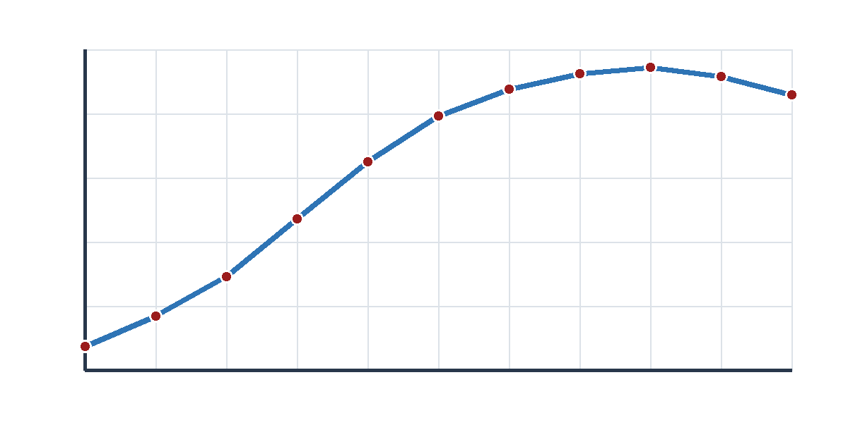
Figure 1. Synthetic response curve / 合成响应曲线
Table 1. Synthetic metrics / 合成指标
Metric / 指标 | Baseline | Reviewed
Peak response / 峰值 | 1.00 | 1.05
Residual ratio / 残余比 | 0.12 | 0.10

4. Review operations / 审阅操作
Insertion case: The test confirms repeatable behavior.
Deletion case: The redundant modifier remains visible in the baseline.
Replacement case: The response was good during the cycle.
Move case: Sensors were calibrated before loading. The specimen was then loaded.
Formatting case: The phrase critical observation is intentionally plain in the baseline.
Range comment anchor: verify the phrase normalized residual before approval.
Point comment anchor: check the following sentence boundary.

5. References / 参考文献
Open Fixture Authors. A Synthetic Record for Reproducible Review Tests. Public Fixture Laboratory, 2026.

