**COMP41670: Software Engineering**

**2023 / 2024**

**Individual Project**

**(REPORT)**

**Subhransu Swain**

**(23202288)**

UCD School of Computer Science,

University College Dublin,

Belfield, Dublin 4.

[subhransu.swain@ucdconnect.ie](mailto:subhransu.swain@ucdconnect.ie)

**Code with the Explanations:-**

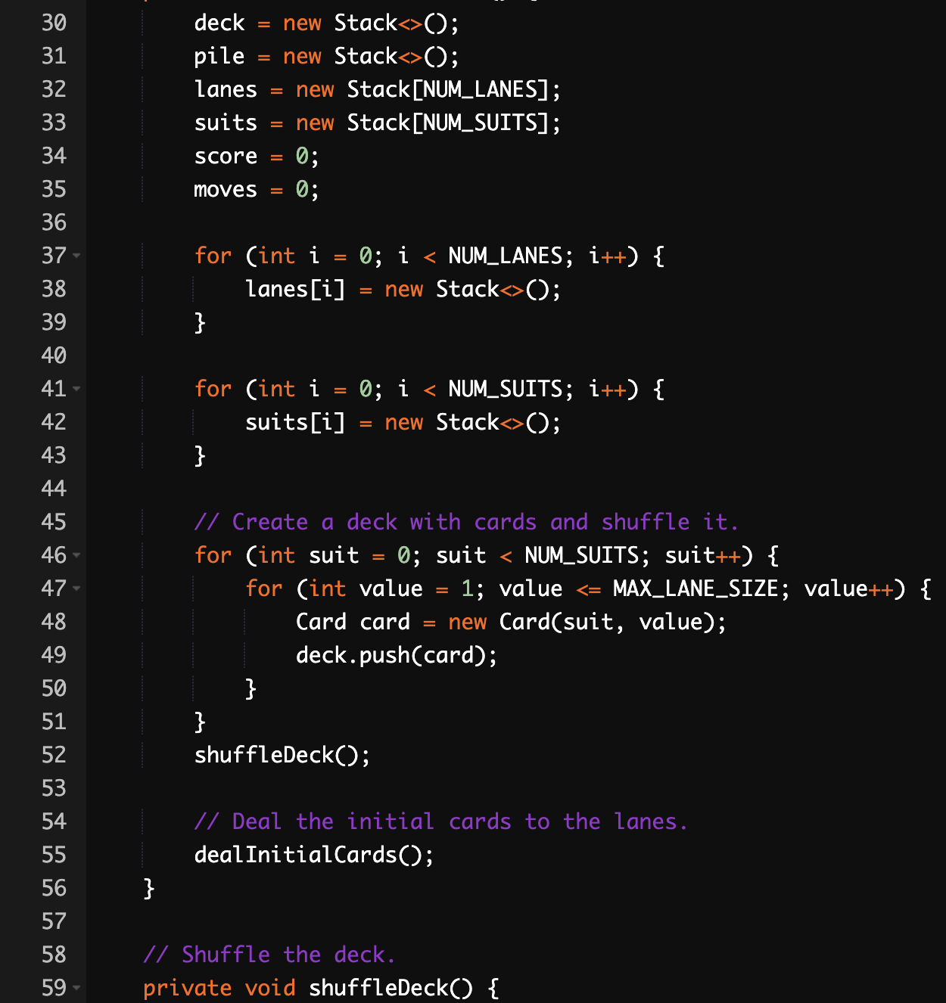

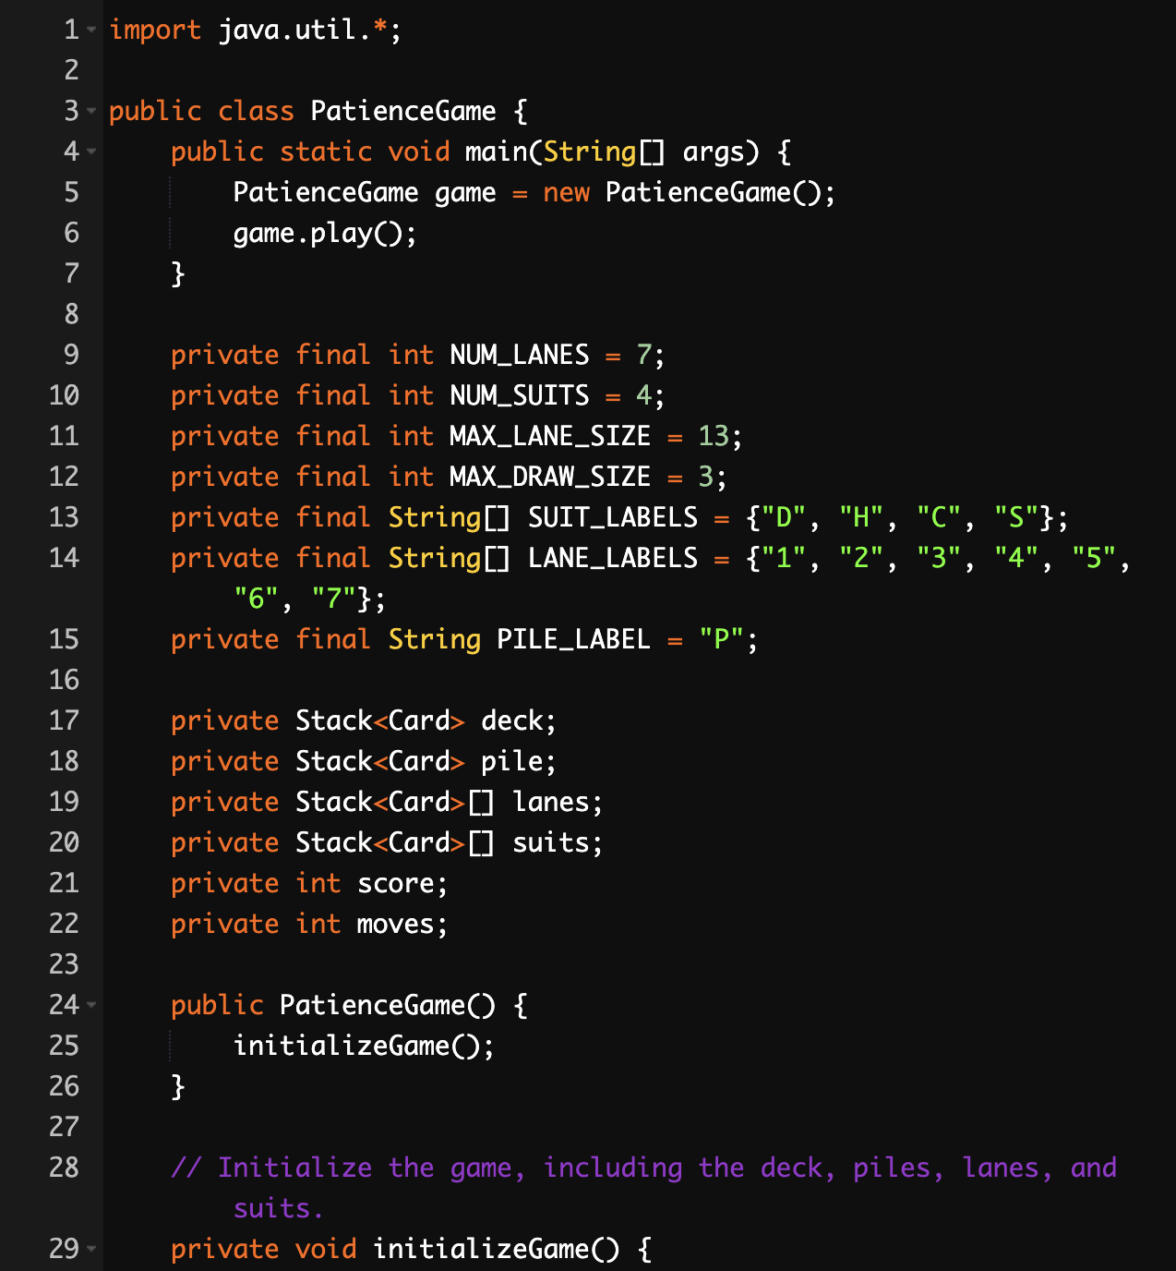

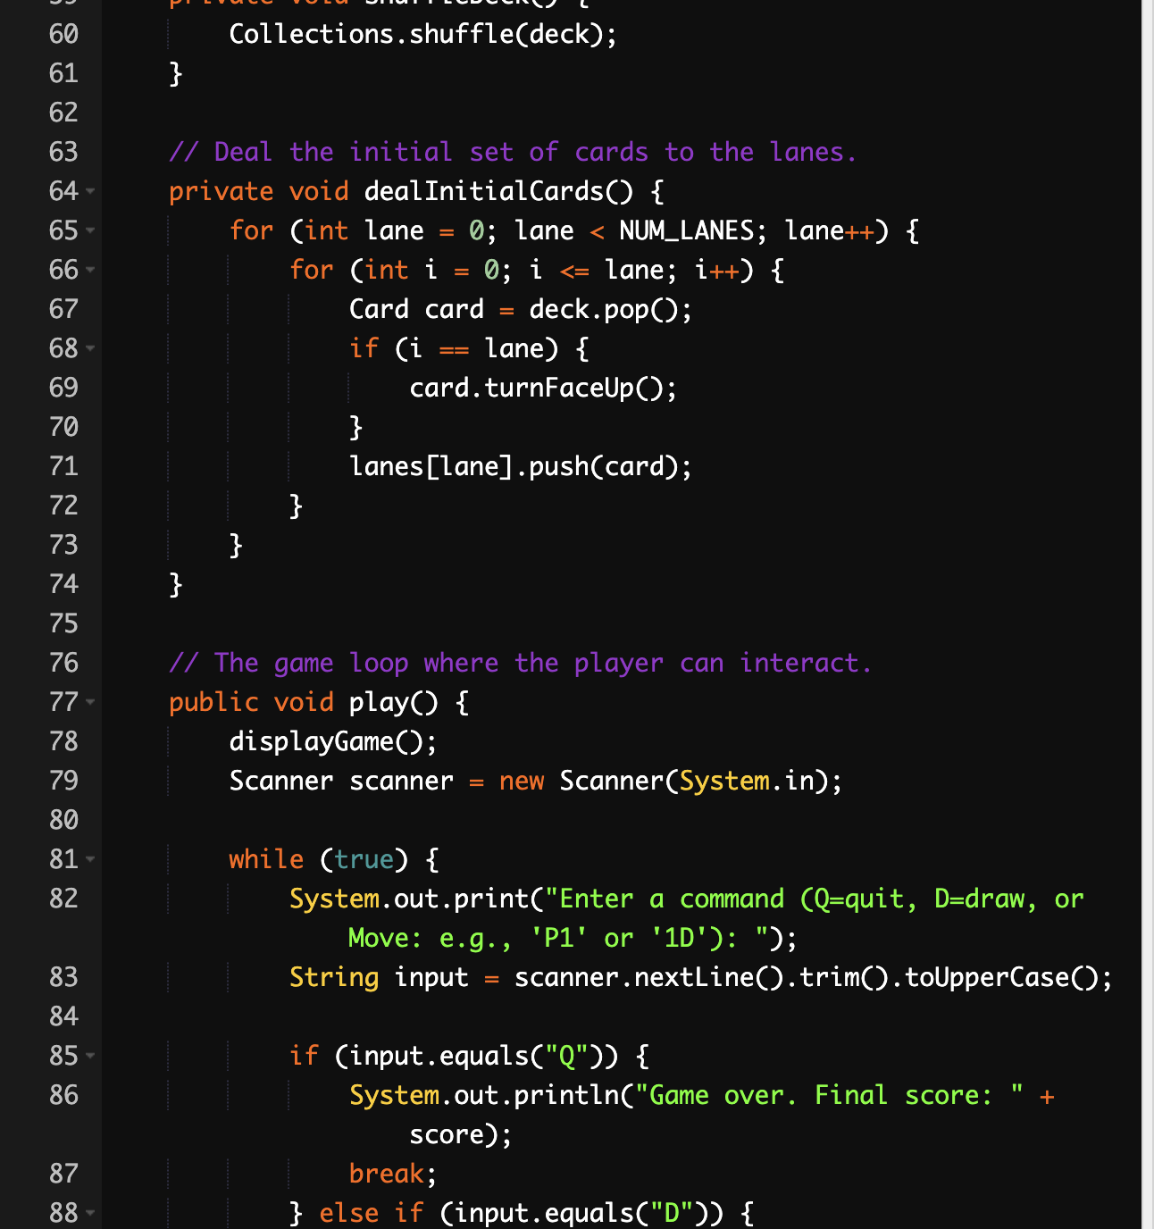

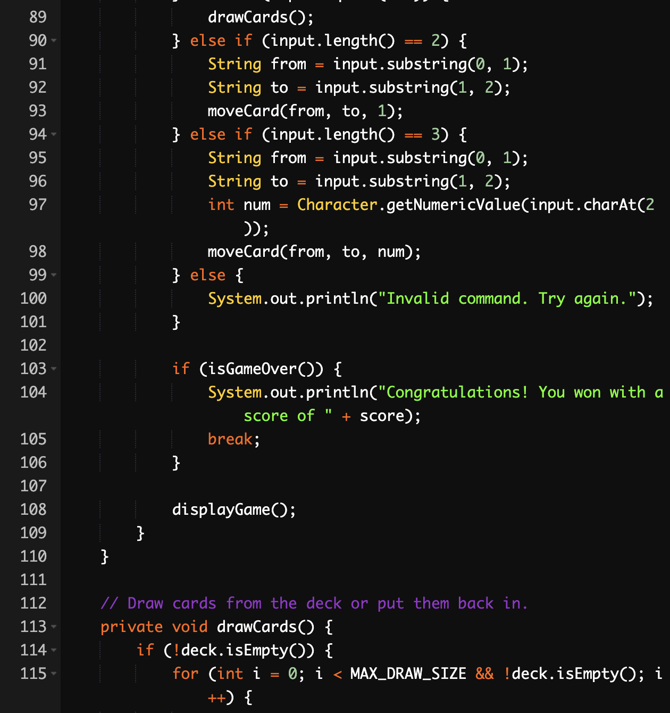

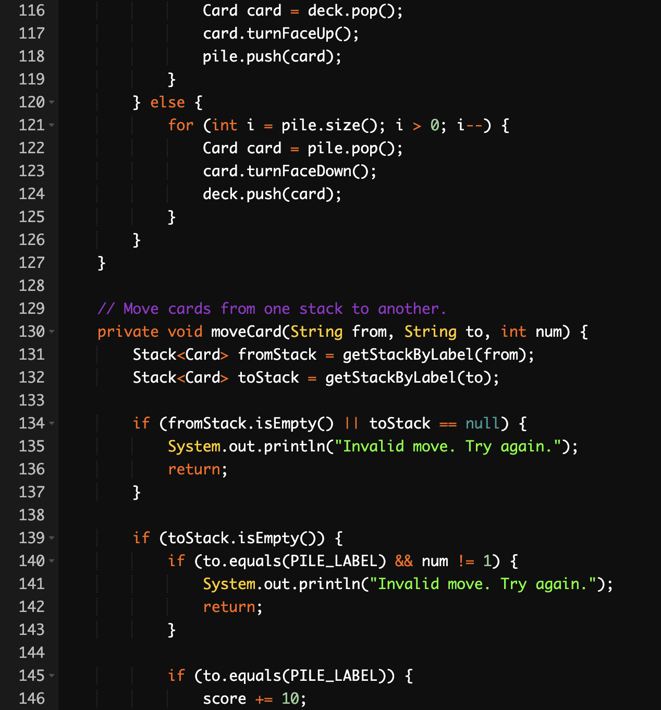

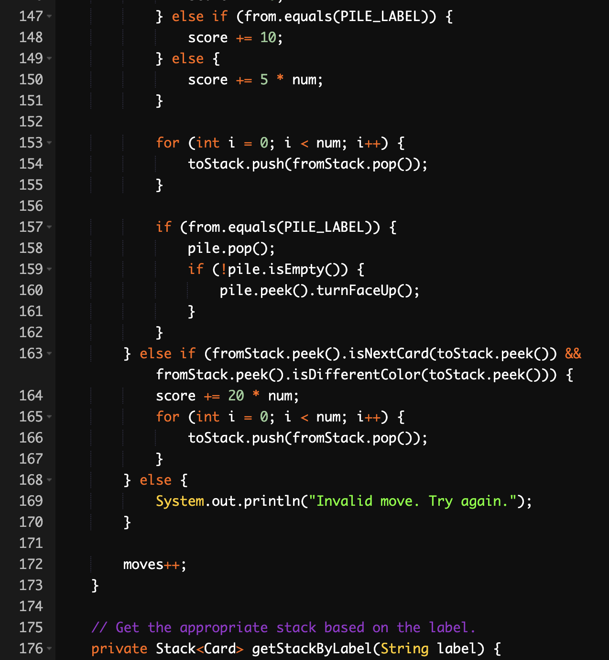

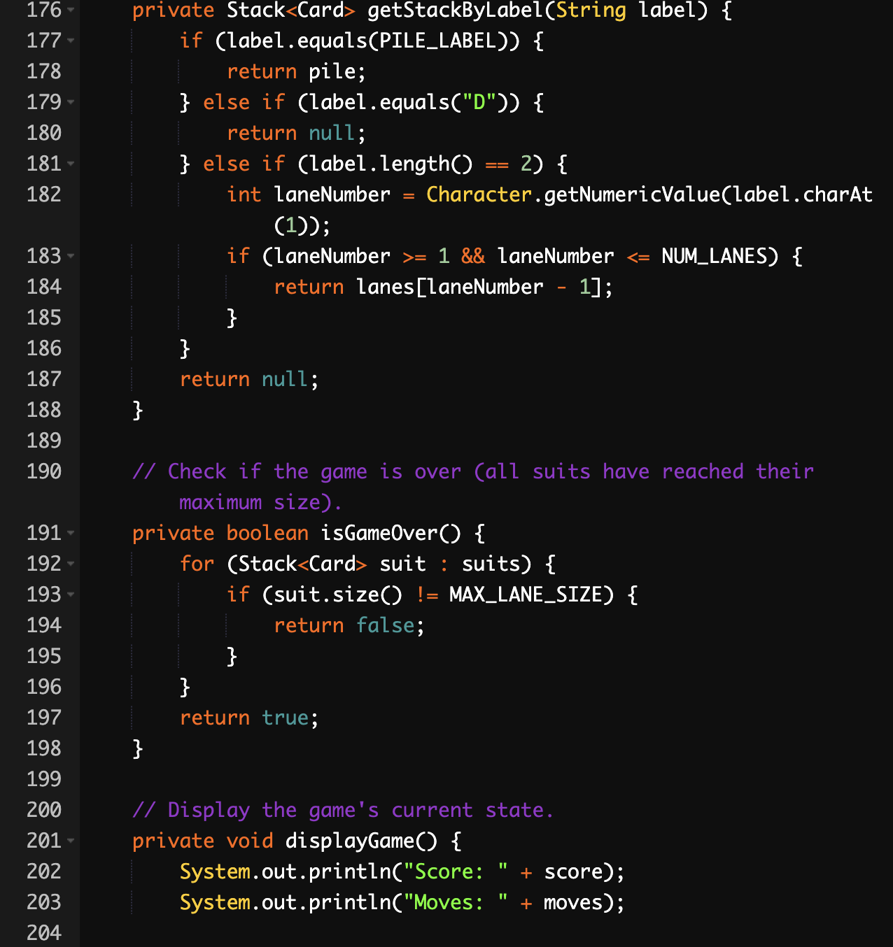

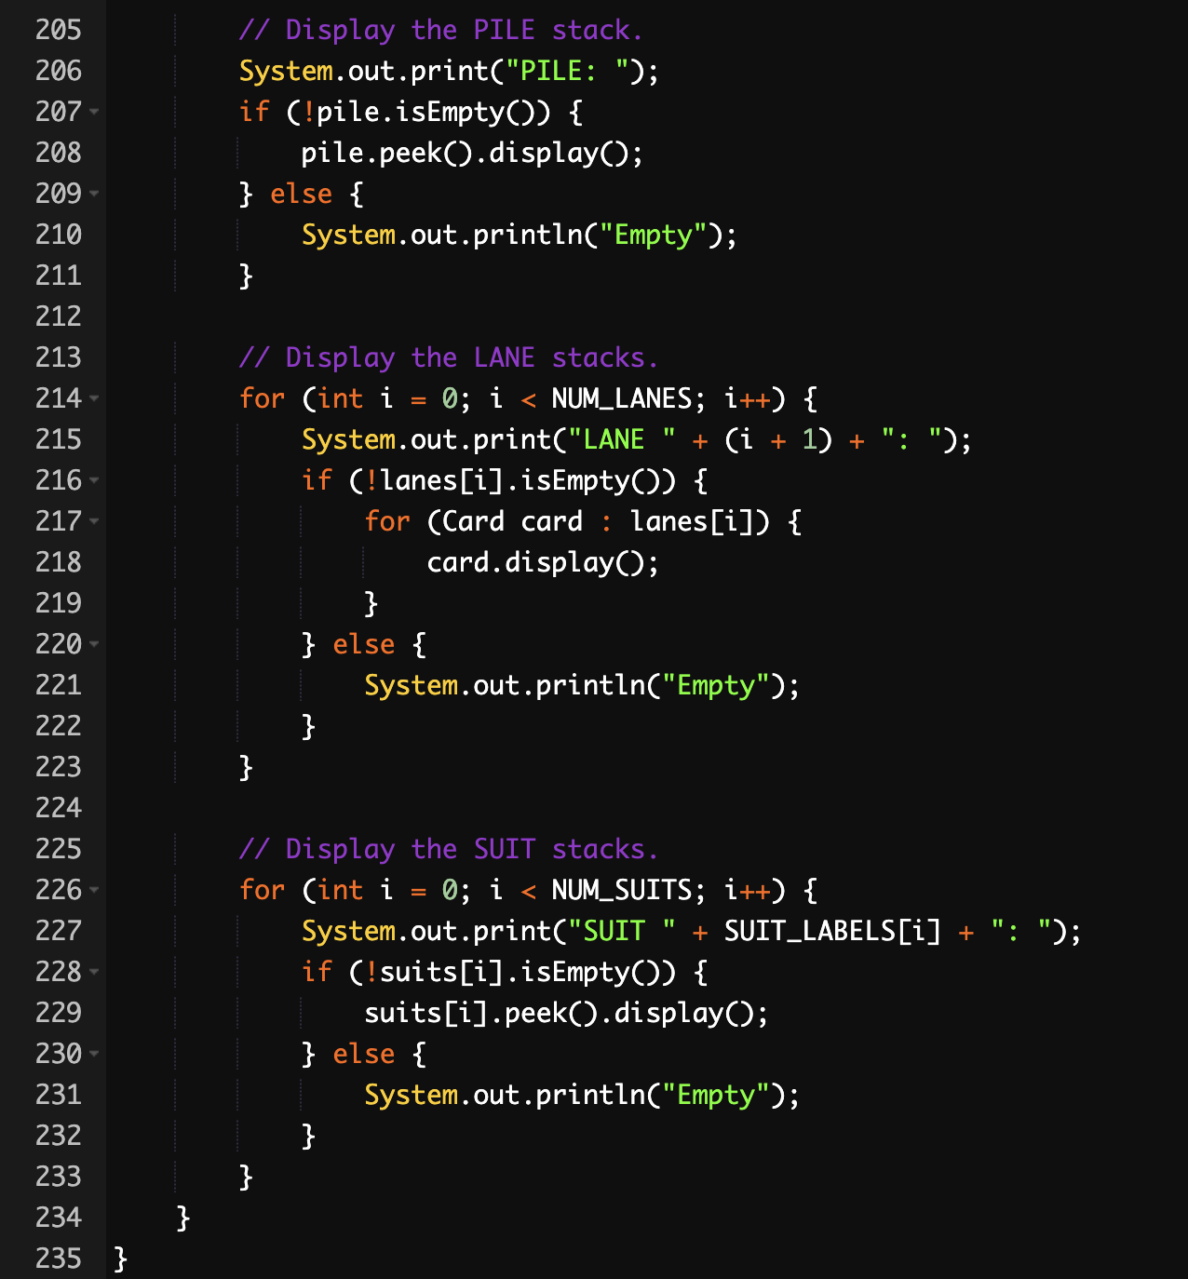

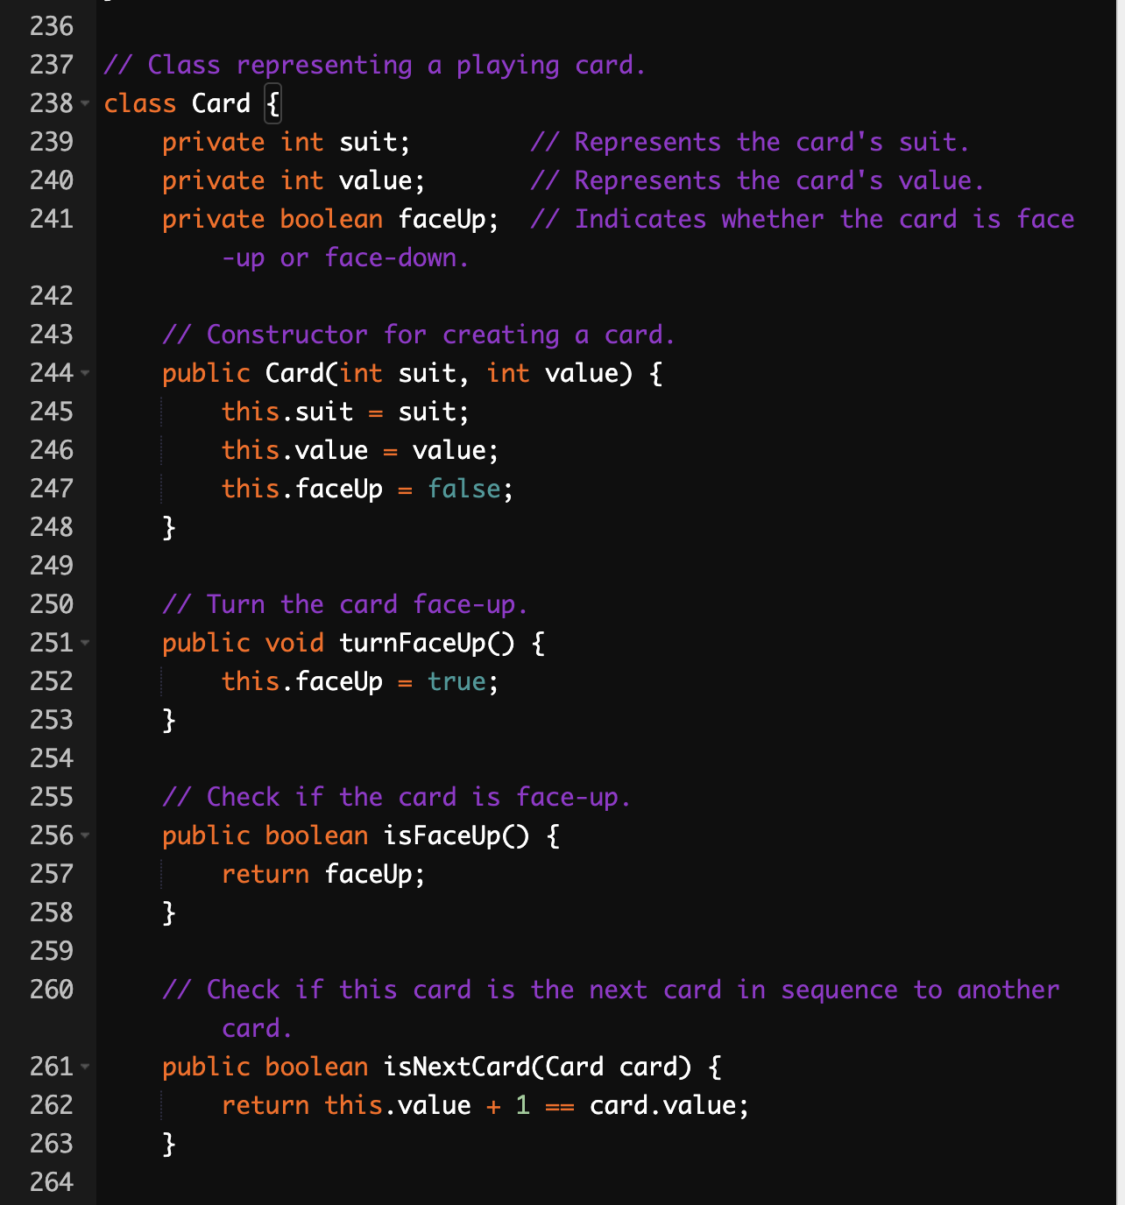

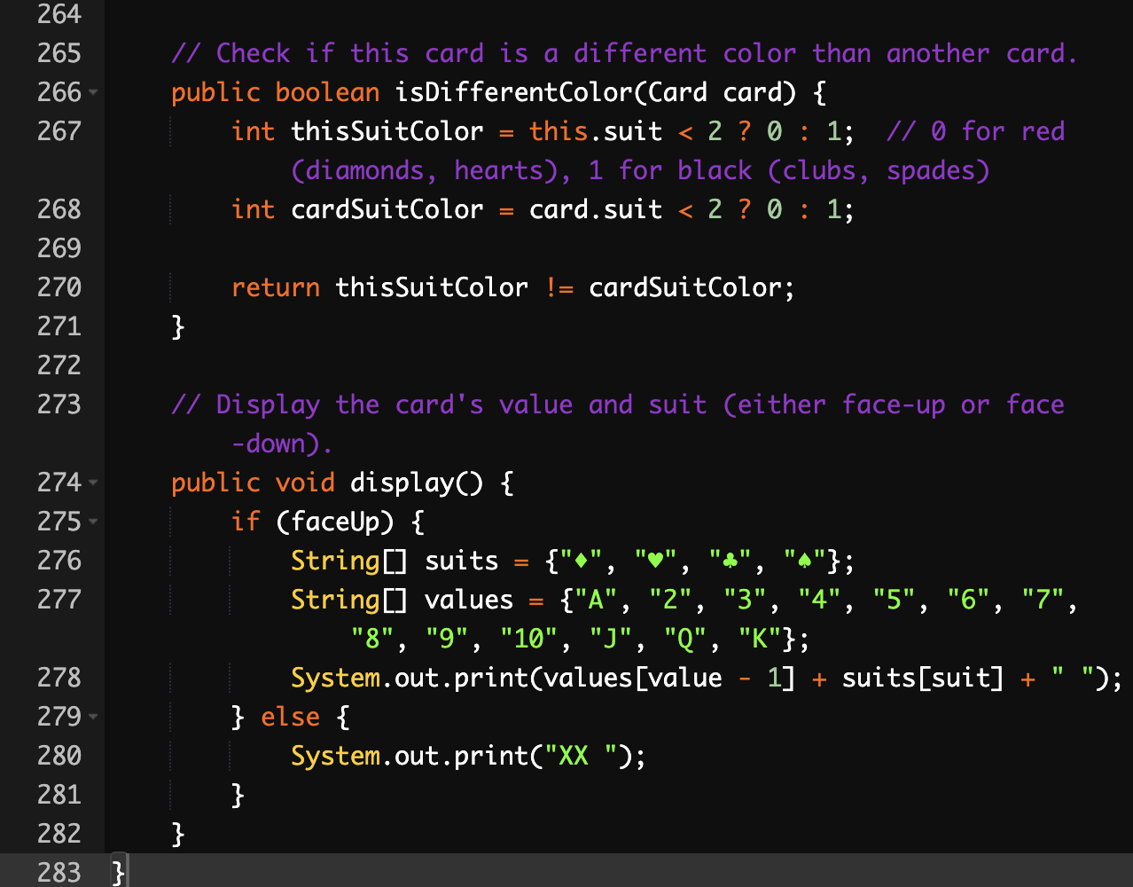

**CHECKLIST :-**

|  |  |  |
| --- | --- | --- |
| Class name | Functionality | Errors ( If Any ) |
| Board.java | Functional |  |
| Card.java | Partial | error: cannot find symbol |
| Command.java | Functional |  |
| Deck.java | Functional |  |
| Display.java | Functional |  |
| Patience.java | Partial | Recompile with -Xlint:unchecked for details. |
| Card.java | Functional |  |
| Command.java | Functional |  |
|  |  |  |
|  |  |  |

Most Occurred Error :- PatienceGame.java:123: error: cannot find symbol

card.turnFaceDown();

^

symbol: method turnFaceDown()

location: variable card of type Card

Note: PatienceGame.java uses unchecked or unsafe operations.

Note: Recompile with -Xlint:unchecked for details.

1 error

When the source code is transferred into the compiler in making a java projects it gives such error. But apparently the class separately is working.