**MANAV RACHNA UNIVERSITY, FARIDABAD**

**Department of Computer Science and Technology**



**Subject : Computer Architecture and Organisation**

**Under the Supervision of: Submitted by:**

**Faculty Name : Student Name:**

**Designation:**

**Department of Computer Science & Technology Roll No. :**

**Batch (Group):**

**LAB-1**

Q) Write a program to simply print a string.

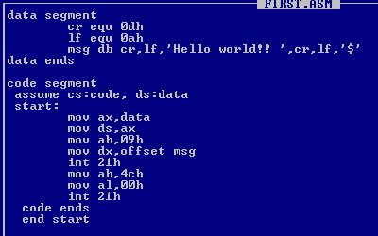



**LAB-2**

Q) Write a program to print two string.

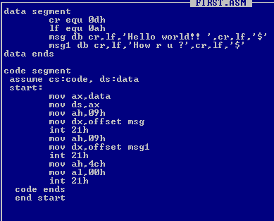

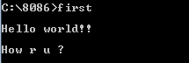

**LAB-3**

Q) Print 2 strings using Macro

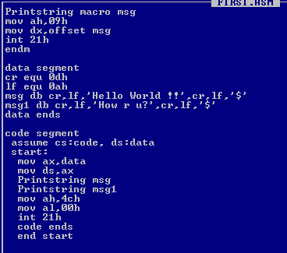

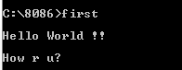

**LAB-4**

Q1) WAP to find successor of a character

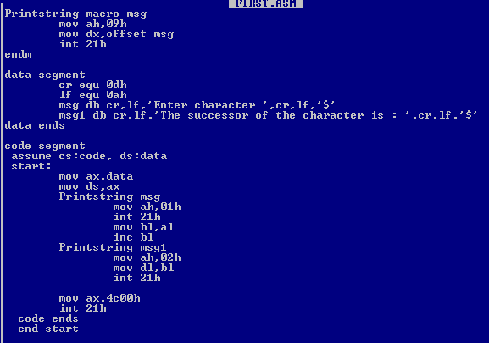

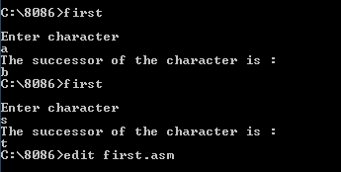

Q2) WAP to print predecessor of a character

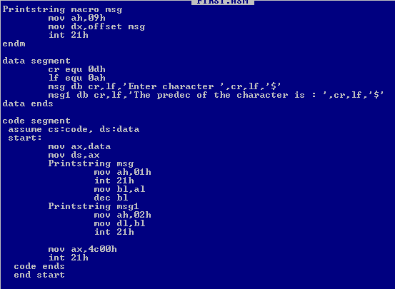

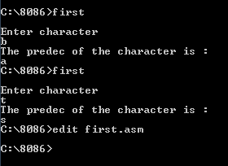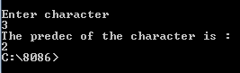

**LAB-5**

Q) WAP to check whether a number is even or odd.

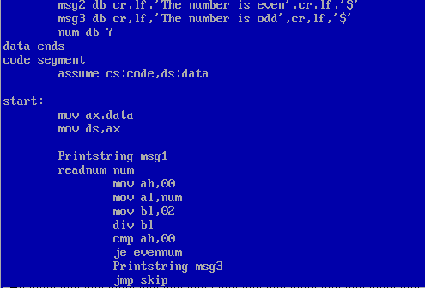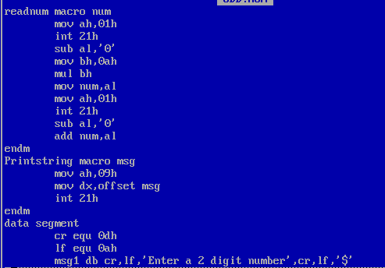

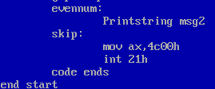

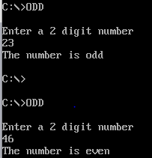

**LAB-6**

Q) WAP to check whether a number is prime or not?

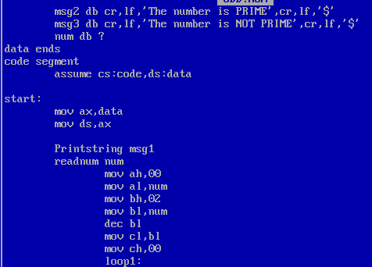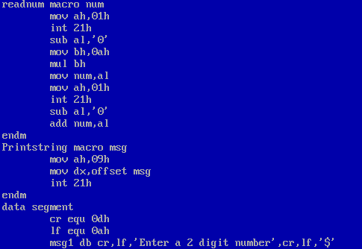

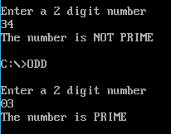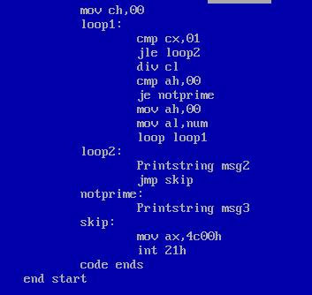

**LAB-7**

Q) WAP to check whether a string Is a palindrome?

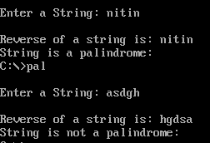

**LAB-8**

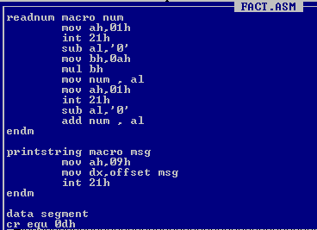Q) WAP to find the factorial of a number

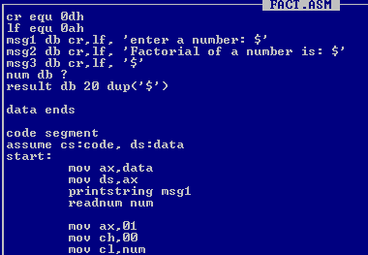

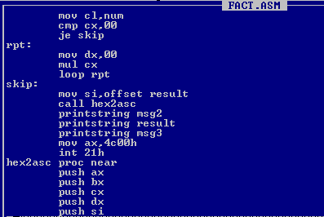

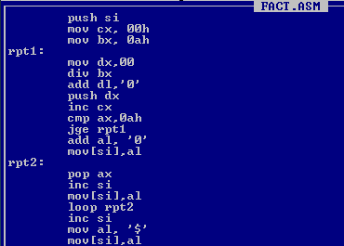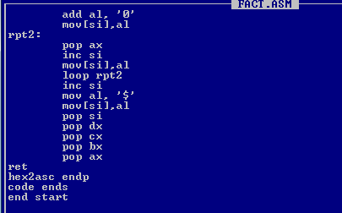

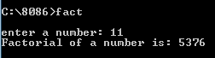

**LAB-9**

Q) WAP to find the largest of 2 number