- Start Up
  - Turn on the robot and the PC with the display.
  - Ensure that the PC is up and running before running any program on the Teach pendant.
- Teach Pendant Setup:
  - Ensure the robot has fully booted up and that the registers are following. More details are given below.
  - Note: Before running the program, ensure these registers are precisely in this arrangement.
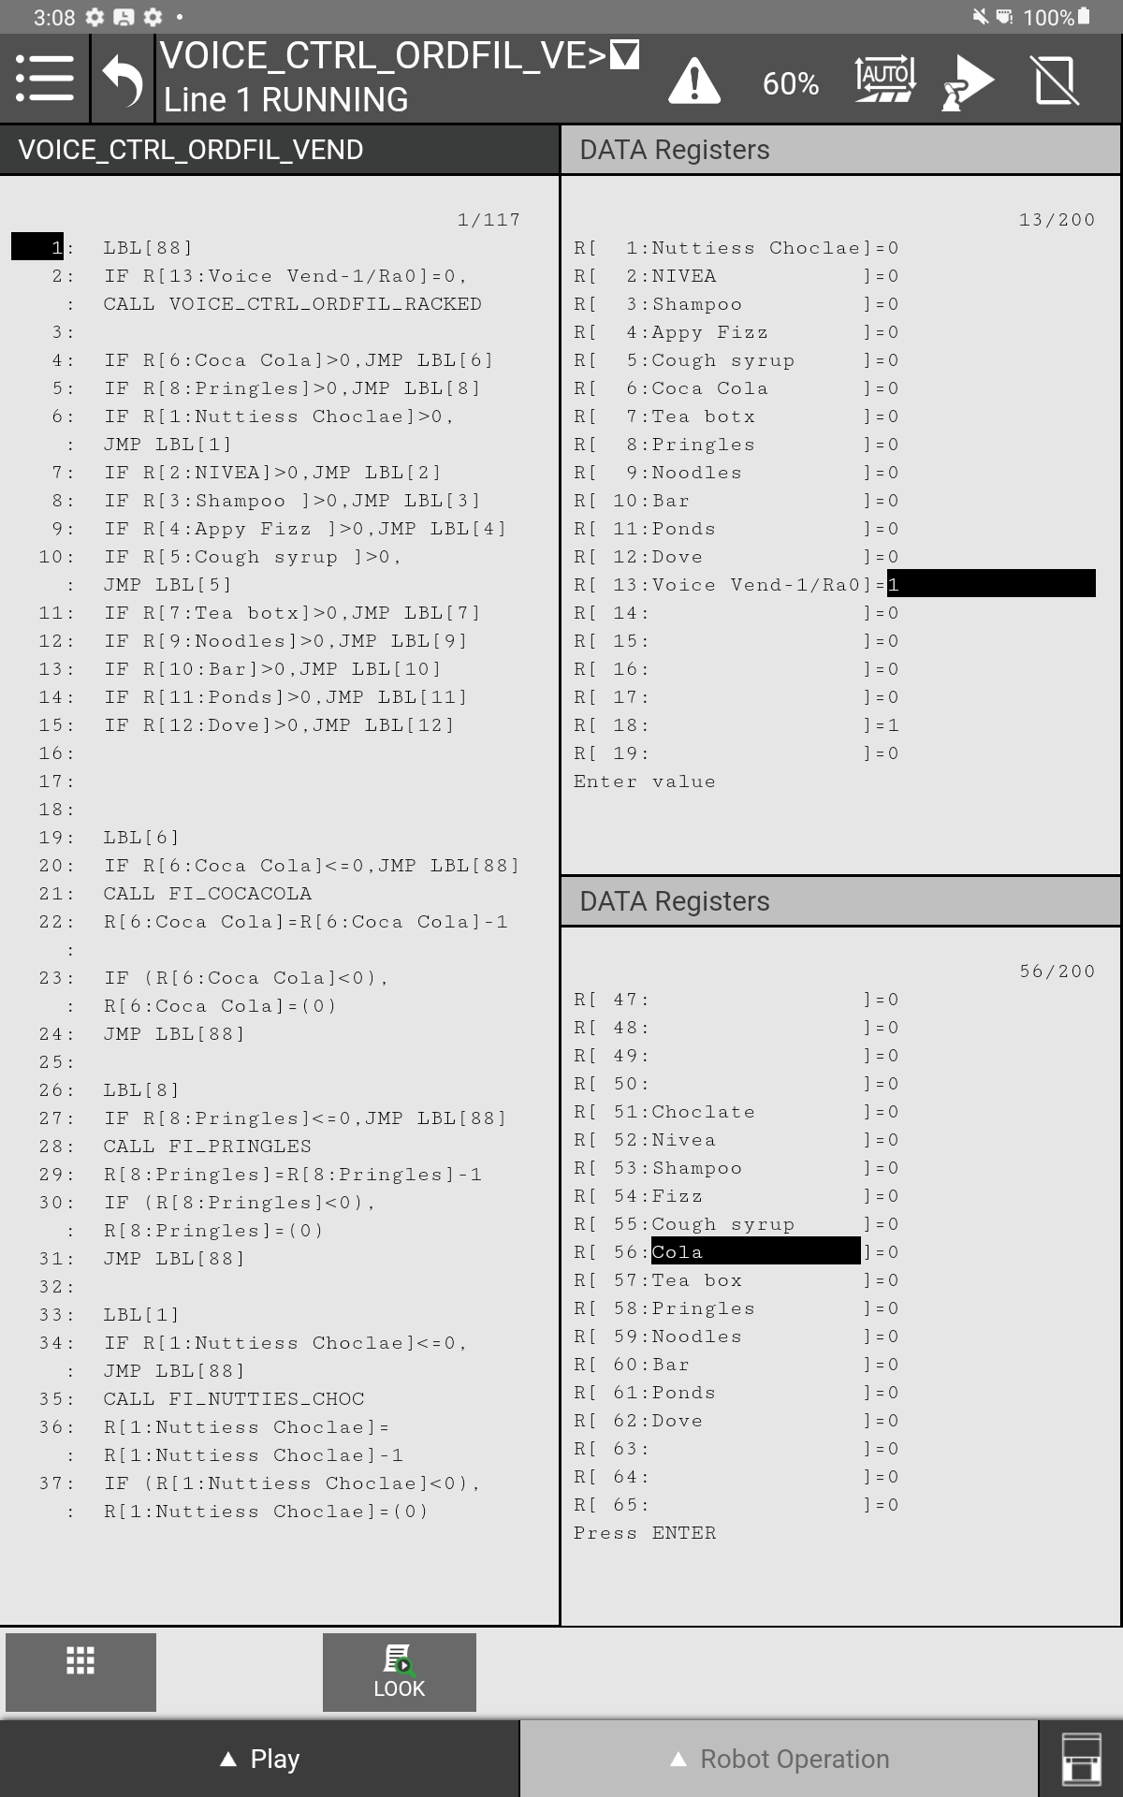
  - Registers R[1] to R[12] must all be zero.
    - These registers define the order quantity or the quantity of items brought from the rack to the cart by the robot.
    - During the startup of the Cell, ensure all items are in their respective racks and in the correct orientation. (insert image of racks 1 and 2).
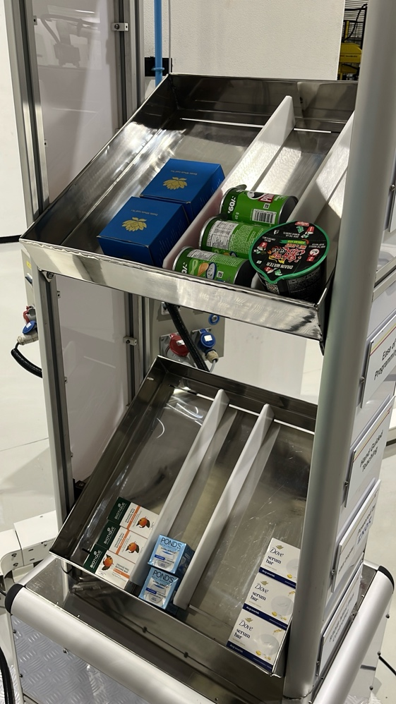
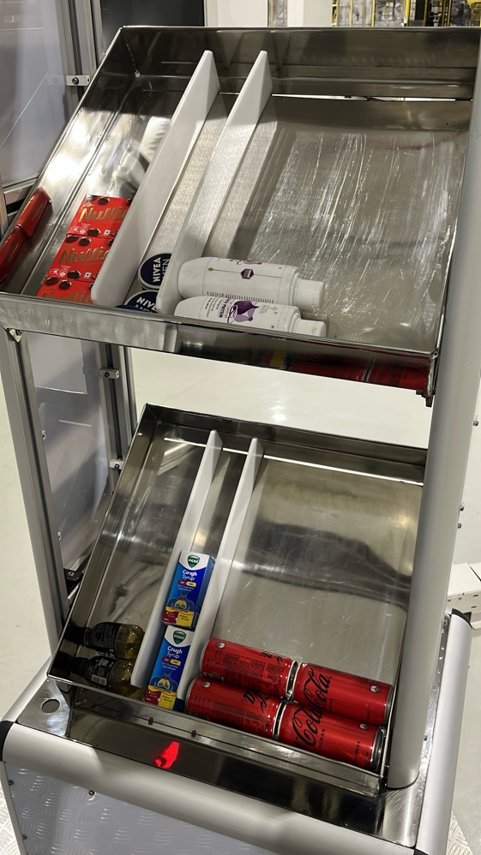
  - Register R[13] = 1 during startup only.
    - This defines whether the robot will rack place the item from the cart back to the rack) or vend(bring item from rack to cart).
    - Info: when R[13] = 1, VOICE_CTRL_ORDFIL_VEND runs and when R[13] = 0 VOICE_CTRL_ORDFIL_RACKED.
  - Registers R[51] to R[62] all need to be zero.
    - Defines which items will be placed back into the rack when the R[13] = 0.
    - Ensure these are also zero during startup.
  - Program to Run:
    - Always run: VOICE_CTRL_ORDFIL_VEND.
    - Run the program in Auto mode, with max speed at 60%, to ensure no items fall off the gripper.
- PC setup:
  - After the system has booted successfully, go to this file location
    - Desktop/New Development/FAUNC_LLM_Control2_ordfil/FANUC_LLM_Control2
Robot_handler/current_cart.json
    - Ensure the JSON in current_cart.json looks exactly like this during startup.
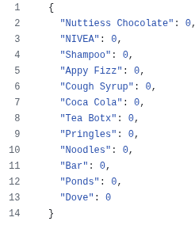
  - Open the Google Chrome browser.
    - On the desktop, you will find the icon and run the application called FANUC_Voice_OrderFil_OneClick.
    - This will automatically run the required checks and open the application as a local host website.
    - The input field at the bottom can be used to provide text input and converse with the robot.
    - Another way is to use voice control.
      - Ensure the microphone is attached and the gain knob is at zero.
      - Click the microphone button at the bottom right-hand corner to start the voice mode.
      - Slightly increase the gain until it is just in the grey region; it doesn’t have to be much. The knob can be turned slightly higher than shown below.
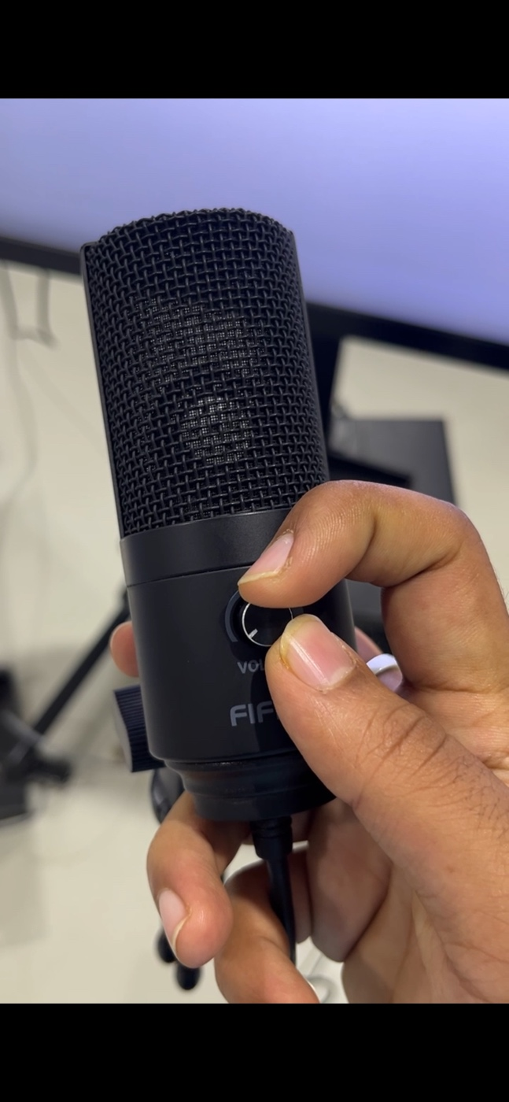
      - Bring the microphone closer, speak clearly without haste for the best interpretation. You can always try again and converse with the robot regarding the interpretation.
- Setup Info
  - Robot IP: 172.168.10.2, Mask: 255.255.255.0
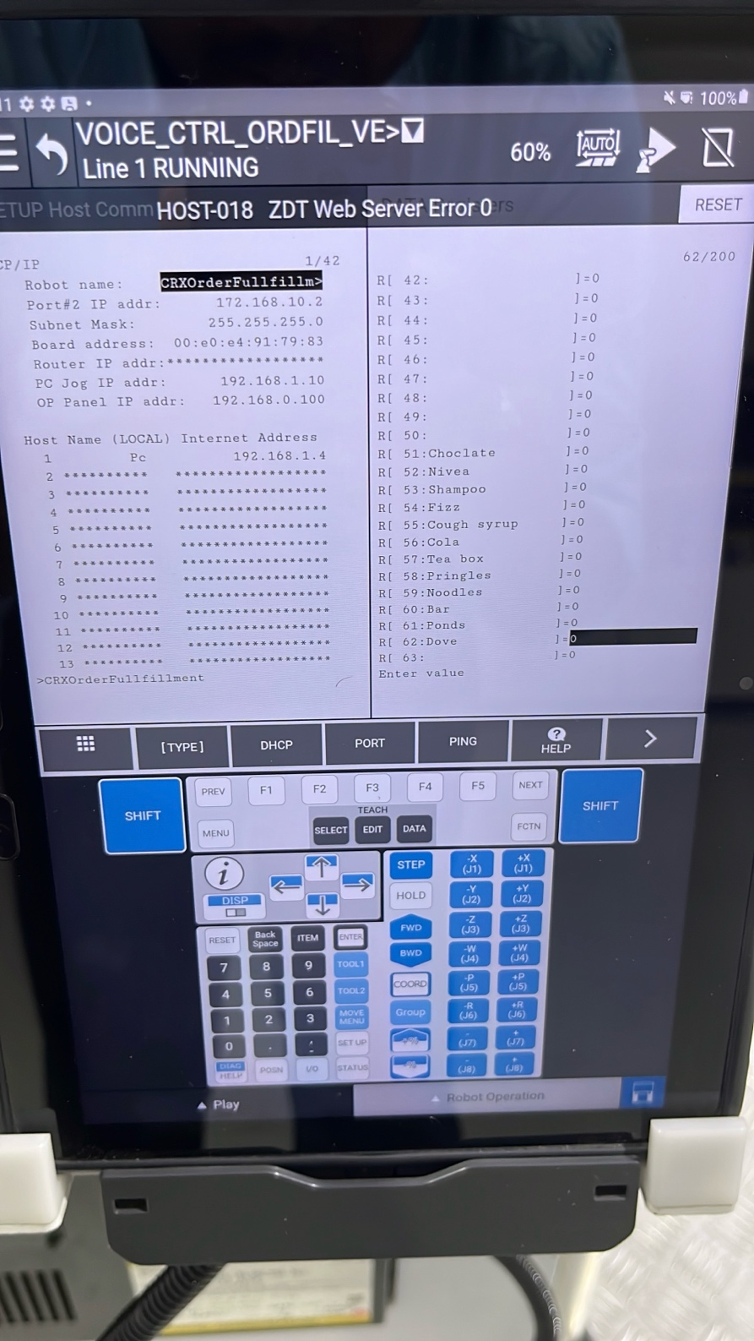
  - System IP: 172.168.10.101, Mask: 255.255.255.0
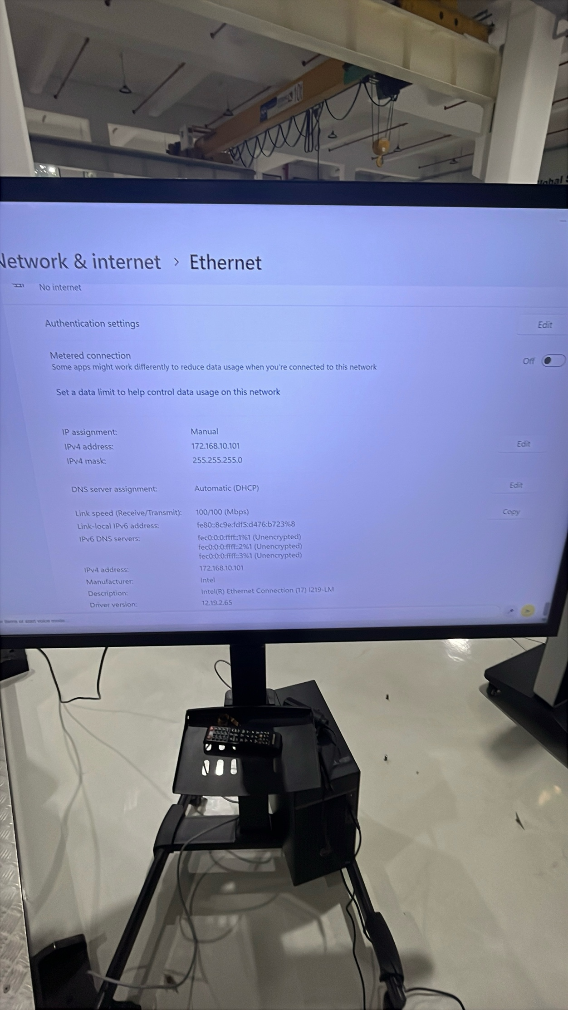
  - Robot IP before Voice order fulfilment (maybe ZDT)

