Blood Bank System Using Django

# TITLE

BLOOD BANK SYSTEM

# INTRODUCTION

The blood bank system project built with Django enables efficient management of blood donation, inventory, and donor information to support lifesaving transfusions.

# TECHNOLOGY USED

Python, Django Framework, HTML, CSS (Bootstrap and some custom CSS). EDITOR – Visual Studio Code

# EXPLANATION OF EACH PAGES

**INDEX.HTML**

The index.html page of the blood bank Django project serves as the central hub, offering users convenient access to essential functionalities such as login, registration, and information about the organization, effectively facilitating a seamless user experience..



**ABOUT.HTML**

The about.html page of our blood bank Django project showcases a captivating video that highlights our services, complemented by comprehensive information about the range of services we offer, ensuring users are well-informed and engaged.



**LOGIN.HTML**

The login.html page of our blood bank Django project offers a comprehensive login system, allowing both regular users to register and login, and administrators to securely access their administrative privileges, ensuring smooth authentication and access control for all users.

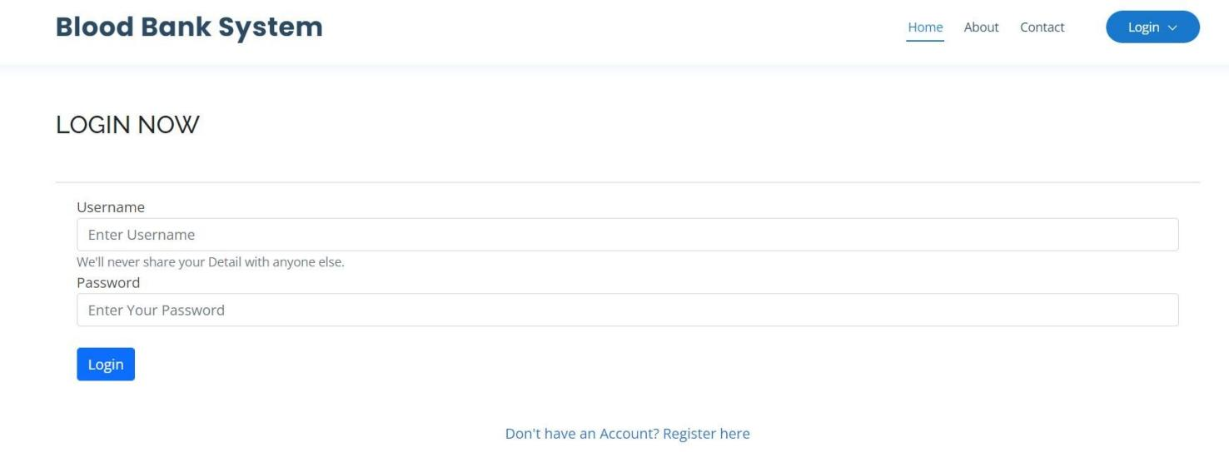

**DOCTORS.HTML**

This page displays the photos and department of each doctor. Each card includes doctor’s name, designation and their respective departments.



**ADMIN_HOME.HTML**

This page shows details about admin home

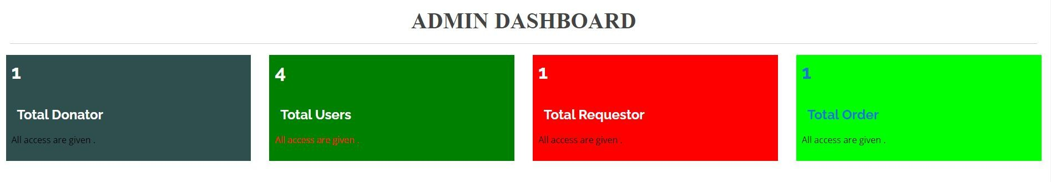

# CONCLUSION

In conclusion, the blood bank system project built with Django leverages the power of web development to create a robust and user-friendly platform for managing blood donation processes, enhancing efficiency, and ultimately contributing to saving lives. With its various pages and functionalities, such as login, registration, appointment booking, and administrative control, the project successfully addresses the critical needs of both donors and administrators, making it a valuable tool in the realm of blood donation management.