|  |  |  |  |  |  |  |
| --- | --- | --- | --- | --- | --- | --- |
| **Table 1** Characteristics of patients at the time of tracheostomy placement | | | | | | |
| Variable | Median | IQR |  | Variable |  | Number (proportion) |
| Median Age at trach (months) | 5.1 | 5.3 |  | Indication for trach | Airway obstruction | 28 (52.8%) |
| PIM Score | 1.4 | 2.0 |  |  | Craniofacial anomaly | 3 (5.7%) |
| PIM Risk of Mortality | 0.8 | 4.7 |  |  | Neuromuscular disorder | 4 (7.6%) |
| Admission Pediatric Cerebral Performance | 3.0 | 2.0 |  |  | Cardiopulmonary disorder | 16 (30.2%) |
| Discharge Pediatric Cerebral Performance | 3.0 | 1.0 |  |  | Brain injury | 2 (3.8%) |
| Pre Admit Functional Status Score | 11.0 | 13.0 |  | Discharge location | Home | 8 (15.1%) |
| Admit Functional Status Score | 21.0 | 11.0 |  |  | Short-term care facility | 44 (83.0%) |
| Discharge Functional Status Score | 13.0 | 4.0 |  |  | Long-term care facility(group home) | 0 (0.0%) |
| Total Hospital Stay(days) | 77.0 | 96.0 |  |  | Other | 1 (1.9%) |
| Days to discharge after tracheostomy | 33.5 | 31.5 |  |  |  |  |
| Total Number of Medical Subspecialists | 3.0 | 2.0 |  |  |  |  |
| Total Number of Surgical Subspecialists | 2.0 | 1.0 |  |  |  |  |
| Total Number of Meds at Discharge | 10.0 | 9.0 |  |  |  |  |

|  |  |  |  |
| --- | --- | --- | --- |
| Table 2 Characteristics of three resource utilization outcomes by years | | | |
| Outcome Variable |  | Year 1 | Year 3 |
| Number of hospital admissions |  |  |  |
|  | Mean (SD) | 3.04 (2.48) | 1.79 (1.95) |
|  | Median [Min, Max] | 2.50 [0, 9.00] | 1.00 [0, 8.00] |
|  | Missing | 3 (5.7%) | 14 (26.4%) |
| Number of ED visits |  |  |  |
|  | Mean (SD) | 1.48 (1.47) | 0.87 (1.34) |
|  | Median [Min, Max] | 1.00 [0, 5.00] | 0 [0, 6.00] |
|  | Missing | 3 (5.7%) | 14 (26.4%) |
| Number of prescription medications |  |  |  |
|  | Mean (SD) | 8.30 (4.00) | 6.84 (4.19) |
|  | Median [Min, Max] | 8.00 [0, 18.0] | 5.00 [1.00, 16.0] |
|  | Missing | 3 (5.7%) | 15 (28.3%) |

|  |  |  |  |  |  |
| --- | --- | --- | --- | --- | --- |
| Table 3a Logistic regression for FSS total on discharge and the decannulation status(yes/no) | | | | | |
| Outcome Variable | Predictor | Unadjusted odds ratio  (95% Confidence interval) | P value | Adjusted odds ratio  (95% Confidence interval) | P value |
| decannulation status (yes/no)  at 3-year | mental | 14.9 (1.7, 121.5) | 0.01 | 7.2e+08(-∞,+∞) | 0.996 |
|  | sensory | 4.5 (0.9, 23.3) | 0.07 | 0.0 (-∞,+∞) | 0.996 |
|  | communication | 1.8 (0.4, 9.0) | 0.42 | 0.75 (0.11, 4.95) | 0.76 |
|  | motor | 4.1 (1.0, 16.4) | 0.05 | 2.83 (0.45, 18.17) | 0.27 |
|  | feeding | 0.0 (-∞,+∞) | 0.99 | 0.0 (-∞,+∞) | 0.999 |
|  | resp | 3.6e+7 (-∞,+∞) | 0.99 | 7.8e+15(-∞,+∞) | 0.995 |

|  |  |  |  |  |  |
| --- | --- | --- | --- | --- | --- |
| Table 3b Logistic regression for FSS total at 1-year and the decannulation status(yes/no) | | | | | |
| Outcome Variable | Predictor | Unadjusted odds ratio  (95% Confidence interval) | P value | Adjusted odds ratio  (95% Confidence interval) | P value |
| decannulation status (yes/no)  at 3-year | mental | 4.9e+07(-∞,+∞) | 0.99 | 2.4e+07(-∞,+∞) | 0.995 |
|  | sensory | 8.2 (1, 73.7) | 0.05 | 3.67 (0.4, 36.6) | 0.28 |
|  | communication | 4.5 (1, 18.2) | 0.05 | 1.65 (0.3, 8.2) | 0.53 |
|  | motor | 2.2 (0.6, 8.2) | 0.27 | 0.9 (0.2, 4.1) | 0.87 |
|  | feeding | 2.7 (0.6, 11.0) | 0.20 | 1.4 (0.3, 6.7) | 0.70 |
|  | resp | 1.3e+07 (-∞,+∞) | 0.99 | 1.4e+07(-∞,+∞) | 0.997 |
| Table 3c Logistic regression for FSS total at 3-year and the decannulation status(yes/no) | | | | | |
| Outcome Variable | Predictor | Unadjusted odds ratio  (95% Confidence interval) | P value | Adjusted odds ratio  (95% Confidence interval) | P value |
| decannulation status (yes/no)  at 3-year | mental | 1.8e+07(-∞,+∞) | 0.99 | 0.0 (-∞,+∞) | 1 |
|  | sensory | 5.9e+07(-∞,+∞) | 0.99 | 1.0 (-∞,+∞) | 1 |
|  | communication | 5.5 (0.61, 49.4) | 0.14 | 1.0 (-∞,+∞) | 1 |
|  | motor | 4.5 (1, 20.09) | 0.06 | 1.0 (-∞,+∞) | 1 |
|  | feeding | 7.4 (1.54, 36.6) | 0.01 | 1.0 (-∞,+∞) | 1 |
|  | resp | 1.15e+23 (-∞,+∞) | 1 | 1.0 (-∞,+∞) | 1 |

Figure 1 Facet plots of FSS total and three resource utilization outcomes in 1-year and 3-year follow-ups

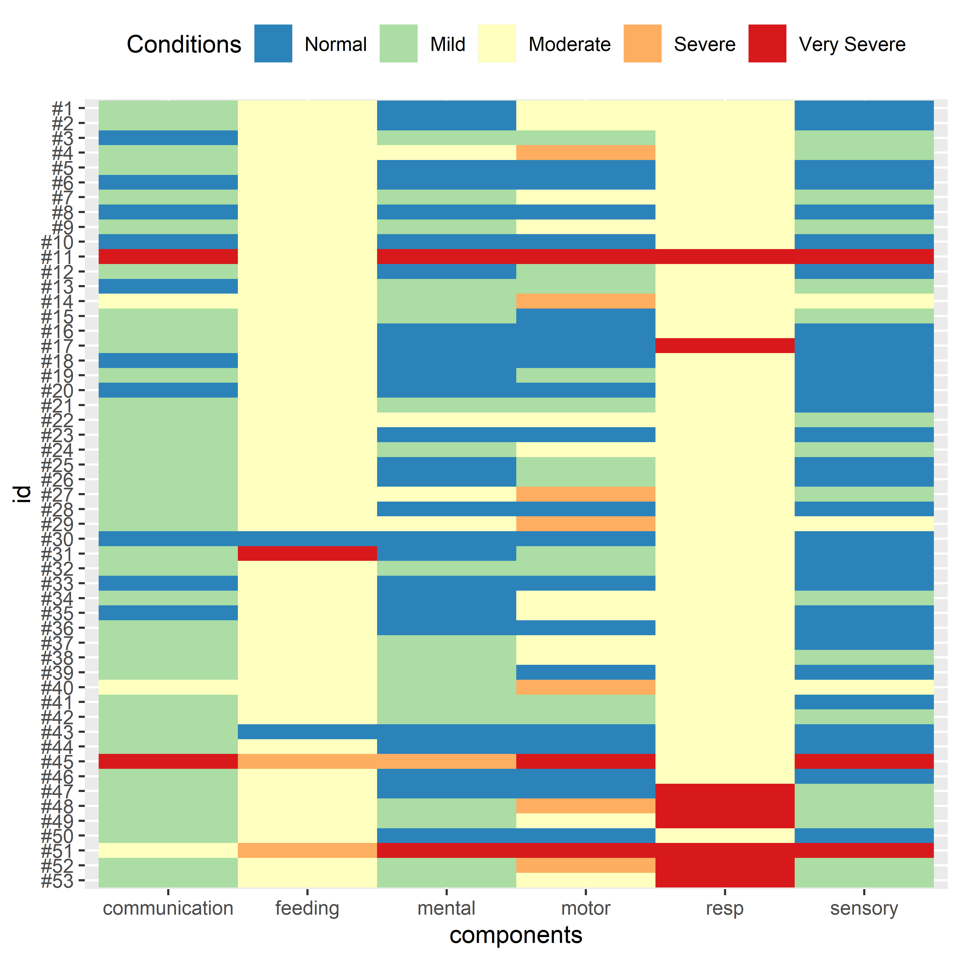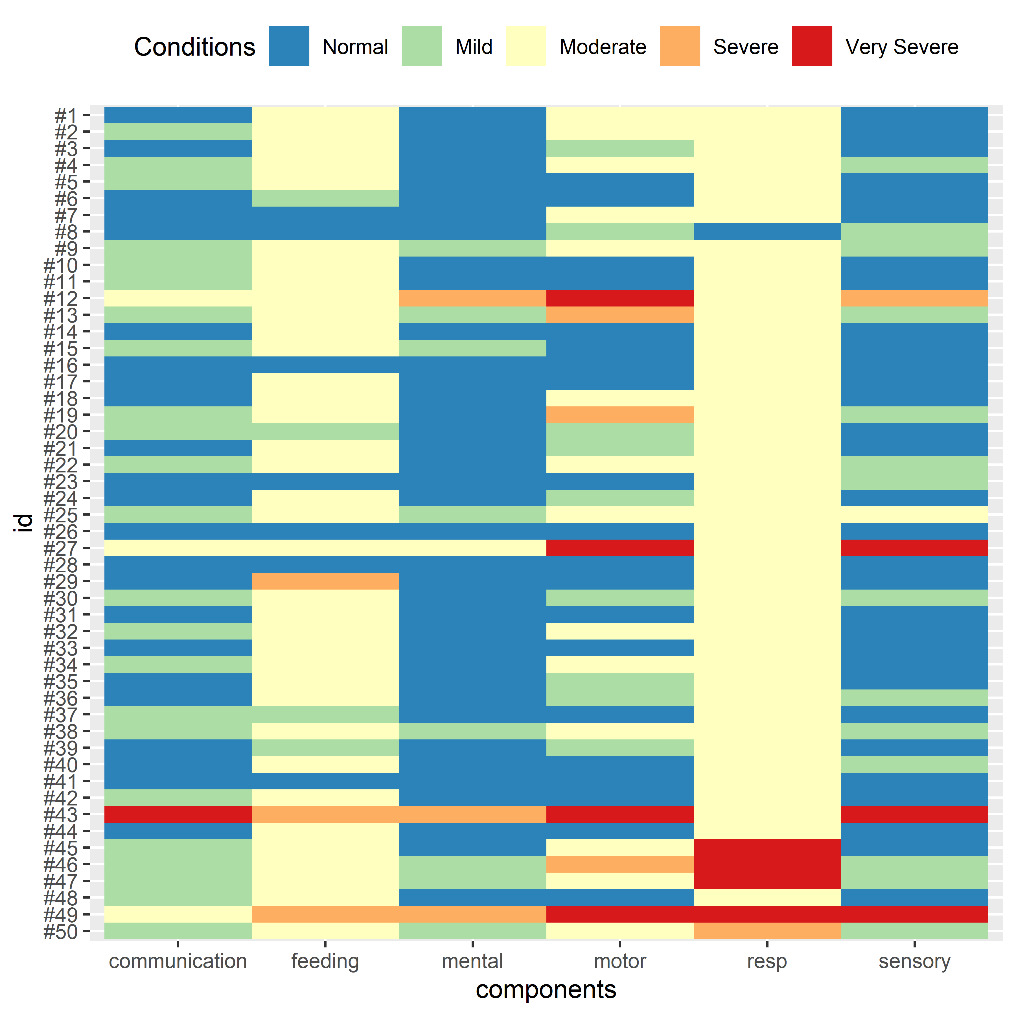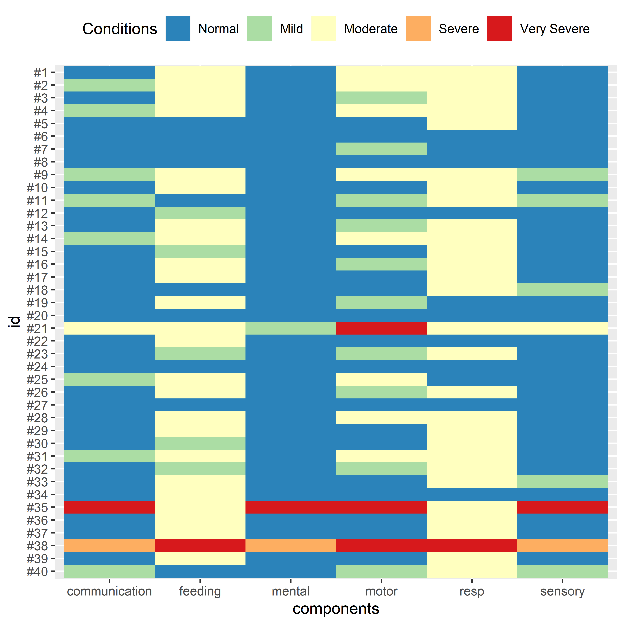

Figure 2 Conditions in six components of FSS total for patients on discharge, at 1-year and 3-year follow-ups