**計算機程式設計HW7-2report 103061223李俊穎**

1. **Introduction of the problem and your solution**

The homework 7-2 is to complete the card game called Royal Casino. We need to write the rules like pair, combine, tailing, build and call, and try to use STL vectors to improve data structures. Although now we don’t need to do it by vectors, I still use it because it is more efficient.

Because this time the instructor has given us some part of codes, what we need to complete is the judge equation and some function or loop, and call them correctly. I judge the condition by the switch-case and if-else, as well as some bool variables.

1. **Implementation details ,Additional features of your program (data structure, flows and algorithms)**

The rules of casino include pair, call, combine, build and tailing, the following is the part of pair：

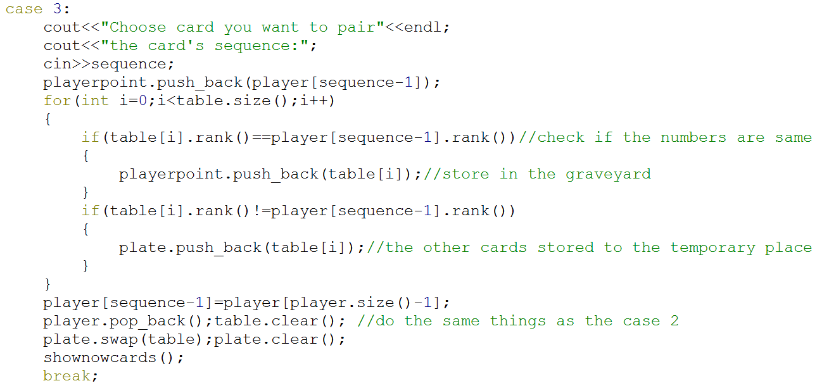

How the pair function run is check the rank name from player to table, and pop_back they from their primary array.

The following is the part of combine：

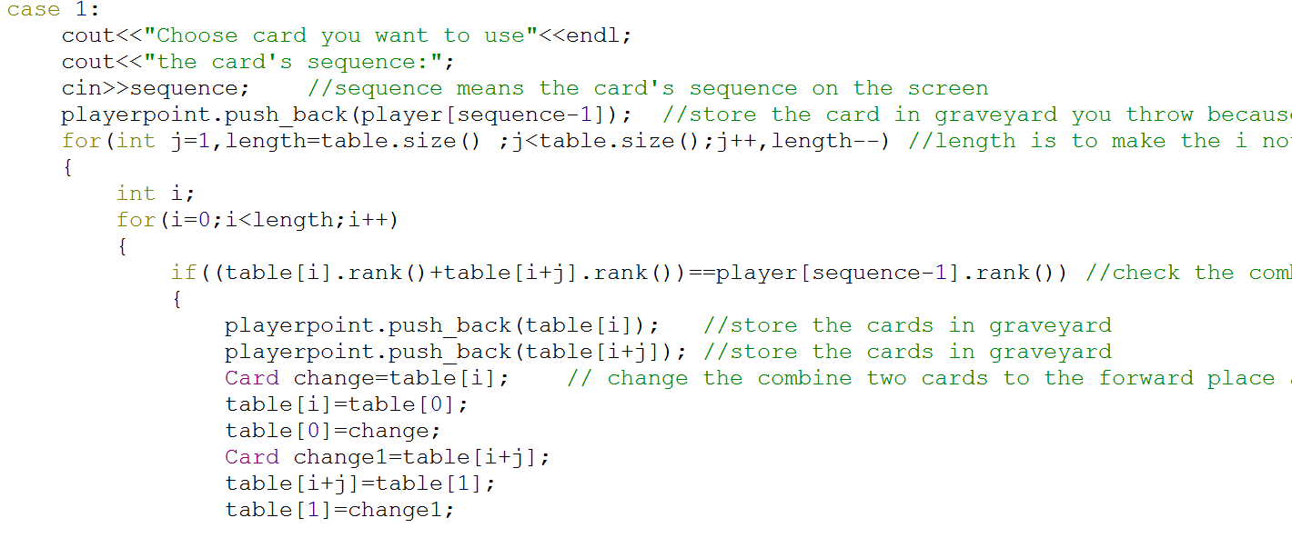

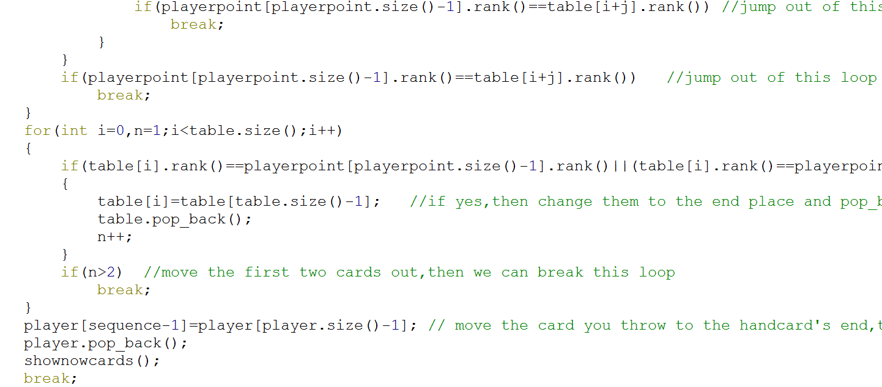

The combine is checking all the condition of sum of two cards on the table. If so, change the two cards to the front, and judge them again and change them to the end then pop_back it.

The following is the trail：

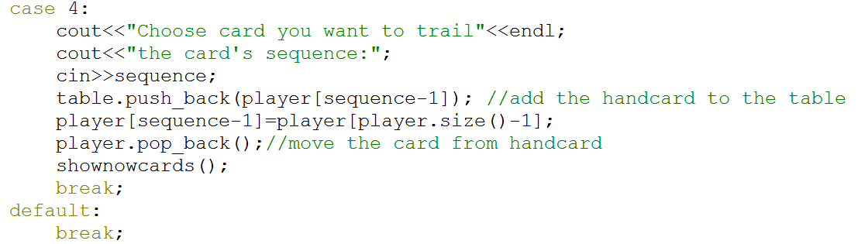

Tailing is just push_back the table and pop_back the hand cards.

The following is the call：

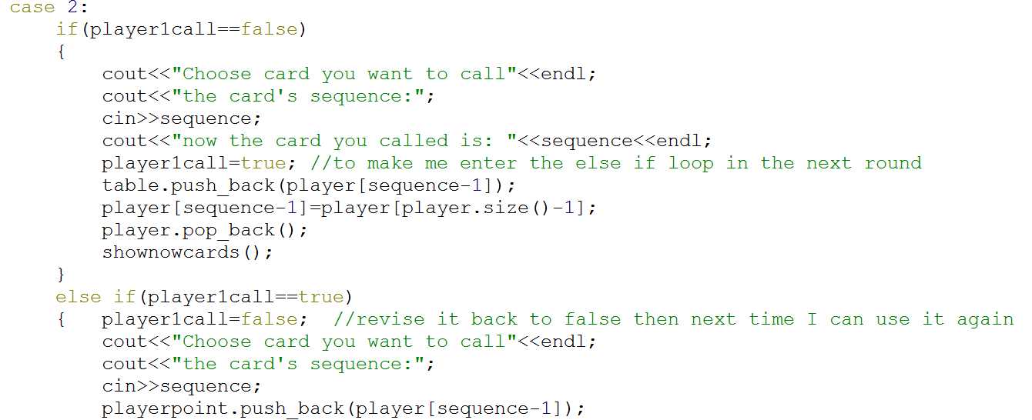

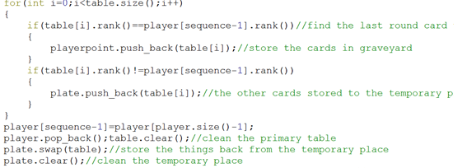

And this time I add my additional feature of my program, I create two function that one can detect if now the player can use pair and the other detect if now the player can use combine and I put then in the for loop to make them check every round when playing game. For example, the check function that check the pair：

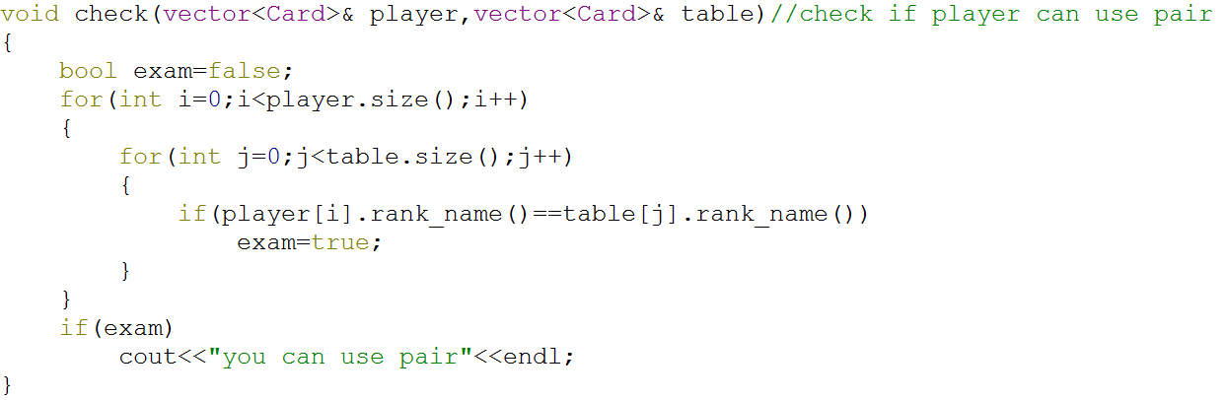

I compare them one to one to know if there are the same number on the hand cards and table, then player can follow by the hint without check their hand cards.

This time I didn’t finish the build rules because my program will have lots of bugs. In other words, I don’t figure out how to judge this condition, so I don’t finish it in my program. I think I have to consider more time on it and discuss with classmates.