NEXUS PORTFOLIO INTELLIGENCE
Mutual Fund Overlap, Risk and Retirement Analytics with Machine-Learned and Quantitative Models
submitted in partial fulfillment of the requirement
for the award of the Degree of

Bachelor of Technology
in
Computer Engineering
T.E. Mini Project, Semester [V / VI]

by
Jinay Shah (UID: [UID])
[Student 2 Name and Surname] (UID: [UID])
[Student 3 Name and Surname] (UID: [UID])

under the guidance of
[Guide Name]
[Co-Guide Name, if any]

Department of Computer Engineering
Bharatiya Vidya Bhavan’s
Sardar Patel Institute of Technology
(Autonomous Institute Affiliated to University of Mumbai)
Munshi Nagar, Andheri (W), Mumbai-400058
University of Mumbai
2026–2027

CERTIFICATE

This is to certify that the project entitled “Nexus Portfolio Intelligence: Mutual Fund Overlap, Risk and Retirement Analytics with Machine-Learned and Quantitative Models” by Jinay Shah, [Student 2] and [Student 3] is approved for the partial fulfillment of the Mini Project of the Third Year (T.E.) under the guidance of [Guide Name] for the award of the Degree of Bachelor of Technology in Computer Engineering from University of Mumbai.

Certified by

[Guide Name]  Project Guide | [HOD Name]  Head of Department

Dr. B. N. Chaudhari
Principal
Department of Computer Engineering
Bharatiya Vidya Bhavan’s
Sardar Patel Institute of Technology
(Autonomous Institute Affiliated to University of Mumbai)
Munshi Nagar, Andheri (W), Mumbai-400058
University of Mumbai
2026–2027

APPROVAL CERTIFICATE

This is to certify that the project entitled “Nexus Portfolio Intelligence: Mutual Fund Overlap, Risk and Retirement Analytics with Machine-Learned and Quantitative Models” by Jinay Shah, [Student 2] and [Student 3] is approved for the partial fulfillment of the Mini Project of the Third Year (T.E.) towards obtaining the Degree of Bachelor of Technology in Computer Engineering from University of Mumbai.

Project Guide  (signature)  Name:  Date: | External Examiner  (signature)  Name:  Date:

Head of Department | Principal

Seal of the Institute

DECLARATION

We wish to state that the work embodied in this report titled “Nexus Portfolio Intelligence: Mutual Fund Overlap, Risk and Retirement Analytics with Machine-Learned and Quantitative Models” forms our own contribution to the work carried out under the guidance of [Guide Name] at the Sardar Patel Institute of Technology. We declare that this written submission represents our ideas in our own words and where others’ ideas or words have been included, we have adequately cited and referenced the original sources. We also declare that we have adhered to all principles of academic honesty and integrity and have not misrepresented or fabricated or falsified any idea/data/fact/source in our submission.
We further declare that the implementation and results reported here are truthful: every feature described as implemented exists in the project repository, every result reported as measured was obtained by the procedure described in this report, and features that were not implemented or not tested are identified as such.

Jinay Shah | [Student 2 Name] | [Student 3 Name]
UID: [UID] | UID: [UID] | UID: [UID]
(signature) | (signature) | (signature)

Date: [DD / MM / YYYY]

ACKNOWLEDGEMENT

We express our sincere gratitude to our project guide, [Guide Name], for valuable guidance, constant encouragement and constructive feedback at every phase of this project. We are thankful to [HOD Name], Head of the Department of Computer Engineering, and to the Principal, Dr. B. N. Chaudhari, for providing the facilities and the environment that made this work possible.
We thank the faculty and staff of the Department of Computer Engineering for their support during the Phase I to Phase IV evaluations. We also acknowledge the maintainers of the open-source software on which the system is built — FastAPI, PostgreSQL, TimescaleDB, Redis, Celery, NumPy, SciPy, pandas, scikit-learn, Next.js, React and three.js — and the public data published by the Association of Mutual Funds in India (AMFI), NSE Indices Ltd. and Nippon India Mutual Fund.
AI-based assistants were used during development and drafting for code suggestions, diagram generation and language editing. All design decisions, code, measurements and text were reviewed by the authors, and every result in this report was produced by running the project’s own code.
Finally, we thank our families and friends for their patience and encouragement.

Jinay Shah | [Student 2 Name] | [Student 3 Name]

ABSTRACT
Problem and motivation. Indian retail investors commonly hold several mutual funds believing that more schemes mean more diversification, but schemes of one fund house often hold the same companies: in Nippon India’s 20 equity schemes, four banks each appear in 11 schemes, and two schemes sharing only 15 holdings can have 41% of their money in the same stocks. Existing tools count shared names, show static risk and give single-number retirement projections, and none reports how accurate its estimates are.
Objectives and proposed solution. Nexus Portfolio Intelligence is a full-stack platform that measures overlap by names and by money, predicts how strongly funds will move together, reports current-regime risk and projects retirement as a calibrated probability range, for all 35 Nippon India schemes, with every model validated out of sample and its evidence shown to the investor.
Technologies and engineering concepts. A Next.js 15 client calls a FastAPI backend (47 REST endpoints) backed by PostgreSQL 16 with TimescaleDB, Redis and Celery, deployed with Docker Compose. The work applies layered software design, client–server networking with REST and WebSocket, relational design with indexing and time partitioning, OS-level processes, thread pools and atomic synchronisation, hash-based and queue-based data structures, and algorithm analysis.
Key features. Five engines: an eligibility filter, holdings overlap, PLOS (a learned co-movement model with exact Shapley explanations), a Risk engine (GARCH blended with an India-VIX HAR-X model, filtered historical simulation and an extreme-value tail) and ARISE (a Monte Carlo retirement engine with estimation risk). A five-tier data fallback labels every result with its source; AMFI codes are verified against factsheet NAVs.
Testing and results. 449 automated tests pass. Out of sample, PLOS accuracy rose from R² 0.570 to 0.626, volatility forecast error fell by 20% (Diebold–Mariano p < 0.00001), VaR/ES passes Kupiec tests for 13 of 13 funds over 21,450 fund-days, and ARISE’s 80% ranges contain 82.8% of real outcomes (previously 67.4%). In load tests on a 4-CPU container, interactive endpoints answered within 36 ms (95th percentile) at 10 concurrent users and over 500 requests per second, with no server errors up to 50 users.
Applicability and limitations. The system suits individual investors, advisors and investor education. It covers one fund house, relies on about two decades of Indian data, and its Risk and ARISE engines are CPU-bound beyond about five simultaneous users; it has not been deployed to a public cloud.
Keywords: mutual fund overlap, diversification, value at risk, volatility forecasting, Monte Carlo simulation, retirement planning, machine learning, FastAPI, performance testing.

TABLE OF CONTENTS
CERTIFICATE
APPROVAL CERTIFICATE
DECLARATION
ACKNOWLEDGEMENT
ABSTRACT
TABLE OF CONTENTS
LIST OF FIGURES
LIST OF TABLES
LIST OF ABBREVIATIONS AND SYMBOLS
INTRODUCTION AND PROBLEM DEFINITION
1.1 Project Background
1.2 Problem Statement
1.3 Motivation
1.4 Objectives
1.5 Scope of the Project
1.6 Proposed Solution
1.7 Novelty and Originality
1.8 Feasibility Analysis
1.9 Social Relevance and Practical Applications
1.10 Success Criteria and Key Performance Indicators
LITERATURE REVIEW AND STUDY OF EXISTING SYSTEMS
2.1 Study of Existing Systems
2.2 Review of Research Papers and Technical Resources
2.3 Comparative Analysis
2.4 Limitations of Existing Systems
2.5 Identified Research and Engineering Gap
2.6 Proposed Improvements
SOFTWARE REQUIREMENTS SPECIFICATION
3.1 Purpose and Scope of the SRS
3.2 Intended Users and Stakeholders
3.3 Overall Product Description
3.4 Functional Requirements
3.5 Non-Functional Requirements
3.6 Hardware and Software Requirements
3.7 Constraints and Assumptions
3.8 Use Cases and User Stories
SYSTEM ARCHITECTURE AND DESIGN
4.1 Overall System Architecture
4.2 Component and Module Description
4.3 Architecture Selection and Justification
4.4 Data Flow Diagrams
4.5 UML Diagrams
4.6 Database Design
4.7 Security and Error Handling Design
ALGORITHM DESIGN AND DATA STRUCTURES
5.1 Identification of Critical Operations
5.2 Algorithm Design
5.3 Flowcharts
5.4 Data Structure Selection
5.5 Algorithm Selection and Justification
5.6 Time Complexity Analysis
5.7 Space Complexity Analysis
5.8 Optimisation Opportunities
SUBJECT-WISE ENGINEERING CONCEPTS AND APNI LEAP ALIGNMENT
6.1 Software Engineering
6.2 Computer Networks
6.3 Database Management Systems
6.4 Operating Systems
6.5 Data Structures
6.6 Design and Analysis of Algorithms
6.7 Cloud Computing
6.8 Engineering Mathematics (Probability and Statistics)
6.9 Mapping of Subjects to Project Implementation
IMPLEMENTATION AND MODULE-WISE CODING
7.1 Development Environment
7.2 Overall Implementation Strategy
7.3 Module-Wise Implementation
7.4 Front-End Implementation
7.5 Back-End Implementation
7.6 Database Implementation
7.7 Communication and Concurrency Implementation
7.8 Git Repository Setup
7.9 Integration of Modules
7.10 Implementation Challenges and Resolutions
SCALABILITY, PERFORMANCE AND RESOURCE MANAGEMENT
8.1 Scalability Requirements
8.2 Workload and Load Model
8.3 Resource Utilisation
8.4 Concurrent Processing
8.5 Scheduling and Synchronisation Analysis
8.6 Performance Measurement
8.7 Performance Results
8.8 Bottleneck Identification
8.9 Optimisation and Improvement
8.10 Cloud Deployment and Resource Utilisation
8.11 Scalability Limitations
TESTING AND VALIDATION
9.1 Testing Strategy
9.2 Unit Testing
9.3 Integration Testing
9.4 Functional Testing
9.5 Non-Functional Testing
9.6 Boundary and Invalid-Input Testing
9.7 Concurrency and Stress Testing
9.8 Test Case Specification
9.9 Defect Identification and Resolution
9.10 Validation Against KPIs
9.11 Limitations and Untested Scenarios
RESULTS, DEMONSTRATION AND DISCUSSION
10.1 Implemented Features
10.2 Screenshots and Demonstration Evidence
10.3 Functional Results
10.4 Performance Results
10.5 Comparison with Existing Systems
10.6 Achievement of Objectives
10.7 Discussion of Findings
10.8 Practical Applicability
CONCLUSION AND FUTURE SCOPE
11.1 Conclusion
11.2 Achievement of Objectives
11.3 Major Engineering Contributions
11.4 Current Limitations
11.5 Future Enhancements
11.6 Lessons Learned
REFERENCES
APPENDIX A: API ENDPOINTS
APPENDIX B: INSTALLATION AND USAGE
APPENDIX C: PLAGIARISM REPORT
APPENDIX D: AI CONTENT DETECTION REPORT

LIST OF FIGURES

LIST OF TABLES

LIST OF ABBREVIATIONS AND SYMBOLS
Table 1: List of abbreviations
Abbreviation | Full form
AMC / AMFI | Asset Management Company / Association of Mutual Funds in India
API / REST | Application Programming Interface / Representational State Transfer
ARISE | The project’s retirement simulation engine
CI | Continuous Integration
CRPS | Continuous Ranked Probability Score
DFD / ER | Data Flow Diagram / Entity–Relationship
ES | Expected Shortfall
EVT / GPD | Extreme Value Theory / Generalised Pareto Distribution
FHS | Filtered Historical Simulation
FIFO | First In, First Out
FR / NFR | Functional / Non-Functional Requirement
GARCH | Generalised Autoregressive Conditional Heteroskedasticity
HAR-X | Heterogeneous Autoregressive model with exogenous inputs
HMM | Hidden Markov Model
JWT | JSON Web Token
KPI | Key Performance Indicator
LTCG / STCG | Long- / Short-Term Capital Gains
NAV | Net Asset Value
PLOS | Portfolio Level Overlap Score (project engine)
QLIKE | Quasi-likelihood loss
SIP | Systematic Investment Plan
SRS | Software Requirements Specification
VaR | Value at Risk
VIX | Volatility Index

Table 2: List of symbols
Symbol | Meaning
w, w_A | Portfolio or fund weight vector
ρ, z | Correlation and its Fisher transform z = artanh(ρ)
Σ, S, F, δ | Covariance matrix: shrunk estimate, sample, target, shrinkage intensity
β, λ | Model coefficients; ridge penalty
φ_i | Shapley contribution of layer i
N_eff | Effective number of independent funds
σ², RV | Variance; realised variance
α, ω | GARCH parameters; confidence level α for VaR
ξ, u | GPD shape parameter; tail threshold
μ, τ, n | Expected return; prior strength (years); years of history
k, N | Successful paths; total Monte Carlo paths

CHAPTER 1

INTRODUCTION AND PROBLEM DEFINITION

1.1 Project Background
Mutual funds are the main route by which Indian households invest in equity and debt markets, and the Systematic Investment Plan (SIP) has made them the default savings product for salaried investors. Investors are told to diversify, and most read diversification as the number of schemes held. However, schemes of the same fund house — especially large-cap, flexi-cap and multi-cap schemes — draw on the same pool of large companies, so a portfolio of several funds can behave almost like a single fund.
The factsheet data used in this project makes the effect concrete. In Nippon India’s 20 equity schemes (holdings as of 31 May 2026), HDFC Bank, ICICI Bank, Axis Bank and State Bank of India each appear in 11 schemes. Nippon India Large Cap Fund and Nippon India Quant Fund share only 15 holdings, yet 41% of their money is invested in the same stocks. Today an investor can read these numbers only by comparing factsheets by hand, and nothing tells them what the overlap means for portfolio risk or for retirement.

1.2 Problem Statement
Retail investors have no single, transparent tool that (a) measures how much their funds really overlap, both in the stocks held and in how the funds move together; (b) reports risk that reflects current market conditions instead of a long historical average; and (c) projects retirement outcomes as an honest probability range instead of a single deterministic number. Existing overlap tools count common stock names but ignore position sizes, risk figures are usually static, retirement calculators assume a fixed return, and almost none of these tools reports how accurate its own estimates have been.
The difficulties are technical as well as presentational: fund data is spread over monthly PDF factsheets, AMFI scheme codes are easy to mismatch, Indian return history is short (about two decades), volatility changes regime quickly, and models fitted on a short history overfit easily. A solution must therefore combine verified data, statistically sound models, out-of-sample validation and a clear user interface.

1.3 Motivation
A household that believes it holds five independent funds but actually holds about one-and-a-half takes more concentrated risk than it intended, and may retire with a smaller corpus than a calculator promised. The people who benefit from solving this are individual SIP investors, who get a clearer view of their portfolio; relationship managers and advisors, who can explain overlap and risk with evidence; and students of finance and engineering, who get an open, documented example of how financial models should be validated. Solving it also demonstrates a broader engineering point: software that makes financial estimates should test those estimates against reality and show the evidence.

1.4 Objectives
- Build a full-stack web platform that takes an investor from a 10-field profile to overlap, diversification, risk and retirement analysis for all 35 Nippon India schemes, through a REST API of at least 40 endpoints.
- Measure overlap as shared names (Jaccard) and shared money (weighted overlap), and predict each fund pair’s next-year return correlation more accurately (out-of-sample R²) than the original hand-weighted PLOS score (R² 0.570).
- Report VaR and Expected Shortfall at 95% and 99% that track the current volatility regime and pass the Kupiec and Christoffersen backtests for at least 90% of the equity funds tested.
- Project retirement outcomes with a Monte Carlo engine whose 80% ranges contain between 75% and 85% of real outcomes, and never report a success probability of exactly 0% or 100%.
- Serve the interactive endpoints (session check, scheme filter, overlap) with a 95th-percentile response time below 200 ms, and every analysis endpoint without server errors, at 10 concurrent users on a 4-core container.
- Maintain engineering quality: an automated test suite with a 100% pass rate, continuous integration on every push, containerised deployment and version control in Git.

1.5 Scope of the Project

1.5.1 Features included
- Secure registration, login and session management; a 10-field investor profile with SIP and annual step-up.
- Discovery of all 35 Nippon India schemes (20 equity, 15 debt) with eligibility flags and reasons.
- Scheme selection and weight allocation; overlap (Jaccard and weighted), PLOS with effective number of funds and redundancy clusters, portfolio risk (VaR/ES, backtests), ARISE retirement projection, and a fund comparison view.
- A transaction ledger with FIFO lots, P&L, XIRR and Indian capital-gains tax; PDF reports; relationship-manager notifications; an optional Upstox broker connection for live prices.
- An offline data and model pipeline: download and verify market data, train and validate each engine’s model, and publish JSON model artifacts.

1.5.2 Features outside the scope
- Order placement or execution of any trade; the system analyses, it does not transact.
- Personalised investment advice; outputs are analytical estimates with their assumptions shown.
- Schemes of other fund houses, stocks held directly, and international tax rules.
- A native mobile application (the web application is responsive) and production cloud deployment.

1.5.3 Intended users, environment and scale
The intended users are individual investors and relationship managers. The system runs as Docker containers on a single host (a developer laptop or one server) and is used through any modern browser. The expected scale for this project is tens of concurrent users, 35 schemes, about 600 equity holdings, 13 years of daily NAV history and a few thousand transactions per user; Chapter 8 reports the measured capacity.

1.6 Proposed Solution
Nexus Portfolio Intelligence is a layered client–server system. A Next.js web client talks to a FastAPI backend over a versioned REST API. The backend contains five analytical engines — a consent-based scheme filter, holdings overlap, PLOS (Portfolio Level Overlap Score), a Risk engine and ARISE (a Monte Carlo retirement engine) — supported by PostgreSQL/TimescaleDB for storage, Redis for caching and rate limiting, and Celery workers for background data refresh. Each analytical engine has its own machine-learned and quantitative model trained offline on verified public data, and a model replaces its predecessor only if it wins an out-of-sample test. Every analysis screen shows the evidence for its model next to the result.

1.7 Novelty and Originality
- Overlap as predicted co-movement, not only shared names. PLOS combines ten holdings-based and returns-based layers in a learned, monotone model and explains each score with exact Shapley contributions.
- Verified data. Every AMFI scheme code is accepted only if the NAV printed on the scheme’s factsheet appears in the downloaded history; this rejected an earlier hand-made code map that contained duplicates.
- Validated, honest estimates. Risk models are backtested on 21,450 fund-days; retirement ranges are calibrated on 390 real three-year fund outcomes; success probabilities use a Jeffreys estimate and are never shown as certain.
- Documented rejection of complexity. Gradient-boosted trees, regime-switching models and a joint equity–inflation bootstrap were tested and rejected with evidence, instead of being adopted because they are fashionable.
- Context-specific engineering. Indian capital-gains rules, SEBI riskometer levels, Section 80C eligibility, AMFI data and India VIX are built into the models rather than added as an afterthought.

1.8 Feasibility Analysis
- Technical feasibility: every component uses mature open-source technology (Python 3.12, FastAPI, PostgreSQL, Redis, Celery, NumPy/SciPy/scikit-learn, Next.js). All model training completes in about five minutes on a laptop, and the slowest analysis (ARISE with 1,000 paths) completes in about 3 seconds (Chapter 8).
- Economic feasibility: all data sources (AMFI via mfapi.in, NSE Indices, Yahoo Finance, Nippon India factsheets) are free, and the system runs in Docker on existing hardware; no paid service is required. Upstox and Alpha Vantage integrations are optional.
- Operational feasibility: an investor needs only a browser; retraining is one command (make train-models); and if a trained model is missing, each engine falls back to its previous behaviour instead of failing.
- Time and resource feasibility: the work was divided into the four evaluation phases — requirements and design, backend engines, frontend and integration, and model work with testing — and was completed by the team within the semester using personal laptops.

1.9 Social Relevance and Practical Applications
Mutual fund investing in India has grown rapidly through SIPs, and many first-time investors hold several overlapping schemes. The system helps them see concentration they cannot see in factsheets, understand downside risk in rupees, and plan retirement with an honest range. It can be used by investors before adding a new scheme, by relationship managers in client reviews, by investor-education programmes as a teaching tool, and by students as an open example of model validation. Because it states its assumptions and evidence, it also supports financial literacy rather than replacing it.

1.10 Success Criteria and Key Performance Indicators
The KPIs below were chosen to match the objectives in Section 1.4. Targets are for the test environment described in Section 8.6; the measured values are compared against them in Section 9.10.
Table 1.1: Key performance indicators and targets
KPI | Definition | Target | Measurement method
Response time (interactive) | 95th-percentile latency of the session-check, scheme-filter and overlap endpoints | < 200 ms at 10 concurrent users | Timestamped HTTP load test (Section 8.6)
Response time (analysis) | Median latency of PLOS, Risk and ARISE (1,000 paths) for one user | PLOS < 1 s, Risk < 3 s, ARISE < 5 s | Timestamped HTTP load test
Throughput | Requests completed per second | ≥ 100 req/s on interactive endpoints | Load test at increasing concurrency
Reliability | Successful responses / total requests under load | 100% (no 5xx) up to 50 concurrent users | Load test error count
Resource utilisation | Peak container memory under load | < 2 GiB of the 4 GiB limit | docker stats sampling during load
Functional correctness | Passed test cases / total test cases | 100% | pytest suite in CI
PLOS accuracy | Forward-in-time R² of predicted vs realised pair correlation | > 0.570 (v1) | Rolling 2022–2025 evaluation
Risk accuracy | QLIKE loss of 1-day volatility forecast | Lower than GARCH (0.421) | 2013–2026 out-of-sample, Diebold–Mariano test
VaR validity | Funds passing Kupiec and Christoffersen tests | ≥ 90% of 13 funds | Backtest on 21,450 fund-days
ARISE calibration | Real outcomes inside the 80% range | 75%–85% | 390 three-year fund outcomes

CHAPTER 2

LITERATURE REVIEW AND STUDY OF EXISTING SYSTEMS

2.1 Study of Existing Systems
Investors who want to understand their mutual fund portfolio today rely on a combination of the following tools and processes.
- Monthly factsheets and portfolio disclosures published by each fund house. They list each scheme’s holdings and risk statistics, but each scheme is described in isolation, so comparing schemes means reading several PDF documents by hand.
- Portfolio-overlap tools on research portals and investment apps. These typically report the percentage of common stock names, or the common weight, between two funds. They rarely consider more than a pair at a time, do not predict how the funds will move together, and do not connect overlap to risk.
- Portfolio analytics in aggregator applications. These show allocation by asset class, sector and market capitalisation and historical returns, but risk is usually a static historical figure and model assumptions are not shown.
- Online retirement calculators, including those provided by fund houses and banks. Most assume one fixed rate of return and inflation and produce a single corpus figure, hiding sequence-of-returns risk and uncertainty.
- Spreadsheets and advisors. A spreadsheet can do any calculation but requires expertise and manual data entry; an advisor’s analysis is valuable but not transparent or always available.

2.2 Review of Research Papers and Technical Resources
Sixteen research papers and technical resources were studied in detail before any model was built. Each is summarised below with its relevance to the project.

2.2.1 Antón and Polk — Connected Stocks [1]
Stocks that share active mutual fund owners move together more than their fundamentals and style similarity predict, and the degree of common ownership forecasts future return correlation. Relevance: fund overlap should be measured by how funds co-move, not only by names held; this is the basis of PLOS.

2.2.2 Sharpe — Returns-Based Style Analysis [2]
A fund’s effective asset-class exposures can be estimated by regressing its returns on index returns with non-negativity and sum-to-one constraints. Relevance: used for the factor-exposure and sector-style layers of PLOS, which work even when holdings are stale.

2.2.3 Ledoit and Wolf — Covariance Shrinkage [4], [5]
When the number of assets is comparable to the number of observations, the sample covariance matrix is noisy or singular; shrinking it toward a structured target reduces out-of-sample risk. Relevance: used for the 190-stock covariance behind the holdings-implied correlation and in the risk engine.

2.2.4 Bollerslev — GARCH [6]
The GARCH(1,1) model makes tomorrow’s variance a function of yesterday’s squared shock and variance, capturing volatility clustering. Relevance: the previous risk model and one half of the adopted blend.

2.2.5 Glosten, Jagannathan and Runkle — Asymmetric GARCH [7]
Negative shocks raise volatility more than positive shocks of the same size. Relevance: GJR-GARCH was a candidate volatility model; HAR-X captures the same effect through a negative-return term.

2.2.6 Corsi — HAR Model of Realised Volatility [8]
Realised volatility can be forecast from its daily, weekly and monthly averages, a simple model that approximates long memory and is hard to beat. Relevance: the base of the adopted HAR-X model.

2.2.7 Christensen, Siggaard and Veliyev — Machine Learning for Volatility [9]
Machine-learning models are competitive with HAR, with gains mainly at longer horizons. Relevance: motivated testing a gradient-boosted HAR-X, which lost to the linear model on Indian data.

2.2.8 Patton — Comparing Volatility Forecasts [12]
Only some loss functions rank volatility forecasts correctly when the true volatility is measured with noise; QLIKE is one of them. Relevance: QLIKE is the project’s volatility accuracy measure.

2.2.9 Garman and Klass — Range-Based Volatility [29]
Open, high, low and close prices estimate daily variance far more efficiently than close-to-close returns. Relevance: used to measure realised variance, the target of HAR-X.

2.2.10 Kupiec [13] and Christoffersen [14] — VaR Backtests
Kupiec’s test checks that VaR is breached at the stated rate; Christoffersen’s test checks that breaches do not cluster. Relevance: both are the acceptance tests for every VaR model in the project.

2.2.11 McNeil and Frey — GARCH-EVT [16]
Fitting a generalised Pareto distribution to the tail of GARCH-standardised residuals gives better extreme-quantile estimates than assuming normality. Relevance: used for the 99% VaR and ES.

2.2.12 Fissler and Ziegel [18]; Patton, Ziegel and Chen [19] — Joint VaR/ES Scoring
VaR and ES are jointly elicitable, so they can be scored together; the FZ0 loss is a practical scoring function. Relevance: FZ0 is the selection criterion among VaR/ES methods that pass the backtests.

2.2.13 Guyton and Klinger — Withdrawal Guardrails [21]
Rules that cut or raise withdrawals when the withdrawal rate drifts allow a higher initial rate safely. Relevance: one of the four withdrawal strategies compared by ARISE.

2.2.14 Milevsky and Robinson — Ruin Probability without Simulation [23]
A closed-form approximation of the probability of outliving one’s money under lognormal returns. Relevance: an independent analytic cross-check on ARISE’s Monte Carlo result.

2.2.15 Choueifaty and Coignard [27]; Meucci, Santangelo and Deguest [28] — Measuring Diversification
The diversification ratio, whose square gives the effective number of independent assets, and the effective number of minimum-torsion bets. Relevance: both were evaluated for the “funds you really hold” measure; the first was adopted (Section 10.4).

2.2.16 Diebold and Mariano — Comparing Predictive Accuracy [30]
A test of whether the difference in loss between two forecasts is statistically significant. Relevance: used to confirm that HAR-X beats GARCH.
Practitioner and Indian sources were also reviewed: the RBI study of filtered historical simulation on Indian indices [15], the IIM Calcutta study of India VIX in Nifty volatility forecasting [11], studies of Nifty valuation and long-horizon returns [25], [26], and the official data documentation of AMFI and NSE Indices [31], [32].
Table 2.1: Summary of research papers reviewed
Ref. | Method | Key finding | Used in
[1] | Panel regressions on common ownership | Common ownership predicts co-movement | PLOS target and design
[2] | Constrained regression on index returns | Effective style exposures from returns | PLOS layers 3 and 5
[4], [5] | Linear / nonlinear covariance shrinkage | Lower out-of-sample risk | PLOS layer 4, Risk
[6], [7] | GARCH, GJR-GARCH | Volatility clusters; asymmetry | Risk (blend half, candidate)
[8], [9] | HAR; ML on realised volatility | HAR strong; ML gains small | Risk HAR-X; rejected boosted model
[12], [30] | Robust losses; DM test | QLIKE robust; significance test | Risk evaluation
[13], [14] | Likelihood-ratio backtests | Breach rate and independence | VaR acceptance
[16], [18], [19] | GARCH-EVT; FZ0 scoring | Better tails; joint scoring | 99% VaR/ES; model selection
[21], [23] | Guardrails; closed-form ruin | Adaptive spending; analytic check | ARISE
[27], [28] | Diversification ratio; minimum torsion | Effective number of bets | PLOS N_eff

2.3 Comparative Analysis
Table 2.2: Comparison of existing solutions with the proposed system
Criterion | Factsheets | Overlap tools | Aggregator apps | Retirement calculators | Proposed system
Overlap by names | Manual | Yes | Partial | No | Yes
Overlap by money | Manual | Sometimes | No | No | Yes
Predicted co-movement | No | No | No | No | Yes (PLOS)
Many funds at once | No | Usually pairs | Yes | No | Up to 20
Current-regime risk (VaR/ES) | Static std. dev. | No | Static | No | Yes, backtested
Probabilistic retirement | No | No | Rarely | Usually fixed return | Yes, calibrated
Shows model evidence | No | No | No | No | Yes
Cost to investor | Free | Free / paid | Free | Free | Free, open source

2.4 Limitations of Existing Systems
- Overlap is reported as a share of names, which ignores position sizes and says nothing about how the funds will move together.
- Risk, where shown, is a long-run historical standard deviation that does not react to the current volatility regime and is never backtested.
- Retirement projections use a single fixed return, hide uncertainty and ignore sequence-of-returns risk and spending strategy.
- No tool reports the historical accuracy of its own estimates, so investors cannot judge how much to trust them.
- Data quality is invisible: users cannot tell whether a figure comes from real NAV history or a modelled estimate.

2.5 Identified Research and Engineering Gap
The research shows that common ownership predicts co-movement [1], that HAR-type models with market inputs forecast volatility well [8], [11], that VaR must be backtested [13], [14] and that retirement planning needs simulation [20]. No available tool brings these together for Indian mutual fund investors, validates them on Indian data, and presents the results with their evidence in a usable interface. The engineering gap is equally clear: a reliable pipeline that verifies AMFI codes, falls back gracefully when data is missing, and serves model results within interactive response times.

2.6 Proposed Improvements
- Measure overlap by names and money, and predict co-movement with an explainable learned model (PLOS v3).
- Forecast volatility with HAR-X using India VIX and global inputs, blended with GARCH, with an extreme-value tail at 99% (Risk v2).
- Calibrate the retirement engine on real outcomes and report success as an interval (ARISE v5).
- Verify every data source, record which source each number came from, and show it to the investor.
- Adopt any model only after it wins an out-of-sample test, and show the validation evidence on screen.
CHAPTER 3

SOFTWARE REQUIREMENTS SPECIFICATION

3.1 Purpose and Scope of the SRS
This SRS specifies the functional and non-functional requirements of Nexus Portfolio Intelligence version 1.0. It is the reference for design (Chapter 4), implementation (Chapter 7) and testing (Chapter 9): every test case in Chapter 9 traces to a requirement identifier defined here. The scope is the web client, the REST API, the five engines, the database, the background workers and the offline model pipeline.

3.2 Intended Users and Stakeholders
Table 3.1: Users and stakeholders
Stakeholder | Role | Main interest
Investor | Primary user | Understand overlap, risk and retirement prospects of the portfolio
Relationship manager | Secondary user | Send notifications and review a client’s analysis
Administrator / developer | Operator | Run the stack, refresh data, retrain and monitor models
Project guide and examiners | Evaluators | Verify design, implementation, testing and results
Data providers (AMFI, NSE Indices, Yahoo Finance, Upstox) | External systems | Supply NAV, index, price and live data

3.3 Overall Product Description
The product is a web application. The investor uses a browser; the Next.js frontend calls the FastAPI backend over HTTPS with JSON payloads and JWT bearer authentication. The backend depends on PostgreSQL/TimescaleDB, Redis and Celery, and on the data files and trained model artifacts produced by the offline pipeline. Major functions are account management, profiling, scheme discovery, selection and allocation, the four analyses, the transaction ledger, reports and notifications. The system operates on a single Docker host; it degrades gracefully when Redis, Upstox or a data source is unavailable (fallbacks are described in Section 4.7).

3.4 Functional Requirements
Table 3.2: Functional requirements
ID | Requirement | Input | Processing | Output | Acceptance criteria
FR-01 | User registration and login | Email, password, name | Validate; bcrypt hash; issue JWT pair | Access + refresh tokens | Valid user receives tokens; duplicate email rejected (409)
FR-02 | Session refresh and logout | Refresh token | Rotate token; detect reuse | New token pair / revoked | Reused token revokes the whole family
FR-03 | Investor profile | 10 profile fields, optional SIP and step-up | Validate ranges and dates | Stored profile | Invalid age or amounts rejected (422)
FR-04 | Scheme discovery | Profile | Apply hard blocks and soft flags | 35 schemes with flags and reasons | All schemes visible; ineligible ones blocked with reason
FR-05 | Selection and allocation | 1–20 scheme IDs, weights | Validate IDs, duplicates, sum to 1 | Saved selection | Duplicates and bad sums rejected
FR-06 | Overlap analysis | Saved selection | Jaccard and weighted overlap per pair | Matrix, shared holdings, network | Symmetric, diagonal 1, values in [0, 1]
FR-07 | PLOS analysis | Selection and weights | 10 layers, learned model, Shapley, N_eff, clusters | Pair scores, N_eff, clusters, evidence | Contributions sum to score minus baseline
FR-08 | Risk analysis | Selection and weights | GARCH + HAR-X blend, FHS / EVT, backtests | VaR/ES 95% and 99%, 1 and 10 days, backtests | Breach rates pass Kupiec at 95% confidence
FR-09 | ARISE retirement projection | Profile, selection, strategy, paths | Monte Carlo with estimation risk and mortality | Success estimate with interval, paths, strategy table | Never exactly 0% or 100%; more SIP never lowers success
FR-10 | Transactions and tax | Buy / SIP / redeem records | FIFO lots, P&L, XIRR, STCG/LTCG | Ledger, holdings, P&L, tax | Matches hand-computed values; duplicates ignored
FR-11 | Reports and notifications | Selected schemes; RM message | Generate PDF; store notification | PDF file; inbox | Report reaches completed or failed state
FR-12 | Data and model pipeline | Command | Download, verify, train, validate | Data files, JSON artifacts, metrics | Model adopted only if it wins out of sample

3.5 Non-Functional Requirements
Table 3.3: Non-functional requirements
ID | Category | Requirement
NFR-01 | Performance | Interactive endpoints p95 < 200 ms at 10 concurrent users; analysis endpoints within the targets of Table 1.1
NFR-02 | Scalability | Stateless API processes so that more workers or replicas can be added; shared state only in PostgreSQL and Redis
NFR-03 | Availability and reliability | No 5xx errors under the tested load; graceful fallback when Redis, Upstox or a data source fails; health and readiness endpoints
NFR-04 | Security and privacy | bcrypt password hashing, short-lived JWTs, refresh rotation with reuse detection, per-user data isolation, rate limiting, secrets outside version control
NFR-05 | Usability and accessibility | Responsive layout; light and dark themes; text contrast meeting WCAG 2.2 AA, enforced by 16 automated checks
NFR-06 | Maintainability | Layered modules, typed code, automated tests, CI, architecture decision records
NFR-07 | Portability | Runs anywhere Docker runs (macOS, Linux, Windows); no platform-specific code
NFR-08 | Resource utilisation | API container peak memory below 2 GiB under the tested load; CPU-heavy work kept off the event loop
NFR-09 | Honesty of estimates | Every model validated out of sample; estimates, assumptions and data sources labelled; no 0% or 100% probabilities

3.6 Hardware and Software Requirements
Table 3.4: Hardware and software requirements
Category | Requirement
Development hardware | 64-bit multi-core CPU, 8 GB RAM minimum (16 GB recommended), 5 GB free disk
Test machine used | Apple M5, 10 cores, 16 GB RAM; API container limited to 4 CPUs and 4 GiB
Operating system | macOS, Linux or Windows with Docker Desktop
Languages | Python 3.12 (backend, models), TypeScript (frontend), SQL
Backend frameworks | FastAPI, Pydantic, SQLAlchemy 2 (async), Alembic, Celery, uvicorn
Databases and cache | PostgreSQL 16 with TimescaleDB, Redis 7
Analytics libraries | NumPy, SciPy, pandas, scikit-learn
Frontend | Node.js 20, Next.js 15, React 19, Tailwind CSS v4, TanStack Query, three.js, GSAP
Tools | Git and GitHub, GitHub Actions, Docker Compose, pytest, ruff, ESLint
Deployment | Docker Compose: web, api, worker, beat, feed-worker, db, redis
Client | Any modern browser (Chrome, Safari, Firefox, Edge)

3.7 Constraints and Assumptions
- Technical: Indian market history is about two decades long, which limits multi-year validation; factsheet holdings are a single monthly snapshot (31 May 2026).
- Financial: only free data sources and open-source software may be used.
- Operational: the system must not place trades or give personalised advice; it must work without the optional Upstox connection.
- Time: the project had to be completed within the semester, across four evaluation phases.
- Assumptions: factsheet data is accurate as published; AMFI NAVs are correct; users enter their own profile data truthfully; past return behaviour is informative about the future only to the degree the validation shows.

3.8 Use Cases and User Stories
The use-case diagram is presented in Section 4.5. The main user stories and the system’s expected response are listed below.
Table 3.5: User stories
ID | User story | Expected system response | Req.
US-01 | As an investor, I want to create an account so that my portfolio is private to me. | Account created; tokens issued; other users cannot see my data. | FR-01
US-02 | As an investor, I want to describe my situation once so that every analysis uses it. | Profile saved and reused by filter and ARISE. | FR-03
US-03 | As an investor, I want to see every scheme with a reason when it does not suit me. | All 35 schemes listed; mismatches flagged with reasons. | FR-04
US-04 | As an investor, I want to know how much my funds overlap in money, not just names. | Jaccard and weighted overlap with shared holdings. | FR-06
US-05 | As an investor, I want to know how many independent funds I really hold. | PLOS N_eff, clusters and per-layer explanation. | FR-07
US-06 | As an investor, I want to know how much I could lose on a bad day or week. | VaR and ES in rupees with backtest evidence. | FR-08
US-07 | As an investor, I want to know how likely my retirement plan is to last. | Success estimate with 95% interval and strategy comparison. | FR-09
US-08 | As an investor, I want to record purchases and see my gains and tax. | Ledger, P&L, XIRR and capital-gains tax. | FR-10
US-09 | As a relationship manager, I want to send a note to a client. | Notification appears in the client’s inbox. | FR-11
US-10 | As a developer, I want to refresh data and retrain models with one command. | Verified data, retrained models, validation report. | FR-12

CHAPTER 4

SYSTEM ARCHITECTURE AND DESIGN
This chapter presents the design of the system: the overall architecture and its modules, the reasons for choosing it, the data flow diagrams, the UML diagrams, the database design and the security and error-handling design. Every diagram represents the system as built; differences between the conceptual diagrams and the implemented database are stated explicitly in Section 4.6.

4.1 Overall System Architecture
The system is organised in layers. The client layer (a web browser on desktop, tablet or mobile) talks to the Next.js frontend over HTTPS. The frontend calls the FastAPI backend through REST APIs that exchange JSON. The backend is divided into services — authentication, user, scheme, portfolio, analysis, report and data — which share PostgreSQL/TimescaleDB for storage, Redis for caching, rate limiting and messaging, and Celery workers for background processing. External services supply mutual fund NAVs, market data and Upstox authentication.
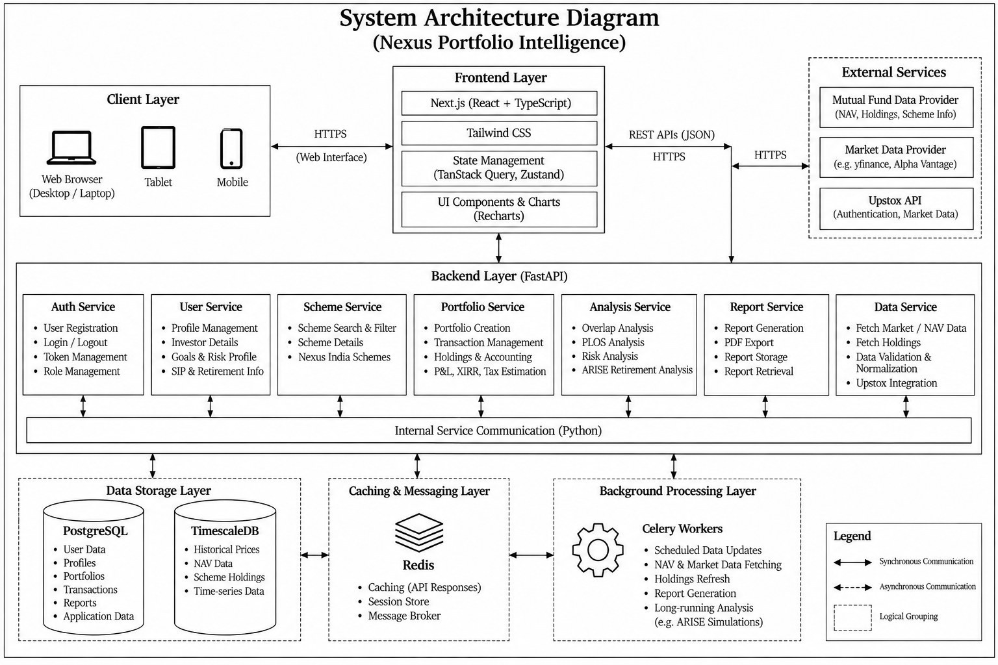
Figure 4.1: Overall System Architecture
The block diagram below expands the architecture into the layers and modules actually present in the code base: the API routers and middleware, the services, the five engines with their trained model artifacts, the data-access fallback chain, the infrastructure containers and the offline data and training pipeline.
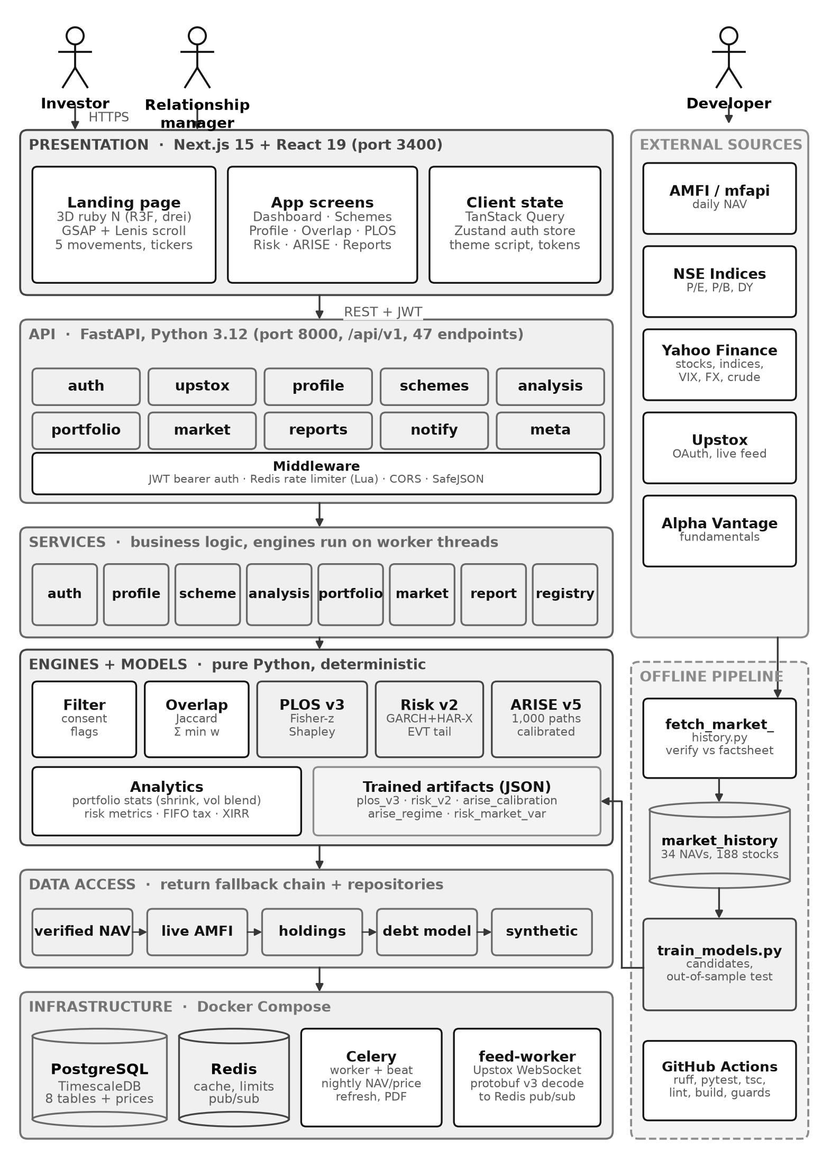
Figure 4.2: Block diagram of the major modules and layers of the implemented system

4.2 Component and Module Description
Table 4.1: Components and modules
Module | Purpose | Inputs | Outputs | Depends on
Web client (Next.js) | Screens, forms, charts, 3D landing page | User actions; API JSON | HTTP requests; rendered pages | API, TanStack Query
API layer (FastAPI routers) | 47 REST operations under /api/v1, validation, auth | HTTP requests | JSON responses, status codes | Services, Pydantic schemas
Middleware | Request ID, JSON logging, rate limiting, CORS, error mapping | Every request | Headers, 429 / 4xx / 5xx bodies | Redis
Auth service | Register, login, token rotation, reuse detection | Credentials, refresh token | JWT pair | users, refresh_tokens
Profile and scheme services | Profile CRUD, filtering, selection, allocation | Profile, scheme IDs, weights | Filter result, selection | Filter engine, DB
Filter engine | Hard blocks and soft flags per scheme | Profile, scheme metadata | 35 schemes with flags and reasons | schemes_metadata.json
Overlap engine | Jaccard and weighted overlap, shared holdings | Scheme IDs | Pair matrix, network edges | sample_holdings.json
PLOS engine (v3) | Predicted co-movement, Shapley, N_eff, clusters | Scheme IDs, weights | Pair scores, N_eff, clusters | Returns, holdings, plos3 artifact
Risk engine (v2) | Volatility forecast, VaR/ES, backtests | Scheme IDs, weights | Risk metrics, VaR/ES, regime | Returns, risk2 artifact
ARISE engine (v5) | Monte Carlo retirement projection | Profile, selection, strategy | Success estimate, paths, strategy table | Portfolio statistics, arise_cal artifact
Portfolio accounting | Ledger, FIFO lots, P&L, XIRR, tax | Transactions, NAVs | Holdings, gains, tax | transactions, NAV loader
Market data loader | Return series with five-tier fallback | Scheme ID, period | ReturnsData with source label | Data files, AMFI, Yahoo, Upstox
Reports and notifications | PDF reports; RM messages | Selection; message | PDF file; inbox items | reports, notifications
Celery worker and beat | Nightly NAV / price refresh, holdings refresh | Schedule | Rows in TimescaleDB | Redis broker, DB
Upstox feed worker | Live quotes over WebSocket | Upstox feed (protobuf) | Quotes published to Redis | Upstox API, Redis
Offline pipeline | Fetch and verify data; train and validate models | Public data | Data files, JSON artifacts, metrics | scripts/

4.3 Architecture Selection and Justification
A layered client–server architecture organised as a modular monolith, with asynchronous background workers, was selected. The reasons are:
- Layering (presentation → API → services → engines → data access → infrastructure) keeps each layer testable: the engines are pure Python with no I/O in their signatures, so they are unit-tested without a server or database.
- Client–server over REST lets the web client, the interactive API documentation and the test suite use the same interface; the API is stateless, so additional uvicorn workers or replicas can be added without code changes.
- A modular monolith rather than microservices. The engines share large in-memory data (holdings, return series, model artifacts). Splitting them into network services would add serialisation cost and operational complexity without benefit at this scale; module boundaries are kept clean so that a heavy engine could be extracted later.
- Event-driven background work. Data refresh and holdings updates run in Celery workers triggered by schedules (Celery beat), and live quotes arrive from a separate feed worker through Redis publish/subscribe, so slow external calls never block user requests.
- CPU-bound engines run on worker threads (anyio.to_thread) so that a long Monte Carlo run does not block the asynchronous event loop that serves other users.
Alternatives considered were a pure serverless design (rejected: cold starts and execution-time limits are unsuitable for multi-second simulations with large in-memory data) and a separate model-serving service (rejected for now: models are small JSON artifacts loaded in-process in milliseconds).

4.4 Data Flow Diagrams
The context-level diagram treats the system as a single process and shows every data flow between it and the external entities: the investor, the market data provider, the authentication service and the database.
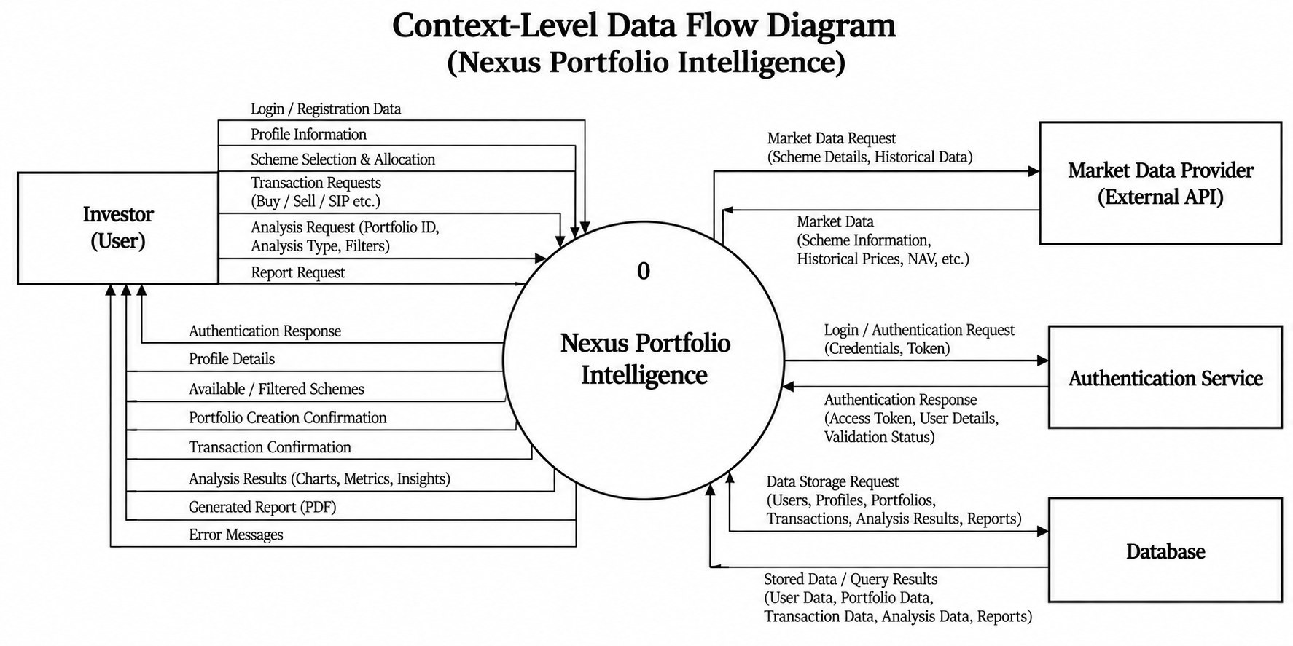
Figure 4.3: Context-Level Data Flow Diagram
The level-1 diagram decomposes the system into six processes — user management, scheme discovery and selection, portfolio creation and transactions, holdings and accounting, portfolio analysis (with its four analysis engines) and report generation — and the data stores they use.
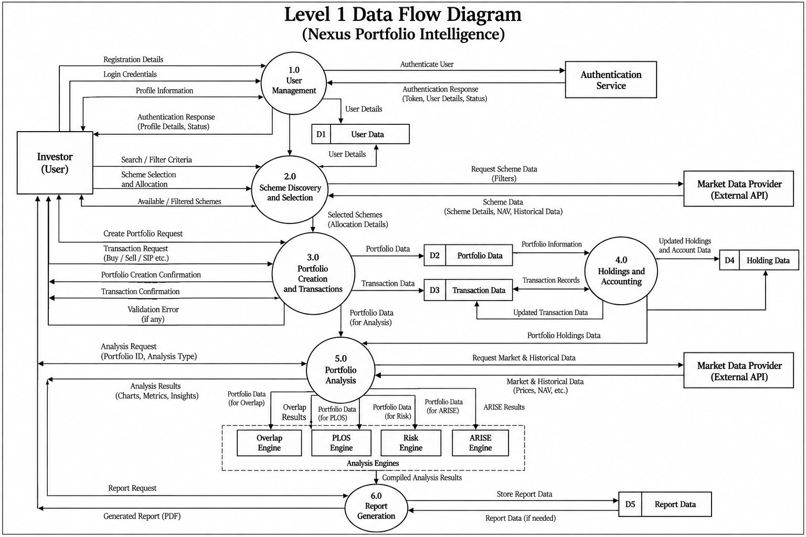
Figure 4.4: Level 1 Data Flow Diagram

4.5 UML Diagrams

4.5.1 Use Case Diagram
The investor is the primary actor and initiates every analytical use case. Include relationships show mandatory sub-functions (for example, login includes authentication and session management) and extend relationships show optional behaviour (for example, filtering by risk level, category or goal). Secondary actors are the system administrator, the market data provider, the mutual fund data source and Upstox.
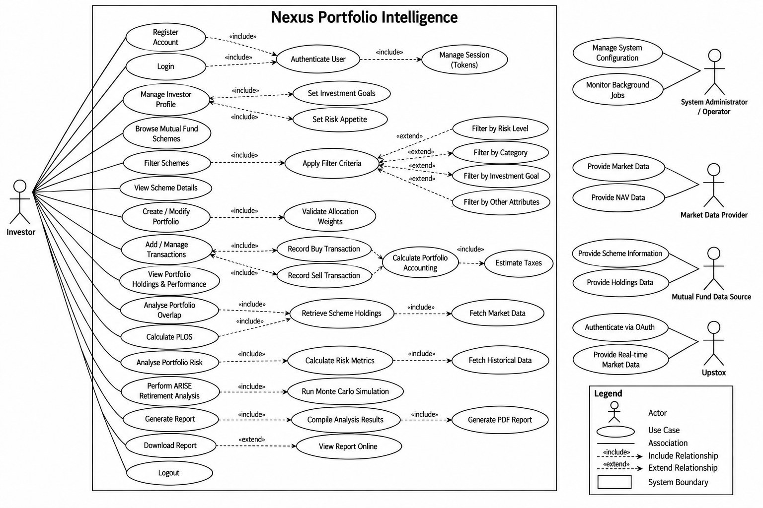
Figure 4.5: Use Case Diagram

4.5.2 Class Diagram
The class diagram shows the domain classes (user, investor profile, scheme, scheme selection, transaction, holding, report and Upstox connection) with their attributes, operations, associations and multiplicities, together with the analysis service and the overlap, PLOS, risk, ARISE, filter and market-data components it coordinates.
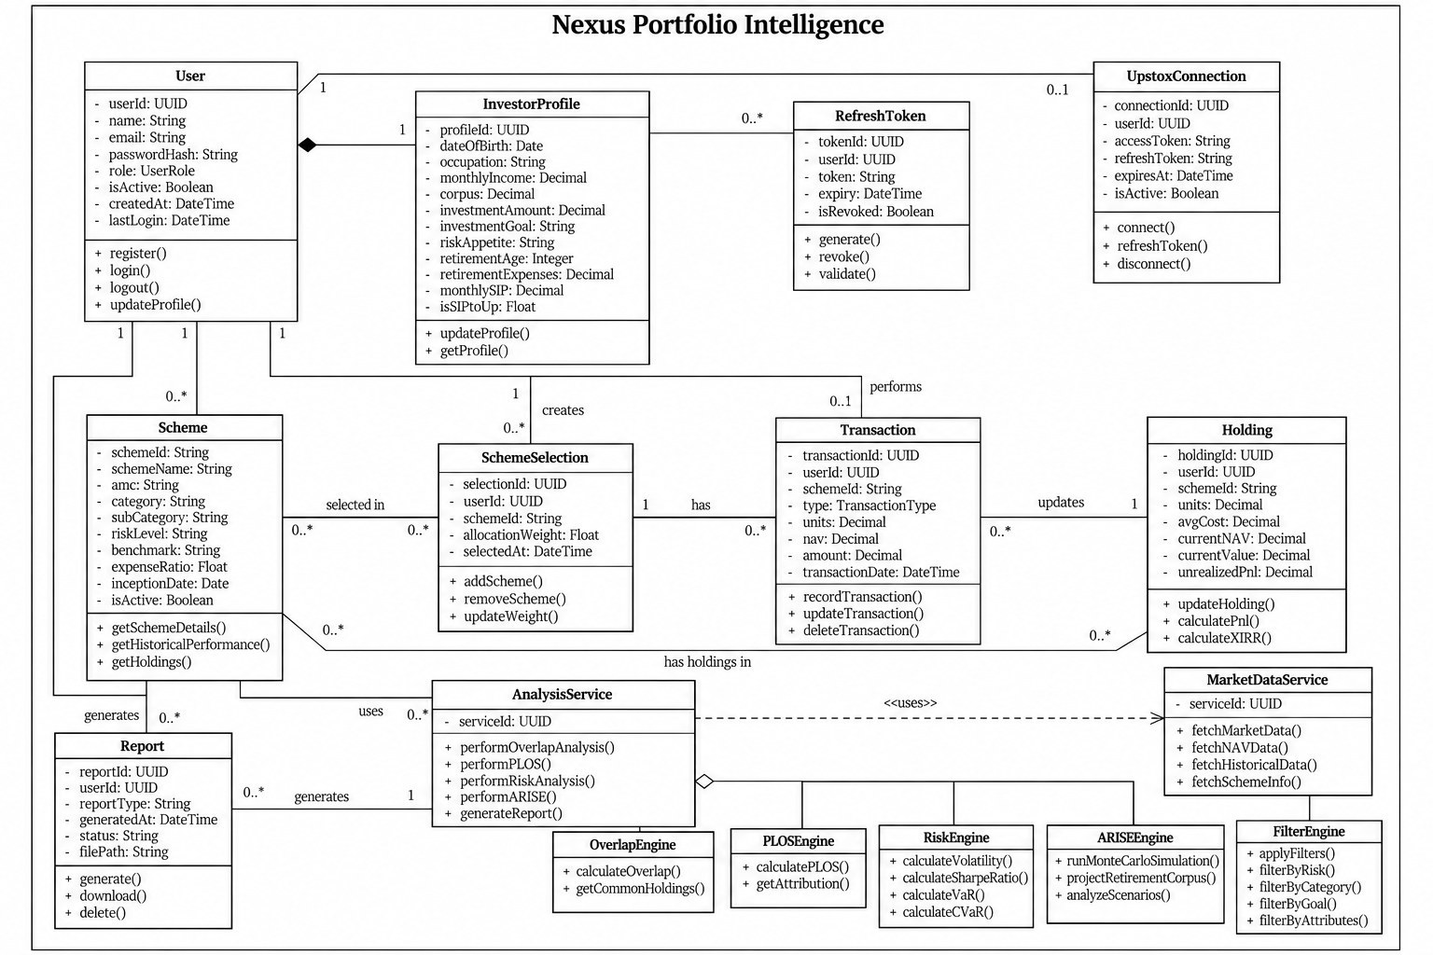
Figure 4.6: Class Diagram

4.5.3 Sequence Diagram
The sequence diagram traces the complete portfolio-analysis workflow in six phases — authentication, investor profile, scheme discovery and selection, portfolio creation and transactions, portfolio analysis and report generation — using alt, loop and par fragments for alternative paths, repeated transactions and the four engines.
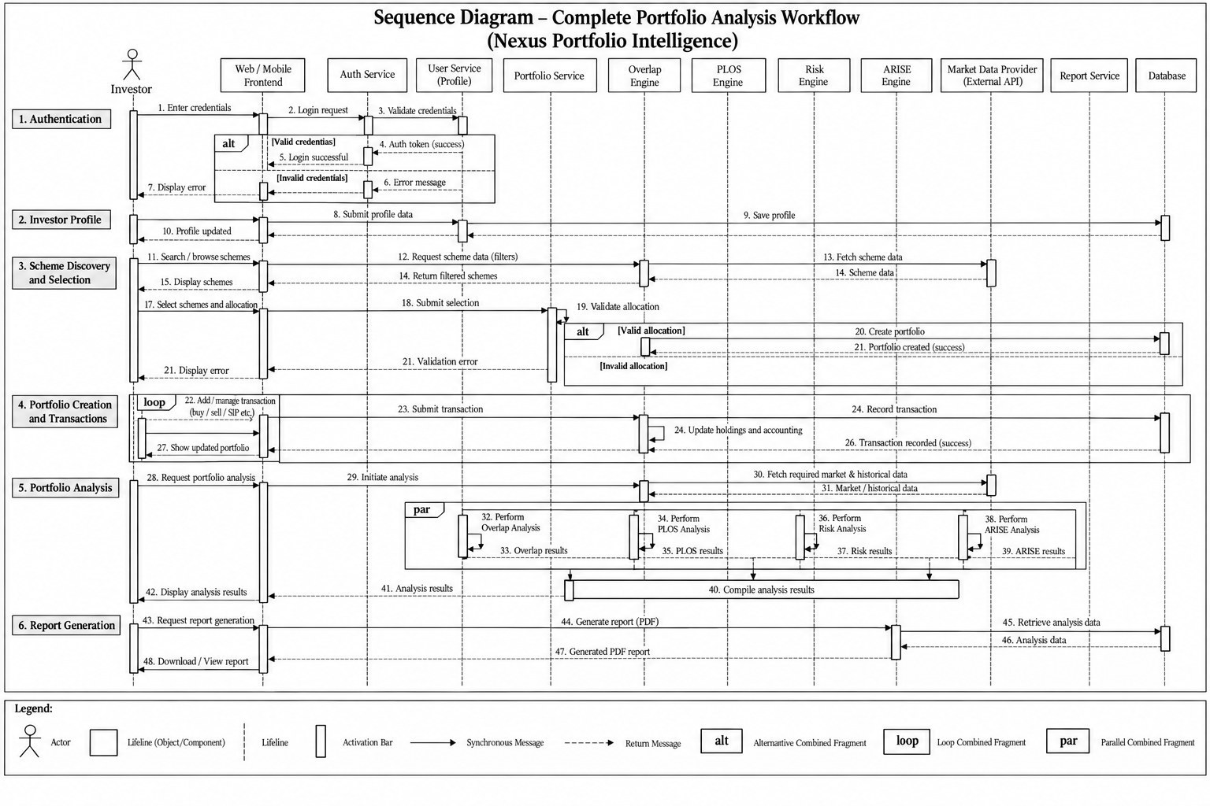
Figure 4.7: Sequence Diagram: Complete Portfolio Analysis Workflow

4.5.4 Collaboration Diagram
The collaboration diagram shows the same interaction organised around the objects instead of time, with numbered messages between the investor, frontend, services, analysis engines, market data provider and database.
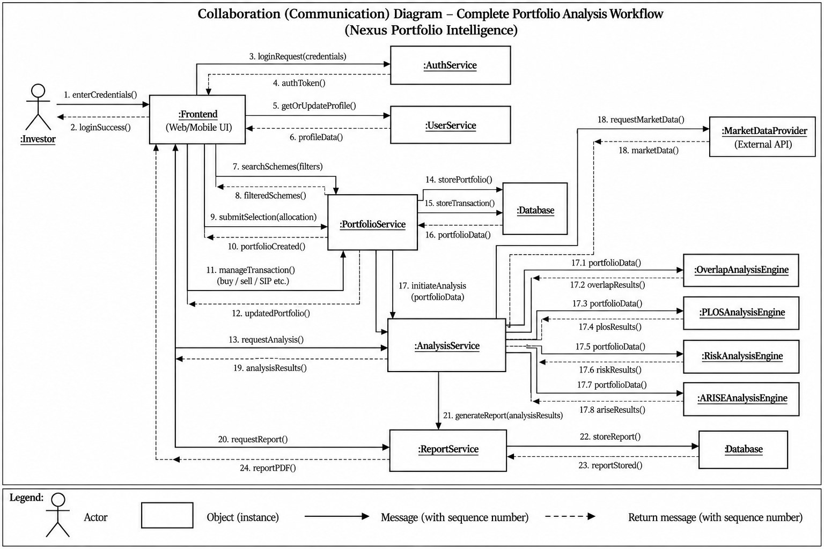
Figure 4.8: Collaboration Diagram: Complete Portfolio Analysis Workflow

4.5.5 Activity Diagram
The activity diagram uses swimlanes for the investor, the system and external services, with decision nodes for credential validation, profile completeness and allocation validity, and a fork and join for the four analyses.
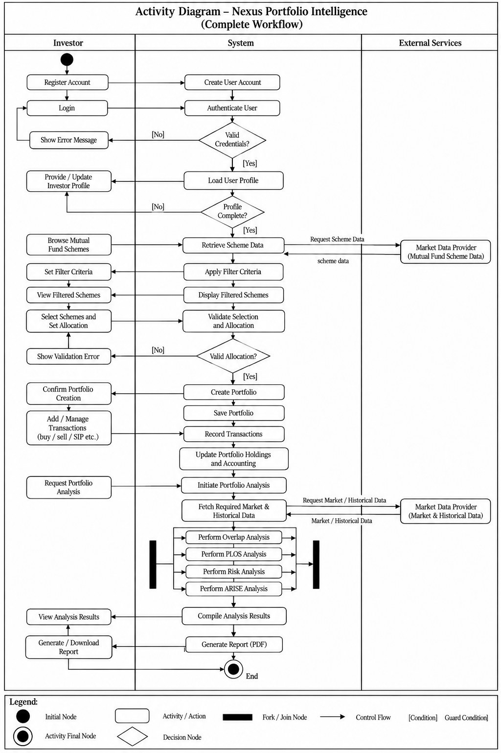
Figure 4.9: Activity Diagram: Complete Portfolio Workflow

4.5.6 State Machine Diagrams
Three objects in the system have an explicit life cycle. (a) An investor account becomes analysable only after a profile, a selection and an allocation exist; an analysis requested earlier is rejected with a 4xx status and the state does not change. (b) A refresh token is active until it is used, logged out or expires; using it rotates it, and presenting a rotated or revoked token again is treated as theft, which revokes every token of that user. (c) A PDF report is created in the generating state and ends as completed or failed.
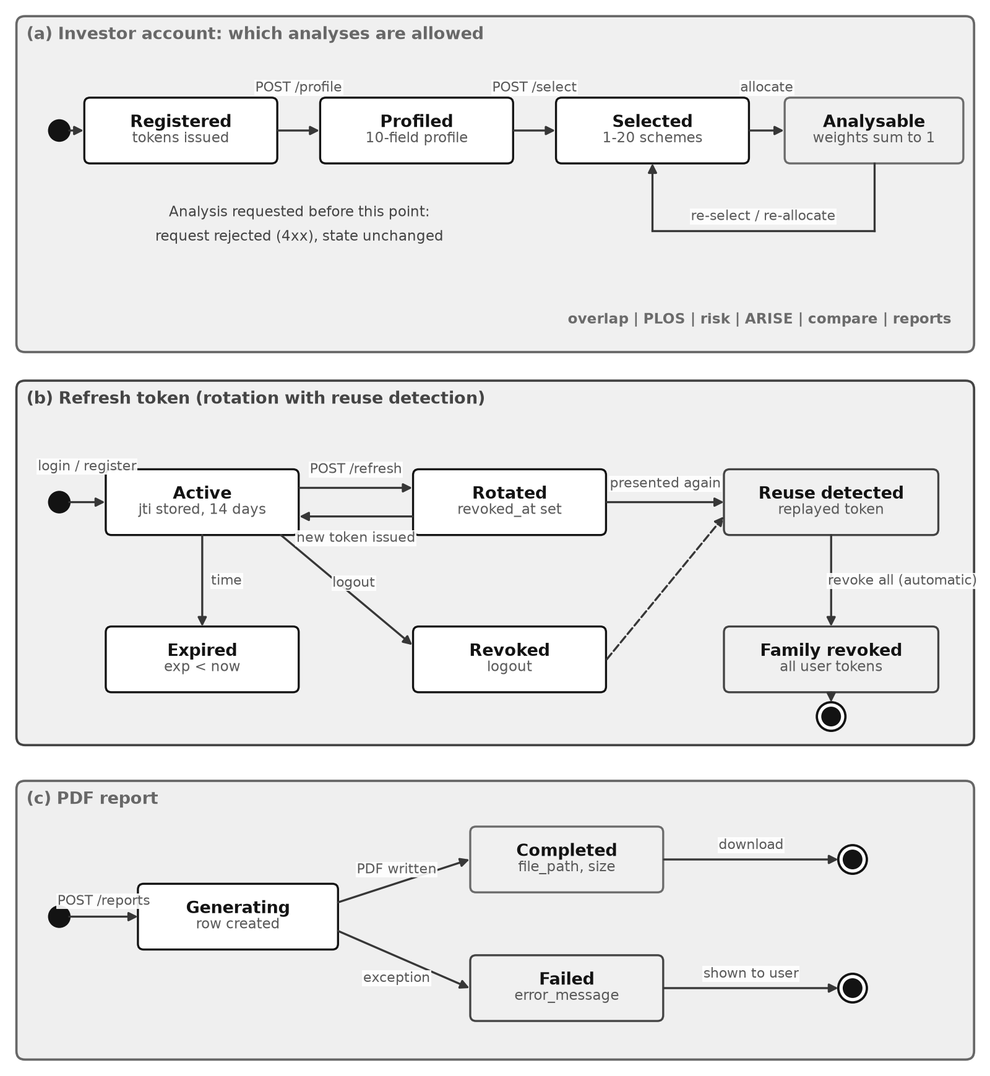
Figure 4.10: State machine diagrams: account, refresh token and report

4.5.7 Deployment Diagram
All components run as Docker containers defined in one compose file. The web container (Node 20, non-root user) serves Next.js on port 3400; the API container (Python 3.12, uvicorn with four worker processes) serves FastAPI on port 8000; Celery worker, Celery beat and the Upstox feed worker run alongside; PostgreSQL 16 with TimescaleDB 2.28 and Redis 7 keep their data in named volumes.
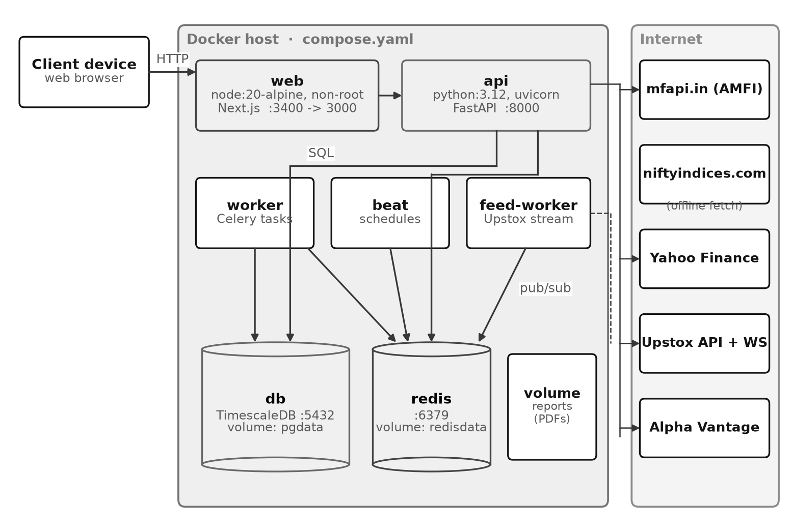
Figure 4.11: Deployment diagram (Docker Compose)

4.6 Database Design

4.6.1 Entity-Relationship Diagram
The conceptual ER diagram models users, investor profiles, scheme selections, schemes, transactions, holdings, market data, analysis results, reports and the external Upstox connection with their keys and cardinalities.
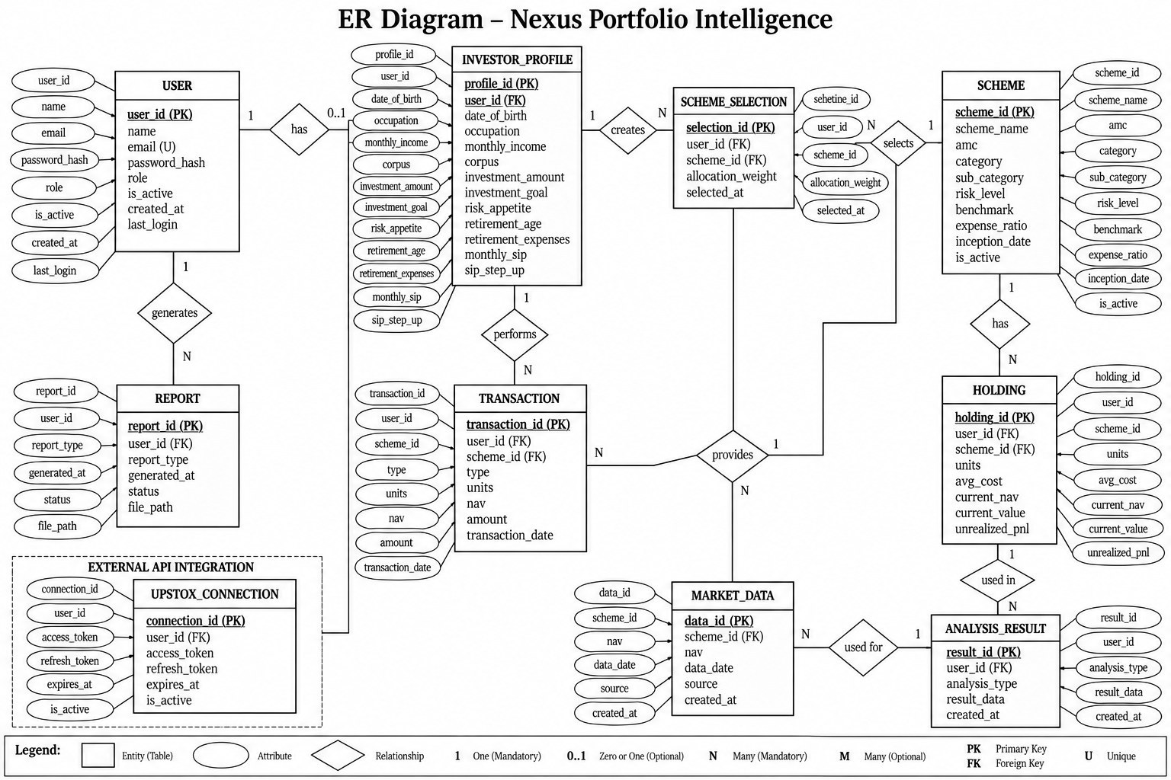
Figure 4.12: Entity-Relationship Diagram (conceptual)
In the implementation, three of the conceptual entities are not database tables. Scheme metadata and factsheet holdings are versioned data files (schemes_metadata.json and sample_holdings.json) loaded into memory, because they change only when factsheets are re-imported; holdings positions are computed from the transaction ledger (Section 5.2) instead of being stored as running balances, so a back-dated correction cannot make them drift; and analysis results are computed on request rather than persisted. Market data is stored in the TimescaleDB tables listed below.

4.6.2 Relational Schema with Keys
Table 4.2: Relational schema
Table | Primary key | Foreign keys | Other columns
users | id (UUID) | — | email (unique), hashed_password, full_name, role, is_active, created_at, updated_at
refresh_tokens | id | user_id → users.id (cascade) | jti (unique), expires_at, revoked_at, created_at
investor_profiles | id | user_id → users.id (unique, cascade) | date_of_birth, occupation, monthly_income, total_corpus, investment_amount, goal, risk_appetite, target_retirement_age, monthly_expenses_in_retirement, monthly_sip, sip_step_up_pct
scheme_selections | id | user_id → users.id (unique, cascade) | selected_scheme_ids (JSON), weights (JSON)
transactions | id | user_id → users.id (cascade) | scheme_id, txn_type, units NUMERIC(18,4), nav NUMERIC(14,4), amount NUMERIC(18,2), txn_date, external_ref
reports | id | user_id → users.id (cascade) | status, scheme_ids (JSON), file_path, file_size_bytes, error_message
notifications | id | investor_user_id → users.id (cascade); rm_user_id → users.id (set null) | notification_type, subject, body, delivery_channel, is_read, related_object_type/id
upstox_connections | id | user_id → users.id (unique, cascade) | upstox_user_id (unique), user name, email, exchanges, products, has_extended_token, last_connected_at
tsdb.stock_prices | (ticker, date) | — | open, high, low, close, volume, daily_return, source — hypertable on date
tsdb.fund_nav_history | (scheme_id, date) | — | nav — hypertable on date
tsdb.corporate_actions | (ticker, date, action_type) | — | value

4.6.3 Integrity Constraints
- Entity integrity: every table has a primary key; application tables use random UUIDs so identifiers cannot be guessed or enumerated.
- Referential integrity: every user-owned row references users.id with ON DELETE CASCADE, so deleting an account removes its data; the relationship manager on a notification uses ON DELETE SET NULL so the investor keeps the message.
- Uniqueness: users.email, refresh_tokens.jti and upstox_connections.upstox_user_id are unique; investor_profiles, scheme_selections and upstox_connections have a unique user_id (one-to-one); transactions have UNIQUE (user_id, external_ref), which makes an imported transaction idempotent.
- Domain integrity: NOT NULL on required columns; exact NUMERIC types for money and units (never floating point); value ranges, date logic and weight sums are validated by Pydantic before any write.

4.6.4 Normalisation
The transactional schema is in third normal form: every non-key attribute depends on the whole key and on nothing else (for example, a transaction stores units, NAV and amount but not the scheme’s name, which is looked up from scheme metadata). Two deliberate exceptions are documented: scheme_selections stores the selected IDs and weights as JSON, because they are always read and written together as one allocation and never queried individually; and transactions store amount alongside units and NAV, because the amount actually paid (including rounding by the fund house) is the legal record for tax and must not be recomputed.

4.6.5 Indexing Strategy
Table 4.3: Indexing strategy
Index | Columns | Query served
ix_users_email (unique) | users(email) | Login lookup by email
ix_refresh_tokens_jti (unique) | refresh_tokens(jti) | Token rotation and reuse check
idx_txn_user_scheme_date | transactions(user_id, scheme_id, txn_date) | FIFO lot matching: one user’s ledger for one scheme, oldest first — a single ordered index scan (verified with EXPLAIN)
uq_txn_user_external_ref | transactions(user_id, external_ref) | Idempotent import of broker transactions
idx_notifications_investor_created | notifications(investor_user_id, created_at) | Inbox, newest first
Foreign-key indexes | user_id on each user-owned table | Per-user reads and cascade deletes
idx_stock_prices_date, idx_fund_nav_date | date DESC | Latest prices and NAVs
Hypertable chunks | Time partitions on date | Range scans touch only the relevant chunks (277 chunks for 233,258 price rows)

4.6.6 Sample Records
The first three records below were read from the running development database (the selection belongs to a benchmark account created for Chapter 8). The development ledger contained no transactions, so the last row is an illustrative example of the stored format.
Table 4.4: Sample records
Table | Representative record
scheme_selections | selected_scheme_ids = [nippon-large-cap-fund, nippon-flexi-cap-fund, nippon-small-cap-fund, nippon-corporate-bond-fund]; weights = {0.35, 0.25, 0.20, 0.20}
tsdb.stock_prices | ticker = ABB.NS, date = 2026-10-23, close = 6140, daily_return = -0.0515, source = yfinance
tsdb.fund_nav_history | scheme_id = nippon-vision-large-mid-cap-fund, date = 2026-10-21, nav = 77.33
transactions (illustrative) | txn_type = sip, units = 52.3412, nav = 95.5300, amount = 5000.00, txn_date = 2026-04-05, external_ref = null

4.7 Security and Error Handling Design
- Authentication: passwords are pre-hashed with SHA-256 (so bcrypt’s 72-byte limit can never truncate them) and stored with bcrypt at cost 12. Access tokens are HS256 JWTs valid for 30 minutes; refresh tokens are valid for 14 days, stored by their unique jti, rotated on every use, and reuse of a rotated token revokes all of the user’s tokens.
- Authorisation: every query for user data is filtered by the authenticated user’s ID, so one user cannot read another’s profile, selection, transactions or reports (tested as IDOR cases); relationship-manager functions require the RM role.
- Input validation: all request bodies are Pydantic models with types, ranges and custom validators (for example, no duplicate scheme IDs, weights that sum to 1, between 100 and 5,000 simulation paths).
- Rate limiting: a Redis sliding-window limiter, executed atomically as a Lua script, allows 10 requests per minute on authentication routes, 12 on analysis routes, 6 on reports and 120 elsewhere; if Redis is down it falls back to an in-process limiter rather than rejecting traffic.
- Error handling: domain errors (not found, forbidden, insufficient data, rate limited) map to consistent JSON error bodies with the right status codes; unexpected exceptions return a generic 500 message without internal details; NaN values are converted to null so responses are always valid JSON.
- Logging: every request gets an X-Request-ID that appears in structured JSON logs with method, path, status and duration, so a user-reported error can be traced.
- Protection of secrets and data: keys and passwords live only in an environment file that is excluded from version control, and a CI job fails if an environment file is ever committed; CORS allows only the configured frontend origins; containers run as non-root users.
- Resilience: every external data source has a fallback (Section 5.2, Algorithm 9), and engines report which data source they used.
CHAPTER 5

ALGORITHM DESIGN AND DATA STRUCTURES

5.1 Identification of Critical Operations
Table 5.1: Critical operations
# | Operation | Trigger | Why critical
O1 | Scheme eligibility filtering | Scheme discovery screen | Runs on every visit; must explain every exclusion
O2 | Pairwise overlap (Jaccard, weighted) | Overlap screen, dashboard | Quadratic in the number of schemes
O3 | PLOS scoring, Shapley explanation, N_eff and clustering | PLOS screen, dashboard | Exponential explanation step; model must be monotone
O4 | Volatility forecast and VaR/ES | Risk screen, dashboard | Most CPU-intensive interactive request
O5 | Monte Carlo retirement simulation | ARISE screen | Thousands of 40–60-year paths per request
O6 | FIFO lot matching and capital-gains tax | Ledger, P&L, holdings | Must be exact to the paisa
O7 | Distributed rate limiting | Every request | Must be atomic across processes
O8 | Return-series retrieval with fallback | Every analysis | External sources fail or return wrong data
O9 | Token rotation with reuse detection | Every session refresh | Security-critical state change

5.2 Algorithm Design
This section presents each major operation as pseudocode, together with the mathematical definitions it implements.

Algorithm 1: Eligibility filter (O1)
FILTER(profile, schemes, held):
for each scheme s in schemes: # all 35 are always returned
hard ← [], soft ← []
if age < s.min_age or age > s.max_age: hard.add(age reason)
if income < s.min_monthly_income: hard.add(income reason)
if amount outside [s.min_inv, s.max_inv]: hard.add(amount reason)
if s in held: hard.add(already held)
if goal = tax_saving and s is not ELSS: hard.add(Section 80C reason)
if s.risk_score not allowed for risk_appetite:
soft.add(risk note with real volatility); level ← mild or strong
if goal not compatible with s.suitable_for: soft.add(goal note)
emit (s, eligible = hard is empty, hard, soft, level)
Hard blocks are reserved for objective or legal facts; risk and goal mismatches are flags with reasons, because every Nippon India equity scheme carries the highest SEBI riskometer level and hiding them would remove all equity from a moderate investor’s view.

Algorithm 2: Pairwise overlap (O2)
For schemes A and B with normalised holding-name sets (names lower-cased, footnote marks removed, and the rows “equity less than 1% of corpus” and “cash and other receivables” excluded), the name overlap and money overlap are:
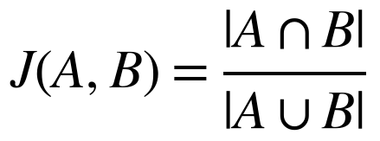 (5.1)
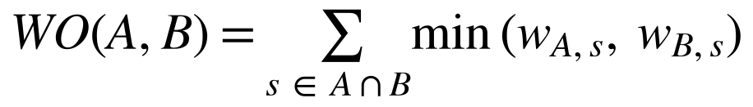 (5.2)
OVERLAP(ids):
for each scheme a: H[a] ← hash map name → weight # built once, O(h)
for each pair (a, b), a < b:
S ← keys(H[a]) ∩ keys(H[b]) # iterate the smaller map
J ← |S| / (|H[a]| + |H[b]| − |S|)
WO ← Σ_{s∈S} min(H[a][s], H[b][s])
top ← the 10 shared names with the largest min-weight
return symmetric matrix (diagonal 1), edges above threshold

Algorithm 3: PLOS scoring and explanation (O3)
PLOS predicts the correlation of two funds’ weekly returns over the next year from ten layers: (1) total return correlation, (2) residual correlation after the Nifty 50 and mid-cap factors, (3) factor-exposure similarity, (4) holdings-implied correlation, (5) sector-style similarity, (6) weighted overlap, (7) Jaccard, (8) top-10 Jaccard, (9) sector cosine and (10) same category. The stock covariance is shrunk (5.3) and combined with each fund’s weights (5.4); correlations are mapped to Fisher-z (5.5); the model is linear and monotone in z (5.6) with weights learned by non-negative ridge regression shrunk toward the hand-set weights (5.7):
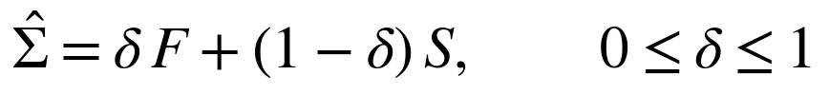 (5.3)
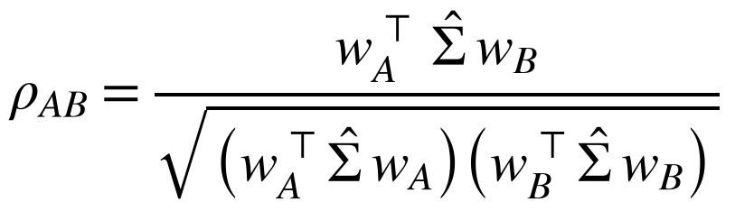 (5.4)
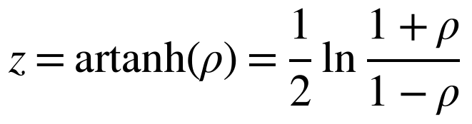 (5.5)
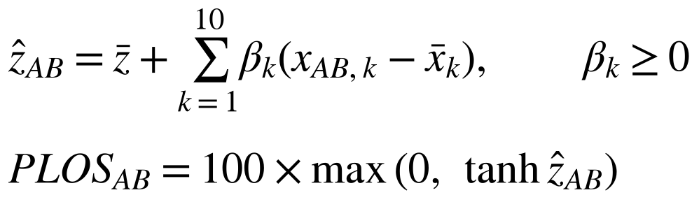 (5.6)
(5.7)
Each layer’s contribution is its exact Shapley value (5.8), computed over all 2^10 = 1,024 coalitions, and the effective number of independent funds is (5.9):
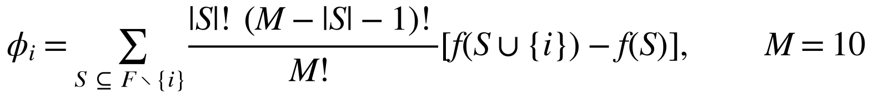 (5.8)
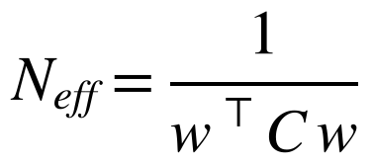 (5.9)
PLOS(ids, w):
for each pair (a, b): x[a,b] ← the ten layer values
(holdings layers only for pairs of the same asset type)
for each pair: z ← z̄ + β·(x − x̄); score ← 100·max(0, tanh z)
for each pair: φ ← SHAPLEY(model, x, baseline) # 1,024 masks, vectorised
C ← matrix of predicted correlations; N_eff ← 1 / (wᵀ C w)
clusters ← average-linkage on distance 1 − C, cut at the redundancy threshold

Algorithm 4: Volatility forecast and VaR/ES (O4)
Market realised variance is measured with the Garman–Klass estimator (5.10) and forecast with HAR-X (5.11). Each fund’s own GARCH(1,1) variance (5.12) is blended with the HAR-X forecast mapped through the portfolio’s beta (5.13). VaR and ES at 95% use filtered historical simulation (5.14); at 99% a generalised Pareto tail is fitted above the 90th-percentile loss (5.15):
(5.10)
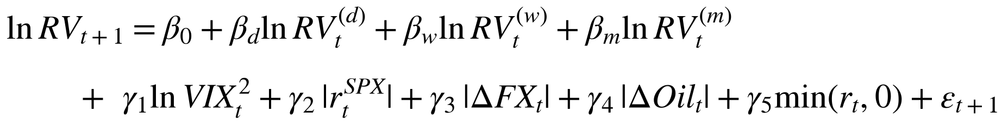 (5.11)
(5.12)
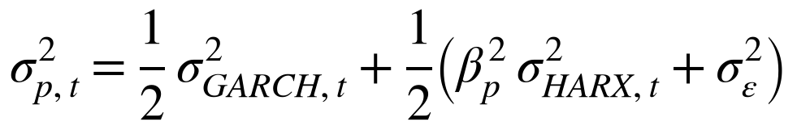 (5.13)
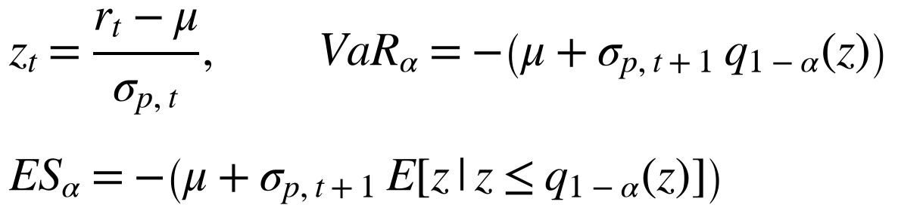 (5.14)
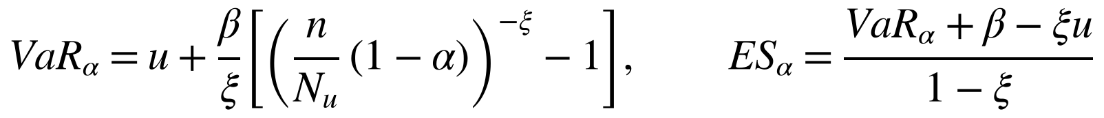 (5.15)
RISK(ids, w):
r ← portfolio daily returns from FALLBACK(ids) and w
fit GARCH(1,1) by maximum likelihood → σ²_GARCH,t+1
σ²_HARX ← HAR-X artifact applied to today's Nifty RV, VIX, S&P 500, FX, crude
β, σ²_ε ← regression of r on Nifty; σ²_p ← ½σ²_GARCH + ½(β²σ²_HARX + σ²_ε)
z ← standardised residuals; sort z
VaR95, ES95 ← empirical quantile and tail mean of z, rescaled by σ_p
fit GPD to the losses above u = 90th percentile → VaR99, ES99
10-day: sum daily variances that revert toward the long-run level
backtest: Kupiec and Christoffersen on the rolling history

Algorithm 5: ARISE Monte Carlo retirement simulation (O5)
Each lifetime j draws its own expected return to represent estimation risk (5.16–5.18); volatility is blended with its long-run level (5.20); a dividend-yield prior (5.21) applies to the first five years; the absence of mean reversion is justified by the variance ratio (5.19); success is reported with a Jeffreys interval (5.22):
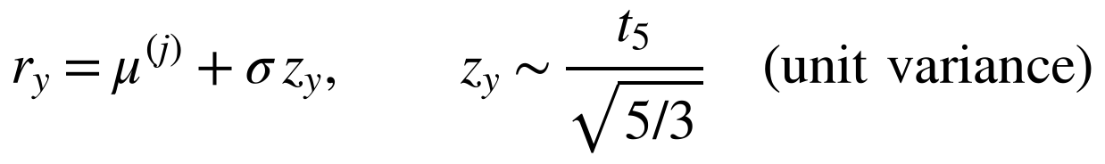 (5.16)
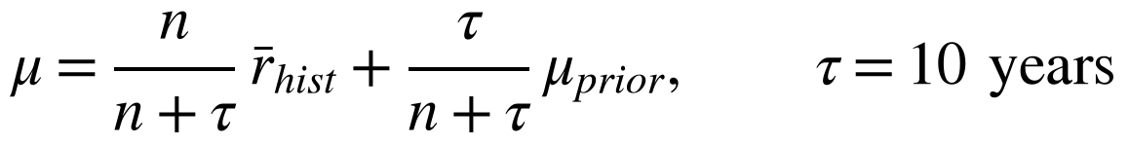 (5.17)
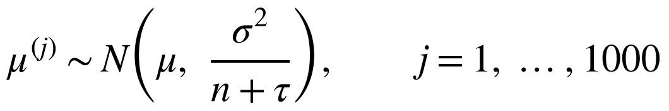 (5.18)
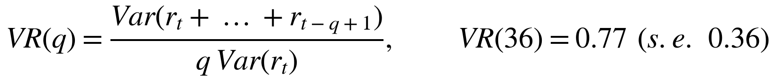 (5.19)
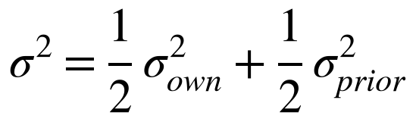 (5.20)
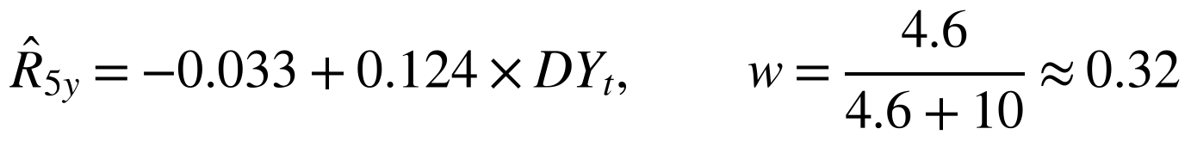 (5.21)
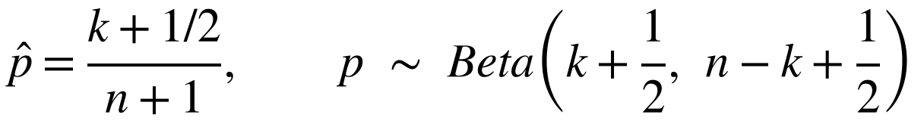 (5.22)
ARISE(profile, w, N paths, strategy):
μ, σ ← shrunk portfolio statistics; rng ← seeded generator
for j in 1..N:
μ_j ← μ + draw(σ / √(n + τ)); lifespan_j ← Gompertz draw (to 105)
shocks ← unit-variance Student-t(5) for every year
inflation ← block bootstrap of historical CPI
for each year y until lifespan_j:
if working: corpus ← corpus·(1 + r_y) + SIP·(1 + step-up)^y
else: withdrawal ← STRATEGY(corpus, spending, guardrails); tax on gains
corpus ← (corpus − withdrawal)·(1 + r_y)
if corpus ≤ 0: mark path as failed
k ← successful paths; report (k + ½)/(N + 1) with Beta(k + ½, N − k + ½) interval
repeat with common random numbers for the other strategies (leaderboard)

Algorithm 6: FIFO lot matching and capital-gains tax (O6)
REDEEM(lots, sell_units, sell_nav, sell_date):
Q ← deque(lots sorted by (txn_date, txn_id)) # oldest first
if sell_units > Σ units in Q: raise InsufficientUnits
while sell_units > 0:
lot ← Q.front; take ← min(lot.units, sell_units)
gain ← take·(sell_nav − lot.nav) # Decimal arithmetic
type ← LTCG if held > 365 days (equity) / 730 days (old debt) else STCG
if take = lot.units: Q.popleft() else: Q.front.units −= take
sell_units −= take
tax ← 20% of equity STCG + 12.5% of (equity LTCG − ₹1,25,000 annual exemption)

Algorithm 7: Sliding-window rate limiter (O7)
ALLOW(client, bucket, limit, window): # one atomic Lua script in Redis
key ← client + bucket
ZREMRANGEBYSCORE key 0 (now − window) # forget old requests
if ZCARD key ≥ limit: return DENY, retry_after from the oldest score
ZADD key now unique_id; PEXPIRE key window
return ALLOW
on Redis failure: same algorithm on an in-process deque per key (fail open)

Algorithm 8: Token rotation with reuse detection (O9)
REFRESH(token):
claims ← verify signature and expiry; row ← refresh_tokens[claims.jti]
if row.revoked_at is set: # a used token came back
revoke every token of row.user_id; return 401
row.revoked_at ← now; issue new access + refresh pair; store new jti

Algorithm 9: Return series with fallback (O8)
RETURNS(scheme, period):
if verified NAV file < 30 days old and has scheme:
return (returns, 'amfi_nav_verified')
if live AMFI NAV for the verified code passes the name check:
return (returns, 'amfi_nav')
if equity and holdings prices exist:
return (Σ weight·stock returns − TER, 'holdings')
if debt: return (duration/YTM model, 'debt_model')
return (regime-switching synthetic series, 'synthetic') # 0 years of evidence

5.3 Flowcharts
The two main user-facing processes and the two most complex internal processes are shown as flowcharts.
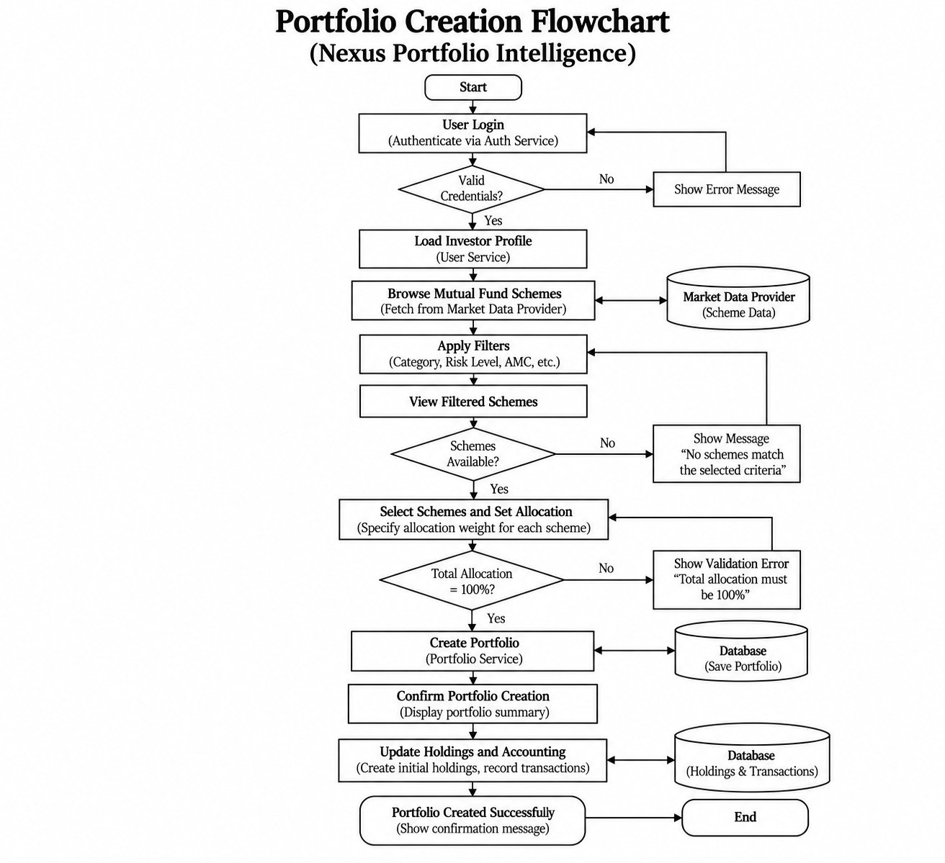
Figure 5.1: Portfolio Creation Flowchart
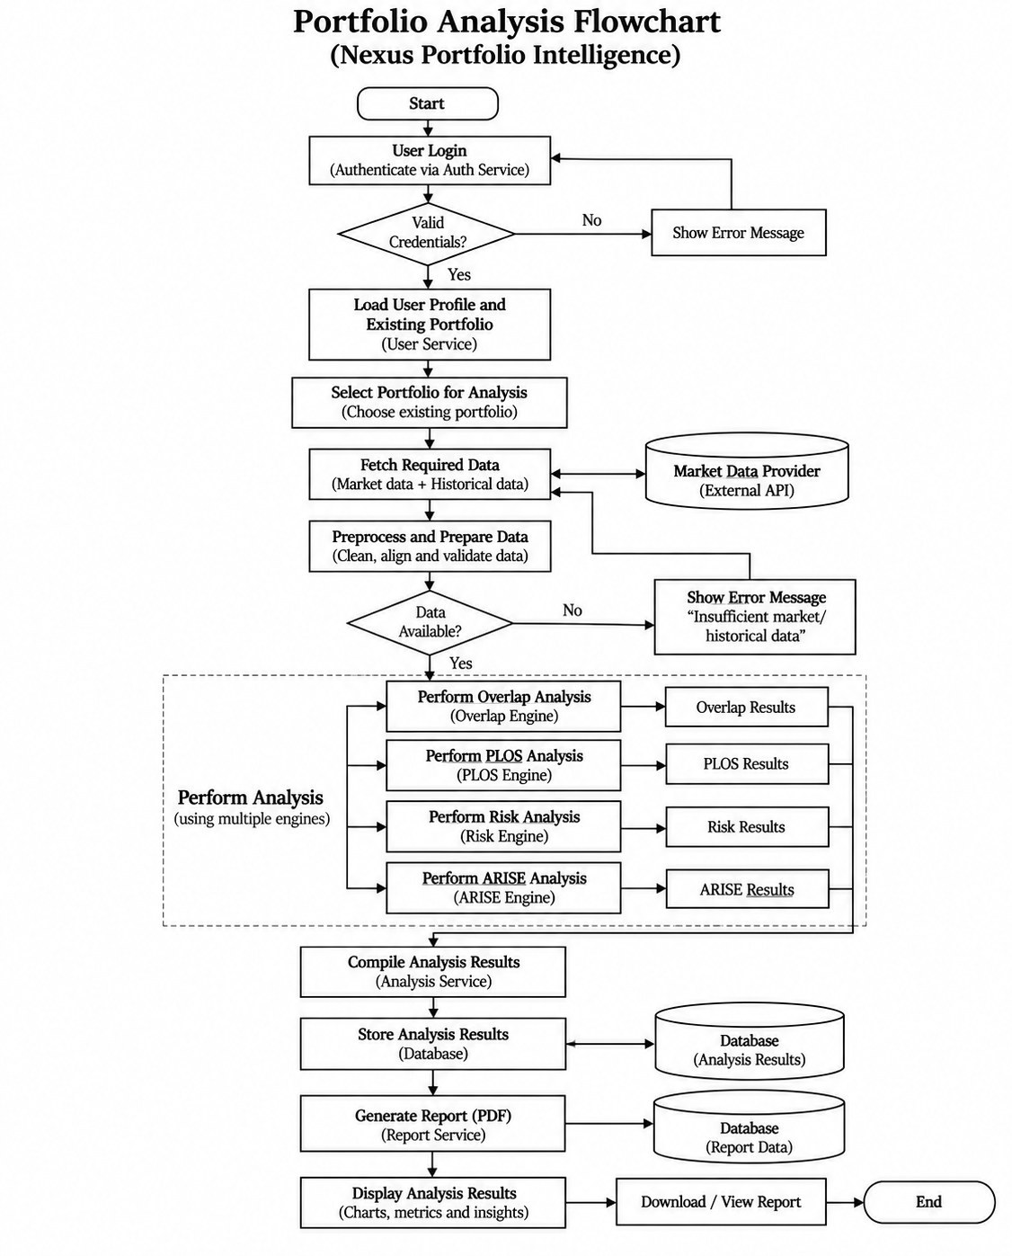
Figure 5.2: Portfolio Analysis Flowchart
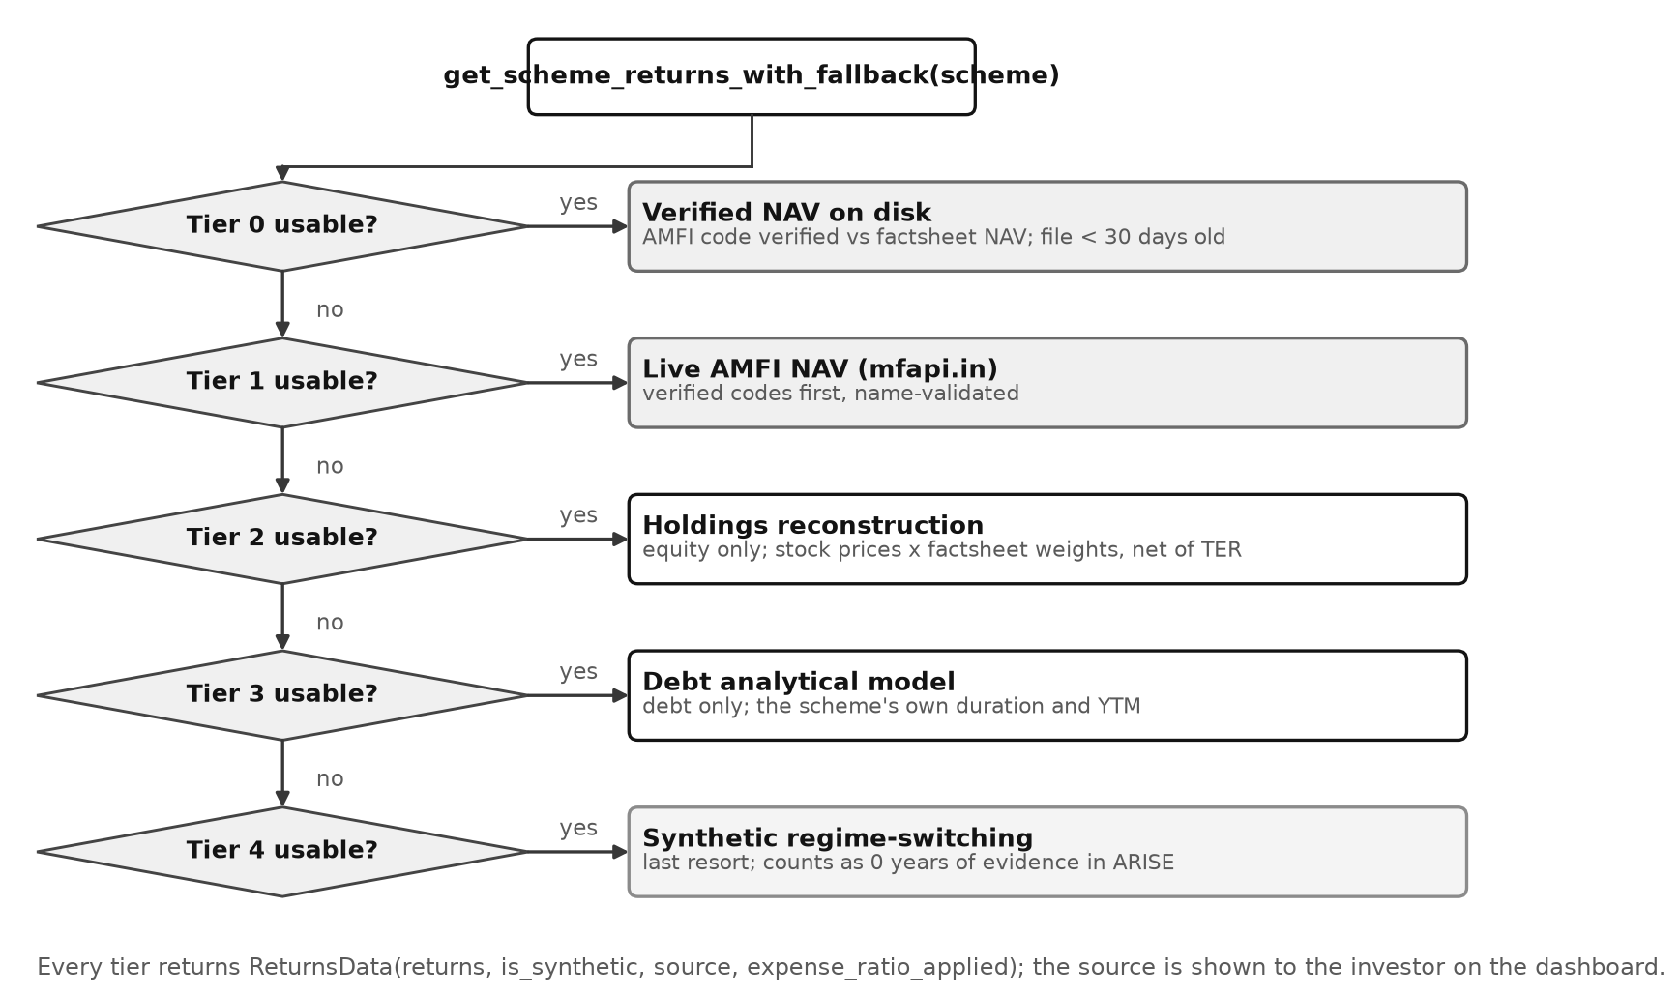
Figure 5.3: Flowchart of the return-data fallback chain (Algorithm 9)
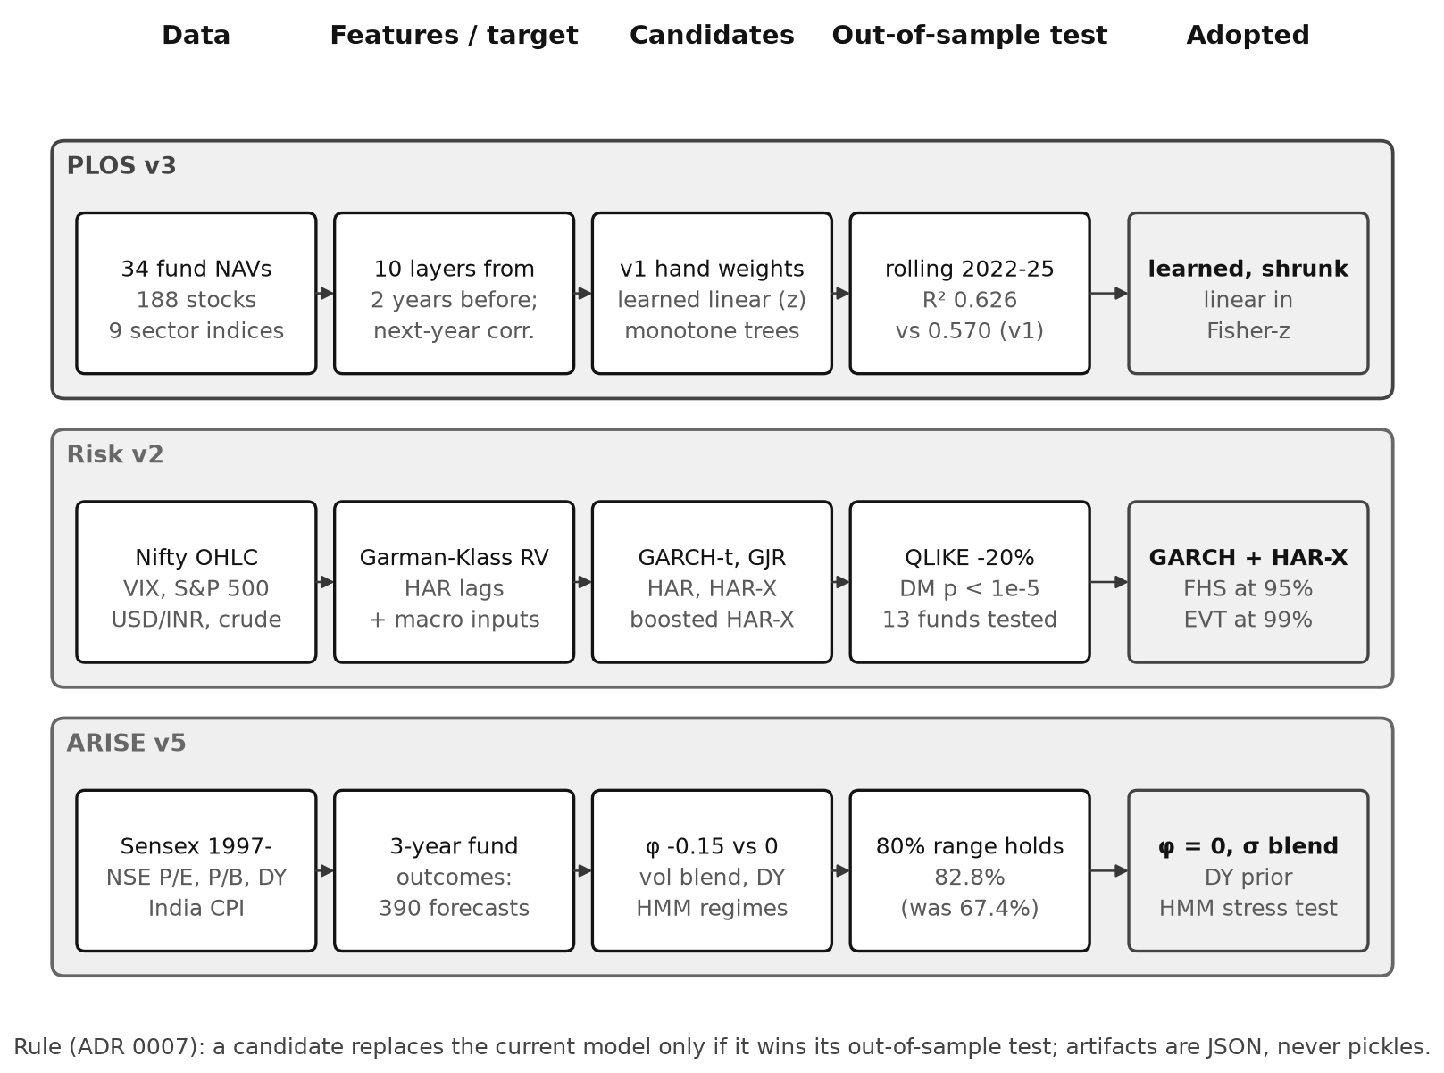
Figure 5.4: Model training and selection pipeline, one lane per engine

5.4 Data Structure Selection
Table 5.2: Data structures and their use
Data structure | Where used | Reason
Hash map (dict) and hash set | Holdings name → weight per scheme; engine registry; schemes by ID | O(1) average lookup makes set intersection linear in the smaller set
Double-ended queue (deque) | Open FIFO lots; in-process rate-limit timestamps | O(1) removal from the front (oldest lot, oldest request)
Sorted set (Redis skip list) | Distributed rate-limit window | Range deletion by score and count in O(log n + m)
Dense matrices (NumPy arrays) | Covariance, correlation, overlap and simulation paths | Vectorised arithmetic in compiled code; contiguous memory
Bit masks (Boolean array) | Shapley coalitions (1,024 × 10) | All coalitions evaluated in one vectorised call
Tree (dendrogram) | Average-linkage clustering of funds (PLOS), HRP ordering | Hierarchical grouping of redundant funds
Graph (nodes and weighted edges) | Overlap network view | Funds as nodes, overlap above threshold as edges
B-tree index | PostgreSQL indexes (Section 4.6.5) | Ordered range scans, e.g. one user’s ledger by date
Time-partitioned table (hypertable) | stock_prices, fund_nav_history | Range queries touch only the relevant time chunks
LRU cache (size 1) | Settings, assumptions, model and data files | Load once per process; constant-time reuse

5.5 Algorithm Selection and Justification
Table 5.3: Algorithm selection
Problem | Alternatives compared | Selected | Justification
Set overlap | Nested loops O(h_a·h_b); sorting O(h log h); hashing | Hashing | Linear time; holdings lists are small and unsorted
PLOS model | Hand weights; learned linear (z); gradient-boosted trees | Learned linear, ridge-shrunk to hand weights | Best forward-in-time R² (0.626); monotone; explainable; trees overfit (0.575)
PLOS explanation | Permutation importance; sampled Shapley; exact Shapley | Exact Shapley | Additive and exact; 1,024 evaluations of a linear model is cheap
Volatility | GARCH-t, GJR, HAR, HAR-X, boosted HAR-X | GARCH + HAR-X blend | Lowest QLIKE; DM p < 0.00001; blend passes backtests
Tail risk | Normal VaR; historical; FHS; GARCH-EVT | FHS at 95%, EVT at 99% | Empirical shape where data is ample, GPD where it is scarce
Retirement | Deterministic; bootstrap; regime-switching; Student-t | Student-t with estimation risk | Best calibration on 390 real outcomes; HMM kept as stress test
Lot matching | Average cost; FIFO; LIFO | FIFO | Required by Indian registrars and the Income Tax Act
Rate limiting | Fixed window; token bucket; sliding window | Sliding window | No 2× burst at window edges; exact count
Diversification count | Count of funds; minimum-torsion bets; diversification ratio | Squared diversification ratio | Gives 1.7 for two near-identical funds plus one independent fund; minimum torsion gives 2.9

5.6 Time Complexity Analysis
Let n be the number of selected schemes, h the holdings per scheme (about 30–60), S the number of distinct stocks in the covariance (about 190), T the number of daily observations (about 3,000), M = 10 the PLOS layers, N the Monte Carlo paths, Y the simulated years (40–70) and K = 4 withdrawal strategies.
Table 5.4: Time complexity of critical operations
Operation | Best / average case | Worst case | Dominant term
O1 Filter | Θ(35 · r) | Θ(35 · r) | Fixed rules r per scheme
O2 Overlap | Θ(n² · h) | Θ(n² · h) | Hash intersection per pair
O3 PLOS layers | Θ(n·S² + n²·(S + T)) | same | Holdings-implied wᵀΣw and return correlations
O3 Shapley | Θ(n² · M · 2^M) | same | 1,024 coalitions per pair (constant for M = 10)
O3 N_eff | Θ(n²) | Θ(n²) | Quadratic form wᵀCw
O3 Clustering | Θ(n² log n) | Θ(n³) | Average linkage
O4 GARCH fit | Θ(I · T) | Θ(I · T) | I optimiser iterations over T days
O4 FHS quantiles | Θ(T log T) | Θ(T log T) | Sorting residuals
O5 ARISE | Θ(K · N · Y) | Θ(K · N · Y) | Paths × years × strategies
O6 FIFO redeem | Θ(1) amortised per lot | Θ(L log L) | Initial sort of L lots, then deque pops
O7 Rate limit | Θ(log m) | Θ(log m + e) | Skip-list operations; e expired entries removed

The complexity analysis was checked empirically against the benchmark container (Section 8.6) by timing each analysis while the portfolio size and the number of Monte Carlo paths were increased. Each value is the median of three warm requests.
Table 5.5: Measured response time against portfolio size
Schemes n | Pairs | Overlap (ms) | PLOS (ms) | Risk (ms)
2 | 1 | 5.8 | 11.4 | 1029.7
4 | 6 | 4.0 | 42.9 | 1171.0
6 | 15 | 4.7 | 100.6 | 1380.6
8 | 28 | 5.4 | 185.6 | 1354.6
10 | 45 | 8.0 | 287.8 | 1589.5
12 | 66 | 10.7 | 431.8 | 1736.4
16 | 120 | 8.7 | 772.6 | 1423.2
20 | 190 | 11.9 | 1184.8 | 1455.4

Table 5.6: Measured ARISE response time against number of paths
Monte Carlo paths N | ARISE response (ms) | Time per path (ms)
100 | 350.3 | 3.50
250 | 794.1 | 3.18
500 | 1570.5 | 3.14
1,000 | 3139.3 | 3.14
2,000 | 6200.4 | 3.10
5,000 | 15276.8 | 3.06

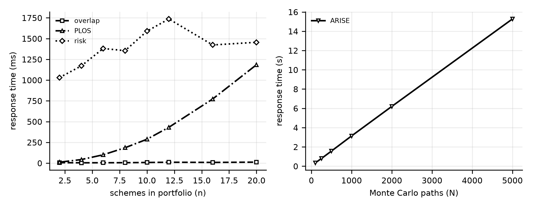
Figure 5.5: Empirical growth of response time with input size
Overlap time grows slowly because each pair costs only a hash intersection, and request overheads dominate at this size. PLOS grows with the number of pairs, as predicted by the n² terms. Risk time grows roughly linearly with n because a GARCH model is fitted for each fund. ARISE time grows linearly with N after a fixed overhead for loading statistics and running the stress test and calibration, confirming the Θ(K·N·Y) analysis.

5.7 Space Complexity Analysis
Table 5.7: Space complexity
Operation | Extra space | Notes
O2 Overlap | Θ(n · h + n²) | Hash maps plus the pair matrix
O3 PLOS | Θ(S² + n² · M + 2^M · M) | 190 × 190 covariance (≈ 0.3 MB), layer tensor, coalition masks
O4 Risk | Θ(n · T) | Return matrix (≈ 3,000 days × n funds)
O5 ARISE | Θ(N · Y) | Per-path yearly records for percentile bands; 1,000 × 60 floats ≈ 0.5 MB per strategy
O6 FIFO | Θ(L) | Open lots
Process baseline | ≈ 120 MB per uvicorn worker | Holdings, metadata, NAV files and model artifacts, loaded once

5.8 Optimisation Opportunities
- Cache analysis results per (selection, weights, data date). The same portfolio is analysed repeatedly (dashboard, then detail page); a Redis cache keyed by a hash of the selection would make repeat Risk requests near-instant.
- Fit per-fund GARCH models in the nightly job instead of on request; request-time work would then be a few matrix operations.
- Bound CPU-heavy work per process with a small worker pool and one numerical-library thread per worker, so that concurrent requests queue instead of competing for the same cores (measured in Section 8.9).
- Vectorise ARISE across paths (years in the outer loop, paths as array lanes) to replace the Python inner loop.
- Precompute wᵀΣ for every fund once per data refresh, reducing holdings-implied correlation per pair from Θ(S²) to Θ(S).
CHAPTER 6

SUBJECT-WISE ENGINEERING CONCEPTS AND APNI LEAP ALIGNMENT
This chapter identifies the Computer Engineering subjects of Semesters I–IV that are genuinely used in the project and shows where each concept appears in the implementation, with the evidence. Subjects or concepts that the project does not use are stated as such rather than claimed.

6.1 Software Engineering
- Process: iterative development across the four evaluation phases — requirements and design, backend engines, frontend and integration, then models and testing — with each phase ending in a working system.
- Requirement traceability: functional requirements FR-01 to FR-12 (Chapter 3) are mapped to modules (Chapter 7) and to test cases (Table 9.2).
- Modularity and cohesion: routers only translate HTTP to service calls; services coordinate; engines are pure functions of their inputs; data access is isolated behind loaders and repositories. Each engine is replaceable (the registry builds it once per process).
- State management: server state lives only in PostgreSQL and Redis, so API processes are stateless; client state is held by TanStack Query (server cache) and a small store for UI state.
- Exception handling: domain exceptions (NotFound, Forbidden, InsufficientData, RateLimited) are raised in services and translated to HTTP responses in one place; unexpected errors are logged with a request ID and returned as a generic message.
- Quality practices: 449 automated tests, static analysis (ruff, ESLint, TypeScript), continuous integration on every push, Dependabot dependency updates, architecture decision records, and a CHANGELOG.
- Version control: Git with GitHub (Section 7.8).

6.2 Computer Networks
- Architecture: client–server over TCP/IP. Browsers connect to the Next.js server and to the API with HTTP/1.1 over TCP; inside Docker, containers communicate over a private bridge network by service name (api, db, redis).
- Protocols and message formats: REST over HTTP with JSON bodies; JWT bearer tokens in the Authorization header; PostgreSQL wire protocol to the database; RESP (Redis serialisation protocol) to Redis; a WebSocket connection (HTTP upgrade, then full-duplex frames carrying Protocol Buffers messages) from the feed worker to the Upstox market feed.
- Connection management: connection pooling for PostgreSQL (SQLAlchemy async pool) and HTTP keep-alive for outbound data requests (a shared httpx client); uvicorn serves many concurrent connections per process with an asynchronous event loop.
- Concurrency and multiple clients: the API serves many clients simultaneously; Chapter 8 measures up to 50 concurrent clients. Live prices are distributed from one feed connection to all API processes through Redis publish/subscribe.
- Error recovery: outbound requests use timeouts; failed data sources fall back to the next tier; the feed worker reconnects after a dropped WebSocket; rate limiting answers 429 with a Retry-After value.
- Not used: raw socket programming and custom application protocols; the system relies on standard protocols and libraries.

6.3 Database Management Systems
- Schema design, keys and constraints: Section 4.6 — UUID primary keys, cascading foreign keys, unique constraints that enforce one-to-one relations and idempotent imports, NOT NULL and exact NUMERIC types for money.
- Normalisation: third normal form with two documented, justified exceptions (Section 4.6.4).
- Indexing and query optimisation: a composite index (user_id, scheme_id, txn_date) serves FIFO lot matching as a single ordered index scan, confirmed with EXPLAIN; time-series tables are hypertables partitioned by date (277 chunks for 233,258 price rows).
- Transactions: each request runs in one database session; writes such as token rotation (revoke old, insert new) commit atomically or roll back together. Bulk price inserts use INSERT … ON CONFLICT DO NOTHING / DO UPDATE so a repeated nightly job is idempotent.
- Schema evolution: three Alembic migrations version the schema; the database can be rebuilt from scratch with one command.
- Concurrent requests: PostgreSQL’s MVCC lets readers and writers proceed without blocking each other; uniqueness constraints, not application checks, guarantee that two concurrent registrations with one email cannot both succeed.
- Not used: distributed databases or multiple database servers; one PostgreSQL instance is sufficient at the measured scale (Section 8.11).

6.4 Operating Systems
- Processes: uvicorn runs four worker processes (one per allotted CPU) that the OS schedules independently; Celery worker, Celery beat and the feed worker are separate processes in separate containers.
- Threads: inside each worker, CPU-bound engine calls are handed to a thread pool (anyio.to_thread.run_sync) so that the event-loop thread keeps serving I/O; NumPy and SciPy release the Python global interpreter lock inside compiled code.
- Synchronisation: the engine registry uses double-checked locking with a threading.Lock so that two threads cannot build the same engine twice; the rate limiter executes its read-check-write as one atomic Lua script, avoiding a check-then-act race across processes.
- Inter-process communication: Redis publish/subscribe (live quotes) and a Redis message queue (Celery tasks) connect processes in different containers.
- Resource allocation: the API container is limited by cgroups to 4 CPUs and 4 GiB; Chapter 8 measures CPU and memory under load and shows the effect of thread oversubscription.
- Scheduling: periodic jobs are scheduled by Celery beat (time-based); request scheduling across worker processes is done by the OS and the shared listening socket. Explicit Round Robin scheduling was not implemented because the workload does not require it.

6.5 Data Structures
Section 5.4 lists the data structures and their roles: hash maps and sets for overlap (linear-time intersection), a deque for FIFO lots and in-process rate-limit windows (constant-time removal of the oldest item), a Redis sorted set for the distributed sliding window (logarithmic insert and range delete), dense matrices for covariance and simulation, bit masks for Shapley coalitions, a dendrogram for fund clustering, a graph for the overlap network and B-tree indexes in the database.

6.6 Design and Analysis of Algorithms
- Correctness: each algorithm has invariant-based tests — the overlap matrix is symmetric with a unit diagonal; Shapley contributions sum exactly to the score minus the baseline (the efficiency property); FIFO tax equals hand-computed values; GARCH recovers known parameters from simulated data.
- Complexity: Section 5.6 derives time and space complexity and confirms it empirically.
- Paradigms: brute-force enumeration with a provable bound (exact Shapley over 2^10 coalitions), greedy consumption (FIFO), divide-and-conquer in hierarchical clustering and HRP, randomised algorithms (Monte Carlo with common random numbers), numerical optimisation (maximum likelihood, non-negative least squares).

6.7 Cloud Computing
- Containerisation: every component is a Docker image with a health check; one compose file defines the whole stack, so it can be moved unchanged to any cloud virtual machine or container service.
- Statelessness and scaling: API processes keep no session state, so horizontal scaling only needs more replicas behind a load balancer; the distributed rate limiter was designed for exactly that case.
- Honest status: the system was not deployed on a public cloud during this project. All measurements in Chapter 8 come from a local Docker host; Section 8.10 describes the intended cloud deployment.

6.8 Engineering Mathematics (Probability and Statistics)
Although not a programming subject, the probability and statistics taught in Engineering Mathematics underpin the analytical engines: correlation and the Fisher-z transform, linear regression with constraints, maximum-likelihood estimation (GARCH, GPD), hypothesis tests (Kupiec, Christoffersen, Diebold–Mariano), the Student-t and Beta distributions, and Monte Carlo estimation with confidence intervals.

6.9 Mapping of Subjects to Project Implementation
Table 6.1: Mapping of subjects to project implementation
Subject | Concept applied | Project module | Evidence
Software Engineering | Layered modular design, traceability, exception handling, CI | Whole backend; CI workflow | Tables 4.1 and 9.4; GitHub Actions runs
Computer Networks | Client–server REST over TCP; WebSocket; pub/sub | API, feed worker, Redis | 47 endpoints (Appendix A); load test logs (Chapter 8)
DBMS | Keys, constraints, 3NF, composite index, ON CONFLICT, migrations | Data access, ledger | Schema (Table 4.2); EXPLAIN output; Alembic versions
DBMS | Time partitioning | TimescaleDB hypertables | 277 chunks / 233,258 rows
Operating Systems | Processes, thread pool, locks, atomic scripts, cgroup limits | uvicorn workers, engine registry, rate limiter | Concurrency tests; CPU/memory measurements (Chapter 8)
Data Structures | Hash maps, deque, sorted set, matrices, trees, graph | Overlap, FIFO, rate limiter, PLOS | Table 5.2; unit tests
Algorithms | Complexity analysis; exact enumeration; Monte Carlo; greedy FIFO | PLOS, ARISE, accounting | Tables 5.4–5.7; scaling measurements
Cloud Computing | Containerisation, stateless scaling (deployment not done) | Docker Compose stack | compose.yaml; Section 8.10
Engineering Mathematics | Regression, MLE, hypothesis tests, distributions | Risk, PLOS, ARISE models | Chapter 10 validation results

CHAPTER 7

IMPLEMENTATION AND MODULE-WISE CODING

7.1 Development Environment
Table 7.1: Development environment
Item | Details
Languages | Python 3.12 (backend, models, scripts), TypeScript 5 (frontend), SQL, Lua (rate-limit script)
Backend | FastAPI, Pydantic v2, SQLAlchemy 2 (async, asyncpg), Alembic, Celery, uvicorn, httpx, bcrypt, python-jose (JWT)
Analytics and ML | NumPy, SciPy, pandas, scikit-learn; models stored as JSON artifacts
Frontend | Next.js 15 (App Router), React 19, Tailwind CSS v4, TanStack Query, Zustand, three.js / React Three Fiber, GSAP, Lenis, Recharts
Data stores | PostgreSQL 16.14 with TimescaleDB 2.28.2; Redis 7
Tools | VS Code, Git and GitHub, Docker Desktop, GitHub Actions, pytest, ruff, ESLint, TypeScript compiler
Machine | Apple M5 (10 cores), 16 GB RAM, macOS
Code size | 313 tracked files; about 20,800 lines of backend Python, 6,300 lines of tests, 9,200 lines of TypeScript

7.2 Overall Implementation Strategy
The design was translated into software from the inside out. First the pure engines were implemented and unit-tested against hand-computed values; then the database schema and services; then the REST API with integration tests that drive the real application over HTTP; then the web client; and finally the offline data and model pipeline, which replaced the engines’ hand-set parameters with validated models without changing their interfaces. Each step left the system runnable, which made it possible to demonstrate progress at every evaluation phase.

7.3 Module-Wise Implementation

7.3.1 Authentication and session management
Table 7.2: Module: Authentication and session management
Aspect | Description
Purpose | Register, log in, refresh and revoke sessions securely (FR-01, FR-02).
Input / output | Credentials or refresh token → JWT access and refresh tokens.
Processing logic | Validate input; check password policy; bcrypt hash; issue tokens; rotate on refresh; revoke family on reuse (Algorithm 8).
Implementation details | SHA-256 pre-hash before bcrypt (cost 12); case-insensitive email; identical errors for wrong password and unknown user.
Dependencies | users, refresh_tokens tables; settings.
Code references | backend/api/v1/auth.py, backend/services/auth_service.py, backend/core/security.py
Test evidence | tests/test_auth.py (14 tests): rotation, reuse, logout-all, forged and wrong-type tokens.

7.3.2 Investor profile and scheme filter
Table 7.3: Module: Investor profile and scheme filter
Aspect | Description
Purpose | Capture the profile and list every scheme with eligibility (FR-03, FR-04).
Input / output | 10 profile fields → stored profile; profile → 35 schemes with flags.
Processing logic | Pydantic validation with cross-field rules; Algorithm 1 for each scheme.
Implementation details | POST is an idempotent upsert; PUT is a partial update that still enforces invariants (e.g. retirement age > current age).
Dependencies | investor_profiles; schemes_metadata.json.
Code references | backend/api/v1/profile.py, backend/api/v1/schemes.py, backend/engines/filter_engine.py
Test evidence | tests/test_profile_schemes.py (18 tests).

7.3.3 Selection and allocation
Table 7.4: Module: Selection and allocation
Aspect | Description
Purpose | Save the chosen schemes and weights (FR-05).
Input / output | 1–20 scheme IDs and weights → saved selection.
Processing logic | Reject unknown or duplicate IDs; default to equal weights; require weights to cover exactly the selection and sum to 1.
Implementation details | Weights stored as fractions in JSON; allocation before selection returns 404.
Dependencies | scheme_selections; filter engine.
Code references | backend/api/v1/schemes.py, backend/schemas/schemes.py
Test evidence | tests/test_profile_schemes.py (selection cases).

7.3.4 Overlap engine
Table 7.5: Module: Overlap engine
Aspect | Description
Purpose | Measure name and money overlap between selected schemes (FR-06).
Input / output | Scheme IDs → symmetric matrix, shared holdings, network edges.
Processing logic | Algorithm 2 with hash maps of normalised names.
Implementation details | Only equity schemes have stock holdings; debt and international schemes appear as nodes with zero overlap.
Dependencies | sample_holdings.json (31 May 2026 factsheets).
Code references | backend/engines/overlap_engine.py
Test evidence | tests/test_analysis.py; the frontend generator re-computes 10 published figures and CI fails on any mismatch.

7.3.5 PLOS v3 engine
Table 7.6: Module: PLOS v3 engine
Aspect | Description
Purpose | Predict co-movement, explain it and count effective funds (FR-07).
Input / output | Scheme IDs and weights → pair scores, Shapley contributions, N_eff, clusters, validation evidence.
Processing logic | Algorithm 3: ten layers, learned monotone model in Fisher-z, exact Shapley, N_eff, average-linkage clusters.
Implementation details | Model weights loaded from models/plos3.json; falls back to the v1 hand weights if the artifact is missing.
Dependencies | Return fallback chain; holdings; Ledoit–Wolf covariance.
Code references | backend/engines/plos_engine.py, backend/ml/plos_model.py
Test evidence | tests/test_ml_models.py, tests/test_plos_top5.py: Shapley sum, monotonicity, bond/equity pairs.

7.3.6 Risk v2 engine
Table 7.7: Module: Risk v2 engine
Aspect | Description
Purpose | Volatility, VaR/ES and backtests for the actual portfolio (FR-08).
Input / output | Scheme IDs and weights → risk metrics, VaR/ES at 95% / 99% for 1 and 10 days, backtests, regime.
Processing logic | Algorithm 4: GARCH + HAR-X blend, FHS at 95%, GPD tail at 99%, mean-reverting 10-day variance.
Implementation details | HAR-X coefficients from models/risk2.json; each fund’s data source reported to the dashboard.
Dependencies | Return fallback chain; factor data.
Code references | backend/engines/risk_engine.py, backend/ml/vol_models.py, backend/ml/garch.py
Test evidence | tests/test_quant_engines.py (29 tests): GARCH parameter recovery, EVT on normal data, Kupiec accept/reject.

7.3.7 ARISE v5 engine
Table 7.8: Module: ARISE v5 engine
Aspect | Description
Purpose | Project retirement success probability (FR-09).
Input / output | Profile, selection, strategy, paths → success estimate with interval, percentile paths, strategy table, stress test, calibration.
Processing logic | Algorithm 5 with Gompertz lifespans, Student-t shocks, estimation risk, four withdrawal strategies on common random numbers.
Implementation details | Seeded generator for reproducibility; Jeffreys estimate; HMM stress scenario; dividend-yield prior.
Dependencies | Portfolio statistics builder; CPI data; arise_cal artifact.
Code references | backend/engines/arise_engine.py, backend/ml/arise_models.py, backend/ml/regime.py
Test evidence | tests/test_arise_longevity.py (20), tests/test_estimation_risk.py (11): monotonicity in SIP, never 0% or 100%.

7.3.8 Portfolio accounting
Table 7.9: Module: Portfolio accounting
Aspect | Description
Purpose | Ledger, holdings, P&L, XIRR and capital-gains tax (FR-10).
Input / output | Transactions and NAVs → holdings, realised and unrealised gains, tax.
Processing logic | Algorithm 6 (FIFO) with Decimal arithmetic; annual aggregate LTCG exemption.
Implementation details | Holdings are replayed from the ledger, never stored; duplicate external references are ignored.
Dependencies | transactions; NAV loader.
Code references | backend/analytics/portfolio_accounting.py, backend/api/v1/portfolio.py
Test evidence | tests/test_portfolio.py (38 tests): partial redemptions, tax against hand computation, idempotency.

7.3.9 Market data loader
Table 7.10: Module: Market data loader
Aspect | Description
Purpose | Supply return series with a reliable source (all analyses).
Input / output | Scheme ID, period → ReturnsData (returns, source, is_synthetic, expense ratio).
Processing logic | Algorithm 9: five tiers from verified NAV to synthetic.
Implementation details | Verified AMFI codes checked against factsheet NAV; legacy codes name-validated.
Dependencies | Data files, AMFI (mfapi.in), Yahoo Finance, Upstox.
Code references | backend/data_loaders/market_data.py, backend/data_loaders/amfi_loader.py
Test evidence | tests/test_provenance.py (12), tests/test_timescale_read_path.py (20).

7.3.10 Reports, notifications and Upstox integration
Table 7.11: Module: Reports, notifications and Upstox integration
Aspect | Description
Purpose | PDF reports, RM notifications and live prices (FR-11).
Input / output | Selection → PDF; message → inbox; Upstox OAuth → live quotes.
Processing logic | Report status machine (Figure 4.10c); OAuth authorisation-code flow; WebSocket feed decoded from Protocol Buffers.
Implementation details | Feed worker publishes quotes to Redis; API reads them; system works fully without Upstox.
Dependencies | reports, notifications, upstox_connections; Redis.
Code references | backend/services/report_service.py, backend/integrations/upstox/
Test evidence | tests/test_reports_market.py, tests/test_upstox.py (34), tests/test_feed_decoder.py, tests/test_feed_worker.py.

7.4 Front-End Implementation
The web client has eleven screens: landing, login, register, dashboard, profile wizard, scheme list, scheme detail, and the overlap, PLOS, risk and ARISE analysis pages. Forms validate on the client (types, ranges and required fields) and display server validation errors next to the relevant field. Navigation uses the Next.js App Router with an authenticated layout that redirects to login when no valid session exists; access tokens are refreshed automatically. Data is fetched through TanStack Query, which caches responses and shows loading and error states. The landing page uses one persistent WebGL canvas (a 3D ruby “N”) with scroll-driven animation and a reduced-motion path. Colour tokens are generated in the OKLCH colour space, and the build fails unless all 16 text/surface pairs pass WCAG AA contrast in both themes. Screenshots are in Section 10.2.

7.5 Back-End Implementation
Requests pass through middleware (request ID and structured logging, rate limiting, CORS) to versioned routers under /api/v1. Routers validate input with Pydantic models and call services; services enforce ownership, load data and call engines; CPU-heavy engine calls run on worker threads so the event loop remains responsive. Responses are Pydantic models, which also generate the interactive OpenAPI documentation at /docs. Domain exceptions are converted to JSON errors by central handlers. Background work (NAV and price refresh, holdings refresh, ISIN map refresh) runs as Celery tasks triggered by Celery beat or by authenticated API calls that return 202 Accepted.

7.6 Database Implementation
Tables are declared as SQLAlchemy 2 ORM models with typed mapped columns, and the schema is created and evolved by three Alembic migrations (initial schema; transactions and SIP fields; Upstox connections). CI applies the migrations to a fresh database and fails if the ORM models and migrations drift apart. The API uses an asynchronous connection pool (asyncpg); each request receives one session that commits or rolls back as a unit. Time-series tables live in a separate tsdb schema, are converted to hypertables when TimescaleDB is available, and are written with idempotent bulk upserts.
class Transaction(Base):
__tablename__ = "transactions"
id: Mapped[uuid.UUID] = mapped_column(Uuid, primary_key=True, default=uuid.uuid4)
user_id: Mapped[uuid.UUID] = mapped_column(
Uuid, ForeignKey("users.id", ondelete="CASCADE"), index=True)
units: Mapped[Decimal] = mapped_column(Numeric(18, 4), nullable=False)
nav: Mapped[Decimal] = mapped_column(Numeric(14, 4), nullable=False)
__table_args__ = (
Index("idx_txn_user_scheme_date", "user_id", "scheme_id", "txn_date"),
UniqueConstraint("user_id", "external_ref",
name="uq_txn_user_external_ref"),
)

7.7 Communication and Concurrency Implementation
- Client–server communication: the browser calls the REST API with fetch; JSON in both directions; JWT in the Authorization header; CORS restricted to the frontend origin.
- Concurrent clients: uvicorn runs four worker processes; each process runs an asyncio event loop that multiplexes many connections, and offloads CPU-bound engine calls to a thread pool.
- Synchronisation: the engine registry builds each engine once per process under a lock (double-checked locking); the rate limiter’s check-and-record step runs atomically inside Redis; database uniqueness constraints arbitrate concurrent writes.
- Sync–async bridge: synchronous engine code that needs asynchronous loaders uses a helper that runs the coroutine on a dedicated thread with its own event loop when a loop is already running, avoiding deadlock (ADR 0004).
- Error handling and recovery: timeouts on outbound requests, tiered data fallbacks, automatic WebSocket reconnection in the feed worker, Celery task retries with delay, and fail-open rate limiting when Redis is unavailable.
def _get_or_build(key, factory):
inst = _instances.get(key)
if inst is not None:
return inst
with _lock: # only the first caller builds
inst = _instances.get(key) # re-check inside the lock
if inst is None:
inst = factory()
_instances[key] = inst
return inst

7.8 Git Repository Setup
Table 7.12: Git repository
Item | Details
Repository URL | https://github.com/JINAYSHAH-888/nexus-portfolio-intelligence
Structure | backend/ (API, engines, ML, tests, Alembic, scripts) · frontend/ (Next.js app, components, generators) · docs/ (architecture, engines, models, API, deployment, 7 ADRs) · report/ · compose.yaml · Makefile · README, CHANGELOG, CONTRIBUTING, SECURITY
Branching strategy | Trunk-based: main is always releasable and protected by CI; short-lived branches for changes; Dependabot opens one branch per dependency update (five open at the time of writing)
Commit conventions | Imperative, sentence-case subject line describing the change (e.g. “Use verified NAV history first, fix dashboard cards, add project report”), with a body explaining why when needed
CI | GitHub Actions: Backend CI (lint, metadata check, proto check, tests, migrations, drift), Frontend CI (data facts, WCAG tokens, generated files, typecheck, lint, build), Secret guard

Development history. The original history consisted of eight commits from 17 to 23 October 2026 (initial commit; local development server and CORS; frontend README; compose stack; documentation and ADRs; model documentation and training commands). Before the public push these were squashed into a single commit at the team’s request, followed by two further commits on main. The original eight commits are preserved on a local branch, backup-before-squash.
Table 7.13: Contribution of group members
Member | UID | Main contributions
[object Object] | [object Object] | [object Object]
[object Object] | [object Object] | [object Object]
[object Object] | [object Object] | [object Object]

7.9 Integration of Modules
Modules are integrated through three contracts: Pydantic schemas between the client and the API; service functions between the API and the engines; and the ReturnsData type between the engines and the data layer. Docker Compose integrates the processes, with health checks that start the API only after the database and Redis are ready. Integration was verified by the end-to-end test that runs the 13-step investor journey (register → me → profile → filter → select → allocate → selected → overlap → PLOS → risk → ARISE → refresh → logout) against the real application, and by the load test in Chapter 8, which exercised every analysis endpoint on the full Docker stack.

7.10 Implementation Challenges and Resolutions
Table 7.14: Implementation challenges and resolutions
Challenge | Cause | Resolution
Two funds returned identical NAV histories | A hand-made AMFI code map assigned one code to two schemes | Codes accepted only if the factsheet NAV appears in the downloaded history (34 of 35 verified); verified codes take priority
Server crash in the sync–async bridge | uvloop event loop on worker threads | Standard asyncio loop and a dedicated bridge thread (ADR 0004)
Long passwords silently truncated | bcrypt limit of 72 bytes; passlib incompatible with bcrypt 4.1 | SHA-256 pre-hash, bcrypt used directly, test for 100-character passwords
Risk and ARISE described different portfolios | Risk used equal weights while ARISE used the real allocation | Weights passed to the risk engine; result states the weighting used
Retirement ranges too narrow | Assumed mean reversion and calm recent volatility | ARISE v5 calibration: 80% ranges now hold 82.8% of real outcomes
Bond issuers counted as shared stocks | Holdings layers applied across asset types | Holdings layers only between funds of the same type
Rate limit multiplied by number of processes | Counters held in each process’s memory | Redis sliding window executed atomically in Lua
Invalid JSON in some responses | NaN produced by statistics on short series | NaN converted to null in the JSON encoder; test added
Model files could execute code | Pickle serialisation | Plain JSON artifacts only (ADR 0007)

CHAPTER 8

SCALABILITY, PERFORMANCE AND RESOURCE MANAGEMENT

8.1 Scalability Requirements
The system is intended for a classroom or advisory setting: tens of concurrent users, 35 schemes, about 600 equity holdings, 13 years of daily NAVs (≈ 3,300 trading days per scheme), 233,258 stored price rows and a few thousand transactions per user. The requirement (NFR-01, NFR-08) is that interactive endpoints stay below 200 ms at the 95th percentile with 10 concurrent users, analysis endpoints complete without server errors, and the API container stays within 2 GiB of memory.

8.2 Workload and Load Model
- Users: 50 benchmark investor accounts, each with a complete profile and the same four-scheme portfolio (Large Cap 35%, Flexi Cap 25%, Small Cap 20%, Corporate Bond 20%).
- Endpoints: health, session check, scheme filter, overlap, PLOS, Risk and ARISE (1,000 paths).
- Concurrency levels: 1, 5, 10, 25 and 50 simultaneous clients. Each client sends its next request as soon as the previous one completes (closed-loop load), using the accounts in rotation.
- Volume per level: 400 requests for health and session check, 200 for filter and overlap, 100 for PLOS and Risk and 40 for ARISE (one-tenth of these, minimum 10, at concurrency 1).
- Rate limiting was disabled in the benchmark container so that the server’s capacity, not the per-user request quota, was measured; in normal operation the analysis bucket allows 12 requests per minute per client.

8.3 Resource Utilisation
The API container’s CPU and memory were sampled with docker stats while each load level ran. At rest the four worker processes used 482 MiB in total (about 120 MiB each). Light endpoints (health, session, filter, overlap) completed in under a second per level, too quickly for meaningful CPU sampling; their memory stayed at 482–500 MiB. Values for the analysis endpoints are below.
Table 8.1: CPU and memory of the API container during analysis load
Endpoint | Users | Average CPU (% of one core) | Peak memory (MiB)
PLOS | 1 | 2 | 500
PLOS | 5 | 198 | 671
PLOS | 10 | 192 | 674
PLOS | 25 | 142 | 679
PLOS | 50 | 101 | 684
Risk | 1 | 86 | 763
Risk | 5 | 391 | 1075
Risk | 10 | 366 | 1416
Risk | 25 | 372 | 2309
Risk | 50 | 415 | 3671
ARISE (1,000 paths) | 1 | 95 | 3450
ARISE (1,000 paths) | 5 | 387 | 3012
ARISE (1,000 paths) | 10 | 401 | 2881
ARISE (1,000 paths) | 25 | 404 | 2666

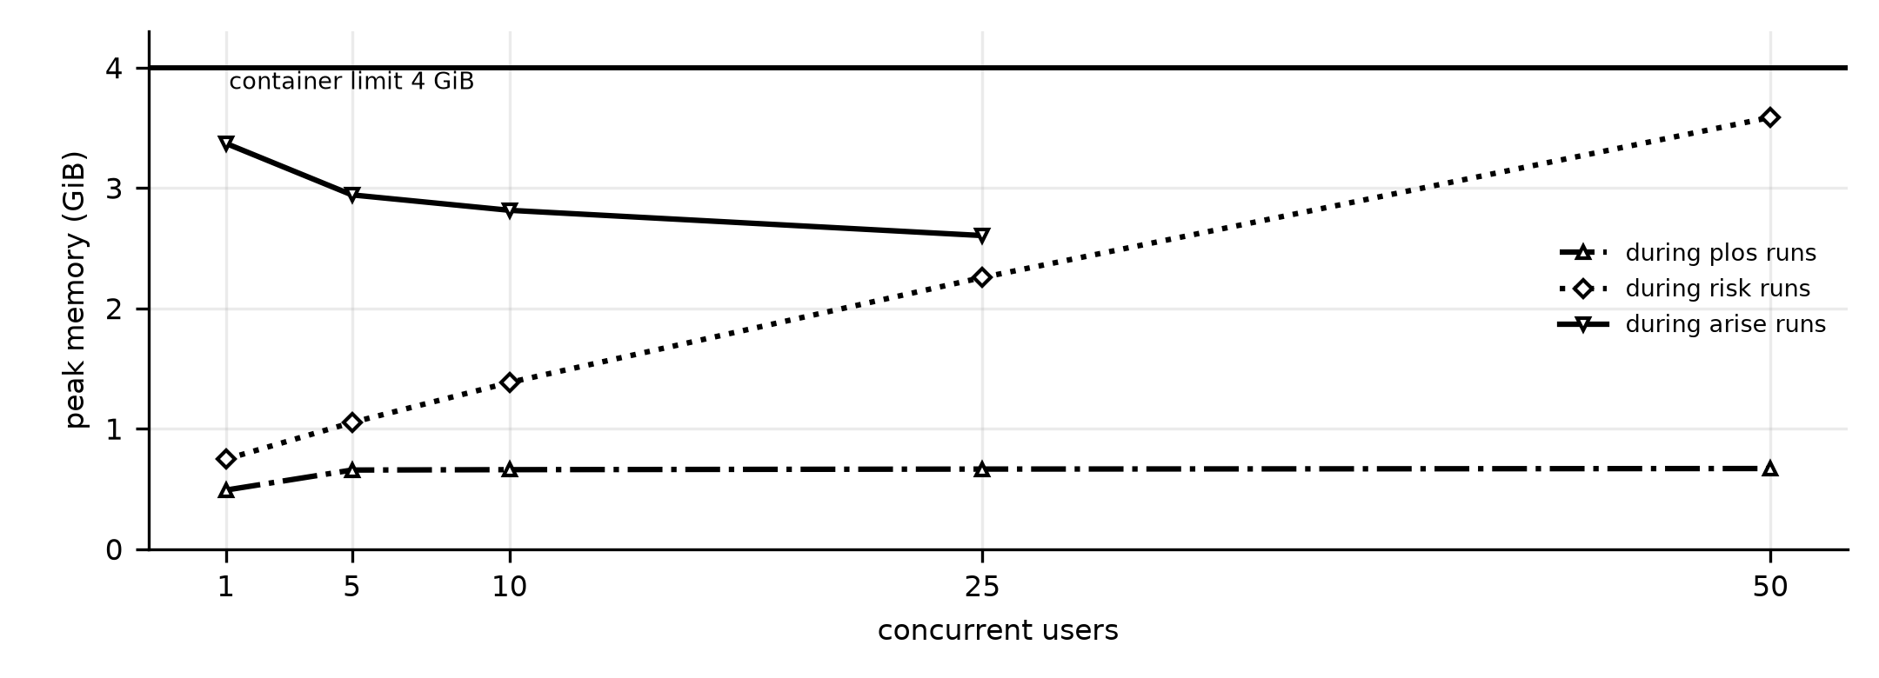
Figure 8.1: Peak container memory against concurrent users
Storage consumption: the PostgreSQL volume holds 233,258 price rows in 277 TimescaleDB chunks and 10,187 NAV rows; the verified market-data files used by the engines occupy about 5 MB, and the JSON model artifacts are a few kilobytes each. Network traffic per request is small (JSON responses of 2–60 KB), so bandwidth was not a constraint in any test.

8.4 Concurrent Processing
uvicorn runs four worker processes, which the operating system schedules on the four allotted cores. Each process runs one asyncio event loop that multiplexes all its connections; when a request reaches a CPU-heavy engine, the call is handed to the process’s thread pool (anyio.to_thread.run_sync), so the event loop keeps accepting and answering other requests. The light endpoints therefore stay fast even while Risk and ARISE calculations are running. Background work (data refresh) runs in separate Celery processes and never competes with request handling inside the API container.

8.5 Scheduling and Synchronisation Analysis
No custom scheduling policy was implemented. Requests are distributed among worker processes by the operating system through the shared listening socket, and inside a process by the event loop (first-come, first-served at each await point) and the thread pool. The measurements show the consequence of this design for CPU-bound work: the thread pool admits up to 40 concurrent engine calls per process, so at 25–50 users far more calculations run at once than there are cores. They compete for the same four cores, numerical-library threads oversubscribe the CPU, and each in-flight calculation holds its own matrices in memory. Synchronisation itself was not a bottleneck: the engine registry lock is taken only when an engine is first built, and the rate limiter’s atomic script runs in Redis.

8.6 Performance Measurement
Table 8.2: Experimental setup
Item | Setting
Hardware | Apple M5 (10 cores), 16 GB RAM, macOS; Docker Desktop
System under test | API image built from the current source, run as a separate container on port 8100 with --cpus=4 --memory=4g, uvicorn with 4 workers, connected to the same PostgreSQL and Redis containers
Load generator | Python asyncio + httpx client on the host (scripts saved with the report data); latency measured with a monotonic timer around each request
Metrics | Median (p50), 95th and 99th percentile latency, throughput (requests completed / wall time), error count (HTTP ≥ 400), CPU and memory from docker stats
Scaling tests | One user; portfolio size n = 2 to 20 equity schemes; ARISE paths N = 100 to 5,000; median of three warm requests (Section 5.6)
Date | 24–25 October 2026

8.7 Performance Results
Table 8.3: Interactive endpoints under increasing load
Endpoint | Users | Requests | p50 | p95 | Req/s | Errors
Health | 1 | 40 | 1.5 ms | 2.3 ms | 585.8 | 0
Health | 5 | 400 | 3.4 ms | 8.4 ms | 1052.2 | 0
Health | 10 | 400 | 9.2 ms | 21.8 ms | 844.6 | 0
Health | 25 | 400 | 28.5 ms | 131.6 ms | 520.0 | 0
Health | 50 | 400 | 65.3 ms | 268.5 ms | 506.4 | 0
Session check (/auth/me) | 1 | 40 | 3.4 ms | 5.9 ms | 253.1 | 0
Session check (/auth/me) | 5 | 400 | 6.4 ms | 9.3 ms | 640.4 | 0
Session check (/auth/me) | 10 | 400 | 14.6 ms | 42.6 ms | 528.8 | 0
Session check (/auth/me) | 25 | 400 | 33.0 ms | 109.5 ms | 538.5 | 0
Session check (/auth/me) | 50 | 400 | 76.6 ms | 374.9 ms | 379.9 | 0
Scheme filter | 1 | 20 | 5.2 ms | 16.4 ms | 167.4 | 0
Scheme filter | 5 | 200 | 9.2 ms | 13.1 ms | 495.1 | 0
Scheme filter | 10 | 200 | 14.6 ms | 35.9 ms | 550.4 | 0
Scheme filter | 25 | 200 | 38.9 ms | 144.2 ms | 437.0 | 0
Scheme filter | 50 | 200 | 83.2 ms | 374.7 ms | 349.4 | 0
Overlap | 1 | 20 | 6.1 ms | 15.4 ms | 145.4 | 0
Overlap | 5 | 200 | 9.9 ms | 17.0 ms | 443.7 | 0
Overlap | 10 | 200 | 14.9 ms | 32.5 ms | 547.2 | 0
Overlap | 25 | 200 | 48.7 ms | 154.9 ms | 390.1 | 0
Overlap | 50 | 200 | 81.5 ms | 316.7 ms | 385.3 | 0

Table 8.4: Analysis endpoints under increasing load
Endpoint | Users | Requests | p50 | p95 | Req/s | Errors
PLOS | 1 | 10 | 44.0 ms | 59.9 ms | 21.9 | 0
PLOS | 5 | 100 | 62.7 ms | 210.1 ms | 41.8 | 0
PLOS | 10 | 100 | 134.7 ms | 215.3 ms | 67.5 | 0
PLOS | 25 | 100 | 323.3 ms | 569.7 ms | 71.1 | 0
PLOS | 50 | 100 | 447.5 ms | 1370.4 ms | 62.4 | 0
Risk | 1 | 10 | 1176.7 ms | 1723.9 ms | 0.8 | 0
Risk | 5 | 100 | 1760.7 ms | 4498.2 ms | 2.1 | 0
Risk | 10 | 100 | 3877.6 ms | 19.9 s | 1.2 | 0
Risk | 25 | 100 | 26.6 s | 49.4 s | 0.7 | 0
Risk | 50 | 100 | 88.4 s | 111.5 s | 0.5 | 0
ARISE (1,000 paths) | 1 | 10 | 2918.4 ms | 3009.3 ms | 0.3 | 0
ARISE (1,000 paths) | 5 | 40 | 5840.9 ms | 16.2 s | 0.7 | 0
ARISE (1,000 paths) | 10 | 40 | 7308.3 ms | 85.6 s | 0.5 | 0
ARISE (1,000 paths) | 25 | 40 | 120.4 s | 225.3 s | 0.2 | 0

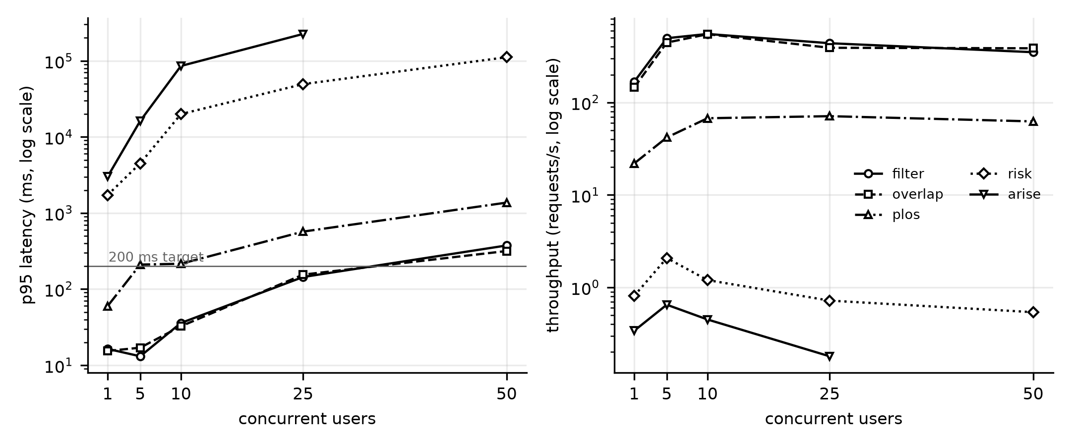
Figure 8.2: 95th-percentile latency and throughput against concurrent users
At 10 concurrent users the interactive endpoints answered in 35.9 ms (filter) and 32.5 ms (overlap) at the 95th percentile, well within the 200 ms target, at about 547 requests per second. They remain under 200 ms up to 25 users and rise to about 316.7 ms at 50. No request at any level failed with a server error.
For a single user, the analysis endpoints take 44.0 ms (PLOS), 1176.7 ms (Risk) and 2918.4 ms (ARISE). Risk and ARISE are CPU-bound: their throughput peaks at 5 users (2.1 and 0.65 requests/s, using all four cores) and then falls as more users are added, while latency grows steeply — the Risk median reaches 88.4 s at 50 users.
Note on the ARISE 50-user level. All 40 requests at this level returned 401 because the benchmark’s access tokens (valid for 30 minutes) had expired after more than four hours of testing; the server log confirms that these were authentication rejections, not failures. This level is therefore reported as not measured (Section 9.11).

8.8 Bottleneck Identification
- CPU in the Risk engine. A GARCH model is fitted by maximum likelihood for each fund on every request (about 1.2 s for four funds). With four cores the server completes at most about two Risk requests per second.
- CPU in ARISE. Each request simulates 1,000 lifetimes for each of four strategies, plus a stress test and calibration; time grows linearly with the number of paths (Table 5.6).
- Unbounded parallelism. Because up to 40 calculations per process may run at once, throughput falls after 5 users instead of levelling off, and memory grows with the number of calculations in flight — to 2.3 GiB at 25 users and 3.6 GiB at 50 users during Risk, close to the 4 GiB limit.
- Not bottlenecks: the database (indexed queries return in milliseconds), the network, Redis and the light endpoints.

8.9 Optimisation and Improvement
One optimisation is already in the system and was measured directly: each process loads holdings, NAV files and model artifacts once and keeps them in memory, and caches return series after first use. The first request after start-up pays the loading cost; later requests do not.
Table 8.5: Effect of in-process data caching (one user)
Endpoint | First request (cold) | Later requests (warm, mean of 3) | Speed-up
Overlap | 9.3 ms | 4.1 ms | 2.3×
PLOS | 862.0 ms | 48.8 ms | 17.7×
Risk | 4785.2 ms | 1206.7 ms | 4.0×
ARISE (1,000 paths) | 3143.0 ms | 2950.3 ms | 1.1×

The bottleneck in Section 8.8 points to three further changes, which were identified but not yet implemented and measured: (1) a small fixed limit on simultaneous engine calls per process (for example two), so that additional requests wait in a queue instead of competing for the cores and memory; (2) caching complete Risk results in Redis per portfolio and data date, since the dashboard and the Risk page request the same result; and (3) fitting each fund’s GARCH model in the nightly job rather than on request. Change (1) is expected to keep throughput at the 5-user peak and memory near 1 GiB at any load; changes (2) and (3) reduce the work itself.

8.10 Cloud Deployment and Resource Utilisation
The system was not deployed to a public cloud during the project. The intended deployment is the same Docker images on a cloud virtual machine or container service: two or more API replicas behind a load balancer (the API is stateless and the rate limiter is already distributed through Redis), a managed PostgreSQL service with the TimescaleDB extension, a managed Redis service, and the Celery worker and beat as separate services. Based on the measurements, each API replica should have 4 vCPUs and 4 GiB of memory with the concurrency limit of Section 8.9 in place.

8.11 Scalability Limitations
- Maximum tested workload: 50 concurrent users for all endpoints except ARISE (25 users, Section 8.7), on one 4-CPU container with 0 server errors.
- Measured capacity: interactive endpoints sustain 350–550 requests/s; Risk about 2 requests/s and ARISE about 0.65 requests/s at best on 4 cores.
- Limit observed: beyond about 5 simultaneous Risk or ARISE users, latency grows rapidly and memory approaches the container limit; this is the main scalability limitation of the current version.
- Projected, not tested: horizontal scaling with several replicas, cloud deployment, and behaviour with thousands of users or millions of transactions.
CHAPTER 9

TESTING AND VALIDATION

9.1 Testing Strategy
Testing was carried out at five levels, from individual functions to the whole running system, and every level is automated so that it is repeated on every change:
- Unit tests of engines, models and helpers with known inputs and hand-computed outputs.
- Integration tests that start the real FastAPI application and call it over HTTP with an isolated test database.
- Functional tests that map each functional requirement to at least one test, including a 13-step end-to-end investor journey.
- Non-functional tests: security (tokens, isolation, error leakage), accessibility (contrast checks), data consistency checks, and the load and scaling tests of Chapter 8.
- Model validation: out-of-sample evaluation of every model against the one it replaces, with no information from the future (Section 9.5).
Continuous integration runs the backend suite, ruff, migration checks, the frontend type check, ESLint, the WCAG contrast check, the generated-data check and the production build on every push. The backend suite contains 459 tests in 29 files; 449 passed and 10 were skipped because they need Upstox instrument files that are not present on the test machine (run on 25 October 2026, 164 s).

9.2 Unit Testing
Table 9.1: Unit tests by area
Area | Test file | Tests | Examples of what is checked
Portfolio accounting | test_portfolio.py | 38 | FIFO partial redemptions; STCG/LTCG against hand computation; LTCG exemption aggregated per year
Quantitative engines | test_quant_engines.py | 29 | GARCH recovers α = 0.08, β = 0.90; EVT VaR/ES on normal data; Kupiec accepts and rejects correctly
Market data candles | test_candles.py | 26 | Daily and intraday paths, date handling
ML models | test_ml_models.py | 22 | Shapley efficiency; PLOS monotonicity; HAR-X shapes; Kupiec
ARISE longevity | test_arise_longevity.py | 20 | Gompertz lifespans; listed pessimistic assumptions; never 0% or 100%
Time-series read path | test_timescale_read_path.py | 20 | Reading stored prices; source labels
Feed decoding | test_feed_decoder.py | 14 | Protocol Buffers market feed decoding
Estimation risk | test_estimation_risk.py | 11 | Posterior spread shrinks with more history
Other engine helpers | 8 further files | about 90 | Fees and benchmarks, HRP, debt returns, safe withdrawal rates, plan costs, mappings

9.3 Integration Testing
Integration tests use an HTTP client bound to the FastAPI application with an isolated database, so routing, validation, authentication, services, engines and serialisation are exercised together. The main files are test_auth.py (14 tests), test_profile_schemes.py (18), test_analysis.py (18), test_reports_market.py (15), test_compare.py (9), test_scheme_detail.py (9), test_security.py (7) and test_upstox.py (34, with the Upstox service simulated). The Docker stack was additionally exercised as a whole by the load test of Chapter 8, in which every analysis endpoint ran against the real PostgreSQL and Redis containers.

9.4 Functional Testing
Each functional requirement is traced to the tests that verify it.
Table 9.2: Traceability of functional requirements to tests
Requirement | Verified by | Result
FR-01 Registration and login | test_register_returns_token_pair, test_duplicate_email_conflicts, test_password_policy | Pass
FR-02 Refresh and logout | test_refresh_rotates_and_burns_the_old_token, test_refresh_reuse_kills_the_whole_token_family, test_logout_all_revokes_every_session | Pass
FR-03 Profile | test_profile_requires_all_ten_fields, test_minor_is_rejected, test_put_is_a_partial_update | Pass
FR-04 Scheme discovery | test_every_risk_appetite_sees_equity, test_tax_saving_is_the_one_hard_goal_block | Pass
FR-05 Selection and allocation | test_duplicate_scheme_ids_are_rejected, test_weights_must_sum_to_one | Pass
FR-06 Overlap | test_analysis.py overlap cases; frontend data check (10 figures) | Pass
FR-07 PLOS | test_ml_models.py Shapley and monotonicity; test_plos_top5.py | Pass
FR-08 Risk | test_quant_engines.py GARCH, EVT and Kupiec tests | Pass
FR-09 ARISE | test_arise_longevity.py, test_estimation_risk.py | Pass
FR-10 Transactions and tax | test_portfolio.py (38 tests) | Pass
FR-11 Reports and notifications | test_generate_report_produces_a_real_pdf; notification scoping tests | Pass
FR-12 Data and model pipeline | Training script validation output (Chapter 10); provenance tests | Pass
End-to-end journey | test_full_investor_journey (13 steps over HTTP) | Pass

9.5 Non-Functional Testing
- Performance: at 10 concurrent users the 95th-percentile latency was 35.9 ms (filter) and 32.5 ms (overlap); full results in Section 8.7.
- Security: seven dedicated tests check that profiles, selections, reports and notifications cannot be read or changed by another user, that internal errors do not leak tracebacks and that password hashes are never returned; authentication tests reject forged, expired, wrong-type and missing tokens, and confirm that a wrong password and an unknown user produce identical responses.
- Usability and accessibility: the frontend build checks all 16 text/surface colour pairs against WCAG 2.2 AA contrast in both themes; all pass.
- Reliability: no request in the load test returned a server error (5xx); fallback behaviour is tested by forcing each data tier to fail.
Model validation. The models were evaluated with scoring rules appropriate to each engine. Volatility forecasts use the QLIKE loss (9.1) and the Diebold–Mariano test (9.2); VaR uses Kupiec’s test (9.3) and Christoffersen’s independence test; retirement forecast distributions use the continuous ranked probability score (9.4) and interval coverage. Every feature is measured before the period it predicts, PLOS is trained on earlier years and tested on later ones, and ARISE forecasts use only data available at each origin.
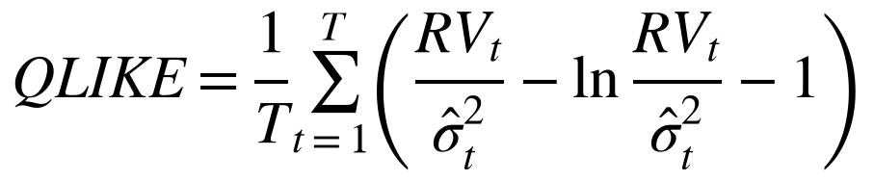 (9.1)
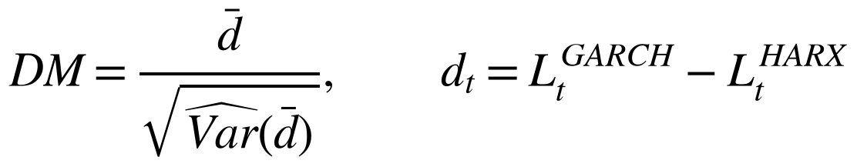 (9.2)
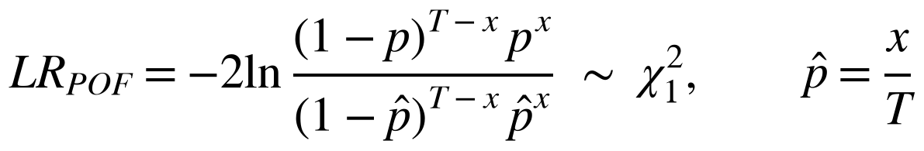 (9.3)
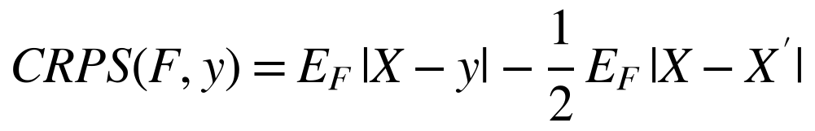 (9.4)

9.6 Boundary and Invalid-Input Testing
Table 9.3: Boundary and invalid-input tests
Input | Case | Expected and actual result | Test
Password | Too short / no digit; 100 characters | Rejected (422); long password accepted and not truncated | test_password_policy, test_long_password_is_not_truncated_at_72_bytes
Email | Duplicate; different case | 409 Conflict; treated as the same account | test_duplicate_email_conflicts, test_email_is_case_insensitive
Profile | Missing field; minor; investment > corpus; retirement age ≤ current age | 422 with a message | test_profile_requires_all_ten_fields, test_minor_is_rejected, test_cannot_invest_more_than_you_have, test_retirement_age_must_exceed_current_age
Selection | Unknown ID; duplicate IDs; more than 20 | 422 | test_unknown_scheme_id_is_rejected, test_duplicate_scheme_ids_are_rejected
Weights | Sum ≠ 1; wrong set of schemes | 422 | test_weights_must_sum_to_one, test_weights_must_cover_exactly_the_selected_schemes
State | Allocate before select; filter without profile | 404 / 4xx; state unchanged | test_allocate_before_select_is_404, test_filter_requires_a_complete_profile
Tokens | Missing, garbage, wrong key, access used as refresh | 401 | test_protected_routes_reject_missing_and_garbage_tokens, test_token_signed_with_a_different_key_is_rejected
Redemption | Sell more units than held | InsufficientUnits error, nothing recorded | test_portfolio.py
ARISE | n_simulations outside 100–5,000 | 422 (schema bounds) | ARISERequest validation

9.7 Concurrency and Stress Testing
The load test (Chapter 8) is the concurrency and stress test: up to 50 simultaneous clients on every endpoint. No request failed with a server error, no deadlock or crash occurred, and the container stayed up through more than four hours of continuous load. Under the heaviest stress (50 users running Risk) the median latency rose to 88 s and memory to 3.6 GiB, which identified the bottleneck described in Section 8.8. Race conditions are prevented by design rather than tested by chance: the rate limiter’s check-and-record is atomic in Redis, token rotation is one database transaction, and uniqueness constraints arbitrate concurrent registrations and imports.

9.8 Test Case Specification
Table 9.4: Test case specification
TC ID | Req. | Scenario | Input / precondition | Expected | Actual | Status | Evidence
TC01 | FR-01 | Register and log in | New email, valid password | 201, token pair | 201, token pair | Pass | test_auth.py
TC02 | FR-02 | Reuse a rotated refresh token | Token already used once | 401; all tokens revoked | As expected | Pass | test_auth.py
TC03 | NFR-04 | Read another user’s selection | Two users | 403 / 404, no data | 404, no data | Pass | test_security.py
TC04 | FR-04 | Moderate investor filters schemes | Complete profile | 35 schemes, equity flagged | 35 shown, flags with reasons | Pass | test_profile_schemes.py
TC05 | FR-06 | Overlap of 3 schemes | Saved selection | Symmetric, diagonal 1, in [0, 1] | As expected | Pass | test_analysis.py
TC06 | FR-07 | PLOS for bond and equity fund | Mixed selection | Holdings layers 0 | 0 | Pass | test_ml_models.py
TC07 | FR-07 | Shapley contributions | Any pair | Sum = score − baseline | Equal to 1e-9 | Pass | test_ml_models.py
TC08 | FR-08 | GARCH on simulated data | α = 0.08, β = 0.90 | Parameters recovered | Recovered | Pass | test_quant_engines.py
TC09 | FR-08 | EVT tail on normal data | Normal sample | 99% VaR ≈ 2.33, ES ≈ 2.67 | Within tolerance | Pass | test_quant_engines.py
TC10 | FR-09 | More SIP | Two runs, same seed | Success not lower | Not lower | Pass | test_arise_longevity.py
TC11 | FR-09 | Full survival of all paths | Very rich investor | Estimate < 100% with range | As expected | Pass | test_estimation_risk.py
TC12 | FR-10 | Partial redemption tax | Two lots, one sale | Hand-computed STCG/LTCG | Matches | Pass | test_portfolio.py
TC13 | FR-10 | Duplicate external reference | Same ref twice | Recorded once | Recorded once | Pass | test_portfolio.py
TC14 | NFR-03 | NaN in a response | Short series | null, valid JSON | null | Pass | test_infrastructure.py
TC15 | FR-12 | Fund with verified AMFI code | Verified NAV file | Source = verified NAV | amfi_nav_verified | Pass | test_provenance.py
TC16 | — | Full investor journey | Fresh database | 13 steps succeed | 13 steps succeed | Pass | test_e2e_flow.py
TC17 | NFR-01 | 10 users on overlap | Load test | p95 < 200 ms | 32.5 ms | Pass | Table 8.3
TC18 | NFR-08 | 50 users on Risk | Load test | Memory < 2 GiB | 3.6 GiB | Fail | Table 8.1

9.9 Defect Identification and Resolution
Table 9.5: Defects and resolutions
Defect | Effect | Corrective action | Retest
Duplicate AMFI code 118778 for Growth Mid Cap and Small Cap | Two funds showed identical NAV histories | Factsheet-NAV verification; verified codes used first | Verified codes pass for 34/35 schemes
Same duplicate in the stored NAV table | 3,395 identical rows for the two funds remain in tsdb.fund_nav_history | Not yet corrected; the table is not read by any engine. Action: remove the legacy code and re-run the NAV download | Open
Risk used equal weights | Risk and ARISE described different portfolios | Weights passed to the risk engine | Integration test
ARISE over-confident | 80% ranges held 67% of outcomes | v5 calibration | 82.8% coverage
NaN in JSON | Client parse failure | NaN → null | TC14
Dashboard units run together | “of4funds” displayed | Letter-spacing reset on unit text | Visual check
Rate limit per process | Limit multiplied by worker count | Redis sliding window | Rate-limit tests

9.10 Validation Against KPIs
Table 9.6: Measured results against KPI targets
KPI | Target | Measured | Status
Response time (interactive) | p95 < 200 ms at 10 users | 35.9 / 32.5 / 42.6 ms | Met
Response time (analysis, 1 user, median) | PLOS < 1 s, Risk < 3 s, ARISE < 5 s | 44 ms / 1.18 s / 2.92 s | Met
Throughput | ≥ 100 req/s interactive | 547 req/s (overlap, 10 users) | Met
Reliability | No 5xx up to 50 users | 0 server errors | Met
Resource utilisation | < 2 GiB peak memory | 1.4 GiB at 10 users; 3.6 GiB at 50 users (Risk) | Met to 10 users; not met above 20
Functional correctness | 100% of tests pass | 449 of 449 run | Met
PLOS accuracy | R² > 0.570 | 0.626 | Met
Risk accuracy | QLIKE < 0.421 | 0.336 | Met
VaR validity | ≥ 90% of funds pass | 13/13 Kupiec; 12/13 independence (95%) | Met
ARISE calibration | 75%–85% inside 80% range | 82.8% | Met

9.11 Limitations and Untested Scenarios
- ARISE at 50 concurrent users was not measured (expired benchmark tokens; Section 8.7).
- No test on a public cloud, with multiple API replicas, or with more than 50 users.
- The frontend has type checks, lint and a production build in CI, but no automated browser tests; screens were checked manually.
- Live Upstox trading-hours behaviour was tested with a simulated service, not during market hours with a live account.
- Model accuracy is limited by about two decades of Indian data; multi-year results are directional.
CHAPTER 10

RESULTS, DEMONSTRATION AND DISCUSSION

10.1 Implemented Features
Table 10.1: Implemented features
Feature | Status
Registration, login, token rotation with reuse detection, logout and logout-all | Implemented and tested
10-field investor profile with SIP and step-up | Implemented and tested
Scheme discovery for all 35 schemes with eligibility flags and reasons; scheme detail pages | Implemented and tested
Selection (1–20 schemes) and weight allocation | Implemented and tested
Overlap analysis (Jaccard, weighted, shared holdings, heatmap and network) | Implemented and tested
PLOS v3 (learned model, Shapley explanation, N_eff, clusters, validation evidence) | Implemented and tested
Risk v2 (GARCH + HAR-X, FHS and EVT VaR/ES, 1 and 10 days, backtests, regime) | Implemented and tested
ARISE v5 (Monte Carlo, four strategies, stress test, calibration evidence) | Implemented and tested
Fund comparison view | Implemented and tested
Transaction ledger, FIFO, P&L, XIRR, capital-gains tax | Implemented and tested (API); limited UI
PDF reports and RM notifications | Implemented and tested
Upstox OAuth connection and live-price feed | Implemented; tested with a simulated service
Data download and verification; model training and validation | Implemented; results in Section 10.4
Cloud deployment, mobile app, other fund houses | Not implemented (out of scope)

10.2 Screenshots and Demonstration Evidence

Figure 10.1: Landing page with the 3D “N”
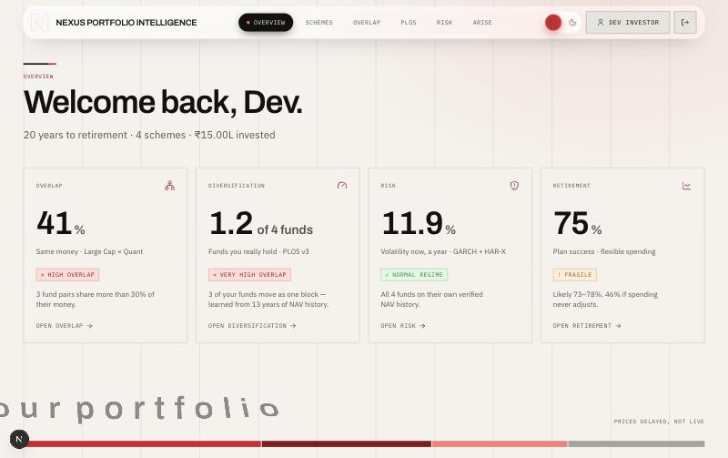
Figure 10.2: Investor dashboard
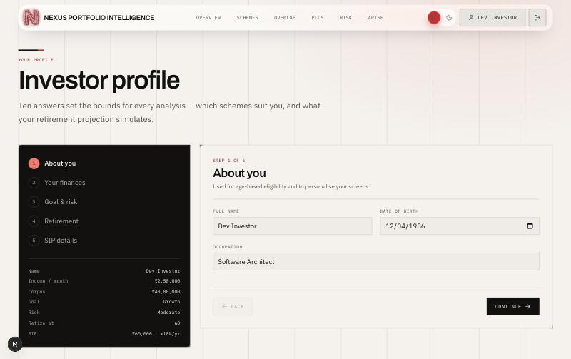
Figure 10.3: Investor profile wizard
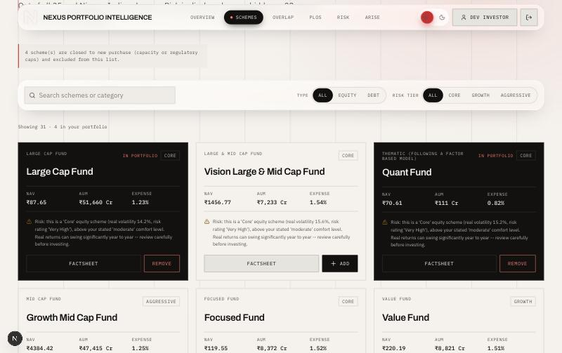
Figure 10.4: Scheme discovery with eligibility flags
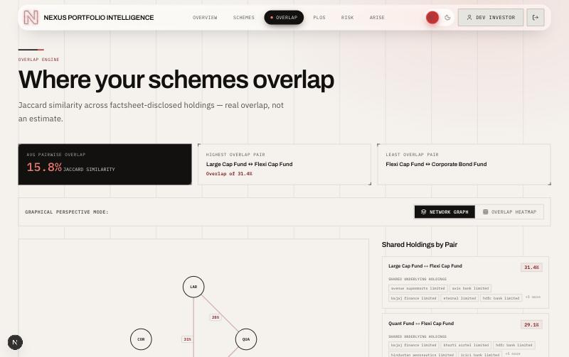
Figure 10.5: Overlap analysis
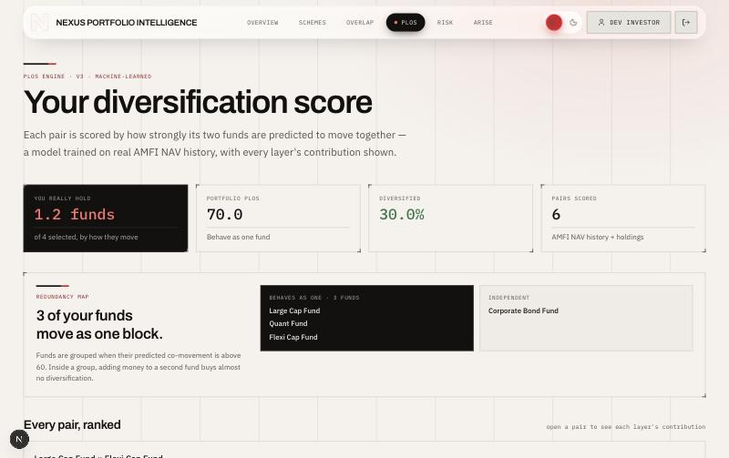
Figure 10.6: PLOS v3: effective number of funds and redundancy map
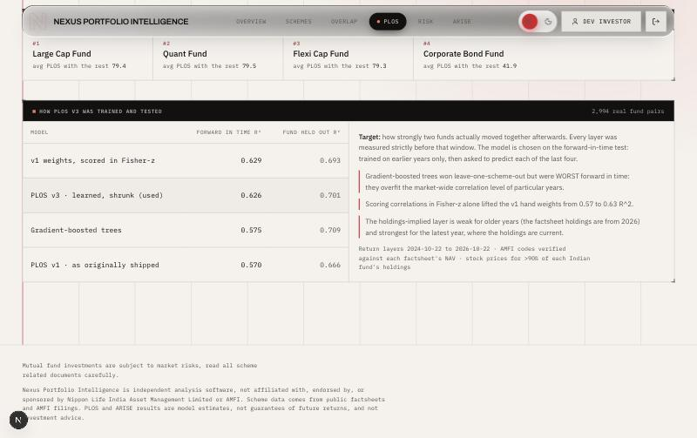
Figure 10.7: PLOS v3: validation evidence shown to the investor
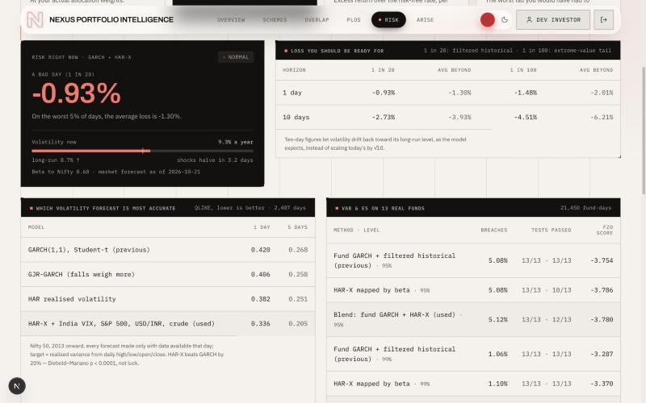
Figure 10.8: Risk v2: conditional VaR/ES with validation evidence
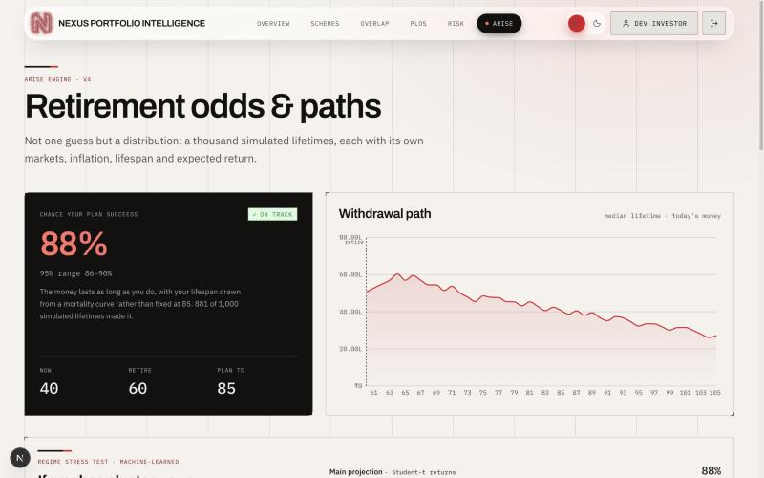
Figure 10.9: ARISE: retirement success probability and withdrawal path
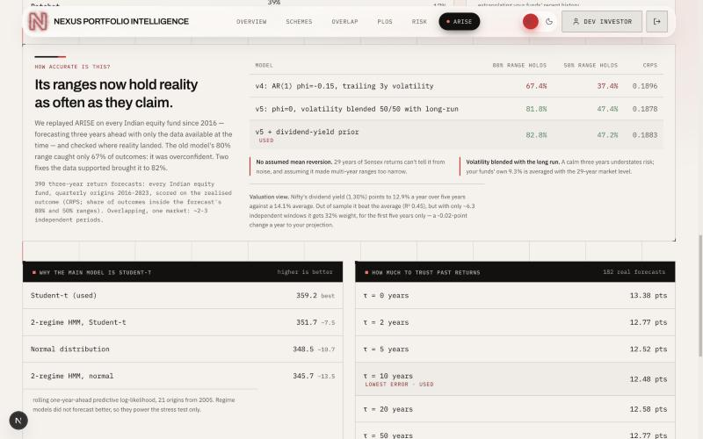
Figure 10.10: ARISE: calibration evidence shown to the investor

10.3 Functional Results
Every functional requirement FR-01 to FR-12 is met and verified by at least one automated test (Table 9.2); all 449 tests pass. For the sample portfolio used in the screenshots (Large Cap, Quant, Flexi Cap and Corporate Bond), the system shows that the three equity funds form one redundancy cluster and that the four funds behave like about 1.2 independent funds; that the portfolio’s VaR and ES are reported in rupees with their backtest results; and that the retirement plan has an estimated success probability of 75.3% (95% range 72.6–77.9%). Every fund in that portfolio is measured on its own verified NAV history, and the dashboard says so.

10.4 Performance Results
System performance (Chapter 8): at 10 concurrent users the interactive endpoints answer within 36 ms at the 95th percentile at over 500 requests per second; a single user’s PLOS, Risk and ARISE requests take about 0.04 s, 1.2 s and 2.9 s; no server errors occurred up to 50 users; Risk and ARISE are CPU-bound beyond about 5 simultaneous users.
Model performance. Each engine’s model was compared out of sample with the model it replaced.
Table 10.2: PLOS model comparison
Model | Forward-in-time R² (2022–2025) | Leave-one-fund-out R²
PLOS v1 (hand-set weights) | 0.570 | 0.666
v1 weights scored in Fisher-z | 0.629 | 0.693
PLOS v3, learned and shrunk (adopted) | 0.626 | 0.701
Gradient-boosted trees (rejected) | 0.575 | 0.709

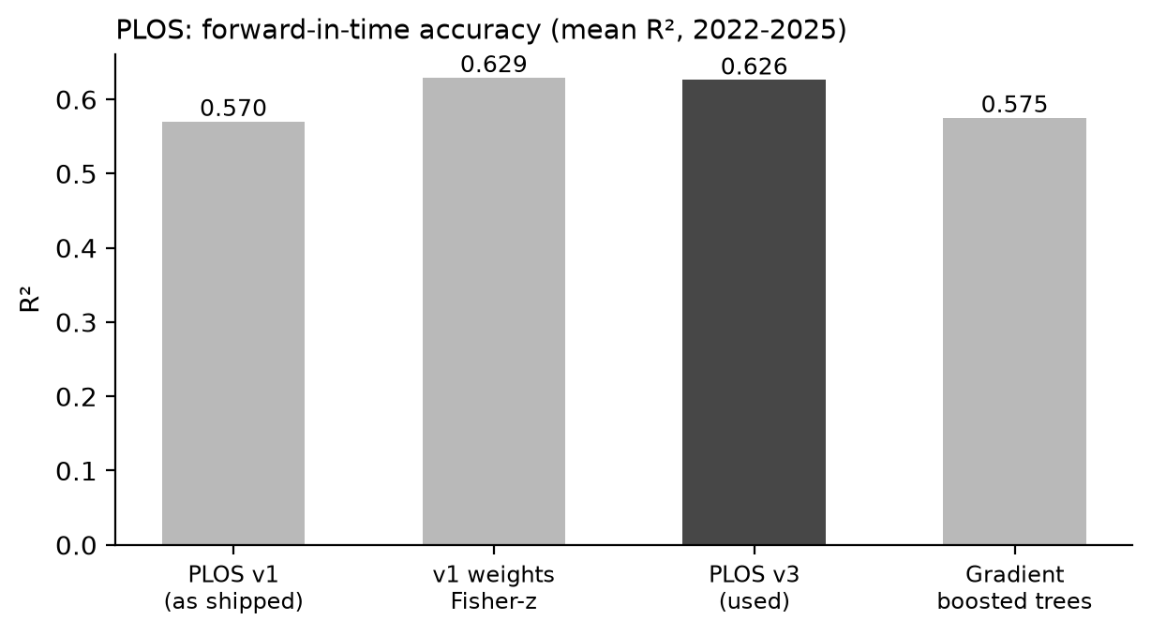
Figure 10.11: PLOS forward-in-time accuracy
Table 10.3: Volatility forecast accuracy, 2013–2026 out of sample (lower is better)
Volatility model | QLIKE, 1 day | QLIKE, 5 days
GARCH(1,1), Student-t (previous) | 0.421 | 0.268
GJR-GARCH | 0.406 | 0.258
HAR | 0.382 | 0.251
HAR-X with India VIX, S&P 500, USD/INR, crude (adopted) | 0.336 | 0.206

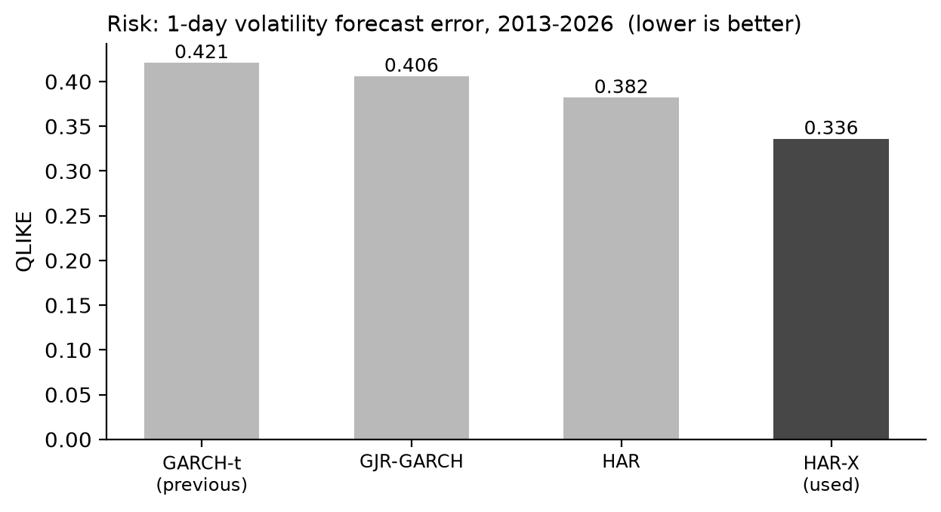
Figure 10.12: One-day volatility forecast error by model
The Diebold–Mariano test confirms that HAR-X is significantly more accurate than GARCH (statistic 5.8 at one day and 5.0 at five days; p < 0.00001 over about 2,400 days). A gradient-boosted HAR-X scored 0.364 and was not adopted.
Table 10.4: VaR/ES backtest on 13 equity funds, 21,450 fund-days (FZ0: lower is better)
Method | Level | Breach rate | Kupiec pass | Independence pass | FZ0
Fund GARCH-FHS (previous) | 95% | 5.08% | 13/13 | 13/13 | -3.754
HAR-X mapped by beta | 95% | 5.08% | 13/13 | 10/13 | -3.786
Blend (adopted) | 95% | 5.12% | 13/13 | 12/13 | -3.780
Fund GARCH-FHS (previous) | 99% | 1.06% | 13/13 | 13/13 | -3.287
HAR-X mapped by beta | 99% | 1.10% | 13/13 | 13/13 | -3.370
Blend with EVT tail (adopted) | 99% | 1.03% | 13/13 | 13/13 | -3.343

Table 10.5: ARISE calibration on 390 real three-year fund outcomes
Model | Inside 80% range | Inside 50% range | CRPS
ARISE v4: AR(1) φ = -0.15, trailing volatility | 67.4% | 37.4% | 0.1896
v5: φ = 0, volatility blended with long run | 81.8% | 47.4% | 0.1878
v5 + dividend-yield prior (adopted) | 82.8% | 47.2% | 0.1883

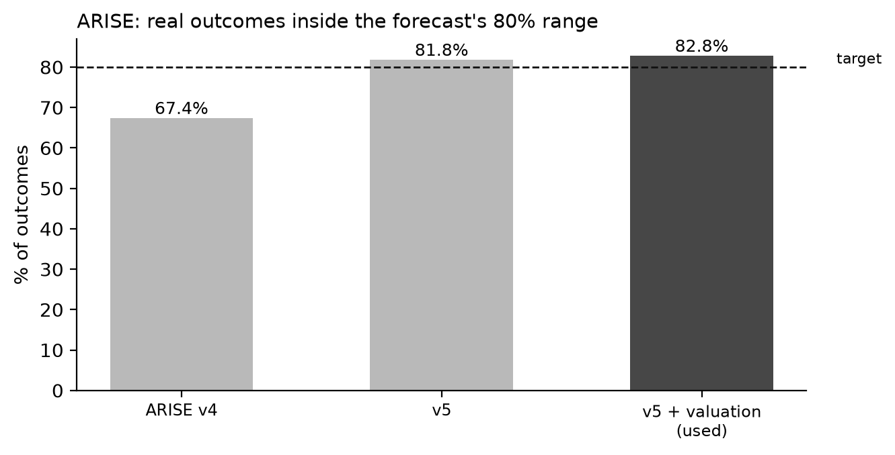
Figure 10.13: Share of real outcomes inside ARISE’s 80% range
Table 10.6: Approaches tested and rejected
Approach | Engine | Reason for rejection
Gradient-boosted trees | PLOS | Best cross-sectionally (R² 0.709) but worst forward in time (0.575)
Gradient-boosted HAR-X | Risk | QLIKE 0.364 vs 0.336 for linear HAR-X
Regime-switching models (HMM) | ARISE | Lost to the Student-t over 21 rolling forecasts; kept as a stress test
Joint equity–inflation bootstrap | ARISE | No equity–inflation link in Indian data, 2003–2025 (r = -0.15, p = 0.49)
Minimum-torsion effective bets | PLOS | Reports 2.9 funds where 1.7 is correct
Earnings-yield valuation signal | ARISE | Out-of-sample R² -0.52 at three years

10.5 Comparison with Existing Systems
Using the criteria of Table 2.2, the proposed system is the only one of the compared approaches that measures overlap by money as well as by names for up to 20 funds at once, predicts co-movement with a validated model, reports backtested VaR/ES that reacts to current volatility, projects retirement as a calibrated probability range, and shows the evidence for each model on screen. It remains free and open source. Its disadvantages relative to commercial tools are its single fund house, the absence of a mobile app and its tested capacity of tens rather than thousands of simultaneous users.

10.6 Achievement of Objectives
Table 10.7: Mapping of objectives to evidence
Objective (Section 1.4) | Evidence | Status
1. Full-stack platform, ≥ 40 endpoints | 47 endpoints (Appendix A); 11 screens; end-to-end test | Achieved
2. Overlap by names and money; PLOS R² > 0.570 | Overlap engine; PLOS v3 R² 0.626 | Achieved
3. VaR/ES passing backtests for ≥ 90% of funds | 13/13 Kupiec at both levels; 12/13 and 13/13 independence | Achieved
4. ARISE 80% ranges hold 75–85% of outcomes; never 0/100% | 82.8%; Jeffreys estimate | Achieved
5. Interactive p95 < 200 ms and no analysis errors at 10 users | 32.5 ms; 0 server errors | Achieved
6. Tests 100% pass, CI, containers, Git | 449/449 passed; 3 CI workflows; Docker Compose; GitHub | Achieved
Resource target < 2 GiB at all tested loads (KPI) | 3.6 GiB at 50 Risk users | Partially achieved

10.7 Discussion of Findings
Three findings stand out. First, simpler, well-regularised models generalised better than flexible ones on short financial histories: in every engine a more complex model looked better in at least one test, and in each case the forward-in-time evidence favoured a simpler, shrunk or blended model. Second, data verification mattered as much as modelling: a wrong AMFI code silently gave two funds the same history, which no model could have corrected. Third, the system is fast for interactive use but CPU-bound for the heavy analyses — an unexpected observation was that Risk throughput fell after 5 users instead of levelling off, which traced to unbounded parallel calculations rather than to the database or network. Making uncertainty visible — calibrated ranges, evidence on screen and labelled data sources — was central to the system’s usefulness.

10.8 Practical Applicability
The system can be run by an investor on a laptop, by a relationship manager to review client portfolios, or by an institution for investor-education sessions; the Docker setup brings up the full stack with one command. With the concurrency limit of Section 8.9 and one or two replicas, it is suitable for a few dozen simultaneous users, which matches a classroom, a branch office or an advisory team. Its outputs are analytical estimates with stated assumptions, not investment advice.
CHAPTER 11

CONCLUSION AND FUTURE SCOPE

11.1 Conclusion
The project addressed a practical problem: investors cannot see how much their mutual funds really overlap, how risky the combination is under current conditions, or how likely their retirement plan is to last. Nexus Portfolio Intelligence solves this for the 35 Nippon India schemes with a layered web platform — a Next.js client, a FastAPI backend with 47 endpoints, PostgreSQL/TimescaleDB, Redis and Celery — and five engines, three of which have dedicated, validated models. The main outcomes are measurable: PLOS forward-in-time accuracy improved from R² 0.570 to 0.626, volatility forecast error fell by 20%, VaR/ES passes its backtests, ARISE’s 80% ranges now contain 82.8% of real outcomes, all 449 tests pass, and the interactive endpoints answer within 36 ms (p95) at 10 concurrent users.

11.2 Achievement of Objectives
All six objectives of Section 1.4 were achieved (Table 10.7). The memory KPI was only partially achieved: it holds up to 10 concurrent users but not under heavy concurrent Risk load, for the reason identified in Section 8.8.

11.3 Major Engineering Contributions
- Design: a layered modular architecture with pure, testable engines and a five-tier data fallback that labels every number with its source.
- Implementation: secure session handling with token rotation and reuse detection, an atomic distributed rate limiter, and exact FIFO tax accounting.
- Algorithms: PLOS v3 with exact Shapley explanations; a GARCH + HAR-X risk model with an extreme-value tail; a calibrated Monte Carlo retirement engine with estimation risk.
- Performance and validation: an out-of-sample validation process for every model and a measured performance profile of the whole system.

11.4 Current Limitations
- Only Nippon India schemes; factsheet holdings are a single monthly snapshot.
- Risk and ARISE are CPU-bound beyond about 5 simultaneous users; memory approaches the container limit at 50.
- About two decades of Indian data limit multi-year conclusions.
- No cloud deployment, automated browser tests or mobile application yet.
- The stored NAV table still contains the duplicated rows described in Table 9.5 (not used by any engine).

11.5 Future Enhancements
- Limit simultaneous engine calls per process, cache Risk results per portfolio and fit GARCH models nightly (Section 8.9), then repeat the load test.
- Deploy to a cloud platform with two API replicas and managed PostgreSQL and Redis.
- Extend the universe to other fund houses and use historical monthly portfolio disclosures.
- Add automated browser tests and scheduled retraining with accuracy-drift alerts.
- Add goal-based planning (education, home purchase), a mobile app and multilingual support.

11.6 Lessons Learned
- Verify data before modelling it. The most serious defect was a data error, not a modelling error.
- Measure, do not assume. The load test revealed a bottleneck that code review had not.
- Validate out of sample and keep the evidence. Several attractive models were rejected only because their out-of-sample results were recorded.
- Keep every phase runnable. Building inside-out, with tests at each step, made every evaluation phase demonstrable and made integration predictable.
- Version control discipline matters. Squashing the history before the public push lost visible evidence of development; small, meaningful commits should be kept.

REFERENCES
[1] M. Antón and C. Polk, “Connected Stocks,” The Journal of Finance, vol. 69, no. 3, pp. 1099–1127, 2014.
[2] W. F. Sharpe, “Asset Allocation: Management Style and Performance Measurement,” Journal of Portfolio Management, vol. 18, no. 2, pp. 7–19, 1992.
[3] MSCI, “MSCI Fund Model Research Notes,” MSCI Inc. [Online]. Available: https://www.msci.com
[4] O. Ledoit and M. Wolf, “A Well-Conditioned Estimator for Large-Dimensional Covariance Matrices,” Journal of Multivariate Analysis, vol. 88, no. 2, pp. 365–411, 2004.
[5] O. Ledoit and M. Wolf, “Nonlinear Shrinkage of the Covariance Matrix for Portfolio Selection: Markowitz Meets Goldilocks,” The Review of Financial Studies, vol. 30, no. 12, pp. 4349–4388, 2017.
[6] T. Bollerslev, “Generalized Autoregressive Conditional Heteroskedasticity,” Journal of Econometrics, vol. 31, no. 3, pp. 307–327, 1986.
[7] L. R. Glosten, R. Jagannathan and D. E. Runkle, “On the Relation between the Expected Value and the Volatility of the Nominal Excess Return on Stocks,” The Journal of Finance, vol. 48, no. 5, pp. 1779–1801, 1993.
[8] F. Corsi, “A Simple Approximate Long-Memory Model of Realized Volatility,” Journal of Financial Econometrics, vol. 7, no. 2, pp. 174–196, 2009.
[9] K. Christensen, M. Siggaard and B. Veliyev, “A Machine Learning Approach to Volatility Forecasting,” Journal of Financial Econometrics, 2023. [Online]. Available: https://arxiv.org/html/2601.13014v1
[10] X. Li, M.Sc. thesis on volatility forecasting (GARCH, HEAVY and realized measures), Erasmus University Rotterdam, 2017. [Online]. Available: https://thesis.eur.nl/pub/38661/Li-X.-422186-.pdf
[11] V. Rajvanshi, A. Santra and S. Basu, IIM Calcutta Working Paper Series, WPS No. 688 (Nifty volatility forecasting with India VIX). [Online]. Available: https://studentlive.iimcal.ac.in/sites/all/files/pdfs/wps_688.pdf
[12] A. J. Patton, “Volatility Forecast Comparison Using Imperfect Volatility Proxies,” Journal of Econometrics, vol. 160, no. 1, pp. 246–256, 2011.
[13] P. H. Kupiec, “Techniques for Verifying the Accuracy of Risk Measurement Models,” Journal of Derivatives, vol. 3, no. 2, pp. 73–84, 1995.
[14] P. F. Christoffersen, “Evaluating Interval Forecasts,” International Economic Review, vol. 39, no. 4, pp. 841–862, 1998.
[15] I. Roy, “Estimating Value at Risk (VaR) using Filtered Historical Simulation in the Indian Capital Market,” Reserve Bank of India. [Online]. Available: https://www.rbi.org.in/scripts/bs_viewcontent.aspx?Id=2596
[16] A. J. McNeil and R. Frey, “Estimation of Tail-Related Risk Measures for Heteroscedastic Financial Time Series: An Extreme Value Approach,” Journal of Empirical Finance, vol. 7, no. 3–4, pp. 271–300, 2000.
[17] “Old-Fashioned Parametric Models Are Still the Best: A Comparison of Value-at-Risk Approaches in Several Volatility States,” Journal of Risk Model Validation. [Online]. Available: https://www.risk.net/journal-of-risk-model-validation/7553981
[18] T. Fissler and J. F. Ziegel, “Higher Order Elicitability and Osband’s Principle,” The Annals of Statistics, vol. 44, no. 4, pp. 1680–1707, 2016.
[19] A. J. Patton, J. F. Ziegel and R. Chen, “Dynamic Semiparametric Models for Expected Shortfall (and Value-at-Risk),” Journal of Econometrics, vol. 211, no. 2, pp. 388–413, 2019.
[20] The Poor Swiss, “Monte Carlo Simulations for FIRE.” [Online]. Available: https://thepoorswiss.com/monte-carlo-for-fire/
[21] J. T. Guyton and W. J. Klinger, “Decision Rules and Maximum Initial Withdrawal Rates,” Journal of Financial Planning, vol. 19, no. 3, pp. 48–58, 2006.
[22] D. Blanchett, “Exploring the Retirement Consumption Puzzle,” Journal of Financial Planning, vol. 27, no. 5, pp. 34–42, 2014.
[23] M. A. Milevsky and C. Robinson, “A Sustainable Spending Rate without Simulation,” Financial Analysts Journal, vol. 61, no. 6, pp. 89–100, 2005.
[24] K. L. Fisher and M. Statman, “Cognitive Biases in Market Forecasts,” Journal of Portfolio Management, vol. 27, no. 1, pp. 72–81, 2000.
[25] indexpe.in, “PE Ratio vs Future Returns: What 27 Years of Data Says.” [Online]. Available: https://indexpe.in/pe-vs-forward-returns
[26] “Multi-Scale Analysis of Nifty 50: Return Characteristics, Valuation Dynamics and Market Complexity (1990–2024),” arXiv:2509.00697. [Online]. Available: https://arxiv.org/html/2509.00697v1
[27] Y. Choueifaty and Y. Coignard, “Toward Maximum Diversification,” Journal of Portfolio Management, vol. 35, no. 1, pp. 40–51, 2008.
[28] A. Meucci, A. Santangelo and R. Deguest, “Risk Budgeting and Diversification Based on Optimized Uncorrelated Factors,” Risk, 2015. SSRN: 10.2139/ssrn.2276632.
[29] M. B. Garman and M. J. Klass, “On the Estimation of Security Price Volatilities from Historical Data,” Journal of Business, vol. 53, no. 1, pp. 67–78, 1980.
[30] F. X. Diebold and R. S. Mariano, “Comparing Predictive Accuracy,” Journal of Business & Economic Statistics, vol. 13, no. 3, pp. 253–263, 1995.
[31] Association of Mutual Funds in India, NAV history (via mfapi.in). [Online]. Available: https://www.amfiindia.com
[32] NSE Indices Ltd., Historical P/E, P/B and dividend yield data. [Online]. Available: https://www.niftyindices.com
[33] Nippon India Mutual Fund, Monthly Factsheets, May 2026. [Online]. Available: https://mf.nipponindiaim.com
[34] FastAPI documentation. [Online]. Available: https://fastapi.tiangolo.com
[35] TimescaleDB documentation: Hypertables. [Online]. Available: https://docs.timescale.com
[36] Redis documentation: Sorted sets and Lua scripting. [Online]. Available: https://redis.io/docs

APPENDIX A: API ENDPOINTS
Table A.1: Complete list of REST API endpoints
Method | Path | Purpose
GET | /health | Health
GET | /health/ready | Ready
GET | /api/v1/meta/assumptions | Get Assumptions
POST | /api/v1/auth/register | Register
POST | /api/v1/auth/login | Login
POST | /api/v1/auth/refresh | Refresh
POST | /api/v1/auth/logout | Logout
POST | /api/v1/auth/logout-all | Logout All
GET | /api/v1/auth/me | Me
GET | /api/v1/auth/upstox/login | Login
GET | /api/v1/auth/upstox/callback | Callback
GET | /api/v1/auth/upstox/status | Status
POST | /api/v1/auth/upstox/disconnect | Disconnect
GET | /api/v1/profile | Read Profile
PUT | /api/v1/profile | Update Profile
POST | /api/v1/profile | Create Profile
GET | /api/v1/schemes/filtered | Filtered
POST | /api/v1/schemes/select | Select
POST | /api/v1/schemes/allocate | Allocate
GET | /api/v1/schemes/selected | Selected
GET | /api/v1/schemes/{scheme_id} | Scheme Detail
GET | /api/v1/analysis/overlap | Overlap
GET | /api/v1/analysis/plos | Plos
GET | /api/v1/analysis/risk | Risk
POST | /api/v1/analysis/arise | Arise
GET | /api/v1/analysis/prices | Prices
POST | /api/v1/analysis/compare | Compare
POST | /api/v1/portfolio/transactions | Create Transaction
GET | /api/v1/portfolio/transactions | List Transactions
DELETE | /api/v1/portfolio/transactions/{txn_id} | Delete Transaction
GET | /api/v1/portfolio/pnl | Pnl
GET | /api/v1/portfolio/holdings | Holdings
GET | /api/v1/market/portfolio-value | Portfolio Value
GET | /api/v1/market/dashboard | Dashboard
GET | /api/v1/market/pnl | Pnl
GET | /api/v1/market/fundamentals/{ticker} | Fundamentals
GET | /api/v1/market/nav/{scheme_id} | Nav
POST | /api/v1/market/tasks/download-prices | Trigger Download Prices
POST | /api/v1/market/tasks/download-nav | Trigger Download Nav
POST | /api/v1/market/tasks/refresh-holdings | Trigger Refresh Holdings
POST | /api/v1/market/tasks/refresh-upstox-isin-map | Trigger Refresh Upstox Isin Map
POST | /api/v1/reports/generate | Generate
GET | /api/v1/reports | List Reports
GET | /api/v1/reports/{report_id} | Get Report
GET | /api/v1/reports/{report_id}/download | Download
GET | /api/v1/notifications/mine | Mine
POST | /api/v1/notifications/{notification_id}/read | Mark Read

APPENDIX B: INSTALLATION AND USAGE
The commands below set up and run the complete system locally. They require Docker Desktop, Python 3.12 and Node.js 20 or later.
git clone https://github.com/JINAYSHAH-888/nexus-portfolio-intelligence.git
cd nexus-portfolio-intelligence
make setup # backend virtualenv + frontend dependencies
make stack # web :3400, api :8000, database, redis, workers
docker compose exec api alembic upgrade head
make seed # local demo investor
make fetch-market # download and verify market data (~3 min)
make train-models # train and validate all models (~5 min)
make ci # lint, tests, type check, generated-data checks
The application then runs at http://localhost:3400, and interactive API documentation is at http://localhost:8000/docs. The load-test and scaling scripts used in Chapter 8 are supplied with the report data (bench/load_test.py, bench/scale_test.py).

APPENDIX C: PLAGIARISM REPORT
The first page(s) of the plagiarism report generated by the plagiarism-detection tool prescribed by the department, clearly showing the similarity percentage, are attached here after the check is carried out with the project guide.
Similarity index: [ ____ % ] Tool: [tool name] Date: [DD / MM / YYYY]

Attach the first page of the plagiarism report here
(showing the similarity percentage)

APPENDIX D: AI CONTENT DETECTION REPORT
The first page(s) of the AI-generated-content detection report, clearly showing the AI-content percentage, are attached here after the check is carried out with the project guide.
AI-content percentage: [ ____ % ] Tool: [tool name] Date: [DD / MM / YYYY]

Attach the first page of the AI content detection report here
(showing the AI-content percentage)

