1. C++中，可以在编译期进行操纵的实体称为元数据（metadata），大致分两范畴：类型（types）和非类型（non_types）。
2. Using this->. For class templates with base classes that depend on template parameters, using a name x by itself is not always equivalent to this->x, even though a member x is inherited. For example:

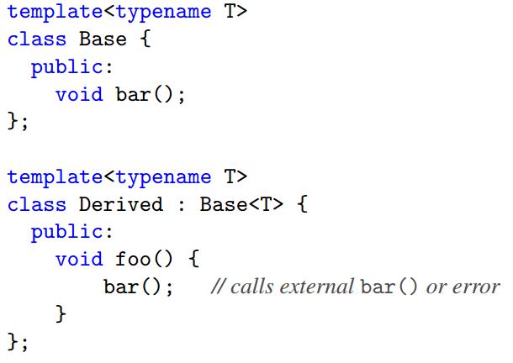

As a rule of thumb, we recommend that you always qualify any symbol that is declared in a base that is somehow dependent on a template parameter with this-> or Base<T>::.

1. Templates for raw arrays and string literals