Meilenstein 2

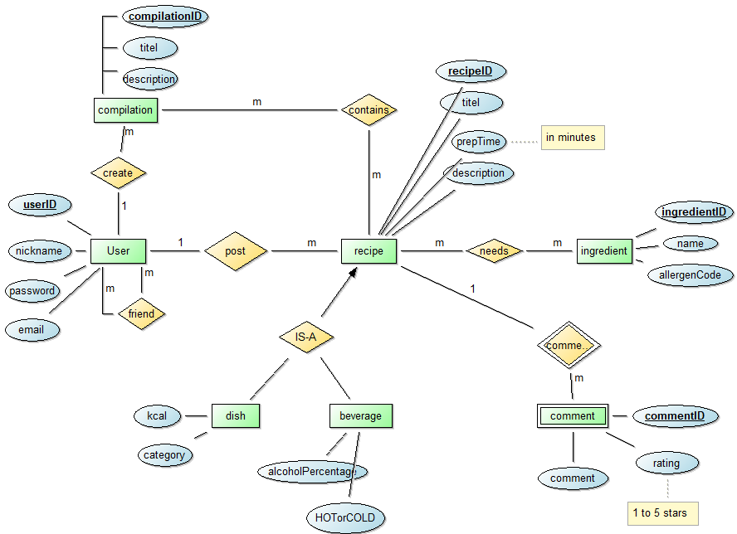

users(userID, nickname, password, *email*)

PK={userID}

friends(*user1, user2*)

PK={user1,user2}

FK: friend.user1◊ users.userID

FK: friend.user2◊ users.userID

recipe(recipeID, titel, prepTime, description, *writer*)

PK = {recipeID}

FK: recipe.writer◊ users.userID

dish(kcal, category, *recipeID*)

PK = {recipeID}

FK: dish.recipeID ◊ recipe. recipeID

beverage(alcoholPercentage, HOTorCOLD,recipeID)

PK = {recipeID}

FK: beverage.recipeID ◊ recipe. recipeID

ingredients(ingredientID, ingredientName, allergenCode)

PK = {ingredientID}

needs(*recipe*, *ingredient*)

PK = {recipe, ingredient}

FK: needs.recipe ◊ recipe. recipeID

FK: needs.ingredient ◊ ingredients. ingredientsID

comments(commentID, rating, commented, *recipe*)

PK = {commentID, recipe}

FK: comment.recipe ◊ recipe.recipeID

compilations(compilationID, titel, description, userID)

PK = {compilationD}

FK: compilation.userID ◊ users.userID

contains(*recipe*, *compilation*)

PK = {recipe, compilation}

FK: add.recipe ◊ recipe.recipeID

FK: add.compilation ◊ compilation.compilationID