Pen & Paper (Lab2)

# Task 1

Neither diffuse nor Phong illumination is approximating the moon well. What observations tell you that this is true? (2 points)

# Answer:

We can notice the deficits of diffuse or Phong illuminatio by observing the full moon. If we light up a sphere using diffuse or Phong illumination and compare it to the full moon we will notice that the light on the sphere falls of around the edges whereas the edges of the moon look bright (not close to zero).

# Task 2

Find the projection of a point onto the plane ax + by + cz + d = 0 from a light source located at infinity in the direction (dx,dy,dz). (2 points)

# Answer:

Let P = (xp, yp, zp) be an arbitrary point, D = (dx,dy,dz) the light direction and S = (xs, ys, zs) the projection we are looking for.

g: P + α*D (line from the light through P)

E: a*x + b*y + c*z + d = 0 (plane we are projecting onto)

With (a*(px+α*dx)+b*(py+ α*dy)+c*(pz+ α*dz))+d=0 we get the intersection of the line from the light through P and our arbitrary plane.

α = (-(a*px+b*py+c+pz))/(a*dx+b*dy*c*dz)

S = P + α*D

The projection matrix is 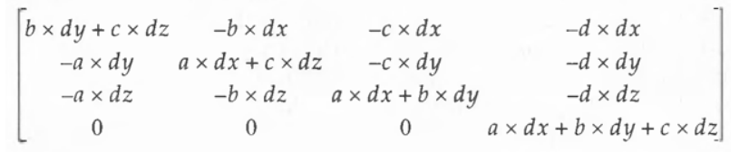

Task 3

Consider a highly reflective sphere centered at the origin with a unit radius. If a viewer is located at P, describe which points this person would see reflected in the sphere at a point on its surface. (2 points)

# Answer:

p : point on surface

l : P to point light source

n : normal vector to the plane or surface

v : p to eye (view point) or center of projection

r : vector of perfect reflection

We can get r with r = 2(n ⋅ l)n – l.

The person will see all points p that lie on the reflection vector.

Task 4

If the light position is altered by an affine transformation, such as a modeling transformation, how must a normal vector be transformed so that the angle between the normal and the light vector remains unchanged? (2 points)

# Answer:

Multiply the normal vector with inverse transpose of the model matrix.

Task 5

Find four points equidistant from one another on a unit sphere. These points determine a tetrahedron. Find the general solution with explanation how you developed it. (Hint: You can arbitrarily let one of the points be at (0, 1, 0) and let the other three be in the plane y = −d, for some positive value of d). (2 points)

# Answer: