CASA0022

Title
Design and Evaluation of a Low-Power Single-Axis Solar Tracking System for Remote Environmental Monitoring

Word Count: 5672

GitHub URL: https://github.com/JINMING2333/solar_tracker

Declaration of Authorship
I, AUTHORS NAME, confirm that the work presented in this assessment is my own. Where information has been derived from other sources, I confirm that this has been indicated in the work.

SIGN WITH YOUR NAME HERE
JINMING XIA

ASSESSMENT DATE
20250822

ABSTRACT
This study presents the design and evaluation of a low-cost, single-axis solar tracking system tailored for self-powered environmental sensing nodes. To identify the most energy-efficient configuration, the tracking system was compared with a fixed-tilt setup through real-world deployments and continuous energy monitoring. The tracking system integrates an astronomical algorithm with LDR-based fine-tuning, and features a gear-bearing structure powered by a low-power DC motor. Results show that on sunny days, the tracker achieved 1.45 times the net energy gain of the fixed system. However, under cloudy or shaded conditions, this advantage diminished. With sleep mode implemented, the fixed system consistently maintained an energy surplus, highlighting its stability. These findings suggest that while tracking offers significant gains in ideal conditions, fixed systems with optimized power management are more robust across varying weather. Future enhancements such as hybrid tracking logic, higher-capacity storage, and waterproof design are essential for long-term, autonomous outdoor deployment.

1. INTRODUCTION
Against the backdrop of global climate change, the demand for environmental data acquisition and ecosystem monitoring is steadily increasing across the world. In particular, remote areas are experiencing a growing need for long-term, autonomous environmental monitoring systems. These deployment environments typically lack access to stable power grids, necessitating self-powered solutions for reliable long-term operation (Luo, K et al., 2024). Among various renewable energy sources—such as wind, thermal, radio frequency, and vibrational energy—solar energy remains the most widely adopted in IoT applications, owing to its high accessibility, maturity, and widespread infrastructure support (Kamarulzaman, A et al., 2021).

Most small-scale solar-powered nodes utilize fixed-tilt photovoltaic panels, which are unable to track seasonal or positional variations in the solar azimuth and elevation angles (Xudong Yang et al., 2025). Additionally, these systems are ill-suited to adapt to rapid atmospheric changes such as cloud cover (Krishna Kumba et al., 2024), thereby limiting their energy harvesting efficiency. In contrast, solar tracking systems (STS) can dynamically adjust panel orientation to remain perpendicular to incident sunlight, substantially improving energy output. This advantage is especially prominent in high-latitude regions such as London (Harazin, J. and Wróbel, A., 2022).

Nevertheless, active tracking mechanisms introduce energy overhead, structural complexity, and increased maintenance requirements. Several studies have pointed out that without well-designed control strategies and efficient actuation mechanisms, the net energy gain from tracking systems may fail to offset their own consumption (Harazin, J. and Wróbel, A., 2022). Therefore, ensuring that such systems operate with positive net energy yield under cost- and complexity-constrained conditions is a key consideration for applying solar tracking technology to compact environmental sensing nodes.

In light of this context, the present study seeks to address the following research question, “Can an optimal solar tracking configuration be identified for micro-scale environmental monitoring nodes through systematic comparisons of hardware selection, mechanical design, and tracking strategies?”

To explore this, we developed and tested a prototype solar tracking system based on single-axis active tracking, and deployed it alongside a fixed-panel system in real-world outdoor conditions. By collecting energy input and consumption data for both systems, we quantified their net energy gain and operational reliability, providing practical insights into the design of solar-powered systems for low-power IoT applications.

2. LITERATURE REVIEW
2.1. Energy Trends in Self-Powered Environmental Monitoring Nodes
With rising awareness of ecological conservation, the global demand for environmental monitoring devices has expanded rapidly. By 2030, the number of connected IoT devices is projected to reach 29.42 billion (Kumar, N., 2024). A significant proportion of these will be deployed in remote natural environments to monitor parameters such as temperature, humidity, and atmospheric composition (De Oliveira Filho, J. I. et al., 2022). However, the limited power infrastructure in these regions presents a major challenge to ensuring long-term, low-maintenance energy supply (De Oliveira Filho, J. I. et al., 2022).

Currently, most IoT sensor nodes rely on battery power (Wang, J. et al., 2024). However, periodic battery replacement in remote areas is not only costly (Rosa, R. L. et al., 2024) but also environmentally unsustainable (Kang, D. H. P. et al., 2013). As a result, researchers have been actively exploring energy harvesting technologies, such as thermal gradients, vibrational energy, radio frequency energy, and solar energy. Among these, solar energy harvesting remains the most viable option due to its relatively high power output: while thermal, vibrational, and RF sources typically deliver power in the microwatt to milliwatt range, solar panels can generate significantly more energy even at small scales (Sarker, M. R. et al., 2024).

2.2. Solar Energy Systems: Current State and Applications
a. Structural Typologies: Fixed vs. Tracking Systems
Solar energy systems can generally be categorized into Fixed Tilt Systems and Solar Tracking Systems (STS). Numerous studies have confirmed that tracking systems can yield 10%–60% more energy than fixed systems, depending on the number of tracking axes, control algorithms, and geographic location (Harazin, J. and Wróbel, A., 2022). For example, the single-axis and dual-axis tracking systems using the five-position angle optimization control strategy can achieve energy gains of 16.71% and 24.97%, respectively, compared to the fixed system (Thungsuk, N. et al., 2023).In medium- to large-scale photovoltaic installations and concentrated solar power (CSP) plants, the performance gains from STS translate into substantial economic benefits, and tracking systems have become a well-established solution (Yao, Y. et al., 2014).

By contrast, research on solar tracking systems for micro-scale environmental monitoring nodes remains relatively scarce (Kapustenko, P. et al., 2023). Most small-scale sensor networks still utilize fixed-panel solar power systems due to their simplicity in both design and control (Sadeghi, R. et al., 2025). One reason is the long-held concern that the energy consumption of tracking mechanisms may outweigh the gains, particularly for small-scale systems. Additionally, complex mechanical and control designs pose integration, weight, and cost challenges for miniaturized devices.

Despite these concerns, some studies have demonstrated meaningful energy gains even in compact tracking systems. For instance, a small-scale dual-axis tracking prototype deployed in Shanghai showed a 24.6% increase in energy output compared to a fixed system (Shang, H. and Shen, W., 2023), thereby supporting the feasibility of this research direction.

b. Solar Tracking Strategies
Solar Tracking Systems can be broadly classified based on their control mechanisms into: Active systems, Passive systems, and Preset (astronomical) systems.Active systems use real-time sensor feedback to drive actuators that follow the sun’s trajectory. For example, “Abdulrhman (2024) used four photodiodes to capture light intensity variations, while Abdollahpour et al (2018) utilized a webcam and shadow image processing to drive solar trackers”. Although highly responsive and adaptive, active systems can suffer from false triggers in cloudy conditions, leading to unnecessary energy consumption.

Passive systems rely on physical principles such as thermal expansion or gravity bias to rotate in response to solar movement. These require no external power, making them more energy-efficient, albeit at the cost of reduced precision.Preset systems are based on astronomical algorithms that predict solar trajectories and control the panel angle accordingly. Since they do not require continuous sensor calibration, algorithm-driven trackers are often more stable and energy-efficient (Musa, A. et al., 2023).

Based on the number of axes, STS can be categorized as single-axis (Fig.A) or dual-axis (Fig.B) tracking systems. SAS achieves dynamic tracking by rotating about a single axis. DAS can achieve simultaneous rotation along both the horizontal and vertical axes, allowing for more precise tracking of the sun's movements. However, DAS systems are more complex, consume more energy, and are typically reserved for large-scale installations where efficiency gains justify the additional cost (Karabiber, A. and Güneş, Y., 2023).
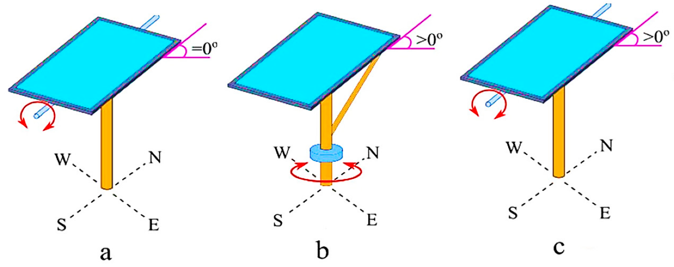
Fig.A. Configurations of single-axis trackers:(a) Horizontal single-axis tracker, (b) Vertical Single-Axis Tracker, and (c) the Polar-Aligned Single-Axis Tracker (Sadeghi et al., 2025).

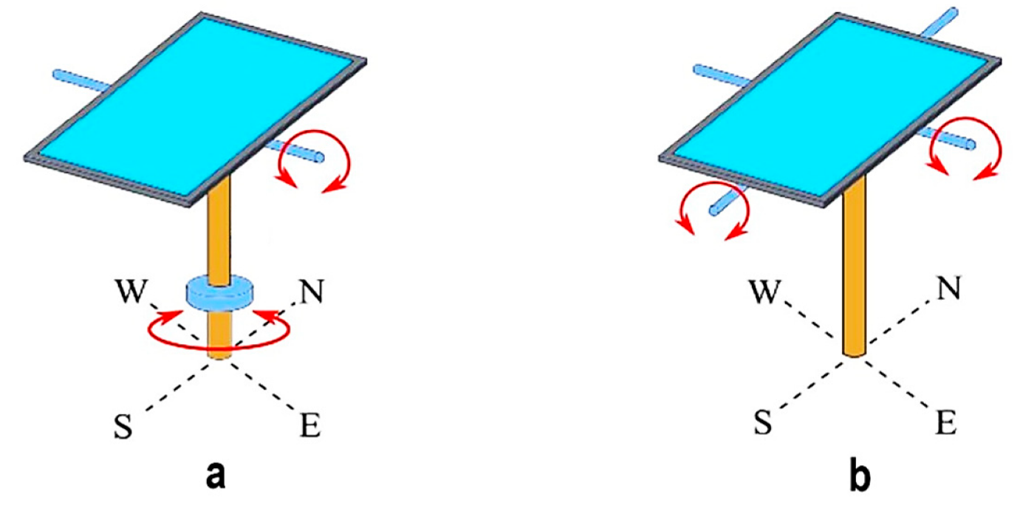
Fig.B. Configurations of dual-axis solar tracking systems: (a) pseudo-azimuthal dual-axis tracker with azimuth and altitude rotation, (b) pseudo-equatorial dual-axis tracker with east-west and solar altitude tracking(Sadeghi et al., 2025).

Each of these strategies has inherent trade-offs, and selecting the appropriate tracking mechanism remains a critical research topic depending on the target application.

2.3. Evaluating Energy Gains
Traditional assessments of solar tracking systems often focus solely on increased power output, without accounting for the energy consumed by the tracking mechanism itself. Recent research increasingly emphasizes that net energy gain should be the core metric when evaluating STS feasibility (Sarker, M. R. et al., 2024). In micro-scale systems, the proportion of energy consumed by motors and control logic can be significant. If not properly optimized, tracking systems may yield negative net returns. A recent review highlights the urgent need for more granular energy balance analyses in solar tracking systems, stressing the importance of reducing tracking-related energy costs while maintaining sufficient precision (Xudong Yang et al., 2025).

2.4. Research Gap and Project Focus
In summary, while solar tracking technology is well-established for large-scale photovoltaic systems, there remains a notable lack of integrated research on hardware selection, structural design, and control strategies tailored to low-power, low-maintenance, high-integration micro monitoring nodes.

To address this gap, the present study develops and evaluates two deployable prototype systems—a fixed-panel system and a single-axis tracking system—in real-world outdoor settings. By comparing energy harvesting performance, system power consumption, and integration feasibility, this work aims to provide experimental evidence and practical design insights for low-cost and sustainable energy solutions in environmental monitoring applications.

3. METHODOLOGY
This study aims to develop a cost-effective, compact, and long-term solar tracking power supply system to support outdoor environmental monitoring nodes. Accordingly, the system design focuses on the following objectives:
- Selection of low-power and easily integrated core hardware;
- Construction of a lightweight and power-saving mechanical structure;
- Implementation of a tracking strategy that balances energy efficiency with low power consumption;
- Accurate acquisition and comparative evaluation of net energy gain between fixed and tracking systems.
This section presents the hardware and software design, as well as the experimental deployment strategy, based on the aforementioned logic.

3.1 Hardware Configuration
3.1.1 Microcontroller Unit（MCU）
The Arduino MKR WAN 1310 (Fig.1) is selected as the main control board. This MCU integrates a LoRa communication module and a SAMD21 processor, enabling low-power remote data transmission and deep sleep modes without additional expansion modules. It is well suited for deployment in remote areas with limited power availability.
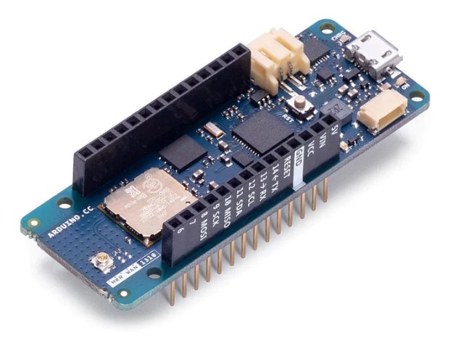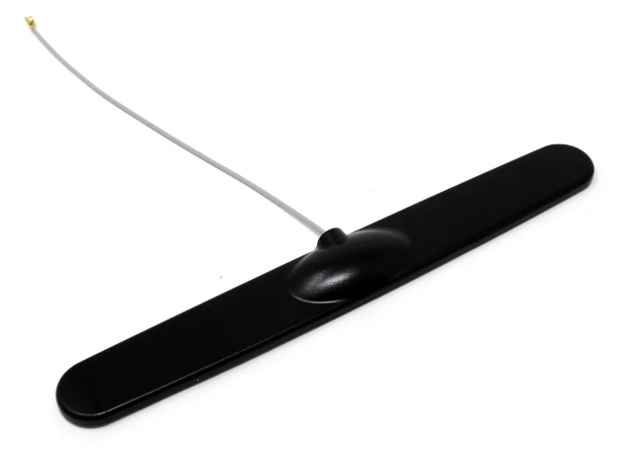
Fig.1. The Arduino MKR WAN 1310 (left) and antenna (right) to assist LORA communication.

3.1.2 Sensors
- Power Monitoring Moudle – INA219
The system employs the INA219 high-precision power monitoring module. Based on a shunt resistor design, the INA219 can accurately monitor voltage, current, and power variations. It supports I²C communication with multiple address configurations, allowing simultaneous monitoring of multiple power channels.After comparing various INA series modules (Table 1), the INA219 proves to be the most suitable choice for this project.

Table 1
Analysis of the advantages and disadvantages of INA series modules
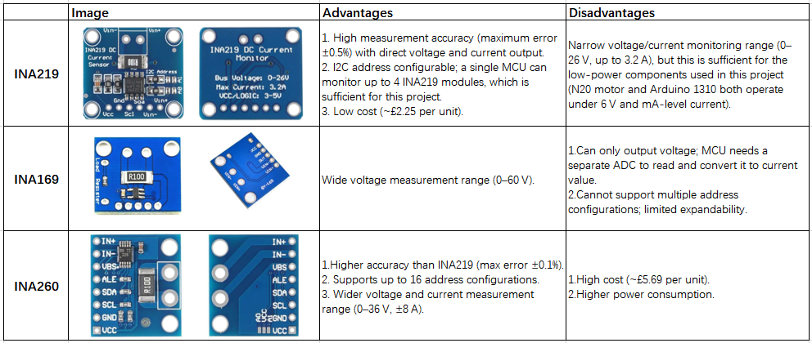

- Light Sensor – LDR
Among the various optical sensors available, the Light Dependent Resistor (LDR) is selected as the most appropriate for this project (Table 2). Connected in a voltage divider configuration to an ADC input, its resistance varies with light intensity, providing differential signals for fine-tuning solar tracking.

Table 2
Analysis of the advantages and disadvantages of optical sensors.
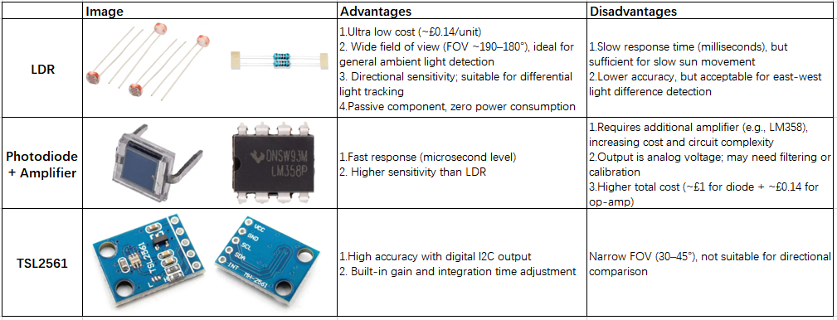

3.1.3 Actuators
To achieve low-power rotational control for the tracking mechanism, three types of actuators were evaluated through controlled experiments:
- Servo Motors
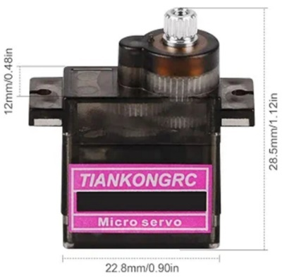
The servo has built-in position control logic, suitable for simple tracking tasks. The MG90S (Fig.2) has advantages such as high torque and low idling current.
Fig.2. The MG90S.

- DC Motors + Encoder + H-Bridge Driver
Research indicates that N20 metal gear DC motors offer lower rotational speeds and higher torque compared to standard DC motors, resulting in more stable and efficient operation—ideal for speed-controlled applications (Jackson, G. et al., 2017).

DC motors rotate continuously via sustained current but lack intrinsic position control. Thus, encoders (Table 3) are required to measure rotation angles precisely.

Table 3
Introduction to Encoder Principle.
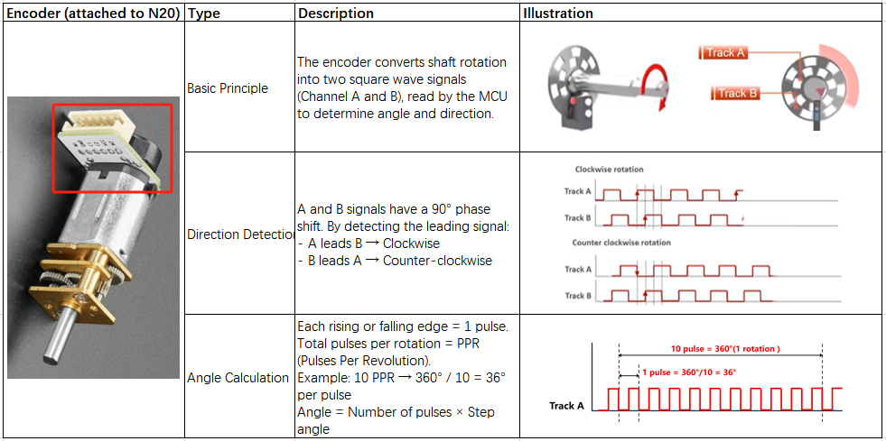

An H-bridge driver module (Table 4) is also necessary to enable bidirectional rotation (Fig.3).
Table 4
Introduction to H-bridge control Principle.
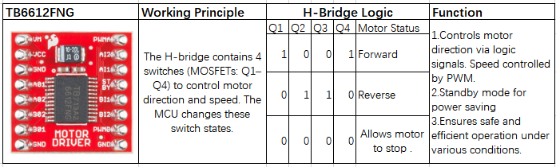

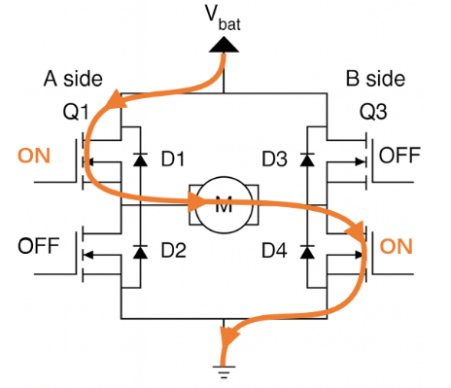
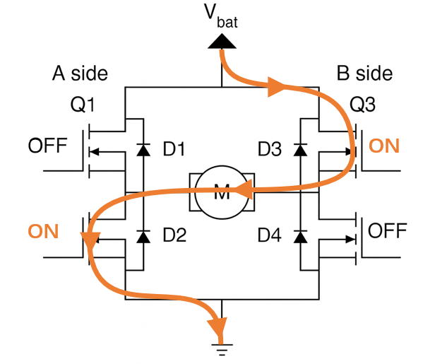
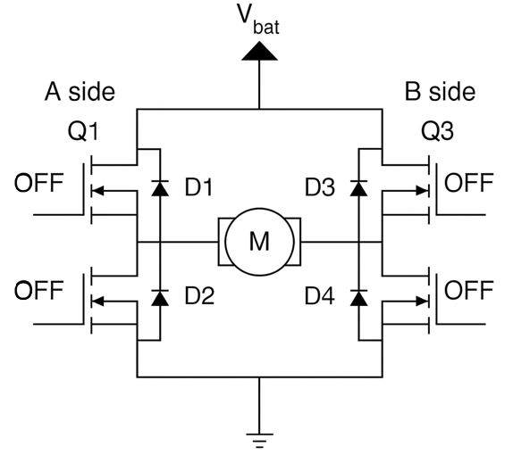
Fig.3. H-bridge schematic diagram. From left to right, the motor states are forward, reverse, and stop.

- Stepper Motors
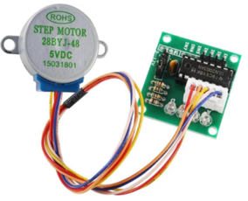
The 28BYJ-48 stepper motor (Fig.4) provides high-precision angle control. However, its relatively high power consumption renders it unsuitable for final deployment and it is used mainly for comparative analysis.
Fig.4. The 28BYJ-48 stepper motor with drive module- ULN2003.

Following the connection setup (Fig.5) and experimental procedure (Table 5), various motor types were tested for simulating solar tracking. Results (Fig.6) showed that the N20 DC motor had the lowest energy consumption (0.389 mWh) and was most suitable for this application.
Table 5
Experimental Setup.
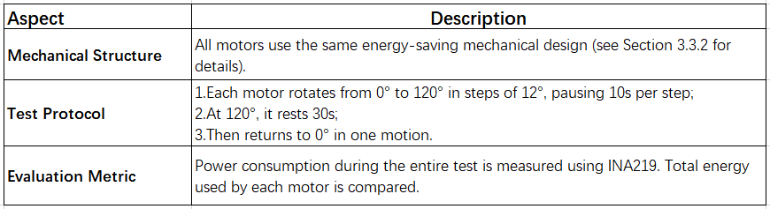

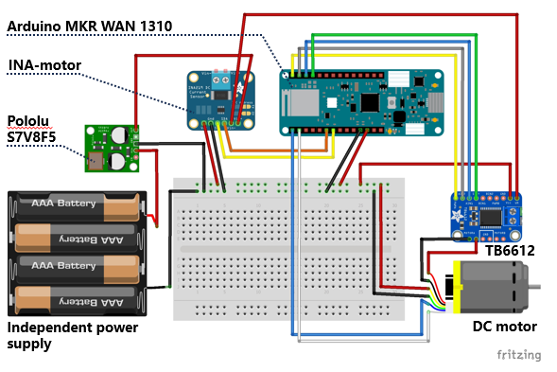
Fig.5. Three types of motor energy consumption test circuit diagram (taking DC motor as an example)

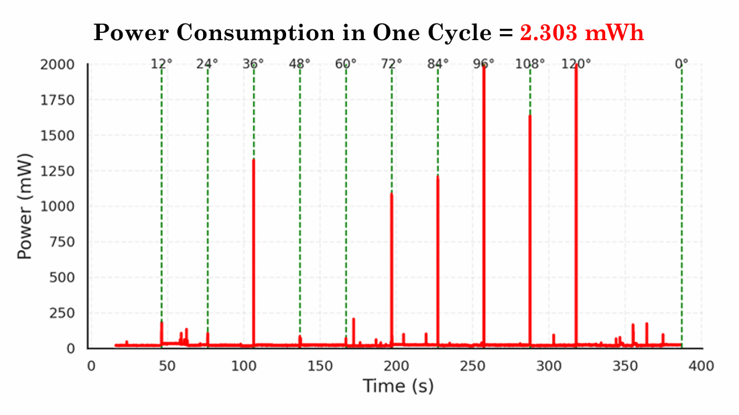
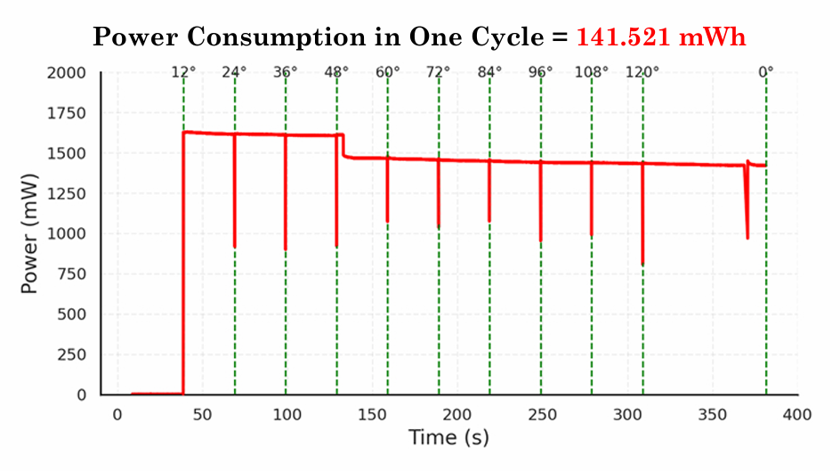
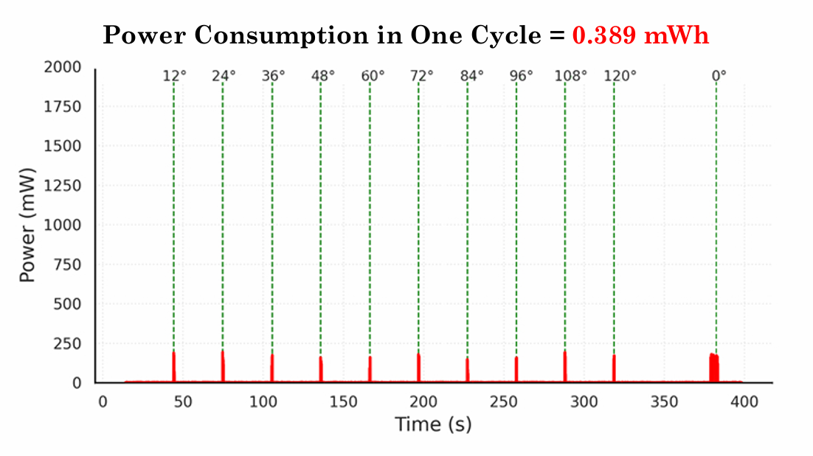
Fig.6. Energy consumption monitoring chart of three motor operation tests, from top to bottom: DC motor (best), servo and stepper motor.

3.1.4 Other Components
- Solar Panel
A high-efficiency, lightweight 3W 6V solar panel (145×145 mm, 75 g) is selected to maximize energy absorption while minimizing motor load during rotation.

- Solar Charging Module
The charging circuit bridges the gap between fluctuating solar input and the stable power demand of the system. The BQ24074 is selected for its ability to safely charge lithium batteries. Its key parameters and selection rationale are detailed in Table 6&7 and Fig.7.
Table 6
BQ24074 Charging Module Overview.
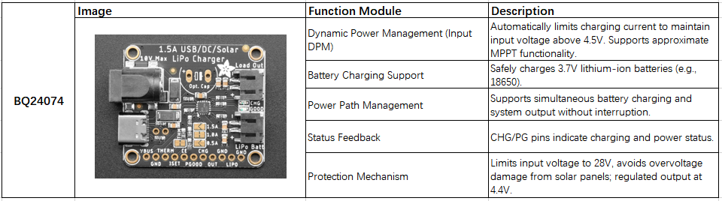
Table 7
Reasons to choose BQ24074 instead of other standard MPPT modules.
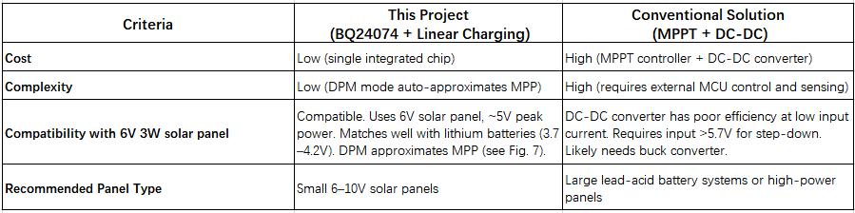
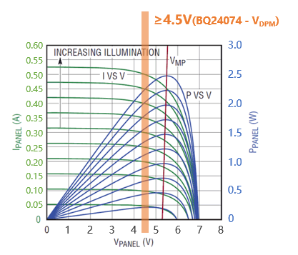
Fig.7. I-V and P-V characteristics of a solar panel and DPM operation.
- Under varying illumination, the solar panel's maximum power point (V<sub>MP</sub>) appears around 5V.
- By setting the DPM threshold at ≥4.5V, the BQ24074 module dynamically reduces input current when voltage drops, helping to keep the panel operating near its peak power zone and improving energy harvesting efficiency.

- Rechargeable Battery
A standard 18650 lithium-ion battery (3.7V, 3300mAh) is used for energy storage. It offers high capacity and efficiency, making it ideal for low-power systems.

- Voltage Regulator
Since the BQ24074 output is limited to below 4.4V, the Pololu S7V8F5 buck-boost regulator is used to stabilize the voltage at 5V for the MCU and motor.

- Micro USB Adapter
Used to safely extract USB lines and monitor MCU power consumption via INA219.

- Real-Time Clock (RTC) Module
To provide accurate timestamps for astronomical tracking, the DS3231 high-precision RTC module is employed. It features temperature compensation and battery backup to maintain reliable timing even during power outages.

3.2 Circuit Design
The experiment progressed in stages, each with slightly different circuit configurations:
3.2.1 Single-Axis Tracking System
- Data Analysis Stage (Fig.8):
The motor and control circuit are powered separately. The solar panel is used only for charging, facilitating independent energy efficiency analysis.
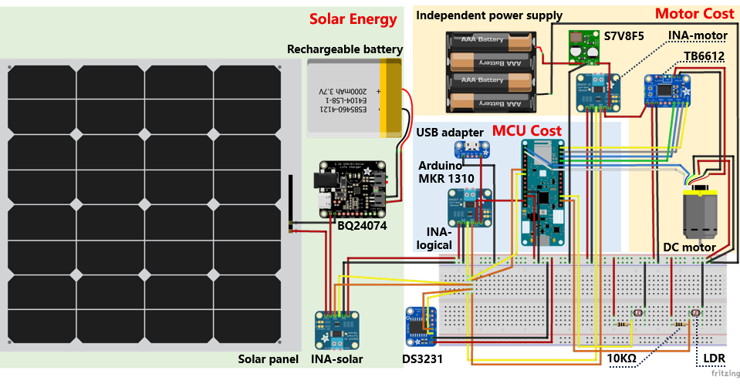
Fig.8. Circuit Diagram (single_ Data Analysis Stage).

- Final Deployment Stage (Fig.9):
Achieves true energy autonomy, with all modules indirectly powered by the solar panel.
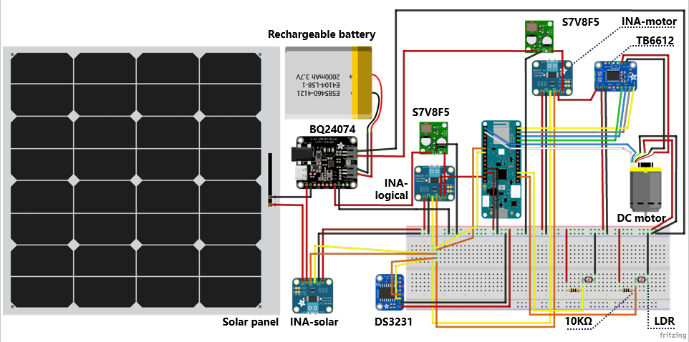
Fig.9. Circuit Diagram (single_ Final Deployment Stage).

3.2.2 Fixed System
A simplified version without motors but following a similar two-stage design:
- Data Analysis Stage (Fig.10)
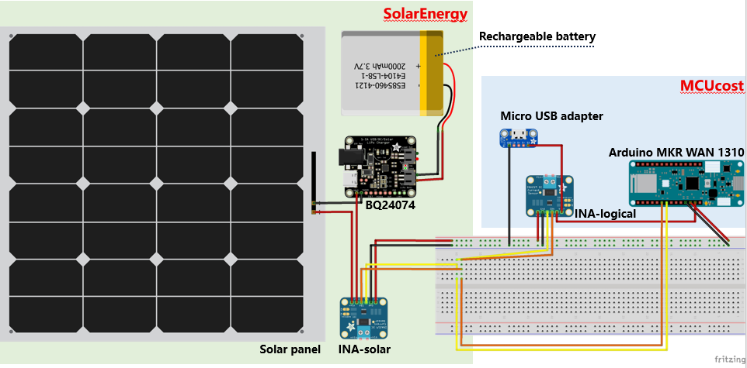
Fig.10. Circuit Diagram (fixed_ Data Analysis Stage).

- Final Deployment Stage (Fig.11)
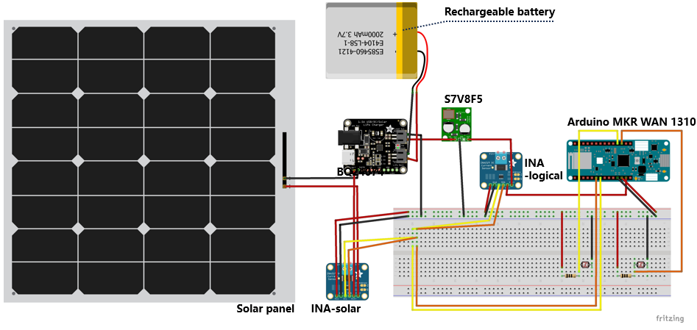
Fig.11. Circuit Diagram (fixed_ Final Deployment Stage).

3.3 Mechanical Structure Design
3.3.1 Single-Axis vs. Dual-Axis structure
A single-axis tracking structure is adopted based on the following rationale (Fig.12):
First, deployment occurs during the summer when solar elevation in high-latitude regions changes more gradually, allowing south-north tilting to achieve near-dual-axis performance (Sadeghi et al., 2025).Second, compared to dual-axis systems, single-axis structures offer better trade-offs in mechanical complexity, energy consumption, and control stability—ideal for long-term outdoor deployment (Xudong Yang et al., 2025).
And, Stanford study based on Typical Meteorological Year (TMY) data indicates that the optimal annual tilt angle for London is approximately 34° (Jacobson, M. Z. and Jadhav, V., 2018). Since this study focuses on summer deployment, the tilt angle is adjusted downward by 10°, resulting in a final fixed tilt of 25° (Charles R. Landau, 2017).

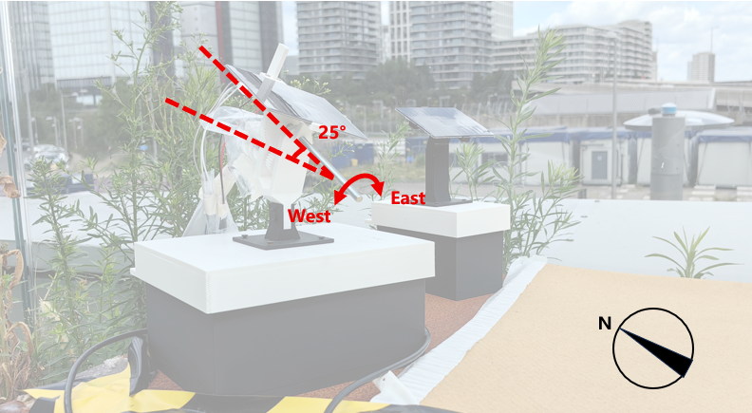
Fig.11. Schematic diagram of the single-axis rotating structure and a 25° north-south tilt angle.

3.3.2 Gear Transmission Optimization
To achieve precise panel alignment, a well-designed transmission structure is essential. Different mechanical configurations can significantly affect motor torque requirements and energy consumption.
This study compares four structural types (Table 8 & Fig.12、13), evaluating their torque requirements and mechanical stability.
Table 8
Overview of the four structures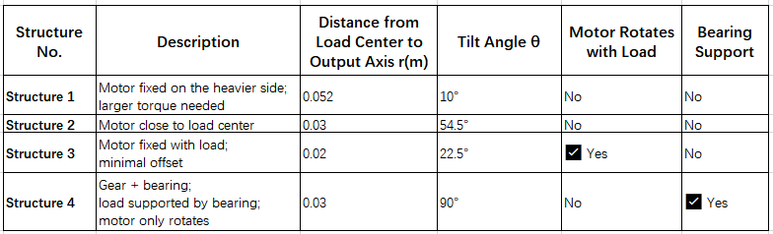

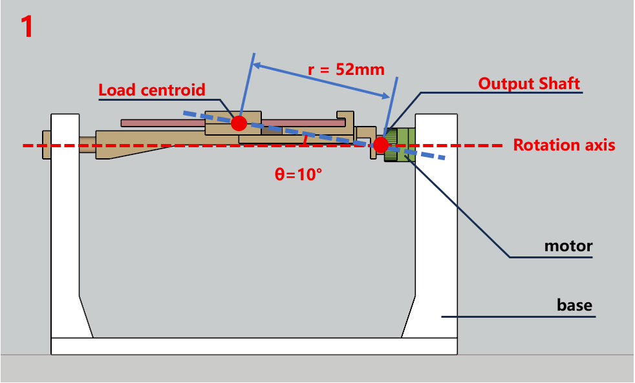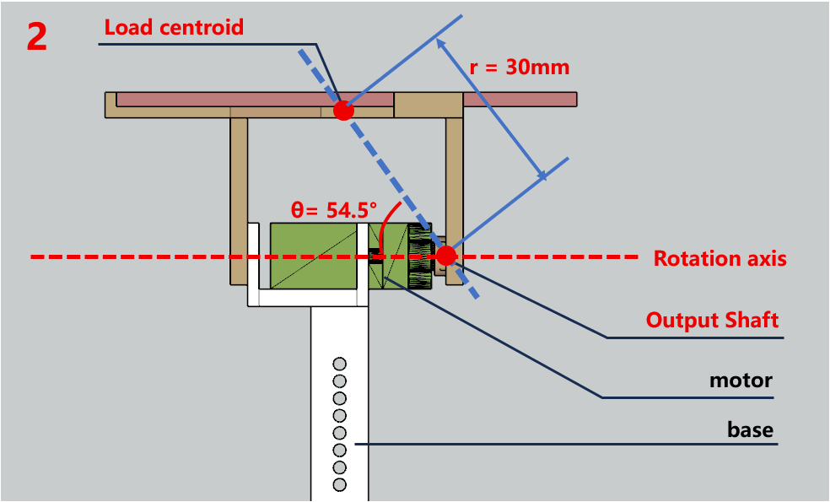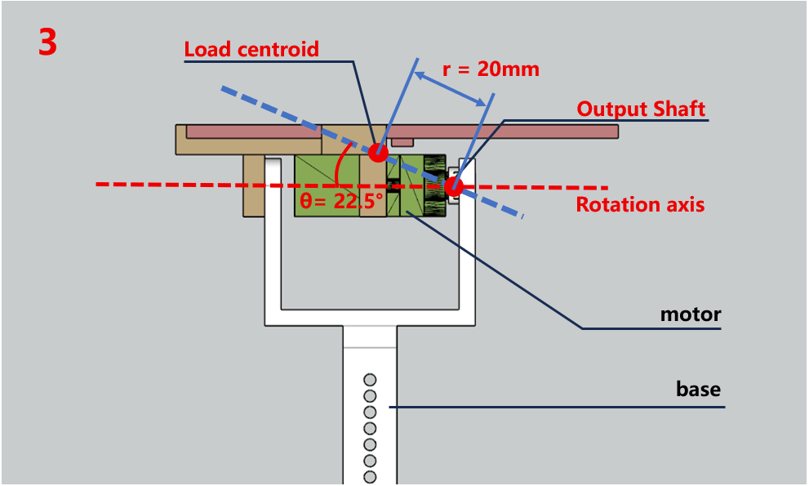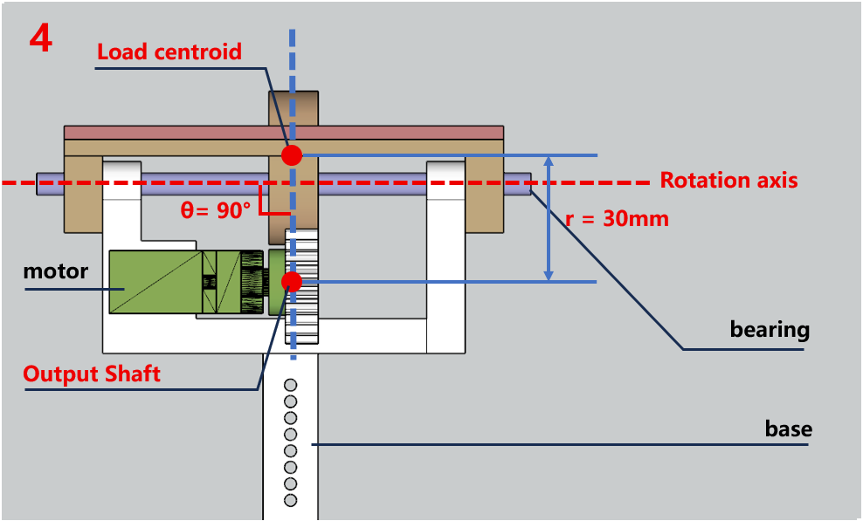
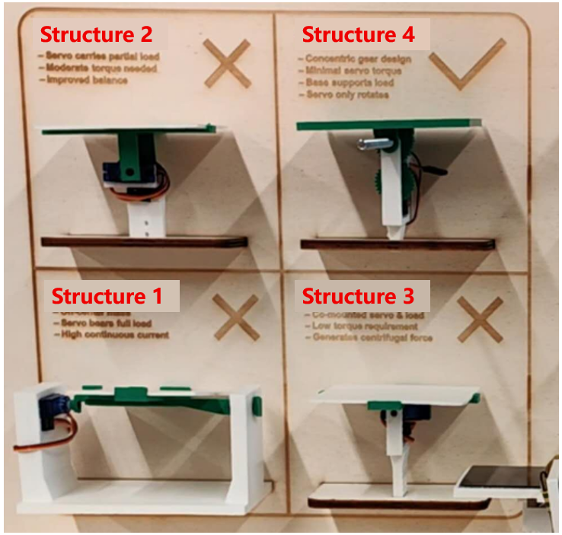
Fig.12. Four structural diagrams.

Fig.13. Actual display of four structures.

Assuming a uniform load mass of 0.2 kg, the following torque types are calculated:
Gravitational Torque (for Structures 1–3):
$$τg​=m⋅g⋅r⋅sin(θ)$$
- m: Mass (kg)
- g: Gravitational acceleration (9.8 m/s²)
- r: Distance from center of mass to axis (m)
- θ: Angle between mass vector and rotation axis

Centrifugal Torque (Structure 3):
$$Fc​=m⋅r⋅ω2$$
τc​=Fc​⋅r=m⋅r2⋅ω2
- $Fc​$: Centrifugal force
- ω: Angular velocity (rad/s)

Bearing Friction Torque (Structure 4):
τf​=μ⋅Fn​⋅rb​
- μ: Friction coefficient (0.001–0.01 typical)
- Fn ​: Normal force = m⋅g
- rb ​: Bearing radius (m)

Considering gear transmission loss (typically 5%–10%), the horizontal gear-bearing structure (Structure 4) was found to perform best and is selected for the final design (Table 9).
Table 9
Estimated Torque Comparison for Different Structures.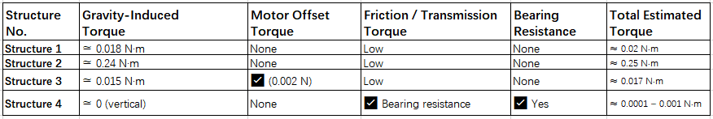

3.4 Enclosure and Protection Design
Given that the system is deployed outdoors, the enclosure must offer reliable water resistance to protect electronic components (Fig.14).
The fixed system uses a hollow support design to route cables internally between the solar panel, LDRs, and the MCU, preventing exposure to moisture (see Diagram). As the system employs LoRaWAN, antenna access must be preserved, so both enclosures feature sidewall openings with multiple layers of protection:
- Overhanging enclosure lids to deflect vertical rainfall;
- Openings sealed with adhesive tape and RS PRO silicone sealant, known for its water resistance and adhesion;
- Seams and screw holes sealed with RS PRO as well, to prevent capillary ingress.
- The enclosure is made from PLA material, which offers waterproofing, UV resistance, and biodegradability—suitable for short-term prototyping in the field.
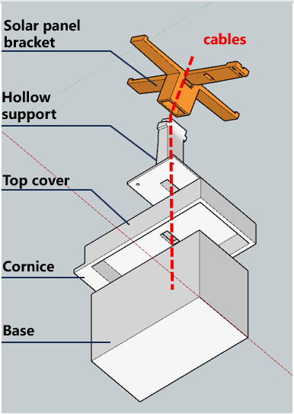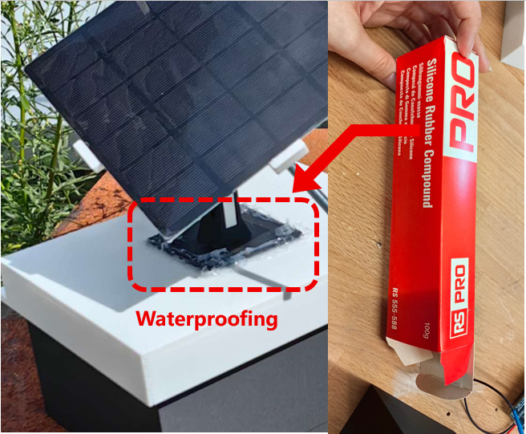
Fig.14. Waterproofing measures. Left: Hollow support enclose cables to prevent leakage; right: RS PRO glue seals pores to prevent water seepage.

3.5 Control Code
3.5.1 Tracking Strategy
A hybrid tracking strategy is employed, combining astronomical algorithms with LDR-based fine-tuning. Compared to purely sensor-driven methods, astronomical algorithms offer greater robustness and lower energy consumption (Musa et al., 2023). However, such algorithms may lack adaptability in real-world conditions. By incorporating LDR feedback, the system balances low power usage with improved accuracy and adaptability (Angulo-Calderón, M. et al., 2022).

3.5.2 Workflow
The operational workflow for both systems is illustrated in the diagrams below (Fig.15).
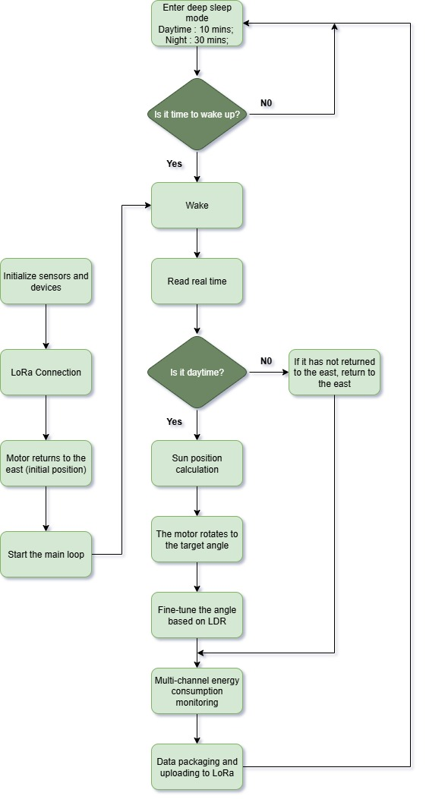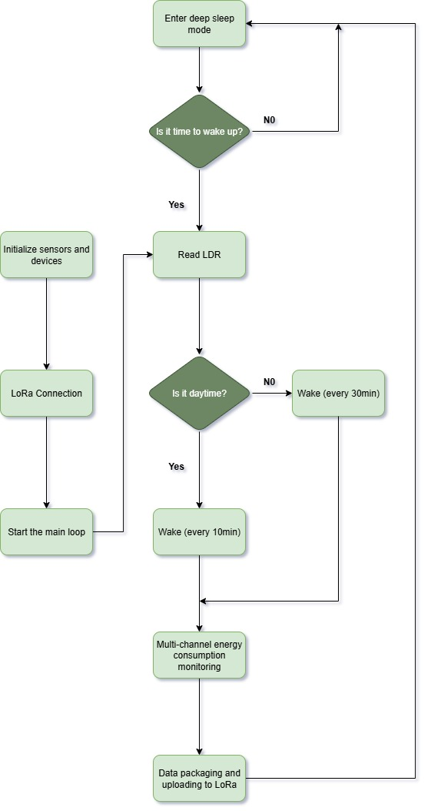
Fig.15. Code workflow. Left: Single-axis tracking system; Right: Fixed system.

3.5.3 Core Code Modules
Both devices share a similar code structure. The key modules for the tracking system include:
- Solar Tracking Control Module (Table 10)
Table 10
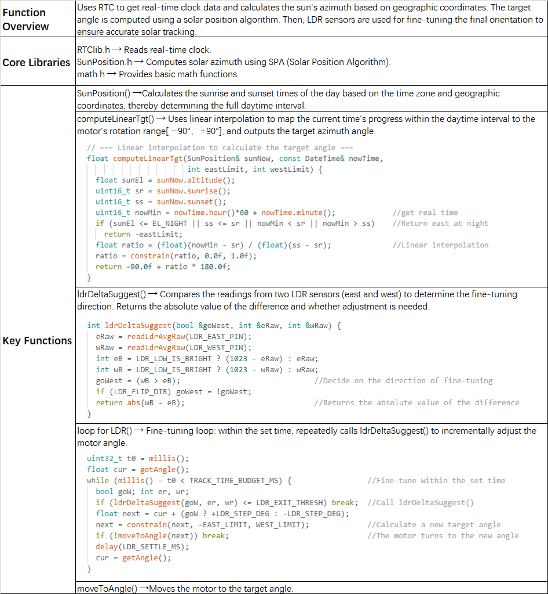

- Energy Monitoring and Calculation Module (Table 11)
Table 11
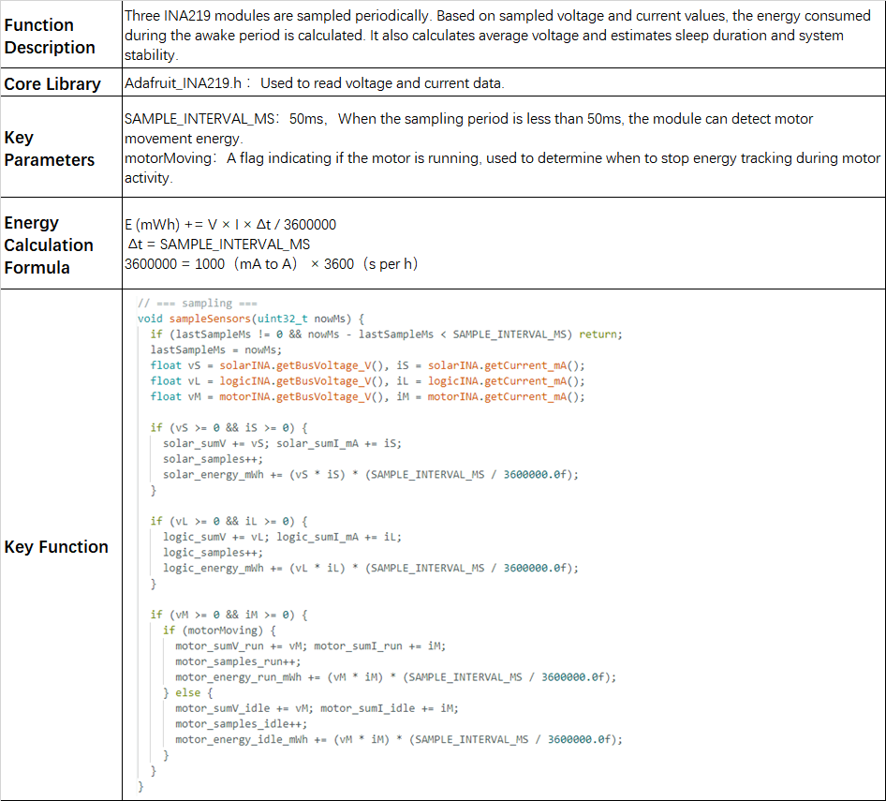

- Low-Power Control Module (Table 12)
Table 12
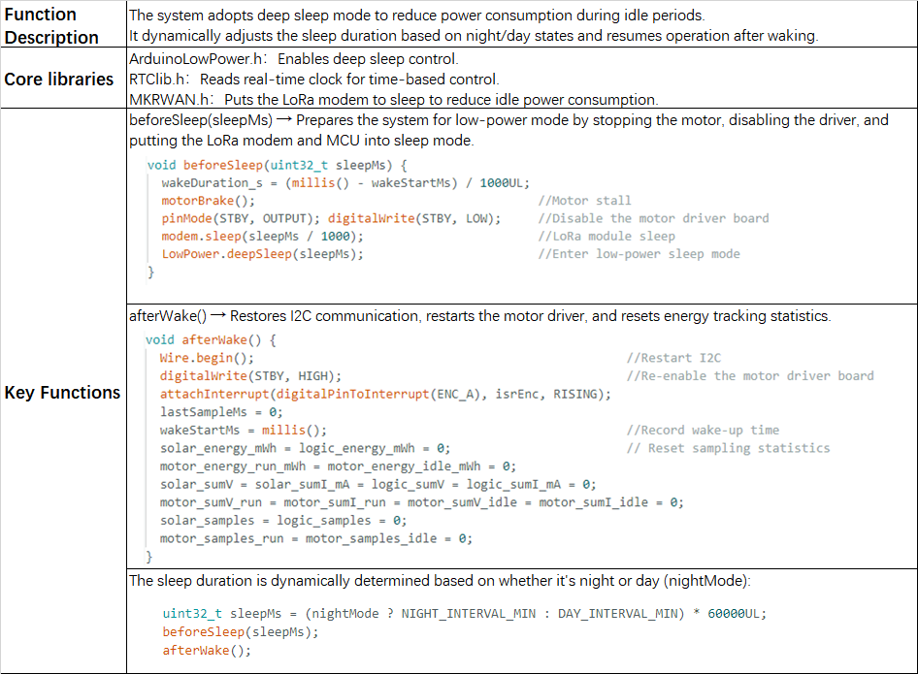

3.6 LoRa Communication and Data Visualization
The MCU transmits data via its LoRa module to The Things Network (TTN). A Payload Formatter decodes the transmitted hexadecimal data into JSON format (Fig.16).
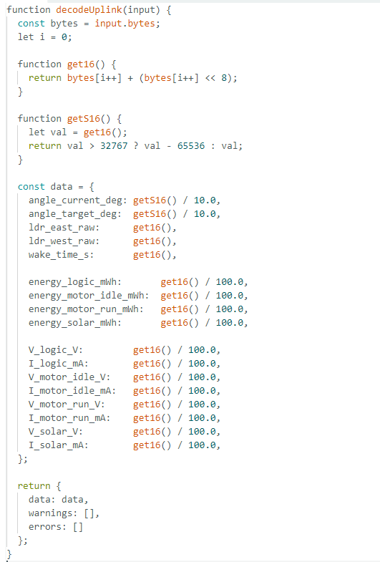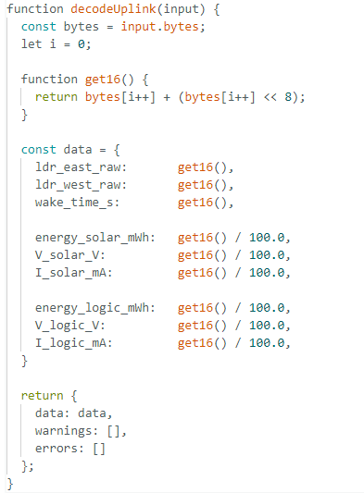
Fig.16. Payload Formatter decoding code. Left: Single-axis tracking system; Right: Fixed system.

Initially, a Raspberry Pi was used to pull daily data from TTN's Message Storage API for offline analysis. In the later stages, the Pi was configured to subscribe to TTN’s MQTT channel, enabling real-time data acquisition. Data were then stored in an InfluxDB database, and visualized via a Grafana dashboard, allowing real-time monitoring of the solar power system’s operational status (Fig.17).

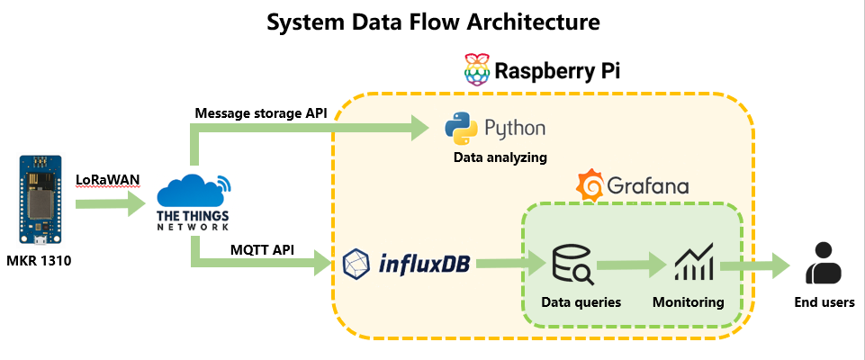
Fig.17. System data flow architecture during visualization.

During the exhibition phase, additional interactive features were introduced (Fig.18). For more details, please see GitHub.
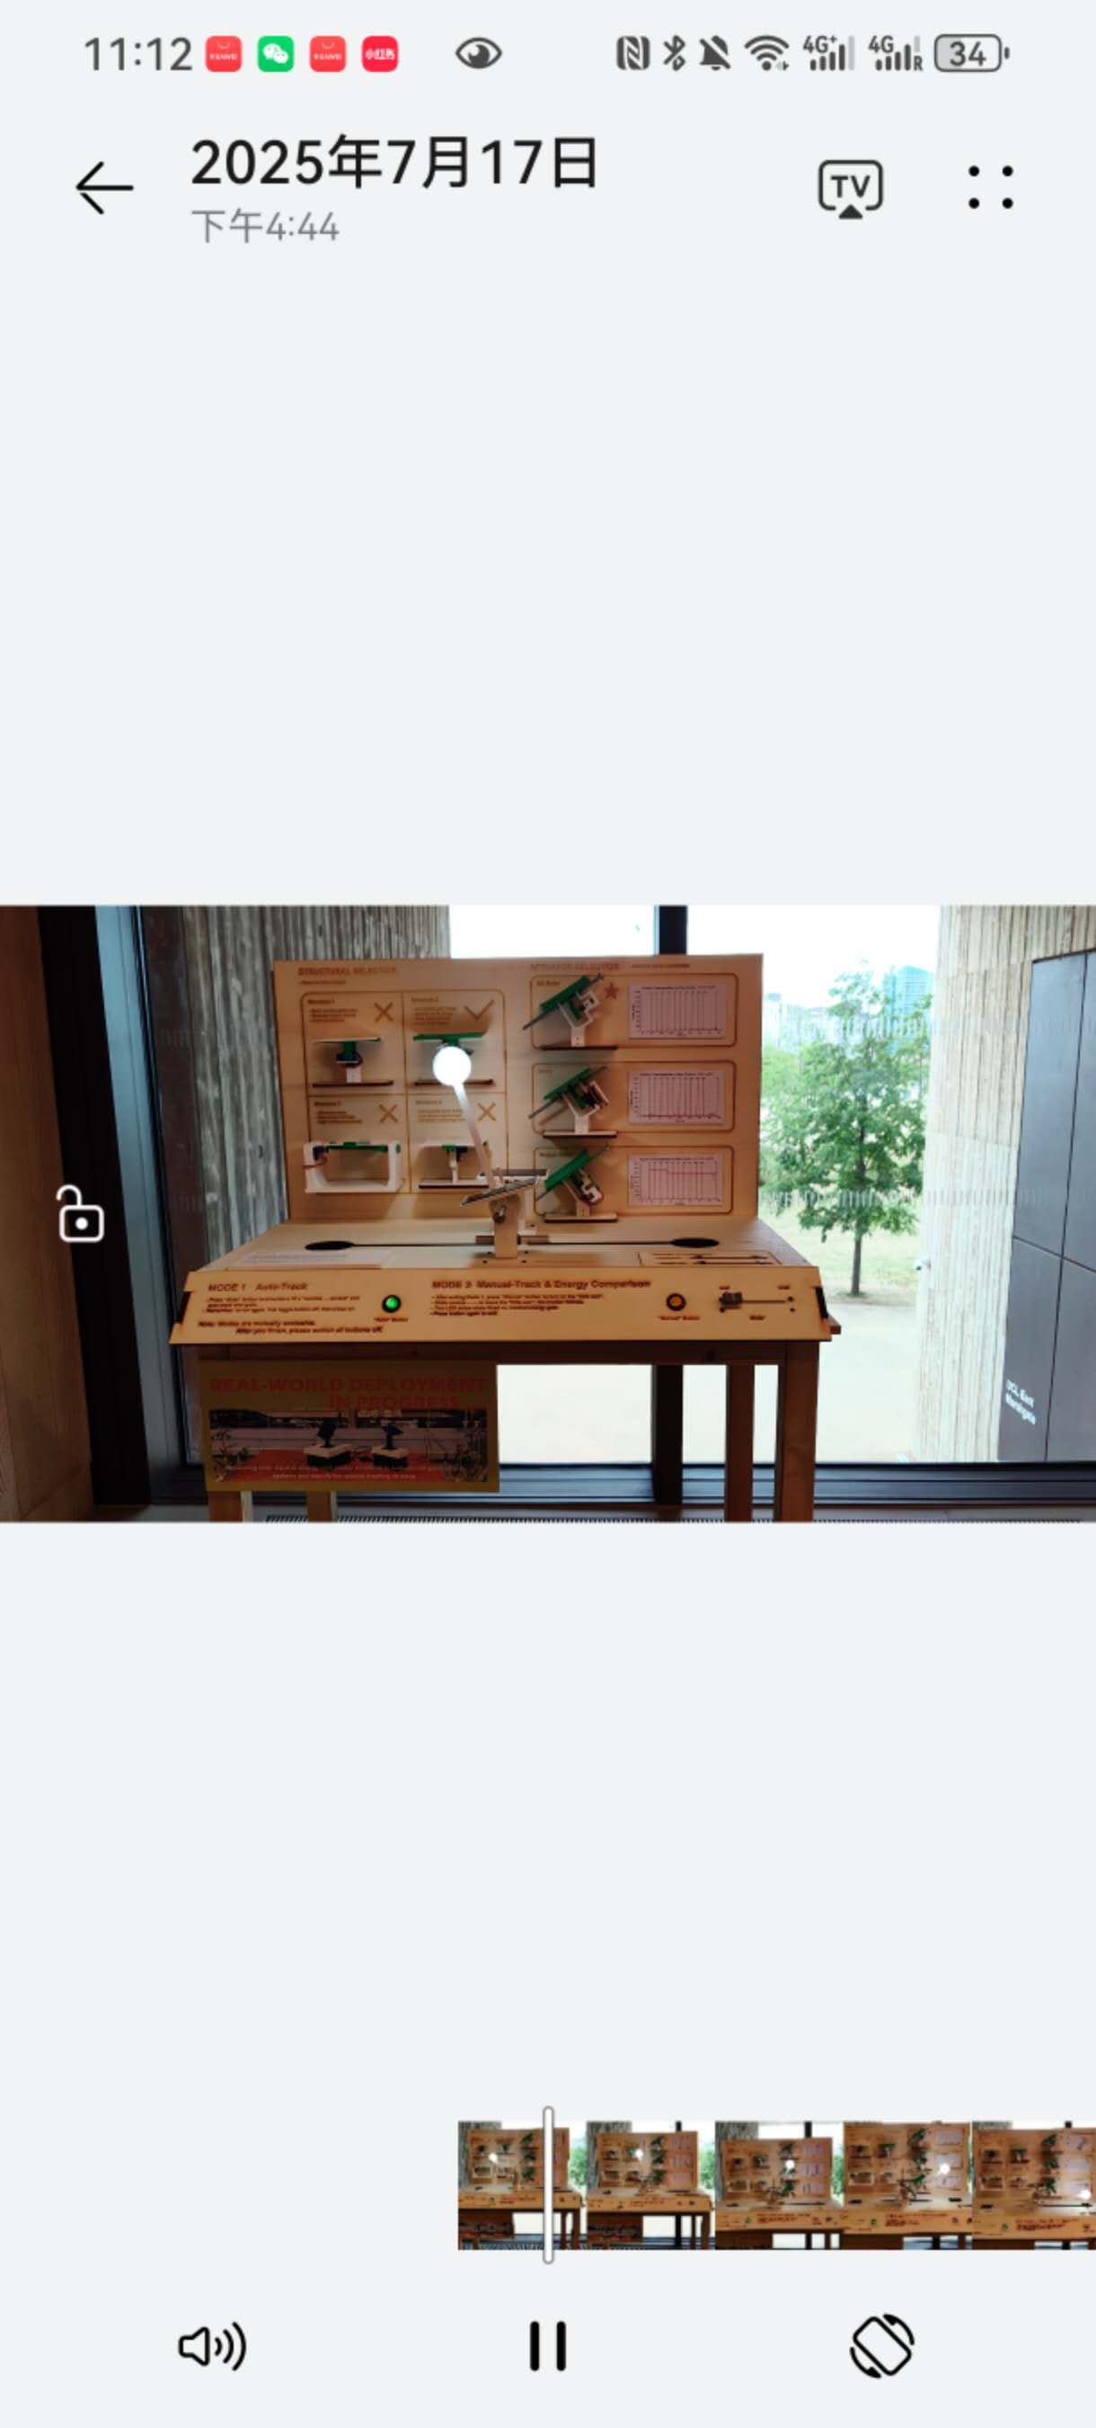
Fig.18. Booth design for the exhibition phase.

4. RESULTS
4.1 Deployment Experiment Overview
To evaluate real-world performance, a series of outdoor field deployments were conducted to systematically compare the energy behavior of fixed and single-axis solar tracking systems. Experiments took place on the rooftop garden of the first floor at One Pool Street, UCL East Campus, London (Fig.19), during British Summer Time (BST).
All solar panels were oriented due south (azimuth a=0°) with a fixed tilt angle of 25° to optimize solar energy absorption. The single-axis system rotated along an inclined east–west axis to simulate changes in solar azimuth throughout the day.
Using INA219 modules, voltage and current data were recorded for the solar panel, motor, and logic circuits. These were uploaded via LoRaWAN to The Things Network (TTN) for later analysis, including energy efficiency evaluation, net gain computation, and tracking strategy assessment.
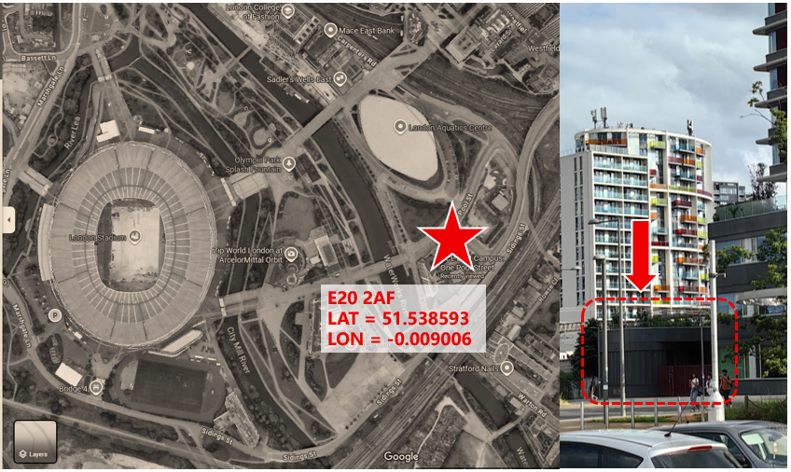
Fig.19. The device deployment location address.
Longitude: -0.009006; Latitude: 51.538593 (affects the accuracy of the sun position calculated by the astronomical algorithm)

4.2 Experimental Results and Analysis
4.2.1 First Deployment (July 1–4)
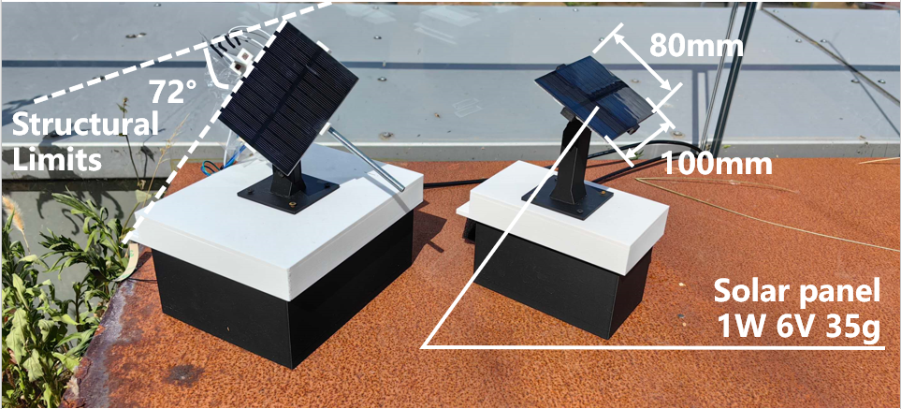
Fig.20. Deployment Status.

Setup:
- Used compact 1W solar panels (80×100 mm, 35g).
- The tracking system uploaded data every 5 minutes during the day, and every 30 minutes at night.
Identified Issues:
- Limited rotation range: The tracking system supported only ±72°, insufficient to fully cover the solar trajectory.
- Lack of RTC module: Required manual input of current time, introducing errors in astronomical algorithm calculations.
- No auto-homing: Manual alignment to due south (a= 0°) introduced significant human error.
- Fixed system's inefficiency: Without a night detection mechanism, the fixed system uploaded data every 5 minutes continuously, resulting in unnecessary power drain.

Observed & Analysis:
- Failure to absorb solar energy: Batteries were nearly fully charged during indoor testing. Consequently, both systems stopped absorbing solar energy shortly after deployment. Since the tracking device only uploaded cumulative energy data, the issue was not immediately apparent. Upon inspection, solar panel voltage（Vm_solar）remained around 6V with current （Im_solar）only 1.5 mA (Table 13)—an open-circuit state (Fig.21). In contrast, active charging typically shows 4.4–4.7V and 150–180mA (Table 14). This indicated that the battery was full and the BQ24074 module had stopped energy conversion due to the inability to draw down voltage. Using the lithium battery to also power the logic and motor circuit resolved this issue.
Table 13. Fixed device data on July 02
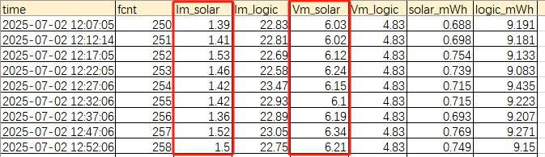
Solar panel voltage（Vm_solar）remained around 6V with current （Im_solar）only 1.5 mA—an open-circuit state.
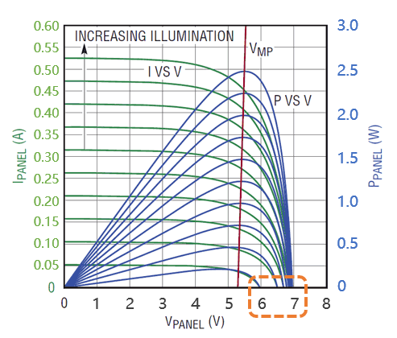
Fig.21. I-V and P-V characteristics of a solar panel.
The figure shows that solar panels reach peak power output near 5V (V<sub>MP</sub>). Once the voltage rises above 6V, current drops to nearly zero, entering an open-circuit state where energy harvesting stops. This explains the charging failure observed during deployment when battery voltage remained too high.

Table 14. Fixed device data on July 02
During normal charging, the voltage （Vm_solar）and current （Im_solar）should be displayed as 4.4–4.7V and 150–180mA.
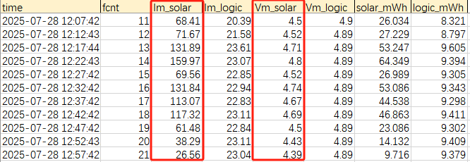

- Tracking operation failures: An overly aggressive fault detection mechanism misjudged short motor delays as “stuck” states (Table 15), causing the driver to shut down. As a result, the motor sometimes froze at its current angle （curDeg）and failed to update toward the target angle（tgtDeg）. This revealed a trade-off: over-optimizing for energy saving may compromise system stability.
Table 15. Single device data on July 02
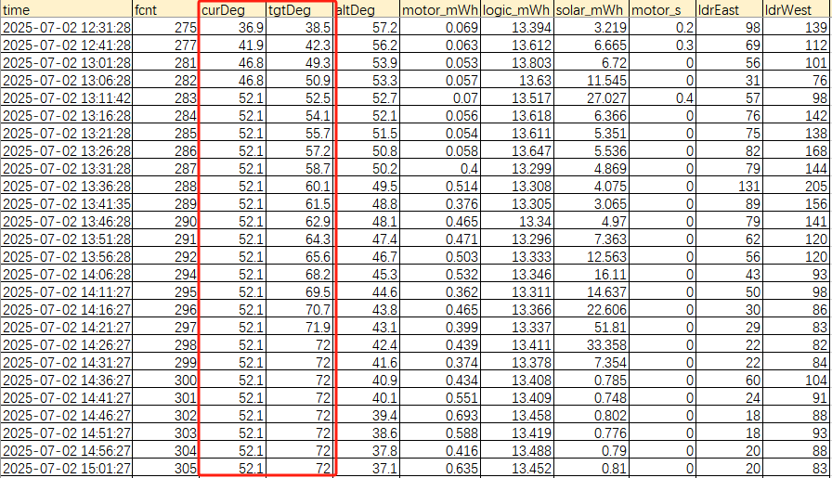
After 13:11, the motor was stuck at 52.1° and no longer followed the target angle.

- Unstable data transmission: LoRaWAN disconnections occasionally interrupted uploads (Fig.22), requiring manual resets. This highlighted the urgent need for automatic LoRa reconnection mechanisms in remote deployments.

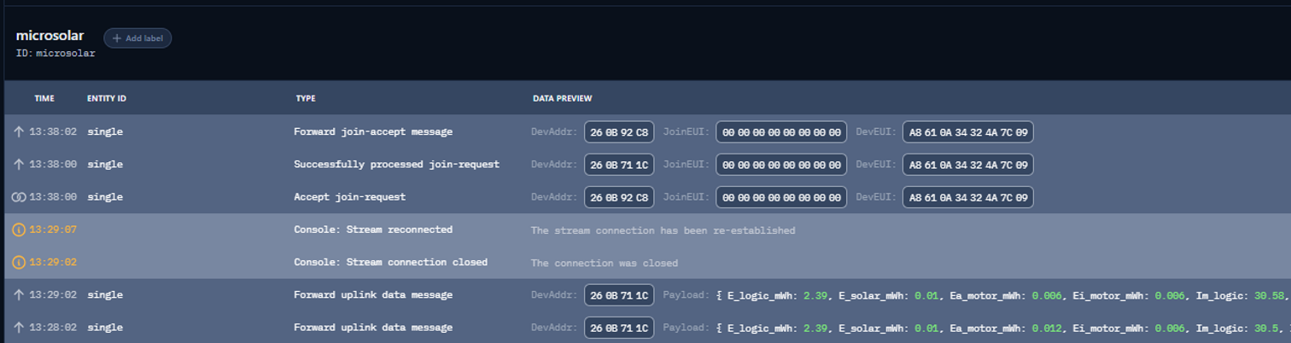
Fig.22. Real-time screenshots on the TTN platform.
The picture shows that the device suddenly lost connection at 13:29.

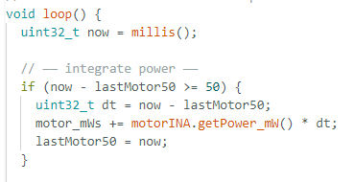
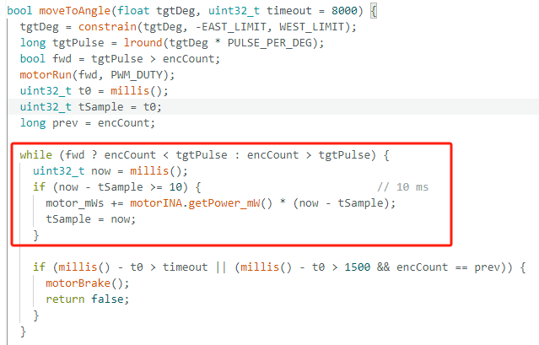
- Inaccurate energy measurements: The mixing of active (moving) and idle motor power consumption in the moveToAngle() function resulted in overestimation (Fig.23). A motor activity detection mechanism is needed to distinguish between active and idle power states.
Fig.23. The moveToAngle() function and the main loop.

Conclusion:
As a stability verification phase, the first deployment exposed several design flaws but provided a clear roadmap for subsequent improvements.

4.2.2 Second Deployment (July 28–30)
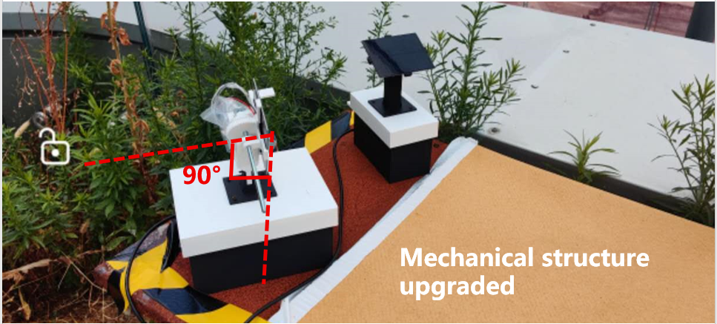
Fig.24. Deployment Status.

Improvements Implemented:
- RTC module added for real-time clock synchronization.
- Mechanical structure upgraded to support ±90° rotation with auto-homing mechanism.
- Simplified motor control logic; removed stuck-motor misjudgment mechanism.
- Extended data uploads to include averaged voltage and current from three INA219 channels during each wake period.
- LoRa reconnection mechanism added to improve upload continuity.

Observed & Analysis:
- Solar absorption under cloudy conditions: Overcast weather persisted throughout deployment. Interestingly, the fixed system performed better than the tracking system due to its ability to absorb diffuse light from all directions (Fig.25). Fig.26 show that while both systems performed similarly in the morning, the tracking system significantly underperformed in the afternoon. This indicates that on cloudy days, diffuse light dominates and directional tracking can reduce efficiency.

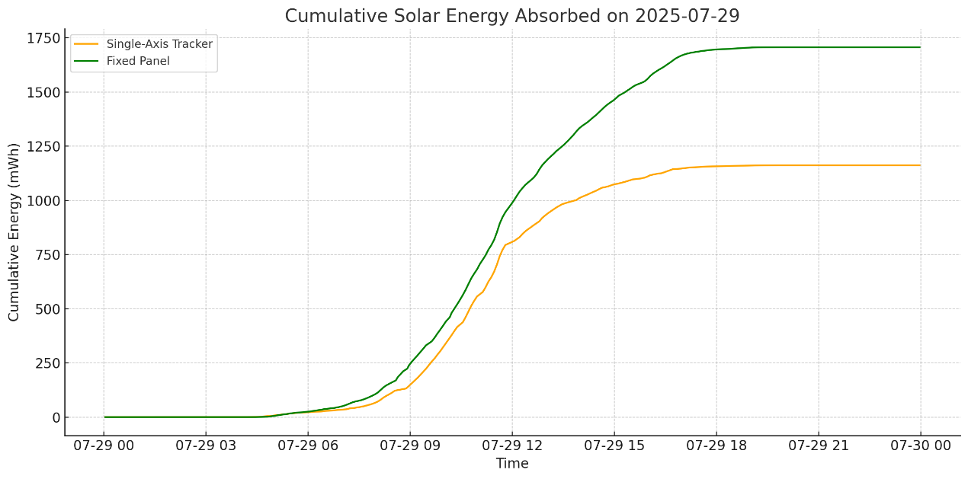
Fig.25. Solar energy comparison.
On cloudy days, fixed installations absorb more energy than tracking systems.

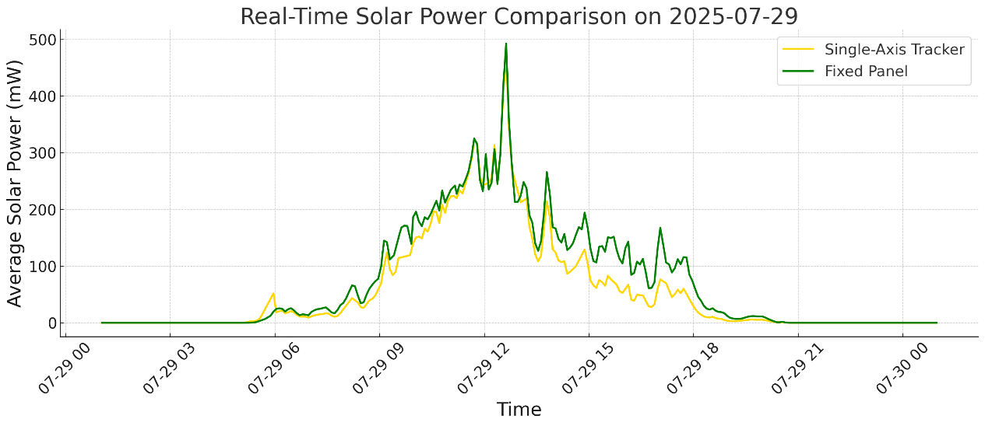
Fig.26. Real-time solar power comparison.
Both systems performed similarly in the morning, the tracking system significantly underperformed in the afternoon.

- Energy performance comparison (Fig. 27, 28):
  - Fixed system: Energy absorbed = 1706.72 mWh; Energy consumed = 2606.2 mWh.
  - Tracking system: Energy absorbed = 1162.03 mWh; Logic consumption = 3130.19 mWh; Motor consumption = 7.13 mWh.
Both systems failed to achieve energy autonomy. Excessive logic power consumption indicates a need for low-power sleep strategies and more efficient solar panels.
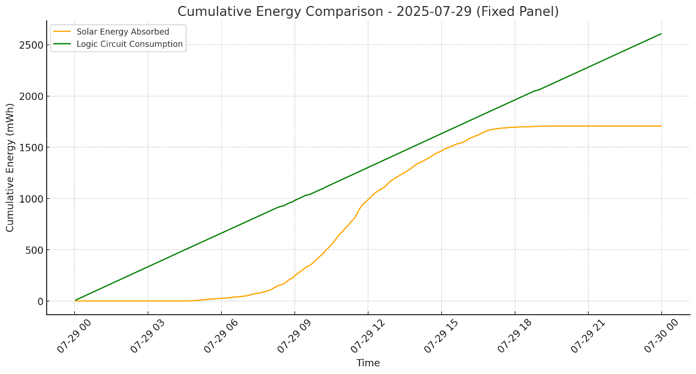
Fig.27. Energy comparison_fixed.
The energy consumption is greater than the energy absorption, indicating that the device cannot currently achieve self-power supply on cloudy days.
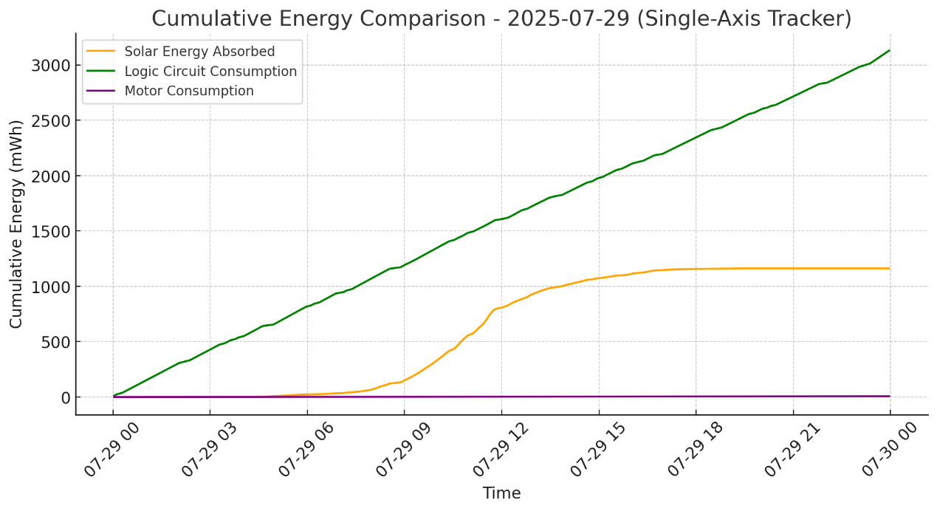
Fig.28. Energy comparison_tracker.
The tracker also failed to sustain self-powered operation. While solar input exceeded motor demand, high logic circuit consumption became the limiting factor. Sleep-mode optimization is needed to improve energy efficiency.

- Azimuth mapping flaw: The sunAz-180 mapping method caused clipping during sunrise and sunset, leading to prolonged target angle（tgtDeg） saturation at ±90° (Table 15). This hindered accurate tracking. A linear interpolation method should be used instead.
Table 15. Single device data on July 29
The sunAz-180 mapping method is limited by early angle saturation. At 16:02, the target angle reached the western limit (90°), while sunset during London’s BST is around 21:00. This indicates the method cannot cover the full daily azimuth range.
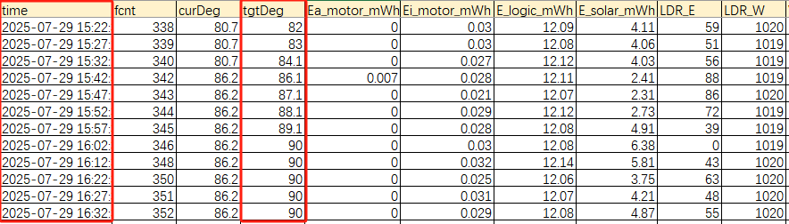

4.2.3 Third Deployment (August 14–17)
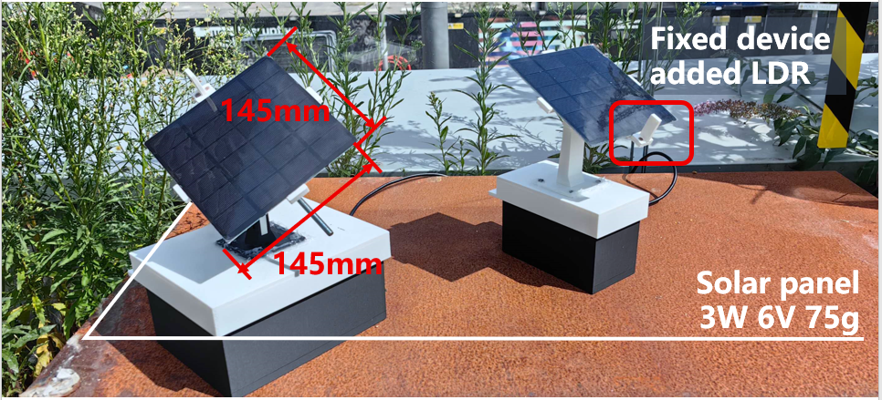
Fig.29. Deployment Status.

Optimizations Introduced:
- Enabled deep sleep mode: 10-minute sampling intervals during the day, 30 minutes at night—significantly reducing energy use.
- Upgraded to a 3W high-performance solar panel (145×145 mm, 75g) for improved absorption.
- Replaced sunAz-180 with linear interpolation to better match real solar paths (tracking system only).
- Added dual LDR-based fine-tuning module to improve environmental adaptability (tracking system only).
- Fixed system equipped with LDR for day/night detection, supporting distinct sleep behaviors.

Energy Computation Methodology (Tracking System):
Since sensors are offline during sleep, energy values must be estimated by combining sleep and wake periods.
Solar Energy Absorbed:
$$E_solar = ∑( V_solarᵢ × I_solarᵢ ×T_intervalᵢ ÷ 3600 )$$
- Vsolar,i: Solar panel voltage (V) during the i-th sample
- Isolar,i: Solar panel current (mA) during the i-th sample
- Tinterval,i​：Time interval between two consecutive records (s)

Logic Circuit Energy Consumption:
$$E_logic = ∑[ E_logicᵢ + ( P_sleep × ( T_intervalᵢ – T_wakeᵢ ) ÷ 3600 ) ]$$
- Elogic,I : Energy consumed by the logic circuit during the i-th awake sample (mWh)
- Tinterval,i​：Time interval between two consecutive records (s)
- Twake,i​：Duration of wake time (s)
- Psleep​：Sleep power consumption (Fig.30):
$$P_sleep​=5.13V×12mA=61.56mW$$
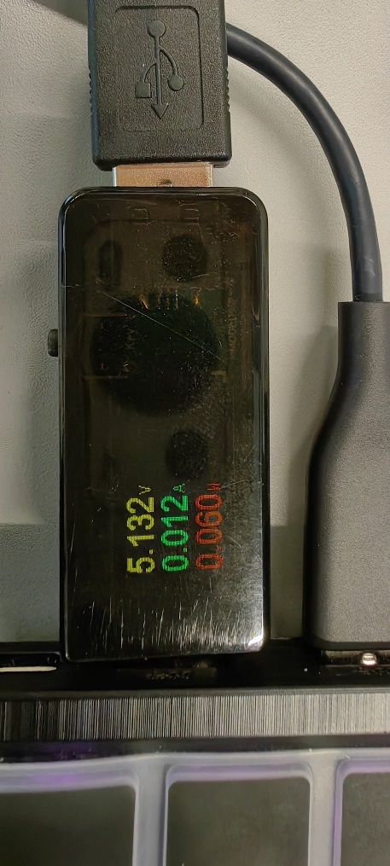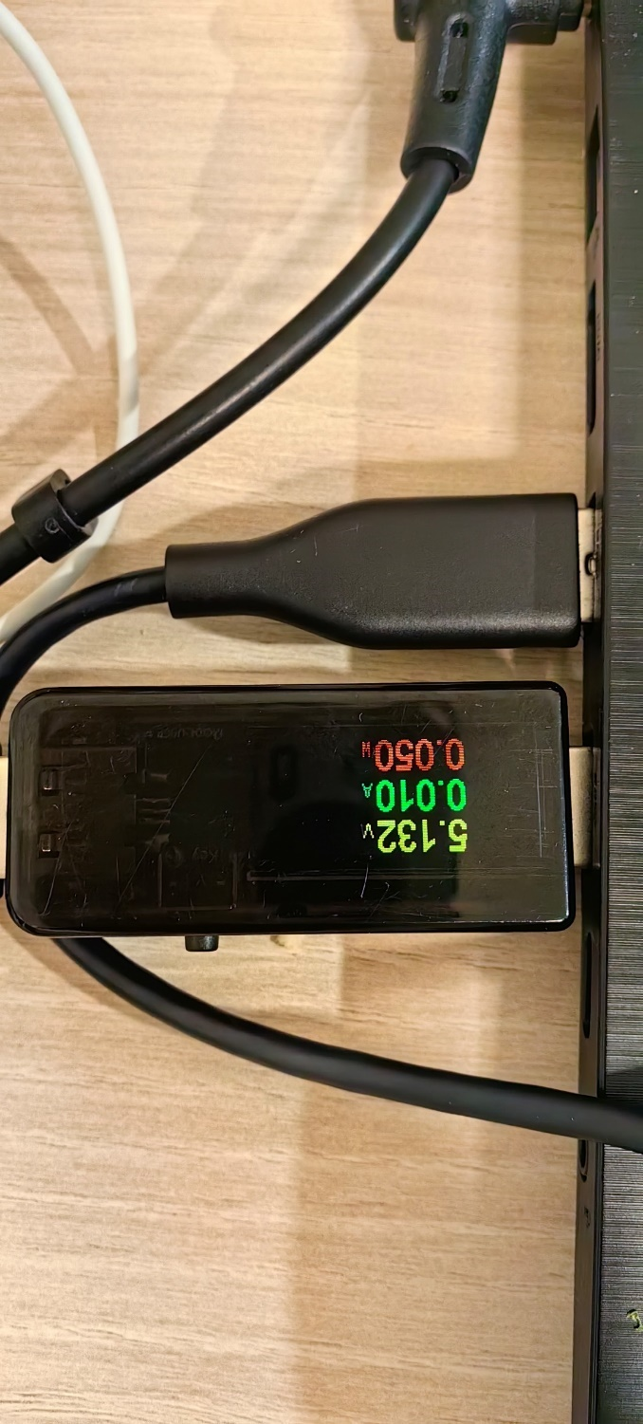
Fig.30. Real-time voltage, current, and power readings of tracking (left) and fixed (right) systems during sleep mode.

Motor Energy Consumption:
$$E_motor = ∑[ \left( E{a_{}}_{motor},i+ Ei_{motor},i\right) +Vi_{motor},i ×I{i_{}}_{motor},i× ( T_intervalᵢ – T_wakeᵢ ) ÷ 3600 ]$$
- Ea_motor,i​ : Energy consumed while the motor was active during the i-th sample (mWh)
- Ei_motor,i​：Energy consumed while the motor was idle during the i-th sample (mWh)
- Vi_motor,i​：Voltage of the idle motor circuit during the i-th sample (V)
- Ii_motor,i​：Current of the idle motor circuit during the i-th sample (mA)
- Tinterval,i​：Time interval between two consecutive records (s)
- Twake,i​：Duration of wake time (s)

Observed & Analysis:
- August 15 (Sunny):
The tracking system outperformed the fixed system overall, with a significant advantage in the morning. Around noon, both systems performed similarly, but in the afternoon, power generation for both dropped sharply due to shading from nearby towers (Fig.30).
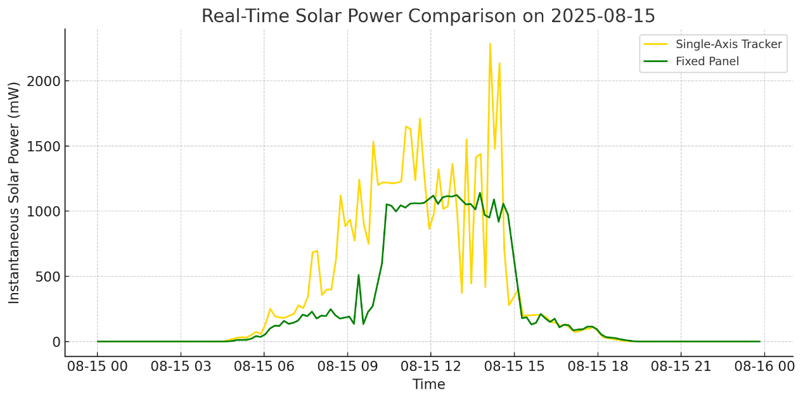
Fig.28. Real-time solar power comparison.

Data showed that the tracker absorbed 8754.71 mWh, with 1459.71 mWh consumed by the logic circuit and 25.05 mWh by the motor, yielding a net gain of 7269.95 mWh. The fixed system absorbed 6225 mWh, consumed 1229.6 mWh, and achieved a net gain of 4995.6 mWh (Fig.31). The tracker’s net energy gain was 1.45 times that of the fixed system (Fig.32).

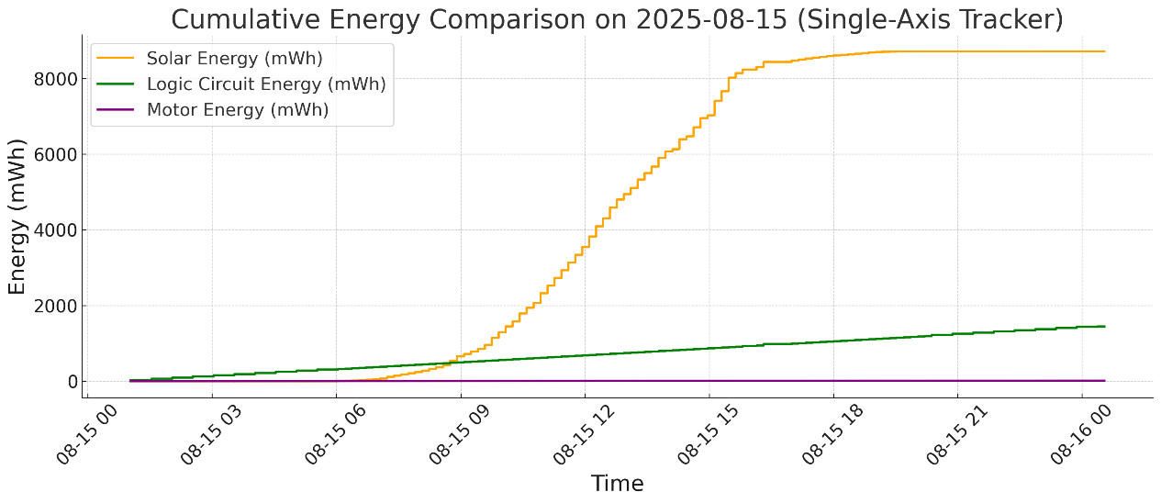
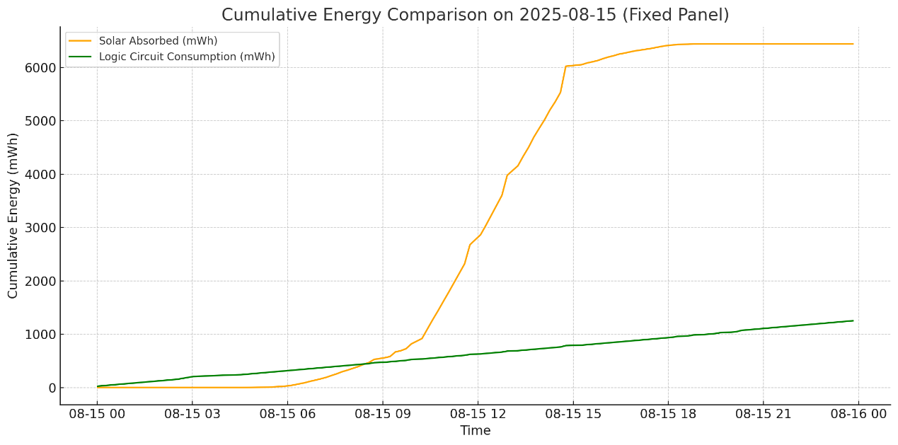
Fig.31. Energy comparison_ tracker (up) and fixed (down).
It is clear from the figure that the solar energy absorbed by both devices far exceeds the energy consumption.
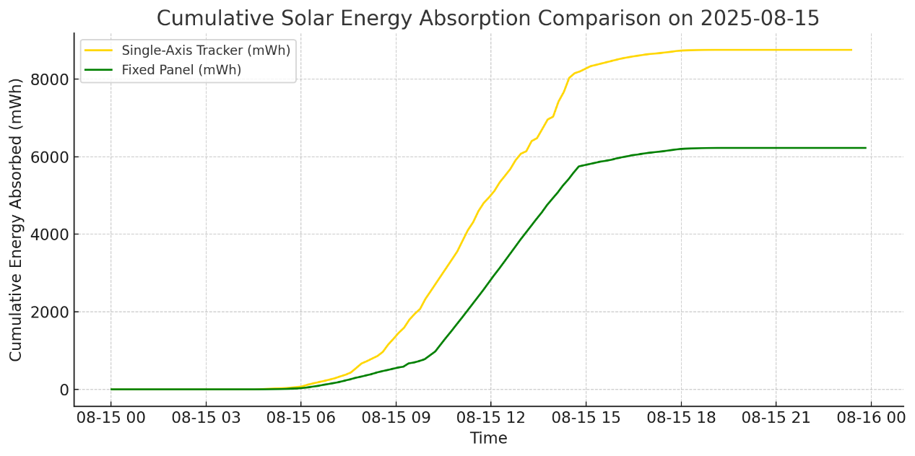
Fig.32. Energy comparison.
Even under partial shading after 16:00, the tracker absorbed 1.45 times the net energy of the fixed system. This highlights the tracker’s strong potential: in a fully unobstructed environment, its energy harvesting efficiency would likely be significantly higher.

- August 16 (Cloudy):
The tracker absorbed only 1417.37 mWh, significantly less than the 2039.91 mWh absorbed by the fixed system, consistent with the results of the second deployment (Fig.33, 25).
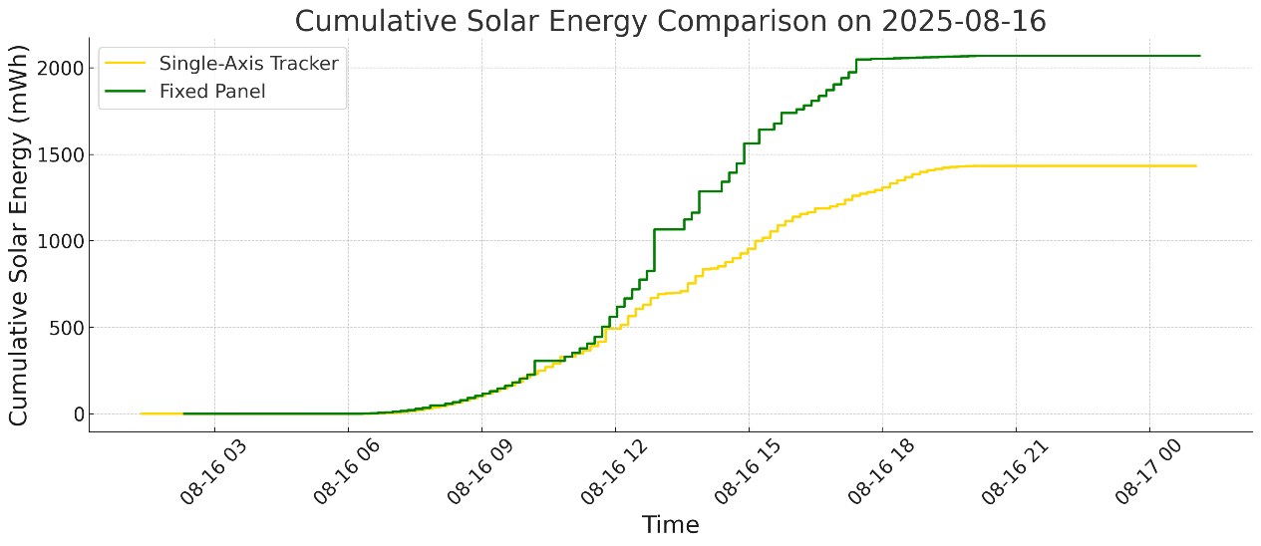
Fig.33. Energy comparison.
On cloudy days, the fixed device absorbed much more energy than the tracking device.

Both systems experienced frequent power drops (Fig.34). Inspection showed that the solar panel voltage (V_solar) reached 6.5V, indicating a fully charged battery and that the BQ24074 module had ceased energy conversion.
Only when power was later drawn by the logic and motor circuits did the panel voltage drop, allowing charging to resume efficiently (Table.16).
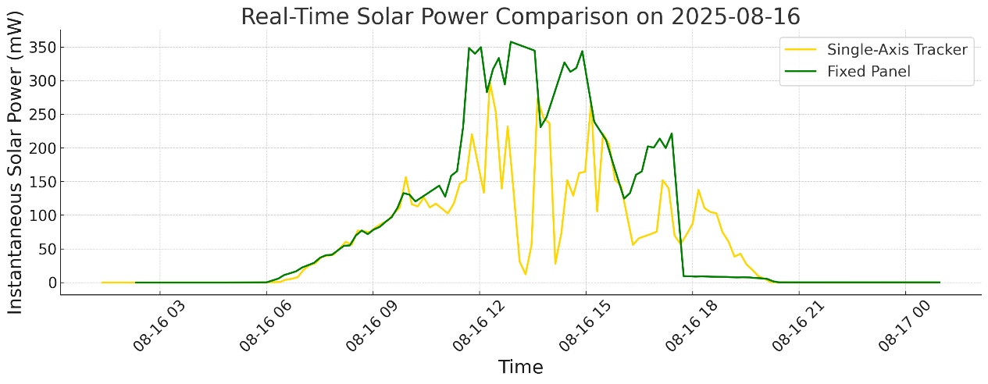
Fig.34. Real-time solar power comparison.
The power values ​​of both devices experienced several sharp drops between 12 noon and 15 o'clock, the time of day when the sun is at its highest.

Table 16. Single device data on August 16
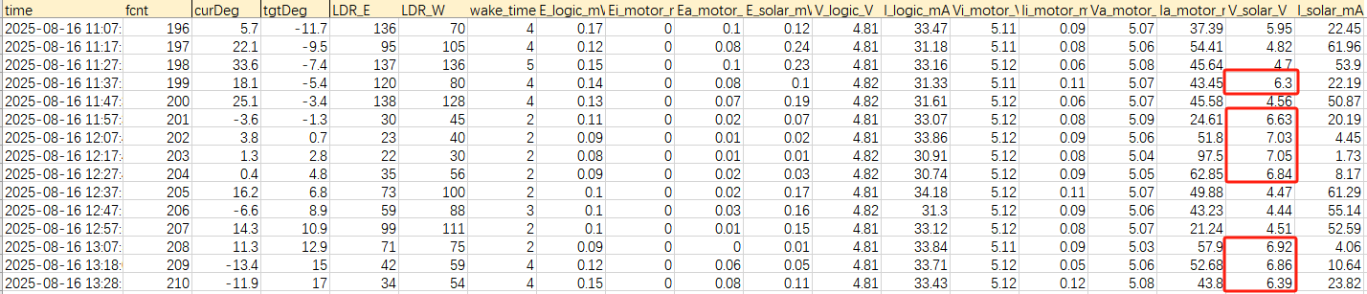

As can be seen from the table, the voltage repeatedly reaches above 6V, indicating that the Li battery is fully charged. It then returns to a normal value of around 4.5V, which is normal due to energy consumption in the logic circuit and motor.

- Sleep strategy significantly reduced energy consumption (Table 1.2):
Under similar cloudy conditions, the logic circuit energy consumption dropped to 1468.43 mWh (tracker) and 1173.97 mWh (fixed)( Fig.31), approximately half of the values recorded during the second deployment.
The tracker’s energy shortfall was only 74 mWh, suggesting that it could operate for over 40 consecutive cloudy days.The fixed system even achieved an energy surplus of 866 mWh, demonstrating that the sleep mechanism plays a critical role in improving system sustainability ( Fig.35).
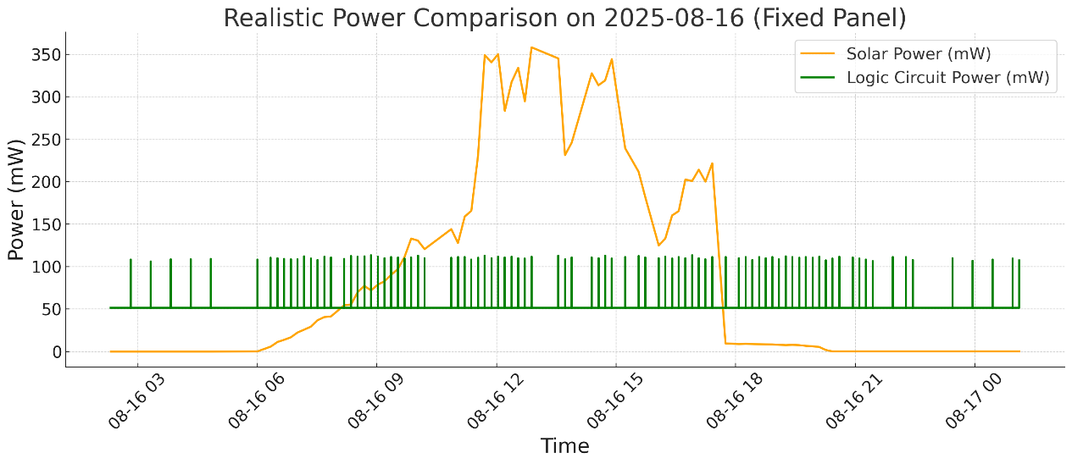
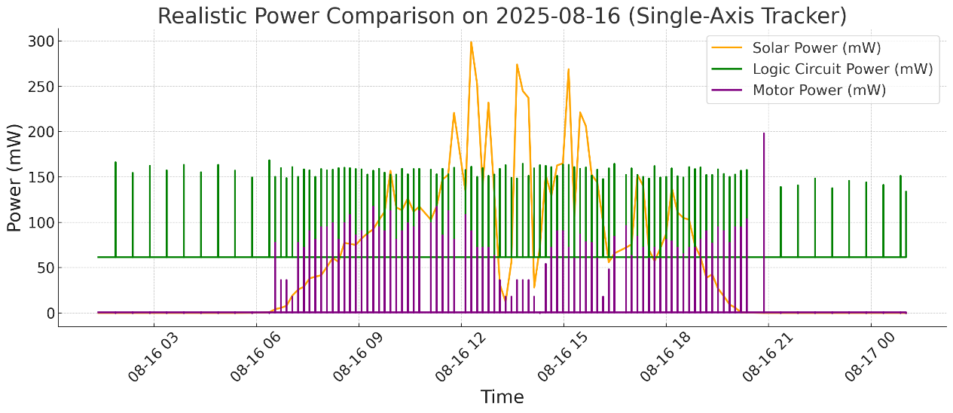
Fig.35. Real-time solar power comparison.
The jagged lines in the chart indicate that sleep mode effectively halved the logic circuit power consumption for both systems, playing a crucial role in overall energy savings.

4.3 Summary
Field deployments show that under clear skies, the tracking system significantly outperforms the fixed one, while under cloudy conditions, it underperforms. Therefore, optimizing power consumption and tracking strategies is crucial to enhancing overall system performance.

5. DISCUSSION
5.1 Design and Implementation Challenges
5.1.1 Insufficient Energy Storage
Field deployment results revealed that the currently used single 3.7V 3300mWh lithium battery becomes fully charged in less than two sunny days, preventing further efficient conversion and storage of solar energy and thus leading to energy waste. To address this issue, the use of higher-capacity single-cell lithium batteries is recommended to improve overall storage capacity and extend device endurance during cloudy periods.
Although parallel battery configurations can also increase capacity, they carry the risk of reverse current flow in cases of voltage mismatch, which could lead to overheating, swelling, or even fire. Therefore, such configurations are not recommended.
Additionally, since the motor requires high instantaneous power during panel rotation, future designs could incorporate supercapacitors to buffer peak loads, reducing the frequency and intensity of battery charge-discharge cycles, thereby prolonging battery life.

5.1.2 Eastward Return Strategy
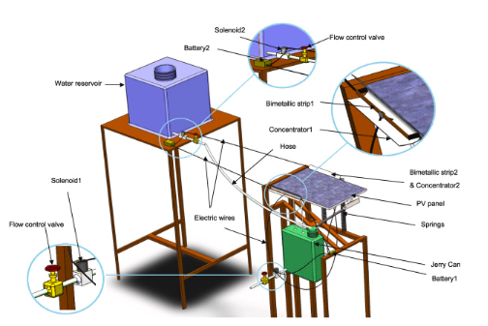
To minimize motor energy consumption, an early version of the design explored passive mechanical return methods, such as using water pumps to adjust the water volume in buckets on either side of the panel, allowing gravity to rotate the panel back to the east at night ( Fig.36). However, real-world tests showed that motor-driven return required very little energy and was more precise and controllable, making it more suitable for the intended deployment scenarios.
Fig.36. A passive mechanism consisting of a reservoir and a bucket (Alemayehu, M. and Admasu, B. T., 2023).

Furthermore, motor-based return mechanisms avoid the complexity and maintenance challenges associated with mechanical or hydraulic systems, reinforcing their practicality for this project.

5.2 Deployment-Related Issues
5.2.1 Waterproofing Deficiencies
Although the PLA material used for the 3D-printed enclosure provides some degree of water resistance, the first deployment experienced water ingress through casing seams and screw holes during rainfall, damaging internal components ( Fig.37). The issue has since been mitigated using sealant to fill gaps. Future iterations could use ABS plastic enclosures or certified IP65 waterproof casings, or apply waterproof coatings to improve weather resistance.
The tracking device's waterproofing still requires improvement. Currently, cables for the LDRs, solar panel, and motor are not fully enclosed and are only temporarily protected with plastic film. Future designs should emulate the fixed device, routing cables through the top cover into the internal cavity, to achieve a more integrated structure and higher protection rating.
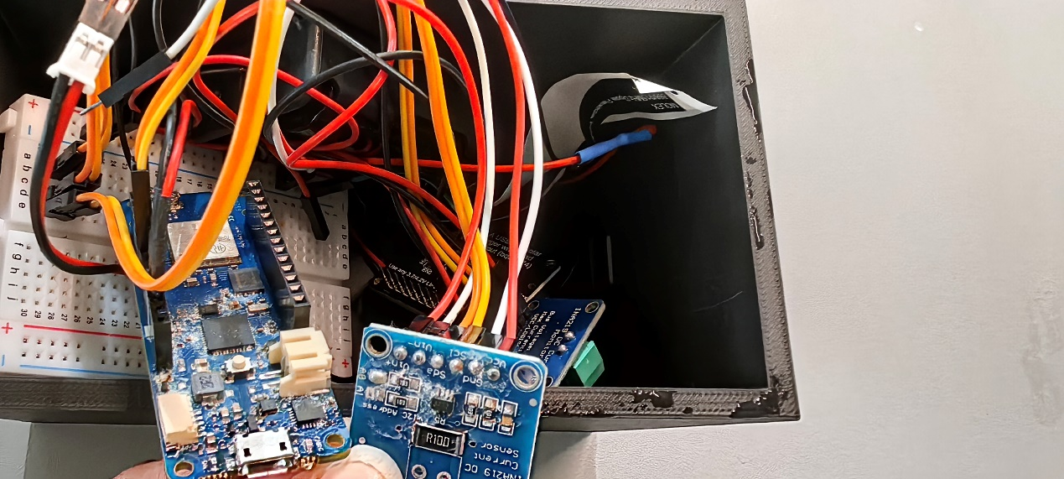
Fig.37. INA219 module damaged by water seepage.

5.2.2 Deployment Location Limitations
The current test site—a rooftop garden on the first floor of One Pool Street—is obstructed by tall buildings in the afternoon, significantly reducing direct sunlight exposure. This restricts the effective demonstration of the tracking system, which is designed to excel during low solar elevation periods such as sunrise and sunset.
For evaluation purposes, it is preferable to conduct testing in unshaded, open environments to fully exploit the tracking system’s potential.
Nonetheless, given that the ultimate goal is to support remote outdoor environmental monitoring, which often involves partially shaded or obstructed terrains, such realistic deployment conditions also offer meaningful insights into the system’s practical applicability.

5.3 Future Work
5.3.1 Adaptive Tracking Strategy for Sunny and Cloudy Conditions
Experimental results demonstrated that the tracking system achieved 1.45 times the net energy gain of the fixed system under sunny conditions. However, it failed to maintain energy self-sufficiency under cloudy weather. In contrast, the fixed system consistently achieved energy surplus, regardless of weather, owing to its simpler structure, lower power consumption, and higher reliability.
For low-power environmental sensing devices, the fixed system may already meet operational requirements. However, for higher-power devices, the tracking system's performance must be improved.
One promising enhancement is to implement a dual-mode tracking strategy:
- Sunny mode: Maintain the current real-time tracking behavior to optimize direct sunlight absorption.
- Cloudy mode: Fix the panel orientation at due south (azimuth 0°) to maximize exposure to diffuse and scattered light, which predominates in overcast conditions.
This hybrid strategy could balance high efficiency under clear skies with greater stability under poor lighting conditions, potentially improving average annual energy yield and overall system practicality.

5. CONCLUSION
This study developed and evaluated a single-axis solar tracking system specifically designed for self-powered environmental monitoring nodes. Field deployments and detailed energy monitoring demonstrated that under clear weather conditions, the tracking system achieved approximately 45% higher net energy gain compared to a fixed-tilt setup, highlighting its significant energy advantage. However, this benefit diminished under cloudy or obstructed conditions, emphasizing the importance of careful site selection and the potential need for adaptive tracking strategies.

In contrast, the optimized fixed system—with reduced logic circuit power consumption—consistently maintained a positive energy balance across various weather conditions, demonstrating its reliability and feasibility as a long-term power solution.

To further enhance continuous operation, future designs should consider integrating larger-capacity energy storage, supercapacitor buffering, and dual-mode tracking strategies. Moreover, waterproofing, mechanical robustness, and appropriate deployment site selection were shown to be critical prerequisites for reliable performance in real-world conditions.

Overall, this research identifies key technical challenges and optimization pathways for micro-scale solar power systems, providing practical insights and feasibility validation for long-term, resilient, and low-maintenance outdoor IoT deployments.

REFERENCE

Luo, K., Chen, Y., Lin, R., Liang, C., & Zhang, Q. (2024). A portable agriculture environmental sensor with a photovoltaic power supply and dynamic active sleep scheme. Electronics, 13(13), 2606. https://doi.org/10.3390/electronics13132606

Kamarulzaman, A., Hasanuzzaman, M., & Rahim, N. A. (2021). Global advancement of solar drying technologies and its future prospects: A review. Solar Energy, 221, 559–582. https://doi.org/10.1016/j.solener.2021.04.056

Yang, X., Zou, T., Xu, Y., Chen, F., Luo, H., Ullah, S., & Li, R. (2025). Research dynamics and applications of tracking technology and devices in solar energy utilization system. Sustainable Energy Technologies and Assessments, 75, 104256. https://doi.org/10.1016/j.seta.2025.104256

Kumba, K., Upender, P., Buduma, P., Sarkar, M., Simon, S. P., & Gundu, V. (2024). Solar tracking systems: Advancements, challenges, and future directions: A review. Energy Reports, 12, 3566–3583. https://doi.org/10.1016/j.egyr.2024.09.038

Harazin, J., & Wróbel, A. (2022). Analysis and study of the potential increase in energy output generated by prototype solar tracking, roof mounted solar panels (No. 9:1381). F1000Research. https://doi.org/10.12688/f1000research.27641.2

Kumar, N. (2024). How many iot devices are there (2025-2030 Data). DemandSage. https://www.demandsage.com/number-of-iot-devices/

De Oliveira Filho, J. I., Trichili, A., Ooi, B. S., Alouini, M.-S., & Salama, K. N. (2022). Self-powered weather station for remote areas and difficult-access locations. Optics Express, 30(2), 2668. https://doi.org/10.1364/OE.441983

Wang, J., Chen, X., Sun, Y., & Qin, X. (2024). A natural-light-enabled self-powered system simultaneously monitoring wind speed, humidity, and irradiance in multiple channels. Nano Energy, 123, 109364. https://doi.org/10.1016/j.nanoen.2024.109364

Rosa, R. L., Boulebnane, L., Pagano, A., Giuliano, F., & Croce, D. (2024). Towards mass-scale iot with energy-autonomous lorawan sensor nodes. Sensors, 24(13), 4279. https://doi.org/10.3390/s24134279

Kang, D. H. P., Chen, M., & Ogunseitan, O. A. (2013). Potential environmental and human health impacts of rechargeable lithium batteries in electronic waste. Environmental Science & Technology, 47(10), 5495–5503. https://doi.org/10.1021/es400614y

Sarker, M. R., Riaz, A., Lipu, M. S. H., Md Saad, M. H., Ahmad, M. N., Kadir, R. A., & Olazagoitia, J. L. (2024). Micro energy harvesting for IoT platform: Review analysis toward future research opportunities. Heliyon, 10(6), e27778. https://doi.org/10.1016/j.heliyon.2024.e27778

Thungsuk, N., Tanaram, T., Chaithanakulwat, A., Savangboon, T., Songruk, A., Mungkung, N., Maneepen, T., Arunrungrusmi, S., Poonthong, W., Kasayapanand, N., Nilwhut, S., Kinoshita, H., & Yuji, T. (2023). Performance analysis of solar tracking systems by five-position angles with a single axis and dual axis. Energies, 16(16), 5869. https://doi.org/10.3390/en16165869

Yao, Y., Hu, Y., Gao, S., Yang, G., & Du, J. (2014). A multipurpose dual-axis solar tracker with two tracking strategies. Renewable Energy, 72, 88–98. https://doi.org/10.1016/j.renene.2014.07.002

Kapustenko, P., Klemeš, J. J., & Arsenyeva, O. (2023). Plate heat exchangers fouling mitigation effects in heating of water solutions: A review. Renewable and Sustainable Energy Reviews, 179, 113283. https://doi.org/10.1016/j.rser.2023.113283

Sadeghi, R., Parenti, M., Memme, S., Fossa, M., & Morchio, S. (2025). A review and comparative analysis of solar tracking systems. Energies, 18(10), 2553. https://doi.org/10.3390/en18102553

Shang, H., & Shen, W. (2023). Design and implementation of a dual-axis solar tracking system. Energies, 16(17), 6330. https://doi.org/10.3390/en16176330

Alshaabani, A. (2024). Developing the design of single-axis sun sensor solar tracking system. Energies, 17(14), 3442. https://doi.org/10.3390/en17143442

Abdollahpour, M., Golzarian, M. R., Rohani, A., & Abootorabi Zarchi, H. (2018). Development of a machine vision dual-axis solar tracking system. Solar Energy, 169, 136–143. https://doi.org/10.1016/j.solener.2018.03.059

Musa, A., Alozie, E., Suleiman, S. A., Ojo, J. A., & Imoize, A. L. (2023). A review of time-based solar photovoltaic tracking systems. Information, 14(4), 211. https://doi.org/10.3390/info14040211

Karabiber, A., & Güneş, Y. (2023). Single-motor and dual-axis solar tracking system for micro photovoltaic power plants. Journal of Solar Energy Engineering, 145(5), 051004. https://doi.org/10.1115/1.4056739

Jackson, G., Ciocoiu, S., & McCann, J. A. (2017). Solar energy harvesting optimization for wireless sensor networks. GLOBECOM 2017 - 2017 IEEE Global Communications Conference, 1–6. https://doi.org/10.1109/GLOCOM.2017.8254851

Jacobson, M. Z., & Jadhav, V. (2018). World estimates of PV optimal tilt angles and ratios of sunlight incident upon tilted and tracked PV panels relative to horizontal panels. Solar Energy, 169, 55–66. https://doi.org/10.1016/j.solener.2018.04.030

Charles R. Landau. “Optimum Tilt of Solar Panels.” Www.solarpaneltilt.com, 18 Mar. 2017, www.solarpaneltilt.com/.

Angulo-Calderón, M., Salgado-Tránsito, I., Trejo-Zúñiga, I., Paredes-Orta, C., Kesthkar, S., & Díaz-Ponce, A. (2022). Development and accuracy assessment of a high-precision dual-axis pre-commercial solar tracker for concentrating photovoltaic modules. Applied Sciences, 12(5), 2625. https://doi.org/10.3390/app12052625

Alemayehu, M., & Admasu, B. T. (2023). Passive solar tracker using a bimetallic strip activator with an integrated night return mechanism. Heliyon, 9(7), e18174. https://doi.org/10.1016/j.heliyon.2023.e18174

ACKNOWLEDGEMENTS

I would like to express my sincere gratitude to the following individuals for their invaluable contributions to this study:

  - Professor Duncan Wilson, for his patient, thorough, and comprehensive supervision throughout the project.

  - Dr. Martin De Jode, for his extensive hardware expertise and generous support.

  - Professor Andy Hudson-Smith, for inspiring the project with his insightful topic suggestions.

  - Dr. Greg Jackson, for his support on algorithm development.

  - Simon Gosling, for his tireless assistance during multiple on-site garden deployments and support during the exhibition setup.

  - Danny Steadman, for his help with laser cutting and guidance on waterproof enclosure design.

Your support and guidance have been crucial to the successful completion of this project.

