**纲领：传承与创新并济（终版、中英对照）**

# Guiding Principle：

# Combination of Inheritance and Innovation(final version)

（with一些在服务月中的实例）

**吕彦霖** Lv Yanlin

总述

努力方向：

1. 宣传-线上宣传、线下不定期小活动
2. 外联-和社团、别的学院交流
3. 权益-发现问题、解决问题

（正式平台已经很完善了，现在考虑:

* + - 1. 多多宣传SRC
      2. 往非正式的方向发展)

THE MAIN AIMS:

1. Publicity methods - online promotion, offline irregular small activities

2. Communication(with other institutions and organizations) - Communicate with clubs and other colleges

3. Rights - identifying and resolving issues

The official platform is already very complete, now consider:

1) Promote SRC more frequently

2) Try to take a more informal direction

1. **传承** Inheritance

传承主要的目的是规范化学生工作。这里的规范化不是指模式化、套路化，而是能高效地举办活动、减少失败，并让同学在活动中更有参与感。

The main purpose of inheritance is to standardize student work. The standardization here refers to neither patternization nor routinization, but rather to the ability to efficiently organize activities, reduce failures, and make students feel more involved in the activities.

1. **办活动的流程：这个的具体实现方式是经验总结。**
2. The process of organizing activities: The specific implementation method for this is experience summary

经验总结是有必要的。比如今年舞会时遇到临时抬价的事情，如何解决，如何规避，可以由相关同学总结并给之后的组织者查阅，少走弯路，活动越办越好。这个方案的可行之处在于，大型的活动流程相似，遇到的问题也会很相似。

It is necessary to summarize experience. For example, when encountering a temporary price increase during the ball this year, how to solve it and how to avoid it can be summarized by organizers and provided to future organizers for reference. Avoid such detours and similar problems, then the event will be better and better. The feasibility of this plan lies in the fact that large-scale events have similar processes and encounter similar problems.

这个措施存在两个问题，我也提出了可能的解决方案：第一，可能会限制同学对活动的设想，使活动循规蹈矩。这可以通过经验总结交给主席团整理，在下一届同学定好策划案之后再给他们参考。第二，会加大同学工作量，同时每个人写出来的都不太一样。改进措施是制定一个大致的方案（活动日程-问题1-如何解决1-如何规避1-问题2……）

There are two problems with this measure, and I have also proposed possible solutions respectively.

Firstly, it may limit students' imagination of the activity and causing the activities stick to the previous versions without any innovation and new ideas. This can be summarized through experience and submitted to the presidium, who will collect them and sort them. Then after students have finalized the planning plan, presidium will provide these files to the next class of students for reference.

Secondly, it will increase the workload of organizers and every organizer might write experience summary differently. The solution is to develop a rough plan (activity schedule - problem 1- how to solve 1- how to avoid 1- problem 2...)

实践：

example(written by me):

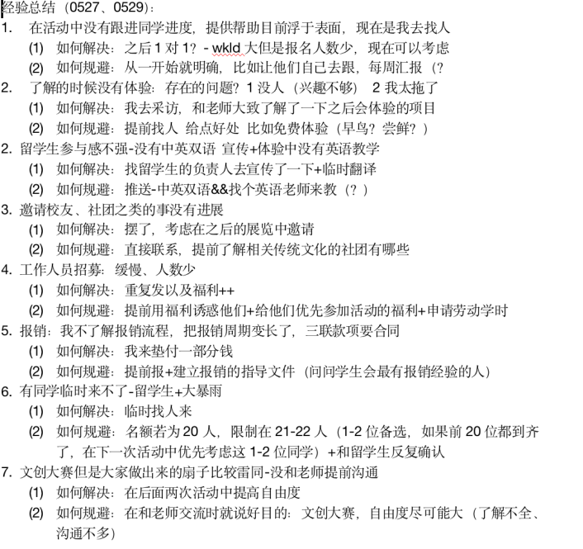

1. **宣传模式：线上(宣传公众号风格统一+加入新的社交媒体)+线下**

2.Improvement of publicizing methods: online (unified style for the posts and subscriptions and joining in other social media)+offline

1. 增强线下宣传

(1)Enhance offline promotion

由于之前疫情封控的原因，活动大多转为线上，宣传方式大多是公众号推送。但是JIers的宣传面有限，有些同学不常看公众号。因此，增强线下宣传有益于想更多人宣传活动。（发发小贴纸、做做小互动）

Because of the pandemic, most of the activities turned online, and most of the publicity methods were through subscriptions. However, the subscription of student union, JIers, has limited publicity, and some students do not often read or check the subscription. Therefore, enhancing offline promotion, such as sending small stickers and creating small interactions, is beneficial for promoting activities to more people.

线下的宣传方式有：第一张贴海报，在龙宾楼里和宿舍楼里张贴海报。这点在之前的大型活动，比如舞会、女生节等活动也实行过。第二，在线下的摆摊的同时进行宣传。比如在小铺摆摊时宣传新的活动，并鼓励每一个来捐赠的同学参加。既能增强部际联动，也能提高活动知名度，吸引更多受众。

The offline promotion methods include:

(a)Posting posters in Longbin Building and dormitories.

This has also been implemented in large-scale events previously, such as dances and Girls' Day.

(b)Combining promotion with stalling.

For example, when setting up a stall in a small shop, promote new activities and encourage every student who comes to donate to participate. It can not only enhance inter departmental linkage, but also increase the visibility of the event and attract more audiences.

1. 公众号风格统一

(2)Unified style of subscription

具体措施有封面+标题风格相似，每个学期色系相同，统一字体。可以每个月让传媒设计一个模版+封面，工作量不大但是可以统一风格，当然如果宣传方面有更好的想法（比如文艺部对推送美工要求更高），可以按照自己的来。同时推文最好统一色系。目前的想法是，秋季学期是蓝色、春季学期是绿色、夏季学期是黄色。

The specific measures include a similar style of cover and title, the same color scheme for each semester, and a unified font. The Communication design can design a template and a cover every month. The workload is small but it can work efficiently. Of course, if there is a better idea in publicity (for example, the Ministry of Arts and Culture has higher requirements for the posts), you can make these posts your own. Another idea is to have a unified color scheme for the posts in one term. (e.g. The current idea is that the autumn semester is blue, the spring semester is green, and the summer semester is yellow.)

实践：

example:



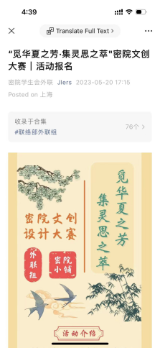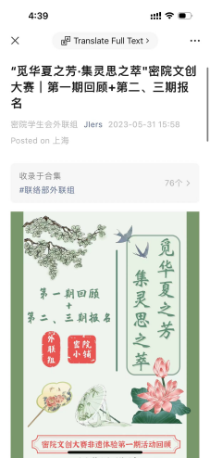

some restriction and advice for designing posts:

(you can see it in [Appendix.1.])

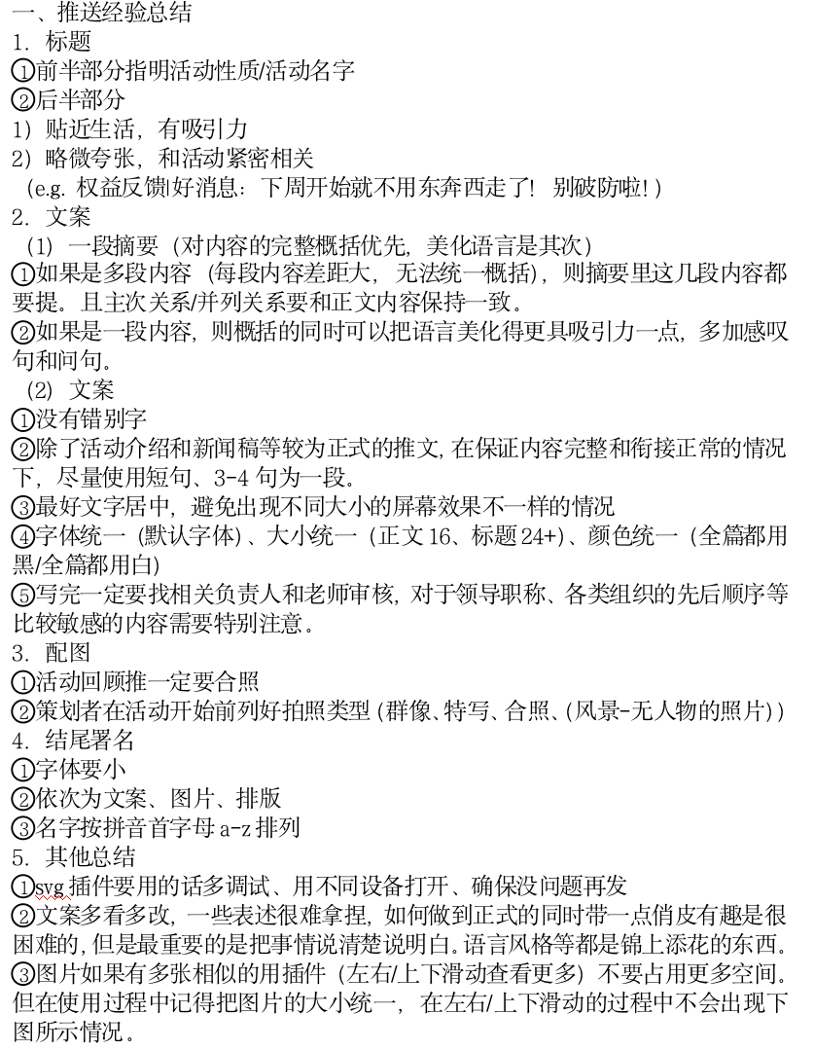

1. **人员规范和限制：精简人数、人员流动、人员去留**

3.Restrictions of Members: concerning reducing the number of members, job rotation and their decisions of whether leave or stay after their freshman year

精简人数：控制在80人左右

人员流动：学期末提供换部门通道

人员去留：春季学期中期调查志愿者去留意向（在下一年离开/担任荣誉部员/担任部长/担任主席）

Reducing the number of people: control the number around 80

Member/Volunteer mobility: Provide department change channels at the end of each semester

Member/Volunteer retention: mid spring semester survey on volunteer retention intentions (leaving the following year/serving as an honorary department member/minister/chairman)

1. **创新 Innovation**

创新是为了提高志愿者和部长团的体验感。学生工作并非仅仅工作，更多的应该是学生参与、体验。创办新活动、或者对活动的部分内容进行改变，融入学生自己的想法和特色，才是学生会的意义所在，也是能让所有参与学生工作的同学有更多获得感、归属感、体验感的方式。

Innovation is to enhance the experience of all the members in the Student Union. We should pay attention to students’ participation and experience during our work. The significance of a student union is to establish new activities or make changes to some content of the activities, integrating students' own ideas and characteristics. It is also a way for all students to get involved in student work to have a greater sense of belonging and experience.

主要的实施方式有：

1. 对一些参与度较低的项目 1.改进 2.合并 3.删除
2. 面试期间就让部长团提出新想法，收集成idea list
3. 不定期征集新想法
4. 策划组统筹安排，下面分设多个小组（比如推送组和现场组），各司 其职。每个小组组长是有这方面经验的同学，组员可以是零基础但 对此方面感兴趣的同学

这样做的好处有：职责明晰；志愿者在不同的活动中打破部门界限，认识更多的人；所有对活动感兴趣的学生会志愿者都有机会参与其中。

1. 新想法的去向：
   1. 和现有项目融合，增强现有项目的吸引力
   2. 开放给大一的同学去组织策划（想法提供者可以协助策划，但是组织策划的主体还是大一的志愿者【更好地培养部长团/主席团】）

这能解决目前“自由工作组”存在的一个问题：有些同学因为想不出新活动而没有参与，导致参与度较低，效果无法体现。

The main implementation methods include:

1. For those projects with low participation:

First, improve them then if it doesn’t work, combine those with similar theme. If both improvement and combination don’t work, delete them.

1. During the interview, ask the ministerial team to propose new ideas(or the activities they want to hold but fail to hold, if so, state the reason of the failure) and integrate them into an idea list
2. Regularly collect new ideas
3. The organizing and planning team will coordinate and arrange multiple teams (such as teams responsible for post and on-site teams) to perform their respective duties. Each group leader is a student with experience in this field, and group members can be students with zero foundation but are interested in this field. The benefits of doing so are:
   * 1. Clear responsibilities;
     2. Volunteers break departmental boundaries and get to know more people in different activities;
     3. All student union volunteers who are interested in the activity have the opportunity to participate.
4. The direction of new ideas:
   1. Integrate with existing projects to enhance their attractiveness
   2. Open to freshmen to organize and plan (idea providers can assist in planning, but the main body of organizational planning is still freshmen volunteers [to better cultivate the ministerial/presidium])

This can solve a problem with the current "free working group": some students do not participate because they cannot think of new activities, resulting in low participation and ineffective performance.

1. **权益 Students’ rights and interests**
   1. 传承: Inheritance：
      1. 长期+短期结合：权益平台长期开放+一年两次的院长见面会
      2. 权益平台多样化：SRC&&提交院长见面会提案

1.Inheritance**：**

* + 1. Combination of Long term activities and short term activities: long-term opening of equity platform+biannual dean meeting
    2. Diversified Rights Platform: SRC and Dean's Meeting
  1. 创新：
     1. 每个季度设定主题：

比如技术问题（e.g.选课网、电脑软件和硬件问题），比如生活环境优化（e.g.宿舍？教室？）比如火鸡节就是和课程设置相关的问题。每季度给个有针对性的feedback

* + 1. 内联部部员的新职务：发现问题并调研
       1. 好处：解决没有提案的问题
       2. 要求：招人标准需要更注重同学的观察能力、调研能力

2.Innovation

(1)Set a theme for each quarter(three months):

For example, technical issues (e.g. course selection website, computer software and hardware issues), optimization of living environment (e.g. about dormitories or classrooms), and issues related to course settings such as Turkey Day. Provide targeted feedback every quarter (three months)

(2)New position of internal communication department member: identifying problems and conducting research

* + - * 1. Benefit: Solve issues without proposals
        2. Requirement: Recruitment standards need to pay more attention to students' observation and research abilities

实践：example:

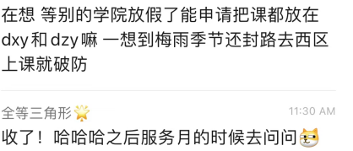

1. **交流 Communication**
   1. 传承：
      1. 欢迎留学生加入各种学生组织（尤其是学生会）
      2. 和别的学院合办活动（男生节、一周cp）
2. Inheritance**：**
   * 1. Welcome international students to join various student organizations (especially student unions)
     2. Co-organizing activities with other colleges (Boys' Day, One Week CP)
   1. 创新：
      1. 学院之间的联络：
         1. 大型活动（电院、安泰）
         2. 长期交流：文化交流、经验分享
      2. 在开学一开始邀请社团来介绍

（他们为什么愿意来？

给他们一个展示的舞台/给赞助-密院特色e.g和文化节开幕式结合）

【和社团和别的学院的活动目前不强的原因：

* + - * 1. 我们学院体系完善，也因此较为封闭
        2. 三学期制，放假时间差距大】

2.Innovation:

* + 1. Communication between colleges:

① Large scale events (Dianyuan, Antai)

② Long term communication: cultural exchange, experience sharing

* + 1. Invite clubs to introduce at the beginning of the semester
       - 1. Why are they willing to come?

Give them a stage to showcase/sponsor - combine the unique features of the secret courtyard with the opening ceremony of the cultural festival)

* + 1. Reasons for the current weak activities with clubs and other colleges:
       1. Our college has a well-established system, which is why it is relatively closed
       2. Three semester system, greatly different from other institutes

1. **更多**
   1. 职能对冲
      1. 融媒体中心
         1. 统筹宣传工作
         2. 主要负责新闻稿和供图（传媒中负责推送的同学也可以在融媒体中心里打工，但融媒体中心不可以抢人，因为融媒体中心资源更多，可以找到更多非学生会的人）
      2. 团委及其其他下属组织

合作共赢

可以合作联名，比如推出机械赛周边（科协×密院小铺）比如AC

1. Functional hedging

(1) Integrated Media Center

① Coordinate publicity work

② Mainly responsible for press releases and providing images (students responsible for pushing in the media can also work in the Rong Media Center, but the Rong Media Center cannot steal people because the Rong Media Center has more resources and can find more non student union members)

(2) Youth League Committee and other subordinate organizations

Creating more cooperation and win-win situation

Collaborate,such as launching mechanical competition peripherals (Science and Technology Association×secret courtyard shops), such as AC

* 1. about timeline

1. 传承：年历+小程序
   1. 年历
      1. 细化活动时长（活动几周，几篇推送，什么时候发，什么时候经验总结）并在活动开始至少一个月前，细致到天（几月几号完成什么）
      2. 公众号年表-共享文档（不会有时间对冲、又能保证较高的更新频率）

2. About timeline

* 1. Inheritance: Calendar+Mini Program
     + 1. Calendar
          1. Refine the duration of the activity (how many weeks, how many articles to push, when to post, and when to summarize experiences) and refine it to days at least one month before the activity starts (what to complete on the day of the month)
          2. Official account chronology - shared documents (so that no time hedging, and high update frequency can be guaranteed)

实践：

example:

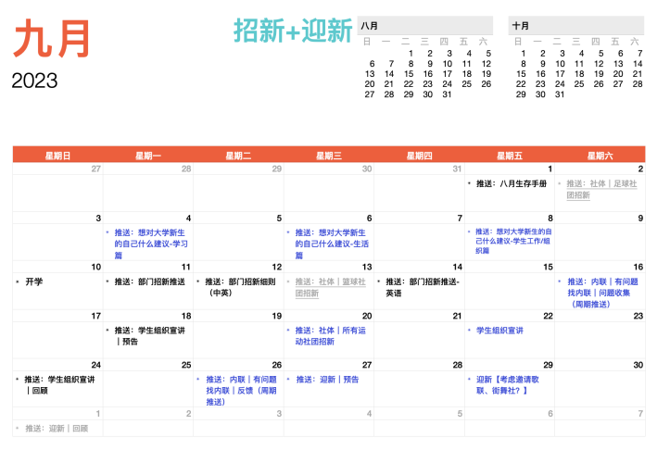

* 1. 小程序
     1. 推动线下、实体化小程序
     2. 丰富内容

改进：加入英文版、加入buddy相关内容/和留学生文化交流相关内容（目的/定位：让大一新生和别的学院的同学了解密院、密院学生会）

2)Mini program

* + - * 1. Promote offline and physical mini programs
        2. Enrich the content

Improvement: Add English version, Buddy related content, and cultural exchange related content for international students (purpose/positioning: to enable freshmen and students from other colleges to understand the Secret School and the Secret School Student Union)

1. 创新：
   1. 实习月（加强年级之间的交流）
   2. 周报+月度会（加强部门交流）

2. Innovation:

(1) Internship Month (Strengthening Communication between Grades)

(2) Weekly report+monthly meeting (strengthen departmental communication)

[附录1]

[Appendix.1]

1. 推送经验总结
   1. 标题
      * 1. 前半部分指明活动性质/活动名字
        2. 后半部分
           1. 贴近生活，有吸引力
           2. 略微夸张，和活动紧密相关

（e.g. 权益反馈|好消息：下周开始就不用东奔西走了！别破防啦！）

* 1. 文案
     1. 一段摘要（对内容的完整概括优先，美化语言是其次）
        1. 如果是多段内容（每段内容差距大，无法统一概括），则摘要里这几段内容都要提。且主次关系/并列关系要和正文内容保持一致。
        2. 如果是一段内容，则概括的同时可以把语言美化得更具吸引力一点，多加感叹句和问句。
     2. 文案
        1. 没有错别字
        2. 除了活动介绍和新闻稿等较为正式的推文，在保证内容完整和衔接正常的情况下，尽量使用短句、3-4句为一段。
        3. 最好文字居中，避免出现不同大小的屏幕效果不一样的情况
        4. 字体统一（默认字体）、大小统一（正文16、标题24+）、颜色统一（全篇都用黑/全篇都用白）
        5. 写完一定要找相关负责人和老师审核，对于领导职称、各类组织的先后顺序等比较敏感的内容需要特别注意。
  2. 配图
     + 1. 活动回顾推一定要合照
       2. 策划者在活动开始前列好拍照类型（群像、特写、合照、（风景-无人物的照片））
  3. 结尾署名
     + 1. 字体要小
       2. 依次为文案、图片、排版
       3. 名字按拼音首字母a-z排列
  4. 其他总结
     + 1. svg插件要用的话多调试、用不同设备打开、确保没问题再发
       2. 文案多看多改，一些表述很难拿捏，如何做到正式的同时带一点俏皮有趣是很困难的，但是最重要的是把事情说清楚说明白。语言风格等都是锦上添花的东西。
       3. 图片如果有多张相似的用插件（左右/上下滑动查看更多）不要占用更多空间。但在使用过程中记得把图片的大小统一，在左右/上下滑动的过程中不会出现下图所示情况。

[附录2]

[Appendix.2]

1. 年历总述
   1. 9月招新
   2. 10月实习、筹备繁星周和午餐会
   3. 11月繁星周、午餐会、男生节、交大运动会
   4. 12月（寒假）小程序
   5. 3月舞会、女生节、春招、文化节开幕式
   6. 4月新生杯重启、一周cp
   7. 5月歌手大赛、文创大赛、体育赛事、小程序上新
   8. 6月服务月
   9. 7月学代会、部长团招新
   10. 8月军训、新老团队交接