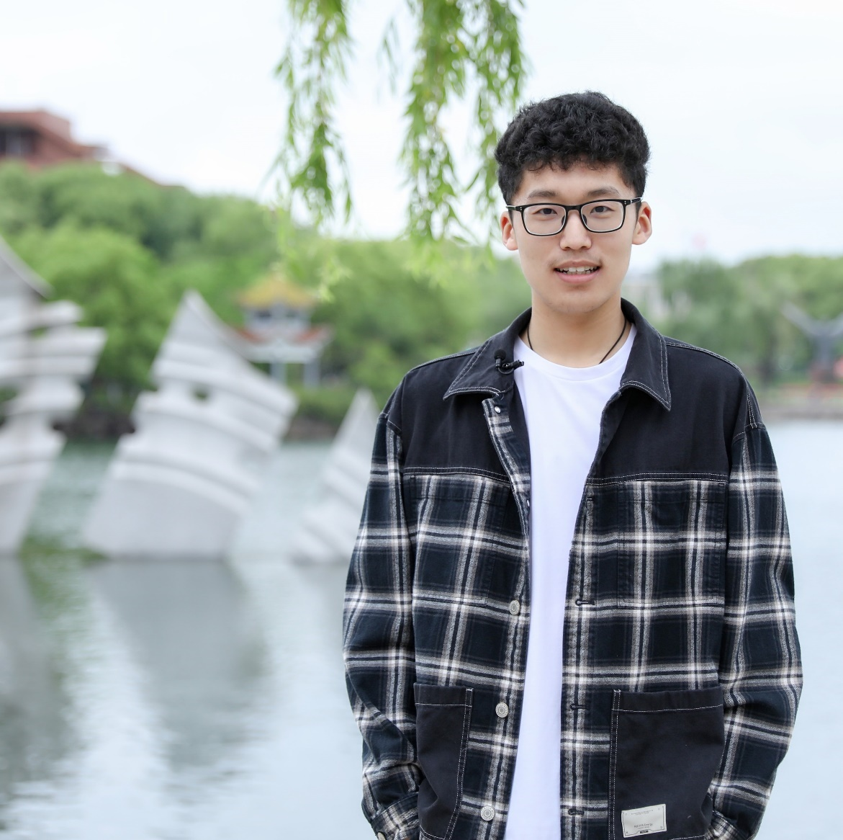

**Self-introduction:**

Hello everyone, I am Haobo Fang, a freshman from Class 8, the current deputy captain of the National Flag Guard of Shanghai Jiao Tong University, the secretary of the Class 8 of the joint institute, and a member of the eighth "Rong Chang · Talent Reserve" plan, the youth volunteer organization and the SSTIA. My campaign idea is: to be a perpetual motion machine that practices what I want, pursues what I love and serves everyone!

"Practice what I want":

I have **strong execution and organization planning ability**, good at proposing ideas and putting them into practice.

From the design of the "Electromagnetic Mystery" featured course in Eryuan volunteer teaching in the winter vacation of 2022 to the overall planning and promotion of "Quidditch" during the service month, I have accumulated relevant experience and learned to consider the coordination and promotion of logistics, publicity, field affairs and other matters from the perspective of the audience when holding activities.

"Pursue what I love":

I am **willing to invest a lot of energy in what I love**, like a "human perpetual motion machine", constantly dedicating myself to what I love.

I like guarding the red flag in the boring and repetitive training in the National Flag Guard. As a result, in my sophomore year, I will stay in the team as the vice-captain. I like to explore the design beauty in the "Liming Cup" mechanical competition, no matter how long it takes... Of course, student work is also one of my motivation sources. I hope that I can burn myself, dedicate myself and chase my love on the higher platform of the Joint Institute Student Union.

"Serve everyone":

I am **willing to do my best to help and serve my classmates**, to build trust and achieve mutual success in the process of mutual help.

No matter in the league branch secretary work of Class 8, or in the process of Eryuan volunteer teaching and “Lvge” sand control, I always hold an enthusiastic service attitude when facing peers and contributing to the community, which I definitely also gained a lot.

**The campaign idea:**

**To be a perpetual motion machine that practices what I want, pursues what I love and serves everyone!**

**ONE. Deepening of student union organization construction and reform plan**

1. Give full play to the talent advantages of the Student Union to better enhance members' sense of gain

Background of the problem:

According to the investigation, there are **common problems** in some departments of the Student Union that the level of volunteer poster production is uneven, and the **internal training resources** and experience with departmental characteristics are difficult to benefit all members of the Student Union;

Solution idea:

(This activity is innovative based on the experience of Antai Student Union's "Young Eagle Program". The introduction link of "Young Eagle Program" is as follows: ["Young Eagle Program" recruitment! Looking forward to every enterprising you](https://mp.weixin.qq.com/s/m360NvezmJuV0GnYdQW4IA))

The training activity will be organized and planned by the presidium, mainly for autumn recruitment volunteers who **show great enthusiasm for student work**, and will be selectively open to non-members of the student union; The goal of the activity is to **provide a platform** for activists to communicate, and at the same time to promote the overall development of students' union volunteers and enhance their sense of participation and gain; The activity is scheduled for the weekend after the completion of the autumn recruitment work of all departments. The trainees will be **voluntarily registered** by the audience. The training activity is divided into two parts: **sharing meetings and lunch meetings**:

Sharing Session:

The lecturers will be ministers with working experience, and the sharing session will consist of two parts:

The first part focuses on **solving the common problems of the department**:

The Media Department will be responsible for carrying out the poster production lecture of “XIUMI /canva” for beginners with an emphasis on its breadth (taking "canva" as an example, it can involve some basic collage, background color matching and other basic knowledge, for details, please refer to [the Media Department Workshop recording in Autumn 2022](https://sjtu.feishu.cn/minutes/obcnumhf131t5q9175377nct));

The second part focuses on **promoting the overall development of participants.** Participants can choose to participate independently. The tentative content is as follows:

The JI Organization Group will be responsible for sharing the theme "How to submit a good proposal"

(the production process from a relatively vague topic to a full research report:

The basic structure of the report:

Name of the proposal, proposer seconder, research background, research results and proposed scheme

Research ideas:

Take the issue of "Insufficient lighting in some sections of the school at night" as an example:

Focus on "why there is insufficient lighting", "where there is insufficient lighting", and "What is the impact of insufficient lighting"

Research methods:

Field visit + online questionnaire);

The Media Department will be responsible for sharing the theme of "Ps/Pr"

(Taking [the Workshop materials of the Media Department in Autumn 2021](https://jbox.sjtu.edu.cn/v/link/view/3fb5d1effaed4b889fe94c2068a925a0) as an example, the contents can obtain certain depth, such as portrait processing and special masks in the post-processing of the pictures);

The sponsorship group of the Outer Liaison Department will be responsible for sharing the theme of "Negotiation skills";

(Generally speaking, to seek sponsorship, the first step is to identify the positioning of the activity to be sponsored, which is mainly based on the scope and personnel involved, the publicity we can provide and the needs of sponsors, and decide a mutually beneficial plan.)

Lunch meeting:

The theme is mainly to **share the work experience** of the minister (for example, the leader of the sponsorship group can share the dispute cases encountered in the process of business negotiation and their own solutions), and the goal is to make the participants gain insights and understanding, and **prepare** for the work of students in the next year;

2. Strengthen departmental coordination to escort large-scale activities

Background of the problem:

The joint meeting system is a regular meeting system proposed by the previous presidium to solve the problem of "the lack of the first contact person of the department and the poor exchange of information between the department and the presidium", which was originally scheduled to be once a week. However, due to the epidemic and other factors, the system has not done a good job of fulfilling its mission. At the same time, during the preparation of large-scale events, there are six departments of the Student Association, which either have casual or lack necessary contacts, and inter-ministerial cooperation is often reflected as **inefficient**;

Solution idea:

Reform the joint meeting system

Standard the frequency of regular meetings organized by students of the Youth League Committee, adjust the fixed frequency of the joint meeting system to **once a month** and add the "department request system" (that is, in the preparation stage of large-scale activities, the minister or the general director of the corresponding department will make a comprehensive list of tasks as far as possible, and clarify which tasks need to be supported by students from other departments with professional skills). The content of the meeting mainly includes the work report of each department and the outlook of activities, while **improving the efficiency of inter-ministerial cooperation**, escorting the smooth implementation of large-scale activities, and discussing the long-term development decision of the student Union when necessary;

At the same time, most of the horizontal contact modes of "minister-minister" and "volunteer-volunteer" are adopted in the preparation of large-scale events, and the vertical contact mode of "minister-volunteer" lacks institutionalized constraints, which may result in poor information communication due to personality problems. The plan is to expand the participation from joint ministers and members of the Bureau to **volunteers and directors who provide technical support from other departments**;

Significance:

The ministerial group of the presidium can complement each other's advantages and avoid the effect of shortcomings. At the same time, the additional "department request system" can make the joint meeting **more flexible**, facilitate departments to **timely reflect the needs** of inter-ministerial cooperation, and help departments sort out planning plans, make more reasonable activity planning, and solve the possible problem of "minister-volunteer" information exchange.

3. Enhance the work enthusiasm of students' Union members

Orientation of the Student Union of the Joint Institute:

A **love-driven** student organization led by the Youth League Committee of the College, focusing on **serving students' needs, improving students' comprehensive abilities and building college culture**;

Background of the problem:

When the Student Union recruits volunteers every autumn, the enthusiasm of the children is high. However, due to **the increasing pressure of schoolwork** and the nature of the student Union driven by love, some students' enthusiasm gradually waned, and their sense of belonging to the student Union also declined. At the same time, because it is difficult to find students who have a strong sense of responsibility and can maintain enthusiasm for work for a long time during the interview, some departments have adopted the admission idea of "rather record more than lose", resulting in the redundancy of personnel; Under the existing new recruitment system, some volunteers successfully pass the interview and once and for all, while some volunteers fail to enroll interested departments. Both types of students may lack enthusiasm;

Solution idea:

* 1. Emphasize the subjective initiative of the presidium and the ministerial Corps

in addition to considering professional counterparts and organizational abilities, the presidium needs to focus on the **enthusiasm, affinity and social ability** of candidates when nominating ministers, and they need to actively integrate into the freshman group of the department as soon as possible and blend with the students in the department;

(Since the orientation of the student Union is a large student group driven by love, improving work efficiency and invigorating the departmental atmosphere cannot be **interest-oriented**: the presidium needs to consciously unite the ministerial group, and the ministerial group should also consciously unite the students in the department, and the presidium can also communicate more and more with the freshmen members of the student union to understand what the children think and how they think);

1.2. Reform the recruitment system

One week before the start of spring recruitment work, the presidium organized all departments to carry out internal intention questionnaires, **for the group of all autumn recruitment volunteers within the department,** the questionnaire mainly provides three channels for volunteers: **the department's retention channel, the department's green channel and the outgoing channel**. At the same time, the presidium should fully grasp the questionnaire of each department (including the list of candidates for the three channels), and actively carry out communication; The scale of spring recruitment in each department is determined by the presidium and the members of the ministerial League taking into account the planning of the work and the number of personnel gaps.

Transfer department green channel:

Based on the basic principle of "**students volunteer, communicate with the minister**", some students are given the opportunity to show themselves again and explore their interests. For the key members who may apply for transfer to the department, the presidium should take the intention of classmates as the priority, and decide whether to stay or go after full communication with the students themselves and the ministers of both sides;

**TWO. College culture and activities**

1. Expand the forms of cultural and sports activities and create business cards for activities

Background of the problem:

As the largest and most influential student organization, the Student Union has the ability and obligation to **provide more platforms and opportunities for students to communicate with each other**. However, due to the impact of the epidemic and other factors, routine activities such as fluorescent night run could not be carried out, the "Lianyuan" magazine was suspended, and the participation of "Freshman Cup" and "JI Cup" also needed to be improved;

Solution idea:

1.1 Create business cards for JI activities to retain JI's life memories - see "Service Month Activities – MiNianJi" section, or "Service Month Activities - Quidditch" section

1.2 Explore short video resources and expand publicity channels - see "Service Month Activity - Quidditch" section for details

1.3 Upgrade the "Freshman Cup" to the Freshman Sports Meeting, continue to expand the influence of "JI Cup", expand the coverage, and enhance the sense of participation

1.3.1 **Expand the coverage** of "JI Cup" and try to re-organize e-sports competitions, chess and card competitions, etc.;

1.3.2 The Freshmen Sports Meeting will consist of two parts: Freshmen Cup + Fun Sports Meeting

"Freshmen Cup" (basketball, badminton, table tennis) seeks opportunities to cooperate with the International Students Association on the basis of the original, hoping to provide students with more opportunities to **make foreign friends at the beginning of enrollment**

The "Fun Sports Meeting" focuses on "**fun, participation and teamwork**", and aims to provide a platform for stylistic communication for freshmen, hoping to make up for the shortcomings of "Freshman Cup" which is relatively professional to some extent, and pay attention to the social and sports needs of female students (consider developing a variety of some small outdoor league construction games such as "standing at 100" and "passing on the torch", and you can also try to cooperate with organizations such as Jianbu football club.)

**THREE. Students' rights and interests maintenance and feedback**

1. Open the paths for resource sharing and information integration

Background of the problem:

In my opinion, the existing channels for safeguarding students' rights and interests based on the meeting with the dean have been more comprehensive and three-dimensional. Compared with the horizontal comparison, the threshold of our feedback channels is not very high. The key is to integrate feedback channels and publicize them through multiple channels. However, in a broad sense, in today's world where information is a resource, resource inheritance represented by the Transferable courses list and "Inheritance · Jiao Tong University" is mainly based on oral teaching, which requires a certain degree of integration and redistribution for freshmen.

Solution idea:

See "Service Month Activities - Information Integration" section for details

2. Pay attention to the needs of international students and help them integrate into the family of the Joint Institute

Background of the problem:

International students are the representatives and participants of the multi-culture of the college, and the student union should help them integrate into the environment of the college and promote the multicultural exchange of the college. However, due to the high threshold of communication, international students often do not participate much in the activities organized by the Student Union. The position of the Student Union is to serve the International student community together with the International Student Association(ISA), and is committed to breaking down communication barriers and growing together.

Solution idea:

1.1 Function restructuring of the Internal Communication Department (see "Reform Plan of Various Departments - Internal Group" section for details)

1.2 Expand activity ideas and strengthen daily contact

Taking the Quidditch Experience Competition organized during this Service month as an example, based on the characteristics of internationalization, the new forms of activities from around the world are introduced to JI, which not only meets the students' sense of novelty and curiosity, but also broadens the international perspective of the Joint institute students, and provides a new platform for the communication between the international students and the Chinese students.

At the same time, we can also encourage international students to participate in social practice, so that they can get to know China and establish a good emotional connection with Chinese students;

**FOUR. Sectoral reform plans**

**Department of Social Sports**

Departmental responsibilities and existing issues:

Served the college community and sports team, connected with the university sports Association, and was responsible for the registration organization and style report of school-level cultural and sports activities (such as the school sports meeting) in JI, and was responsible for the whole process of preparation for the freshmen sports meeting and the "JI Cup";

Due to the influence of the epidemic and other factors, the routine fluorescent night run cannot be carried out. At the same time, due to the professional limitations of the existing "freshmen Cup" and "JI Cup", the participation of cultural and sports activities organized by the student Union can have more exploration space;

Reform plan:

1. Create diversified feature series push to condense brand effect

Jiaotong University has a system of freshmen Cup series organized by various associations from football, basketball, swimming and tennis. The Social and Sports Department should integrate the information, send push feedback to students and organize registration. At the same time, it should follow up the activity in real time and release the sports style display of students in JI.

The activities related to the Social and Sports Department are more concentrated in time and diverse in type. The unified first picture (which can be supported by the graphic design team of the Media Department) and Xiumi template can be adopted from the pre-registration, mid-term follow-up and post-summary.

2. Identify the position of the Social and Sports Department and clarify the functions of the minister

2.1 On the one hand, it is necessary to make overall arrangements for the venue requirements and submit them to the hospital before the semester, so as to obtain a training venue for a fixed period of time. On the other hand, it is necessary to give full play to the venue advantages of Longbinlou Gym and table tennis table

2.2 The minister of the Department of Social and Sports needs to have a certain participation in at least one sport, and it is better to have a certain mobilization ability and voice, and to be able to conduct in-depth research and timely feedback on the problems existing in the school team, which will also become one of the important factors in the "nomination of the minister" of the Department of Social and Sports

**Department of literature and Art**

Sorting out department activities:

Welcome party, dim light exhibition, spring dance, singer competition, farewell party, (not open air singing), etc

**Media department**

Departmental responsibilities and existing issues:

The Media Department now has three working groups: "Graphic Design Group", "Push Production Group" and "Video Photography Group". The graphic design Group is mainly responsible for the poster and Logo design of large-scale events and the docking; the push production group is mainly responsible for the production of some push messages in the official public account of "JIers". The video photography group is positioned to provide photography services for large-scale events; At the same time, the Media Department also holds workshops every year to introduce the use of publicity tools such as Ps/Pr.

However, due to the impact of the epidemic and other factors, the external shooting activities of the media department have been suspended, and its positioning has gradually shifted to that of a publicity "worker" in other departments. It needs fresh elements to help it return to the traditional functions of traditional news reporting and publicity in a way that is popular with students.

Reform plan:

Explore short video resources, develop new positions in photography and video editing

The Media Department has a relatively complete reserve of talents in photography and video editing, and is able to complete the whole process of short video planning from director to camera operation to the final film. Meanwhile, short video positions such as wechat video number and B station number have gradually become the focus of students' attention. The Media Department should also grasp the trend and explore short video resources.

According to the survey, it takes 3-4 days to complete the workload of ordinary videos from pre-planning to post-editing, which is not a small test for the task allocation of the media department. Therefore, it is tentatively scheduled for monthly, which can focus on the work dynamics of students in the Joint Institute, involve knowledge and science and science videos such as "industry trends", and include character videos showing students' style and recording life. It can also include fun videos of activities with high student participation;

**Business division**

Sorting out department activities:

Preparation of "Departure in JI", enterprise job fair, enterprise visit, etc

**Liaison Department outreach team**

Sorting out department activities:

Boys' Day, weekly CP, small shop on the new (basically once a month), large-scale event sponsorship tasks, etc

**Liaison team within the department**

Departmental responsibilities and existing issues:

The work functions of the liaison department are mainly divided into students' rights and interests and in-school activities. In terms of rights and interests, it is mainly responsible for the preparation of the dean's meeting twice a year and the daily maintenance of the Student Right Center platform (SRC platform), as well as the collection, investigation, sorting and feedback of proposals. School activities are for all students, including the organization and planning of girls' Day, Turkey Day and other activities;

In the process of interviewing the minister in charge of SRC, I found that the work burden of the minister in charge of SRC was relatively small, and after the epidemic, the international students came to China to attend classes, and the student union now had new tasks and new needs to connect with ISA and unite them.

Reform plan:

The internal team functions are reorganized, the former SRC platform is now managed by the Director in charge of the Dean's meeting, and the vacant minister position is now responsible for international affairs, whose responsibilities include:

1. Maintain close contact with ISA Association, provide communication support for large-scale activities held by the Student Union, and actively encourage international students to participate in the registration of activities such as freshman sports meeting and spring dance;

2. Transfer the experience of organizing activities in the internal organization, organize activities to enhance the connection between Chinese students and international students after the enrollment of international students in the fall, and hold at least one event with similar goals in the next academic year;

(See "Month of Service Events - Quidditch" section for details);

**Technical department**

Departmental responsibilities and existing issues:

I took advantage of my technical advantages to serve students' needs in terms of computer hardware and software. I was responsible for the daily maintenance of the "JISU one-day Tour" mini program and the development of Tools such as JOJ Tools, and inspired students' enthusiasm by holding hands-on workshops (such as mechanical keyboard Workshop and Reflow Workshop). By holding lecture workshops (such as VScode, Latex Workshop) to share software experience and impart core knowledge;

However, due to the professional limitations of some workshops, the participation of some activities needs to be improved. At the same time, the original on-duty system of the Technical department cannot well meet the needs of students due to the epidemic and participation factors, so there can be more diversified forms of activities with lower threshold to serve all undergraduates in the JI.

Reform plan:

1. Expand the forms of activities, lower the threshold of participation, and appropriately enhance the interest

After fully docking with the members of the technical Department and the minister, the interim activity plan is as follows:

Computer Evaluation Session - covering performance comparison of graphics cards commonly used by engineering students. It is planned to be launched in summer to serve prospective students of JI;

Establish a memorandum mechanism to integrate a collection of frequently asked questions during software installation - combined with the following shift system, take SolidWorks as an example, similar Q&A summary is available on the Software licensing center of Jiaotong University, but the coverage is not extensive;

2. Be more oriented to the needs of classmates

2.1 When there are software installation requirements in each semester (taking freshman year as an example, the worker guides Solidworks installation requirements, and the project guides VScode and Clion installation requirements), the on-duty system is combined with the lab after communicating with lab TA without violating HC. To provide students with software installation question answering services based on the basic principle of "no interference in any homework content";

2.2 Review the development of workshops each semester, and integrate and provide screen recording channels of each Workshop in the review push;

**FIVE. Service Month activities**

1. Quidditch

Based on the international characteristics of Michigan College, this activity not only introduced the sport of live Quidditch to JI, but also provided a new platform for communication between Chinese students and international students. It also proved to a certain extent that as long as the interest trend of the majority of the JI students is grasped, the cultural and sports activities will be welcomed by everyone. At the same time, the review video of the Quidditch experience competition has also made a positive exploration in expanding the propaganda channels of the student union;

1.1 There are a lot of cultural resources represented by Quidditch in JI with the characteristics of internationalization, and some activities can be built into a business card with the characteristics of JI with proper attention and exploration;

1.2 The Quidditch Experience grasped the interest trend of the students, and the enthusiasm to participate was high

(The number of registered readers ranked first among all service month events in the past two years, which can be seen in Quidditch Experience competition)

(The number of likes of the review video also hit a record high on the emerging platform of "Shanghai Jiao Tong University JI Student Union", and some videos played under the platform of "Jiao Tong University Michigan College" are also similar)

1.3 In this activity, I put forward the idea of activities, coordinated logistics and material purchase, etc. At the same time, I independently completed the whole process planning of short videos, launch, layout and venue reservation tasks

2. "MiNianJi" magazine

"MinianJi" magazine is positioned to use paper media to sort out college activities for students, retain JI memories, and provide a platform to show themselves and share life details, and the information is constantly strengthening the identity of Joint institute students to JI;

2.1 The unique academic system of the JI makes the students of the JI have a stronger need to retain the memory of life in the university. Meanwhile, the publication of paper magazines across the university is also conducive to the establishment of the cultural business card of JI;

2.2 In this activity, I was responsible for sorting out the "skimming" part and other activity materials, and also undertook the tasks of meeting transcript and offline distribution of the East 20th floor building

3. Information Integration Month

I got inspiration from "How to avoid proposals being rejected", which mainly focuses on the initial attempt to integrate resources such as Transferable courses list. If I am lucky enough to be elected, I hope to brainstorm with the children in the business department and include similar content into the writing scope of "Starting in JI".

In this activity, I proposed the idea of the activity and was responsible for task allocation, resource integration and final push layout