**贪吃蛇设计报告**

**221300066**

**季千焜**

**qkjiai@smail.nju.edu.cn**

**一．选题描述：**

本项目是一个基于BFS等算法的贪吃蛇小游戏，利用python语言编写，采用pygame库实现图形化界面，玩家版通过键盘控制贪吃蛇的移动，AI版实现了自动寻路，小蛇的初始长度为2，吃到食物后蛇的长度增加，得分加1，撞到墙壁或自身则游戏结束，最终目标是使贪吃蛇的长度尽可能长，尽可能占满空间。

**二．设计方案：**

整个项目可以分为图形化界面、蛇与食物的生成、小蛇的运动、游戏逻辑、算法套路、分数统计等模块，各模块功能如下：

**1.图形界面模块：**

使用pygame库实现游戏窗口、各元素(如屏幕大小，背景颜色，蛇与果实的颜色，网格线等)的布局。

优化：添加开始与结束模块。

**2.蛇体运动模块：**

根据键盘键控制蛇的运动，形成蛇身体的位置变化，判定游戏是否结束等。

**3.食物生成模块：**

随机生成食物，若蛇的头部碰到食物，则认为蛇吃食物成功，蛇身体长度增加，同时重新随机生成食物。

**4.游戏逻辑模块：**

根据蛇与食物的交互情况，判断游戏是否结束，同时维护分数等信息。

**5.算法套路模块：**

以BFS广度搜索为基础算法，加入虚拟的小蛇，探索吃到食物的最短路径，最安全的路径（DFS最远路径，不进入死路的路径，头追着尾的路径等），为继续运行而随便走的路径(哈密顿路径三选一)等。

**6. 分数统计模块：**

使用文本框实现分数的实时统计，通过Show_Score函数处理得分。

**三．代码模块的功能划分与描述：**

（一些准备代码省略）

**玩家版**

1. 显示蛇

def Show_Snake(coords):

x = coords[0]['x'] * Cell_Size

y = coords[0]['y'] * Cell_Size

Snake_head_Rect = pygame.Rect(x, y, Cell_Size, Cell_Size)

pygame.draw.rect(Main_Display, (0, 80, 255), Snake_head_Rect)

Snake_head_Inner_Rect = pygame.Rect(x+4, y+4, Cell_Size-8, Cell_Size-8)

pygame.draw.rect(Main_Display, (0, 80, 255), Snake_head_Inner_Rect)

for coord in coords[1:]:

x = coord['x'] * Cell_Size

y = coord['y'] * Cell_Size

Snake_part_Rect = pygame.Rect(x, y, Cell_Size, Cell_Size)

pygame.draw.rect(Main_Display, (0, 155, 0), Snake_part_Rect)

Snake_part_Inner_Rect = pygame.Rect(x+4, y+4, Cell_Size-8, Cell_Size-8)

pygame.draw.rect(Main_Display, (0, 255, 0), Snake_part_Inner_Rect)

2. 显示果实

def Show_Apple(coord):

x = coord['x'] * Cell_Size

y = coord['y'] * Cell_Size

apple_Rect = pygame.Rect(x, y, Cell_Size, Cell_Size)

pygame.draw.rect(Main_Display, (255, 0, 0), apple_Rect)

3. 画网格

def draw_Grid():

# 垂直方向

for x in range(0, Window_Width, Cell_Size):

pygame.draw.line(Main_Display, (40, 40, 40), (x, 0), (x, Window_Height))

# 水平方向

for y in range(0, Window_Height, Cell_Size):

pygame.draw.line(Main_Display, (40, 40, 40), (0, y), (Window_Width, y))

4. 显示开始与结束界面

def Show_Start_Interface():

title_Font = pygame.font.Font('simkai.ttf', 100)

title_content = title_Font.render('贪吃蛇', True, (255, 255, 255), (128,0,128))

angle = 0

while True:

Main_Display.fill(Background_Color)

rotated_title = pygame.transform.rotate(title_content, angle)

rotated_title_Rect = rotated_title.get_rect()

rotated_title_Rect.center = (Window_Width/2, Window_Height/2)

Main_Display.blit(rotated_title, rotated_title_Rect)

pressKey_content = Main_Font.render('按任意键开始游戏！', True, (255, 255, 255))

pressKey_Rect = pressKey_content.get_rect()

pressKey_Rect.topleft = (Window_Width-200, Window_Height-30)

Main_Display.blit(pressKey_content, pressKey_Rect)

if Check_PressKey():

# 清除事件队列

pygame.event.get()

return

pygame.display.update()

Snake_Clock.tick(Display_Clock)

angle -= 5

def Show_End_Interface():

title_Font = pygame.font.Font('simkai.ttf', 100)

title_game = title_Font.render('Game', True, (233, 150, 122))

title_over = title_Font.render('Over', True, (233, 150, 122))

game_Rect = title_game.get_rect()

over_Rect = title_over.get_rect()

game_Rect.midtop = (Window_Width/2, 70)

over_Rect.midtop = (Window_Width/2, game_Rect.height+70+25)

Main_Display.blit(title_game, game_Rect)

Main_Display.blit(title_over, over_Rect)

pressKey_content = Main_Font.render('按任意键开始游戏！', True, (255, 255, 255))

pressKey_Rect = pressKey_content.get_rect()

pressKey_Rect.topleft = (Window_Width-200, Window_Height-30)

Main_Display.blit(pressKey_content, pressKey_Rect)

pygame.display.update()

pygame.time.wait(500)

# 清除事件队列

Check_PressKey()

while True:

if Check_PressKey():

pygame.event.get()

return

5. 检测玩家的按键是否合理

def Check_PressKey():

if len(pygame.event.get(QUIT)) > 0:

close_game()

KeyUp_Events = pygame.event.get(KEYUP)

if len(KeyUp_Events) == 0:

return None

elif KeyUp_Events[0].key == K_ESCAPE:

close_game()

return KeyUp_Events[0].key

6. 获得果实位置

def Get_Apple_Location(snake_Coords):

flag = True

while flag:

apple_location = {'x': random.randint(0, Cell_W-1), 'y': random.randint(0, Cell_H-1)}

if apple_location not in snake_Coords:

flag = False

return apple_location

7. 显示当前得分

def Show_Score(score):

score_Content = Main_Font.render('得分：%s' % (score), True, (255, 255, 255))

score_Rect = score_Content.get_rect()

score_Rect.topleft = (Window_Width-120, 10)

Main_Display.blit(score_Content, score_Rect)

8. 运行游戏

def Run_Game():

# 蛇的出生地

start_x = random.randint(5, Cell_W-6)

start_y = random.randint(5, Cell_H-6)

snake_Coords = [{'x': start_x, 'y': start_y},

{'x': start_x-1, 'y': start_y}]

direction = 'right'

apple_location = Get_Apple_Location(snake_Coords)

while True:

for event in pygame.event.get():

if event.type == QUIT:

close_game()

elif event.type == KEYDOWN:

if (event.key in (K_a, K_LEFT)) and (direction != 'right'):

direction = 'left'

elif (event.key in (K_d, K_RIGHT)) and (direction != 'left'):

direction = 'right'

elif (event.key in (K_w, K_UP)) and (direction != 'down'):

direction = 'up'

elif (event.key in (K_s, K_DOWN)) and (direction != 'up'):

direction = 'down'

elif event.key == K_ESCAPE:

close_game()

# 碰到墙壁或者自己则游戏结束

if (snake_Coords[Head_index]['x'] == -1) or (snake_Coords[Head_index]['x'] == Cell_W) or \

(snake_Coords[Head_index]['y'] == -1) or (snake_Coords[Head_index]['y'] == Cell_H):

return

if snake_Coords[Head_index] in snake_Coords[1:]:

return

if (snake_Coords[Head_index]['x'] == apple_location['x']) and (snake_Coords[Head_index]['y'] == apple_location['y']):

apple_location = Get_Apple_Location(snake_Coords)

else:

del snake_Coords[-1]

if direction == 'up':

newHead = {'x': snake_Coords[Head_index]['x'],

'y': snake_Coords[Head_index]['y']-1}

elif direction == 'down':

newHead = {'x': snake_Coords[Head_index]['x'],

'y': snake_Coords[Head_index]['y']+1}

elif direction == 'left':

newHead = {'x': snake_Coords[Head_index]['x']-1,

'y': snake_Coords[Head_index]['y']}

elif direction == 'right':

newHead = {'x': snake_Coords[Head_index]['x']+1,

'y': snake_Coords[Head_index]['y']}

snake_Coords.insert(0, newHead)

Main_Display.fill(Background_Color)

draw_Grid()

Show_Snake(snake_Coords)

Show_Apple(apple_location)

Show_Score(len(snake_Coords)-2)

pygame.display.update()

Snake_Clock.tick(Display_Clock)

9. 主函数

def main():

global Main_Display, Main_Font, Snake_Clock

pygame.init()

Snake_Clock = pygame.time.Clock()

Main_Display = pygame.display.set_mode((Window_Width, Window_Height))

Main_Font = pygame.font.Font('simkai.ttf', 18)

pygame.display.set_caption('Normal_snake')

Show_Start_Interface()

while True:

Run_Game()

Show_End_Interface()

**AI版**

算法主要思路：

1.蛇每走一步，就使用BFS计算游戏界面中每个位置（蛇身除外）到达食物的最短路径长；

2.将蛇的安全路径定义为蛇可以跟着蛇尾运动，即蛇头和蛇尾间存在路径；

3.蛇每次行动前先利用虚拟的蛇进行探路，若虚拟的蛇吃完食物后是安全的，蛇才行动；

4.若蛇和食物之间不存在路径或者吃完食物后并不安全，就跟着蛇尾走，保证不死；

5.若蛇和食物之间、蛇和蛇尾之间均不存在路径，就随便挑一步来走；

6.需要注意目标是食物时蛇走最短路径，目标是蛇尾时蛇走DFS的最长路径（保证不死）。

具体代码：

1.每走一步都要重置board

def board_reset(psnake, pboard, pfood):

temp_board = pboard[:]

pfood_idx = pfood['x'] + pfood['y'] * Cell_W

for i in range(FIELD_SIZE):

if i == pfood_idx:

temp_board[i] = FOOD

elif Is_Cell_Free(i, psnake):

temp_board[i] = FREE_PLACE

else:

temp_board[i] = SNAKE_PLACE

return temp_board

2.BFS最短路径吃果实

def board_refresh(psnake, pfood, pboard):

temp_board = pboard[:]

pfood_idx = pfood['x'] + pfood['y'] * Cell_W

queue = []

queue.append(pfood_idx)

inqueue = [0] * FIELD_SIZE

found = False

while len(queue) != 0:

idx = queue.pop(0)

if inqueue[idx] == 1:

continue

inqueue[idx] = 1

for move_direction in ['left', 'right', 'up', 'down']:

if is_move_possible(idx, move_direction):

if (idx+move_directions[move_direction]) == (psnake[Head_index]['x'] + psnake[Head_index]['y']*Cell_W):

found = True

# 该点不是蛇身(食物是0才可以这样子写)

if temp_board[idx+move_directions[move_direction]] < SNAKE_PLACE:

if temp_board[idx+move_directions[move_direction]] > temp_board[idx]+1:

temp_board[idx+move_directions[move_direction]] = temp_board[idx] + 1

if inqueue[idx+move_directions[move_direction]] == 0:

queue.append(idx+move_directions[move_direction])

return (found, temp_board)

# 根据board中元素值

# 从蛇头周围4个领域点中选择最短路径

def choose_shortest_safe_move(psnake, pboard):

best_move = ERR

min_distance = SNAKE_PLACE

for move_direction in ['left', 'right', 'up', 'down']:

idx = psnake[Head_index]['x'] + psnake[Head_index]['y']*Cell_W

if is_move_possible(idx, move_direction) and (pboard[idx+move_directions[move_direction]]<min_distance):

min_distance = pboard[idx+move_directions[move_direction]]

best_move = move_direction

return best_move

3. 虚拟蛇运行一次

def virtual_move(psnake, pboard, pfood):

temp_snake = psnake[:]

temp_board = pboard[:]

reset_tboard = board_reset(temp_snake, temp_board, pfood)

temp_board = reset_tboard

food_eated = False

while not food_eated:

refresh_tboard = board_refresh(temp_snake, pfood, temp_board)[1]

temp_board = refresh_tboard

move_direction = choose_shortest_safe_move(temp_snake, temp_board)

snake_Coords = temp_snake[:]

temp_snake.insert(0, find_snake_head(snake_Coords, move_direction))

# 如果新的蛇头正好是食物的位置

if temp_snake[Head_index] == pfood:

reset_tboard = board_reset(temp_snake, temp_board, pfood)

temp_board = reset_tboard

pfood_idx = pfood['x'] + pfood['y'] * Cell_W

temp_board[pfood_idx] = SNAKE_PLACE

food_eated = True

else:

newHead_idx = temp_snake[0]['x'] + temp_snake[0]['y'] * Cell_W

temp_board[newHead_idx] = SNAKE_PLACE

end_idx = temp_snake[-1]['x'] + temp_snake[-1]['y'] * Cell_W

temp_board[end_idx] = FREE_PLACE

del temp_snake[-1]

return temp_snake, temp_board

4. 选择最远路径

def choose_longest_safe_move(psnake, pboard):

best_move = ERR

max_distance = -1

for move_direction in ['left', 'right', 'up', 'down']:

idx = psnake[Head_index]['x'] + psnake[Head_index]['y']*Cell_W

if is_move_possible(idx, move_direction) and (pboard[idx+move_directions[move_direction]]>max_distance) and (pboard[idx+move_directions[move_direction]]<FREE_PLACE):

max_distance = pboard[idx+move_directions[move_direction]]

best_move = move_direction

return best_move

5. 蛇头朝着蛇尾运行一步

def follow_tail(psnake, pboard, pfood):

temp_snake = psnake[:]

temp_board = board_reset(temp_snake, pboard, pfood)

# 将蛇尾看作食物

end_idx = temp_snake[-1]['x'] + temp_snake[-1]['y'] * Cell_W

temp_board[end_idx] = FOOD

v_food = temp_snake[-1]

# 食物看作蛇身

pfood_idx = pfood['x'] + pfood['y'] * Cell_W

temp_board[pfood_idx] = SNAKE_PLACE

# 求得每个位置到蛇尾的路径长度

result, refresh_tboard = board_refresh(temp_snake, v_food, temp_board)

temp_board = refresh_tboard

# 还原

temp_board[end_idx] = SNAKE_PLACE

# temp_board[pfood_idx] = FOOD

return choose_longest_safe_move(temp_snake, temp_board)

6. 找一条安全的路径

def find_safe_way(psnake, pboard, pfood):

safe_move = ERR

real_snake = psnake[:]

real_board = pboard[:]

v_psnake, v_pboard = virtual_move(psnake, pboard, pfood)

# 如果虚拟运行后，蛇头蛇尾间有通路，则选最短路运行

if is_tail_inside(v_psnake, v_pboard, pfood):

safe_move = choose_shortest_safe_move(real_snake, real_board)

else:

safe_move = follow_tail(real_snake, real_board, pfood)

return safe_move

7. 各种方案均无效时，随便走一步

def any_possible_move(psnake, pboard, pfood):

best_move = ERR

reset_board = board_reset(psnake, pboard, pfood)

pboard = reset_board

result, refresh_board = board_refresh(psnake, pfood, pboard)

pboard = refresh_board

min_distance = SNAKE_PLACE

for move_direction in ['left', 'right', 'up', 'down']:

idx = psnake[Head_index]['x'] + psnake[Head_index]['y']*Cell_W

if is_move_possible(idx, move_direction) and (pboard[idx+move_directions[move_direction]]<min_distance):

min_distance = pboard[idx+move_directions[move_direction]]

best_move = move_direction

return best_move

**四．实现效果：**

**玩家版**

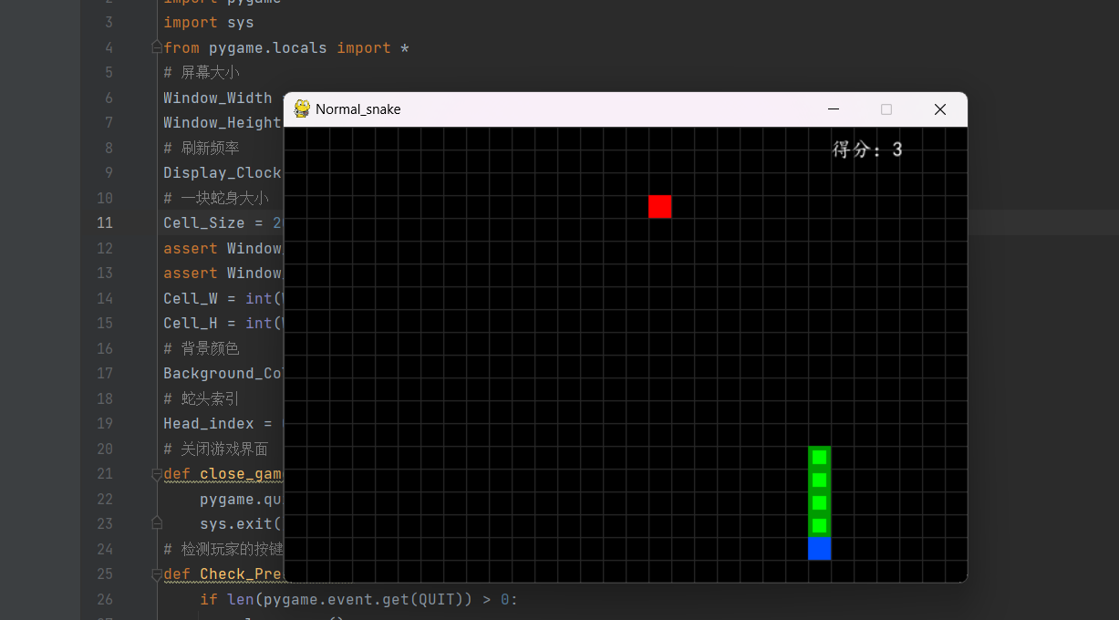

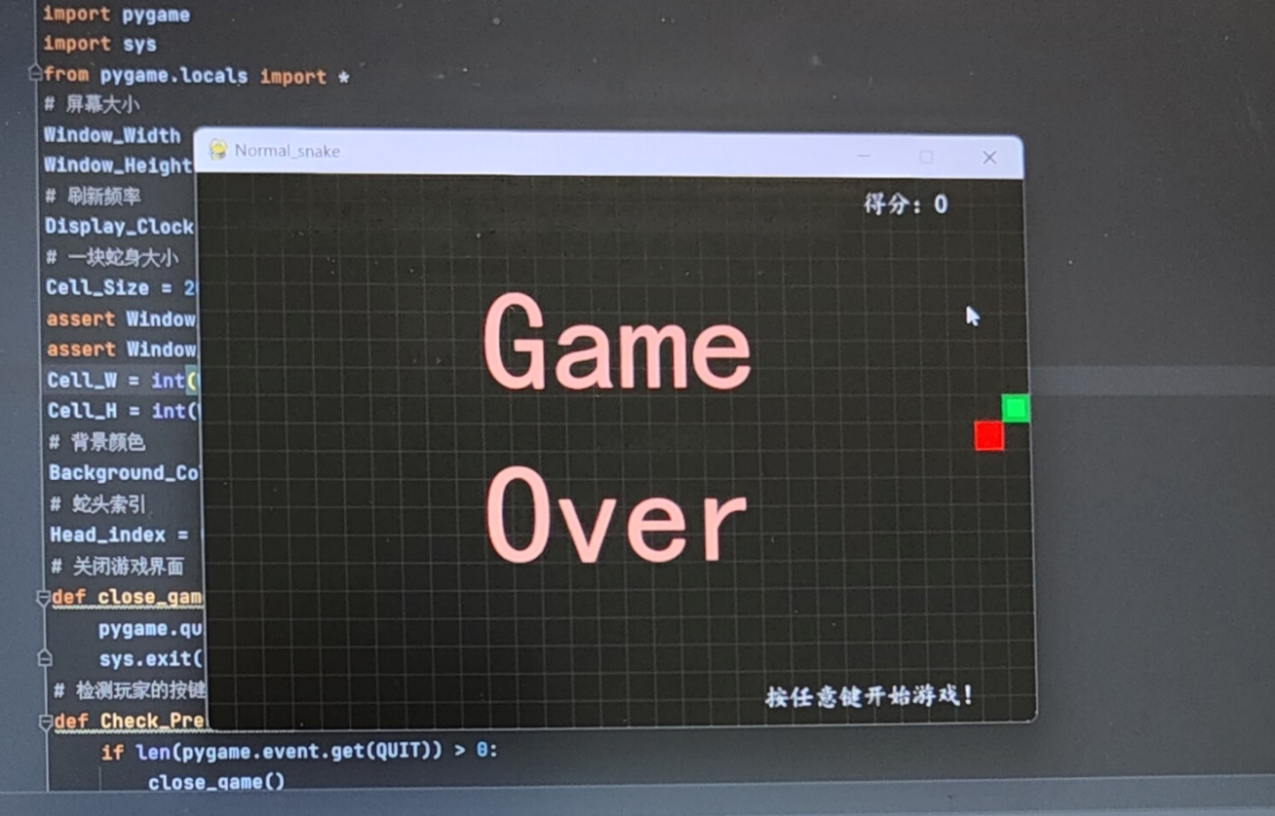

**AI版**

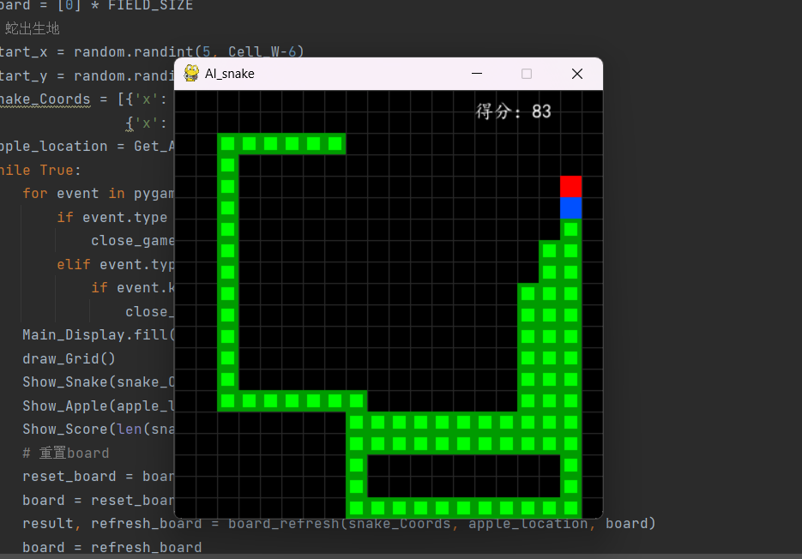

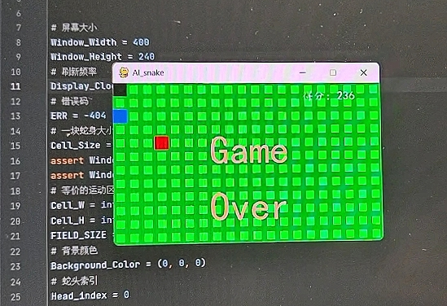

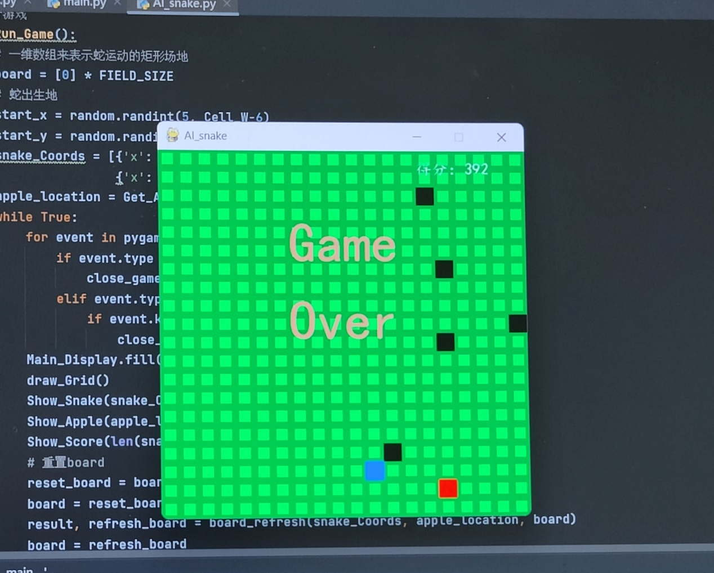

**五．一些不足：**

因为食物是随机出现的，在空格较少的时候，若虚拟的蛇跑一遍发现去吃食物是不安全的，真蛇就不会去吃食物，而是选择追着蛇尾跑，若一直如此，就陷入了死循环，蛇一直追着蛇尾跑，游戏不会停止。

P.S.我测试过程中只有一次小蛇铺满了整个区域，但是我没有截图555