**EXPERIMENT_11**

**DCL COMMANDS**

SQL>create table Bank(Bankid number(3) primary key,bankname varchar(30),Headoffice varchar(50),Branch varchar(30),BranchCode varchar(10));

SQL>Insert Into Bank Values(101,'SBI','delhi','pala','SBI122');

SQL>Insert Into Bank Values(102,'icici','rajasthan','punai','ICICI24');

SQL>Insert Into Bank Values(103,'PUNJAB_NATIONAL_BANK','GUJARAT','NAGPUR','PNB25');

SQL>Insert Into Bank Values(104,'Sib','mumbai','palak','Sib122');

SQL>Insert Into Bank Values(105,'CANARA','KERALA','PALAI','CAN345');

SQL>SELECT * FROM Bank;

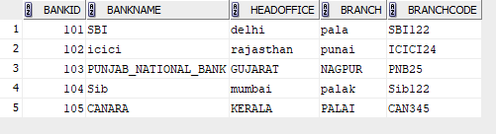

SQL>GRANT select on bank to c22csa36;

Grant succeeded;

SQL>select * from c22csa35.bank;

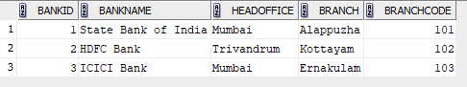

SQL>REVOKE SELECT ON BANK FROM c22csa36;

Revoke succeeded.

select * from c22csa35.bank;

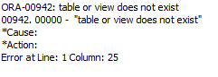

SQL>GRANT select,update on bank to c22csa35;



SQL>SELECT * FROM c22csa36.bank;



SQL>update c22csa36.bank set bankname=’SIB’ where bankid=104;

Commit;

SQL>Select * from bank;

