**EXPERIMENT_10**

SQL>create table Bank(Bankid number(3) primary key,bankname varchar(30),Headoffice varchar(50),Branch varchar(30),BranchCode varchar(10));

Insert Into Bank Values(101,'SBI','delhi','pala','SBI122');

Insert Into Bank Values(102,'icici','rajasthan','punai','ICICI24');

Insert Into Bank Values(103,'PUNJAB_NATIONAL_BANK','GUJARAT','NAGPUR','PNB25');

Insert Into Bank Values(104,'Sib','mumbai','palak','Sib122');

Insert Into Bank Values(105,'CANARA','KERALA','PALAI','CAN345');

SELECT * FROM Bank;

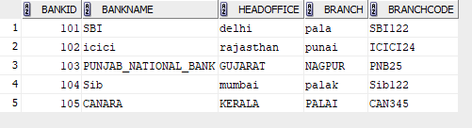

SQL>commit;

COMMITTED;

SQL>savepoint A;

DELETE FROM bank where bankid='102';

SELECT * FROM BANK;

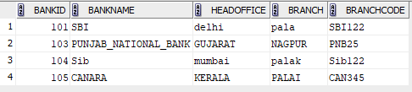

rollback to savepoint A;



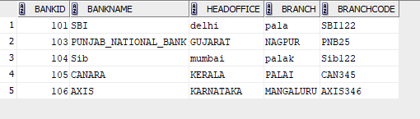



select * from bank;

