JCM Beam Shim Pack
Download, Install, and Test Guide
JCT BeamFlangeShimpack Tool · Installer v1.0.0 · SDS2 2026 · Windows
This guide walks through downloading the JCM Beam Shim Pack installer from GitHub, extracting it, installing it into an SDS2 plugins folder with a JiTech license code, and confirming the plugin loads inside SDS2. Screenshots match each step; the red box in every screenshot marks the item to click.

Before you start
- A GUID license code issued by JiTech. Each code activates one installation only.
- Access to the GitHub repository JITECHSDS2-2026/BeamFlangeShimpack.
- The path to the plugins folder you are installing into (a job-specific plugins folder or your SDS2 Program data plugins folder. Please Note the Installer uses the same default as sds2 C:\SDS2\plugins which may not be correct).
- At least 70 MB of free disk space at the destination, plus write access to it.
- Recommendation: SDS2 closed during installation, so the plugin files are not locked.

Part 1 — Download the installer

Step 1. Open the repository and click Code
Go to github.com/JITECHSDS2-2026/BeamFlangeShimpack and click the green Code button above the file list.
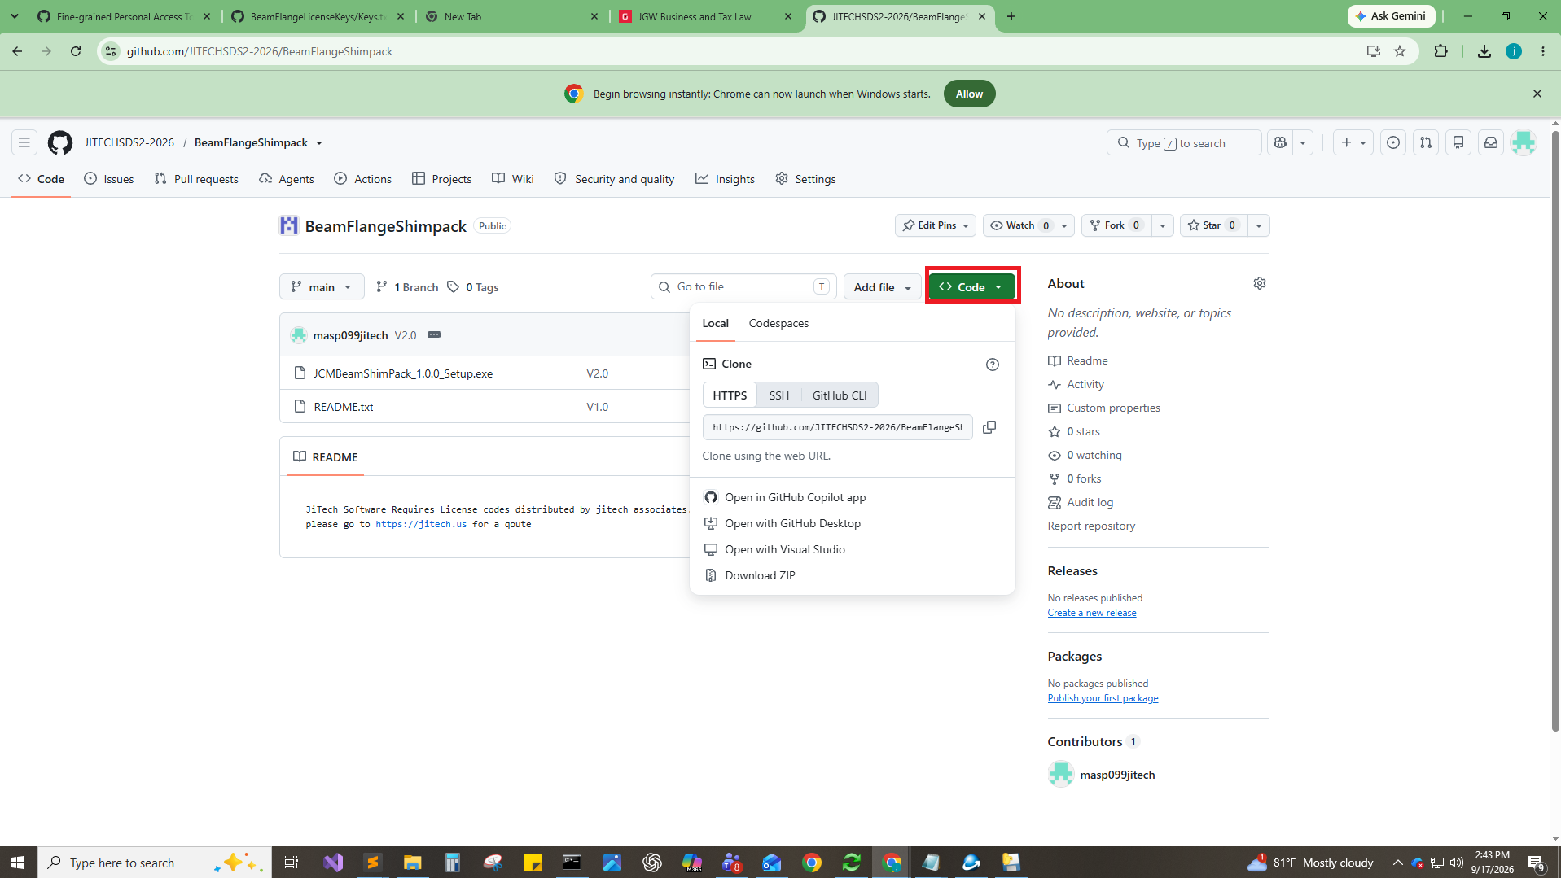

Step 2. Download the ZIP
On the Local tab of the dropdown, click Download ZIP. Chrome saves BeamFlangeShimpack-main.zip to your Downloads folder.
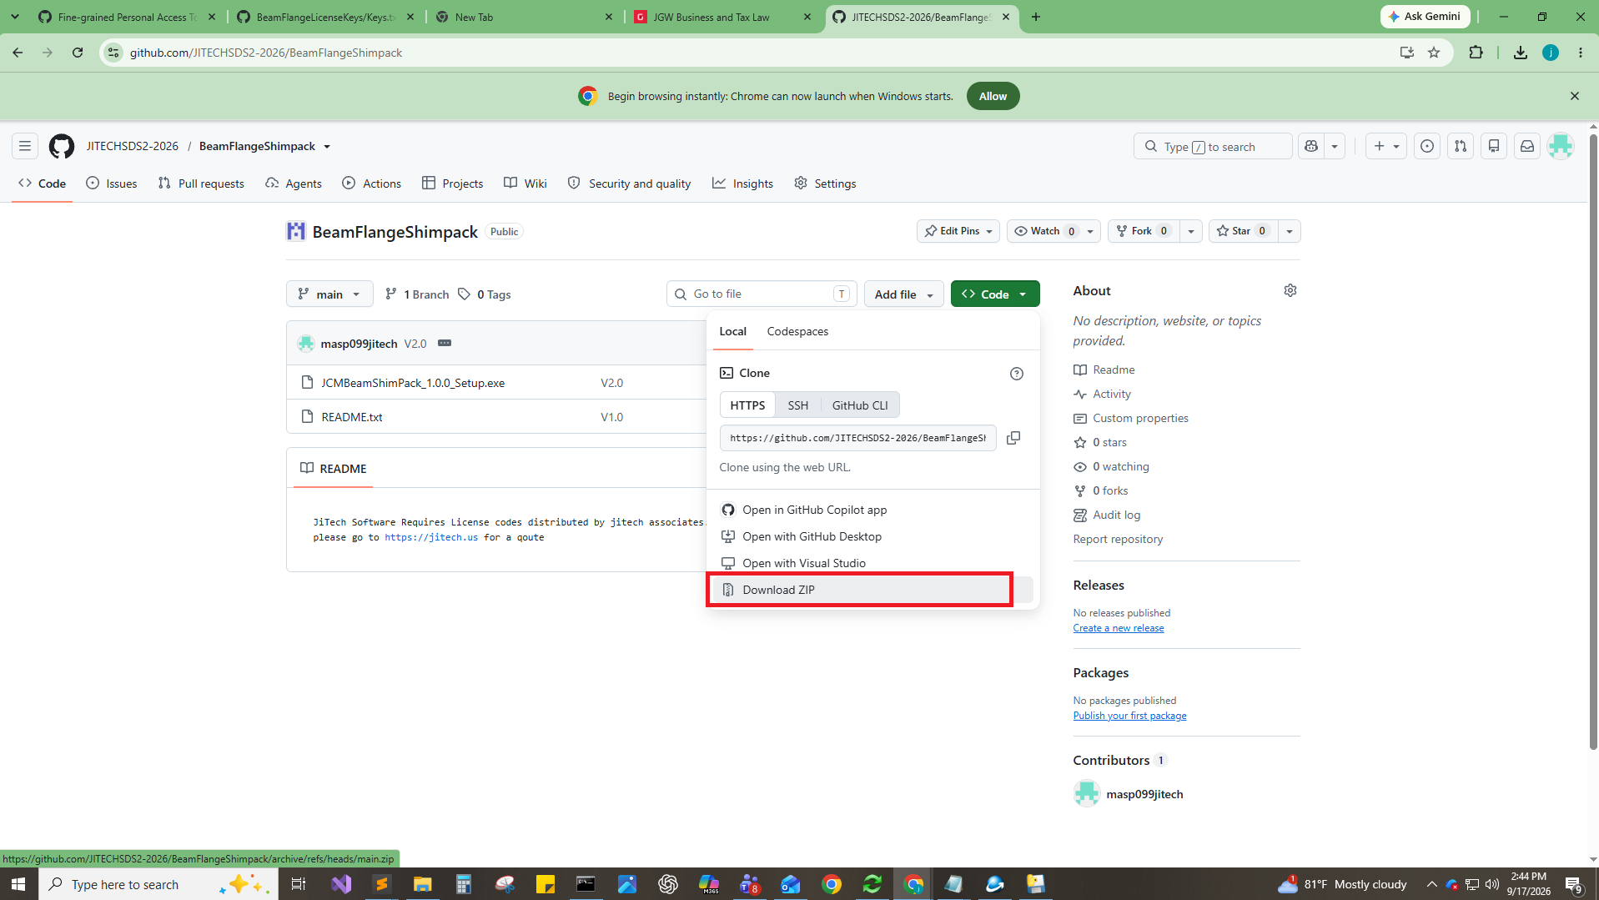

Part 2 — Extract the archive

Step 3. Find the download
Open This PC > Downloads and locate BeamFlangeShimpack-main (Compressed zipped folder, roughly 38 MB).
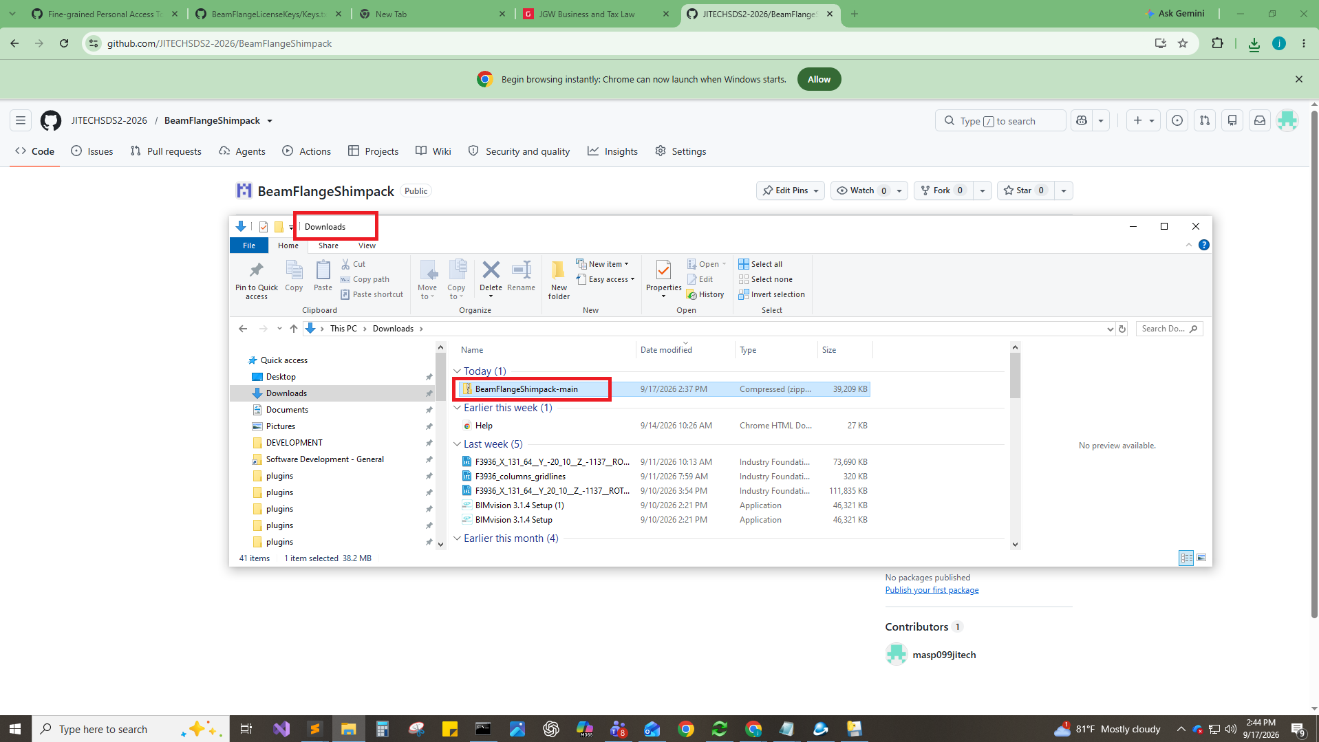

Step 4. Extract Here
Right-click the zip file and choose 7-Zip > Extract Here. If 7-Zip is not installed, use Extract All… from the same menu instead.
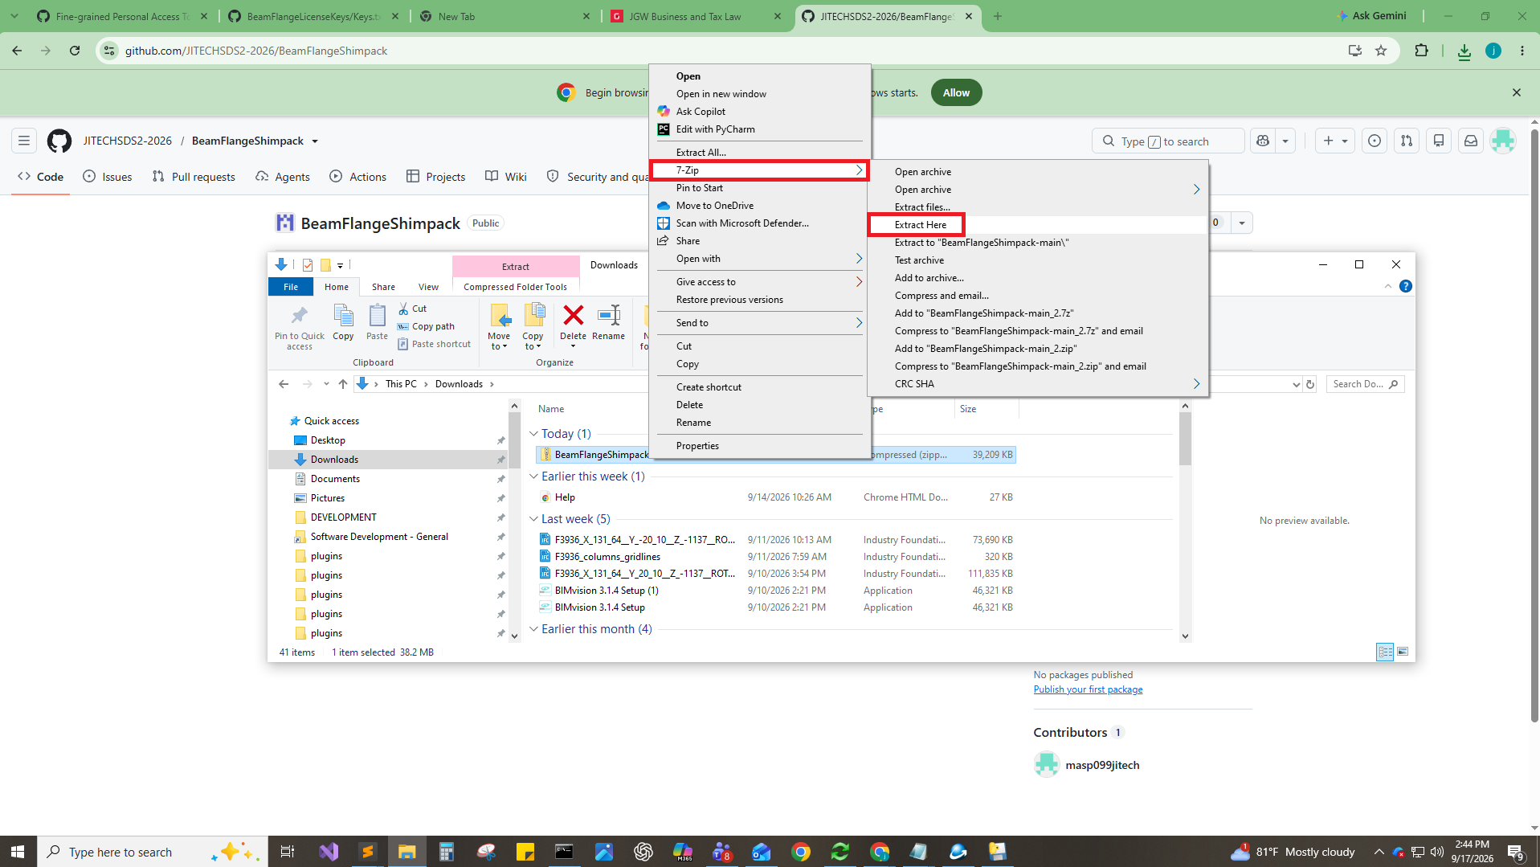

Step 5. Open the extracted folder
A folder named BeamFlangeShimpack-main now sits beside the zip. Double-click it to open.
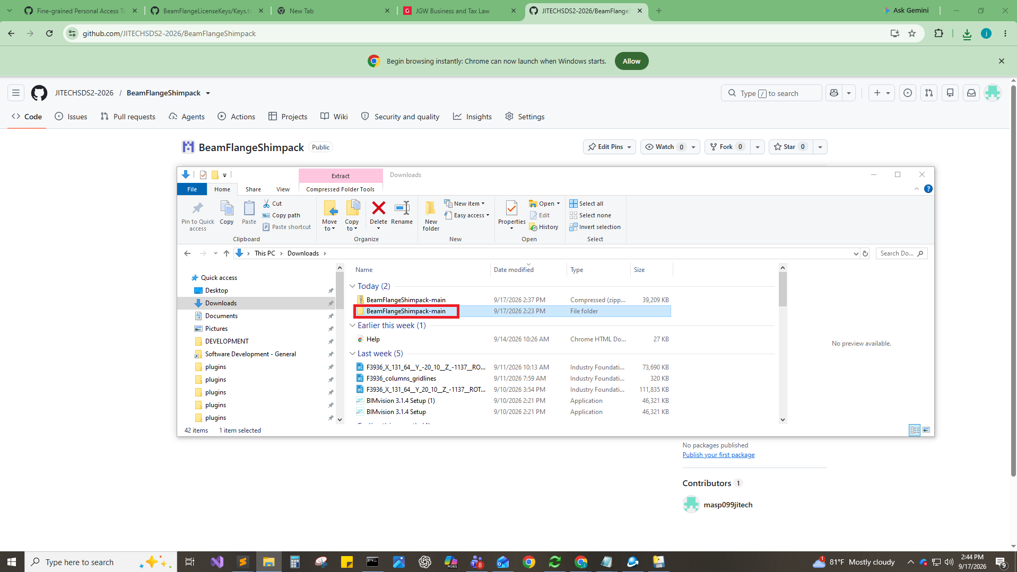
Note Run the installer from the extracted folder, not from inside the zip. Running it from the zip can leave temporary files behind and fail to write to the plugins folder.

Part 3 — Run the installer

Step 6. Launch the setup file
The folder contains two items. Double-click JCMBeamShimPack_1.0.0_Setup (Application, ~38 MB). README.txt holds the licensing notice.
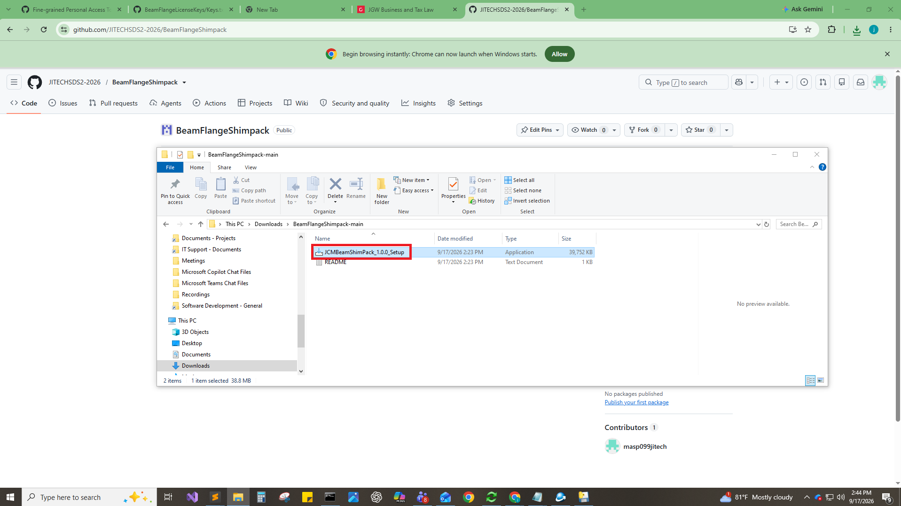

Step 7. Enter the license code
Setup opens on the License page. Paste the GUID license code provided by JiTech into the License code field. Recommendation: Paste rather than type it — the code must match exactly.
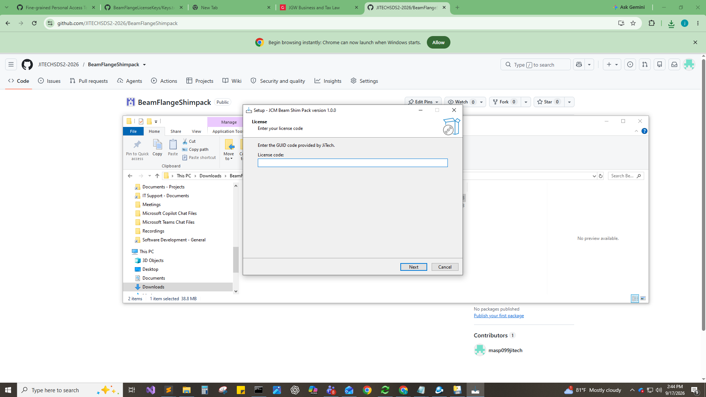

Step 8. If the code is rejected
An invalid or previously redeemed code produces the message “This license code is invalid or has already been used. Please enter a different code.” Click OK, then check the code for missing or transposed characters. Codes activate once, so a code already used on another machine needs to be replaced by JiTech.
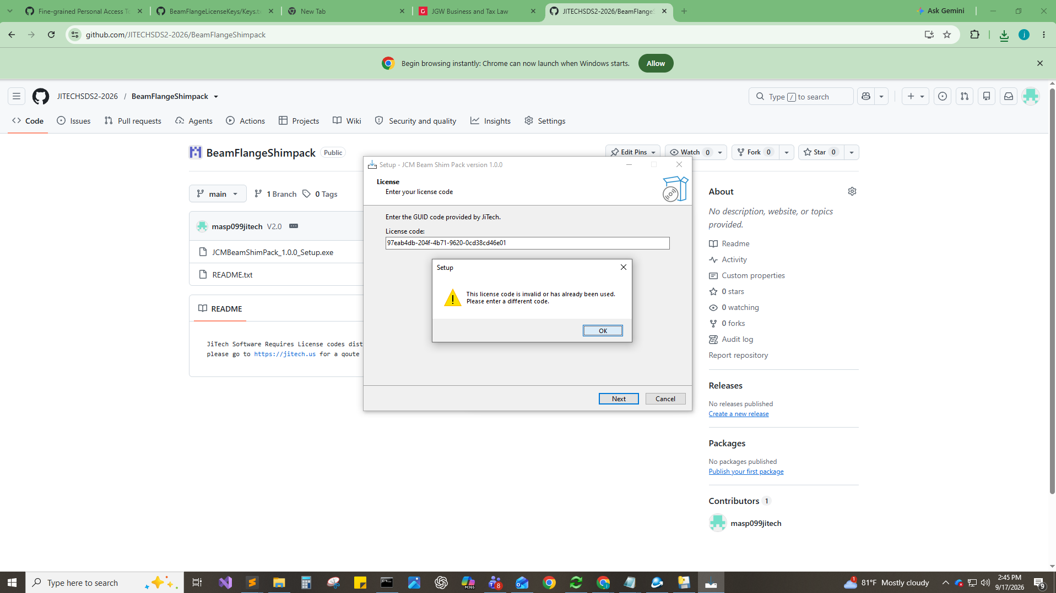

Step 9. Continue past the license page
With a valid code in the field, click Next. Setup only advances once the code validates.
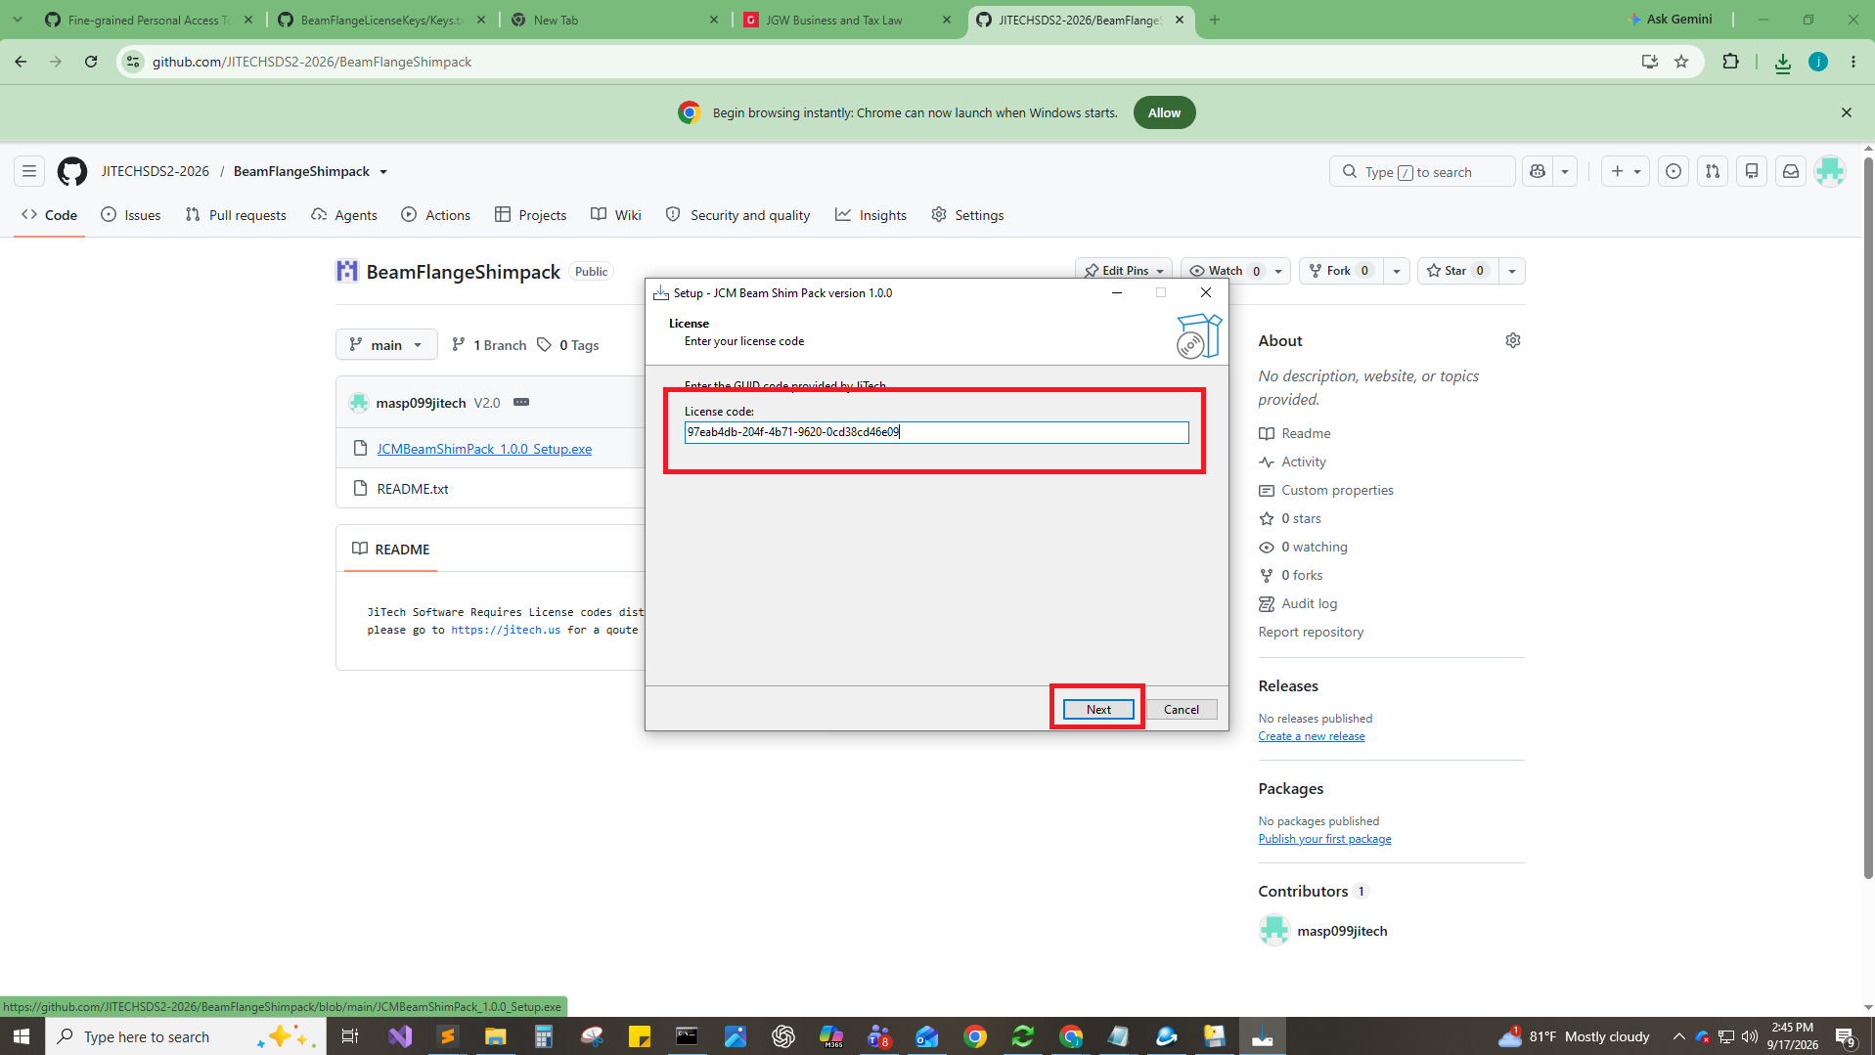

Step 10. Choose the destination
Setup proposes C:\SDS2\plugins. To install into a different plugins folder — for example a job-specific one — click Browse….
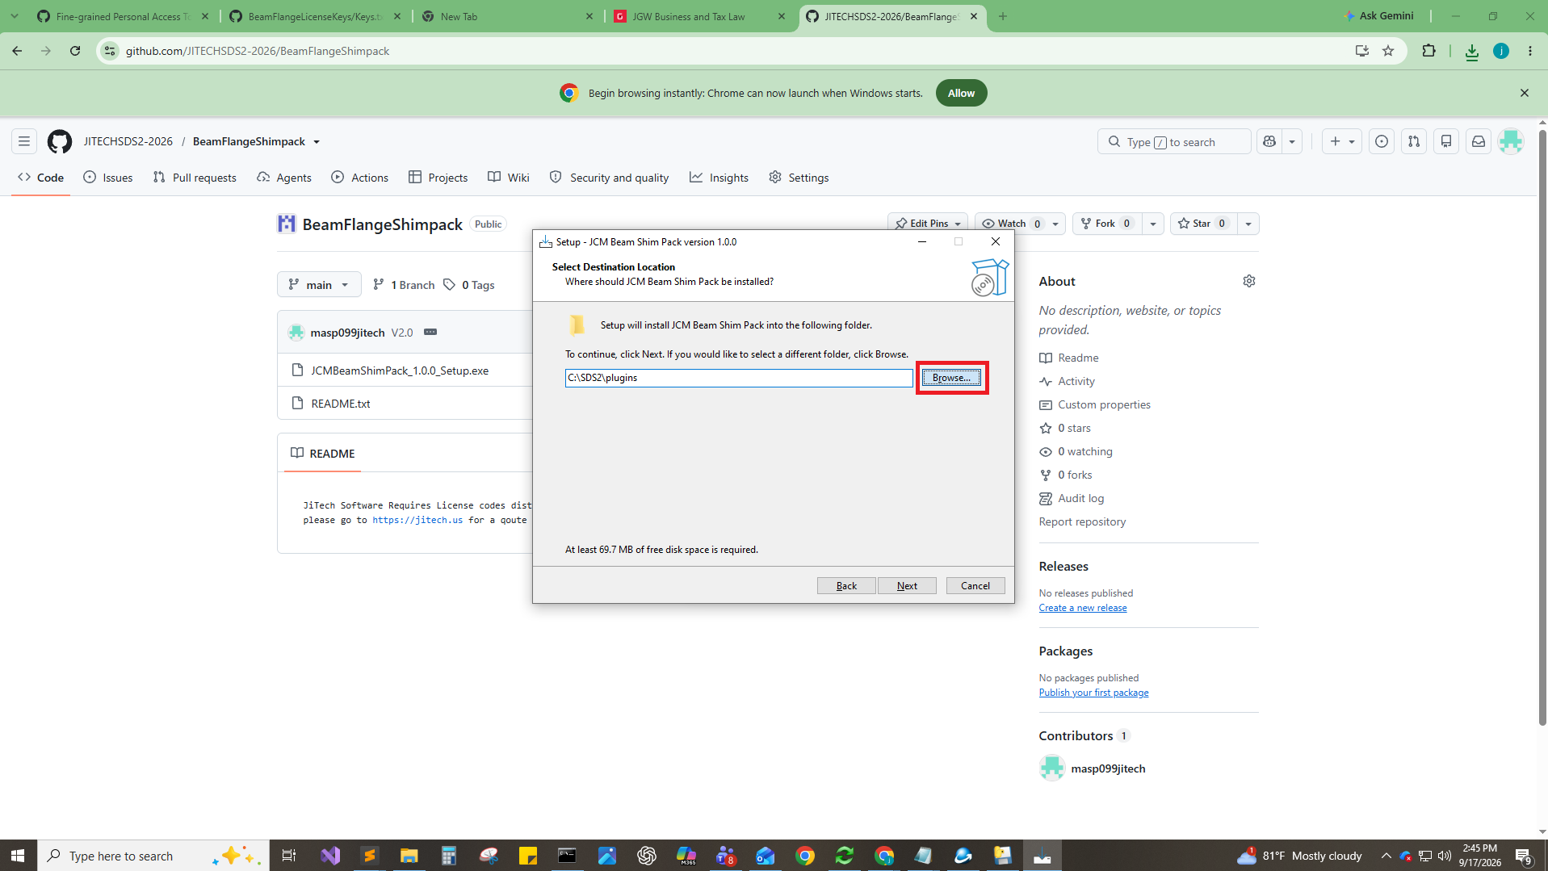

Step 11. Select the plugins folder
In Browse For Folder, navigate to the target plugins folder and click OK. Always select the plugins folder itself, not its parent. Please Note the Installer uses the same default as sds2 C:\SDS2\plugins which may not be correct Confirm your own directory.
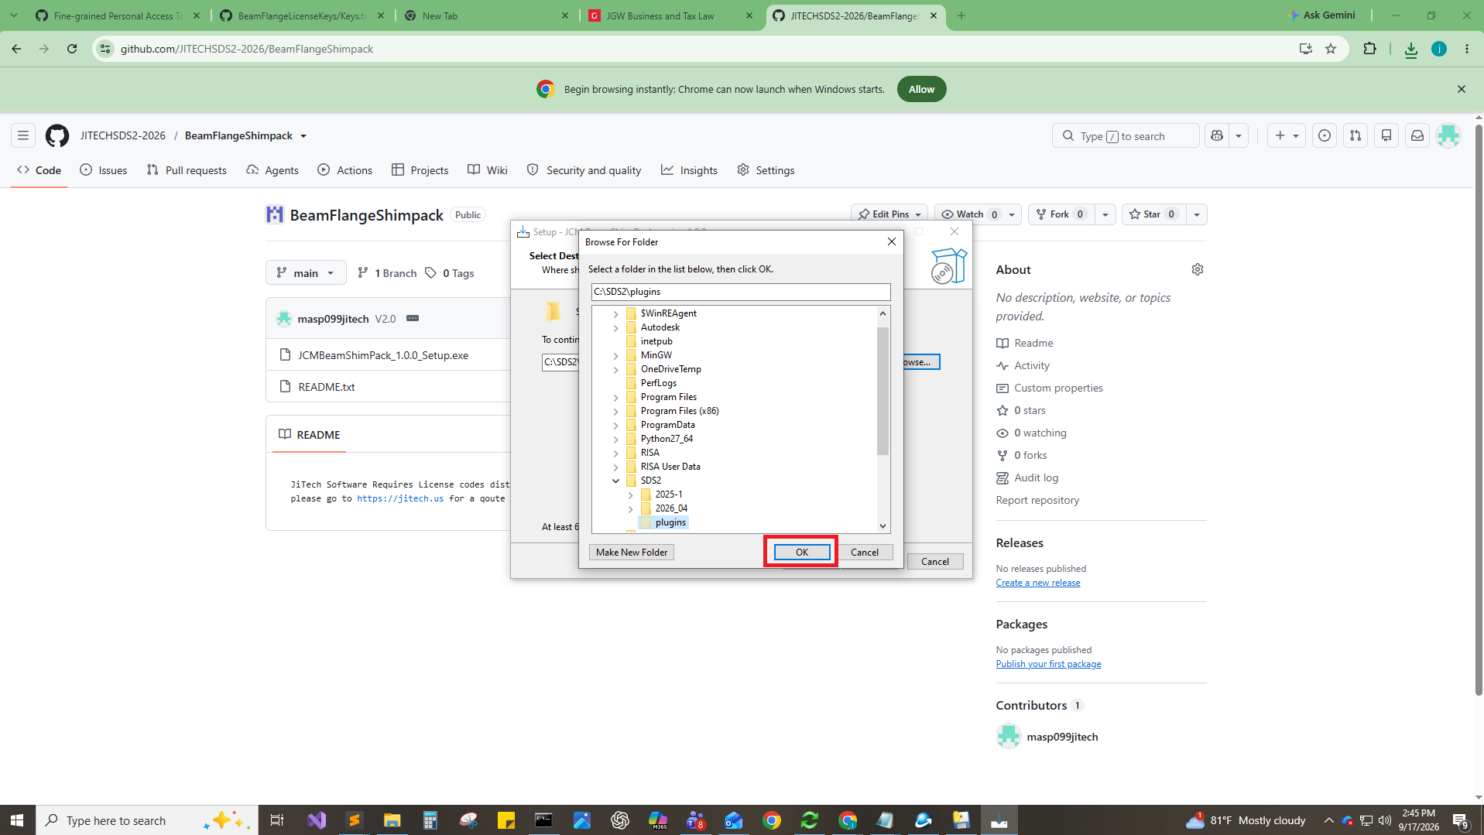

Step 12. Confirm the path
Check that the destination field shows the folder you picked — in this example T:\COOPER\2026_04\DEVELOPMENT\F3936_2026-09-09\plugins — then click Next. Setup reports the disk space it needs (69.7 MB).
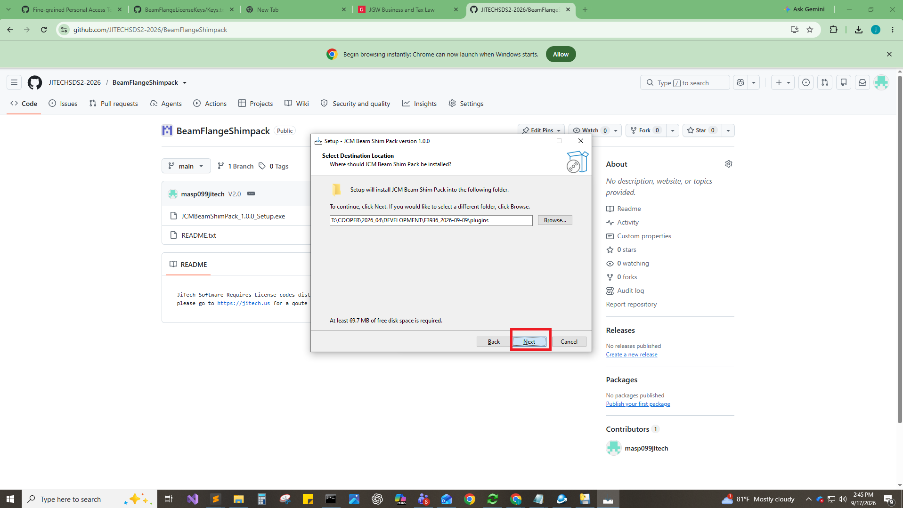

Step 13. Install
The Ready to Install page lists the destination location. Review it and click Install, or Back to change anything.
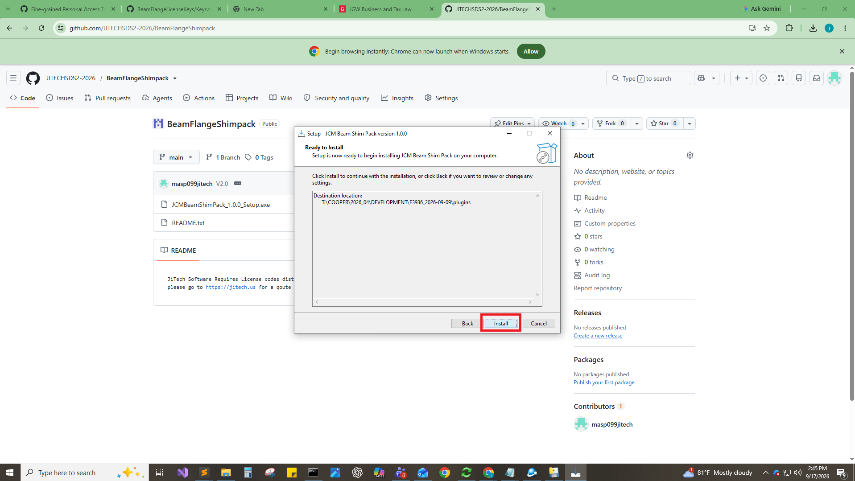

Step 14. Finish
When the wizard reports that setup has finished, click Finish to exit.
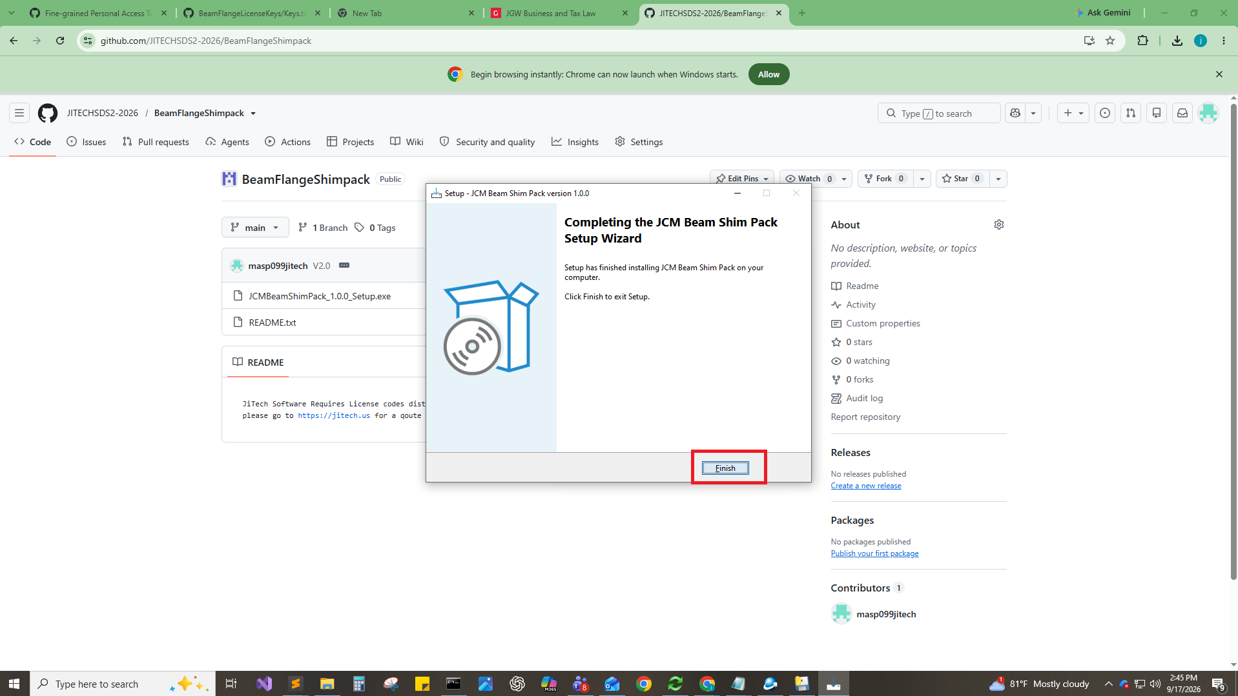

Part 4 — Test the plugin in SDS2

Step 15. Open the job in SDS2
Start SDS2 and open the job whose plugins folder received the install, then click the Modeling icon at the bottom left of the Home screen.
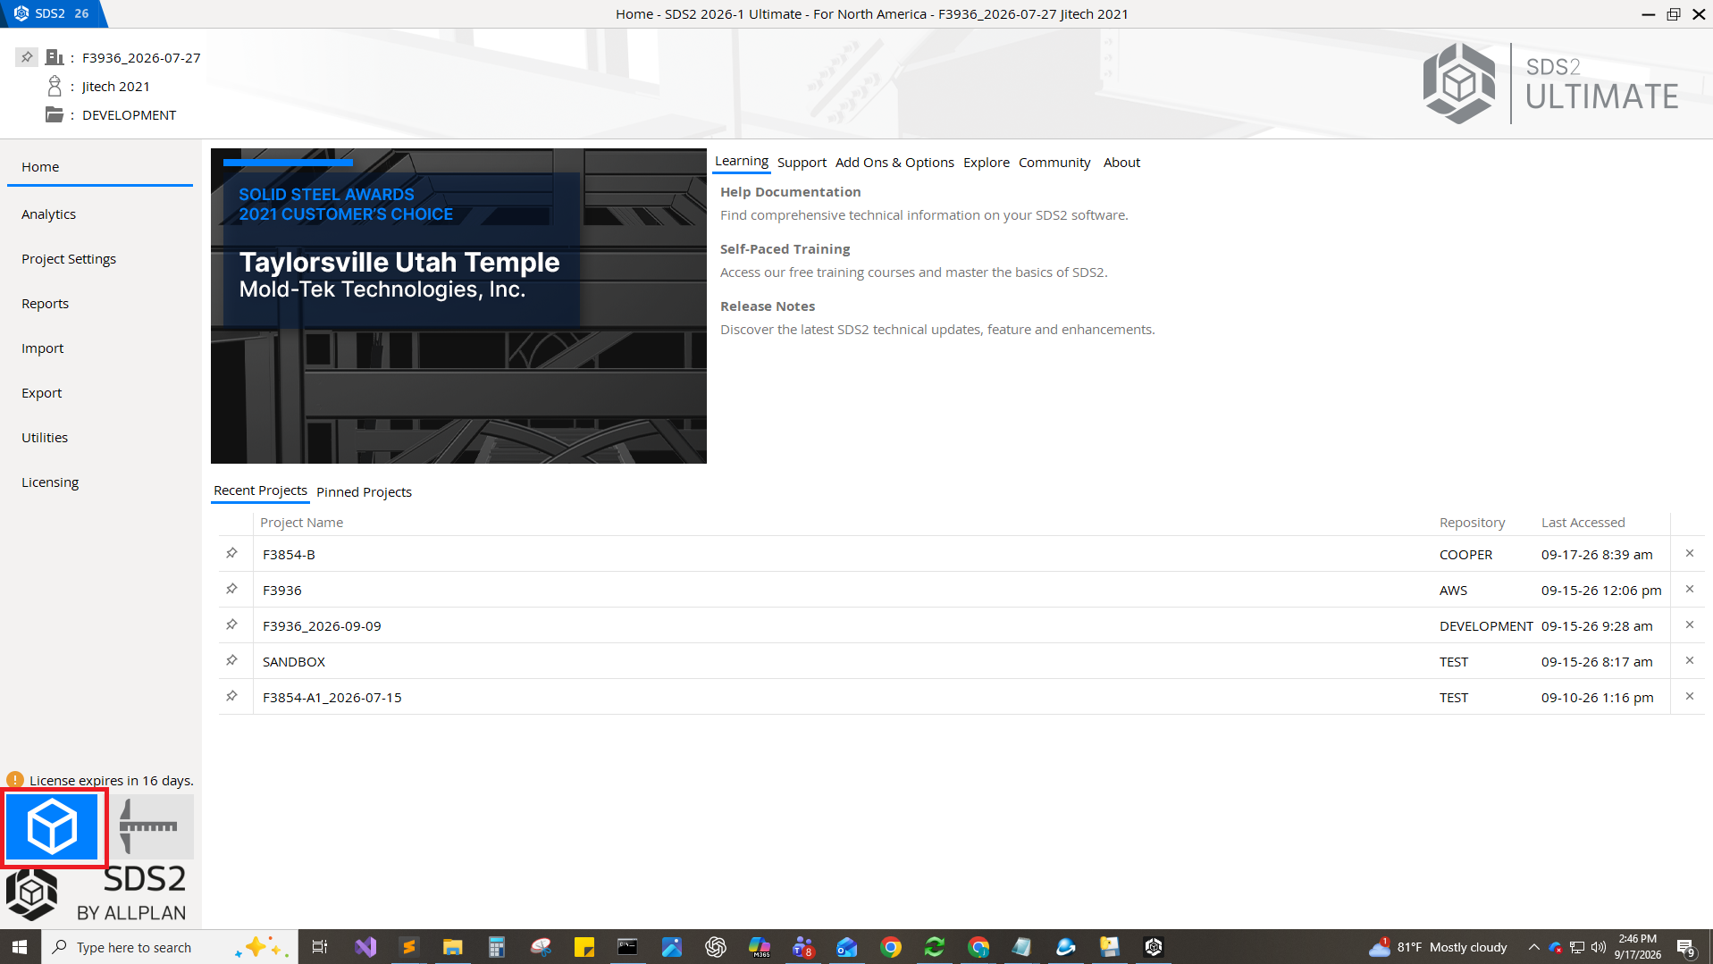

Step 16. Find the tool
In the command search box at the top right of Modeling, type ‘jct’. JCT BeamFlangeShimpack Tool appears in the results list — select it. If it is missing, the installer wrote to a plugins folder this job does not use.
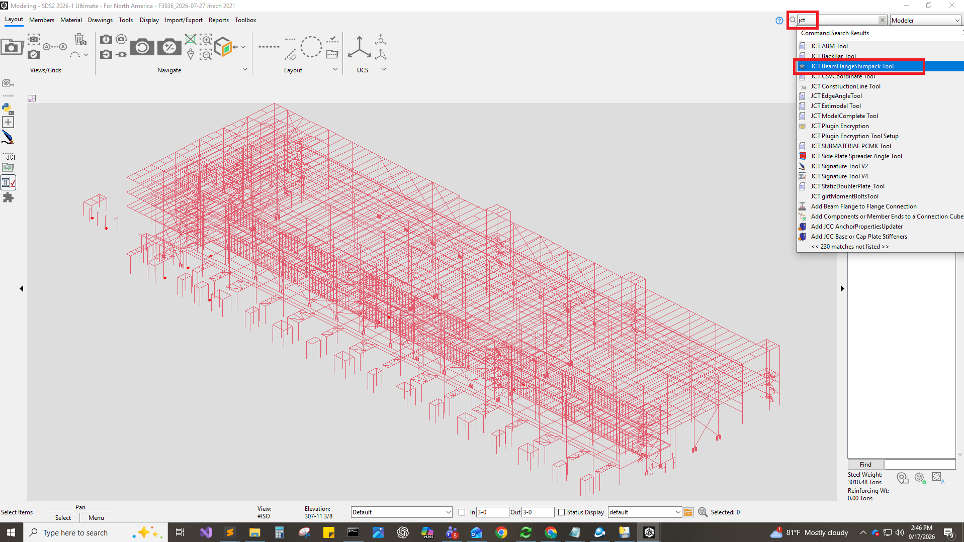

Step 17. Check the dialog and open Help
The tool opens a single General page with the shim settings (member end, flange, length, width, number of plates, gap, shimplate thickness, steel grade, surface finish). Confirm the fields populate, then click Help.
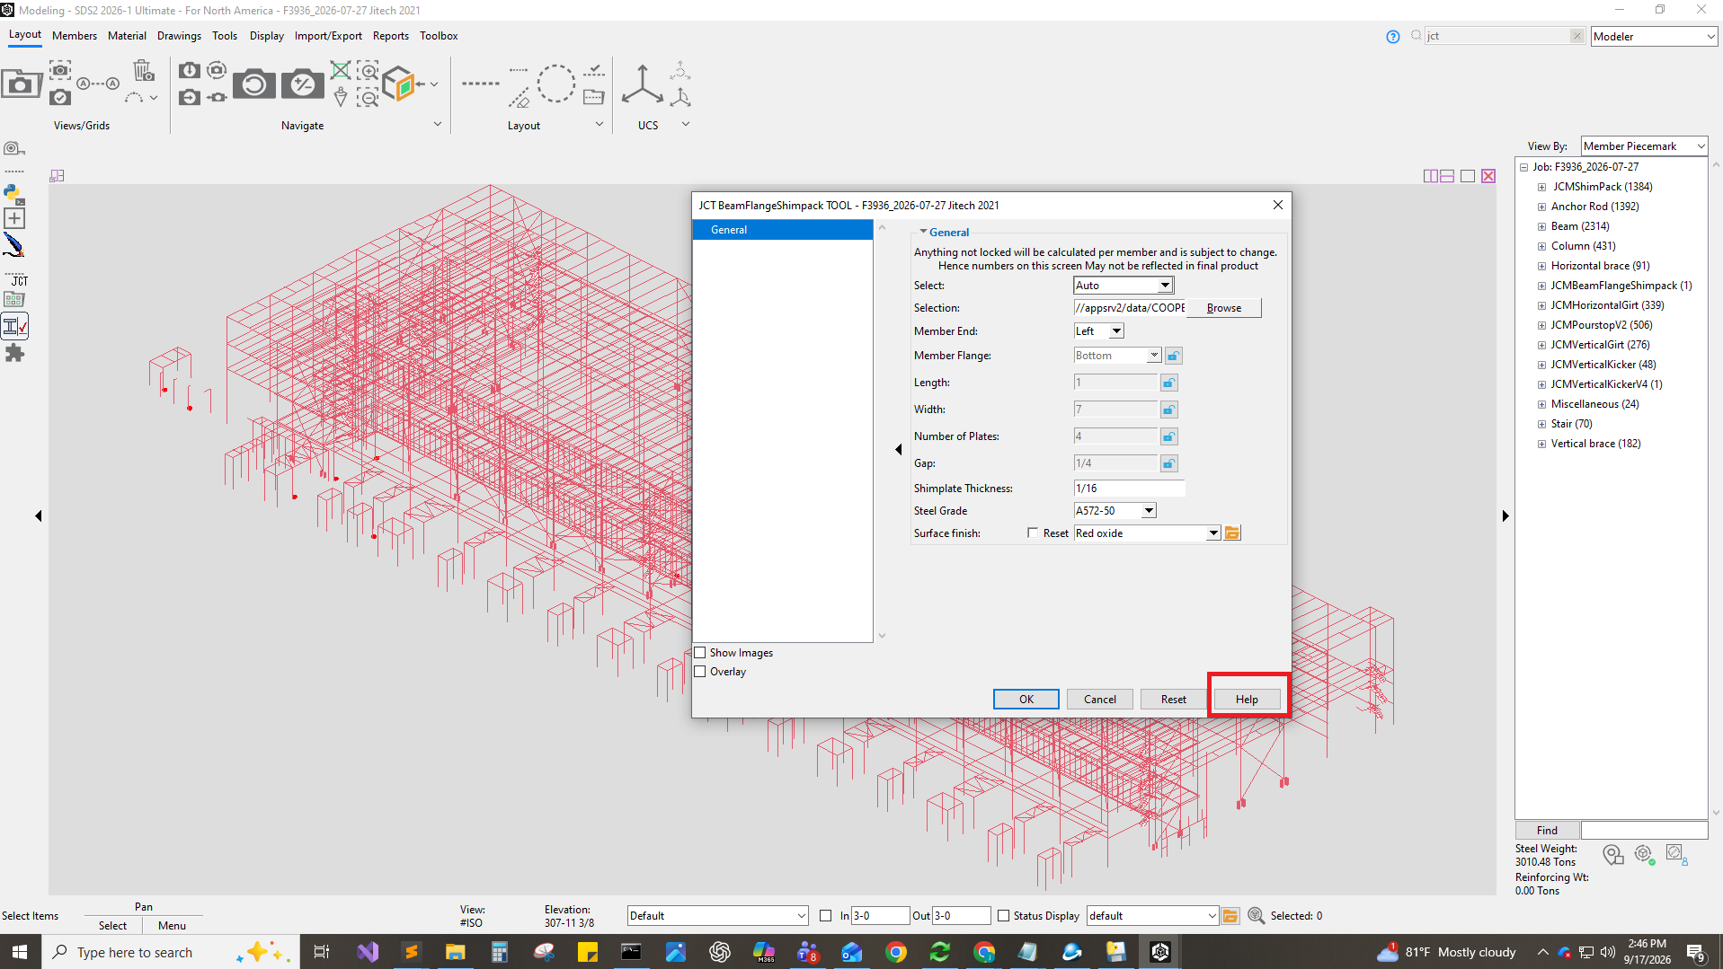

Step 18. Confirm the user guide opens
The browser opens Help.html from the installed plugin folder, showing the JCT BeamFlangeShimpack Tool user guide. That confirms both the plugin and its help files installed correctly.
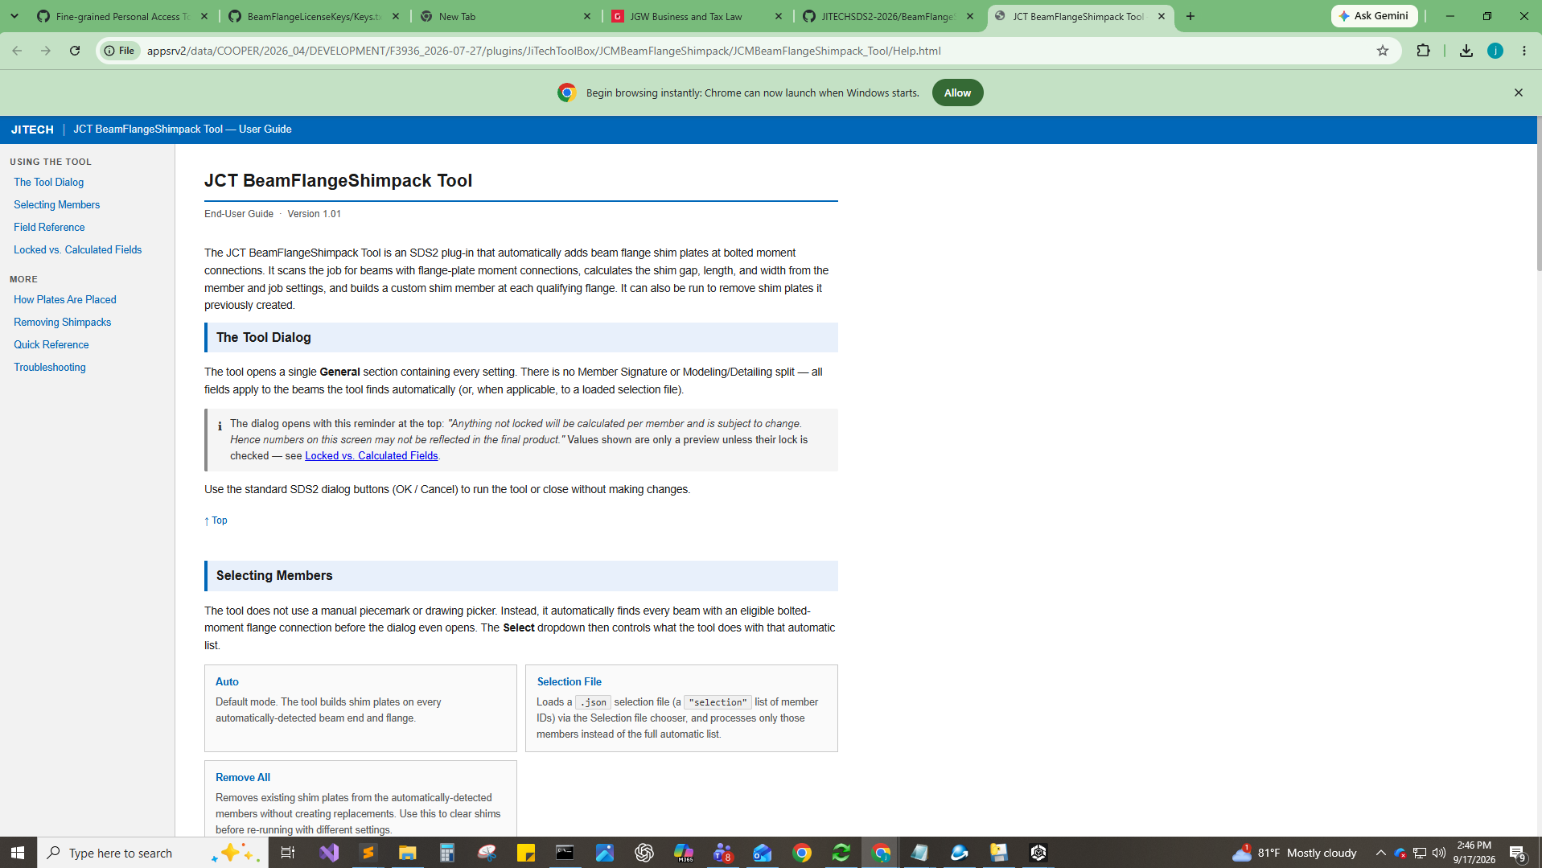

Verification checklist
- Installer completed without a license error.
- JCT BeamFlangeShimpack Tool appears in the SDS2 command search.
- The tool dialog opens and its General fields are populated.
- The Help button opens Help.html from the installed plugin folder.

Troubleshooting
License code rejected. Re-paste the code to rule out a typo or trailing space. If it still fails, the code has already been redeemed — request a new one from JiTech.
Tool missing from the command search. The job is reading a different plugins folder than the install target. Re-run the installer and browse to the plugins folder that job uses, then exit SDS2 completely before restart SDS2.
Install fails or files are locked. Close SDS2 and re-run the installer. Confirm you have write access to the destination, especially on a network drive.

