AUTOMATED PAINTING ROVER (APR)
Work Breakdown Structure
Requirements Definition Document

1. Task Objective
Convert the finalized use-case into a complete set of measurable engineering requirements. Each requirement must include specific, quantifiable values that the APR prototype must meet during testing and validation.
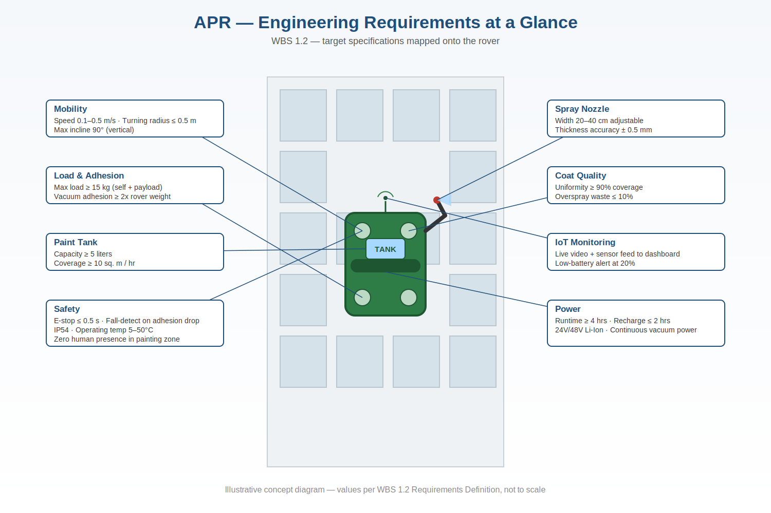
Fig. 1 — Requirement targets mapped onto the rover

2. Mobility Requirements
Requirement | Target Value | Measurement Method
Rover speed on vertical surface | 0.1 – 0.5 m/s | Encoder / Tachometer
Maximum load on vertical surface | ≥ 15 kg (self + payload) | Load cell test
Surface adhesion force (vacuum) | ≥ 2x rover weight | Pull-off test
Turning radius | ≤ 0.5 m | Physical measurement
Maximum incline angle | 90 degrees (vertical) | Inclined test surface

3. Spray & Paint Quality Requirements
Requirement | Target Value | Measurement Method
Paint thickness accuracy | ± 0.5 mm of target | Dry film thickness gauge
Surface coverage per hour | ≥ 10 sq. meters / hr | Area covered / time taken
Paint tank capacity | ≥ 5 liters | Volume measurement
Spray nozzle spray width | 20 – 40 cm adjustable | Ruler / camera
Overspray waste target | ≤ 10% paint wastage | Paint consumed vs. area
Uniformity of coat | ≥ 90% uniform coverage | Camera / image analysis

4. Power & Battery Requirements
Requirement | Target Value | Notes
Battery operating duration | ≥ 4 hours continuous | 24V/48V Li-Ion pack
Battery recharge time | ≤ 2 hours | Fast charge compatible
Low battery alert threshold | 20% battery remaining | IoT monitoring alert
Power to vacuum system | Continuous during operation | Critical — cannot be interrupted

5. Safety & Operational Requirements
- Emergency stop trigger: within 0.5 seconds of command
- Overload protection on all motors — automatic shutoff
- Fall detection sensor: alarm if adhesion force drops below threshold
- Remote monitoring: live video and sensor feed to operator dashboard
- Operating temperature range: 5°C – 50°C
- IP54 rating minimum for dust and splash water protection
- Zero human presence required in immediate painting zone

6. Important Notes for Team
For each requirement listed above, the team must define specific measurable values — not vague statements. Examples:
- Speed of rover: 0.2 m/s on vertical surface (not just 'fast enough')
- Area coverage per hour: 10 sq. meters (not just 'efficient')
- Paint tank capacity: 5 liters minimum (not just 'enough for the job')
- Spraying thickness: ±0.5 mm (not just 'uniform coating')
- Battery duration: 4 hours minimum (not just 'long-lasting battery')
Every requirement must be testable and verifiable with a real measurement method during prototype evaluation.

7. Phase Deliverable
Deliverable | Description
Engineering Requirements Document | All measurable specs with target values and test methods
Payload & Mobility Spec Sheet | Detailed mobility, adhesion, and weight requirements
Spray Quality Spec Sheet | Paint thickness, coverage rate, uniformity targets
Safety & Power Requirements List | Battery, emergency stop, IP rating, temperature range

8. Traceability to WBS 1.1 Success Criteria
Every requirement above exists to satisfy a success criterion already agreed in WBS 1.1. Mapping them back shows the reviewer that the numbers aren't arbitrary — each one closes a specific gap.
WBS 1.1 Success Criterion | Satisfied by (WBS 1.2 requirement)
Adheres and moves without slipping or falling | Adhesion ≥ 2x weight; fall-detection sensor; overload shutoff
Uniform coat across ≥ 90% of surface | Uniformity ≥ 90%; spray width 20–40 cm; thickness ± 0.5 mm
No manual intervention during operation | Continuous vacuum power; ≥ 4 hr battery; remote dashboard
Thickness deviation within ± 0.5 mm | Paint thickness accuracy requirement, dry film gauge test
Zero human exposure to fumes / height | Zero human presence in painting zone; IP54; 5–50°C range
IoT dashboard active throughout | Live video + sensor feed; low-battery alert at 20%

9. Key System Components
A quick visual reference tying each subsystem to the requirement it needs to satisfy — useful if the panel asks "what does this actually look like on the rover."
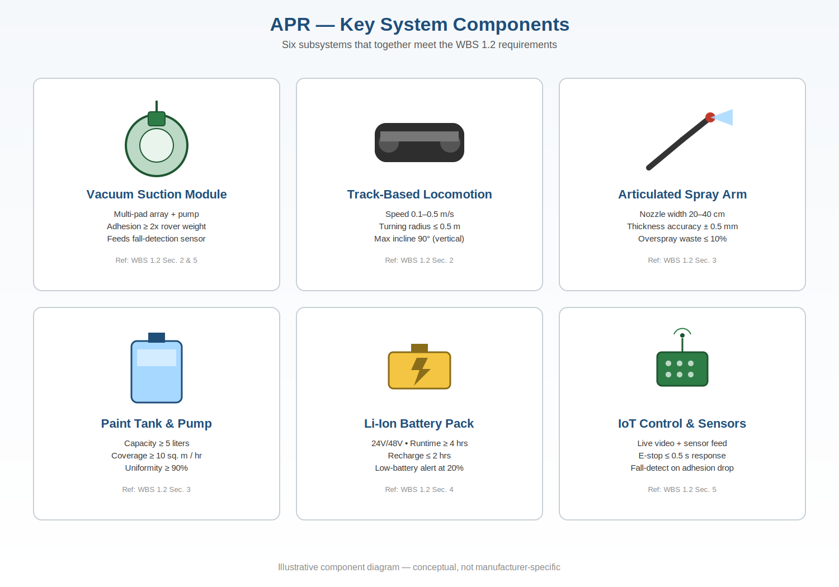
Fig. 2 — APR key system components and the requirements each one satisfies

10. Open Items for the Team to Decide Before Review
A few numbers above are reasonable engineering targets but haven't been back-checked against actual component datasheets yet. Worth having answers ready if the panel asks:
- Vacuum pump selection: does a pump that gives ≥ 2x rover weight in adhesion force at 15 kg payload exist within the ₹15 lakh budget, or does this need a multi-pad array?
- Battery sizing: has the 4-hour / 24V-48V Li-Ion pack been checked against the continuous power draw of the vacuum pump + spray pump + motors together, not each system in isolation?
- Turning radius vs. track locomotion: a 0.5 m turning radius with track-based locomotion (chosen in WBS 1.1) needs a concrete steering mechanism decision — skid-steer vs. articulated joint.
- Fall-detection threshold: what adhesion-force value (in kPa or N) actually triggers the alarm? This needs a number before it's testable, not just "drops below threshold."
- IP54 vs. paint overspray: IP54 protects against splash water, but the rover will also be coated in wet paint during use — confirm this is sufficient or if a higher rating is needed for the spray zone specifically.

APR Project | Anurag University | Ref: INC25ETS084848

