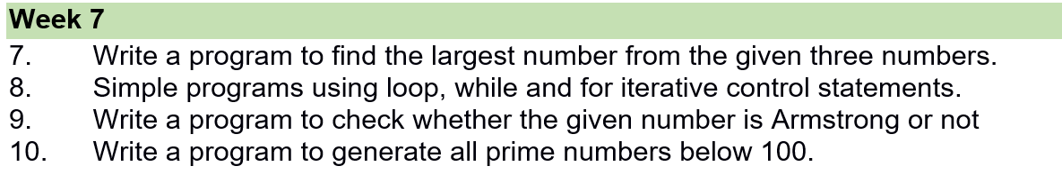

7) Write a program to find the largest number from the given three numbers.
declare
a number:=0;
b number:=0;
c number:=0;
begin
a:=&a;
b:=&b;
c:=&c;
if a>b and a>c then
dbms_output.put_line('a is larger');
elsif b>a and b>c then
dbms_output.put_line('b is larger');
else
dbms_output.put_line('c is larger');
end if;
end;
/
Output:-
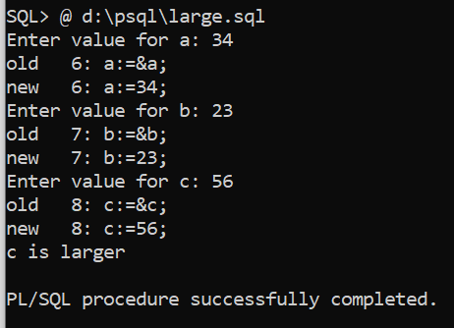
******************************************************************************

8) Simple programs using loops, while and for iterative control statements.
a)--PL/SQL program to illustrate loop
declare
i number;
begin
i:=1;
loop
dbms_output.put_line(i);
i:=i+1;
exit when i>5;
end loop;
end;
/
Output:-
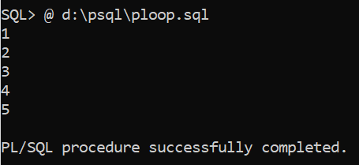

*********************************************************************************
8b)Pl/sql program to illustrate while loop
declare
i number;
begin
i:=1;
while(i<=10)
loop
dbms_output.put_line(i);
i:=i+1;
end loop;
end;
/
Output:-
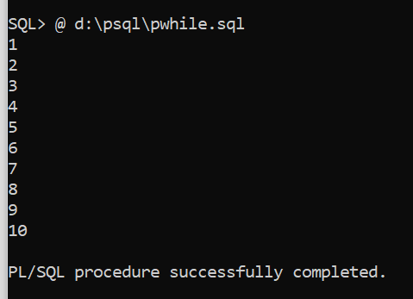
***********************************************************
8c)Pl/Sql program to illustrate for loop.
declare
i number;
begin
for i in 1..15 loop
dbms_output.put_line('value of i:'|| i);
end loop;
end;
/

Output:-
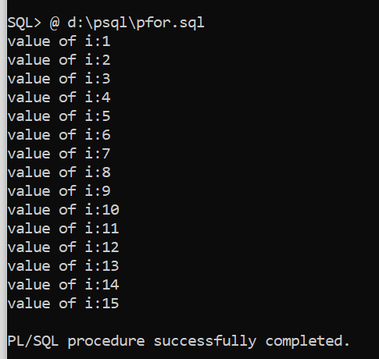
*****************************************************************************

9) Write a program to check whether the given number is Armstrong or not
declare
n number;
c number;
m number;
r number;
begin
n:=&n;
c:=0;
m:=n;
while(n!=0)
loop
r:=mod(n,10);
c:=c+power(r,3);
n:=floor(n/10);
end loop;
if(m=c) then
dbms_output.put_line('number is an armstrong ');
else
dbms_output.put_line('number is not an armstrong');
end if;
end;
/
Output:-
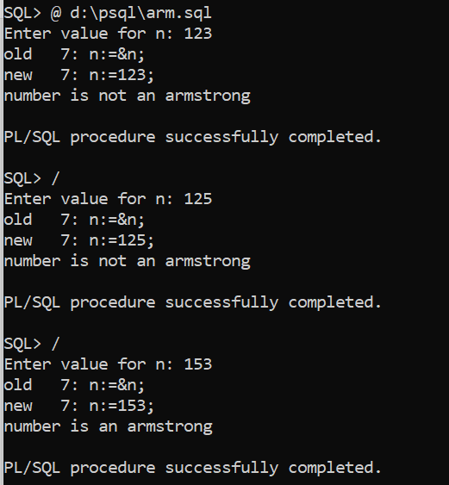
********************************************************************************

10) Write a program to generate all prime numbers below 100.
Prime numbers:- prime numbers are the numbes which have only 2 factors 1 and the number itself
Eg:- 2,3,5,7,11,13,17,19,…………………

DECLARE
i NUMBER(3);
j NUMBER(3);
BEGIN
dbms_output.Put_line('The prime numbers are:');
dbms_output.new_line;
i := 2;
LOOP
j := 2;
LOOP
EXIT WHEN( ( MOD(i, j) = 0 ) OR ( j = i ) );
j := j + 1;
END LOOP;
IF( j = i )THEN
dbms_output.Put(i||' ');
END IF;
i := i + 1;
exit WHEN i = 100;
END LOOP;
dbms_output.new_line;
END;
/
Output:-

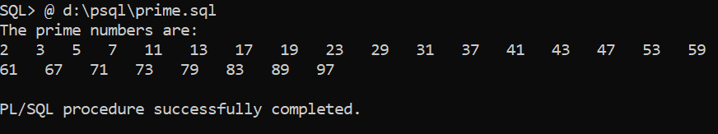

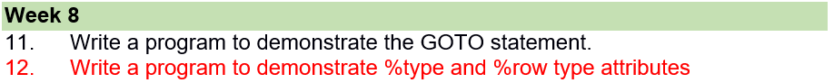

11) Write a program to demonstrate the GOTO statement

The GOTO statement
This statement changes the flow of control within a PL/SQL Block. It allows the execution of a section of code which is not in the normal flow of control. The entry point into such a block of code is marked using the tags <<userdefined name>>. The GOTO statement can then make use of this user defined name to jump into the block of code for execution.
Syntax : GOTO <code-block name>

BEGIN
GOTO second_message;
<<first_message>>
DBMS_OUTPUT.PUT_LINE( 'Hello' );
GOTO the_end;
<<second_message>>
DBMS_OUTPUT.PUT_LINE( 'PL/SQL GOTO Demo' );
GOTO first_message;
<<the_end>>
DBMS_OUTPUT.PUT_LINE( 'and good bye...' );
END;
/
Output:-
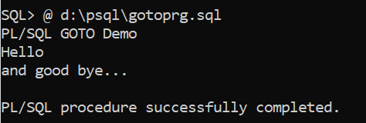

/* PL/SQL program to illustrate GO TO statement*/
declare
i number;
begin
dbms_output.put_line('enter i value:');
i:=&i;
if(i>=0) then
goto here;
else
dbms_output.put_line(' i is negative');
end if;
goto abc;
<<here>>
dbms_output.put_line(' i is positive');
<<abc>>
dbms_output.put_line('');
end;
/
Output:-
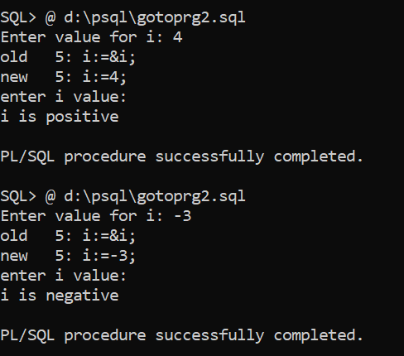

**************************************************************************************

12) Write a program to demonstrate %type and %row type attributes
Datatypes in SQL:-
1)Built in types
2)User defined data types
3)Reference type

Reference types:- 1) %type 2) %row type
%type:-
1)used to refer column type and size
2)used to match variable type and size with column type and size.
Eg:- vsal emp.sal%type;

3)What ever datatype &size declared for sal column the same type and size assigned to variable.
4)Advantage of %type is even if column type or size changes PL\SQL prg is not affected.

%ROWtype:-
- Used to refer record type
- A variable declared with %rowtype is called record type variable
- In rowtype variable we can store row
Eg:- r emp%rowtype;
Empno | Empname | Job | Manager | Hiredate | Sal | Comm | deptno

Select * into r from emp where empno=7844;
r.sal=1500;
r.ename=tony
r.job=salesman

4)Advantage of %rowtype is it reduces number of variables required in the program and reduces complexity.

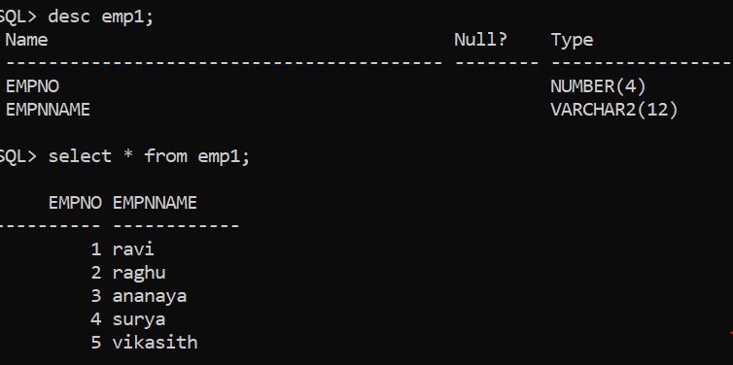

/* illustration of %type and %row type*/
declare
my_empid emp1.empno%type;
my_empname emp1.empnname%type;
my_emprow emp1%rowtype;
no number:=0;
begin
no:=&no;
select empno,empnname into my_empid,my_empname from emp1 where empno=no;
if (sql%rowcount=1) then
dbms_output.put_line('empno is:' ||my_empid|| ' , ' || 'empnname is : ' || my_empname);
else
dbms_output.put_line('error');
end if;
select * into my_emprow from emp1 where empno=no;
if (sql%rowcount=1) then
dbms_output.put_line('empno is:' ||my_empid|| ' , ' || 'empname is :' ||my_empname);
else
dbms_output.put_line('error');
end if;
end;
/
Output:-
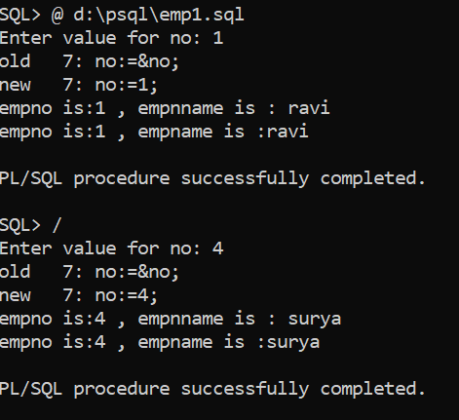

Create customer table
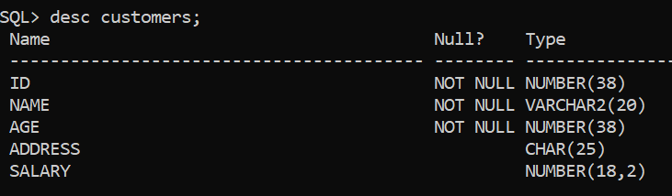
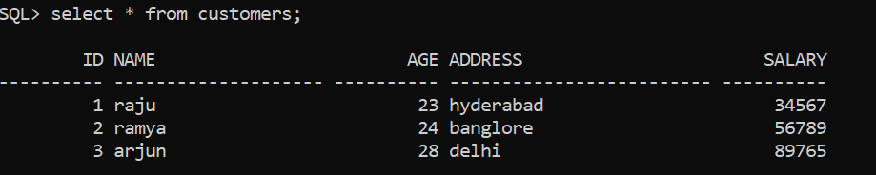

DECLARE
cust Customers%rowtype;
BEGIN
SELECT * INTO cust FROM customers WHERE id = 1;
dbms_output.put_line ('Customer ' ||cust.name || ' from ' || cust.address || ' earns ' || cust.salary);
END;
/
Output:-


