***USE CASE DIAGARAM***

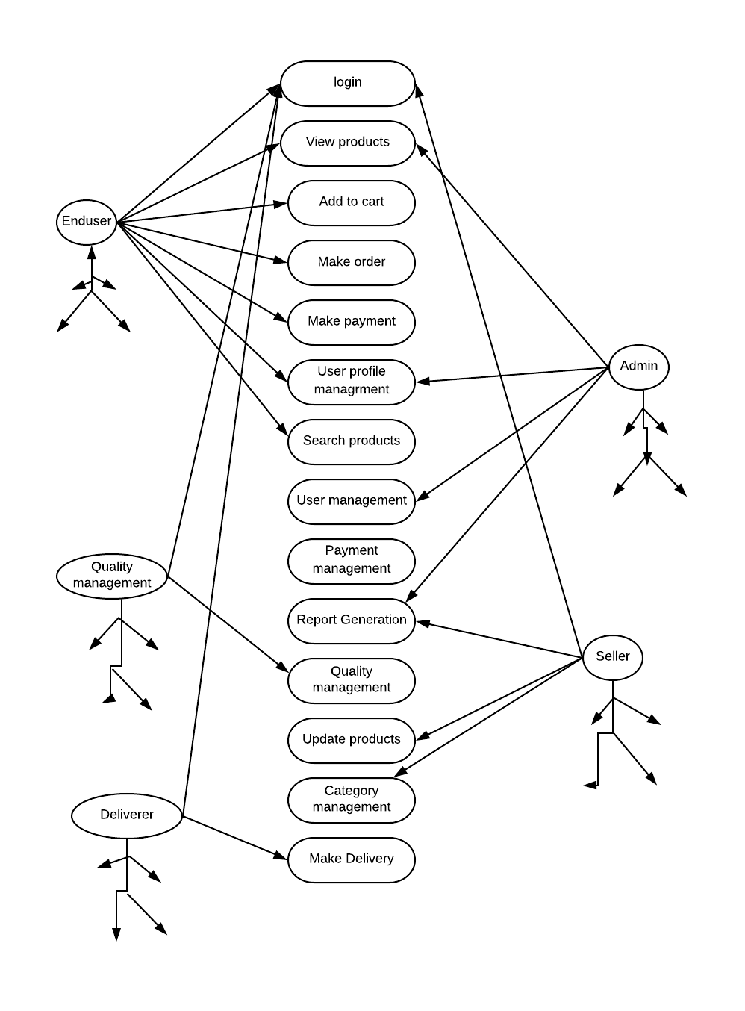

**DATA FLOW DIAGARAM**

***LEVEL 0***

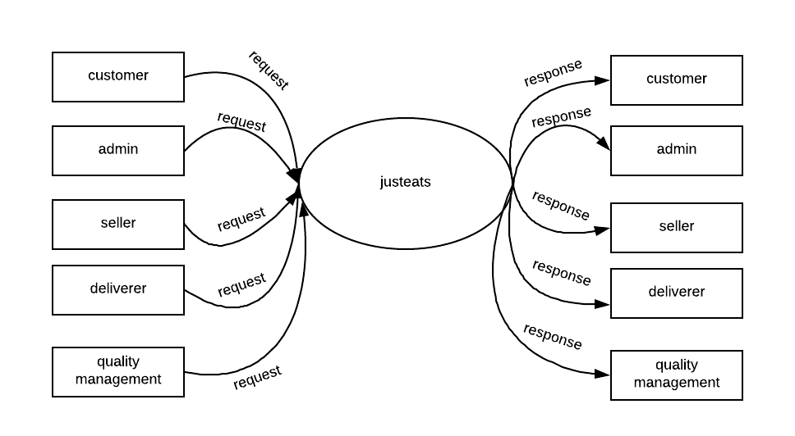

***LEVEL 1***

**NORMAL USER**

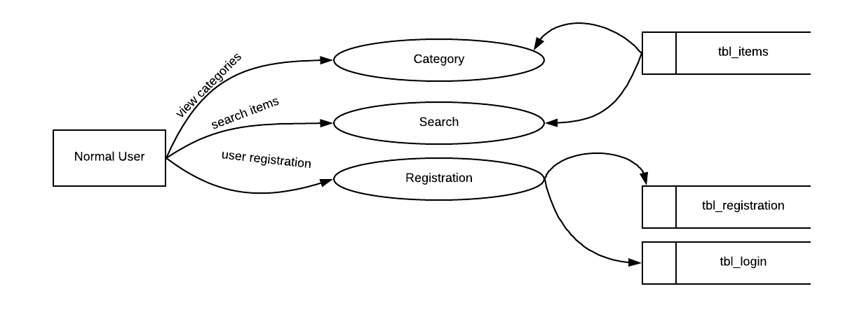

**ADMIN**

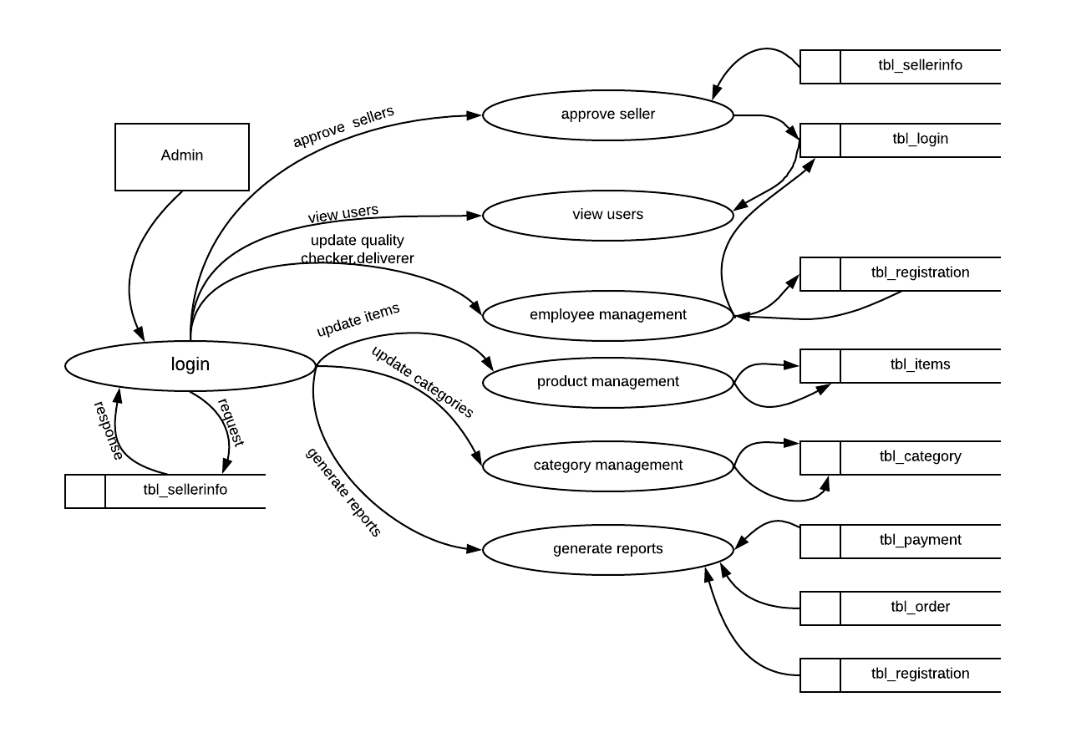

**ENDUSER**

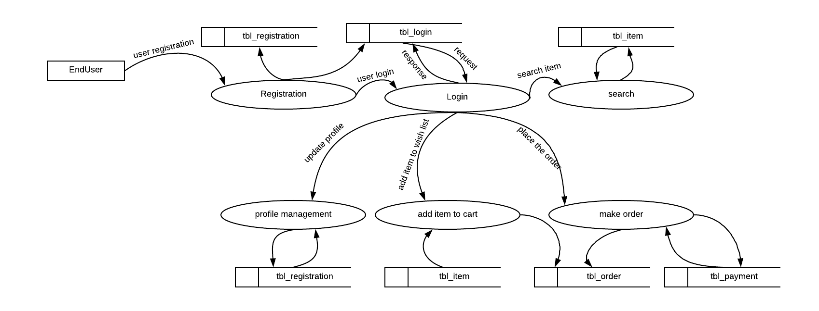

**QUALITY MANAGEMENT**

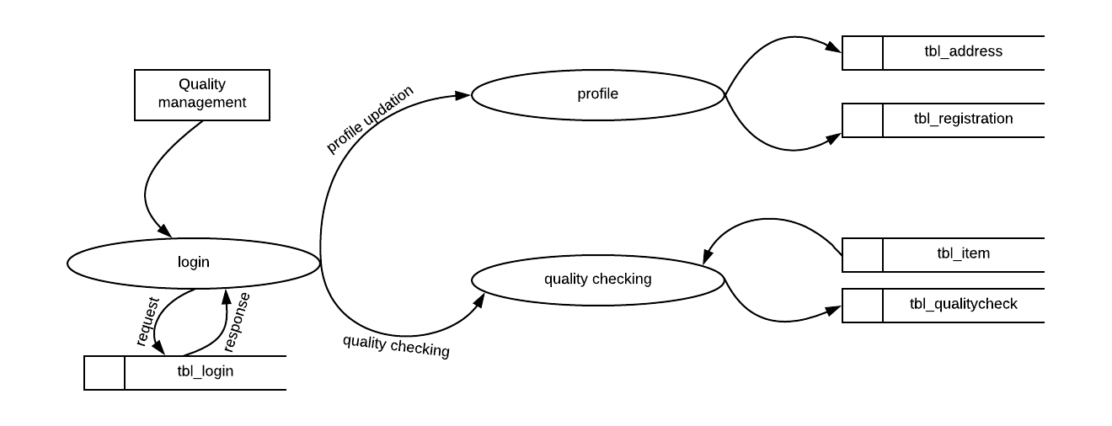

**SELLER**

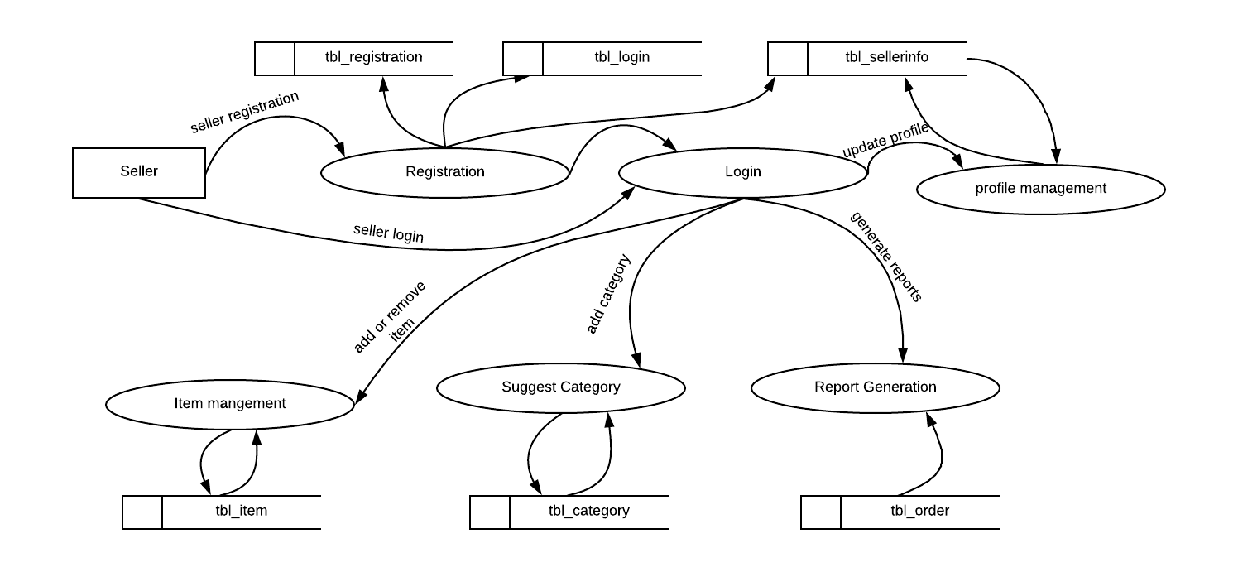

**DELIVERY**

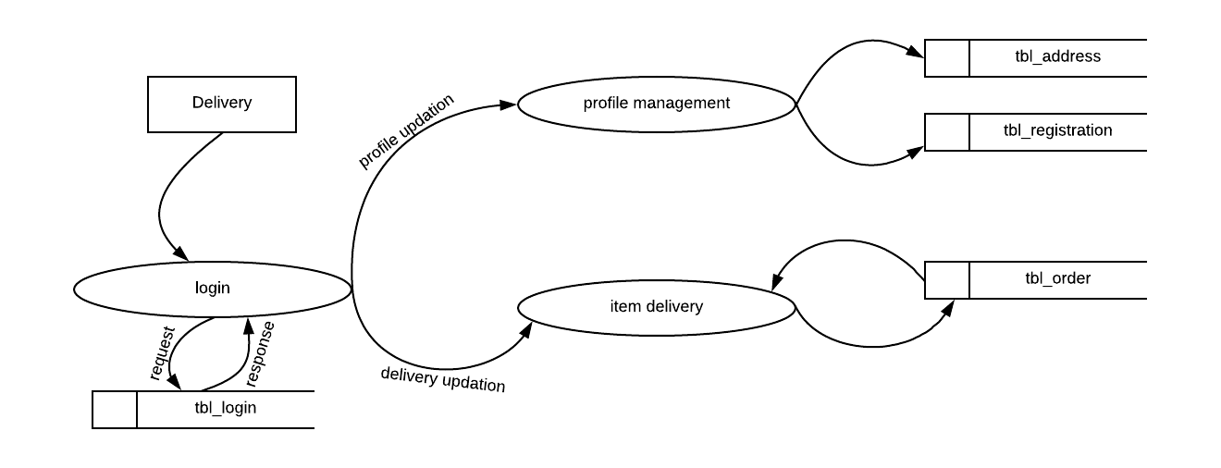

**TABLE**

**1.tbl_registration**

|  |  |  |  |
| --- | --- | --- | --- |
| **Field Name** | **Data Type** | **Key** | **Description** |
| user_id | int | Primary key | Id of user |
| phone_number | int |  | Phon number |
| address_id | varchar(200) | Foreign key in tbl_address | Address of user |
| status | int |  |  |
|  |  |  |  |

**2.tbl_login**

|  |  |  |  |
| --- | --- | --- | --- |
| **Field Name** | **Data Type** | **Key** | **Description** |
| login_id | int | Primary key | Id of login |
| employee_id | int | Foreign key in tbl_registration | user id from register table |
| email | varchar(50) |  | Email of user |
| password | varchar(50) |  | Password of user |
| type | varchar(50) |  | Type of user |
| status | int |  |  |

**3.tbl_items**

|  |  |  |  |
| --- | --- | --- | --- |
| Field Name | Data Type | Key | Description |
| item_id | int | Primary key | Id of items |
| login_id | int | Foreign key in tbl_login | Id of user |
| product_name | varchar(50) |  | Name of items |
| category_id | int | Foreign key in tbl_category | Id of categories |
| price | int |  | Price of items |
| quantity | int |  | Quantity of items |
| date | date |  | Date of insertion |
| description | varchar(50) |  | Detailes of items |
| photo | varchar(50) |  | images of items |
| status | int |  |  |

**4.tbl_category**

|  |  |  |  |
| --- | --- | --- | --- |
| **Field Name** | **Data Type** | **Key** | **Description** |
| category_id | int | Primary key | Id of categories |
| category_name | varchar(50) | Foreign key in tbl_registration | Name of categories |
| status | int |  |  |

**5.tbl_address**

|  |  |  |  |
| --- | --- | --- | --- |
| **Field Name** | **Data Type** | **Key** | **Description** |
| address_id | int | Primary key | Id of address |
| address_1 | varchar(50) |  | Address line one |
| address_2 | varchar(50) |  | Address line two |
| city | varchar(50) |  | City of user |
| district_id | int | Foreign key in tbl_district | District id from district table |
| pin_code | int |  | Pin code of user |
| status | int |  |  |

**6.tbl_district**

|  |  |  |  |
| --- | --- | --- | --- |
| **Field Name** | **data type** | **Key** | **Description** |
| district_id | int | Primary key | Id of district |
| district_name | varchar(50) |  | Name of district |
| status | int |  |  |

**7.tbl_order**

|  |  |  |  |
| --- | --- | --- | --- |
| **Field Name** | **data type** | **Key** | **Description** |
| order_id | int | Primary key | Id of order |
| login_id | int | Foreign key in tbl_login | Login id from login table |
| ltem_id | int | Foreign key in tbl_item | Item id from item table |
| address_id | int | Foreign key in tbl_address | Address id from address table |
| date | date |  | Date of order |
| quantity | int |  | Quantity of item ordered |
| total_amount | int |  | Total price |
| payment_status | varchar(50) |  | Status of payment |
| delivery_status | varchar(50) |  | Status of delivery |
| status | int |  |  |

**8.tbl_qualitycheck**

|  |  |  |  |
| --- | --- | --- | --- |
| **Field Name** | **Data Type** | **Key** | **Description** |
| qualitycheck_id | int | Primary key | Id of quality checker |
| login_id | int | Foreign key in tbl_login | Login id from login table |
| item_id | int | Foreign key in tbl_item | Item id from item table |
| check_quantity | int |  | True if quantity is correct |
| check_price | int |  | True if price is good |
| check_quality | int |  | True if quality is good |
| status | int |  |  |

**9.tbl_sellerinfo**

|  |  |  |  |
| --- | --- | --- | --- |
| **Field Name** | **data type** | **Key** | **Description** |
| seller_id | int | Primary key | Id of seller |
| login_id | int | Foreign key in tbl_login | Id from login table |
| license_number | varchar(50) |  | License number of seller |
| experience | int |  | Experience of seller |
| unit_type | varchar(50) |  | Type of unit |
| status | int |  |  |

**10.tbl_payment**

|  |  |  |  |
| --- | --- | --- | --- |
| **Field Name** | **data type** | **Key** | **Description** |
| bank_id | int | Primary key |  |
| accountholder_name | varchar(50) |  |  |
| account_number | int |  |  |
| card_number | int |  |  |
| cvv | int |  |  |
| month | varchar(50) |  |  |
| year | int |  |  |
| balance | int |  |  |
| status | int |  |  |