**SHADOWSHARE**

**Date:15-02-2019**

**Guide: Teenu V Therese**

**UML DIAGRAM**

1. **STRUCTURAL DIAGRAM**

* **Class diagram**

`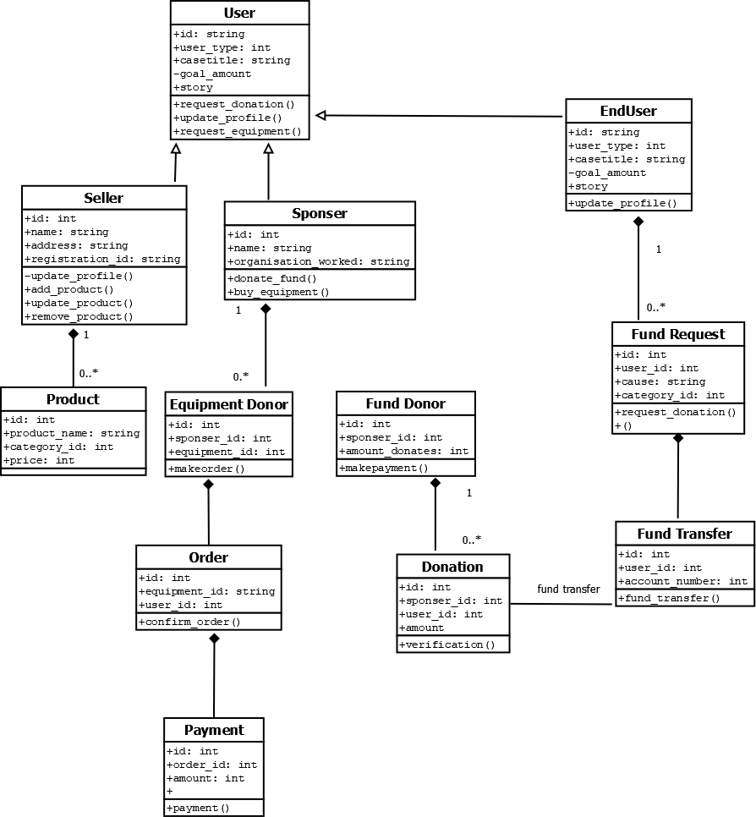

* **Object Diagram**

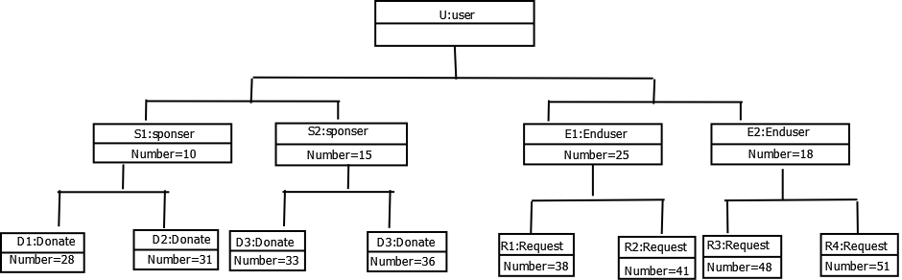

* 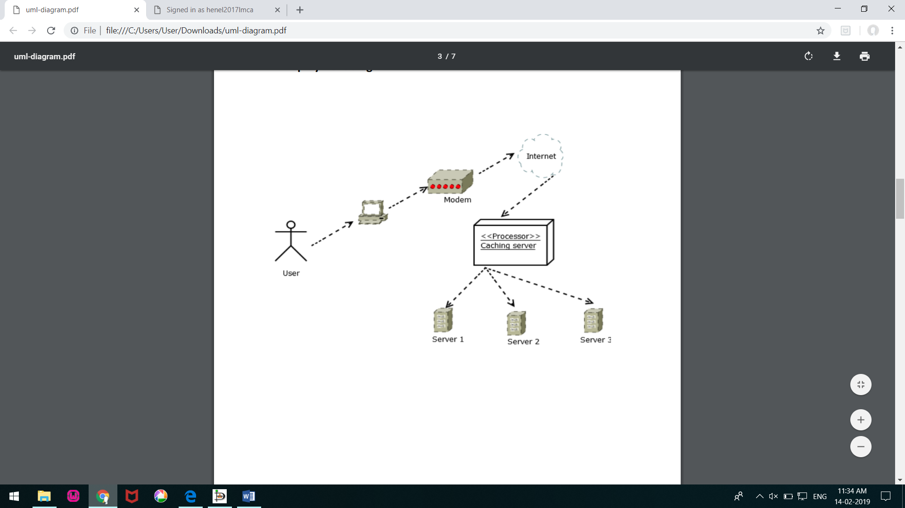**Deployment diagram**

1. **BEHAVIORAL DIAGRAM**

* **Use case diagram**

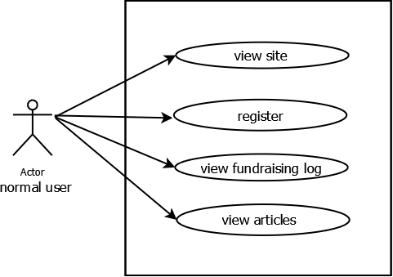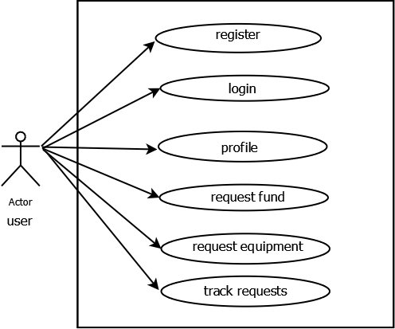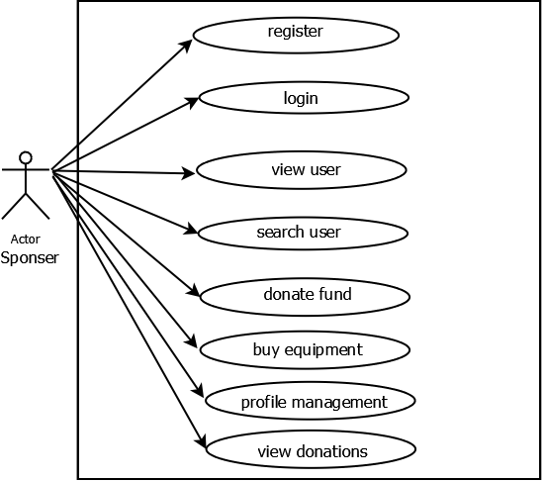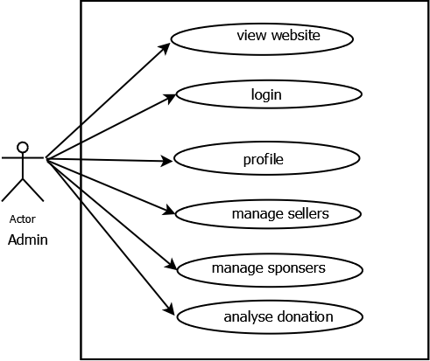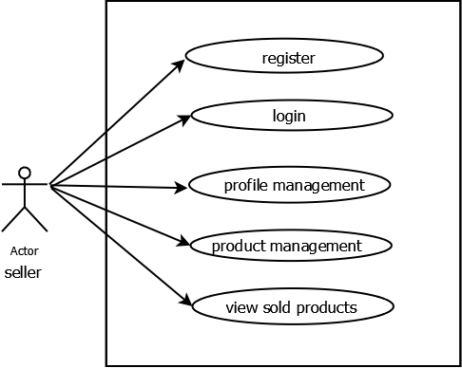

* **Collaboration diagram**

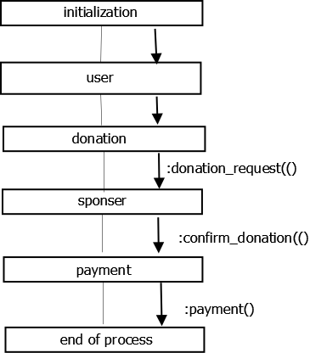

* **Statechart diagram**

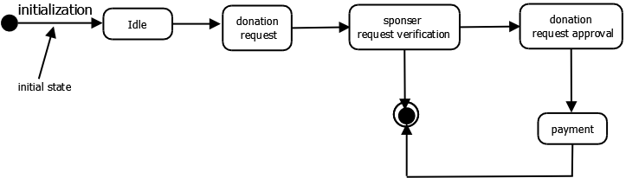

* **Activity Diagram**

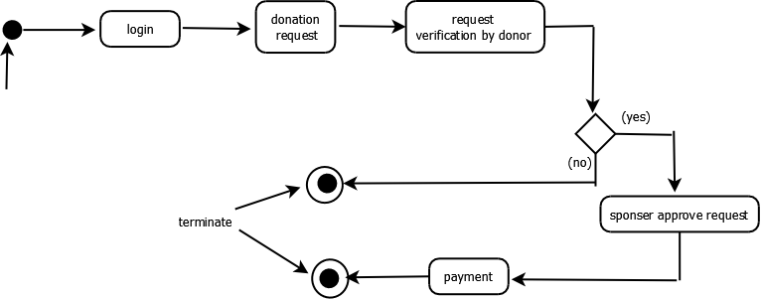

* **Sequence diagram**

