EVADE AND SURVIVE
Sprint Document — Character Design
Sprint 3
Role: Character Designer

1. Sprint Overview
This sprint document outlines the individual contribution made to the Zombie Evade Shooter group project during this week. My designated role within the team is Character Designer, responsible for conceptualizing, detailing, and delivering all character assets used throughout the game. This sprint's work covered the full character roster from initial ideation through to finalized concept sheets, including all five zombie enemy types, the two playable survivor characters, and the Trader NPC.
The Zombie Evade Shooter is a survival-based shooter in which players navigate zombie-infested environments, survive increasingly difficult enemy waves, and interact with an in-game economy through a Trader NPC. Character design plays a critical role in the game's success — enemies must communicate their behavior and threat level at a glance, and player characters must feel believable, practical, and visually consistent with the world they inhabit.
All finalized character concept sheets were compiled and organized in Figma to serve as a centralized, shared design reference for the entire team, enabling seamless handoff to other areas of development including environment design, UI, and programming.

2. Work Completed This Sprint

2.1 AI-Assisted Initial Concept Generation
The character design pipeline began with the use of AI generation tools to rapidly explore a broad visual space of potential designs across all character categories simultaneously. Rather than designing from scratch, AI was used strategically as a creative launchpad — producing rough visual directions for zombie enemy types, survivor player characters, and the Trader NPC in parallel.
This accelerated the early ideation phase considerably, allowing multiple design directions to be evaluated and compared quickly before committing to a final visual language. Critically, the AI output was treated strictly as a conceptual scaffold — a starting reference point that informed creative decision-making rather than functioning as a finished product. Each design was then substantially built upon and refined manually.
Key design decisions locked in during this phase:
- All characters would use a low-fidelity model type with optimized, performance-focused polygon geometry — keeping the game running efficiently without sacrificing visual clarity or character readability.
- Zombie types would be differentiated primarily through silhouette shape, body proportion, and color palette, rather than complex clothing details — ensuring enemies remain immediately readable during fast-paced gameplay and at varying screen sizes.
- Survivor characters would use muted, practical color tones and worn clothing — grounding them visually in the post-apocalyptic setting and contrasting clearly against the zombie roster.
- The Trader NPC would be entirely masked and hooded to conceal their identity, while still projecting a non-threatening and approachable energy — mysterious but not hostile.

2.2 Deep Refinement and Individual Character Detailing
Following the AI-assisted concept phase, each character was worked on individually through a thorough refinement process. This involved closely annotating every visual element of each design — specifying materials, color values, body proportions, gameplay-relevant visual indicators, and the design logic behind each decision. The objective was to produce concept sheets detailed and professional enough to serve directly as reference documents for the 3D modelling phase planned for the next sprint.
Zombie Type Designs — 5 Enemy Variants
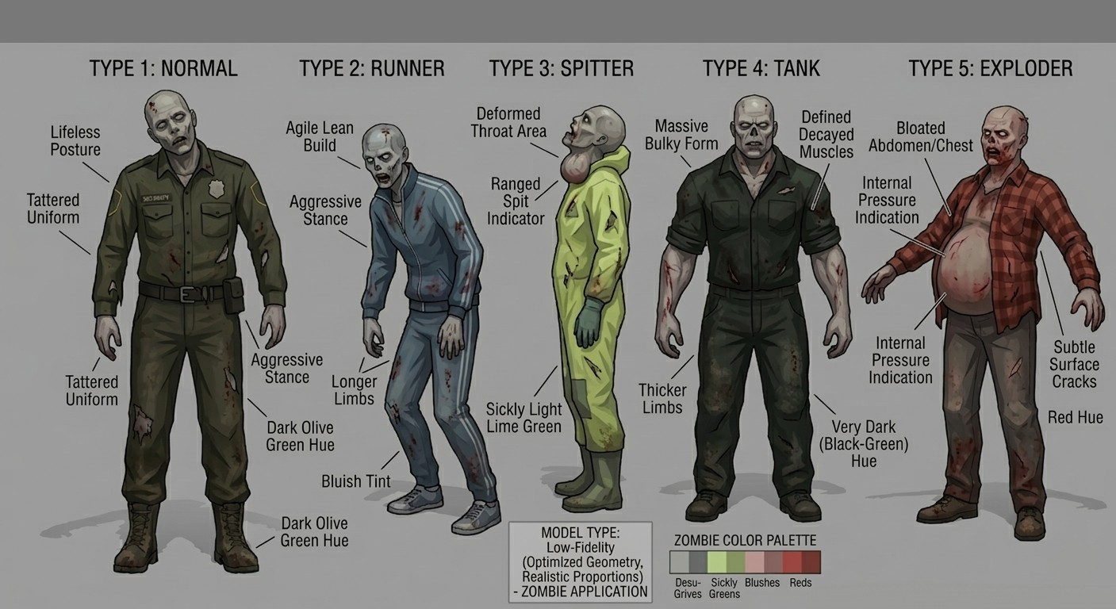
Figure 1 — Zombie Type Designs: Normal, Runner, Spitter, Tank, and Exploder

Five fully detailed zombie variants were designed, each built around the principle that the enemy's gameplay role and threat type should be immediately readable from its visual design alone — without relying on UI labels or tooltips:
- Type 1 — Normal: The baseline enemy and the first type player’s encounter. Wears a tattered security uniform, suggesting a pre-apocalypse authority figure now reduced to a mindless threat. Dark olive-green skin hue, lifeless upright posture, and a simple silhouette establish this as the standard, readable enemy archetype.
- Type 2 — Runner: Designed entirely around communicating speed. Features an agile and lean body build, elongated limbs, and a pronounced forward-leaning aggressive stance that visually telegraphs rapid movement. A bluish skin tint and dark olive-green undertone distinguish it clearly from the Normal type.
- Type 3 — Spitter: A ranged-threat enemy whose danger must be communicated purely through its visual design. The defining feature is a severely deformed and swollen throat area, which signals a spit or projectile attack mechanic to the player without any UI prompts. The full sickly lime-green hazmat jumpsuit creates an immediately memorable and unmistakable silhouette.
- Type 4 — Tank: The high-health, heavy-damage powerhouse of the enemy roster. Features an enormously bulky body mass, defined decayed musculature, and significantly thicker limbs compared to all other types. A very dark near-black, green hue sets it apart dramatically and communicates elevated danger and toughness.
- Type 5 — Exploder: The most visually urgent enemy in the game. A bloated, distended abdomen and chest, combined with visible internal pressure indicators and surface crack details, communicate imminent explosion danger even to first-time players. The red-hued skin functions as a deliberate use of color psychology — an instinctive visual warning to keep distance.
A unified zombie color palette was also established across all five types — ranging from desaturated greys and sickly greens through to blush tones and reds — creating visual cohesion across the enemy roster while preserving clear differentiation between each variant.

Survivor Character Designs — 2 Playable Characters
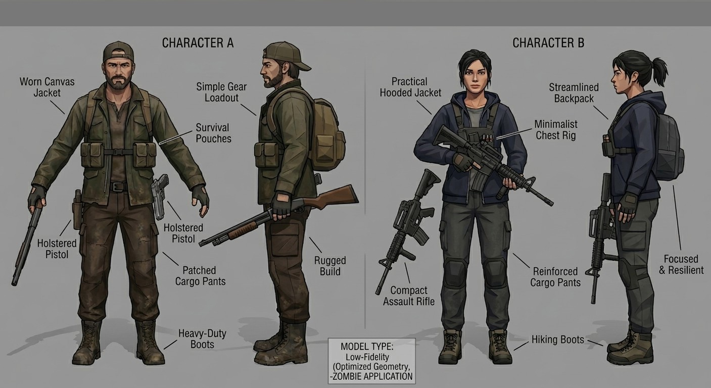
Figure 2 — Survivor Character Designs: Character A (left) and Character B (right)

Two distinct playable survivor characters were designed, each targeting a different player archetype and playstyle while maintaining full visual consistency with the game's established art direction:
- Character A — The Rugged Survivor (Male): Dressed in a worn canvas jacket, survival pouches, patched cargo pants, and heavy-duty boots. Carries a holstered pistol as his sidearm. The design language is deliberately weathered and utilitarian — every element contributes to the story of prolonged survival. His simple gear loadout and rugged build communicate the image of a battle-hardened fighter who has been navigating the apocalypse for a long time.
- Character B — The Tactical Survivor (Female): Wears a practical hooded jacket, a minimalist chest rig, reinforced cargo pants with knee protection, and hiking boots. Carries a compact assault rifle as her primary weapon along with a streamlined backpack. Her design projects tactical precision, efficiency, and quiet resilience — disciplined and adaptable rather than brute-force.
Both characters are shown from front and side views, providing full 360-degree reference coverage suitable for direct use in the 3D modelling phase. Both adhere to the same low-fidelity model specification as the zombie roster, ensuring a cohesive visual style across the entire cast of in-game entities.

Trader NPC Character Design
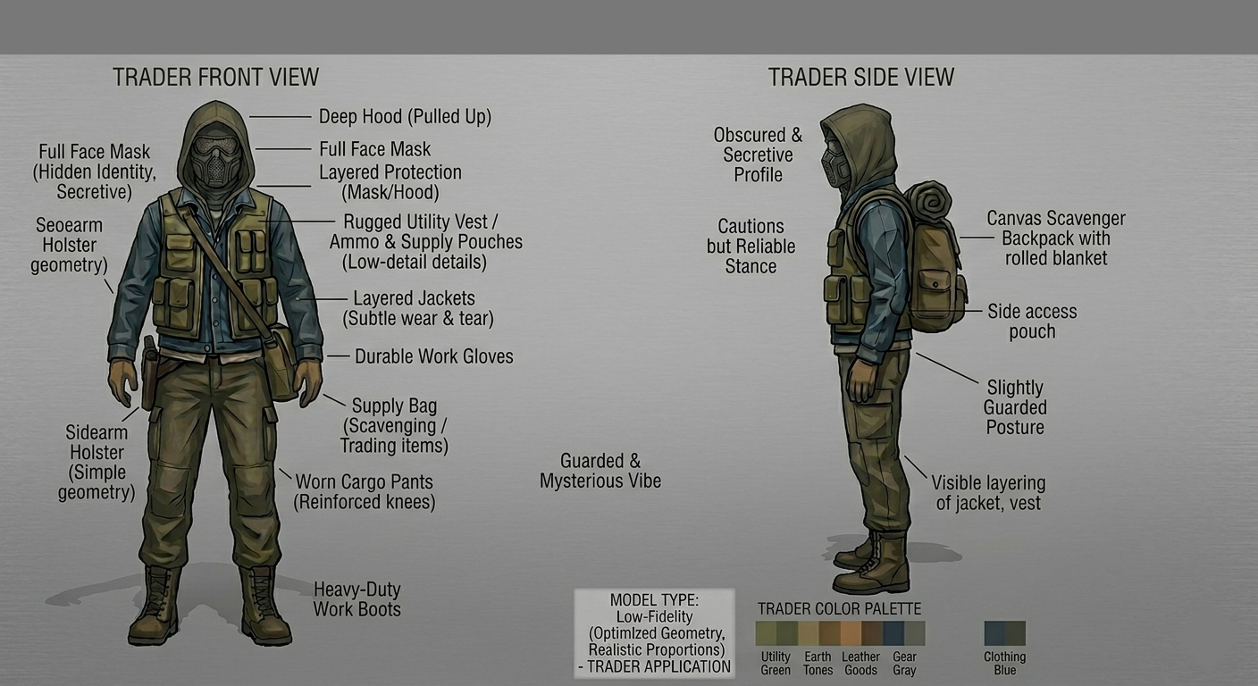
Figure 3 — Trader NPC Character Design: Front View (left) and Side View (right)

The Trader is the game's central NPC — the in-game economy hub where players exchange scavenged resources for weapons, ammunition, and supplies. The core design challenge was creating a character who reads simultaneously as secretive and trustworthy: the player must feel safe approaching them, yet remain intrigued by their hidden identity.
Key design decisions and their rationale:
- A full-face mask combined with a deep, forward-pulled hood completely conceals the Trader's identity, building narrative mystery and suggesting they have reason to hide — without making them feel like an enemy or a threat.
- A rugged utility vest loaded with ammo and supply pouches signals preparedness and resourcefulness, subconsciously communicating to the player that this character is experienced and reliable in a survival context.
- Layered jackets with subtle wear and tear communicate that the Trader has been operating in this world for a significant period — they are a long-term survivor, not a newcomer.
- A canvas scavenger backpack with a rolled blanket attached to the top suggests constant movement and nomadic behavior — the Trader never settles in one location, adding to their mystique and narrative flexibility within the game.
- Durable work gloves, reinforced cargo pants, and heavy-duty work boots round out a completely practical look — this is a survivor who happens to trade, not a merchant who happens to survive.
- A dedicated color palette of utility green, earth tones, leather goods brown, gear grey, and clothing blue was defined to ensure the Trader reads distinctly from both the survivor characters and the zombie roster, making them instantly identifiable as a unique entity.
Both front and side views were produced, accompanied by fully annotated callouts for every design element — providing comprehensive reference material for the 3D modelling phase.

2.3 Figma Compilation and Team Handoff
Following the completion of all individual character concept sheets, all assets were imported into Figma and organized into a structured, clearly labelled design board. Each character was laid out with annotations, color palette swatches, and front/side view pairings — creating a single, centralized reference document accessible by every member of the team at any time.
The Figma board functions as the team's shared source of truth for all character visuals. It gives the programming team accurate proportion and silhouette references for implementing hitboxes and collision geometry. It gives the environment design team a color reference to ensure characters read clearly against the backgrounds being developed. And it will serve as the primary reference document when 3D modelling begins in the next sprint.

3. Team Collaboration and Design Alignment
The group project is structured so that each team member owns a distinct area of development, with all contributions feeding into the same unified game. My role is Character Design — covering every entity the player will see, fight, or interact with throughout the game. While I have been focused on characters in this sprint, my groupmates have been working in parallel on their corresponding areas of the project:
- Environment and level design — creating visual language, maps, terrain, and environmental assets that form the world the characters inhabit.
- UI and HUD design — developing the heads-up display, health indicators, inventory screens, menus, and other interface elements that frame the gameplay experience.
- Game mechanics and programming — building the core systems including player movement, shooting mechanics, enemy AI behavior patterns, wave management, and the trading system logic.
This parallel structure works effectively because each discipline is informed by, but not blocked by, the others. The character concept sheets now live in Figma provide the programming team with the visual references they need to begin setting up character controllers and enemy AI. The environment team can reference my established color palettes to ensure characters read clearly against the backgrounds they are creating. All areas of design are being developed simultaneously to converge into the same cohesive product.
Team communication has been maintained throughout this sprint to ensure consistency across disciplines. A key example is the decision to use low-fidelity, geometry-optimized models for all characters — this was made collaboratively with the team to align with Unity performance requirements and directly shaped every design decision made during this sprint. My character designs are therefore not made in isolation; they are built to integrate cleanly with the technical and visual constraints the rest of the team is working within.

4. Next Sprint — Planned Work

4.1 3D Modelling of All Characters
The immediate focus of the next sprint is to transition all eight finalized character concept sheets into 3D models. The designs produced this sprint were deliberately built with this transition in mind — front and side reference views, annotated proportion notes, low-fidelity geometry specifications, and clearly defined color palettes all directly support and accelerate the modelling workflow.
All models will be built to the low-fidelity specification outlined in the concept sheets — optimized polygon geometry with realistic proportions, matched to the performance requirements of a real-time Unity application. The planned modelling priority order is:
- The two survivor/playable characters first — these are the most player-critical assets and are needed by the programming team as soon as possible to begin implementing player controllers, movement systems, and animations.
- The five zombie types next — starting with the simplest silhouettes (Normal and Runner) and progressing toward the more complex forms (Tank, Spitter, Exploder). A modular workflow will be established early so that shared geometry elements can be reused across variants, speeding up the overall process.
- The Trader NPC last — as this character is a stationary interaction point rather than an active gameplay element, it is not required for early gameplay testing and can be completed towards the end of the modelling phase without blocking other work.

4.2 Texturing and Material Application
Once base 3D models are complete, textures and materials will be applied to each character — translating the color palettes and material descriptions from the concept sheets into actual surface textures within the 3D application. Because color palettes were fully defined during this sprint for all character categories, this phase has a strong head start and the transition from modelling to textured asset should be relatively smooth.
Attention will be paid to ensure that textures remain readable and consistent at the sizes characters will appear on screen during gameplay, rather than only looking correct in close-up model views.

4.3 Unity Import and In-Engine Integration
After modelling and texturing, all character assets will be exported and imported into the Unity game engine for integration with the rest of the project. This process involves:
- Exporting each character model in the appropriate Unity-compatible format (FBX).
- Creating Unity prefabs for each character type, correctly scaled and positioned relative to the game world and the level geometry being developed by the environment team.
- Coordinating directly with the programming team to link character models to their corresponding scripts — movement controllers for the survivor characters, AI behavior scripts for each zombie type, and interaction trigger logic for the Trader NPC.
- Running in-engine visual tests to confirm all models render correctly, with no texture mapping errors, geometry clipping, or scale inconsistencies relative to the environment.
The target by the end of the next sprint is to have the two survivor characters and at least two zombie types — the Normal and the Runner — fully imported and functional within Unity. This will give the programming team real character assets to work with for active gameplay testing, replacing any placeholder geometry currently in use and enabling the project to move into a more complete, testable state.

5. Summary
This sprint successfully delivered a complete set of character concept designs for the Zombie Evade Shooter — eight characters across three categories, each fully annotated, color-defined, and compiled in Figma as a shared team resource. The work was completed individually and represents my core contribution to the group project this week.
All designs were built with the next phase of development firmly in mind. Low-fidelity geometry specifications, clear front and side reference views, and fully defined color palettes ensure that the transition into 3D modelling next sprint has a thorough, well-documented foundation to build from.
With the full team working in parallel across character design, environment design, UI, and programming — all contributing work that is designed to fit together — the project is on a strong trajectory to bring all elements together into a cohesive, playable Unity experience in the coming sprints.

