UNITED STATES MILITARY ACADEMY

OBJECT-ORIENTED MONOPOLY: MILESTONE 1

CS403: OBJECT-ORIENTED PROGRAMMING

SECTION SAP

LTC CHEWAR

By

CADET DAVID SU ’16, CO B4

CADET JINNY YAN ‘16, CO F2

WEST POINT, NEW YORK

28 MARCH 2014

**_______** MY DOCUMENT IDENTIFIES ALL SOURCES USED AND ASSISTANCE RECEIVED IN COMPLETING THIS ASSIGNMENT.

__JY, SU___ I DID NOT USE ANY SOURCES OR ASSISTANCE REQUIRING DOCUMENTATION IN COMPLETING THIS ASSIGNMENT.

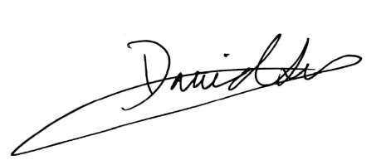

SIGNATURE: ______________________________________________________

______________________________________________________

**The Game**

*Introduction*

Our game is an American classic, Monopoly. The game is modeled after a real-life situation of buying and selling properties of different values and different characteristics in an attempt to be the winner, the one with all of the money at the end of the game. This is essentially achieved by aiming to establish a monopoly in a given zone (indicated by different colors) and then to profit off of having that property. This profit comes in the form of rent, which must be paid by the player who lands on an owned property of another player’s. Rent is more expensive in properties of higher value and rent also grows when there are more houses/hotels on that property.

Two die seal your fate, as the combination of the number on each dice is the amount of steps a player makes. The game also becomes more realistic as a jail, railroads, taxes, and utilities are added, as well as a series of “Chance” and “Community Chest” cards that can be drawn randomly to cause the player to assume either a positive or negative fate. Railroads, taxes, and utilities work almost the same as property, with minor differences in the way payment is made and to whom. The jail takes a player out of the game for three turns with a minor chance of getting out early. Seen to be an omen in the beginning of the game, jail is actually a good place to be near the end of the game. “Chance” and “Community Chest” cards range anywhere from paying up or receiving money to moving forward or moving backward on the board.

In the end, the message Monopoly is sending is clear, while in your search to fortune you may have important decisions to make, a lot of what you are given is on a game of chance, and is completely, and undeniably random.

*Our Implementation*

Because of the complication of the original game in its physical version, we have chosen to select aspects of the game to retain in our version that we will implement in Scala, and to remove parts of the game that we find unnecessary. However, although we will implement chosen parts of the game originally, we see the potential of saving the other features of the game for further milestones. This way, we can ensure that we create a quality product first and then add a quantity of additional features once the game is already underway.

We are creating this game at the National TsingHua University in Hsinchu, Taiwan instead of at the United States Military Academy in West Point, New York which sets us apart from our peers. We hope this puts us at an advantage rather than a disadvantage when it comes to creating a quality project. We are driven to produce a fantastic game with quality graphics through the use of the program Unity, which our advisor is very familiar with. We are learning our object-oriented concepts at the sister university, National Chiao Tung University, although the concepts we are learning are being implemented in C and C++. Through this combination, we are confident that we are receiving a quality education.

*Starting the Game*

The game begins when each player selects a token and then places that token on the Go space. The order is then created based on the numbers that each player rolls on the two die (thus this is a random creation of an order). Each player also receives the same initial amount of money (two $500 bills, two $100 bills, two $50 bills, six $20 bills, five $10 bills, and five $1 bills). Although it is noted that each player has this amount of bills, it is more important to note that each player initially begins with $1500.

At the beginning of the game, none of the property has been bought and therefore everything is up for grabs. The “Chance” and “Community Chest” cards have been shuffled and placed in their order. This order means that once a “Chance” card is selected and the action has been taken, the card goes to the bottom of the deck and it takes an entire round through the cards for that card to be called up again.

There is no money in the community vault, which is placed at the middle of the board. That money is the location of where tax goes and is also the collection point for when a player lands on “Free Parking.”

*Occurrences*

In this game, you can buy property when your token has landed on that property. If that property is already bought, you must pay a rent. We have chosen to not include trading, mortgages, or hotels in our version of Monopoly in order to minimize the complication of an already very complicated game. The rent of landing on a property rises when there are more houses on each property. Houses can only be built at the point of the game when that color of houses has been completely bought out (it doesn’t matter if that color is bought by different people). The cost of building each house is to repay once-over the value of the property. These values are in our “Board Layout” chart.

Landing on railroads also requires a charge to the player if that railroad is bought. This fee grows with the amount of railroads that the owner of the railroad has under his possession. The cost of each railroad is the same, as no one railroad is more valuable than another.

Landing on utilities each have their own specific price that also involve the value of the two die that caused the player to land on that utility. In addition, if the individual that owns the utility that is landed on also owns the other utility, the rent that the renting player must pay is significantly more. For specific values, please view our “Board Layout” chart.

Tax payments go to the community vault and the payment made can be either fixed on a percentage of what the player owns. The player will choose whichever one is less for the player to pay.

If landed on one of the special zones of “Free Parking,” “Visiting in Jail,” or “Go to Jail,” different actions occur. Please refer to the “Playing Actions Diagram” to view the different possibilities.

At “Chance” and “Community Chest,” a card is drawn in the random order that it resides, and the player must complete that action. Each card requires a different action. The different cards that we have chosen for our version of this game are noted in the “Equipment” section of this report.

If the player passes “Go” on his turn, he is given $200. This is an action that occurs alongside the buying and paying that the player already has to do on each turn.

*Winning Conditions*

When the first person goes bankrupt (runs out of money), the status of that moment is the winning order. The player that has the most money at that time will be 1st, then second most money 2nd, and the third with money will be 3rd. That player that dies out first then assumes the last place standing.

*Player Actions*

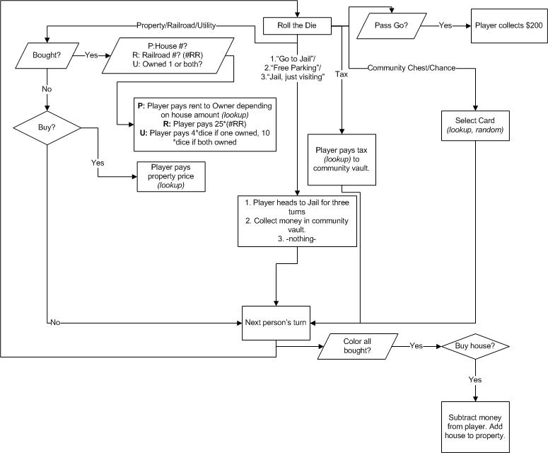

**Equipment**

Our equipment needed to play the game includes:

* A pair of 6-side die
* Money bills (endless amount of $500, $100, $50, $20, $10, $5, $1)
* Chance cards (6 different options)
  + Pay poor tax of $15
  + Advance to go
  + Go back 3 spaces
  + You have been elected chairman of the board, pay each player $50
  + Go directly to jail
  + Your building and loan matures. Collect $150
* Community chest cards (6 different options)
  + You inherit $100
  + Bank error in your favor, collect $200
  + Pay hospital $100
  + Go to jail
  + You have won second prize in a beauty contest, collect $10
  + Income tax refund, collect $20
* Playing board (picture below)
* Green houses
* Player tokens (4- Top Hat, Thimble, Shoe, Battleship, more details in our “Players” section)

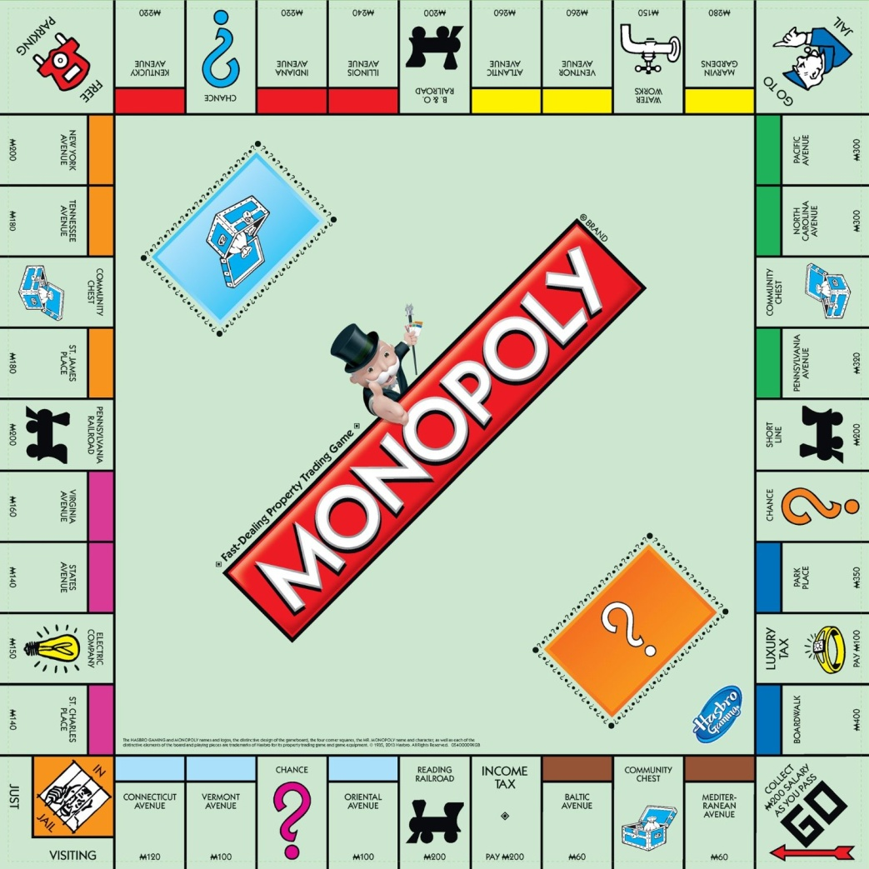

*Board Layout*

* Cost to build 1 house requires paying the price of the property again.
* Electric Company and Water Works: 4*dice if only one owned, 10*dice if both owned.

|  |  |  |  |  |  |  |  |  |  |  |  |
| --- | --- | --- | --- | --- | --- | --- | --- | --- | --- | --- | --- |
| **Property** | **Cost** | | | **Rent/Payment if Landed** | | **1 hse** | **2 hses** | | | **3 hses** | |
| **Mediterranean Avenue** | 60 | | | 2 | | 10 | 30 | | | 90 | |
| **Baltic Avenue** | 60 | | | 4 | | 20 | 60 | | | 180 | |
| **Reading RR** | 200 | | | 25 if 1 owned, 50 if 2 owned, 100 if 3 owned, 200 if all 4 owned | |
| **Oriental Avenue** | 100 | | | 6 | | 30 | 90 | | | 270 | |
| **Vermont Avenue** | 100 | | | 6 | | 30 | 90 | | | 270 | |
| **Connecticut Avenue** | 120 | | | 8 | | 40 | 100 | | | 300 | |
| **St. Charles Place** | 140 | | | 10 | | 50 | 150 | | | 450 | |
| **Electric Company** | 75  If one owned, 4*dice roll, If both owned, 10*dice roll. | |
| **States Avenue** | 140 | | 10 | | 50 | | | 150 | 450 | |
| **Virginia Avenue** | 160 | | 12 | | 60 | | | 180 | 500 | |
| **Pennsylvania RR** | 200 | | 25 if 1 owned, 50 if 2 owned, 100 if 3 owned, 200 if all 4 owned | |
| **St. James Place** | 180 | | 14 | | 70 | | | 200 | 550 | |
| **Tennessee Avenue** | 180 | | 14 | | 70 | | | 200 | 550 | |
| **New York Avenue** | 200 | | 16 | | 80 | | | 220 | 600 | |
| **Kentucky Avenue** | 220 | | 18 | | 90 | | | 250 | 700 | |
| **Indiana Avenue** | 220 | | 18 | | 90 | | | 250 | 700 | |
| **Illinois Avenue** | 240 | | 20 | | 100 | | | 300 | 750 | |
| **B&O RR** | 200 | | 25 if 1 owned, 50 if 2 owned, 100 if 3 owned, 200 if all 4 owned | |
| **Atlantic Avenue** | 260 | | 22 | | 110 | | | 330 | 800 | |
| **Ventnor Avenue** | 260 | | 22  If one owned, 4*dice roll, If both owned, 10*dice roll. | | 110 | | | 330 | 800 | |
| **Water Works** | 75 |
| **Marvin Gardens** | 280 | | 24* | | 120 | | | 360 | 850 | |
| **Pacific Avenue** | 300 | | 26 | | 130 | | | 390 | 900 | |
| **North Carolina Avenue** | 300 | | 26 | | 130 | | | 390 | 900 | |
| **Pennsylvania Avenue** | 320 | | 28 | | 150 | | | 450 | 1000 | |
| **Short Line** | 200 | | 25 if 1 owned, 50 if 2 owned, 100 if 3 owned, 200 if all 4 owned | |
| **Park Place** | 350 | | 35 | | 175 | | | 500 | 1100 | |
| **Boardwalk** | 400 | | 50 | | 200 | | | 600 | 1400 | |

**Players**

In our Monopoly game, we will choose to have four players with four different tokens (Top Hat, Thimble, Shoe, and Battleship) that are iconic pieces with differing strategies. Each piece will have its own strategy that is consistent with a sort of personality.

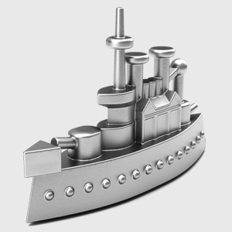

Battleship

Shoe

Top Hat

Thimble

*Strategies*

The Top Hat will be a spender with a purpose, and establishing a monopoly with property is his primary goal, it doesn’t matter where. This is because the Top Hat believes in the return of people landing on his property and he hopes to be able to establish a monopoly and build house/hotels. To him, it’s less important to buy utilities or railroads because those are merely stable incomes that do not bring elevated returns at a later time.

The Thimble is stingy, and only chooses to buy properties of higher value because they reap higher benefits. He believes that buying lesser properties, although cheaper, are not worth it. However, the thimble believes in the stable income of buying railroads and utilities.

The Shoe is a hard worker, a player that chooses to work from the bottom up, and therefore is more interested in buying lesser valued properties and then to build houses as soon as possible. He also believes in buying railroads and utilities to maintain a stable income.

The Battleship is a headstrong buyer, buying absolutely anything and everything, believing that his money will last him until the point that he can fully rely on the money he owns.

|  |  |  |  |  |
| --- | --- | --- | --- | --- |
| **Player** | *Top Hat* | *Thimble* | *Shoe* | *`Battleship* |
| Buy Railroads? | N | Y | Y | Y |
| Buy Utilities? | N | Y | Y | Y |
| Buy side 1? | Y | N | Y | Y |
| Buy side 2? | Y | N | Y | Y |
| Buy side 3? | Y | Y | N | Y |
| Buy side 4? | Y | Y | N | Y |