Final Documentation — BE-02: Connecting to the Database

FlyRank AI

Name: Jiya yadav
Assignment Name: Connecting to the Database
Code: BE-02
Track: Backend AI Engineering
Week: Week 3
Contents
1. Project Overview 3
Before vs After 3
2. Architecture 4
System Diagram 4
Layer Responsibilities 4
3. Project Structure 5
4. Database Design 5
Schema 5
Column Reference 5
Seed Data 6
5. API Reference 6
Base URL 6
Interactive Docs 6
Endpoints 6
Query Parameters: 7
Example Requests: 7
GET /tasks 7
200 Response: 7
GET /tasks/{id} 8
200 Response: 8
404 Response: 8
POST /tasks 8
Request Body: 8
201 Response: 9
400 Response (missing title): 9
PUT /tasks/{id} 9
Request Body: 9
200 Response: 10
404 Response: 10
DELETE /tasks/{id} 10
200 Response: 10
404 Response: 10
GET /stats 10
200 Response: 11
Status Code Summary 11
6. SQL Queries Reference 11
Queries Explored Manually in DB Browser 12
7. Testing Guide 13
Start the Server 13
Full Test Suite Using PowerShell 13
8. Results Table 16
9. Key Learnings 19
Concepts Learned 19
Architecture Insight 20
What Transfers to Production 20
10. Requirements Checklist 20
Core Requirements 20
Optional Extras 21
Stage Checkpoints 21
📦Dependencies 21
🔗 Resources Used 21

1. Project Overview
What This Project Is
A production-style RESTful Task Management API built with FastAPI and backed by a SQLite database. This project is a direct evolution of the Week 2 in-memory API. The core goal of this assignment was to prove one of the most important ideas in backend engineering:

Before vs After
Week 2 Architecture:
Client ──► FastAPI Routes ──► Python List ──► ❌ Lost on restart
Week 3 Architecture:
Client ──► FastAPI Routes ──► SQLite Database ──► ✅ Persists forever
The client sees zero difference. Every URL, request body, and response format stayed identical. Only the storage layer changed.

2. Architecture

System Diagram
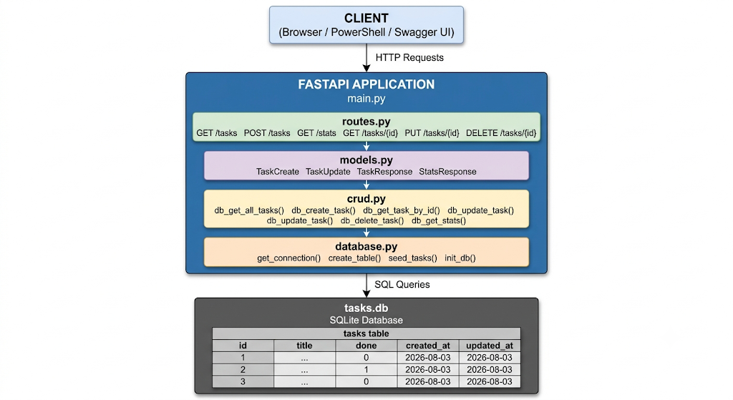

Layer Responsibilities
Layer | File | Responsibility
Entry Point | main.py | Starts the app, runs init_db() on startup
Routes | routes.py | Defines HTTP endpoints, handles status codes
Models | models.py | Validates request bodies, shapes responses
CRUD | crud.py | Contains all SQL queries, talks to the database
Database | database.py | Manages connection, creates table, seeds data
Storage | tasks.db | The actual SQLite database file

3. Project Structure
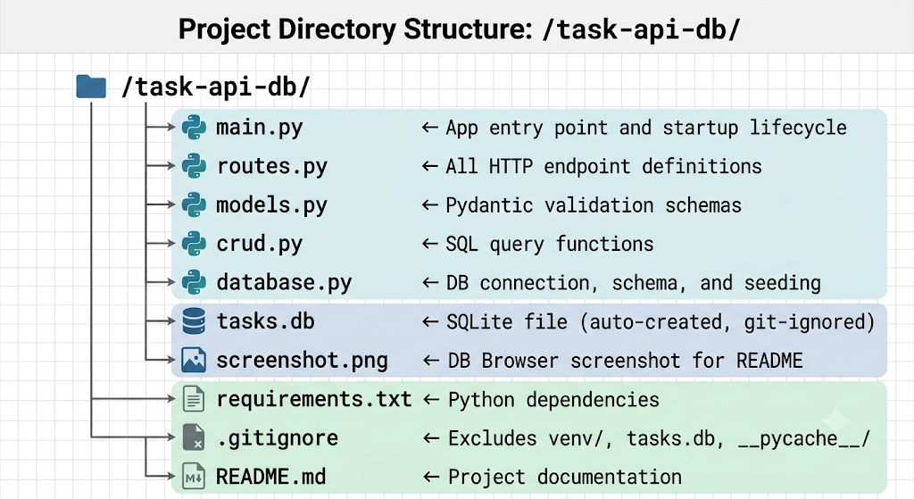

4. Database Design

Schema
CREATE TABLE IF NOT EXISTS tasks (
id INTEGER PRIMARY KEY AUTOINCREMENT,
title TEXT NOT NULL,
done INTEGER NOT NULL DEFAULT 0,
created_at TEXT DEFAULT (datetime('now')),
updated_at TEXT DEFAULT (datetime('now'))
);

Column Reference
Column | Type | Constraints | Description
id | INTEGER | PRIMARY KEY, AUTOINCREMENT | Unique identifier for each task
title | TEXT | NOT NULL | Task description, cannot be empty
done | INTEGER | NOT NULL, DEFAULT 0 | 0 = pending, 1 = completed
created_at | TEXT | DEFAULT datetime('now') | Timestamp when task was created
updated_at | TEXT | DEFAULT datetime('now') | Timestamp when task was last modified

Seed Data
Three tasks are inserted only when the table is empty (first run only):
seed_data = [
("Learn SQL fundamentals", 0), # pending
("Connect SQLite to FastAPI server", 1), # completed
("Build an AI feature with Claude", 0), # pending
]

5. API Reference

Base URL
http://localhost:8000

Interactive Docs
http://localhost:8000/docs ← Swagger UI
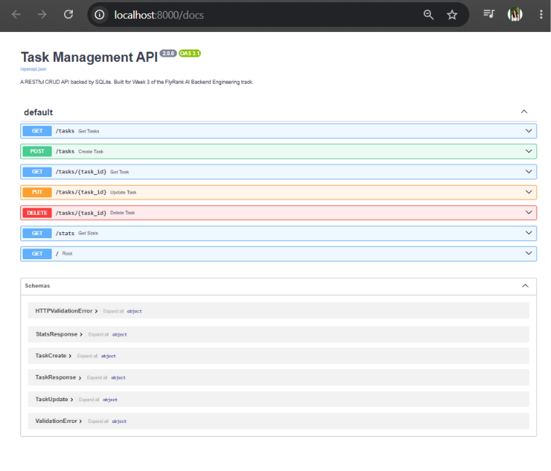

Endpoints
GET /tasks
Returns all tasks. Supports optional filtering and sorting.

Query Parameters:
Parameter | Type | Default | Description
search | string | — | Filter tasks whose title contains this keyword (SQL LIKE)
done | boolean | — | Filter by completion status
sort_alpha | boolean | false | Sort results alphabetically by title

Example Requests:
GET /tasks
GET /tasks?done=false
GET /tasks?search=sql
GET /tasks?done=true&sort_alpha=true

GET /tasks

200 Response:
[
{
"id": 1,
"title": "Learn SQL fundamentals",
"done": false,
"created_at": "2026-08-03 20:16:59",
"updated_at": "2026-08-03 20:16:59"
},
{
"id": 2,
"title": "Connect SQLite to FastAPI server",
"done": true,
"created_at": "2026-08-03 20:16:59",
"updated_at": "2026-08-03 20:16:59"
}
]

GET /tasks/{id}
Returns one task by its ID.
Path Parameter:
Parameter | Type | Description
id | integer | The task's unique ID

200 Response:
{
"id": 1,
"title": "Learn SQL fundamentals",
"done": false,
"created_at": "2026-08-03 20:16:59",
"updated_at": "2026-08-03 20:16:59"
}

404 Response:
{
"detail": "Task not found"
}

POST /tasks
Creates a new task and saves it to the database.

Request Body:
{
"title": "Write unit tests",
"done": false
}
Field | Type | Required | Description
title | string | ❌ No | Task description (cannot be empty)
done | boolean | ❌ No | Defaults to false

201 Response:
{
"id": 4,
"title": "Write unit tests",
"done": false,
"created_at": "2026-08-03 20:25:00",
"updated_at": "2026-08-03 20:25:00"
}

400 Response (missing title):
{
"detail": "Title is required"
}

PUT /tasks/{id}
Updates an existing task. All fields are optional.

Request Body:
{
"title": "Updated task title",
"done": true
}
Field | Type | Required | Description
title | string | ❌ No | New task title
done | boolean | ❌ No | New completion status

200 Response:
{
"id": 1,
"title": "Updated task title",
"done": true,
"created_at": "2026-08-03 20:16:59",
"updated_at": "2026-08-03 20:30:00"
}

404 Response:
{
"detail": "Task not found"
}

DELETE /tasks/{id}
Permanently removes a task from the database.

200 Response:
{
"message": "Task 1 deleted successfully"
}

404 Response:
{
"detail": "Task not found"
}

GET /stats
Returns task count statistics calculated entirely in SQL.

200 Response:
{
"total_tasks": 5,
"completed_tasks": 2,
"pending_tasks": 3
}

Status Code Summary
Code | Meaning | When It Happens
200 | OK | Successful GET, PUT, DELETE
201 | Created | Successful POST
400 | Bad Request | Missing or empty title
404 | Not Found | Task ID does not exist

6. SQL Queries Reference
Queries Used Inside the Application
Operation | SQL | Operation
Create table | CREATE TABLE IF NOT EXISTS tasks (...) | Create table
Count rows for seeding | SELECT COUNT(*) AS total FROM tasks | Count rows for seeding
Seed data | INSERT INTO tasks (title, done) VALUES (?, ?) | Seed data
Get all tasks | SELECT id, title, done, created_at, updated_at FROM tasks ORDER BY id ASC | Get all tasks
Get one task | SELECT ... FROM tasks WHERE id = ? | Get one task
Search by title | SELECT ... FROM tasks WHERE title LIKE ? | Search by title
Filter by done | SELECT ... FROM tasks WHERE done = ? | Filter by done
Sort alphabetically | SELECT ... FROM tasks ORDER BY title ASC | Sort alphabetically
Create task | INSERT INTO tasks (title, done) VALUES (?, ?) | Create task
Update task | UPDATE tasks SET title = ?, done = ?, updated_at = datetime('now') WHERE id = ? | Update task
Delete task | DELETE FROM tasks WHERE id = ? | Delete task
Count stats | SELECT COUNT(*), SUM(CASE WHEN done = 1 ...) FROM tasks | Count stats

Queries Explored Manually in DB Browser

-- 1. See everything in the table  SELECT * FROM tasks; | 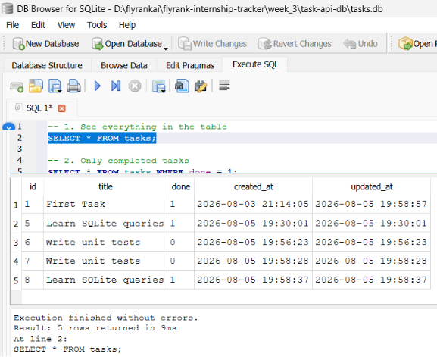
-- 2. Only completed tasks  SELECT * FROM tasks WHERE done = 1; | 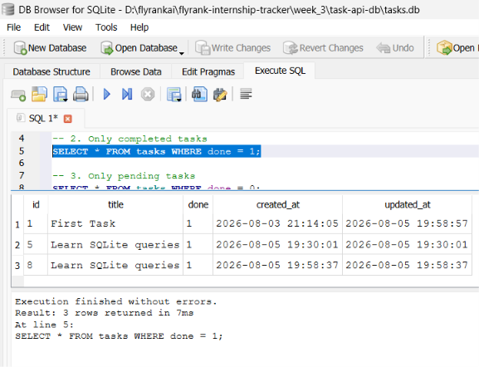
-- 3. Only pending tasks  SELECT * FROM tasks WHERE done = 0; | 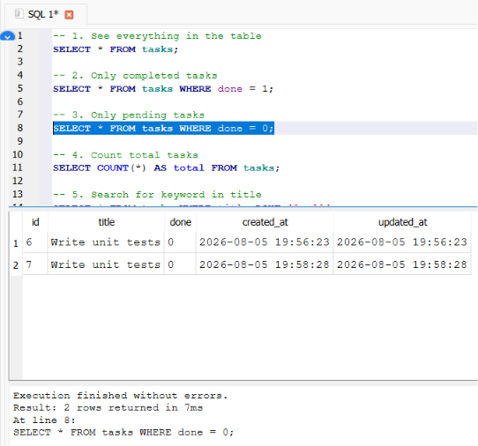
-- 4. Count total tasks  SELECT COUNT(*) AS total FROM tasks; | 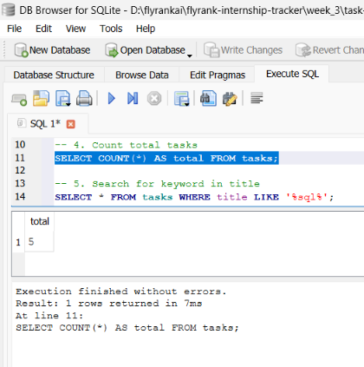
-- 5. Search for keyword in title  SELECT * FROM tasks WHERE title LIKE '%sql%'; | 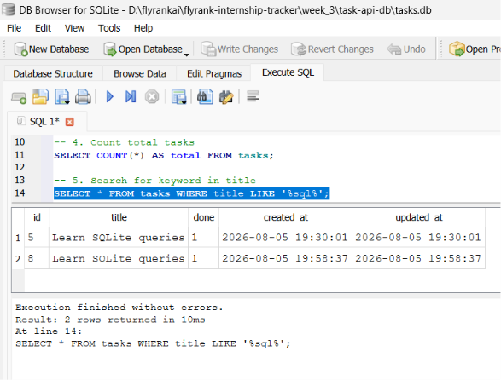
-- 6. Sort alphabetically  SELECT * FROM tasks ORDER BY title ASC; | 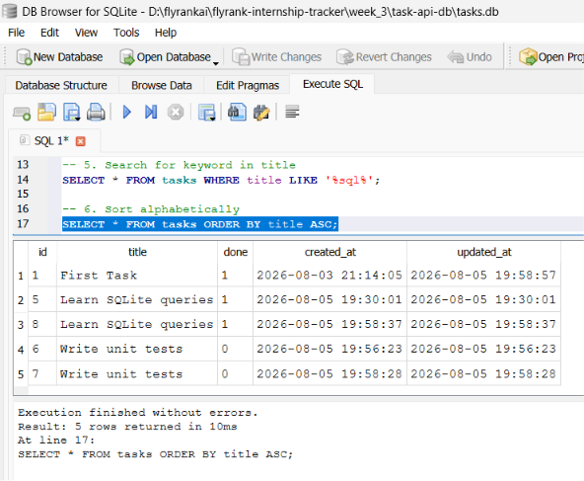
-- 7. Mark all tasks complete  UPDATE tasks SET done = 1; | 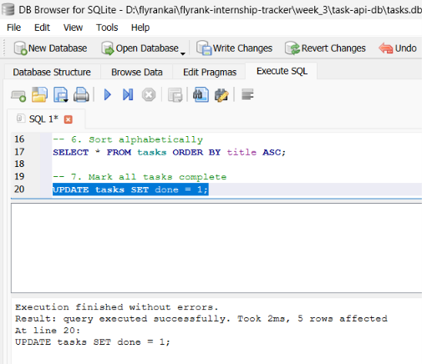
-- 8. Delete all completed tasks  DELETE FROM tasks WHERE done = 1; | 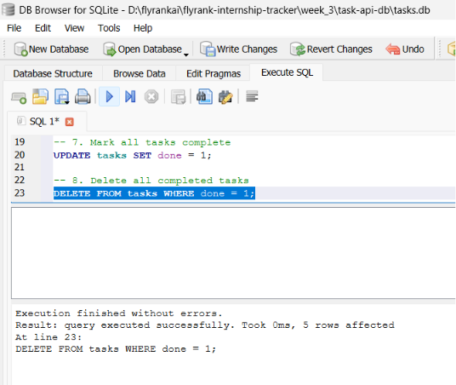
-- 9. Pending vs completed count  SELECT  SUM(CASE WHEN done = 0 THEN 1 ELSE 0 END) AS pending,  SUM(CASE WHEN done = 1 THEN 1 ELSE 0 END) AS completed  FROM tasks; | 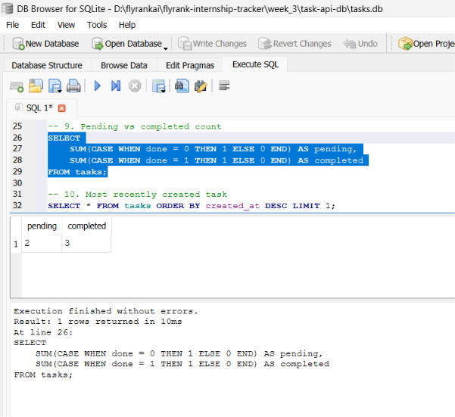
-- 10. Most recently created task  SELECT * FROM tasks ORDER BY created_at DESC LIMIT 1; | 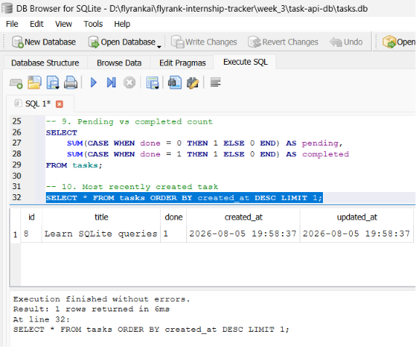

7. Testing Guide

Start the Server
uvicorn main:app --reload --port 8000

Full Test Suite Using PowerShell
# ── READ ──────────────────────────────────────────────
# Get all tasks
Invoke-RestMethod -Uri "http://localhost:8000/tasks" -Method GET
# Get one task
Invoke-RestMethod -Uri "http://localhost:8000/tasks/1" -Method GET
# Test 404
Invoke-RestMethod -Uri "http://localhost:8000/tasks/999" -Method GET

# ── CREATE ────────────────────────────────────────────
# Create a task
Invoke-RestMethod -Uri "http://localhost:8000/tasks" `
-Method POST `
-ContentType "application/json" `
-Body '{"title": "Write unit tests", "done": false}'

# Create a completed task
Invoke-RestMethod -Uri "http://localhost:8000/tasks" `
-Method POST `
-ContentType "application/json" `
-Body '{"title": "Learn SQLite queries", "done": true}'

# Test 400 — empty title
Invoke-RestMethod -Uri "http://localhost:8000/tasks" `
-Method POST `
-ContentType "application/json" `
-Body '{"title": ""}'

# ── UPDATE ────────────────────────────────────────────
# Mark task 1 as done
Invoke-RestMethod -Uri "http://localhost:8000/tasks/1" `
-Method PUT `
-ContentType "application/json" `
-Body '{"done": true}'

# Update title only
Invoke-RestMethod -Uri "http://localhost:8000/tasks/2" `
-Method PUT `
-ContentType "application/json" `
-Body '{"title": "Updated title"}'

# ── DELETE ────────────────────────────────────────────
# Delete task 4
Invoke-RestMethod -Uri "http://localhost:8000/tasks/4" -Method DELETE

# Test 404 delete
Invoke-RestMethod -Uri "http://localhost:8000/tasks/3" -Method DELETE

# ── FILTERS & EXTRAS ─────────────────────────────────
# Search
Invoke-RestMethod -Uri "http://localhost:8000/tasks?search=sql" -Method GET

# Filter pending only
Invoke-RestMethod -Uri "http://localhost:8000/tasks?done=false" -Method GET

# Filter completed only
Invoke-RestMethod -Uri "http://localhost:8000/tasks?done=true" -Method GET

# Sort alphabetically
Invoke-RestMethod -Uri "http://localhost:8000/tasks?sort_alpha=true" -Method GET

# Stats
Invoke-RestMethod -Uri "http://localhost:8000/stats" -Method GET

# ── PERSISTENCE TEST ──────────────────────────────────
# Stop server → CTRL+C
# Restart server → uvicorn main:app --reload --port 8000
# Run this — data must still exist
Invoke-RestMethod -Uri "http://localhost:8000/tasks" -Method GET

8. Results Table
Test | Status | Result
GET /tasks | 200 | 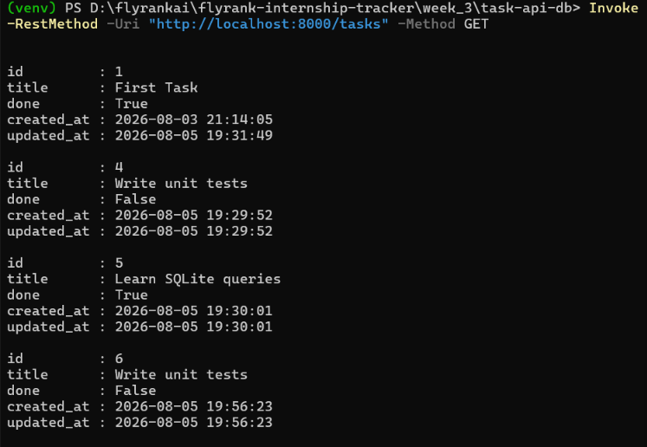  Array of task objects
GET /tasks/1 | 200 | 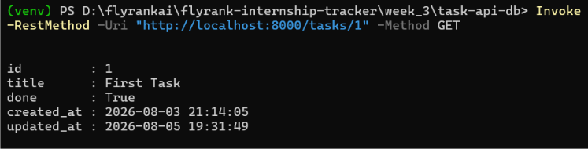  Single task object
GET /tasks/999 | 404 | 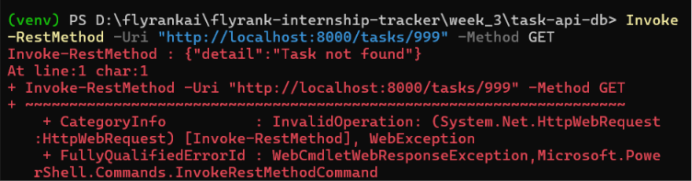  {"detail": "Task not found"}
POST with title | 201 | 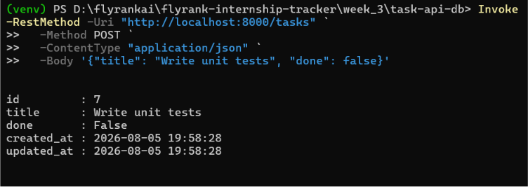  New task with auto id
POST empty title | 400 | 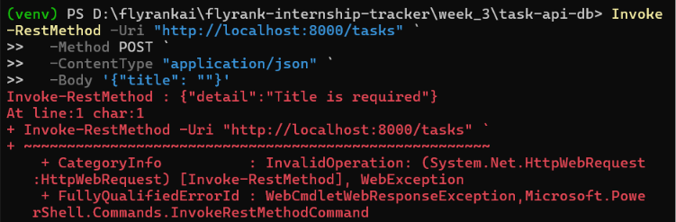  Validation error
PUT /tasks/1 | 200 | 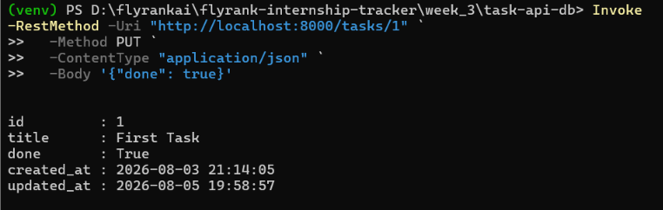  Updated task object
PUT /tasks/2 | 404 | {"detail": "Task not found"}  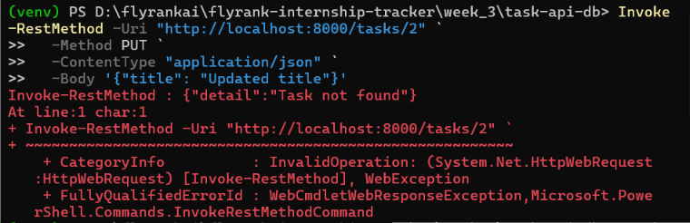
DELETE /tasks/4 | 200 | 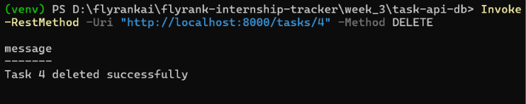  Success message
DELETE /tasks/3 | 404 | {"detail": "Task not found"}  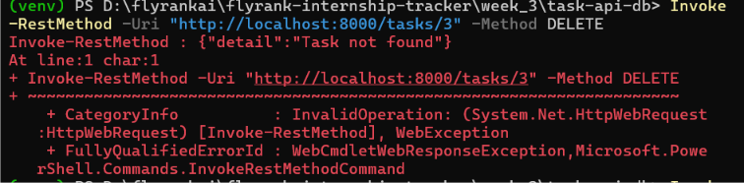
GET /stats | 200 | Count object  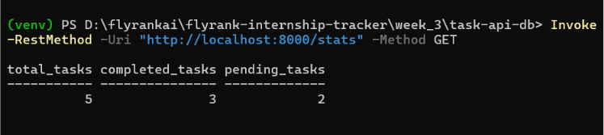
Restart server | — | All tasks still present

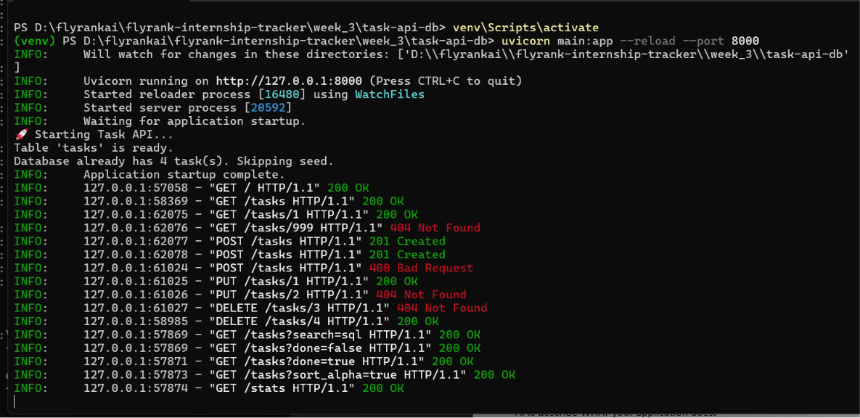

9. Key Learnings
The Most Important Idea
- APIs describe WHAT your application does.
- Databases describe WHERE your application stores its data.
These two concerns are completely separate. Changing one does not require changing the other.

Concepts Learned
Concept | What It Means | Where used
Database | Permanent storage that survives restarts | tasks.db
SQLite | Lightweight file-based database, no server needed | database.py
Table | Rows and columns, like a spreadsheet | tasks table
Row | One record in a table | One task
Column | One property of every row | id, title, done
SQL | Language for querying databases | All CRUD operations
Primary Key | Unique identifier for each row | id column
Persistence | Data survives after the program stops | Proven by restart test
Schema | Structure of the database | CREATE TABLE statement
Migration | Controlled schema changes | Will be explored in later weeks

Architecture Insight
- Week 2 Problem: Python list = wiped clean every time the server restarts
- Week 3 Solution: SQLite file = data written to disk, survives forever
- The API layer stayed 100% identical.
- This separation is the foundation of backend engineering.

What Transfers to Production
Skill Learned Here | Transfers To
SQL SELECT queries | PostgreSQL, MySQL, any relational database
SQL INSERT / UPDATE / DELETE | Same syntax works everywhere
Separating routes from queries | Standard pattern in all frameworks
Pydantic validation | Used in production FastAPI apps
IF NOT EXISTS table creation | Database migration patterns

10. Requirements Checklist

Core Requirements
✅ API exposes same CRUD endpoints as Assignment 1
✅ Tasks stored in SQLite instead of memory
✅ Data survives server restarts
✅ Database file auto-created if missing
✅ Tasks table auto-created if missing
✅ Three example tasks inserted only on first run
✅ All CRUD operations use SQL queries
✅ Unknown ids return 404
✅ Invalid requests return 400
✅ Public GitHub repository with README and screenshot

Optional Extras
✅ GET /tasks?search= using SQL LIKE operator
✅ GET /tasks?done= using SQL WHERE clause
✅ GET /tasks?sort_alpha= sorted by title
✅ GET /stats using SQL COUNT()
✅ created_at and updated_at timestamps on every task

Stage Checkpoints
✅ Stage 0 — Server restart shows seed tasks only once
✅ Stage 1 — GET /tasks returns database contents
✅ Stage 2 — Tasks survive server restart after POST
✅ Stage 3 — Create, update, delete all confirmed via GET
✅ Stage 4 — Manual SQL changes reflected immediately in API
✅ Stage 5 — README complete with screenshot and SQL example

📦Dependencies
fastapi==0.111.0
uvicorn==0.29.0
pydantic==2.7.1
sqlite3 — built into Python, no installation needed

🔗 Resources Used
Resource | Purpose
FastAPI Docs | Framework reference
SQLite Docs | SQL syntax reference
DB Browser for SQLite | Visual database inspection
Pydantic Docs | Validation schema reference

