FL-01 WORKFLOW AUDIT — JIYA YADAV
SECTION 1: Workflow Audit Table
# | Task | Frequency | Classification | One-Line Reason
1 | Fine-tuning ML models (like DistilRoBERTa training runs) | Project-based | Collaborate with AI | I make architectural decisions; AI helps debug training code and explain results
2 | Writing and updating GitHub README and documentation | Weekly | Delegate to AI with Review | AI drafts structure and language; I verify technical accuracy
3 | Updating CV with new projects and skills | Monthly | Collaborate with AI | AI suggests phrasing and formatting; I decide what to include based on my goals
4 | Studying Python (core concepts and practice) | Daily | Collaborate with AI | I attempt problems first; AI explains where my logic breaks and suggests better approaches
5 | Preparing and giving tuition classes | Daily | Just Me | Teaching requires real-time human judgment, student relationships, and adaptive explanation
6 | Debugging code errors in my projects | Daily | Collaborate with AI | Iterative back-and-forth; I explain the error, AI suggests fixes, I test and verify
7 | Writing college certification and administrative documentation | As needed | Delegate to AI with Review | AI handles formatting and language; I verify facts and official requirements
8 | Updating LinkedIn profile and writing posts | Weekly | Delegate to AI with Review | AI drafts content; I adjust tone to match my personal voice
9 | Taking online courses and extracting key learnings | Weekly | Collaborate with AI | I watch/read first; AI helps me summarize and test my understanding
10 | Building and updating my portfolio website/profile | As needed | Collaborate with AI | AI suggests structure and copy; I make design and content decisions
11 | Writing project test suites and CI/CD documentation | Project-based | Collaborate with AI | AI suggests test cases; I validate that they reflect real system behavior
12 | Deciding which jobs or opportunities to apply to | Weekly | Just Me | Requires my personal judgment about career fit, values, and risk — AI cannot weigh this for me
13 | Attending masterclasses and taking notes | As needed | Delegate to AI with Review | AI converts my rough notes into clean summaries; I verify that nothing important is lost
14 | Deploying and monitoring projects on Hugging Face Spaces | Project-based | Collaborate with AI | I handle deployment logic; AI helps troubleshoot configuration and monitoring setup
15 | Tracking daily tasks and planning my week | Daily | Fully Automate | Simple scheduling task; AI can draft time blocks once I give it my constraints

SECTION 2: Three Target Tasks
🎯 Target Task 1: Writing Technical Documentation (GitHub README, Project Docs)
Why I picked this: I do this for every project. It is time-consuming, and quality matters.
Done well means:
- The README covers what the project does, how to run it, the tech stack, and key results clearly
- Someone with no context can understand the project in under 2 minutes of reading
- Technical details (model names, metrics, stack) are 100% accurate — I verify every number
- Requires less than 20 minutes of my editing after the AI draft
- No corporate or robotic language — reads as if a developer wrote it
🎯 Target Task 2: Studying Python (Concept Understanding + Problem Solving)
Why I picked this: I do this 2–3 hours daily. AI can make this deeper, not just faster.
Done well means:
- I can explain the concept back in my own words without looking at the AI output
- AI-generated practice problems cover beginner to intermediate difficulty
- I attempt every problem before asking AI for help — AI never solves it cold for me
- After a session, I can write working code from memory on at least 1 new concept
- Session takes the same time (2–3 hours), but I retain and understand more
🎯 Target Task 3: Updating CV and LinkedIn for Job Applications
Why I picked this: I just updated both. This will keep happening as I apply to jobs.
Done well means:
- Every bullet point is specific and has a number or outcome (like my current CV does)
- Tone is confident but honest — nothing overstated
- Tailored version for a specific job takes under 30 minutes with AI help
- A recruiter unfamiliar with ML can still understand what I built and why it matters
- I review every word — nothing goes in that I cannot explain in an interview

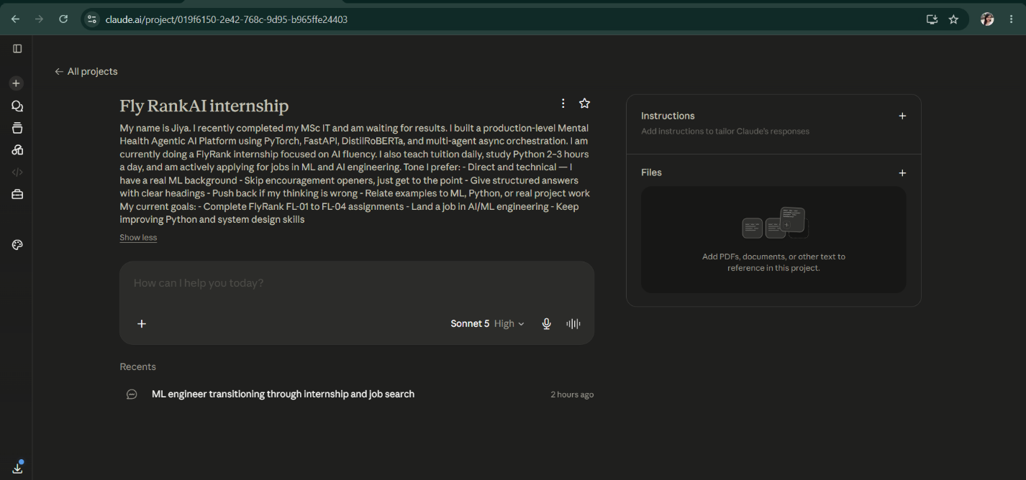
SECTION 3: Claude Project Screenshot

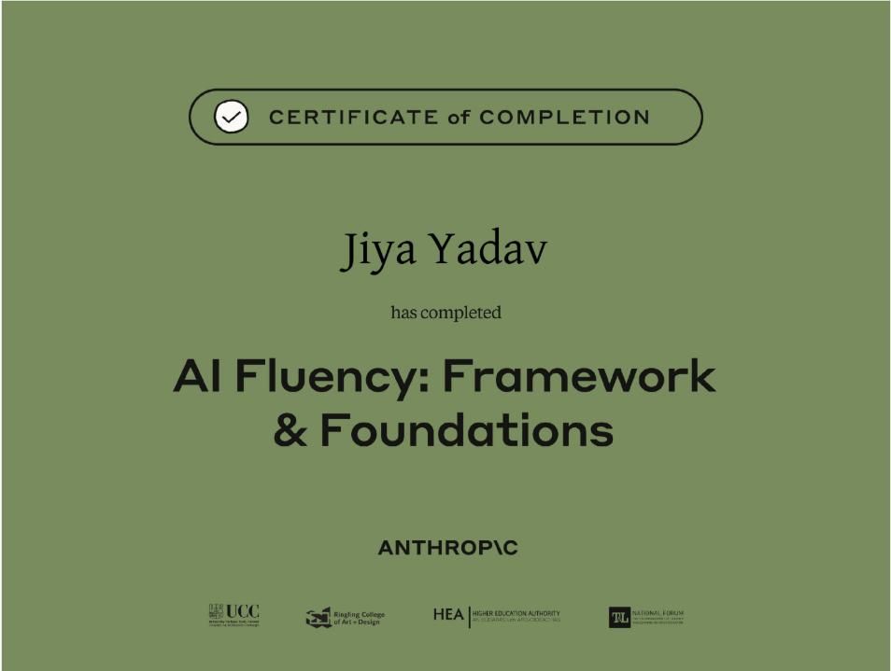
SECTION 4: Anthropic Academy Completion

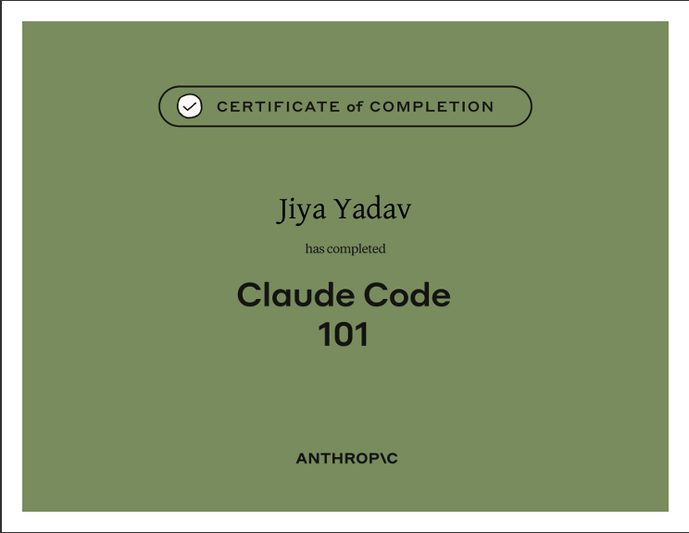
SECTION 5: Short Reflection
Completing this workflow audit forced me to look honestly at how I actually spend my week, rather than how I imagined I did. The four-category framework (Just Me, Delegate with Review, Collaborate, Fully Automate) made it clear that most of my recurring tasks fall into the "Collaborate with AI" zone — which reflects how I already work on my Mental Health Agentic AI Platform, where I make the architectural decisions but rely on AI to accelerate debugging, documentation, and iteration.
The most valuable insight came from identifying my "Just Me" tasks. Teaching tuition and deciding which jobs to apply to are areas where AI adds no value and could actually harm the outcome — one requires real human presence, the other requires judgment grounded in my personal goals and values. Recognizing this protects the parts of my work that must stay human.
I configured my Claude Project with a direct technical tone, no filler language, and context about my ML background so that every interaction stays efficient and grounded in my actual work. Completing the Anthropic AI Fluency and Claude Code 101 courses reinforced this framework and gave me concrete techniques for delegation, verification, and prompt structuring that I will apply across FL-02 to FL-04.
Going forward, my three target tasks (technical documentation, Python study, and CV/LinkedIn updates) will serve as the recurring test cases I use to measure whether AI genuinely improves my output — or just makes it faster without improving quality.

