ФЕДЕРАЛЬНОЕ АГЕНТСТВО СВЯЗИ
ФЕДЕРАЛЬНОЕ ГОСУДАРСТВЕННОЕ БЮДЖЕТНОЕ ОБРАЗОВАТЕЛЬНОЕ
УЧРЕЖДЕНИЕ ВЫСШЕГО ОБРАЗОВАНИЯ
«СИБИРСКИЙ ГОСУДАРСТВЕННЫЙ УНИВЕРСИТЕТ ТЕЛЕКОММУНИКАЦИЙ И ИНФОРМАТИКИ»

Кафедра вычислительных систем

КУРСОВАЯ РАБОТА
по дисциплине «Структуры и Алгоритмы Обработки Данных»

на тему «Tango дерево»

Выполнил: Романюта Алексей Андреевич
студент 2-ого курса, группы ИВ-521

Проверил: Молдованова О.В.

Новосибирск, 2016

Введение

Данная работа написана на языке Си.

2. Выполнение работы

2.1 Задачи
В данной работе моей поставленной задачей было написание кода программы на языке Си, для реализации поставленной задачи.

2.2 Встречающие проблемы в ходе выполнения работы
При выполнение работы возникали такие проблемы, как отсутствие должного описания алгоритмов в источниках

2.3 Полученный опыт в ходе выполнения работы
В ходе выполнения был получен опыт работы с данной структурой

3. Код программы

#include "tree.h"

#include <sys/time.h>
#include <stdio.h>

double wtime()
{
struct timeval t;
gettimeofday(&t, NULL);
return (double)t.tv_sec + (double)t.tv_usec * 1E-6;
}

long long count;
long long ii;

long long *a;

int main(int argc, char *argv[]) {
srand(time(NULL));
if(argc < 2) {
fprintf(stderr, "\nMissing arguments!\n");
exit(EXIT_FAILURE);
}

FILE *datamax = fopen("datamax.dat", "a"); //a- to end file
FILE *datamin = fopen("datamin.dat", "a"); //a- to end file

count = atoi(argv[1]);
a = (long long*)malloc(count * sizeof(long long));

tangoTree *headTangoTree = NULL;
headTangoTree = createTangoTree(getrand(-1000000000,1000000000));
double time = wtime();
for(long long i = 0; i < count - 1; i++){
headTangoTree = initTangoTree(headTangoTree);
}

long long col = 0, coll;
splayTree *headSplayTrees = NULL;
headSplayTrees = createSplayTrees(headTangoTree);

time = wtime() - time;

printf("\nN=%ld, time = %.12lf", ii, time);
//printf("--%ld !!!! %d",ii,headSplayTrees->node->value);

long long max = a[0],imin = 0;
long long min = a[0],imax = 0;
for(long long i = 0; i< ii;i++){
if (a[i] < min) {
min = a[i];
imin = i;
}

if(a[i] > max){
max = a[i];
imax = i;
}
}
double time2 = wtime();

struct nodeTree *tst = searchValue(max, headSplayTrees);

for(int i = 0; i < 1000; i++){
if(tst != NULL){
// printf("\n=%ld=",tst->value);
restructTree(tst->value, headSplayTrees);
}
}

time2 = wtime() - time2;

system("pause");

//printf("\nN=%ld,%ld time = %.12lf\n\n ",ii,max, time2);
fprintf(datamax,"\nN=%ld,%ld %ld time = %.12lf ",ii,max,imax, time2);
system("pause");
double time3 = wtime();
for(int i = 0; i < 1000; i++){
tst = searchValue(min, headSplayTrees);
if(tst != NULL){
// printf("\n=%ld=",tst->value);
restructTree(min, headSplayTrees);
}
}
time3 = wtime() - time3;
//printf("\nN=%ld,%ld time = %.16lf", ii,min, time3);
fprintf(datamin,"\nN=%ld,%ld %ld time = %.12lf ",ii,min,imin, time3);

fclose(datamax);
fclose(datamin);
return 0;

}

#include "tree.h"
extern long long count;
extern long long ii;
extern long long *a;

int getrand(int min, int max)
{
return (double)rand() / (RAND_MAX + 1.0) * (max - min) + min;
}

tangoTree * createTangoTree(long long _value)
{

a[ii++] = _value;

// printf("\n%d", _value);
tangoTree *_tangoTree = (tangoTree *)malloc(sizeof(tangoTree));
if(_tangoTree == NULL) exit(1);

_tangoTree->character = -1;
_tangoTree->value = _value;
_tangoTree->left = NULL;
_tangoTree->right = NULL;

//printf("\n%d",_value);
return _tangoTree;
}

tangoTree * initTangoTree(tangoTree *_tree)
{

long long _value = getrand(-1000000000,1000000000);
if (_tree == NULL) {
_tree = createTangoTree(_value);
} else {
int isLeft = 0;

tangoTree *cursor = _tree;
tangoTree *prev = NULL;

while (cursor != NULL) {
prev = cursor;
if (_value <= cursor->value) {
cursor = cursor->left;
isLeft = 1;
} else if (_value > cursor->value){
cursor = cursor->right;
isLeft = 0;
}
}
if (isLeft == 1) {
prev->left = createTangoTree(_value);

if (prev->right != NULL) {
prev->character = RIGHT;
}
if (prev->right == NULL) {
prev->character = LEFT;
}
} else if (isLeft == 0) {
prev->character = RIGHT;
prev->right = createTangoTree(_value);
}

}
return _tree;
}

//----------------------------------------------------------------------------//

splayTree * createSplayTrees(tangoTree *_tangoTree)
{
splayTree *_tree = (splayTree *)malloc(sizeof(splayTree));
if(_tree == NULL) exit(1);

splayTree *cursorSplay = _tree;
tangoTree *cursorTango = _tangoTree;
struct nodeTree *cursorNode = NULL;
struct nodeTree *prev = NULL;

int isLeft = 0;
int flg = 0;

_tree->node = (struct nodeTree *)malloc(sizeof(struct nodeTree));
if(_tree->node == NULL) exit(1);

_tree->node->value = _tangoTree->value;
_tree->node->left = NULL;
_tree->node->right = NULL;
_tree->node->nextTree = NULL;

while (1) {
//cursorSplay = _tree;

cursorNode = _tree->node;
while (cursorNode != NULL) {
prev = cursorNode;
if (cursorNode->value > cursorTango->value) {
cursorNode = cursorNode->left;
isLeft = 1;
} else if (cursorNode->value < cursorTango->value){
isLeft = 0;
cursorNode = cursorNode->right;
} else {
isLeft = -1;
break;
}
}

if (flg == 1) {

if (isLeft) {
prev->left = (struct nodeTree *)malloc(sizeof(struct nodeTree));
if(prev->left == NULL) exit(1);
prev->left->value = cursorTango->value;
prev->right = NULL;
prev->left->left = NULL;
prev->left->right = NULL;
prev->left->nextTree = NULL;
cursorNode = prev->left;
} else {
prev->right = (struct nodeTree *)malloc(sizeof(struct nodeTree));
if(prev->right == NULL) exit(1);
prev->right->value = cursorTango->value;
prev->left = NULL;
prev->right->right = NULL;
prev->right->left = NULL;
prev->right->nextTree = NULL;
cursorNode = prev->right;
}
}

flg = 1;

if (cursorTango->character == -1) {
break;
}

if (cursorTango->character == RIGHT) {

if (cursorTango->left != NULL) {
cursorNode->nextTree = createSplayTrees(cursorTango->left);
}
cursorTango = cursorTango->right;
} else if (cursorTango->character == LEFT){

if (cursorTango->right != NULL) {
cursorNode->nextTree = createSplayTrees(cursorTango->right);
}
cursorTango = cursorTango->left;
}
}

int i = 0;
int ctr = rand()%4;
int vect = rand()%2;

while (i < ctr) {

if (_tree->node->left == NULL && _tree->node->right != NULL) {

if (_tree->node->right->left == NULL){
_tree->node->right->left = (struct nodeTree *)malloc(sizeof(struct nodeTree));
if(_tree->node->right->left == NULL) exit(1);
_tree->node->right->left->left = NULL;
_tree->node->right->left->right = NULL;
_tree->node->right->left->nextTree = _tree->node->nextTree;
_tree->node->right->left->value = _tree->node->value;

struct nodeTree *tmp;
tmp = _tree->node;
_tree->node = _tree->node->right;
free(tmp);
}
} else if (_tree->node->right == NULL && _tree->node->left != NULL) {

if (_tree->node->left->right == NULL){
_tree->node->left->right = (struct nodeTree *)malloc(sizeof(struct nodeTree));
if(_tree->node->left->right == NULL) exit(1);
_tree->node->left->right->left = NULL;
_tree->node->left->right->right = NULL;
_tree->node->left->right->nextTree = _tree->node->nextTree;
_tree->node->left->right->value = _tree->node->value;

struct nodeTree *tmp;
tmp = _tree->node;
_tree->node = _tree->node->left;
free(tmp);
}
} else if (_tree->node->left != NULL && _tree->node->right != NULL) {

if (_tree->node->right->left == NULL && vect == LEFT) {
_tree->node->right->left = (struct nodeTree *)malloc(sizeof(struct nodeTree));
if(_tree->node->right->left == NULL) exit(1);
_tree->node->right->left->left = _tree->node->left;
_tree->node->right->left->right = NULL;
_tree->node->right->left->nextTree = _tree->node->nextTree;
_tree->node->right->left->value = _tree->node->value;

struct nodeTree *tmp;
tmp = _tree->node;
_tree->node = _tree->node->right;
free(tmp);
} else if (_tree->node->left->right == NULL && vect == RIGHT) {
_tree->node->left->right = (struct nodeTree *)malloc(sizeof(struct nodeTree));
if(_tree->node->left->right == NULL) exit(1);
_tree->node->left->right->left = NULL;
_tree->node->left->right->right = _tree->node->right;
_tree->node->left->right->nextTree = _tree->node->nextTree;
_tree->node->left->right->value = _tree->node->value;

struct nodeTree *tmp;
tmp = _tree->node;
_tree->node = _tree->node->left;
free(tmp);
}
}
i++;
}
return _tree;
}

struct nodeTree * searchValue(long long _value, splayTree *_tree)
{
struct nodeTree *cursor = _tree->node;
int searchSuccess = 0;
while (1) {

if(cursor==NULL){
searchSuccess = 0;
break;
}
if(cursor != NULL)
if (cursor->left == NULL && cursor->right == NULL &&_value != cursor->value) {
if(cursor->nextTree !=NULL){
if(cursor->nextTree->node ==NULL){
searchSuccess = 0;
break;
}
}
}

if (_value == cursor->value) {
searchSuccess = 1;
break;
}

if (_value < cursor->value) {
if(cursor->left != NULL) {

cursor = cursor->left;
} else {
if (cursor->nextTree != NULL) {
cursor = cursor->nextTree->node;
} else {
searchSuccess = 0;
break;
}
}
} else if (_value > cursor->value) {
if(cursor->right != NULL) {

cursor = cursor->right;
} else {
if (cursor->nextTree != NULL) {

cursor = cursor->nextTree->node;
} else {
searchSuccess = 0;
break;
}
}
}
}

if (searchSuccess == 1) {
return cursor;
}

return NULL;
}

void restructTree(long long _value,splayTree *_tree)
{

struct nodeTree *cursor = _tree->node;
struct nodeTree *tmp = NULL;

while (1) {
if (cursor->left == NULL && cursor->right == NULL && cursor->nextTree == NULL &&_value != cursor->value) {
break;
}

if (_value == cursor->value) {
break;
}

if (_value < cursor->value) {
if (cursor->left != NULL) {
cursor = cursor->left;
continue;
} else {
if (cursor->nextTree != NULL){
tmp = cursor->nextTree->node;
cursor->nextTree->node = cursor->right;
cursor->left = tmp;

cursor = cursor->left;
continue;
} else {
break;
}
}
} else if (_value > cursor->value) {
if (cursor->right != NULL) {
cursor = cursor->right;
continue;
} else {
if (cursor->nextTree != NULL){
tmp = cursor->nextTree->node;
cursor->nextTree->node = cursor->left;
cursor->right = tmp;

cursor = cursor->right;
continue;

} else {
break;
}
}
}

}
}

#ifndef TREE_H

#define TREE_H

#include <sys/time.h>

#include <stdio.h>

#include <stdlib.h>

#define LEFT 0

#define RIGHT 1

int getrand(int min, int max);

struct nodeTree;

typedef struct TangoTree {

long long value;

struct TangoTree *left;

struct TangoTree *right;

int character;

} tangoTree;

tangoTree * createTangoTree(long long _value);

tangoTree * initTangoTree(tangoTree *_tree);

typedef struct SplayTree {

struct nodeTree *node;

} splayTree;

struct nodeTree {

long long value;

struct nodeTree *right;

struct nodeTree *left;

struct SplayTree *nextTree;

};

splayTree * createSplayTrees(tangoTree *_tangoTree);

struct nodeTree * searchValue(long long _value, splayTree *_tree);

void restructTree(long long _value,splayTree *_tree);

#endif

4.Графики
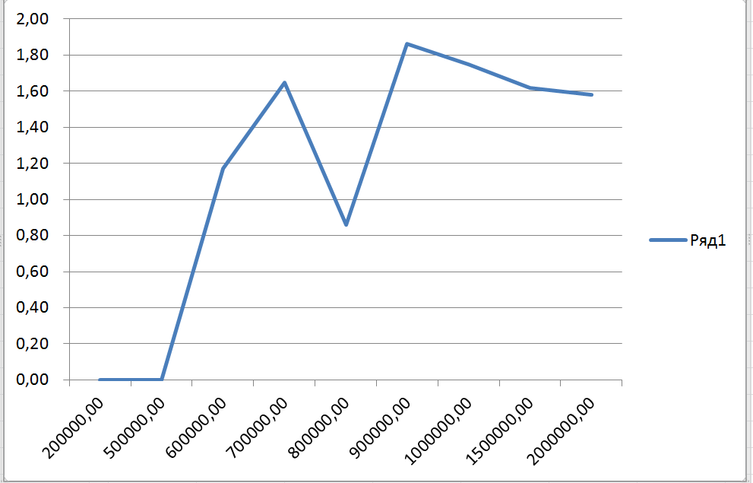
Поиск максимального элемента
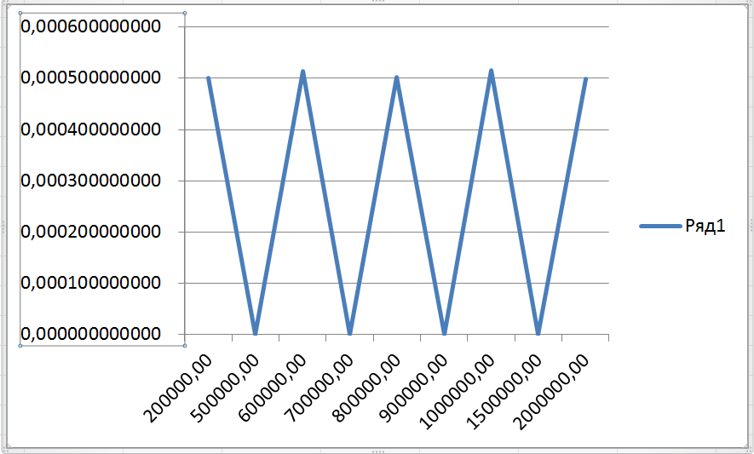

Поиск минимального элемента

Заключение
Выполнять данную курсовую работу было очень весело. Было много интересных моментов. Изучены разные вещи, которые до этого мне были не известны. В дальнейшем, если будут изучены различные языки, я постараюсь написать более эффективную реализацию данной структуры.

