Student Name: James Ignacio
Assignment 2 – Screenshots: (CRUD)
Mongo:
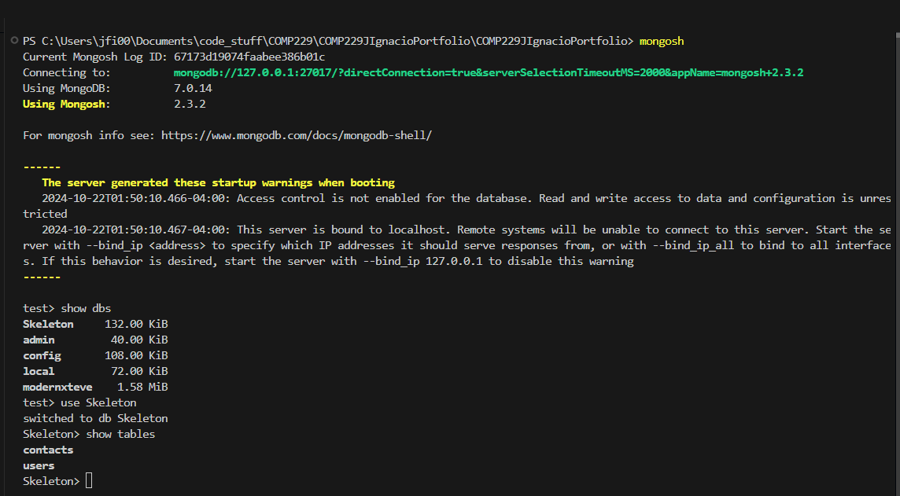
Contacts
Methods | Urls | Screenshot
GET | api/contacts | 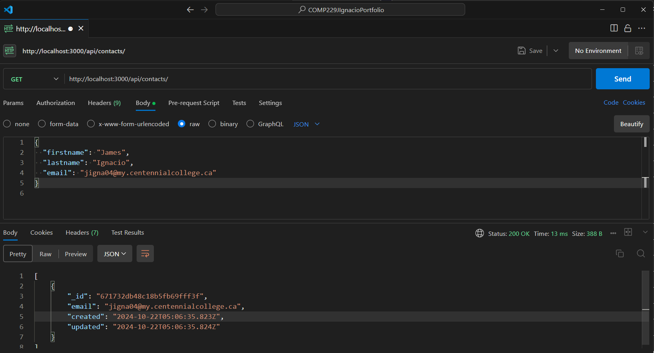
GET | api/contacts/:id | 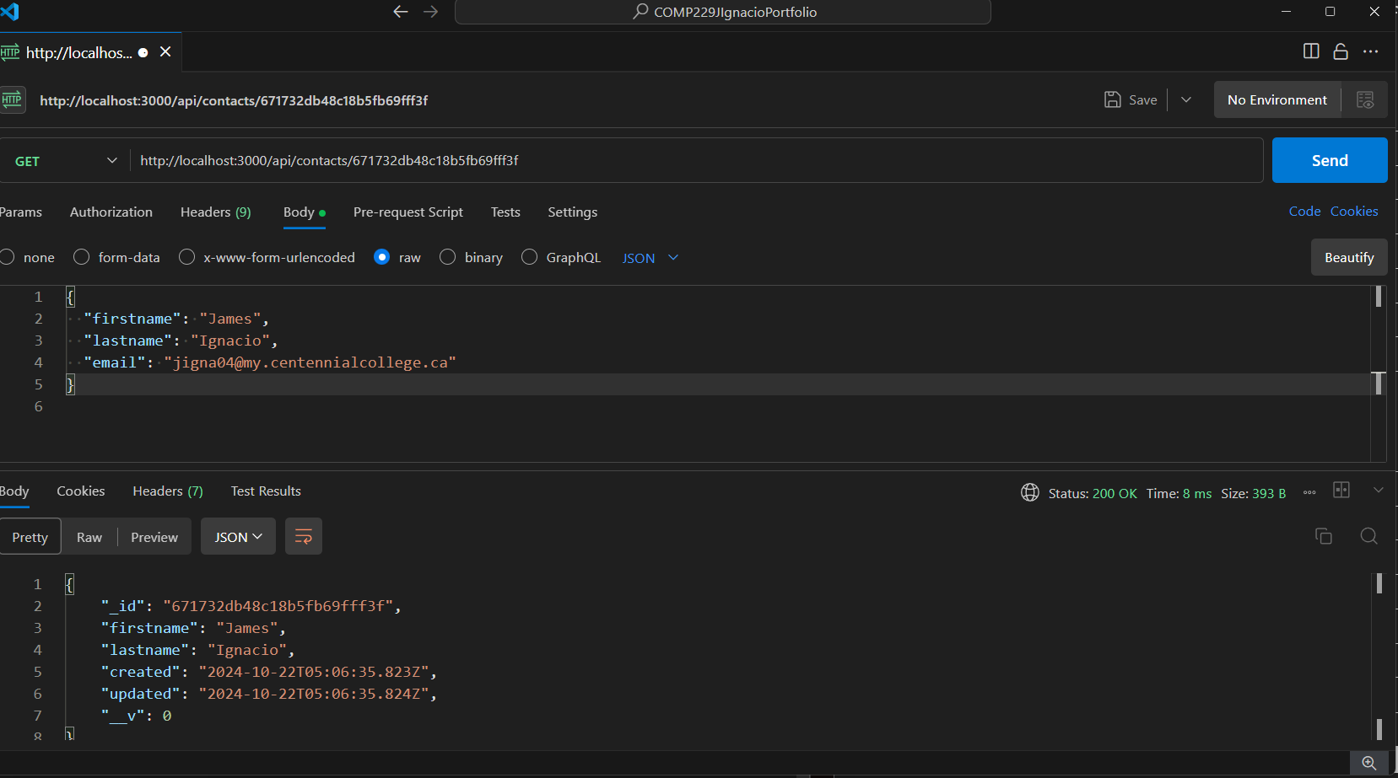
POST | api/contacts | 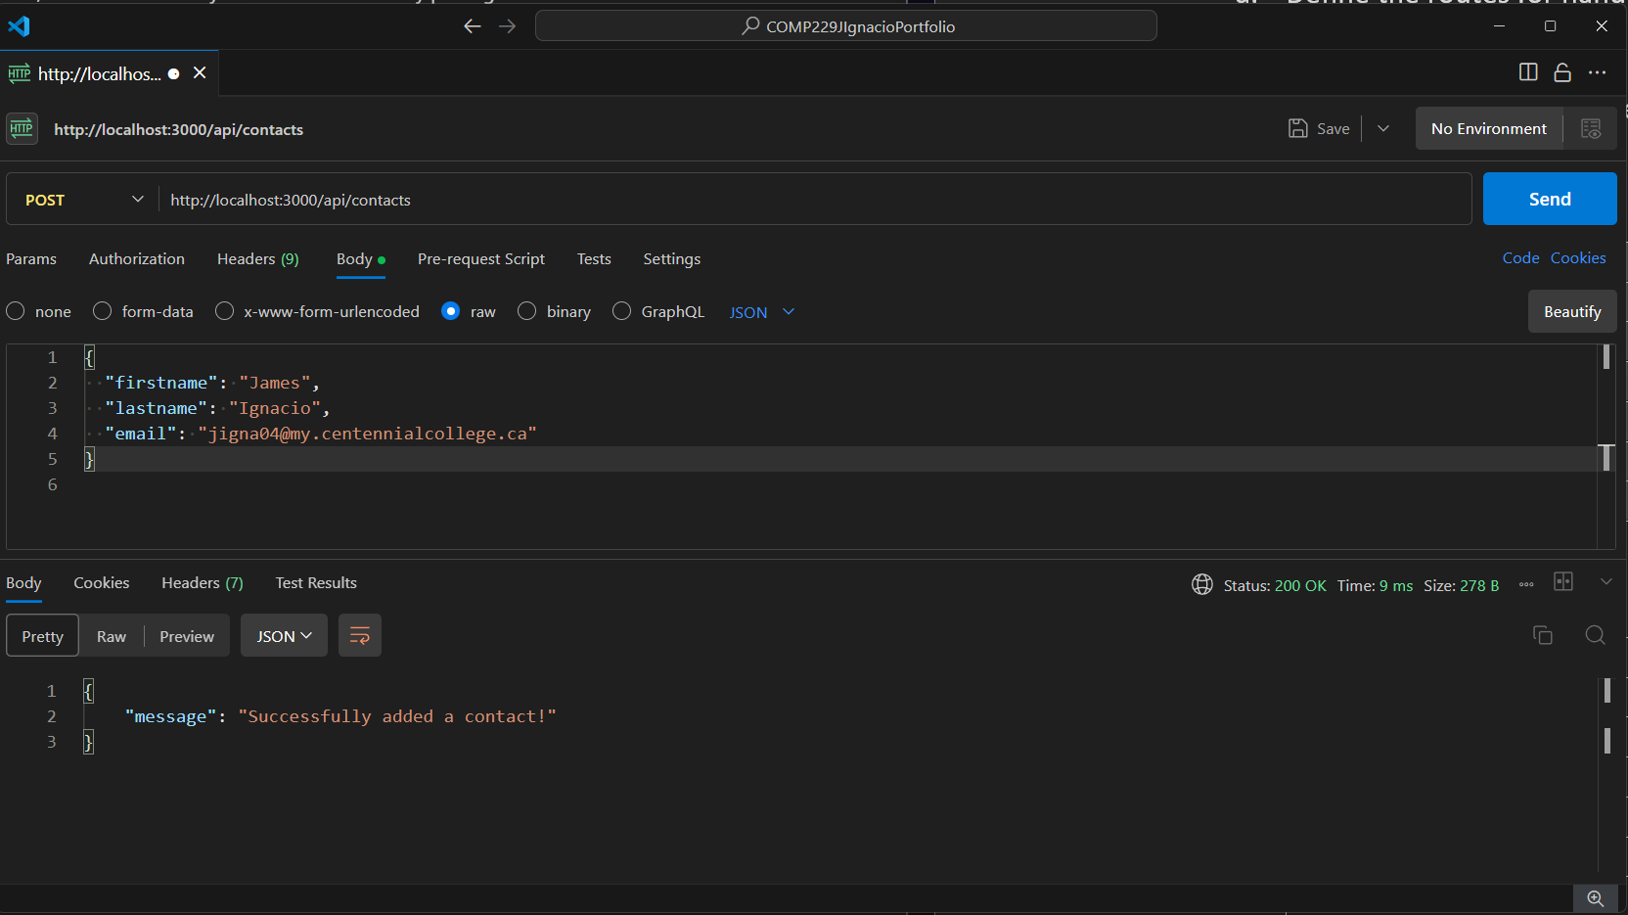
PUT | api/contacts/:id | 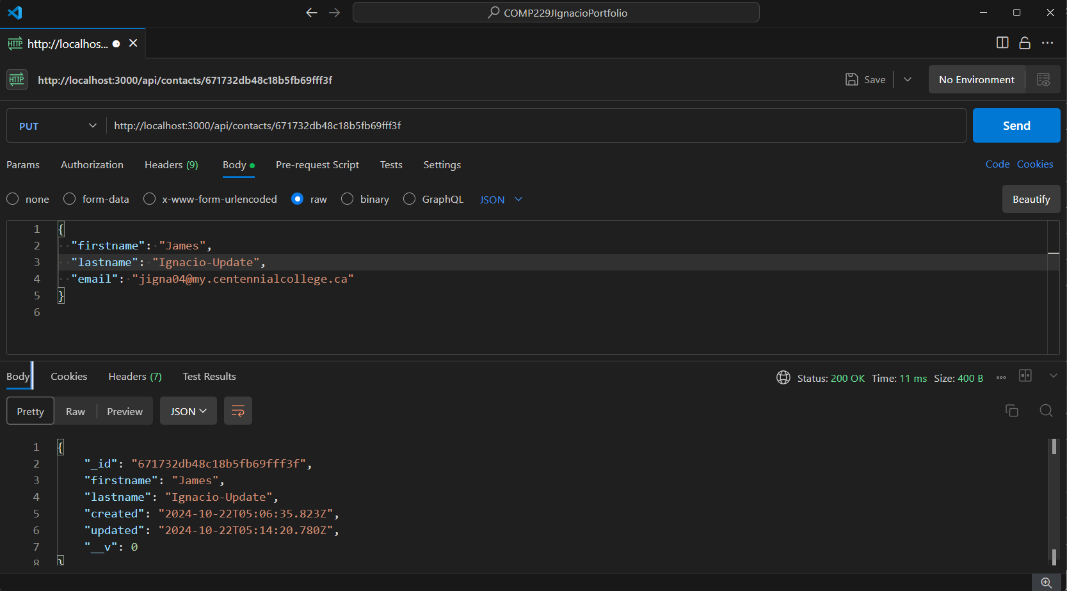
DELETE | api/contacts/:id | 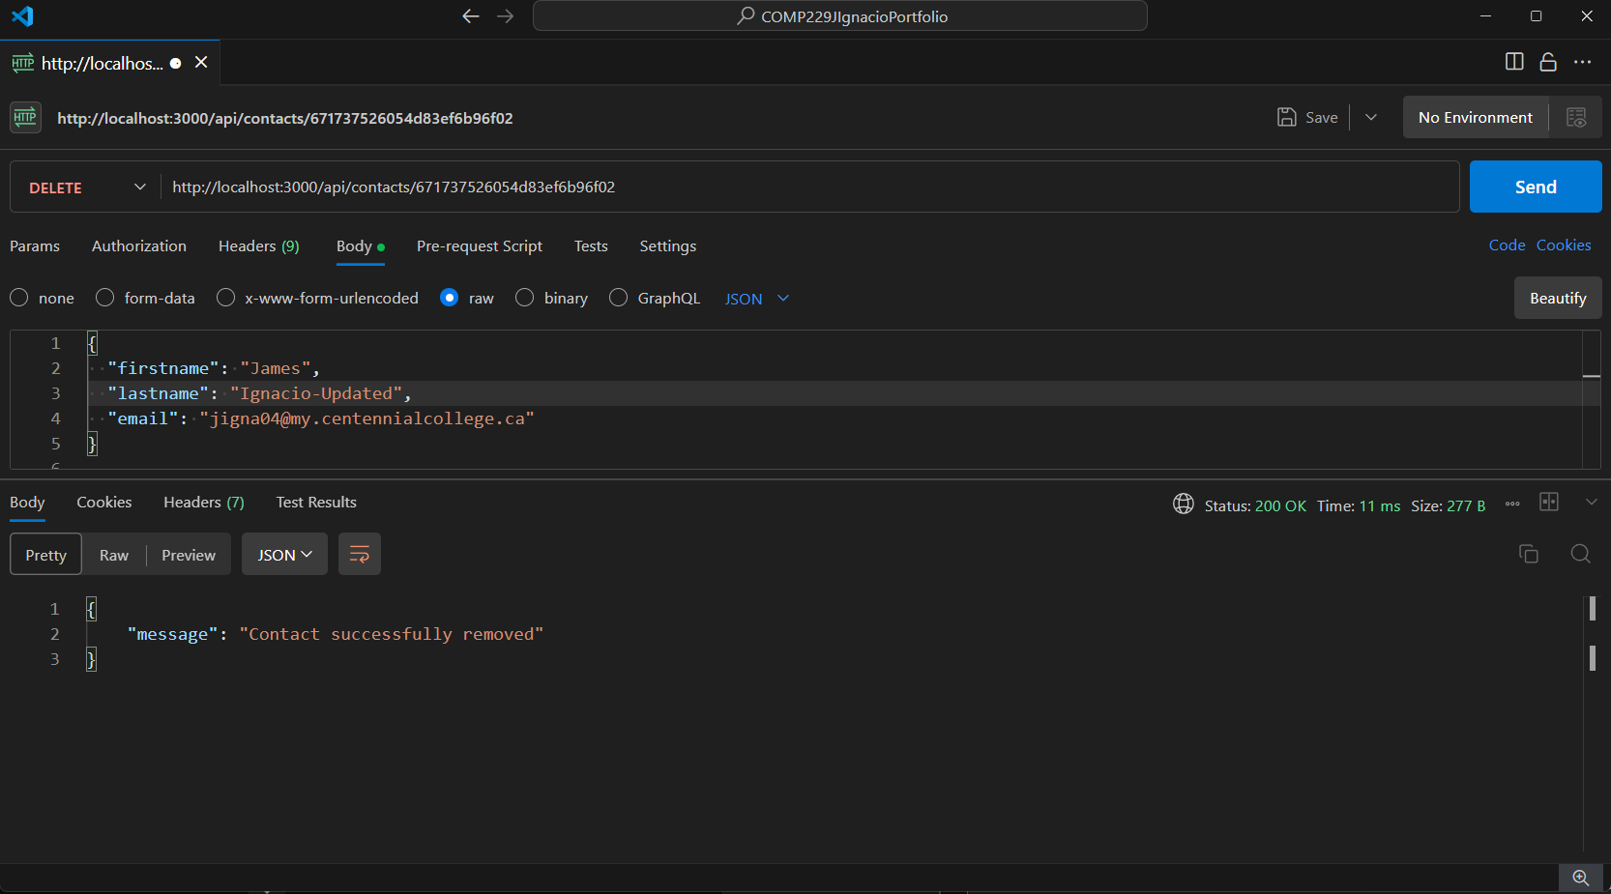
DELETE | api/contacts | 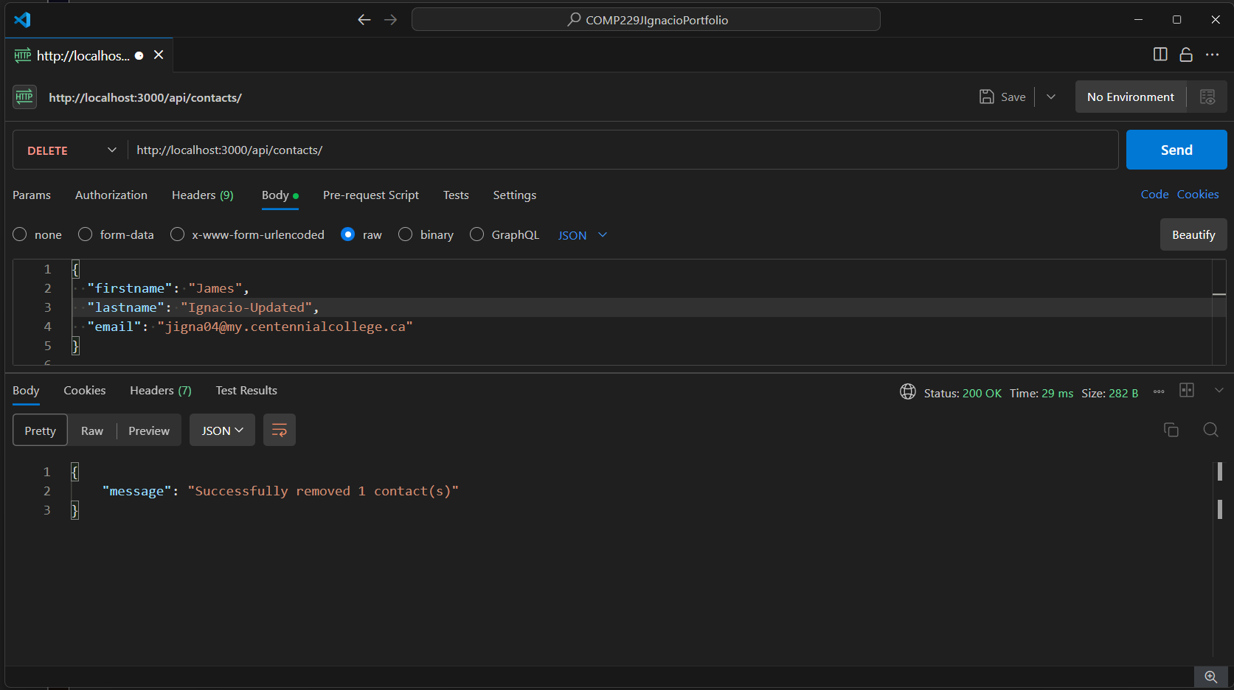

USERS:
Methods | Urls | Actions
GET | api/users | 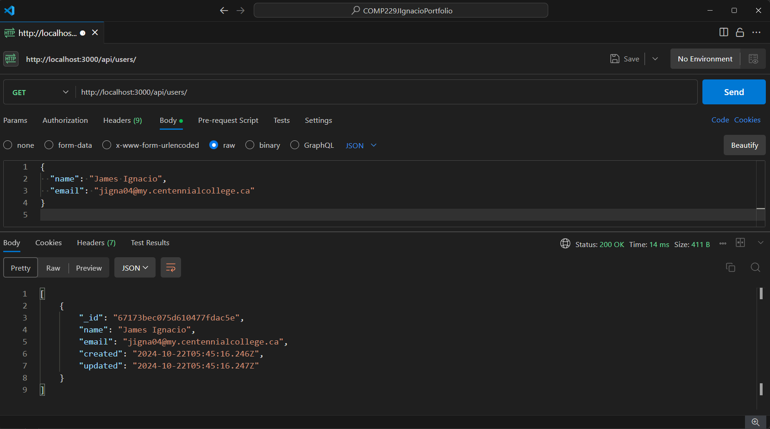
GET | api/users/:id | 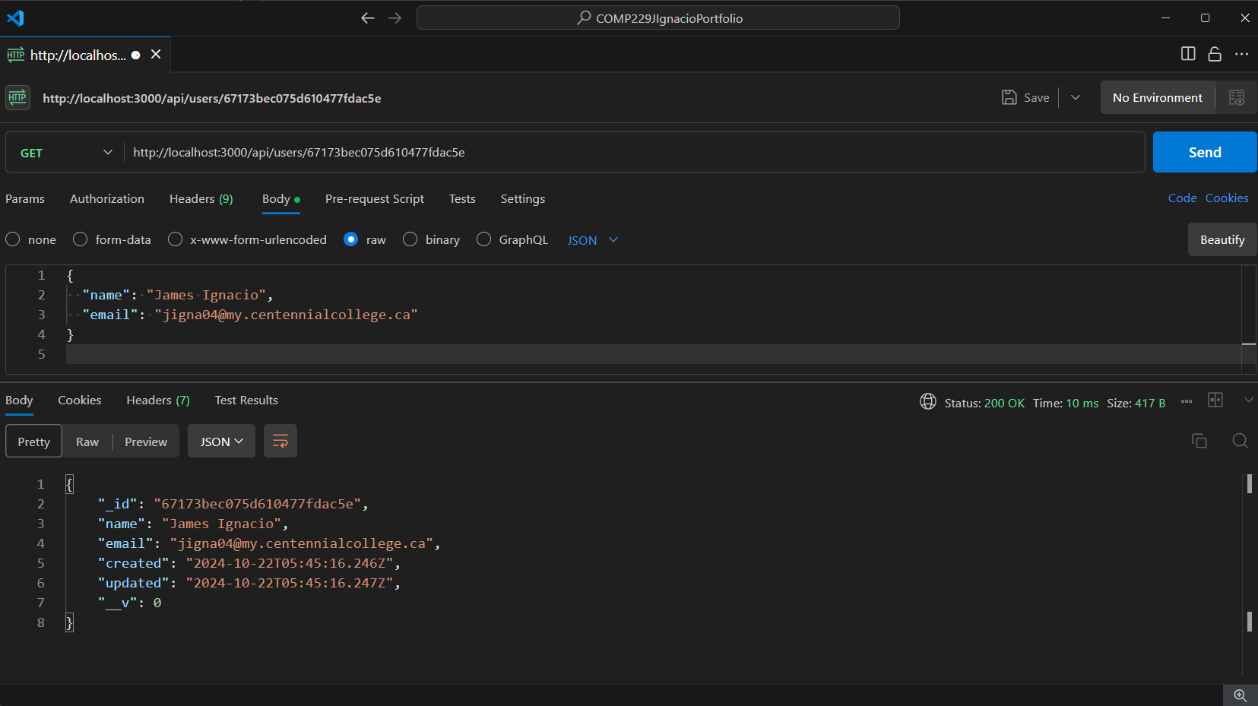
POST | api/users | 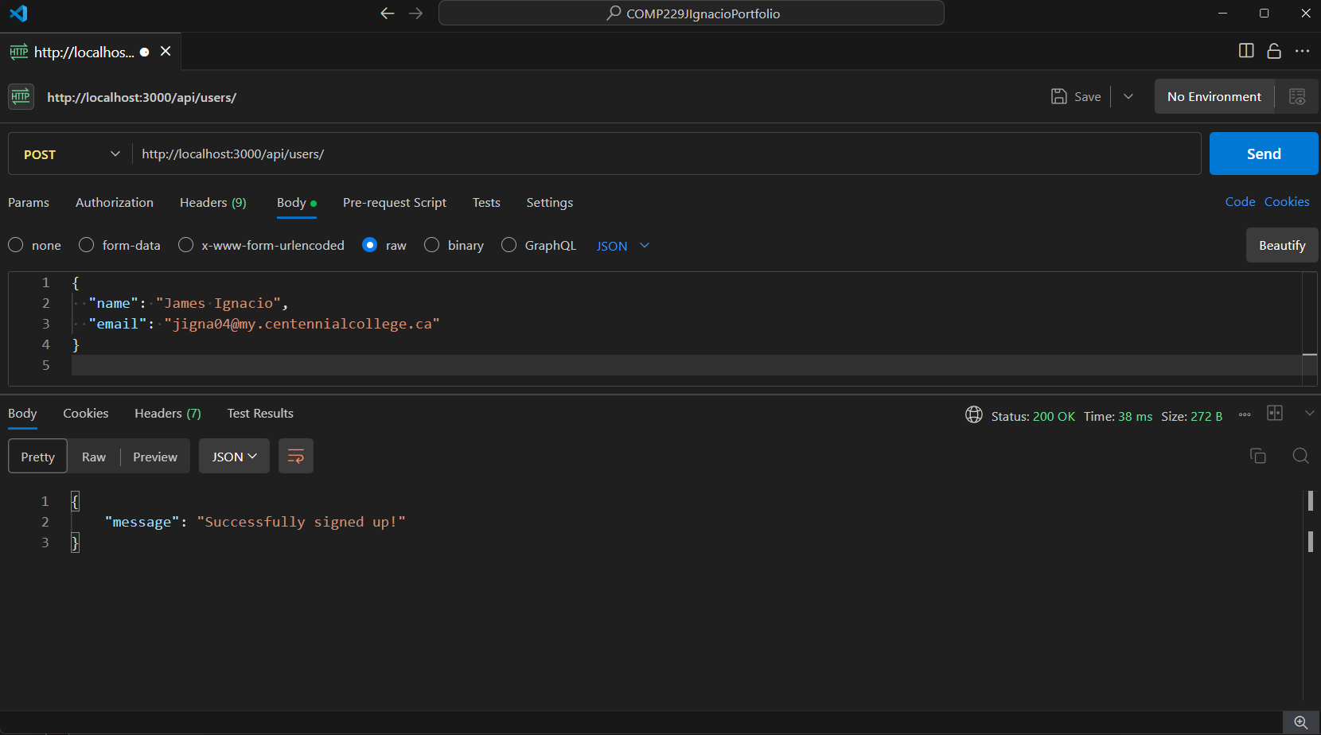
PUT | api/users/:id | 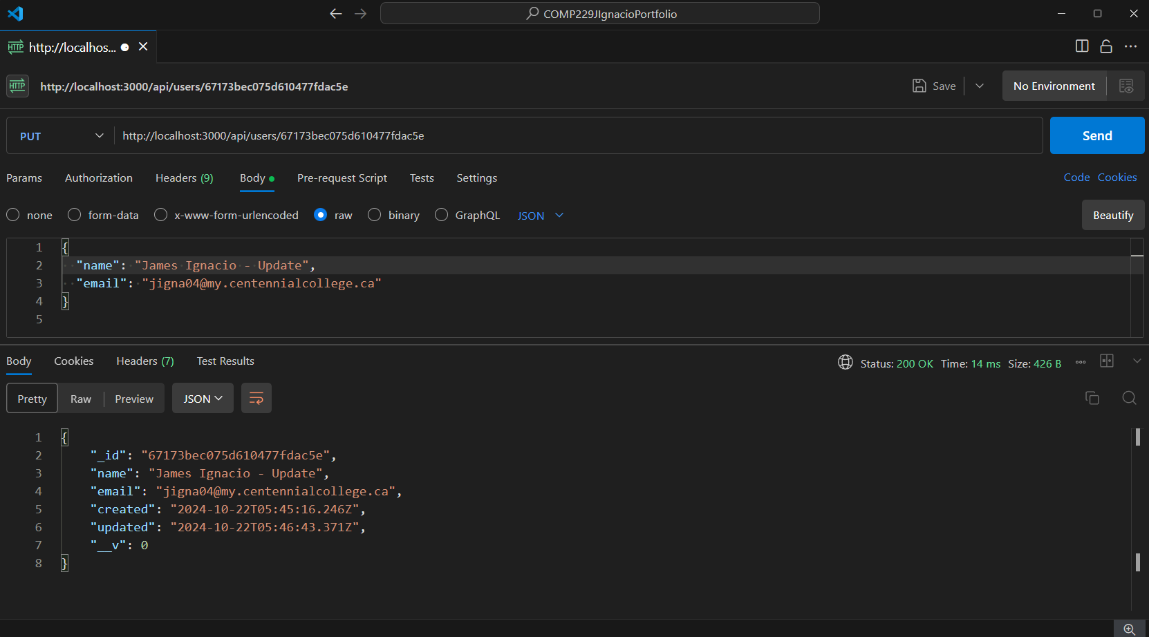
DELETE | api/users/:id | 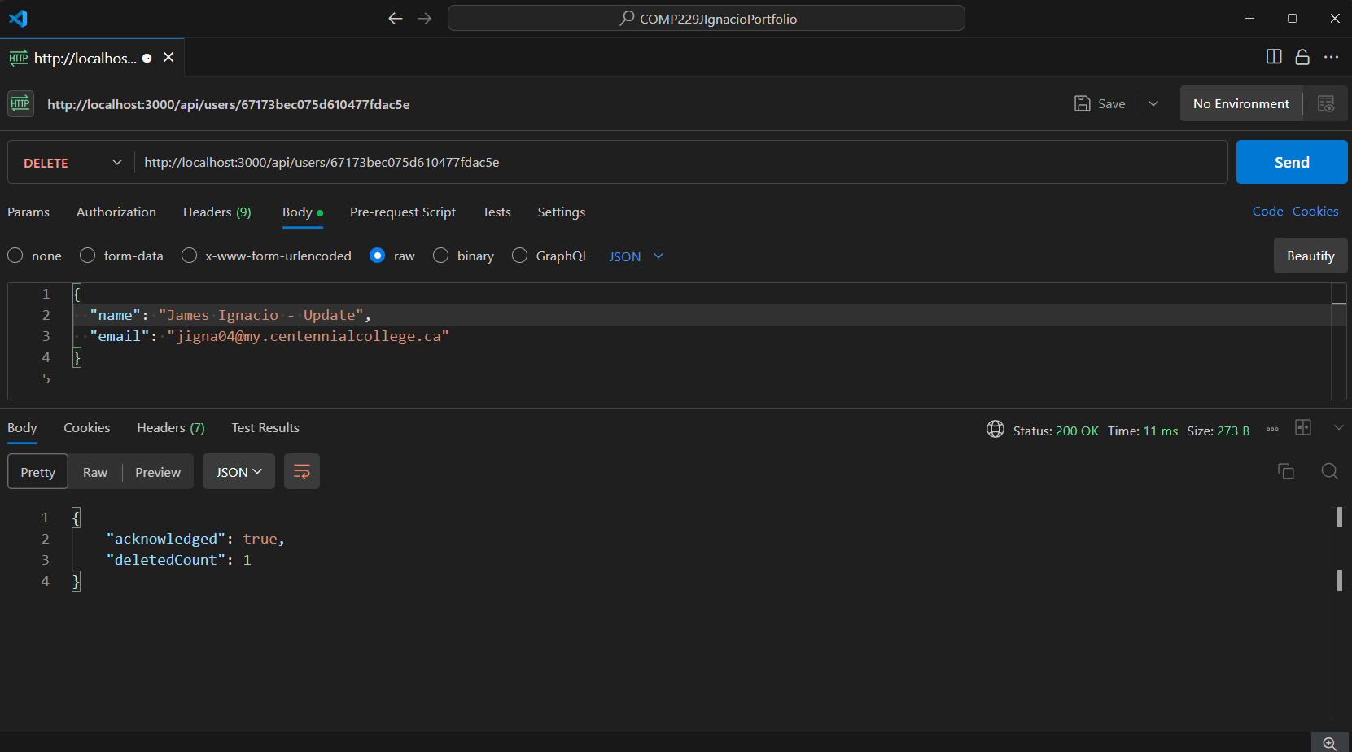
DELETE | api/users | 