Task 1: System Monitoring Setup
- install Monitoring Tools:
- sudo apt update && sudo apt install htop -y
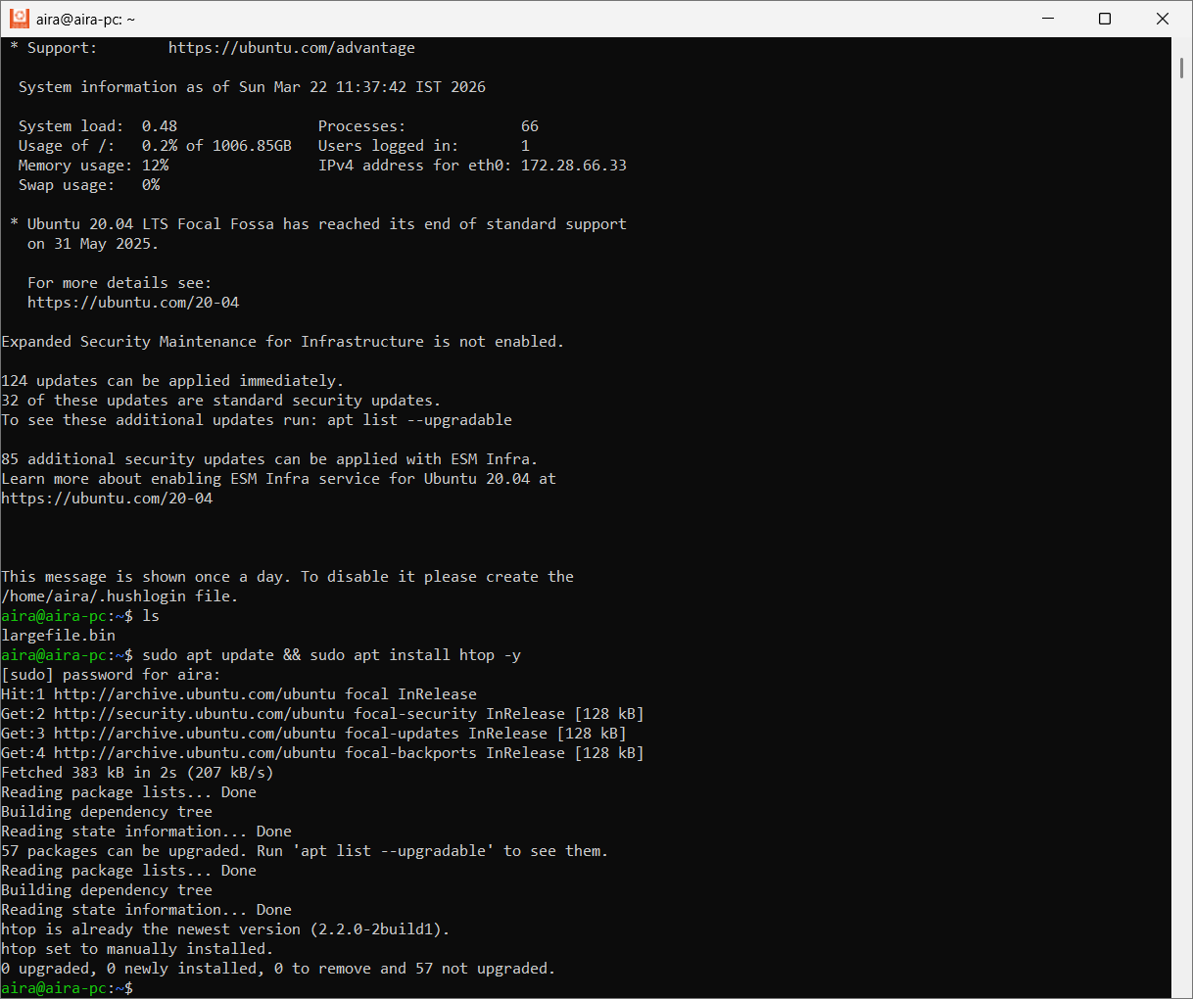
- Command: run the htop to get to know the CPU and Memory usage
htop
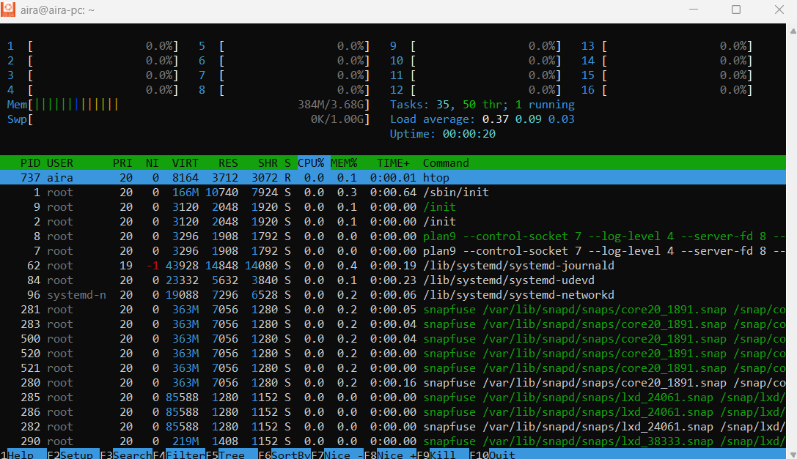
- Command : Run the df -kh , to know the files/folder size in the path
df -kh

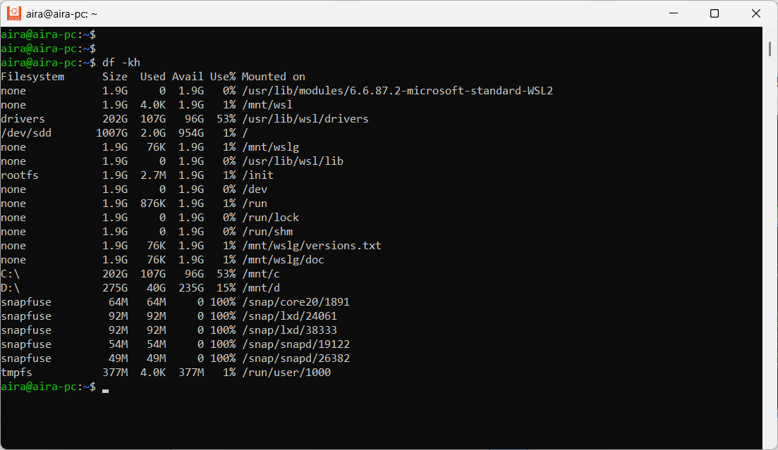

- I
- Command : Run the du -sh folder_name , To get to know the which particular folder is consumed space

sudo du -sh workspace/
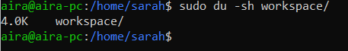

- Sorting:
we can pipe the results to sort -h to see the largest items at the bottom:
du -sh /folder_name/* | sort -h

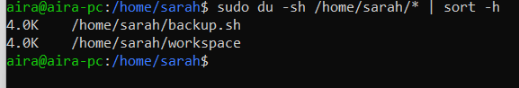

- Commands : To check the CPU and the Memory Resources
sudo ps aux --sort=-%cpu | head -10
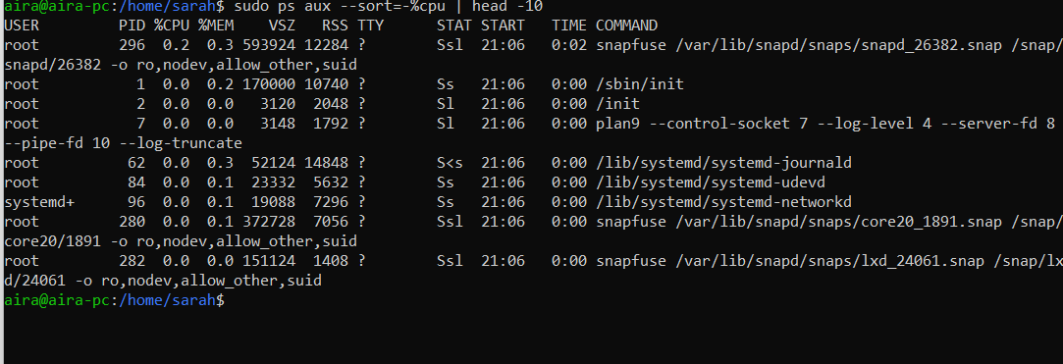
sudo ps aux --sort=-%mem | head -10
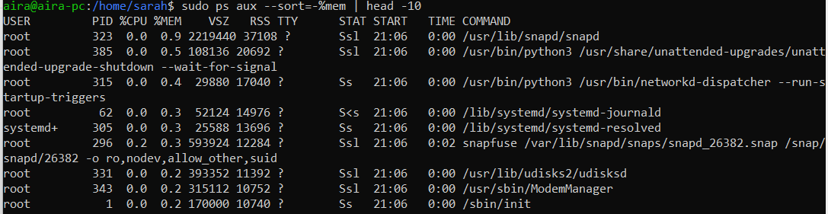

- Disk & Process Monitoring Script:
Create a script /usr/local/bin/sys_monitor.sh to log system health:
sys_monitor.sh code:

#!/bin/bash
LOG_FILE="/var/log/sys_health.log"
echo "--- Report Date: $(date) ---" >> $LOG_FILE
echo "Disk Usage:" >> $LOG_FILE df -h >> $LOG_FILE
echo "Top 5 Resource Intensive Processes:" >> $LOG_FILE
ps -eo pid,ppid,cmd,%mem,%cpu --sort=-%cpu | head -n 6 >> $LOG_FILE
echo "------------------------------" >> $LOG_FILE
- Run chmod +x /usr/local/bin/sys_monitor.sh to make it executable.
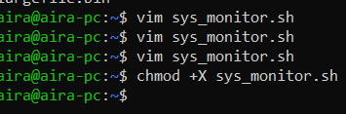

Task 2: User Management & Access Control
- Create Users and Workspaces:
sudo useradd -m sarah
sudo useradd -m mike
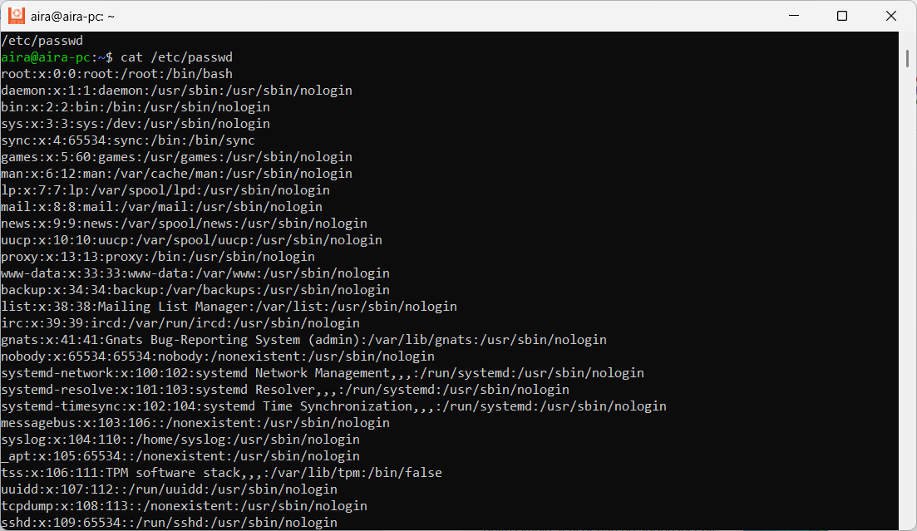
- check created users:
ls -ld /home/sarah
ls -ld /home/mike

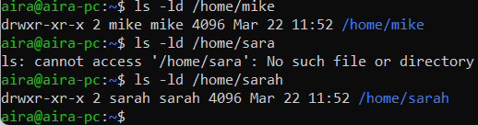

- Set set passwords for Created users
echo "sarah:SecurePass123!" | sudo chpasswd
echo "mike:SecurePass456!" | sudo chpasswd

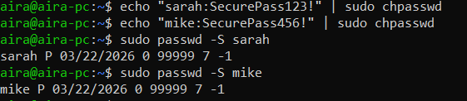

- Verify Created passwwords of sarah nad mike
sudo passwd -S sarah
sudo passwd -S mike



- Create and secure directories for Sarah and mike
sudo mkdir -p /home/sarah/workspace /home/mike/workspace
ls -ld /home/sarah/workspace /home/mike/workspace

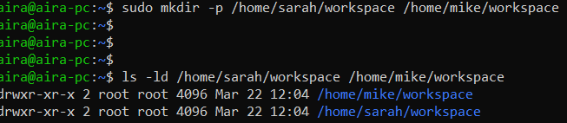
- Granting User Ownership of Home Subdirectories
sudo chown sarah:sarah /home/sarah/workspace
sudo chown mike:mike /home/mike/workspace

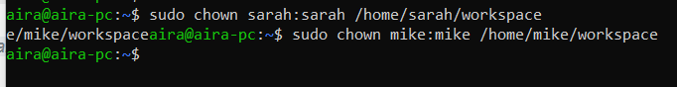
- Isolating Sarah and mikes’s Workspace Directories
sudo chmod 700 /home/sarah/workspace /home/mike/workspace

- Implement Password Policy:
Set password expiration to 30 days
sudo chage -M 30 sarah
sudo chage -M 30 mike

- Verify 30 days Password created for Sarah and mike
sudo chage -l sarah
sudo chage -l mike

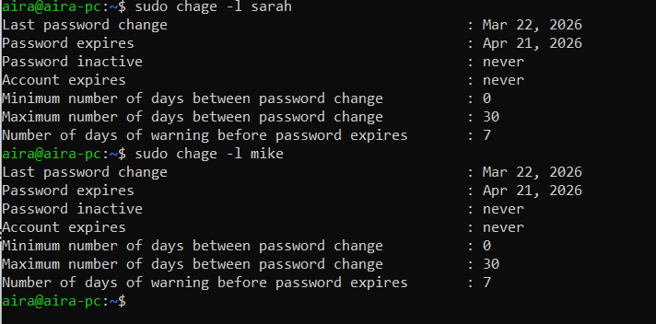
- Implementing a Strong Password Complexity Policy
To enforce complexity (on Debian/Ubuntu), edit /etc/pam.d/common-password:
Add:
password requisite pam_pwquality.so retry=3 minlen=12 lcredit=-1 ucredit=-1 dcredit=-1 ocredit=-1
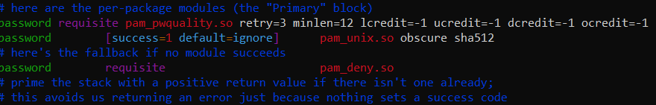
- How to Verify
It should now give you an error if the password doesn't meet your 12-character, multi-case, and symbol requirements

sudo passwd sarah
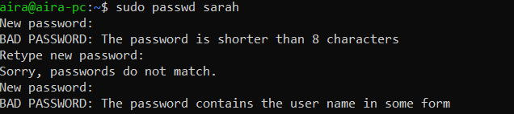
Task 3: Backup Configuration for Web Servers
- Create Backup Directory:
sudo mkdir -p /backups
sudo chmod 777 /backups

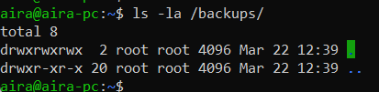

- Sarah’s Backup Script (/home/sarah/backup.sh)
cd /home/sarah/
make backup.sh
#!/bin/bash
DATE=$(date +%Y-%m-%d)
FILE="/backups/apache_backup_$DATE.tar.gz"
tar -czf $FILE /etc/httpd/ /var/www/html/
echo "Verification for $DATE:" >> /backups/verify.log
tar -tf $FILE >> /backups/verify.log
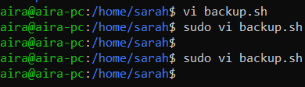

- Mike’s Backup Script (/home/mike/backup.sh)
cd /home/mike/
make backup.sh

#!/bin/bash
DATE=$(date +%Y-%m-%d)
FILE="/backups/nginx_backup_$DATE.tar.gz"
tar -czf $FILE /etc/nginx/ /usr/share/nginx/html/
echo "Verification for $DATE:" >> /backups/verify.log
tar -tf $FILE >> /backups/verify.log

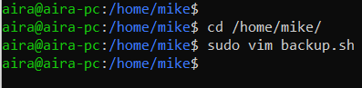

- Granting Execution Rights to User Scripts
sudo chown sarah:sarah /home/sarah/backup.sh
sudo chown mike:mike /home/mike/backup.sh
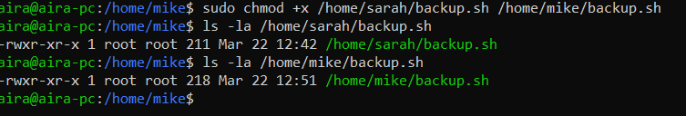
- Automating Weekly Backup Schedules via Cron job:
- This job has to run every Tuesday at 12:00 AM
sudo crontab -e
0 0 * * 2 /bin/bash /home/sarah/backup.sh
0 0 * * 2 /bin/bash /home/mike/backup.sh

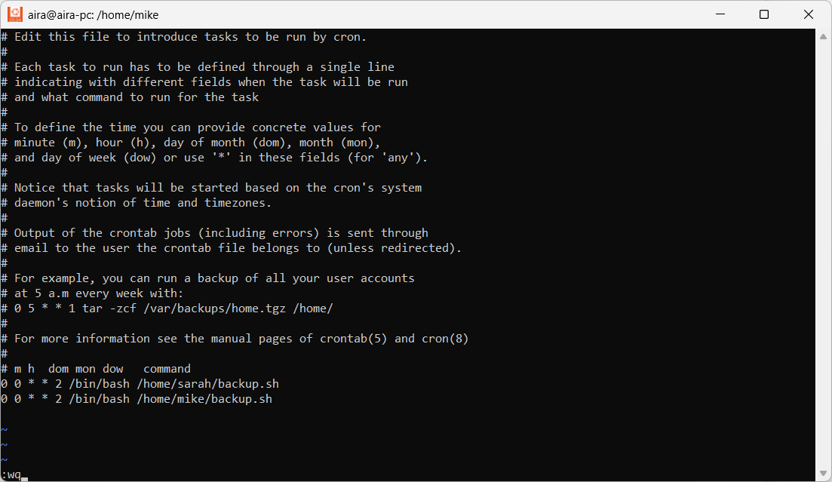

The Breakdown of 0 0 * * 2
Cron uses five fields to determine the timing. Here is how yours is set up:
Field | Value | Description
Minute | 0 | At the start of the hour (00)
Hour | 0 | At midnight (00:00)
Day of Month | * | Every day of the month
Month | * | Every month
Day of Week | 2 | Tuesday (0=Sun, 1=Mon, 2=Tue...)

- How to verify it is scheduled
Run this command to list all active cron jobs and make sure yours are there

sudo crontab -l
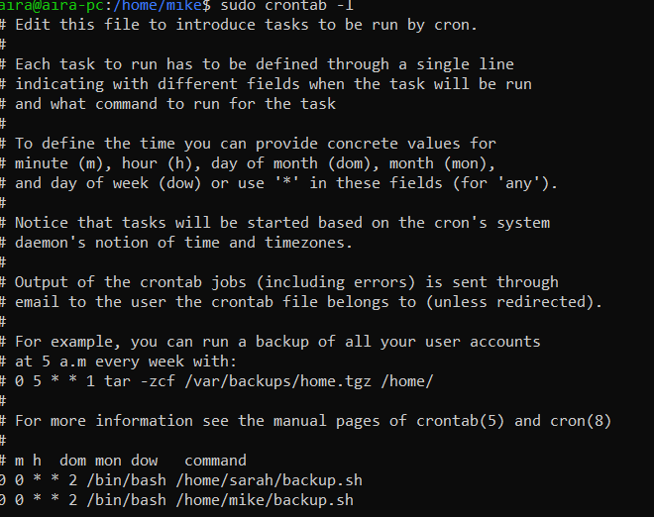

- Check the Cron Service Status
sudo systemctl status cron
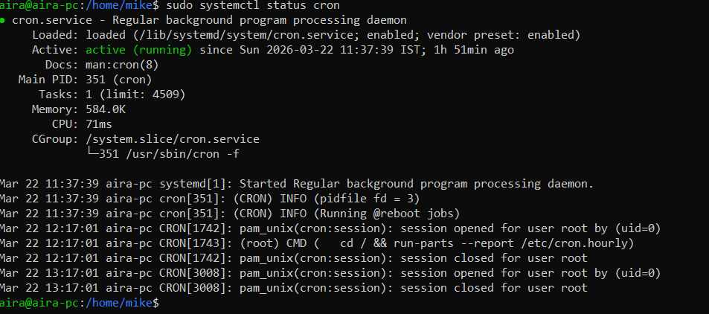
- Run for Verification.
To confirm everything is working now without waiting until Tuesday,
you can temporarily set a job to run every minute:

Steps:
  - Open crontab: sudo crontab -e
  - Add: * * * * * /bin/bash /home/sarah/backup.sh
* * * * * /bin/bash /home/mike/backup.sh
  - Save and wait 60 seconds, then check the logs again using the grep commands above.

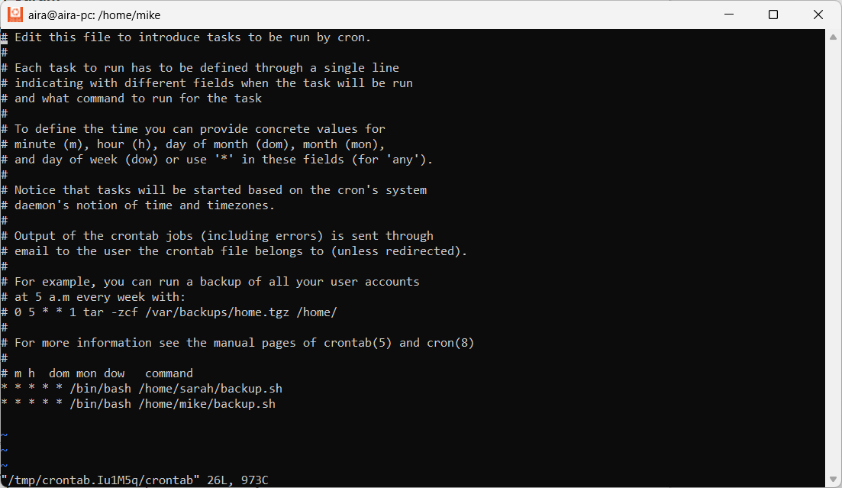
- Backups for Every 60 Seconds:
ls -lrt /backups/
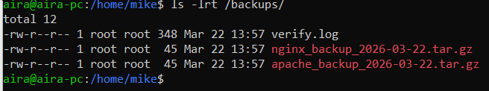
Implementation Report Summary:
- Task 1: Tools like htop provide real-time visibility, while the custom script ensures historical data for capacity planning.
- Task 2: Isolation was achieved using chmod 700, preventing users from "peeking" into each other's workspaces. Password aging was enforced via chage.
- Task 3: Automation via cron ensures backups occur without manual intervention. The inclusion of tar -tf in the script provides an automated integrity log.
- Challenges: Ensuring the /backups directory had correct permissions for both user scripts to write to was critical. For production, consider moving backups to an external volume.

