Travel Memory App — Full Stack Deployment (MERN + DevOps)

🚀 Project Overview
The Travel Memory application has been developed using the MERN stack. Your challenge is to deploy this application on an Amazon EC2 instance. This will provide you with hands-on experience in deploying full-stack applications, working with cloud platforms, and ensuring scalable architecture. This project demonstrates end-to-end deployment of a production-grade application using modern DevOps practices on AWS.

🧠 Tech Stack

🔹 Frontend:
- React.js
- Axios
- CSS

🔹 Backend:
- Node.js
- Express.js
- MongoDB (Atlas)
- Mongoose

🔹 DevOps & Infrastructure
- AWS EC2 (Compute)
- AWS Application Load Balancer (ALB)
- Nginx (Reverse Proxy + Static Hosting)
- PM2 (Process Manager)
- Cloudflare (DNS, CDN, SSL)

Architecture:
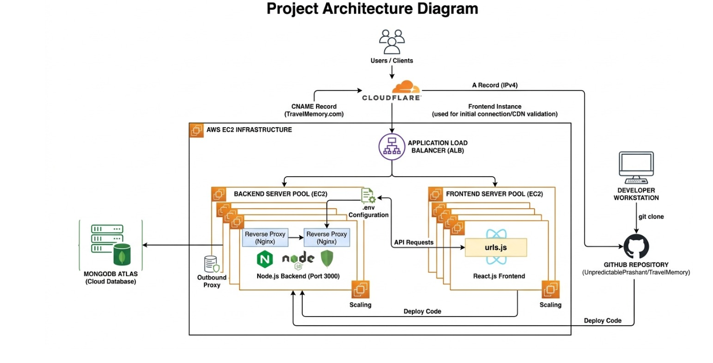

Project Tasks:
Task1. Backend Configuration:
Launch EC2 Instance
Connect via SSH
Installed below softwares
  - sudo apt update && sudo apt upgrade -y
  - sudo apt install -y git
  - sudo curl -fsSL https://deb.nodesource.com/setup_18.x | sudo -E bash -y
  - sudo apt install -y nodejs
  - sudo apt install nginx -y
  - sudo systemctl start nginx
  - sudo systemctl enable nginx
  - sudo npm install -g pm2

Launch EC2 Instance:
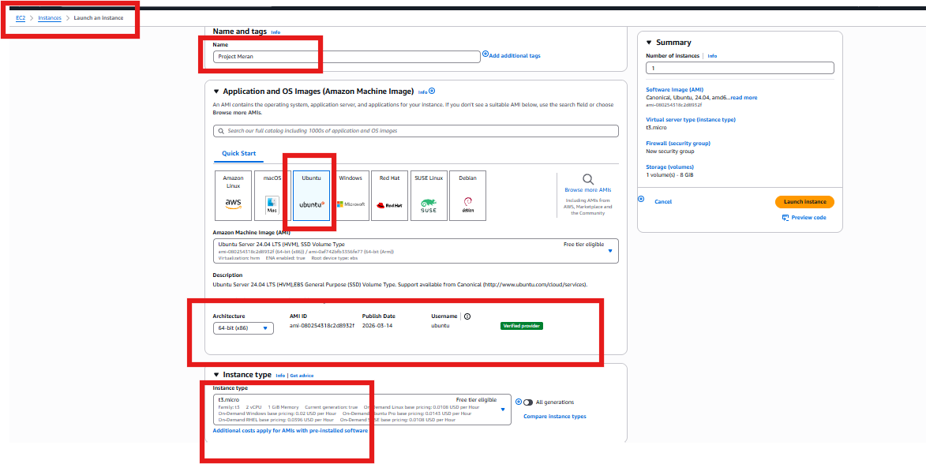

Create the Key pair .pem for the SSH and HTTP access,
And , we have added the Security policy which we have created earlier
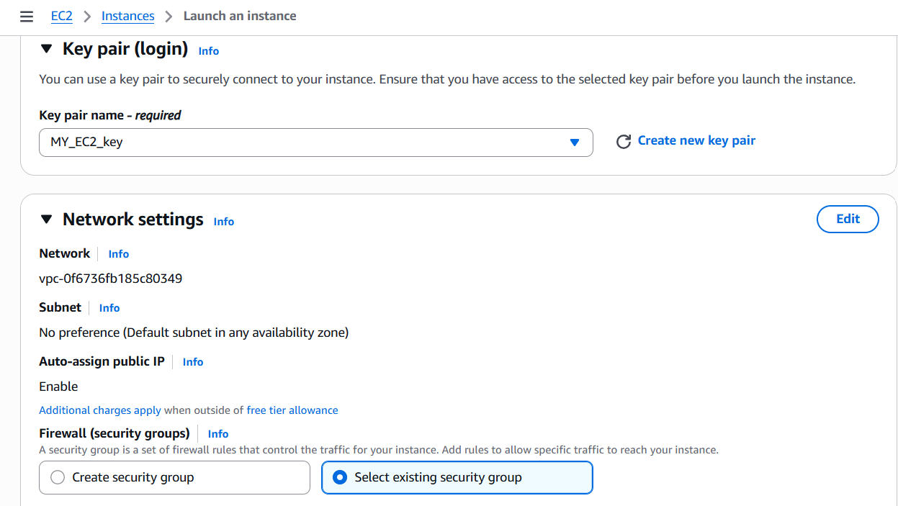
Advance feature option, I have Configured Bash Script to download and install the
Task Dependencies: like npm, nginx,Node.js, Git,Nginx.pm2

Executed or configured bash commands for EC2 setup:
- sudo apt update && sudo apt upgrade -y
- sudo apt install -y git
- sudo curl -fsSL https://deb.nodesource.com/setup_18.x | sudo -E bash -
- sudo apt install -y nodejs
- sudo apt install nginx -y
- sudo systemctl start nginx
- sudo systemctl enable nginx
- sudo npm install -g pm2

Verification for installed soft wares:
- node -v
- npm -v
- git --version
- nginx -v
- systemctl status nginx --no-pager
- pm2 status
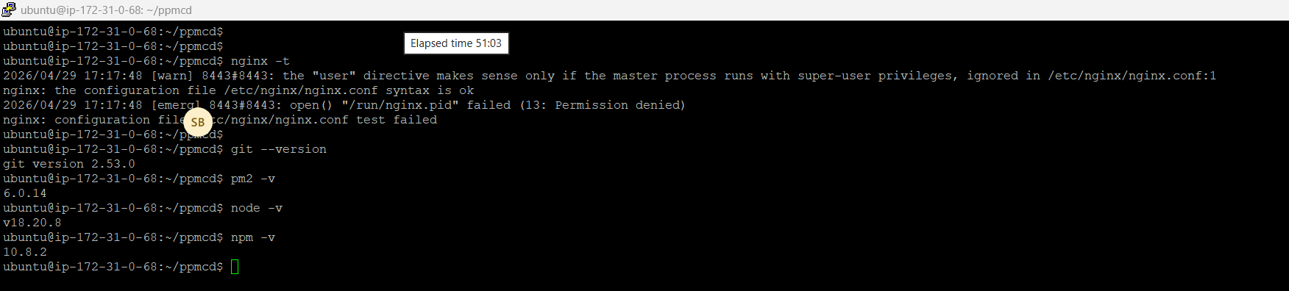
Clone MERN Full stack application from GITHUB on EC2:

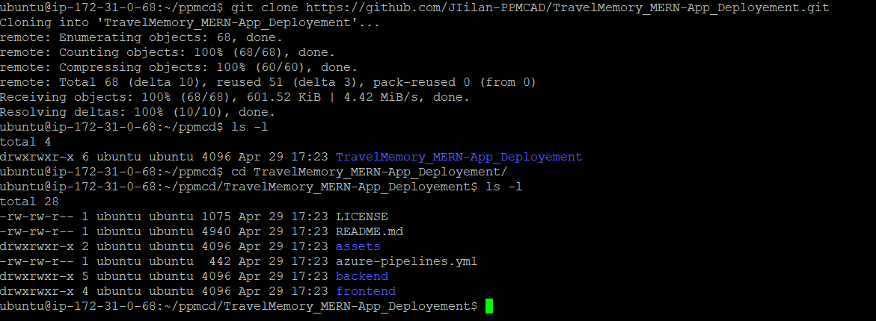
- Run back end (npm start)
- Test → http://EC2-IP:3000

First create the Security rules for this application:
- Go to the EC2 and the →Networking >> Security Rules >> Create a new Rule ,
In Bound Rules:
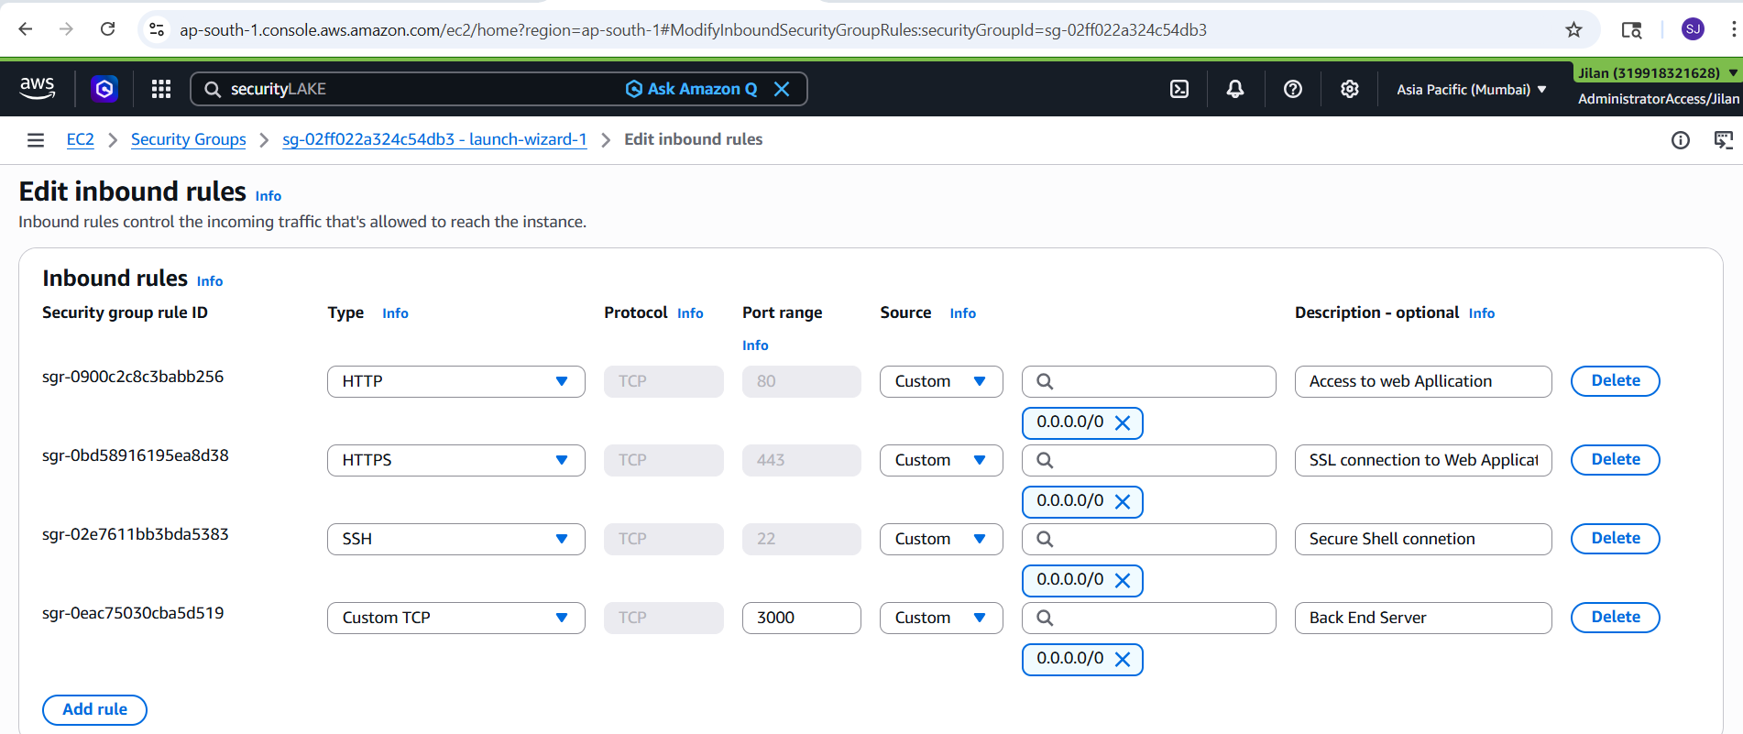

Out Bound Rules:
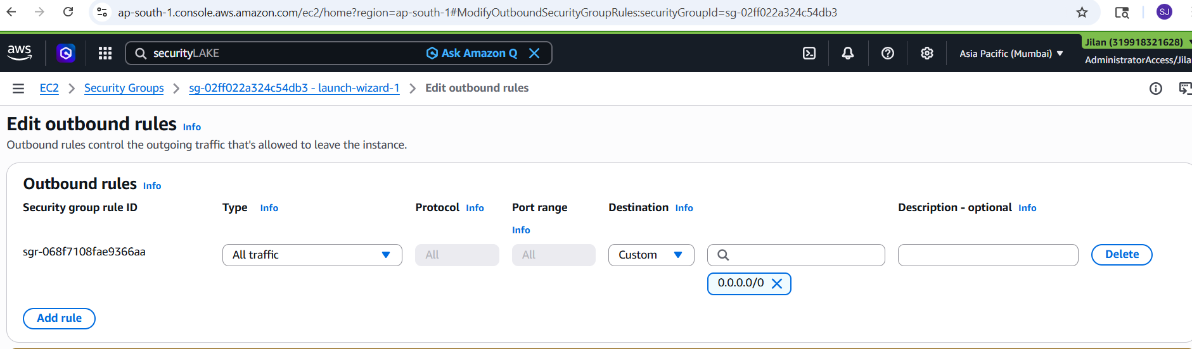

Next step Setup the Mongo DB:

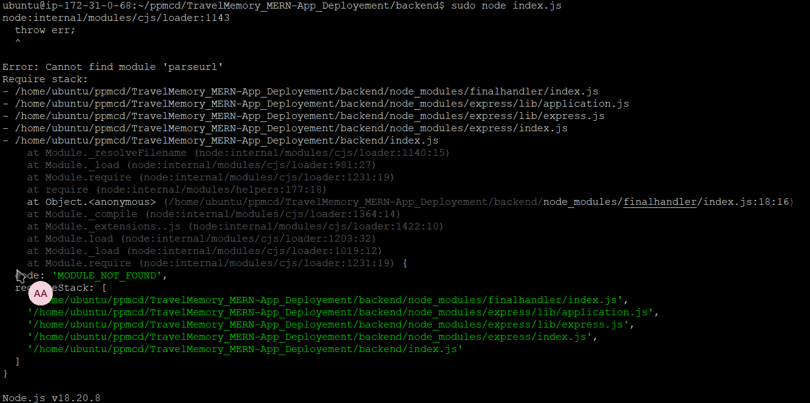
Run the node.js for backend:
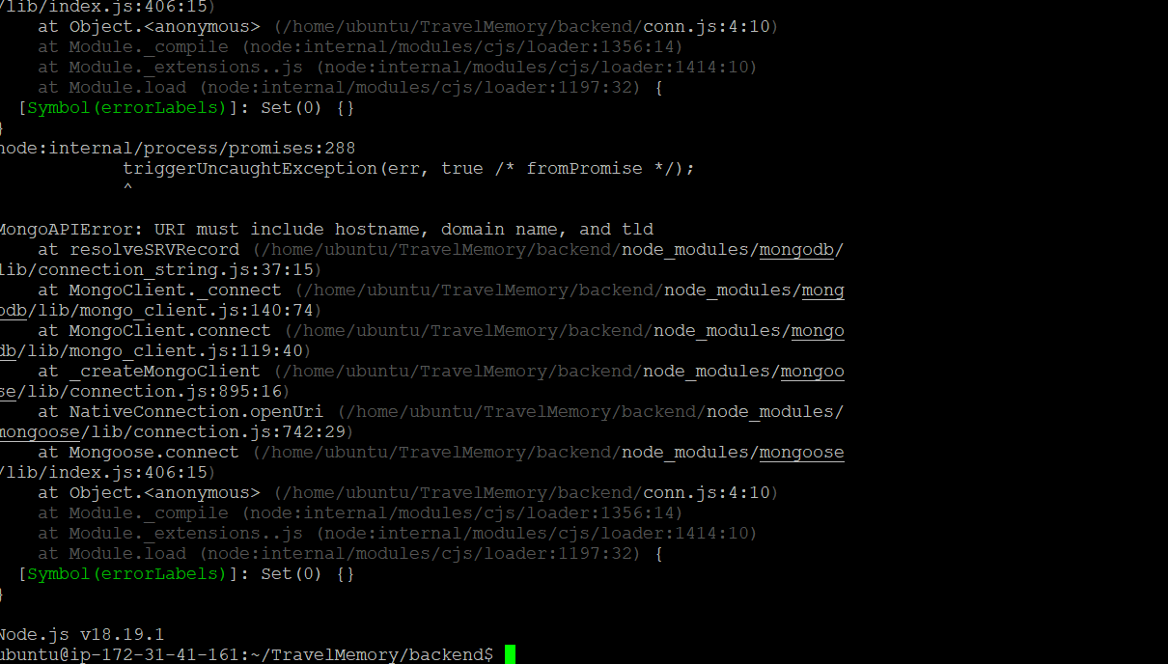
We have connected the MongoDB to the Server, using the DB cluster Details connecting string from mongo DB
Run the “nano.env” And verify it

After verify , We need to create the Job need to run in backend ,
Install the pm2 and verify it

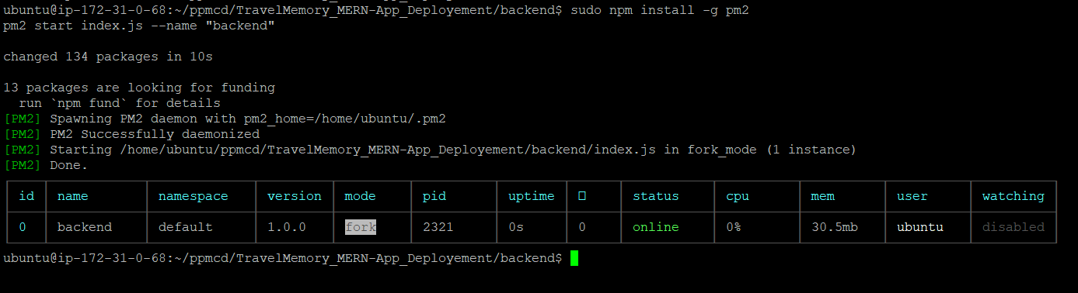

Then start the pm2 in back end:
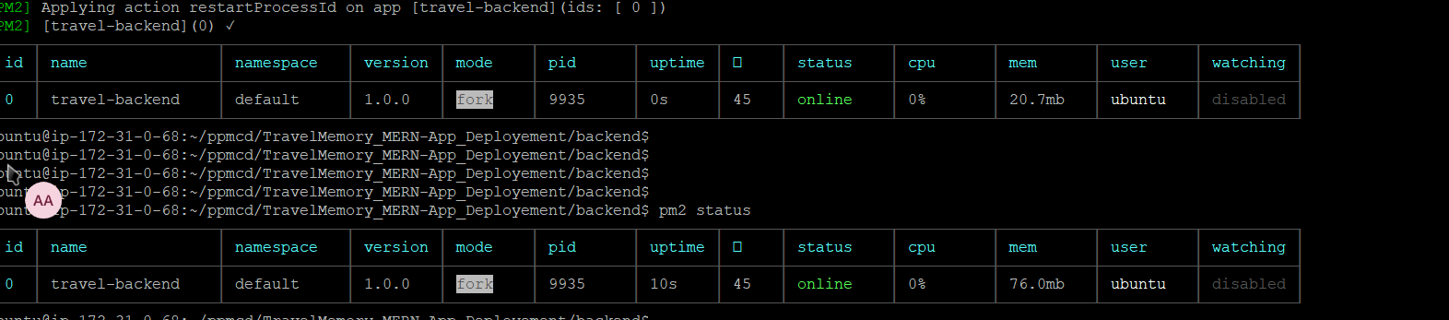
Configured the Ngnix default config file:
Executed commands and Expected out puts commands::
  - command: sudo nano /etc/nginx/sites-available/default

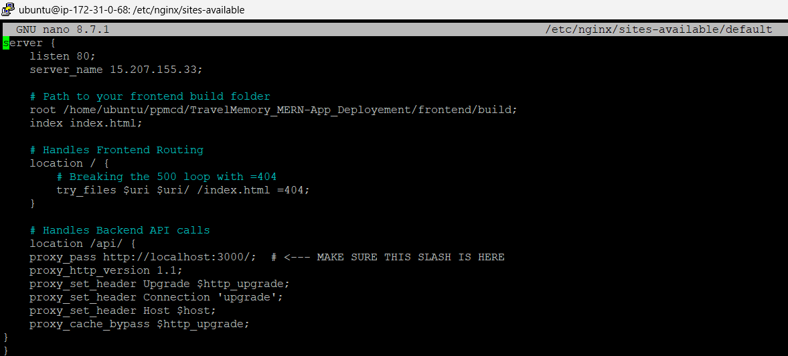
- sudo nginx -t
- sudo nano /etc/nginx/sites-available/Ngnix_Config
- sudo systemctl reload nginx

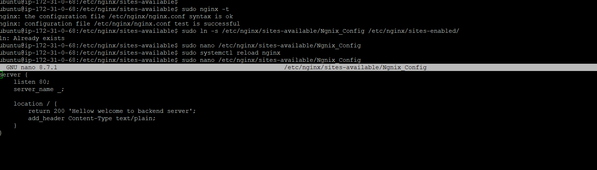
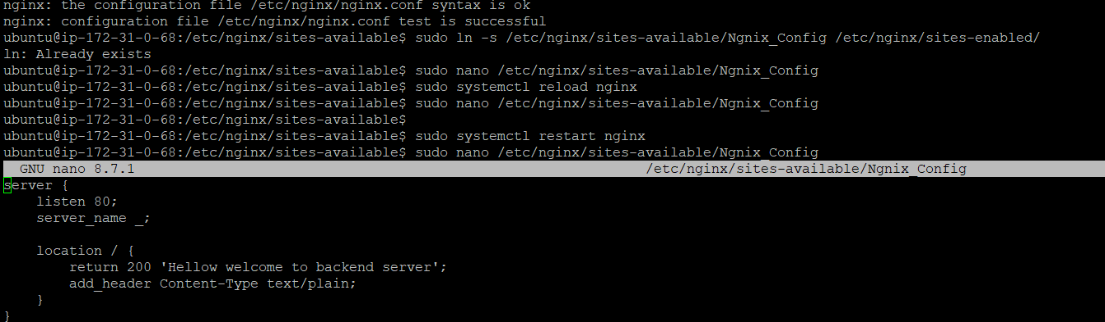
- sudo ln -s /etc/nginx/sites-available/Ngnix_Config /etc/nginx/sites-enabled/
- sudo systemctl restart nginx
- sudo systemctl status nginx.service

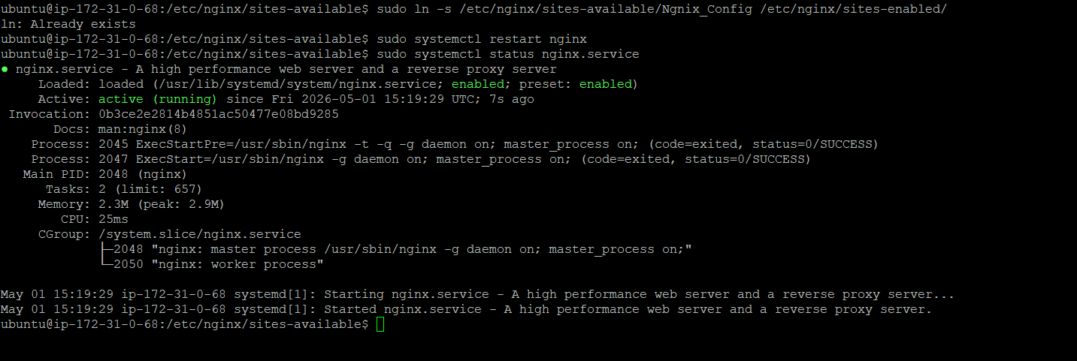
Configuration for back end:
/etc/ngnix/sites-available/default
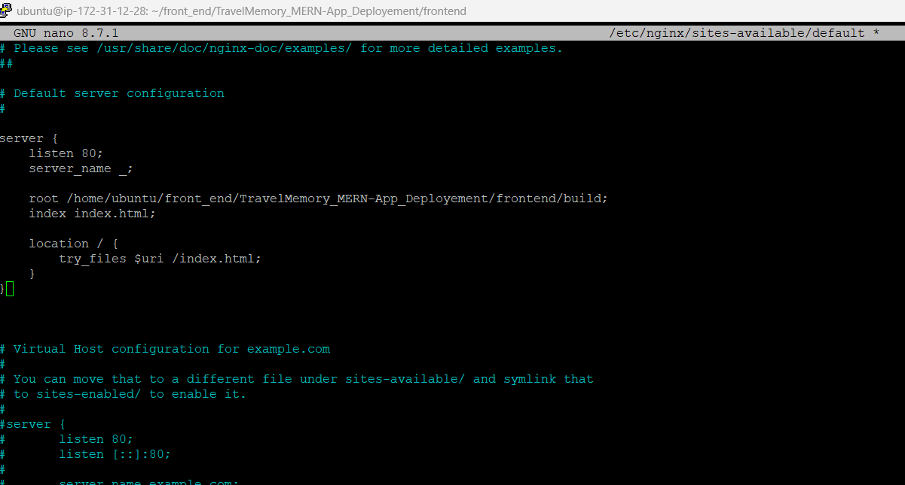
Start your Backend EC2:
Ensure your Node server is actually running in the background.
Use PM2 so it stays running even if you close the terminal
Executed command and expected outputs:
  - sudo npm install -g pm2
  - pm2 start index.js --name "backend"

Test & Reload Nginx:
Executed command and expected outputs:
- sudo systemctl reload nginx



- suod ln -s /etc/ngnix/sites-availabe/Ngnix_Config /etc/ngnix/sites-enabled/

- sudo nginx -t
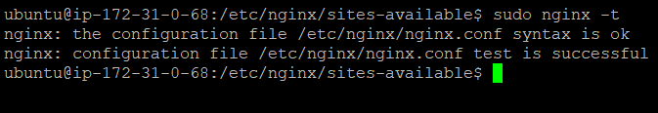

Task 2. Frontend and Backend Connection:
Frond End server Configuration:
In staling same setup on this front end ec2:
Executed commands and expected responces:
- sudo apt update && sudo apt upgrade -y sudo apt install -y git nginx
- curl -fsSL https://nodesource.com | sudo -E bash -
- sudo apt install -y nodejs
- sudo npm install -g pm2
Verification of Executed Commands:
- node -v &&
- npm -v
- git --version
- nginx -v
- systemctl status nginx --no-pager
- pm2 status

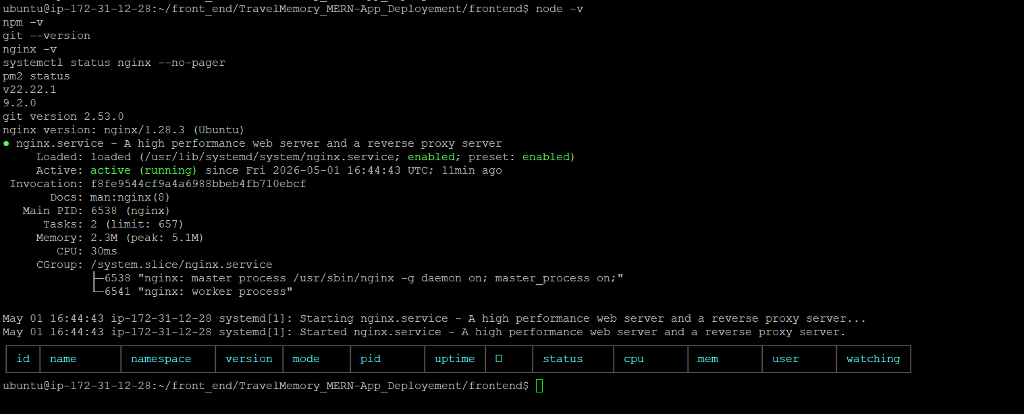
Compiling front end Build:
Build commands:
sudo npm install
sudo npm run build
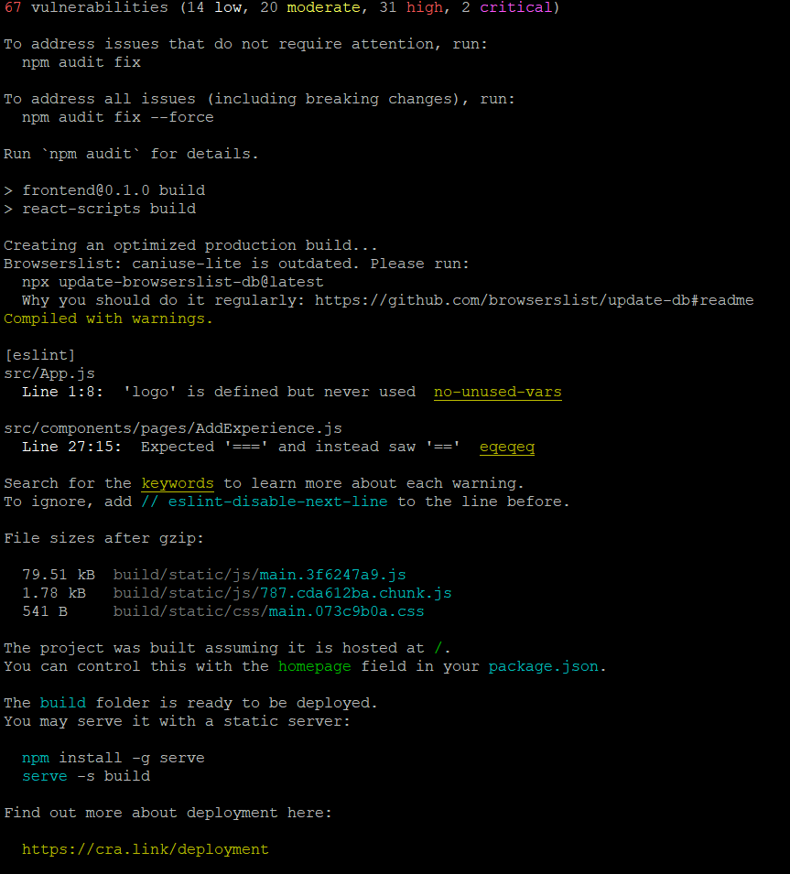

Point Nginx to your Build Folder: Configure Nginx:
Run this command to edit the Nginx configuration:
sudo nano /etc/nginx/sites-available/default

Restart Nginx:
sudo systemctl restart nginx


Faced Errors and it’s fixes.
error: 500 cause permission issue.
Fixes:
chmod +x /home/ubuntu chmod +x /home/ubuntu/front_end
chmod +x /home/ubuntu/front_end/TravelMemory_MERN-App_Deployement
chmod +x /home/ubuntu/front_end/TravelMemory_MERN-App_Deployement/frontend
chmod +x /home/ubuntu/front_end/TravelMemory_MERN-App_Deployement/frontend/build

sudo chmod o+x /home/ubuntu
sudo chmod -R 755 /home/ubuntu

Done with Backend EC2 (15.207.155.33) and your Frontend EC2 (13.127.131.16)

Task 3. Scaling the Application: [AWS Application Load Balancer(ALB)]
Step 1: Create Target Groups (AWS Console)
Target Group 1: Frontend
Target type: Instances
Name: TG-Frontend
Protocol: HTTP, Port: 80
Health checks: Path /
Next: Select your Frontend EC2 (13.127.131.16) and click Include as pending below.

TG_Front end pg1.
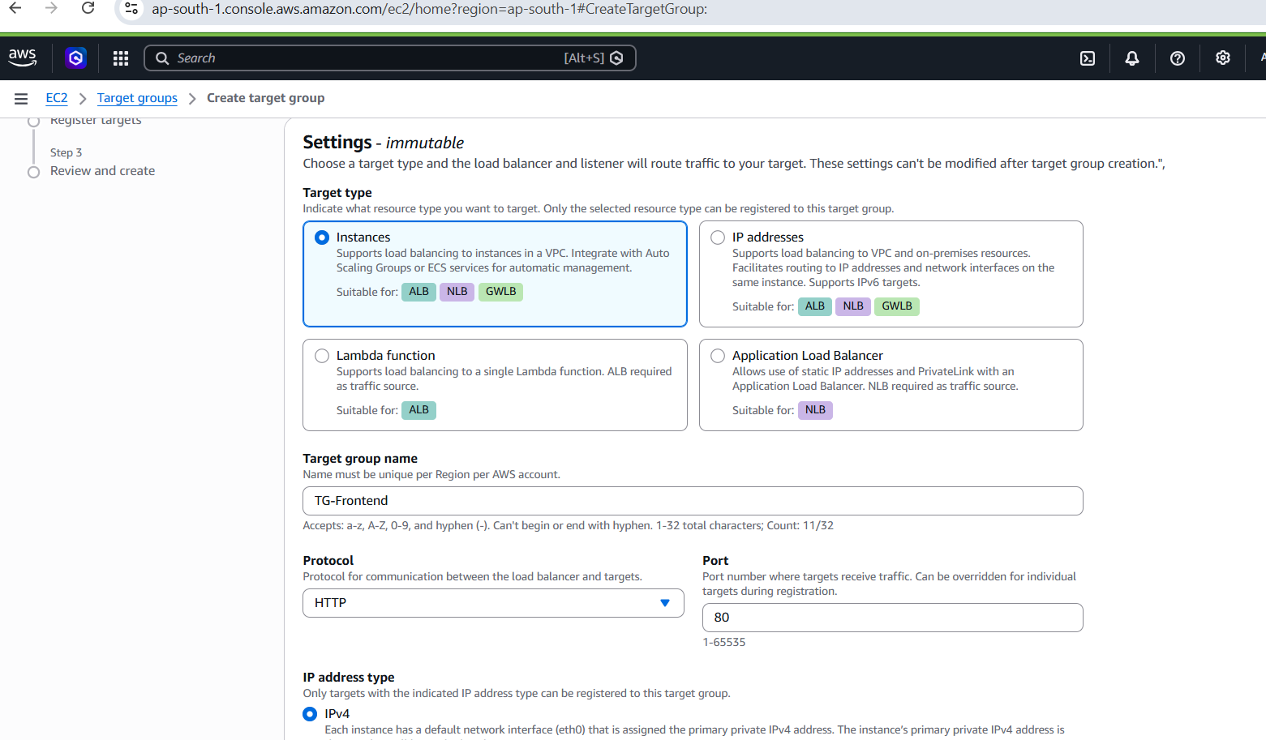

TG_Front end pg2:
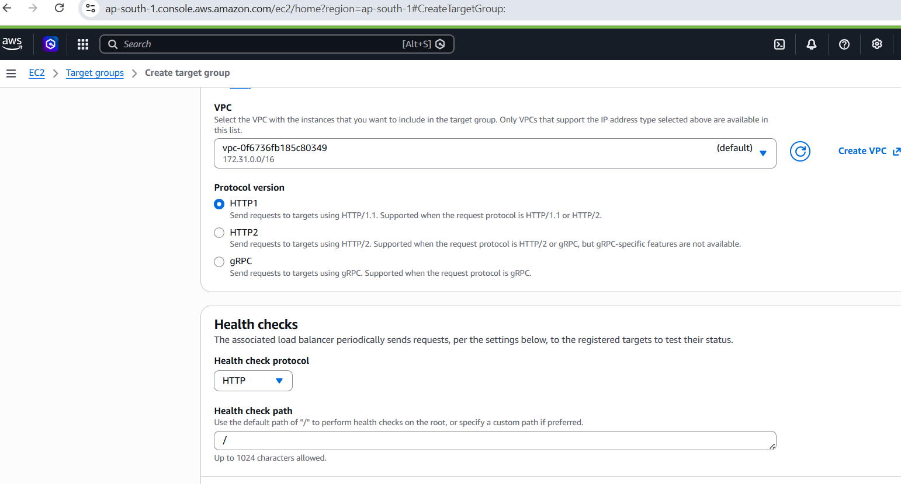

TG_Front end pg3:
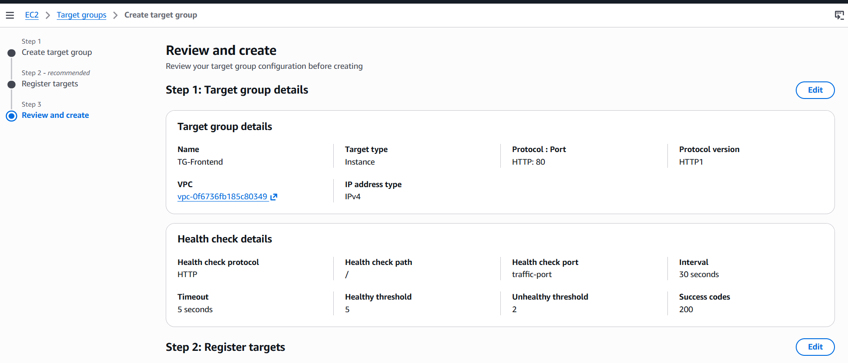
Target Group 2: Backend
Target type: Instances
Name: TG-Backend
Protocol: HTTP, Port: 3000 (This is crucial!)
Health checks: Path / (or /api/hello)

TG_Back-end
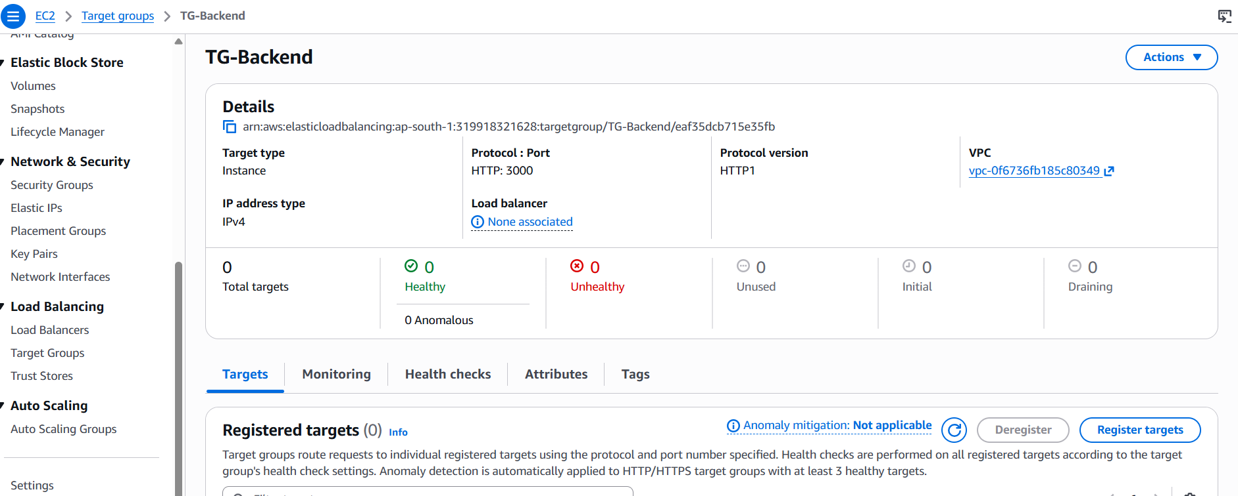

Frontend and background Target Groups:

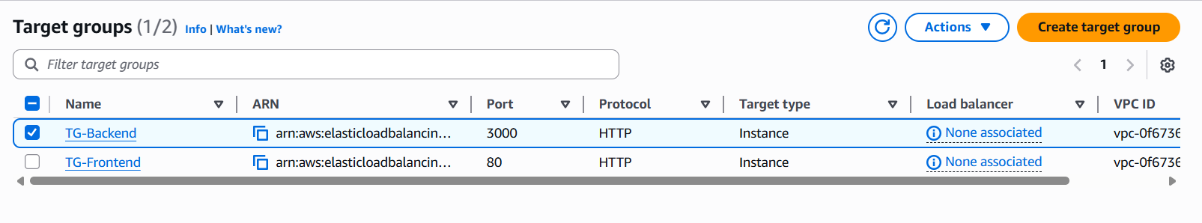

Task3. Scaling the Application:
- Create an Image (AMI):
Frontend AMI. Backend AMI.
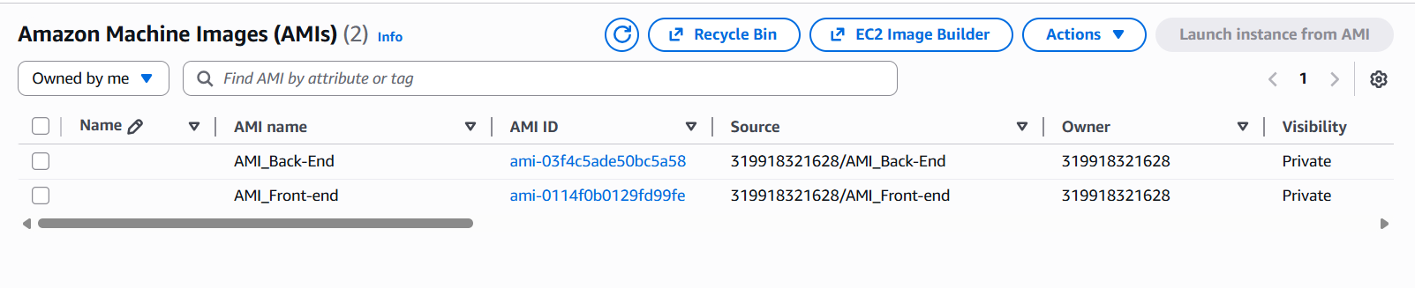
How Many Instances to Launch.?
Since I have already 2(front-end and back-end).
Just launching front-end:1 back-end:1
Scaling up.
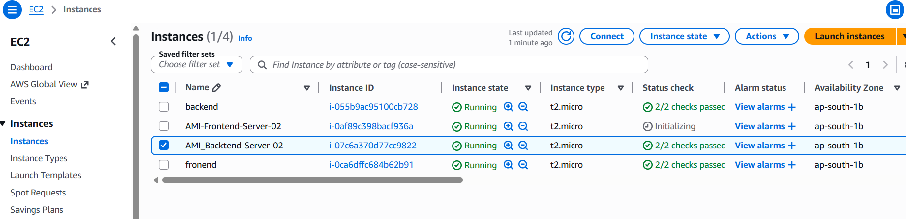
Create the Load Balancer:

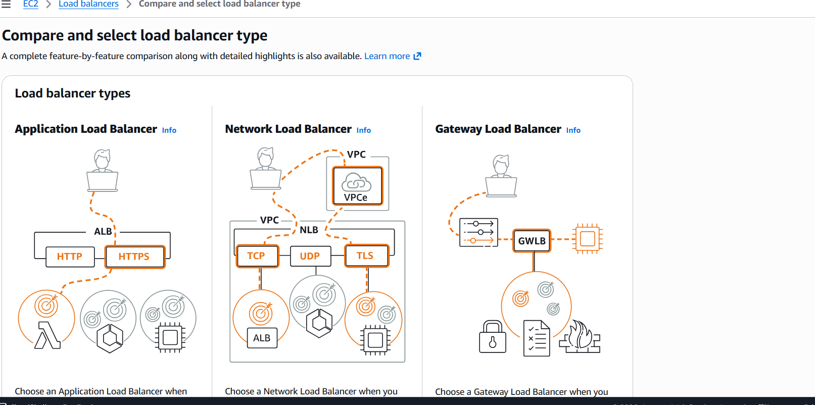

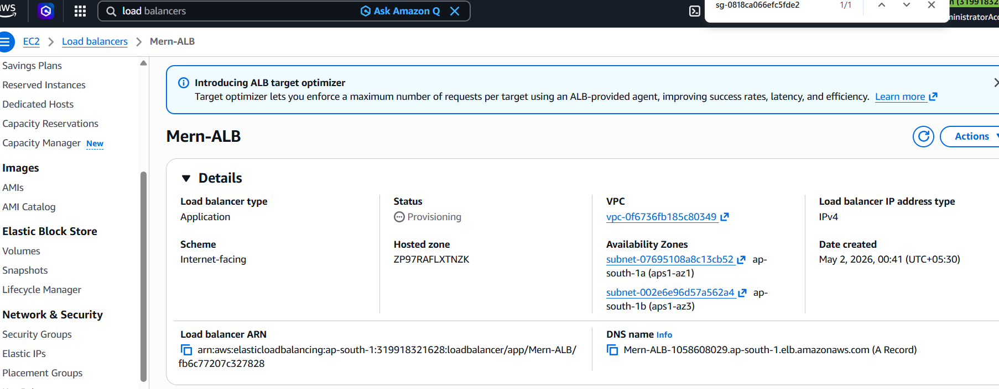

ALB_Frontend_TG:

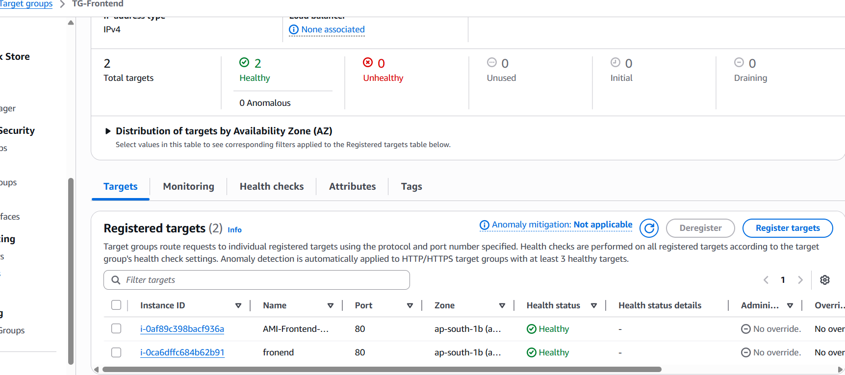
ALB_Backend_TG:
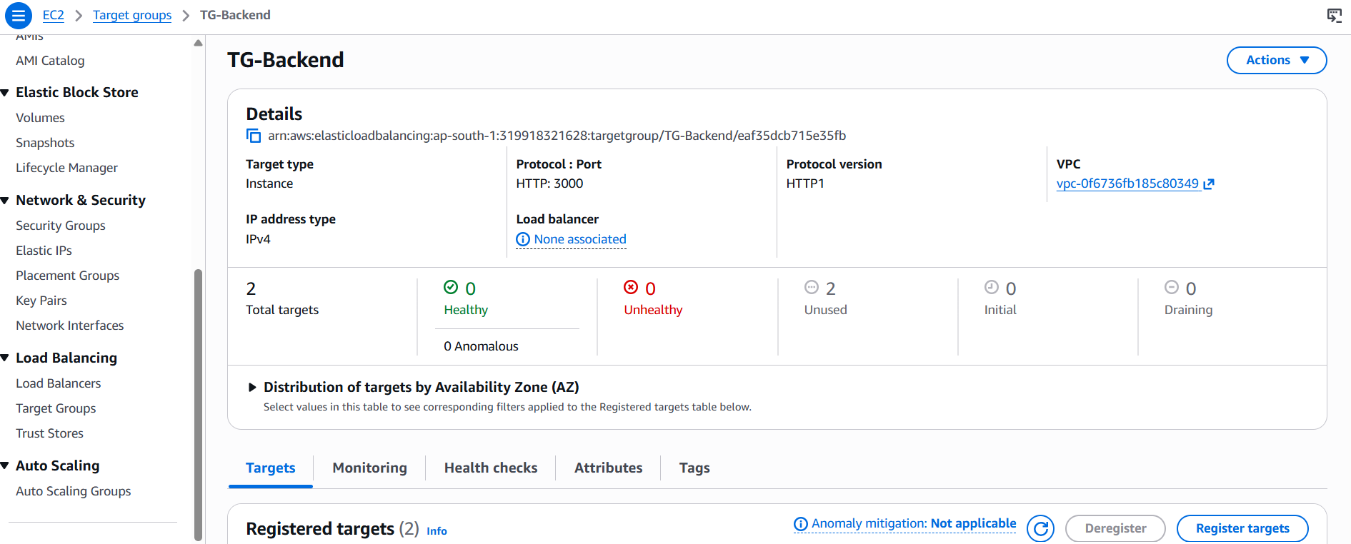
DNS name:
Mern-ALB-1058608029.ap-south-1.elb.amazonaws.com.

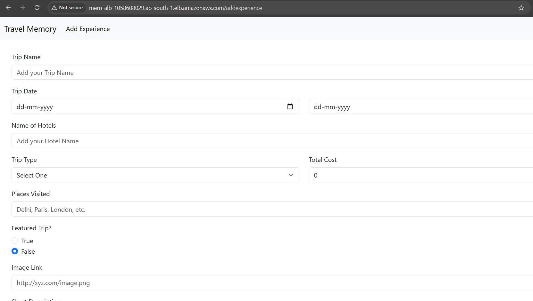

Task4: Domain Setup with Cloud flare:
I have purchased jilan-ppmcad.online from Namecheap site.

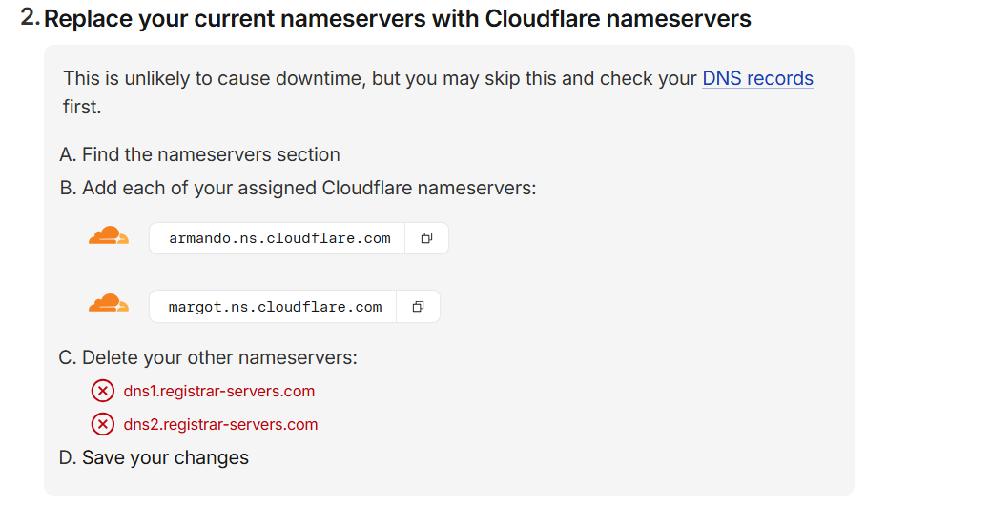

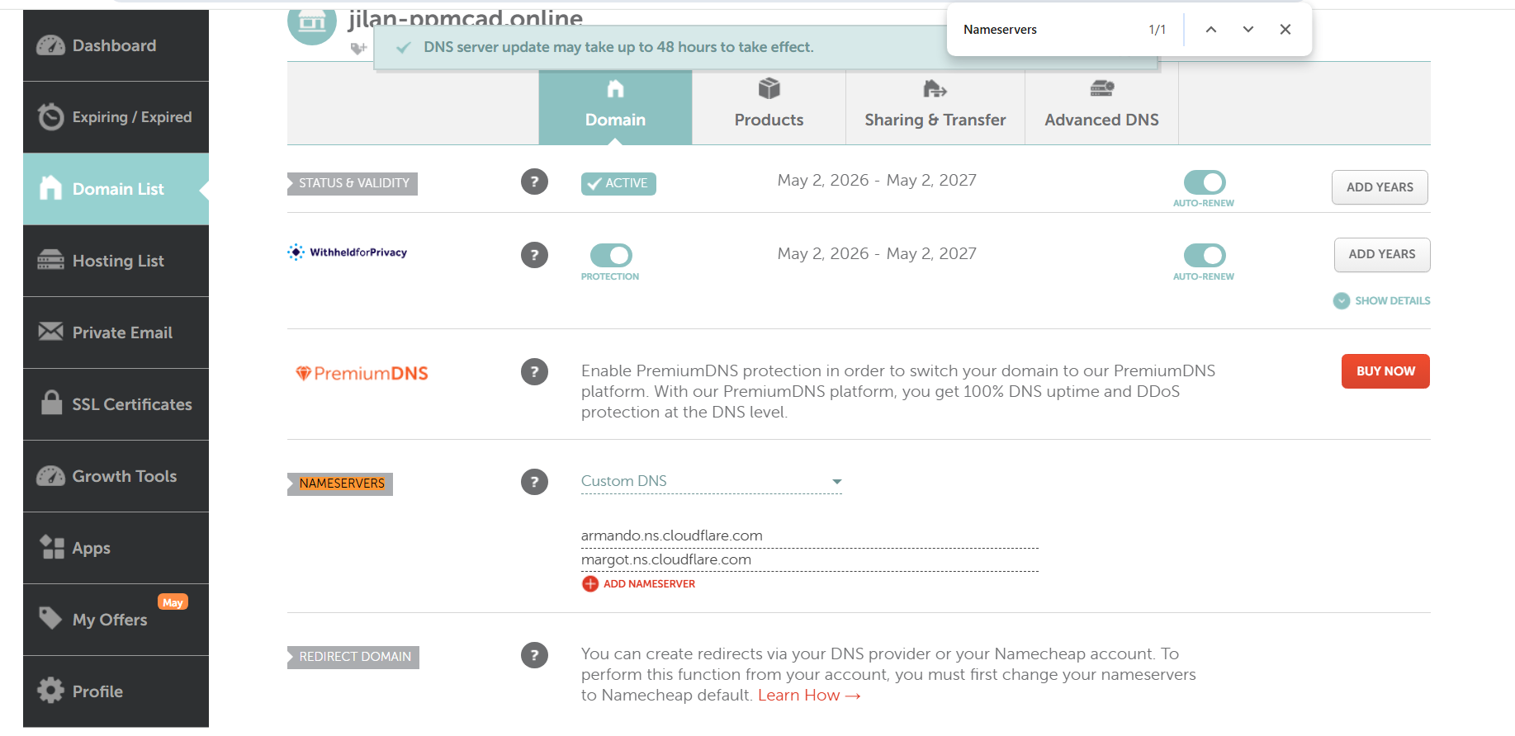

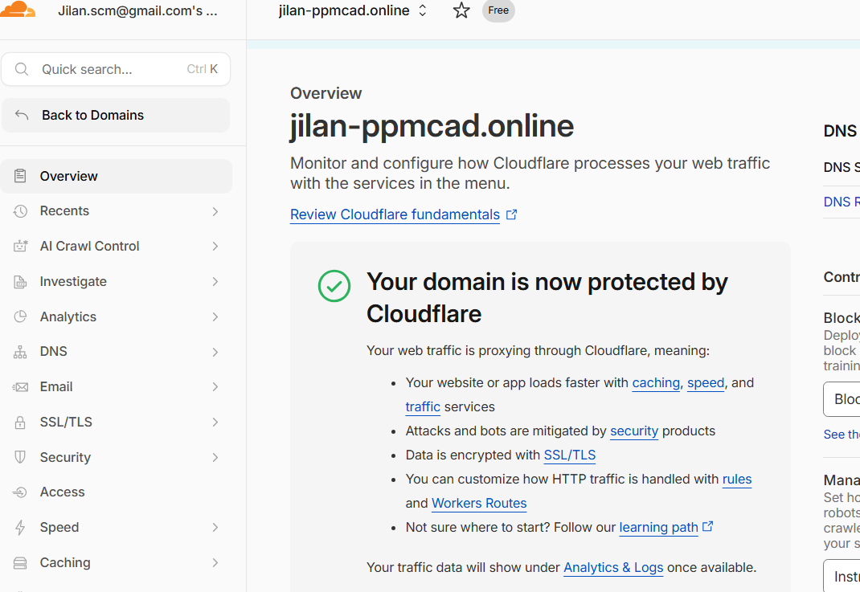

http://www.jilan-ppmcad.online/

