TopCoder Project Mom and Pop
Deployment Guide

Revision History
Author | Revision Number | Date
CaptainChrno | 1.0 | 2015/01/25

Deployment Instructions 3
1. Organization of Submission 3
2. Application Setup 3
2.1. Prequisite Installations 3
2.2. Prequisite Global NPM Modules 3
2.3. Other Prequisites 4
2.4. Install 4
3. Configurations 4
4. Deployment Instructions 5
5. Verification 5
6. Source Verification 7

Deployment Instructions

Organization of Submission
The folder structure (the root directory of the submission is referred as the <base> throughout the document.
Name | Description
config/ | All configuration files should be placed in this folder. The default configuration file is default.yaml
controllers/ | The controllers of the app. This is mainly a wrapper to expose business services to REST interface.
docs/ | All documentations should be placed in this folder. Currently, it has this deployment guide, applicant design specification, REST API specification, and tcuml (the architecture) file.
helpers/ | Helper modules that logically isolates specific functions to its own file. For example, response-helper is a helper for formulating a JSON response for this app.
middlewares/ | All custom middlewares should be placed here.
migrations/ | Migration files are placed here.
models/ | The models of the app. This contains the Mongoose Schema.
services/ | The services of the app. The main business logic of the app is placed here.
tests/ | The tests of the app.
views/ | The views of the app. It currently is only used to place email templates.

Application Setup

Prequisite Installations
- NodeJS 0.10.21 http://nodejs.org/
- NPM (it should be included when installing node) https://www.npmjs.org/
- MongoDB http://www.mongodb.org/
- Make sure mongo service is running by being able to execute ‘mongo’ command.

Prequisite Global NPM Modules
- Migrate https://github.com/tj/node-migrate

npm install –g migrate
- Grunt-CLI http://gruntjs.com/

npm install –g grunt-cli

- Mocha http://mochajs.org/

npm install –g mocha

Other Prequisites
- Any external/3rd party SMTP Server. In this submission, I already include a free SMTP server account. You can access the control panel here:

URL: www.smtp2go.com
Username: johnnyawesome.tc@gmail.com
Password: topcoder255
Daily Limit: 20

Install
- Download the submission. Place the folder anywhere you deem suitable.
- Go to the root folder of the project.
- Run npm install.

Configurations
There is nothing you need to change to make the app runs. Currently, all app configuration variables are placed in ./docs/default.yaml. In this submission, only relevant configuration variables are included.

Name | Description
MONGODB_URL | The URL of the database. It currently supports MongoDB. The default value is mongodb://localhost/mom-and-pop-db, which means the default database is mom-and-pop-db.
MONGODB_CONNECTION_POOL_SIZE | The number of maximum connection pool size. The default value is 50.
WEB_SERVER_PORT | The port this app will listen to. The default value is 10100.
SMTP_HOST | SMTP Host. smtp2go default host is smtpcorp.com.
SMTP_PORT | SMTP Port. smtp2go default port is 2525.
SMTP_USERNAME | Your SMTP account username. The provided username for verification is johnnyawesome.tc@gmail.com.
SMTP_PASSWORD | Your SMTP account password. The provided password for verification is topcoder255.
CONFIG_EMAIL | The anonymous email sender. This can be the one you used to register with the external smtp server or any mail domain where you are allowed to use as mail sender. The default value is johnnyawesome.tc@gmail.com.
SITE_ADMIN_EMAIL | The admin site email. This email is where feedbacks and reported abuses are sent to. The default value is johnnyawesome.tc@gmail.com.

Deployment Instructions
For the local deployment, you only need to run grunt in the project root.

Verification
Before you do any verification, make sure the API runs. Now, there are 2 kinds of testing provided in current submission, which are:

- Unit Testing
Open a new terminal (don’t stop the API server). Run grunt test in the project root. Make sure it passes.

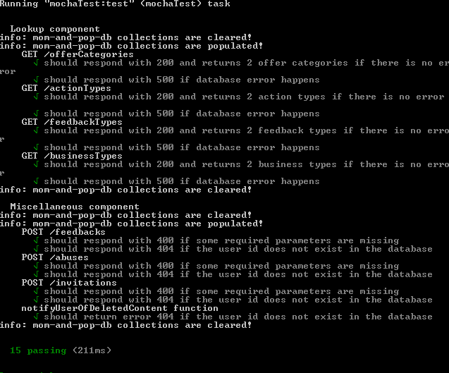

You’ll notice that the unit tests skip on the paths where sending emails is concerned. This one is better tested using the second method.

- Manual Testing
The second method uses postman, which is one of the best tool to manual test an API. There are several steps you have to do before you can run the test though.
- To populate the database, run migrate. It will run all migrations file in ./migrations.

- Get the id of the generated user in the mongo database. Assuming the database is still mom-and-pop-db,
- Run mongo from terminal.
- Run use mom-and-pop-db.
- Run db.users.find().
- Copy the objectId of the generated user. See the highlighted text from below:
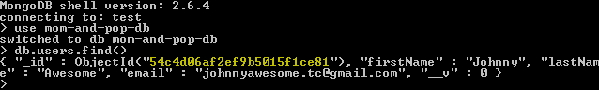

- Open the postman plugin. Import postman.json that is located in the root folder of the project.

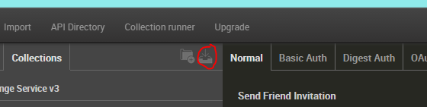

- Create new environment variables for postman. Make url variable filled with the url of the API. Also, make userId variable filled with the objectId you get from step II.3.

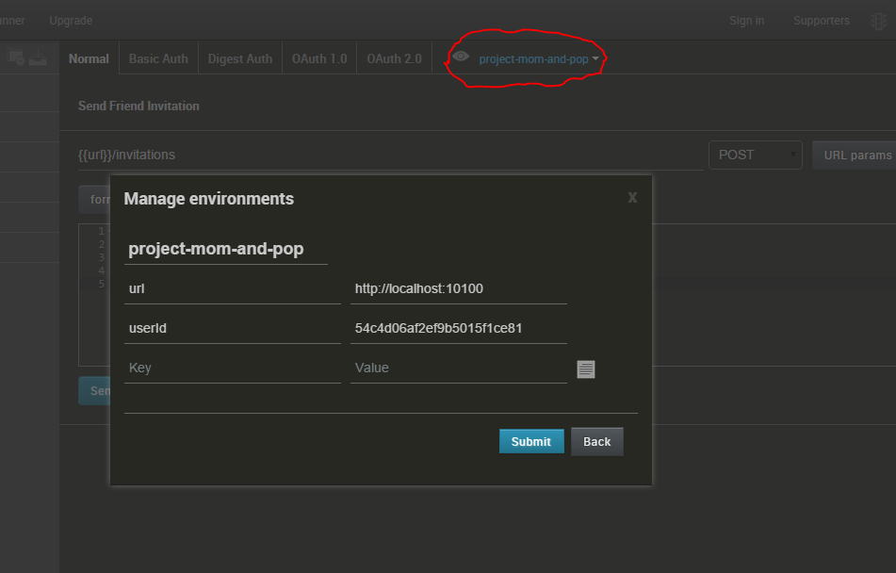

- Now you should be able to run all the tests!

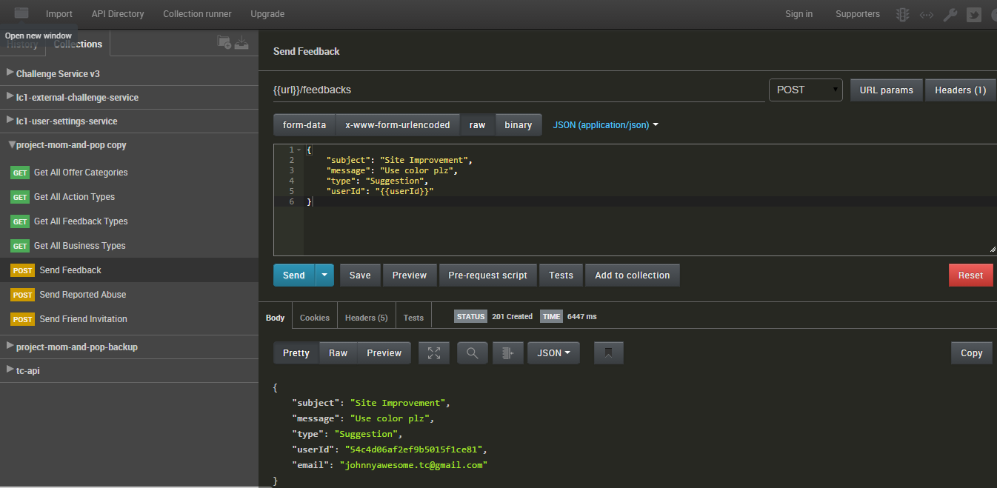

- For the POST tests. Those are sending emails to johnnyawesome.tc@gmail.com (again, configurable). If you use the default email, you can check the gmail account:

URL: www.gmail.com
Username: johnnyawesome.tc@gmail.com
Password: topcoder255

Like so:

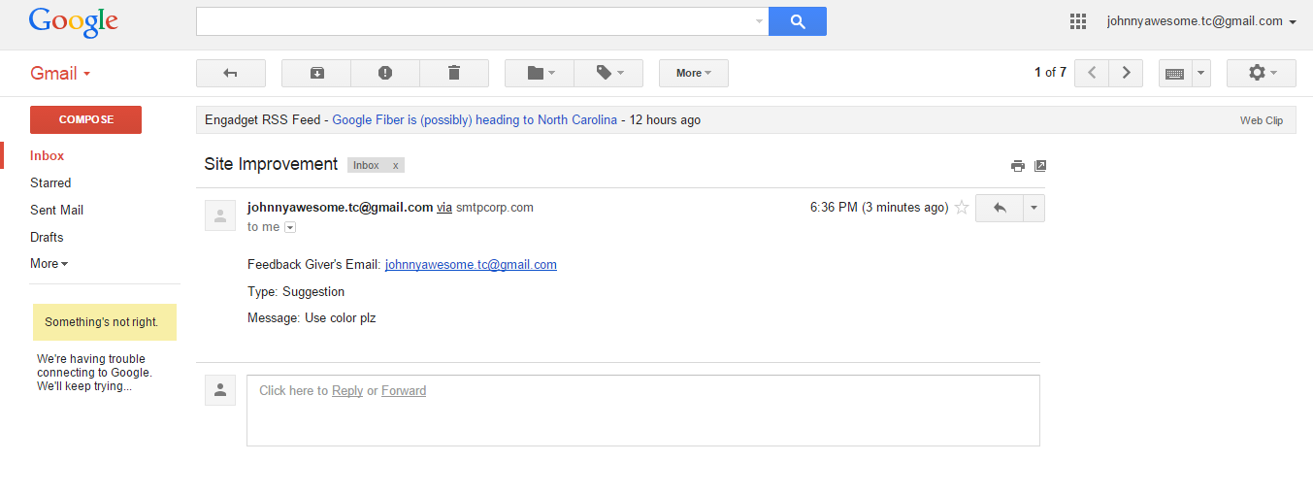

Source Verification
Here is the list for you to verify whether the requirements are met:

  - MiscellaneousController
It is implemented in ./controllers/miscellaneous.js
  - NotificationService
It is implemented in ./services/notification.js
  - LookupController
It is implemented in ./controllers/lookup.js
  - LookupService
It is implemented in ./services/lookup.js
  - Relevant DTOs and schemas
It is implemented in ./models/*.js

