Project Mom and Pop Champion Home Mobile Front End and Services
v1.0
Deployment Guide

Revision History
Author | Revision Number | Date
TCSASSEMBLER | 1.0 | 2015-02-13

1 Organization of Submission 3
2 Application Setup 3
2.1 config.js File 3
3 Database Setup 3
4 Deployment Instructions 4
5 Verification 4
5.1 RESTful function 4
5.2 Front end 8
6 Resource Contact List 11

Deployment Instructions

Organization of Submission

configs – contains the config files
controller – contains the controller files
doc – contains the deployment guide (this document)
erros – contains the error defines
helpers – contains the helper files
middlewares – contains the middle wares for this project
models – contains the mongoose model files
public – contains the web show files
services – contains the service files
test_files – contains files for initial DB
app.js – The main script to start
package.json – contains required packages
Project-Mom-and-Pop.postman_collection – the collection for Postman to testing API
Project-Mom-and-Pop.postman_environment – the environment for Postman

Application Setup

config.js File

Property Name | Description | Example Setting
MONGODB_URL | Database URL | "mongodb://127.0.0.1:27017/project-mom"
MONGODB_CONNECTION_POOL_SIZE | Database pool size | 50
WEB_SERVER_PORT | Host port | 3000
DEFAULT_SORT_BY | Sort by
DEFAULT_SORT_ORDER | Sort order | "Ascending" or "Descending"
DEFAULT_PAGE_SIZE | Page size | 10
QR_CODE_SIZE | QrCode size | 16
DEFAULT_REDEEME_AMOUNT | Redeeme amount | 20
QR_CODE_FILE_DIR | The path to store qrCode picture | "public/i/qrcode/"

Others are from giftcardofferandsecurity, I do not find any config detailed information.

Database Setup
Tests will initial DB data automatically. Please note it will not clear data from DB after testing.
Because I want to use it for web verify later.

Deployment Instructions

You just need run "npm install" to install all dependence.

Verification

RESTful function

Run “node app.js” to start server first, and then you can use Postman to test all API.

Import Project-Mom-and-Pop.postman_collection and
Project-Mom-and-Pop.postman_environment, then you can use Postman directly.

Please first use security/login
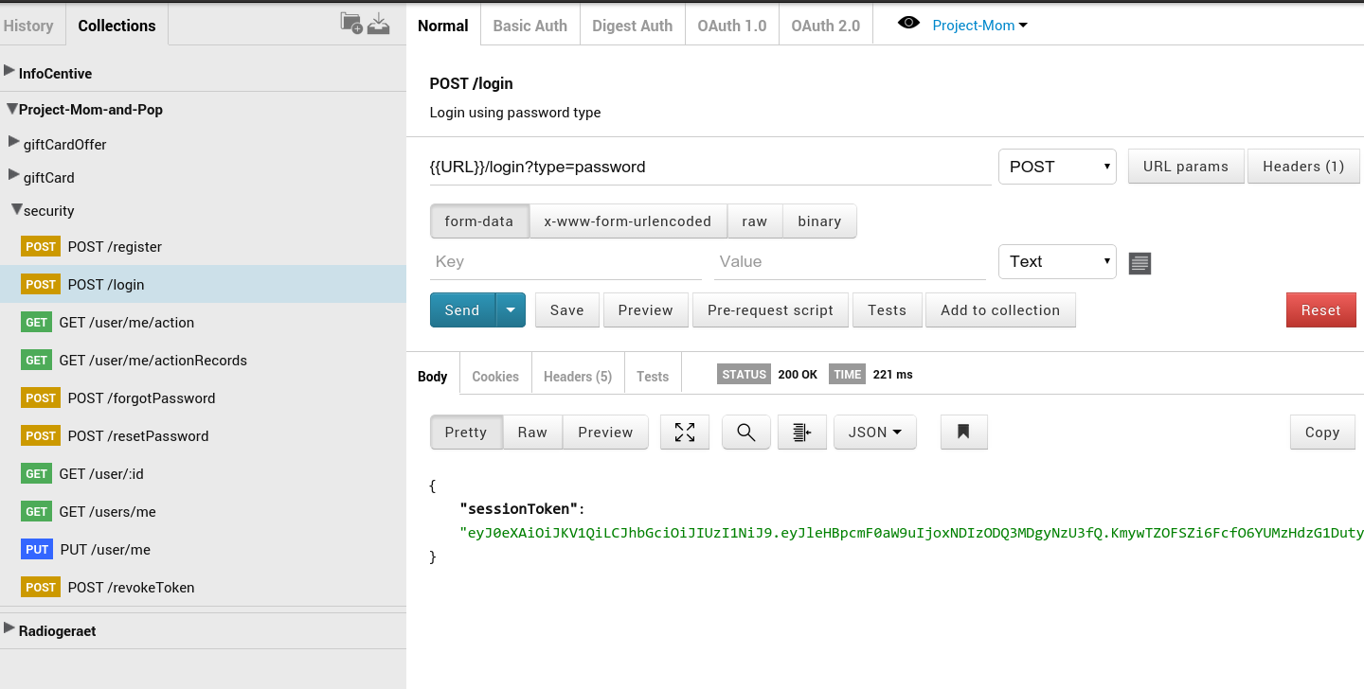

And set it to your postman environment.

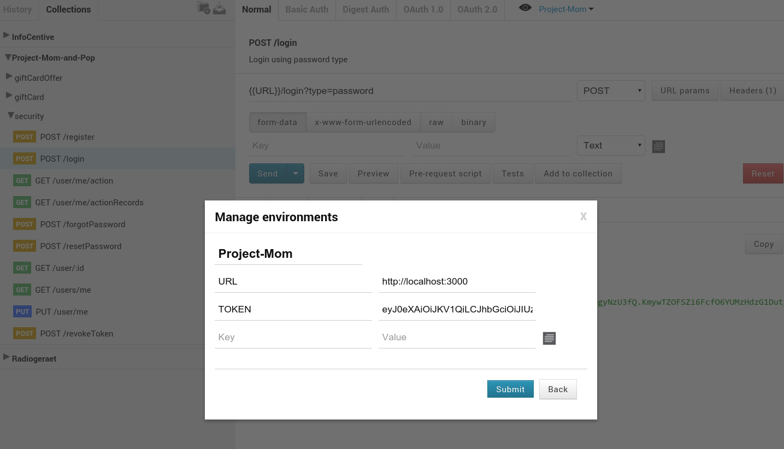

OK, then you can test all APIs freely.

I use three forlders for all APIs.
One is "security":

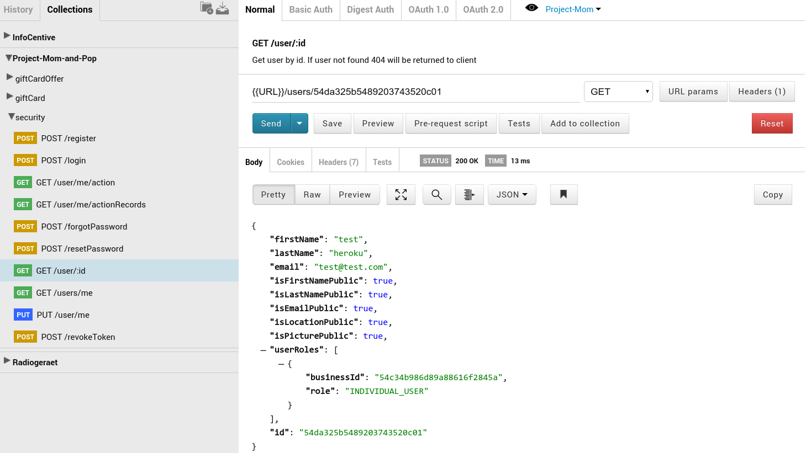

One is "giftCardOffer":

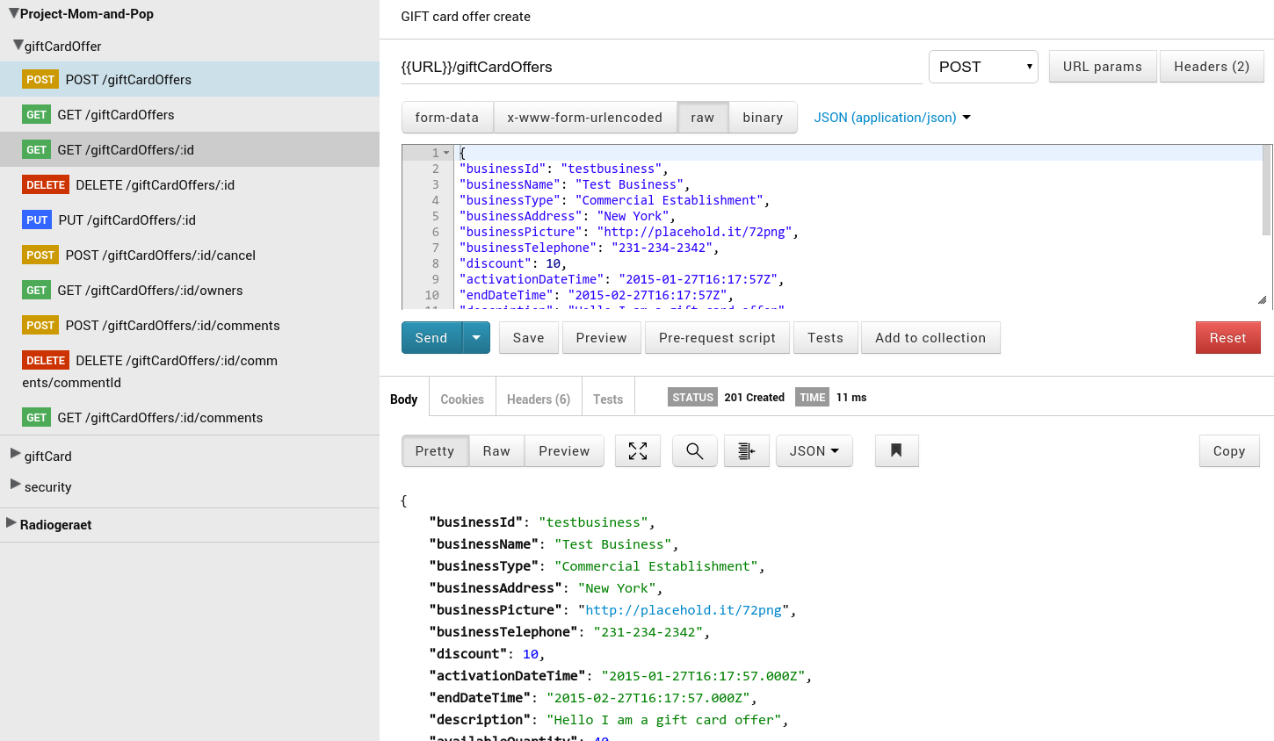

The last is "giftCard":

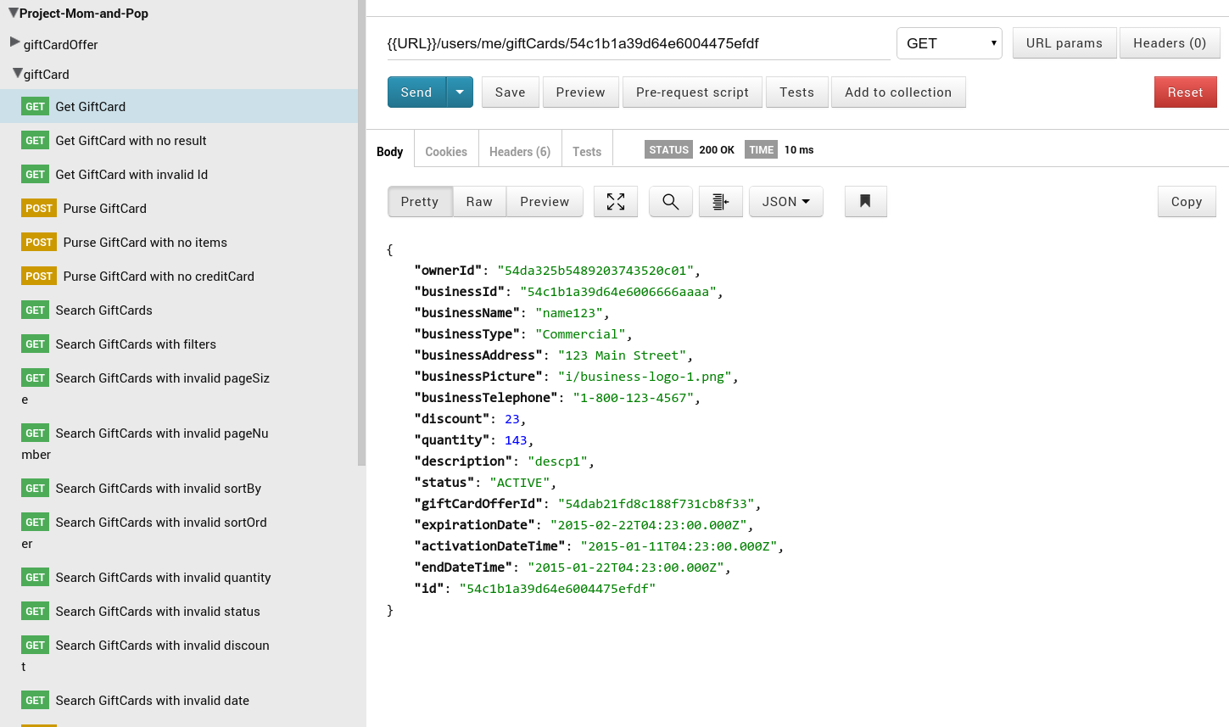

Front end

Ok, all front end files are in /public, we can directly visit them.
Go to url like localhost:3000

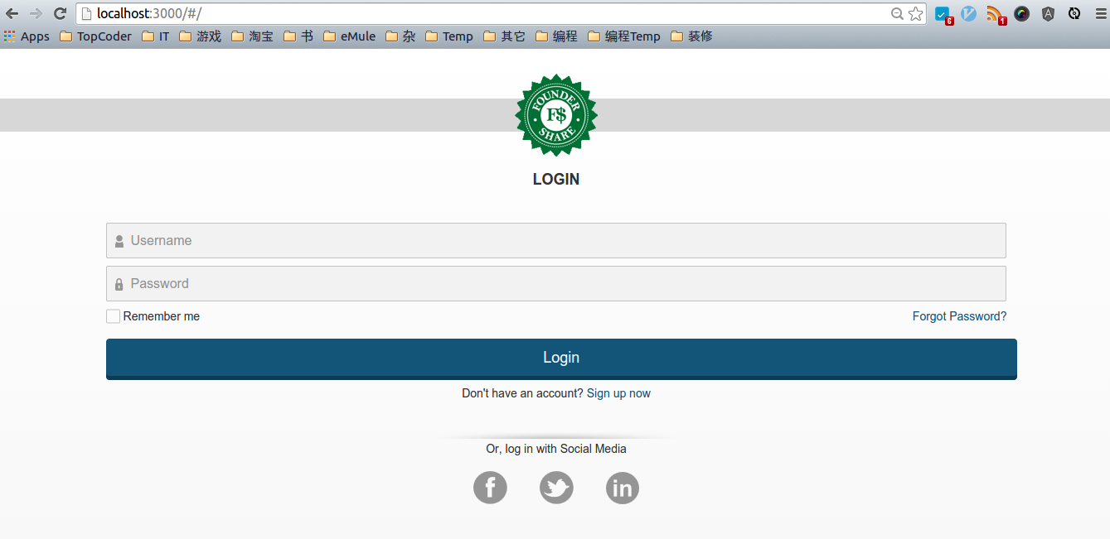

If you fill with wrong/wrong, you will get warning:

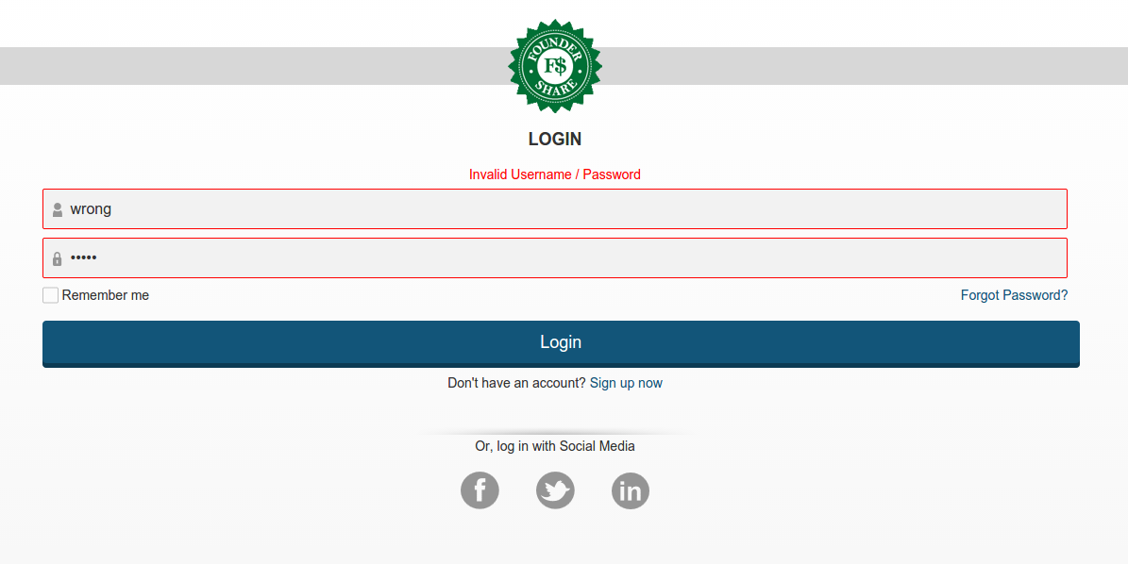

Please use test@test.com / password to login:
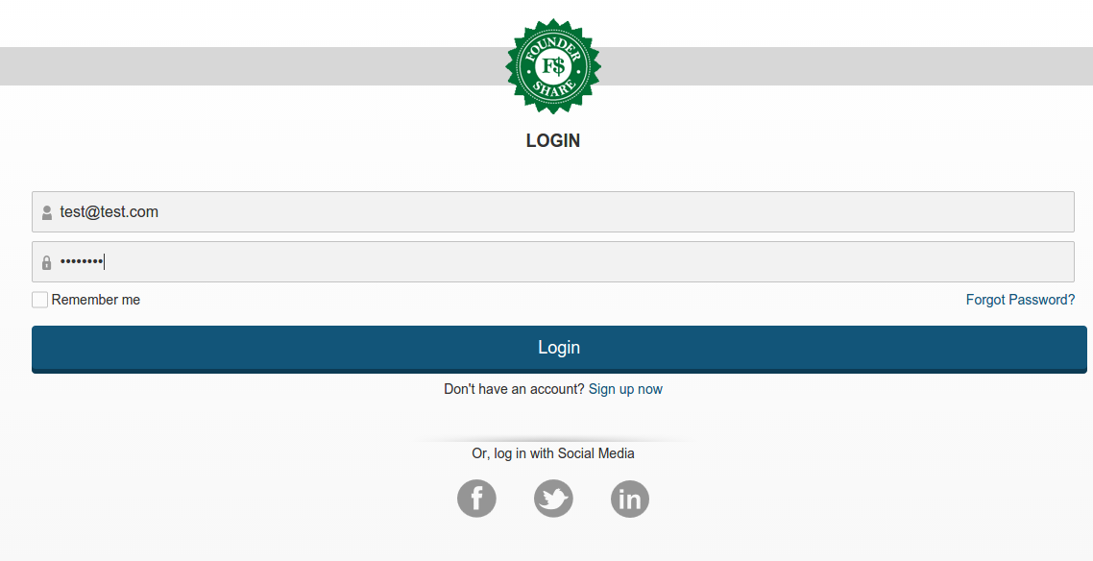

The you can see list page:
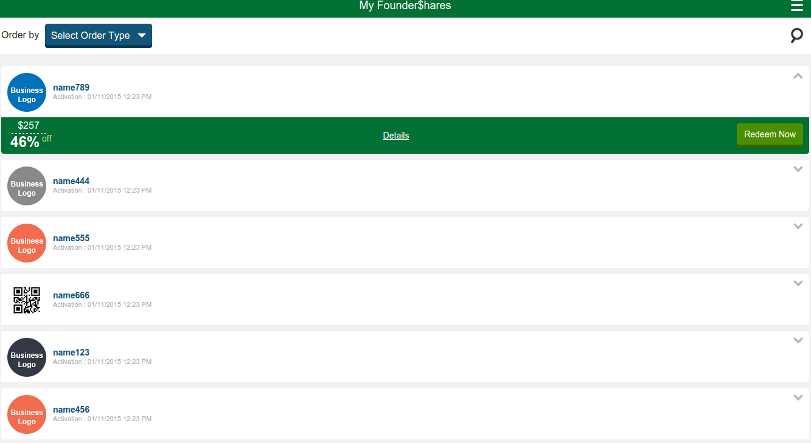

You can click "Order by":
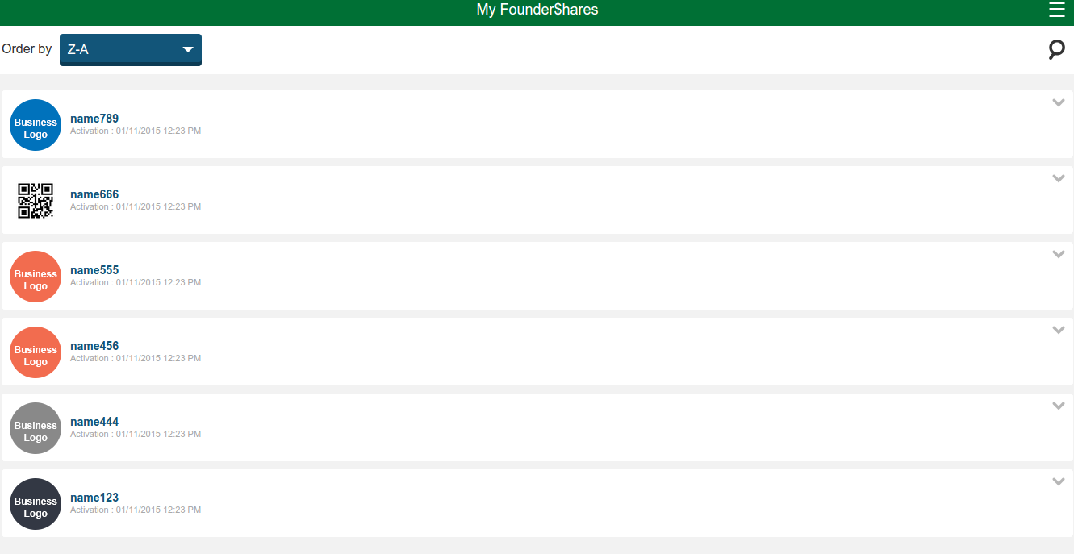

Also the search function works well:

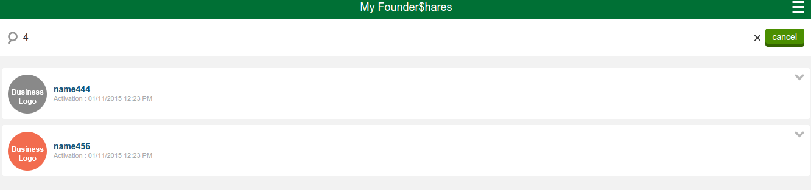

Resource Contact List

Name | Resource Email
TCSASSEMBLER

