Smart Water Quality Monitoring

System

Leong Yuen Theng1, Tang Tzu Li2, Joshua Chew Chun Thoe3, Ma Yu Chuan4

[1]

***Abstract***

**Water contamination poses a substantial risk to both human and animal well-being, as well as the broader ecology. Early detection of water pollution is essential to minimise negative health consequences and ecological harm. The significance of employing intelligent solutions for monitoring water contamination in real-time using IoT technology and sophisticated sensors has increased. This study presents a thorough examination of current progress in intelligent water pollution monitoring systems and suggests a cost-efficient and effective solution based on the Internet of Things (IoT). The suggested system employs Arduino R3 and a range of sensors to continuously analyse water quality parameters. The collected data is sent to a cloud server using Blynk, allowing for immediate monitoring and quick responses to any discovered problems.**

***Index Terms***

**Smart water quality monitoring system, Internet of Things, machine learning (ML), Arduino Uno R3, WiFi Module (ESP8266), sensors, Blynk**

# I. INTRODUCTION

One of nature's greatest gifts to humanity is freshwater, which is essential for agriculture, industry, and human life on the planet. Fresh practical issues are currently facing drinking water facilities. The water quality that is available to people has drastically deteriorated due to factors such as scarcity of drinking water, high financial needs, population growth, urbanisation of rural areas, and overuse of sea resources for salt extraction. One major factor contributing to the global decline in water quality is the extensive use of chemicals in the manufacturing, construction, and other industries; fertilisers in agriculture; and the direct discharge of industrially contaminated water into neighbouring water bodies. Even due to the containment of water, the number of water-borne diseases is increasing day by day, due to which many human beings are losing their lives.

Water quality was formerly detected manually, requiring the collection of water samples and their shipment to laboratories for analysis. This procedure was labour-intensive, expensive, and required a lot of manpower. Real-time data is not provided by these methods. The suggested water quality monitoring system is small and extremely helpful for measuring pH, turbidity, water level, temperature, and humidity in the atmosphere. It also sends continuous and real-time data to the monitoring station wirelessly. The system consists of a microcontroller and simple sensors.

# II. INTERNET OF THINGS

The term "Internet of Things" (IoT) describes the widespread internet connectivity of items, which turns common appliances into networked devices (Yue et al., 1997). The implementation of a large number of smart devices that can sense their environment, gather and transmit data, and interact with it is at the heart of the Internet of Things (IoT) (Sisinni et al., 2018).

According to Gunturi et al. (2018), Figure 1 depicts the Internet of Things (IoT) as a conceptual framework in which particular objects are able to transmit data to a network without the need for direct human-to-human or human-to-computer interaction. The combination of wireless technologies, the internet, and micro-electromechanical systems (MEMS) has resulted in a rapid development of the Internet of Things. According to Suresh et al. (2018), the word "IoT" first appeared and refers to the concept of expanding the benefits of constant internet access. Devices with embedded sensors can connect to a network and perform many functions, such as data sharing and remote control (Suresh et al., 2018).

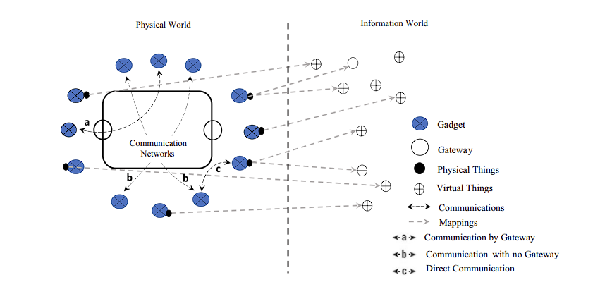

**Figure 1:** Concept of IoT

***iii. Contributions in this proposed IoT project***

The Smart Water Quality Monitoring System, developed as part of our project, intends to fundamentally transform the methods by which we monitor and preserve water resources. Our system employs the Arduino Uno R3 microcontroller, sensors, and actuators to offer real-time monitoring, optimise resource utilisation, and promote environmental conservation.

**Real-Time Monitoring:** The core of our project is the Arduino Uno R3 microcontroller, which serves as the central processing unit. The system is equipped with four sensors that measure important factors including pH value, water turbidity, temperature, and spO2 levels. These measures are essential indicators of water quality, allowing for the prompt identification of abnormalities or contamination. By utilising real-time monitoring, we can rapidly detect possible difficulties and implement essential measures to safeguard water supplies.

**Resource Optimization:** The availability of water treatment resources is often limited, and it is crucial to use them in the most efficient way possible to ensure sustainable water management. The Smart Water Quality Monitoring System addresses this difficulty by integrating resource optimisation capabilities. The system can evaluate the necessity for particular treatments and allocate resources accordingly by consistently monitoring water quality data. This guarantees the efficient utilisation of resources, resulting in waste reduction and the minimization of the total environmental consequences of water treatment procedures.

***iv. Related Work***

According to the proposed system by Sathish Pasika and Sai Teja Gandla,. [Pasika, S., & Gandla, S. T. (2020).](https://doi.org/10.1016/j.heliyon.2020.e04096) The Water Quality Monitoring (WQM) system measures important characteristics such as water pH, turbidity, water level, and temperature/humidity of the surrounding atmosphere. The system employs four sensors (pH, turbidity, ultrasonic, DHT-11), an Arduino Uno R3 microcontroller for data processing, and an ESP8266 Wi-Fi module for transmitting the data. The microcontroller unit has a vital function in translating analogue signals from sensors into a digital format, while the ESP8266 module facilitates wireless communication and data transmission to the ThingSpeak server. The system functions in real-time, acquiring, storing, examining, and transferring the gathered data, which may be accessed by authorised users for additional analysis and decision-making. The incorporation of sensors, microprocessor, and Wi-Fi module enables the efficient monitoring of water quality and contributes to the optimal management of water resources.

According to the proposed system by Chafa, Allen T. [Chafa,A.T., et al., (2022)](https://doi.org/10.1080/23311916.2022.2143054) The developed system comprises a microcontroller and multiple sensors for measuring temperature, pH, turbidity, dissolved oxygen, hardness, and total dissolved solids. The Arduino microcontroller facilitates data storage and retrieval from the sensors. Optical dissolved oxygen sensors detect oxygen concentration by measuring the interaction between oxygen and luminescent dyes. The pH sensor indicates acidity or alkalinity, while the temperature sensor measures water temperature. The turbidity sensor detects suspended particles in water, and the oxidation reduction potential (ORP) sensor measures oxidizers and reducers. The total dissolved solids (TDS) sensor indicates the amount of soluble solids in water. A solenoid water valve controls water flow direction. Real-time data is transmitted through an ESP8266 Wi-Fi module to a web-based application, and analysis and processing are performed on a host computer. The information is then sent to the user's mobile device via a GSM module. Deviations from WHO standards trigger autonomous control measures, implemented through fuzzy logic control and automated chemical dosing units. The system ensures water quality at each stage of the treatment process and incorporates multimedia filters for correction..

According to the proposed system by Wiryasaputra. [(Wiryasaputra et al., 2024)](https://doi.org/10.3390/s24041180) The proposed drinking water quality monitoring method combines IoT sensor packages and machine learning models. The IoT sensor packages include a Total Dissolved Solids (TDS) sensor, pH sensor, dissolved oxygen (DO) sensor, and temperature sensor. These sensors are assembled to measure different parameters of water quality. The TDS sensor measures electrical conductivity, the pH sensor detects acidity or alkalinity, the DO sensor measures oxygen concentration, and the temperature sensor monitors water temperature. The collected data is transmitted using NB-IoT technology. Machine learning models such as Decision Trees (DT), Support Vector Machines (SVM), and Random Forest (RF) are employed for predictive analysis. These models evaluate the water quality data and generate predictions. Evaluation metrics such as Accuracy, F1-score, and Receiver Operating Characteristic (ROC) curve are used to assess the performance of the models. The proposed method aims to provide an efficient and accurate system for monitoring and predicting drinking water quality.

According to the proposed system by Hui Zeng. [(Zeng et al., 2021)](https://web-p-ebscohost-com.tarc.idm.oclc.org/ehost/pdfviewer/pdfviewer?vid=0&sid=2ec5e806-dbea-49ee-a523-ab6366ee699c%40redis) The study proposes a smart water management system using IoT and Blockchain. The implementation is illustrated in Figure 6, which shows three operational stages: mobile environment, Blockchain environment, and sensor deployment/control subsystems. In the mobile environment, farmers created irrigation requirements using action rules, while the manager node creates management rules to optimise water resources. The blockchain environment stores and executes smart management, providing additional trust through cryptography hashing. The control subsystem collects information about water state, soil situation, and seed quality. The study includes experimental analysis, where a prototype was implemented on a Linux-based system using Node.js technology. Real-time monitoring of sensor data, such as soil humidity and temperature, is depicted in Figure 7, along with water storage and irrigation status. The system incorporates smart devices, RFID technology for user recognition, and Arduino-based sensor nodes. The performance evaluation measures the average response time, indicating acceptable results for irrigation execution. Overall, the study demonstrates the feasibility of the proposed IoT and Blockchain-based smart water management system for agriculture.

According to the proposed system by Mehedi Hasan Jewel and Abdullah Al Mamun. [Mehedi Hasan Jewel and Abdullah Al Mamun (2022))](https://ieeexplore-ieee-org.tarc.idm.oclc.org/document/10103355) The study proposes a system architecture for monitoring and managing water quality and consumption in the unplanned and crowded city of Dhaka. The system addresses the challenges of the complex infrastructure by incorporating specific features to ensure stability and longevity of devices. These features include low-powered microcontrollers that can enter sleep mode to save battery, a Battery Management System (BMS) for continuous power supply, precise sensors for collecting water health data, a data storage system for storing consumption and parameter values, and internet connectivity for real-time monitoring. The proposed system architecture consists of three blocks: the end-user node, intermediate device (local gateway), and cloud server/storage system. The end-user node gathers sensor data related to pH, turbidity, dissolved oxygen, TDS, and flow, while the BMS and solar module provide battery backup. The system utilises a radio frequency (RF) network for communication, with the LoRa network selected for its long range and low power consumption. The intermediate device serves as a gateway between the nodes and the cloud server, facilitating two-way communication. The cloud server collects and analyses data, storing it in a SQL-based database system, and provides a web-based interface for users to access and assess their water quality and consumption data. Overall, the study presents a comprehensive system architecture to address the water management challenges in Dhaka's complex urban environment.

According to the proposed system by [Muhammad Hidayatullah et al.](https://doaj.org/article/a675bf7a25744722900990c284b41ef4) which have developed a water quality monitoring system for hydroponics using an Arduino UNO microcontroller and a Total Dissolved Solid (TDS) sensor (SEN0244). The system measures water sensitivity and displays readings on an LCD. It includes a buzzer and dosing pump that automatically add nutrients A and B when the TDS sensor reading is below 2.30 Volts or 1000 ppm and sounds the buzzer once, or above 2.40 Volts or 1200 ppm and sounds the buzzer twice. The system has been tested successfully with well water, but experienced unstable or erroneous voltage readings with saltwater and soapy water samples. Overall, this system aims to simplify hydroponic cultivation, particularly for farmers, by providing an efficient and automated solution for monitoring water quality.

***v. Methodology***

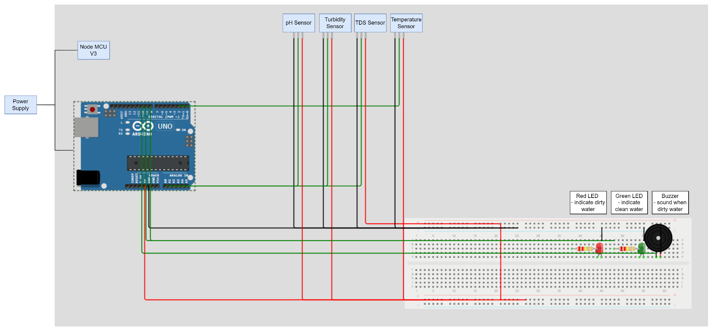

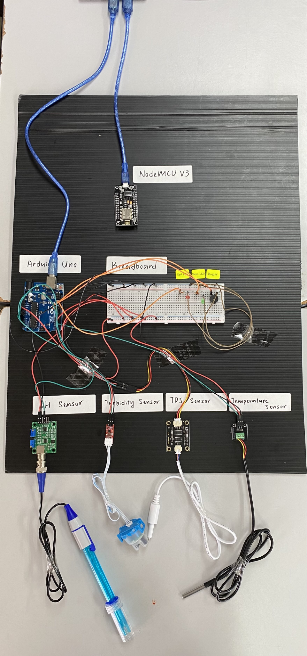

Figure 1.1 SWMQS setups

The measurement parameters of SWQM system is basically is needed to be measured for water quality analysis which included:

* Water’s pH value
* Turbidity of the water
* The TDS levels of the water
* Temperature of the water

This proposed system employs four sensors, specifically pH, TDS, turbidity, and temperature, to oversee and assess the quality of water. The main controller used is the Arduino Uno R3, which is well-known for its cost-effectiveness. The pH, TDS, and turbidity sensors are directly linked to the digital pins of the Arduino Uno R3, allowing for a direct connection between the sensors and the Arduino board. The microcontroller unit (MCU) receives and analyses data from many sensors, then transmits it to the Blynk server. The ESP8266 Wi-Fi module serves as a data communication module, enabling this communication. The ESP8266 module uses the Tx and Rx serial transceiver pins for transmitting and receiving data, modifying module configurations, and executing serial inquiry commands. Although the Wi-Fi module and the microcontroller need both Tx and Rx pins to communicate, they are linked in a reversed manner. Establishing an IoT application using the Wi-Fi module may be easily done by utilising the SPI (Serial Peripheral Interface) and UART (Universal Asynchronous Receiver-Transmitter) interfaces.

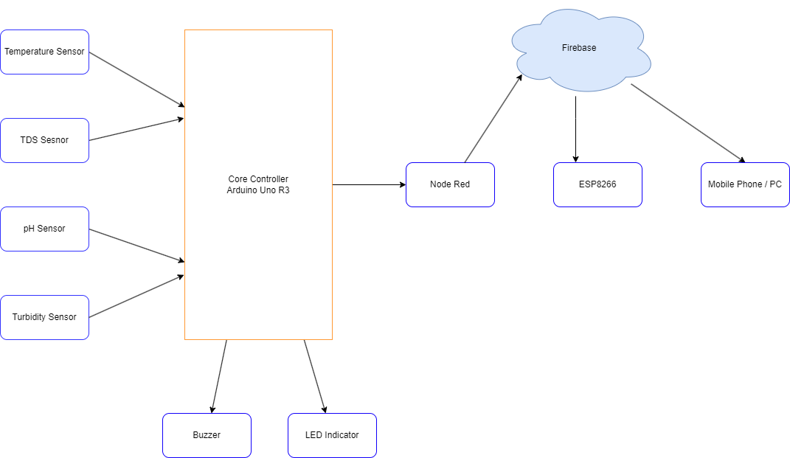

Figure 1.2 Taxonomy diagram of Smart Water Quality Monitoring System.

| Parameter | Range |
| --- | --- |
| pH | pH 6.5 to 8.5 |
| Turbidity | <1 NTU |
| TDS | < 500 ppm |
| Temperature | 50°F (10°C) and 60°F (15.5°C) |

**Table 1: Water quality parameter range for clean water table**

**Table 2**: Turbidity Sensor’s Specifications

| **Element** | **Descriptions** |
| --- | --- |
| **Operating Voltage** | 5V DC |
| **Operating Current** | 30mA (MAX) |
| **Signal Output** | Analog(Default) & Digital |
| **Operating Temperature** | -30℃ ~ +80℃ |
| **Measuring Range** | 0 ~ 1000 NTU |

**\* NTU = Nephelometric Turbidity Unit**

The turbidity sensor finds suspended particles in water, revealing possible contaminants such as pollutants or organic matter that may have an impact on the quality and clarity of the water. With a maximum current of 30mA, it runs at 5V DC and provides both digital and analogue outputs for flexible integration. The sensor measures turbidity levels quantitatively from 0 to 1000 NTU (Nephelometric Turbidity Units), which is important for determining water quality and safety. It operates in temperatures ranging from -30°C to +80°C.

**Table 3**: TECAI-499 pH Sensor’s Specifications

| **Element** | **Descriptions** |
| --- | --- |
| **Operating Voltage** | +5V DC |
| **Operating Current** | 5-10mA |
| **Signal Output** | Analog |
| **Operating Temperature** | 0℃ ~ 60℃ |
| **Measuring Range** | 0 - 14 PH |

The pH sensor determines the acidity or alkalinity of water, giving important details about how caustic the water is and if it complies with drinking water regulations. With an operational current of 5 to 10 mA and a 5V DC power source, it provides an analogue output that is compatible with a range of systems. The sensor detects pH quantitatively on a scale of 0 to 14 pH units, which is crucial for monitoring water treatment systems and identifying health hazards. It can operate in temperatures ranging from 0°C to 60°C.

**Table 4**: TDS Sensor’s Specifications

| **Element** | **Descriptions** |
| --- | --- |
| **Operating Voltage** | 3.3V ~ 5V DC |
| **Operating Current** | 3mA ~ 6mA |
| **Signal Output** | Analog |
| **Measuring Range** | 0 ~ 1000 PPM |

**\* PPM = Parts Per Million**

The quantity of minerals, salts, and dissolved materials in water is measured by the TDS (Total Dissolved Solids) sensor. This information can be used to identify possible pollutants and determine the flavour and quality of the water. With an operational current of 3 mA to 6 mA and a voltage range of 3.3V to 5V DC, it provides an analogue output that may be used with a variety of systems. This sensor, which has a measurement range of 0 to 1000 parts per million (PPM), is crucial for hydroponics, water quality monitoring, and other applications that require the evaluation of the composition and cleanliness of water.

**Table 5**: DS18B20 Temperature Sensor’s Specifications

| **Element** | **Descriptions** |
| --- | --- |
| **Operating Voltage** | 3.05.5V DC |
| **Operating Current** | 5-10mA |
| **Signal Output** | Analog |
| **Temperature Range** | -55℃ ~ +125℃ |

In order to monitor chemical and biological processes and ensure water safety by inhibiting bacterial development and preserving efficient disinfection, the temperature sensor (DS18B20) measures the temperature of the water. It is compatible with a wide range of systems, operating between 3.0 and 5.5 V DC, with an analogue output and an operational current of 5 to 10 mA. The DS18B20 sensor offers precise and dependable temperature readings, which are essential for industrial operations, environmental monitoring, and HVAC systems. Its temperature range is -55°C to +125°C.

**Table 6**: LCD 1602 Module’s Specifications

| **Element** | **Descriptions** |
| --- | --- |
| **Operating Voltage** | 5V DC |
| **Operating Current** | 1mA (without backlight) |
| **Display type** | (16x2) 32 Alphanumeric Characters |

Displaying 32 alphanumeric characters in a 16-character by 2-line configuration, the LCD 1602 module is a versatile display unit. It's suitable for low-power applications because it runs at 5V DC with an operational current of 1mA (without backlight). This module, which is widely utilised in microcontroller projects, embedded systems, and electronic devices, offers a straightforward and affordable text-based interface for a range of applications needing small, readable displays.

ESP-8266: The ESP-8266 is a diminutive and economical WiFi module that was created by Espressif Systems. The device is built around the ESP8266 microprocessor and is commonly used for Internet of Things (IoT) purposes. The ESP-01 module offers wireless connectivity, allowing devices to connect to WiFi networks and communicate via the internet. This makes it well-suited for projects that require wireless connectivity in a compact size.Sir, certain files have exceptionally large file sizes, therefore it may be necessary to utilise Google Drive to download those files.

**Table 7**: ESP-8266 Wi-Fi Module’s Specifications

| **Element** | **Descriptions** |
| --- | --- |
| **Operating Voltage** | 3.3V DC |
| **Operating Current** | 70mA ~ 300mA |
| **Frequency Range** | 2412 ~ 2484MHz |
| **Security** | WEP/WPA-PSK/WPA2-PSK |
| **Operating Temperature** | -20℃ ~ 85℃ |

Built for Internet of Things applications, the ESP-8266 is a small and reasonably priced WiFi module. It supports multiple security protocols, including WEP, WPA-PSK, and WPA2-PSK, and 2.4GHz WiFi, operating at 3.3V DC with a maximum current of 300mA. It works well in a variety of settings with a temperature range of -20°C to 85°C. Devices may connect to and successfully interact via WiFi networks thanks to the ESP-01 module, which also makes wireless connectivity possible for Internet of Things, home automation, and related applications.

* **Stage 1 (Data Gathering):** IoT sensors that are based on smart water monitoring and testing can collect data about water.
* **Stage 2 (Water Data Management)**: Before being used, the dataset gathered from the IoT system in any smart water testing and monitoring applications must be assembled; it may contain noise or missing data values. These missing results could result from malfunctioning sensors or a breakdown in communication between the various parts of a data gathering system. Because these missing data have an impact on the system's performance, they must be addressed appropriately.
* **Stage 3 (Feature Selection):** The environmental water quality characteristics are analysed in this step using a feature selection approach, which chooses the useful indicators for the water monitoring and testing system.
* **Stage 4 (Analysis of Water Quality Data):** Assembling the information for useful environmental indicators related to drought forecasting. using machine learning methods to assess and monitor the quality of water data on large data platforms like Apache Spark (for large water data).

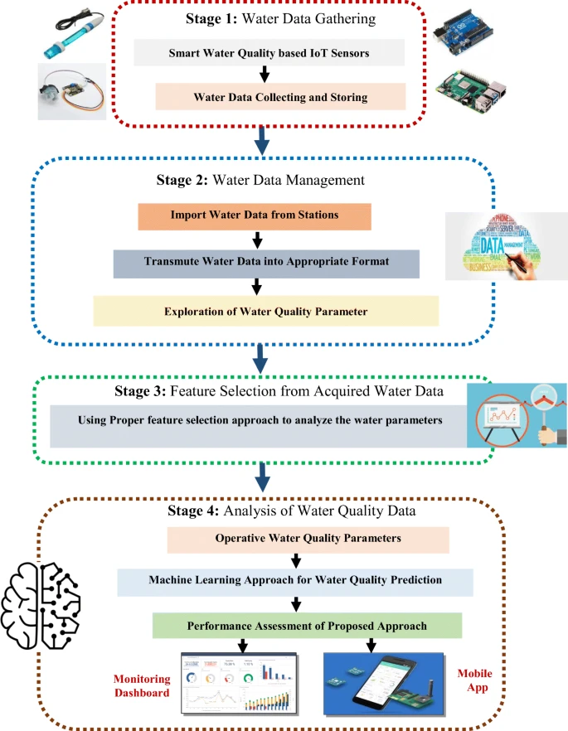

Figure 1.3: SWQMS Block Diagram

*vi. Challenges and Issues*

Difficulties and problems encountered when integrating IoT. The IoT technology can be utilised for monitoring water quality by detecting parameters such as pH value, TDS value, temperature, and turbidity. Although there are technical advantages, the deployment of IoT faces several hurdles and issues, including worries about privacy and security, as well as other developmental obstacles. Below are some of the prominent concerns and challenges:

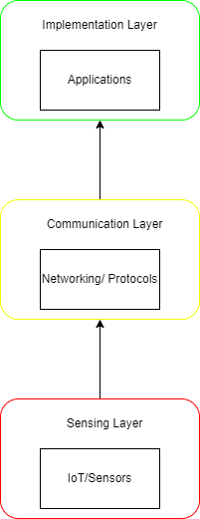

Figure 1.4 Function diagram of IoT

**IoT Globalisation**

The issue of globalising IoT, in which data gathered by water quality monitoring devices could be sent to service providers in other countries, presents difficulties surrounding the management of data, legal authority, national independence, confidentiality, protection, and reliability. Establishing explicit data governance principles, adhering to relevant regulations, and ensuring data sovereignty are essential for maintaining control over critical water quality data. It is necessary to establish strong security protocols to safeguard data while it is being transmitted and stored, taking into account the different data protection rules and cybersecurity practices in different nations. Establishing trust through open and honest data management procedures. Promoting cooperation across borders will help tackle these problems and enable responsible sharing of data for efficient water quality management.

**Data Privacy and Security**

Transferring water quality data across international boundaries presents further complications in terms of safeguarding data privacy and ensuring security. Data protection rules and cybersecurity policies vary among various countries. Evaluating the security protocols employed by service providers to safeguard data during transmission, storage, and processing is crucial, especially when data is transported over international borders.

**Trust and Confidentiality**

Water quality monitoring systems depend on trust and confidentiality to guarantee the precision and dependability of the data. The possible disclosure of critical water quality data to foreign service providers can influence the confidence that stakeholders, such as water management authorities and the public, have in the system. To solve this difficulty, it is crucial to establish confidence by implementing clear data management methods and strong security measures.

**Regulator Challenge By MCMC**

The regulatory challenges encountered by regulators when implementing a Smart Water Quality Monitoring (SWQM) system encompass guaranteeing the accessibility and effective distribution of spectrum resources, overseeing network ports and addresses for secure data exchange, advocating for standardisation to enable interoperability, addressing the demands of mobility and roaming, ensuring the protection and security of data, and promoting the development of skilled personnel and proof of concept initiatives. These difficulties are essential for establishing a regulatory framework that supports the efficient use of resources, ensures data security, fosters innovation, and allows for the smooth integration of SWQM systems to effectively monitor water quality.

**Machine learning (Z-Score)**

| **Composite Calculation** |
| --- |
| waterQualityScore = phValue + tdsValue + temperature + turbidityValue; |

**Table 8: The formula of Composite Calculation**

| **Z-score Calculations** |
| --- |
| zScore = (waterQualityScore - mean) / stdDeviation; |

**Table 9: The formula of Z-Score Calculations**

In these calculations, a higher z-score in this situation would suggest that the water quality differs noticeably from the mean or predicted value. This could indicate that the water quality metrics (temperature, turbidity, TDS, and pH) are not within the usual range or that the water is perhaps contaminated. Consequently, a higher z-score may indicate contaminated or low-quality water, which may be described as "dirty" water.

1. **Gather information on water quality**: Collect the information required to track the quality of the water. This can involve variables including turbidity, temperature, TDS value and pH levels.

2. **Preprocess the dataset**: Encode any categorical features in your dataset into numerical values prior to performing the Z-score normalisation. For instance, using an appropriate encoding algorithm, you can encode the values of a categorical feature, such as "water source," such as "water hose," "lake," or "well," as numeric values (e.g., 0, 1, 2).

3. **Utilise normalisation of Z-score**: After encoding the dataset, you can normalise the numerical characteristics by using Z-score normalisation. Determine the mean and standard deviation of the values in each feature column. The normalised value can then be obtained by applying Equation 1 (the Z-score formula) to each value in the column.

4. **Use anomaly detection**: To find any unusual water quality results, apply an anomaly detection method after normalising the dataset. A variety of machine learning methods, including time series analysis, classification, and clustering, can be used to do this. Using the normalised dataset, train a suitable model to identify any deviations from the patterns of normal water quality.

5. **Configure alerts and monitoring**: Include the anomaly detection model in the system you use to monitor water quality. Keep an eye on incoming data on water quality and run it through the anomaly detection model. Create alerts or notifications in the event that abnormalities or possible problems are found so that the necessary steps can be taken. These could be alerting operators, starting maintenance tasks, or launching corrective actions.

By applying this formula, calculating the z-score of a variable and checking for anomalies in a water quality monitoring system, can be a valuable tool in ensuring accurate and reliable water quality measurements. The z-score calculation normalises the variable by subtracting the mean and dividing by the standard deviation, which brings the data onto a standardised scale. This normalisation process helps in comparing different water quality parameters by removing the influence of their respective scales. By printing the z-score, it allows for easy monitoring and debugging, providing insights into the magnitude of deviation from the mean. Additionally, the anomaly check determines if the variable falls within a normal range or if it deviates significantly, indicating a potential issue with the water quality. This information can trigger alerts or notifications, enabling prompt actions to be taken to address any abnormal readings. Overall, the z-score calculation and anomaly check contribute to enhancing the accuracy, reliability, and efficiency of the water quality monitoring system, ensuring the timely identification and resolution of any water quality concerns.

***vii. Results & Discussions***

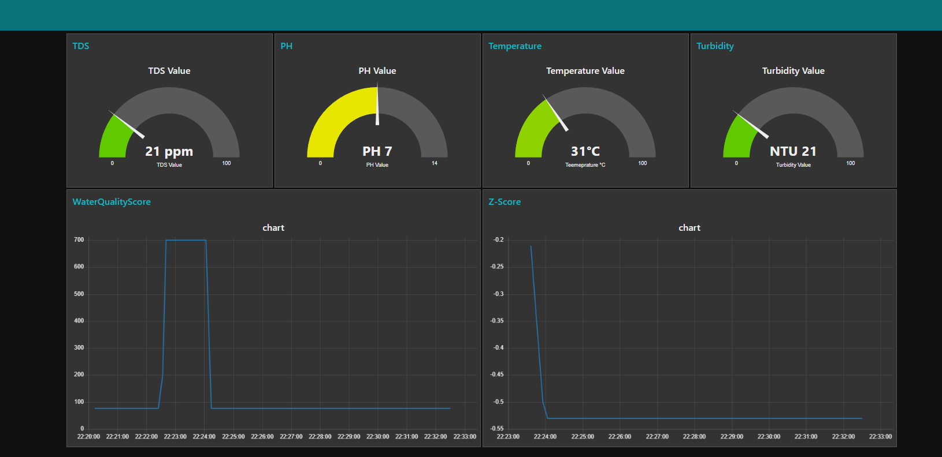

Figure 1.5: SWQMS Dashboard

Understanding the WaterQualityScore and z-scores is necessary for interpreting the data from a smart water quality system that analyses variables like pH, temperature, turbidity, and total dissolved solids (TDS). The TDS, turbidity, pH, and temperature values are added up to provide the WaterQualityScore, which offers a thorough evaluation of the overall quality of the water. Higher WaterQualityScores reflect purer water due to lower turbidity, balanced pH within the required range, appropriate temperature, and reduced quantities of dissolved solids. On the other hand, a lower WaterQualityScore denotes inferior quality water, which may be caused by elevated turbidity, high dissolved solids, excessive heat, or pH levels that are outside of the advised range.

Furthermore, with respect to a reference dataset, the z-scores for distinct parameters such as TDS, turbidity, temperature, and pH provide information on each particular facet of water quality. A parameter that has a higher z-score indicates that the parameter's mean deviates from the dataset mean in a positive way, indicating cleaner water quality for that parameter. A lower z-score, on the other hand, indicates lesser water quality in comparison to the dataset mean. Consequently, one can thoroughly evaluate and analyse the individual and overall quality characteristics of the measured water by examining both the WaterQualityScore and z-scores. This information can then be used to inform decisions and take appropriate action on the treatment and management of water.

***viii. Conclusion and Future Work***

In order to precisely measure water safety and health risks, this study presents an intelligent water quality monitoring system that makes use of pH, turbidity, temperature, and TDS sensors. In line with Sustainable Development Goal 6, the system utilises machine learning to improve sensor accuracy and is integrated with the Blynk platform and ESP8266 for remote real-time monitoring. To protect communities and the environment, proactive water quality control is made possible by fusing IoT biosensors with cloud-based monitoring. More IoT integration, better wireless data transport, and sophisticated sensor technologies will be the main areas of future improvement. In the end, this method provides a workable, reasonably priced alternative for water classification, thereby addressing the pressing need to protect water resources.

***ix. Acknowledgement***

The authors express their profound appreciation to Tunku Abdul Rahman University Management and Technology, Penang Branch, Malaysia, and particularly to lecturer Tan Aik Theng for their unwavering assistance throughout the research. The authors would like to express their gratitude to those persons who offered both direct and indirect support over the duration of this project. Their efforts were of great value in the effective execution of the project.

***Journal of Related Work:***

1. Pasika, S., & Gandla, S. T. (2020). Smart water quality monitoring system with cost-effective using IoT. Heliyon, 6(7), e04096. <https://doi.org/10.1016/j.heliyon.2020.e04096>
2. Chafa, A. T., Chirinda, G. P., & Matope, S. (2022). Design of a real–time water quality monitoring and control system using Internet of Things (IoT). Cogent Engineering, 9(1). <https://doi.org/10.1080/23311916.2022.2143054>
3. Wiryasaputra, R., Huang, C.-Y., Lin, Y.-J., & Yang, C.-T. (2024). An IoT Real-Time Potable Water Quality Monitoring and Prediction Model Based on Cloud Computing Architecture. Sensors, 24(4), 1180–1180. <https://doi.org/10.3390/s24041180>
4. Pasika, S., & Gandla, S. T. (2020). Smart water quality monitoring system with cost-effective using IoT. *Heliyon*, *6*(7), e04096. <https://doi.org/10.1016/j.heliyon.2020.e04096>
5. Ezz El-Din Hemdan, Essa, Y. M., Shouman, M. A., Ayman El-Sayed, & Moustafa, A. N. (2023). An efficient IoT based smart water quality monitoring system. *Multimedia Tools and Applications*, 82(19), 28827–28851. https://doi.org/10.1007/s11042-023-14504-z
6. Zeng, H., Dhiman, G., Sharma, A., Sharma, A., & Tselykh, A. (2021). An IoT and Blockchain ‐based approach for the smart water management system in agriculture. Expert Systems. <https://doi.org/10.1111/exsy.12892>
7. Mehedi Hasan Jewel, & Abdullah Al Mamun. (2022). Internet of Things (IoT) for Water Quality Monitoring and Consumption Management. Internet of Things (IoT) for Water Quality Monitoring and Consumption Management. <https://doi.org/10.1109/sti56238.2022.10103355>
8. Hidayatullah, M., Sofyan, S., Topan, P. A., Andriani, T., & Nurhairunnisah, N. (2022). Monitoring System of Water Quality on Hydroponic Planting Media using Total Dissolved Solid (TDS) Sensor Based Arduino Uno R3. Jurnal Ilmu Fisika, 14(2), 108–115. <https://doi.org/10.25077/jif.14.2.108-115.2022>

***Reference for Website:***

1. United Nations. (2015). The 17 Sustainable Development Goals. United Nations; United Nations. <https://sdgs.un.org/goals>

1.