DONE IN JUPYER NOTEBOOK,
GitHub Repo: https://github.com/JJ-wqr/Assignment4_Comphysics.git

Computational Physics (SCIE6063001)

Week 4. Integral and Derivatives – Part 1

In each of the following problems:
- plot the functions to be integrated within the given intervals;
- use the numerical methods learned in the class: trapezoidal or Simson’s methods;
- estimate and print the errors of the computed integrals. To estimate the errors, you can use the true value of the integrals (if possible) or formulas learned in the class.

Exercise 1.1.
Write a program to find the mass of the one-dimensional object:
a metal rod that is 20 cm long (starting at 𝑥=0) and has a density function of ρ(𝑥)=𝑒^{1/2𝑥} gr/cm3.
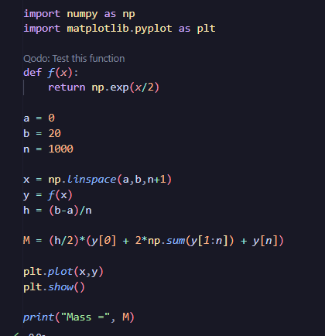
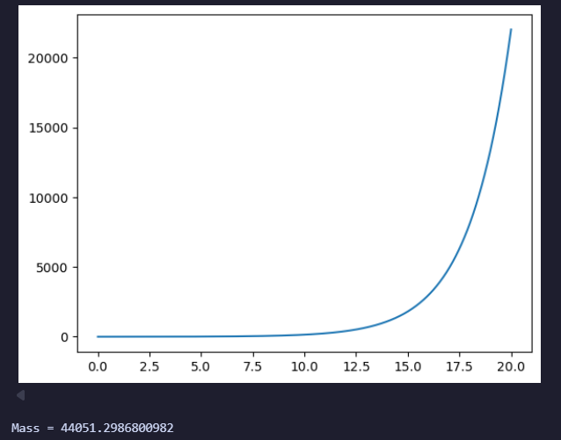

Exercise 1.2.
Write a program to find the mass of the two-dimensional object that is centered at the origin:
A disk of radius 5 cm with density function ρ(𝑥)=$\sqrt{3x}$. [Answer: 20π$\sqrt{15}$]
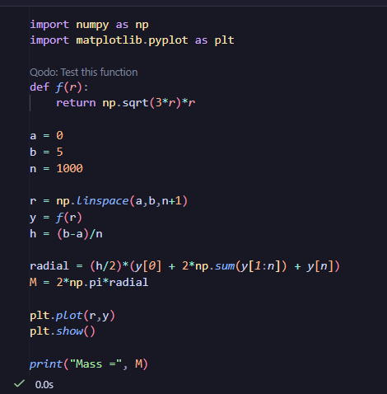
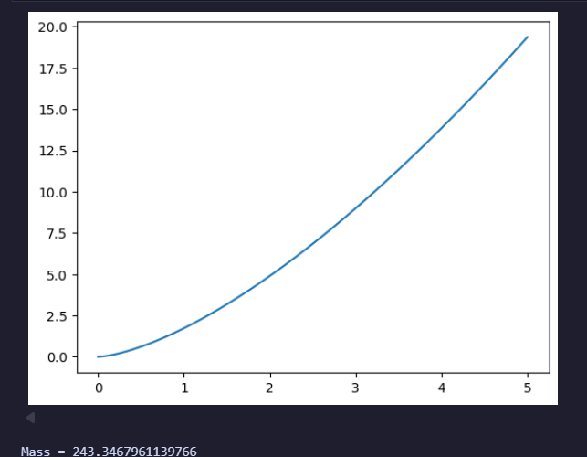

Exercise 1.3.
A spring has a natural length (at rest) of 10 cm. It takes 2J to stretch the spring to 15 cm. Write a program to find work needed to stretch the spring from 15 cm to 20 cm? [Answer: 𝑊 = 6 J]
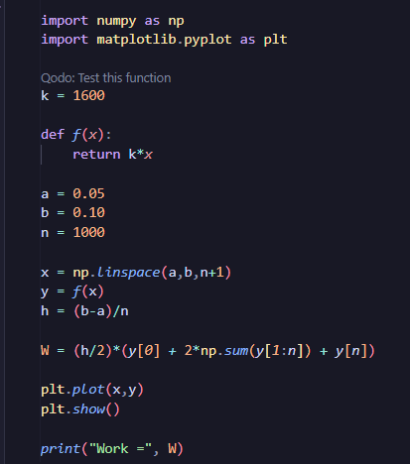
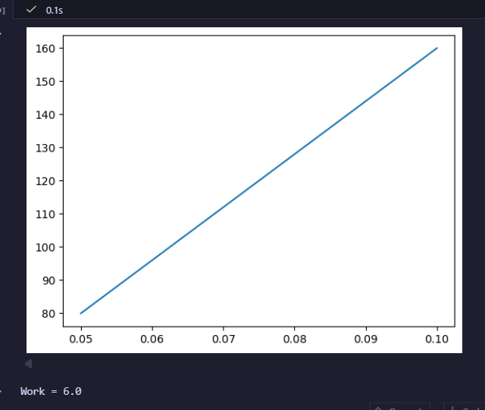

Exercise 1.4.
Assume a tank in the shape of an inverted cone, with height 12 m and base radius 4 m. The tank is full to start with, and water is pumped over the upper edge of the tank until the height of the water remaining in the tank is 4 m. Write a program to find work required to pump out that amount of water.
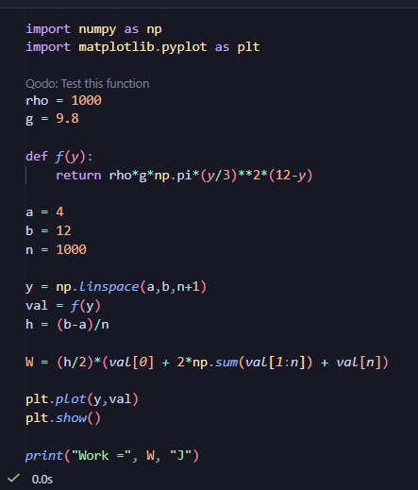
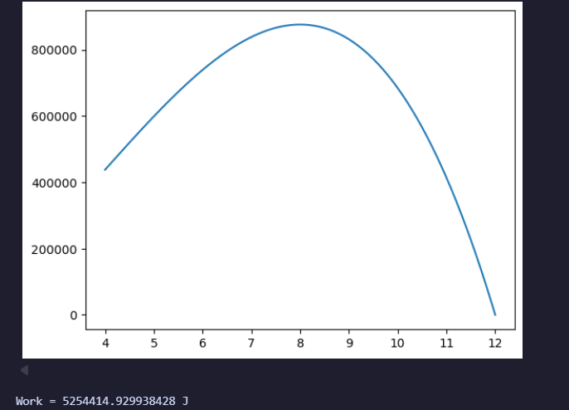

Exercise 1.5.
Write a program to find the lengths of the function f(𝑥) = 1/3*(x²+2)^{3/2} from 𝑥=0 to 𝑥=1.
[Answer: L=4/3 units]
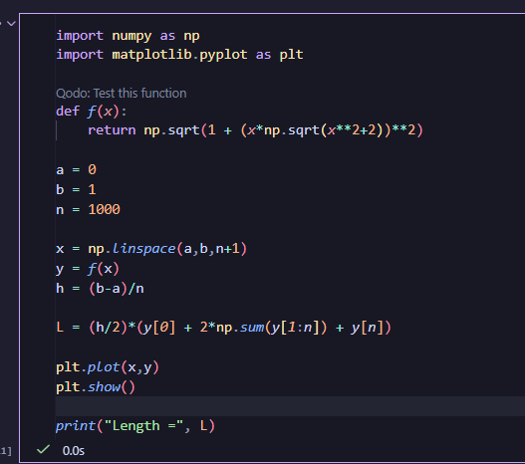
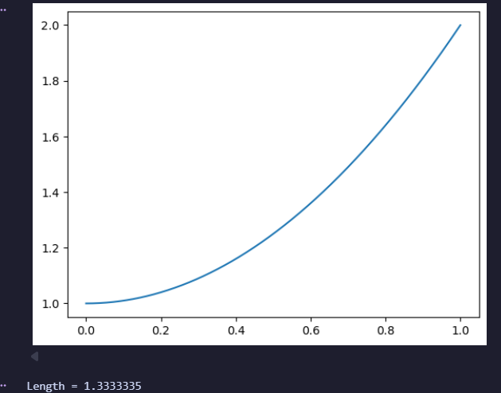

Exercise 1.6. (skipped)
Write a program to find the surface area of the volume generated when the curve
$y=\sqrt{4-x^{2}}$ from x=0 to 𝑥=2 and revolve around the 𝑥-axis. [Answer: 𝐴 = 8π units²]

Source: https://math.libretexts.org/Bookshelves/Calculus/Calculus_(OpenStax)/06%3A_Applications_of_Integration/6.05%3A_Physical_Applications_of_Integration

See the necessary formulas below.

Key Formulas:

