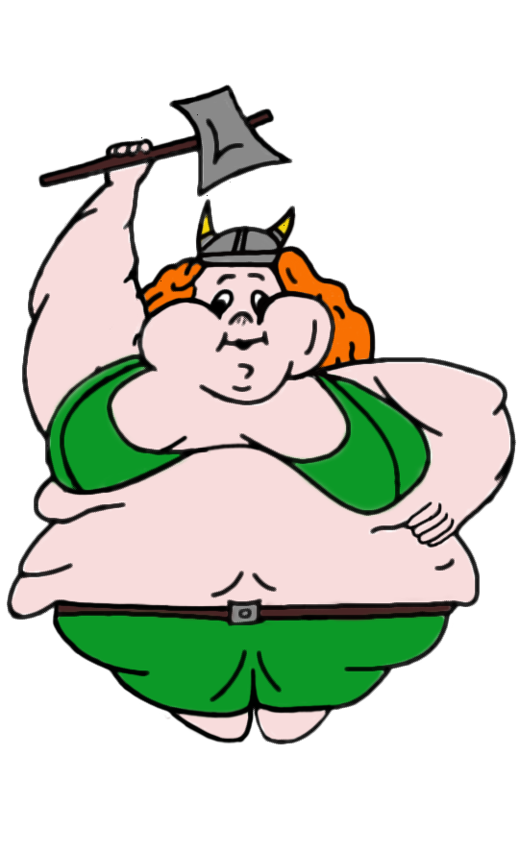

|  |
| --- |
| **Big Julie**  by John Jennings |

For Stuart, my heart will go on.

“I love challenges. If you don't have any and can do whatever you want, then it's probably time to die”

- Jean-Claude Van Damme