Lab 02

# Objectives:

The purpose of this lab is to familiarize you with tables, columns, relationships, and constraints as provided to you within the sample database. By the end of this lab you should be able to:

* Produce a relationship diagram of an existing database
* Visualize the sample database provided to you and display the relationships between the tables
* Be familiar with the sample database that we will be using for the remainder of the term

# Preface:

During this lab, you will need to create a relationship diagram. There are many free tools available to you for this task. One example would be <http://draw.io>.

# LAB 02 – SUBMISSION

You will be submitting either a PDF or a screenshot of a completed database relationship diagram.

**Your Name, Student ID number and the date must be visible in the submitted file (not the file name).** This can be achieved by creating a simple box in the diagram before saving it.

## Explore the Database

By navigating through SQL Developer and looking at the Columns, Data and Constraints tabs for each table, you will create a relationship diagram for all the tables in the database.

Your diagram must include:

* All 8 tables
* The names of the entities (tables)
* The attributes (columns) for each table
* Lines representing the relationships between tables, try to get the lines to as closely point to the correct fields as possible (not always possible to be exact, but do your best here). Do not overlap or cross the lines.
* Crows Foot Symbols on the lines representing the type of relationship (1-1, 1-many)
* Required fields should be **bolded**
* Primary Key fields should be underlined **or** indicated with a PK beside it.
* Child fields in the relationships should be indicated with an FK beside it.

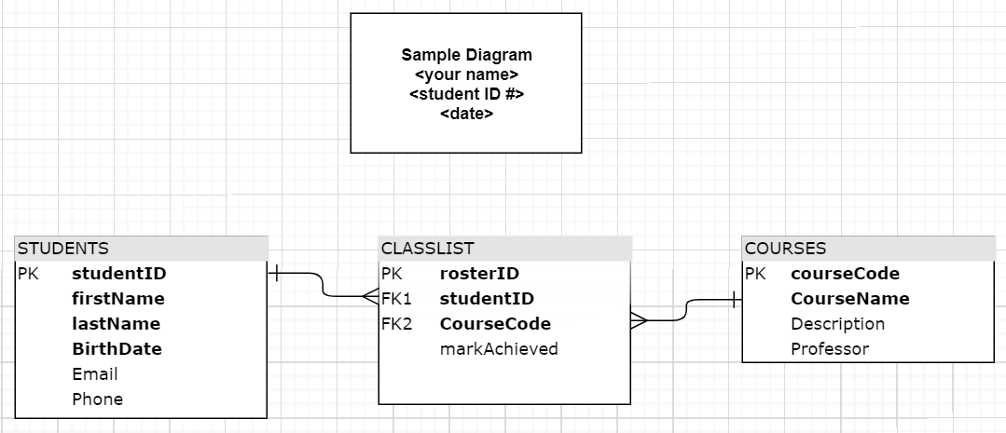

**Example**: