

DEPARTMENT OF COMPUTER SCIENCE & INFORMATION TECHNOLOGY

DR MARTINS ARASOMWAN

NOVEMBER 2020

Kerrin Klaaste – 201727404

JOCELYN ATWELL – 201800014

MFUNDO MONCHWE - 201726904

CAPSTONE PROJECT: DROWZINESS DETECTION IN COMPUTER USERS

# Acknowledgements

# Plagiarism Declaration

We clarify that this research study is our own work and is based on our personal research ideas along with innovations of existing ideas. We have acknowledged all material and sources used in preparation, which include books, articles, lecture notes, videos, reports and any other kind of document. We also certify that we have not copied in part or whole or otherwise plagiarised any work from other students and/or person.

# Abstract

Drowsiness and fatigue in students are some of the leading causes of failing. This research study focuses on detecting drowsiness via a webcam in computer users specifically, studying the environmental contributors which are obtained through a questionnaire and then building a recommendation system to counteract drowsiness and enhance maximum productivity. Additional features include taking a screenshot of the screen when the user has become inactive for a certain period of time and then putting the computer to sleep after saving the screenshot. Similar studies have only been conducted on drivers of vehicles. This system deals with artificial intelligence and drowsiness detection based on visual information obtained through a model built in python to calculate the user’s Eye Aspect Ratio (EAR) and compare it to a threshold value before sounding an alarm if drowsiness is detected. This idea is further scientifically supported by associating it with slow eye closure. The model can be improved by adding yawning as a factor for drowsiness detection. We made use of a keras model to classify and categorize images into two classes, namely drowsy and not drowsy using the ReLu activation function.

# Keywords

Drowsiness, detection, recommendation, keras model, ReLU function, Sigmoid function, Eye Aspect Ratio, fatigue, sleepiness, squinting, eye strain, caffeine, binary cross entropy, metrics, accuracy, COVID-19, computer, laptop, python, Viola algorithm

Table of Contents

Acknowledgements 1

Plagiarism Declaration 1

Abstract 1

Keywords 1

Table of Figures 3

CHAPTER 1: Introduction 3

CHAPTER 2: Literature Review 5

2.1: Netflix 5

2.2: Computer Vision to Detect Drowsiness 5

2.3: Drowsiness Detection and Alert System 6

2.4: The use of Anaesthesia in the Medical Field 6

2.5: Heart Rate VS Sleeping Stages 7

CHAPTER 3: Design and Methodology 8

The Study design: 8

Population and Sampling: 8

Methods used to collect data: 8

System specifications with reasons: 10

Data Analysis: 11

Chapter 4: Results and Discussion 11

Findings 11

Reading Piece 1 11

Reading Piece 2 14

Reading Piece 3 16

Number List 1-20 18

Number List 1-100 19

Findings on the Keras Model 20

Comparison with prior studies 24

Casual Arguments 25

Limitations 26

Speculations/Assumptions 26

Logical Arguments 26

Chapter 5: Conclusion and Recommendations 27

References 29

# Table of Figures

Figure 1:Reading Piece 1 Desk Chart 12

Figure 2:Reading Piece 1 Bed Chart 13

Figure 3:Reading Piece 2 Desk Chart 14

Figure 4:Reading Piece 2 Bed Chart 15

Figure 5: Reading Piece 3 Desk Chart 16

Figure 6: Reading Piece Bed Chart 17

Figure 7: Number List 1-20 18

Figure 8:Graph of Number List 1-20 19

Figure 9: Number List 1-100 19

Figure 10: Graph of Number List 1-100 20

Figure 11: Keras Model Output 1 21

Figure 12: Keras Model Output 2 22

Figure 13: Keras Model Accuracy 23

Figure 14: Keras Model Loss 23

# CHAPTER 1: Introduction

According to NBCI, The National Institute of Health, drowsiness can be described as an inclination to fall asleep. (Arun Sahayadhas, 2012). Drowsiness Detection is used to find reasons or causes why users lose focus when using their computers for long periods of time. Some of the causes could be bad lighting, humidity, font size or it could simply be the low brightness levels of the monitor. (‘The 14 Most Common Causes of Fatigue’, 2018)

Drowsiness is an important concept to deal with. It can impact the performance of a student in their studies as well as the performance of someone in the workplace as well.

Description of problem

Drowsiness negatively impacts the performance of a user and could affect their studies or the company they work for. Our project will test all the factors which contribute to drowsiness and recommend what actions can be taken to prevent it.

When compiling our research, we discovered that drowsiness has only been tested for drivers as a method to prevent accidents from occurring. We would take a different approach to testing for drowsiness which could be applied to any individual who uses a computer. There are a few methods that could be used to detect drowsiness and we would test a few and recommend the accurately predicted method to the users. This project would be beneficial to allow users especially students to optimise learning when using their computers.

Aims and Objectives

We have an aim to accurately detect drowsiness in real time. To achieve this, we will need to test our main model on persons of every nationality with big and small shaped eyes. Another aim we have is to estimate which factors contribute to drowsiness and to successfully recommend how to prevent it from having an impact on the individual. To achieve this, we would make use of it and else statements in our main model and our possible second model as well as finding trends in the data after it is processed to recommend the best action to take.

Research Questions

Research questions are what we ask ourselves when conducting our experiment to formulate a theory. Does drowsiness reduce focus? How does body posture while sitting contribute towards drowsiness? Does the screen brightness affect concentration levels? How do the environmental factors contribute to drowsiness? These are a few of our research questions.

Significance of Study

What is the significance of our project? Firstly, early detection can prevent data loss should the user fall asleep. This is because the alarm could assist in keeping the user awake. However, if the user does fall into a light sleep, the computer would be put to sleep. If the computer does however shut down, data could be lost if it was not saved. Our project also Assists users of all ages, not only students and adults. It shows how the Viola Jones Algorithm is used. It also makes use of computer vision technology to solve an everyday problem amongst students. Our quantitative data will be collected from the environmental factors and the images. Our qualitative data will come from our questionnaire.(McCombes, 2020) The area of conducting experiment is anywhere around a computer. Our goal for this project is to successfully detect drowsiness and provide recommendations on how to prevent and reduce the effects.

Scope of the study

Quantitative data from environmental factors and images

Qualitative data from questionnaire

Area of conducting experiment is anywhere around a computer

Goal: successfully detect drowsiness by sounding an alarm.

Limitations of study

* Area of focus is limited to workspace around a computer
* All tests had to be conducted during the day or in a room with good lighting to assist the webcam during Eye Aspect Ratio detection
* Volunteers would not remain 100% anonymous because of facial detection while using the webcam
* The recommendations after conducting the tests would not be a constant generalization, but instead a different recommendation for each person due to their preferences indicated in the questionnaire
* Cross referencing using a book could be classified as drowsiness through tilting of head and seemingly shut eyelids
* The experiment would be deemed unreliable if computer shuts down during the process
* If the participant wears glasses, the webcam might struggle to differentiate between the participant’s eyes and the glasses frame
* Volunteers could also respond differently to each factor contributing to drowsiness

Assumptions

* During the tests, participants were not allowed to eat or drink anything although no attention was paid to items consumed prior to testing therefore we assume that participants did not overindulge in energy-rich foods prior to testing
* The user makes use of a laptop and not a desktop and monitor

# CHAPTER 2: Literature Review

## 2.1: Netflix

Netflix is an international media streaming platform providing a vast variety of award-winning movies, series and documentaries. This platform makes use of notification technology to determine whether or not the user is still actively watching the show. After the user has played two consecutive episodes (regardless of the length of the episodes) and had zero interaction with the controls (mouse or keyboard), a popup will appear two minutes into the third episode on the user’s end. This is to prevent the user from missing an entire season of a show and instead miss only one or two episodes. Similarly, our research study aims to incorporate this popup notification feature by monitoring control inactivity and in turn keeping track of where the user left off the task at hand.

## 2.2: Computer Vision to Detect Drowsiness

The second source that inspires the idea for our project makes use of computer vision to detect drowsiness. This source elaborates on trying to detect whether or not the user is experiencing any effects of drowsiness. It also only pauses video’s the user is watching when effects of drowsiness are detected and takes a snapshot for the user to see where they were before they dosed off. It would also keep all the tabs and windows opened via the internet open as well as any other programs or documents. Instead of shutting down the entire operating system and forcing applications to stop, the program will instead put the computer to sleep thus opening all applications when the device is switched on again. This prevents data lost in case the auto-save feature isn’t activated. We would like to expand on this concept by adding additional features the users could make use off to alert them of any factors that could cause drowsiness in their working environment. We would also make use of methods to assist in keeping the user focused on any tasks they find themselves with on their computer. (Jain, 2019)

## 2.3: Drowsiness Detection and Alert System

Several experiments have been conducted on drowsiness in drivers to prevent accidents from occurring, however, they all have many variables. Various sensors were used to detect drowsiness behavioural signs such as yawning and eye blinking. A warning system is used to alert the driver that they are at risk of causing an accident as soon as drowsiness is detected via the sensors. (Gabhane, 2018) (Arun Sahayadhas, 2012) This concept is extremely applicable to our research study although our focus is primarily on computer users and not drivers.

## 2.4: The use of Anaesthesia in the Medical Field

How do medical personnel know the exact dosage of a drug and approximately how long a patient would be unconscious or unresponsive for? [General anaesthesia](https://www.cardiosmart.org/healthwise/stg1/7243/stg17243) is a combination of medicines that you inhale through a mask or receive through a needle via your vein which results in [unconscious](https://www.cardiosmart.org/healthwise/not2/4435/not24435)ness. The drug affects your entire body. While under anaesthesia, you should be completely unaware and should not feel any sort of pain during the surgery or procedure. In order to manage the duration during which the patient is unconscious, the anaesthesia dosages need to be adjusted accordingly. Patients for short procedures only need a small dosage to become operable whereas longer procedures need much higher or more frequent dosages. (Alkire, Hudetz and Tononi, 2008) Clinically tested, at a low-sedative dosage anaesthetics cause a state similar to drunkenness, with amnesia, distorted time perception, depersonalization, and increased sleepiness. At a slightly higher dosage, a patient fails to move in response to a command and is considered unconscious. While in the second state, the patient may be perceived to be sleeping and during this time the patient’s heart rate will be constant given no operation has been performed yet. General anaesthesia suppresses many of your body's normal automatic functions. These include breathing, heartbeat/rate, circulation of the blood (blood pressure), movements of the digestive system (diaphragm), and throat reflexes such as swallowing, coughing, or gagging. A heart rate between 40 and 60 bpm is not uncommon for adults under general anaesthesia although it may vary secondary to home medications. By looking at the effects of anaesthesia in conjunction with the patient’s heart rate patterns, scientists were able to deduce how dosages should be adjusted to manipulate the consciousness of the patient before the patient becomes operable. Similarly, our project aims to explore the connection between the participant’s heart rate and state of consciousness and thereafter draw conclusions from the data obtained.(Alkire, Hudetz and Tononi, 2008)

## 2.5: Heart Rate VS Sleeping Stages

By using smart watches, we can sync the watch to our device to detect the heart rate of the participant and monitor when individual is awake, in a light sleep or a deep sleep and send alert notifications when the participant has drifted into light sleep.

Brain activity accounts for the 4 different stages of sleep namely, NREM (Non-rapid Eye Movement) Stage 1, NREM Stage 2, NREM Stage 3 and REM (Rapid Eye Movement) Sleep. (Wickramasinghe, 2018) NREM Stage 1 is the beginning of the sleep cycle and is relatively light. It can be seen as the transition period between wakefulness and sleep because the brain produces a high amplitude of theta waves and lasts for about 5-10 minutes. NREM Stage 2 lasts for about 20 minutes and is when the brain produces rapid, rhythmic wave activity. You become less aware of your surroundings, body temperature drops and your breathing and heart rate regulate. During NREM Stage 3, there are deep, slow brain waves and you become less responsive to noise and environmental activity around you. This is the transition to very deep sleep which is where our research study aims to invoke its alert features. During the final stage (REM Sleep), the majority of dreaming occurs and the brain and other body systems become more active yet muscles are more relaxed because voluntary muscles have become immobilized.

With that being said, it is a proven fact that heart rate and blood pressure decreases continuously until it becomes constant during deep sleep. By using the technology within smart watches, one is able to monitor heart rate during sleep. Thereafter the information can be analysed to see the different stages of sleep the person went through. By creating a heart rate scale for beats per minute, the different stages of sleep can be graphically represented against time. A bench mark heart rate will be set as the rate at which a person is said to be transitioning into light sleep. This is turn will trigger a notification/alarm to prompt the user to stretch, drink water or simply ask if the user would still like to continue working.

# CHAPTER 3: Design and Methodology

## The Study design:

With this project there are many ways in which we have conducted our experiment and how we have done our research. With our project we have separated it into three parts. The first part of our project was focused on detecting drowsiness. The second part of our project was focused on assisting the user when drowsiness does occur. The third part of our project was a keras model. The keras model will test how accurate drowsiness can be detected through images. In initiating our experiment, we have asked the user to access our webpage. The first thing the user must complete is a consent form for ethnicity reasons. Thereafter we asked the user to complete a questionnaire. The data from the questionnaire assisted us in collecting insights on the factors that could contribute to causing drowsiness. The final part was for the user to run our model. Further observations were done during the experiment using excel and Microsoft access. Tableau was used to collect insights.

## Population and Sampling:

We have worked with a very large population which consists of anyone and everyone who is able to use a computer or any computing device. We have sampled it by focusing on students from the age of 16 and older. We chose students, because we ourselves are students and every student has access to a computing device.

## Methods used to collect data:

We’ve incorporated various data collection methods of which the primary method being the combination of questionnaires and EAR (Eye Aspect Ratio) tests. This combination formed the basis of the primary method in addition to the JavaScript code combined with python as an additional model.

Participants were first required to complete a questionnaire pertaining to their individual preferences of working conditions such as preferred font size and working environment. This information will be used to justify the results obtained from how they fared in the tests conducted thereafter. Participants then did a series of 5 tests which includes 3 reading pieces and 2 number charts. The aim of the experiment is to monitor eye movement and eye aspect ratio change while the participants reads. All tests were conducted during the day due to lighting limitations. The participant must sit between 30 and 60 centimetres away from the screen and read any portion of the article for a duration of 1 minute. Each time the alarm sounds as a results of the EAR dropping below the threshold value, the test conductor will record the total number of times the alarm is sounded. Participants were not allowed to wear sunglasses or hats and the screen zoom settings remained on 100% for all tests.

Three articles relating to our project were chosen as reading pieces. During test 1, the participant will sit on a chair at a desk with a screen brightness of 100%. During test 2, the participant will read while sitting on their bed with the screen brightness still set at 100%. For test 3 and 4, the screen brightness was lowered to 20% while the tests were conducted while sitting on a chair at a desk and on a bed respectively. Test 5 was aimed at identifying weak areas in our model by instructing the participant to look at different numbers on a number chart. Each time the alarm sounded, the results were recorded the higher the frequency of the identified numbers the better we could identify where on the screen the model wasn’t as effective.

Our secondary data collection method was obtained by downloading images online using a JavaScript code then combining it with python code to extract random images from query to create our own dataset in our order to build our model. At first, our original dataset consisted of 381 images, but due to internet connectivity some images were corrupted and others were irrelevant. We then decided to remove irrelevant images which left us with a total of 261 images.

Our Keras model architecture has a 2D convolution with input shape of 32. The model used the ReLu activation function where a maximum pooling with a pool size of 2 by 2 was applied. The dimensions of those images obtained were flattened by convolving them. Dropout was used to avoid the overfitting on the dataset. The Sigmoid function was used in the last layer of the network. (Gupta and Murzova, 2017)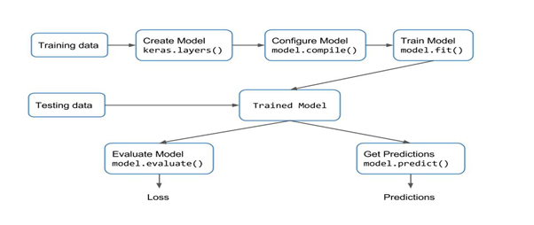

Figure 1: Keras Model Layout

## System specifications with reasons:

System requirements specification(SRS) is set of documentation that describes the features and behaviour of a system or software application. It also includes variety of elements that defines the intended functionality required by the customer to satisfy their different users. (Japenga, 2011)

Users must have systems that are able to have good functionality when coming to programming platforms and also must have a high computational speed in terms of wanting quicker results. The minimum requirements in terms of laptops needed to manage this model (DDRS), is that it must have a processor type of minimum core i5 Processor, although we recommend the Core i7.

It must have memory of at least 8GB RAM or higher and as for HDDS must have memory of 500GB or higher. We recommend SDD since they are very fast and much better than HDDs although they are more expensive than HDDs because of their functionality and minimum requirement 250GB or higher. In terms of Operating Systems, Windows 8.1 is sufficient although we recommend Windows 10 Home or Pro whereas 10.13 or higher is recommended for Apple Macintosh.

The user will need to make use of Anaconda or an online platform to access Jupyter Notebook to code in Python. This is the approach that we made use of. Failure to meet any of the above requirements will result in system execution failure.

## Data Analysis:

For the experiment we used the Eye Aspect Ratio (EAR) drowsiness detection system which analyses video frames. The EAR uses the Viola Algorithm in which it uses the video frame to estimate wideness of the eye. (Jensen and Larsen, 2008) Viola Algorithm also includes the Mouth Aspect Ratio (MAR) which refers to the wideness of the mouth. Whenever this estimate drops significantly for the EAR, we know that the wideness of the eye as decreased.(Maior *et al.*, 2020) This means that the eye is closing or is closed. For the MAR, when the estimate increases significantly, it means that the mouth is wider meaning that the user is yawning which is an indication of fatigue, tiredness and drowsiness. We chose this specific algorithm because it was most relatable to our project aim. The webcam had to be active throughout the experiment. To ensure that the video frame was not accidently closed, we made sure that within the code, the frame could only be closed when “q” was entered on the keyboard.

Microsoft Access and Microsoft Excel was used to collect our data manually during the experiment. It was also used to plot down results from our questionnaire. Access was used to create queries to process our data to get insights. This file was read in Tableau and further processed to get graphical results of the data. It was not necessary to clean the data.

# Chapter 4: Results and Discussion

Under this heading we will deal with the results we found from conducting our experiments and explain them.

## Findings

### Reading Piece 1

We asked our volunteers to read any portion of the article for 1 minute. The results varied from volunteer to volunteer due to various factors such as reading speed which was evident in eye movement across the screen. These factors may include short-sighted users, far-sighted users and partially blind users. Other factors include working by a desk in a chair with good posture, sitting on the bed as well as the brightness of the monitor while working. These factors are constant for all the reading pieces that follow.

#### Trends from Reading Piece 1 data:

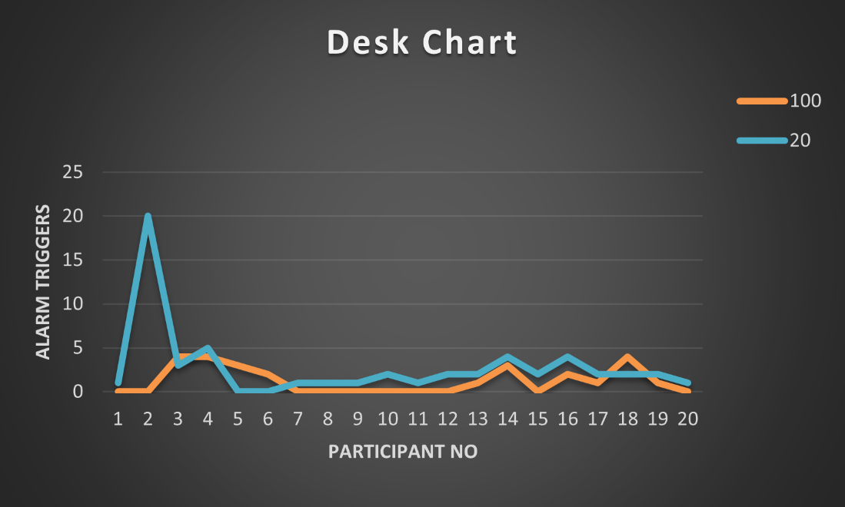

Figure 2:Reading Piece 1 Desk Chart

Figure 2 above is a chart representing the number of times the alarm was triggered when the user was reading at the desk with 100% monitor brightness as well as 20% monitor brightness. The article the user was reading had a 20pt font. The orange data line shows how the alarm was triggered during reading piece one at 100% monitor brightness. Throughout most of this test, at 100% brightness the alarm was triggered less than five times or not at all.

When looking at the blue data line, at 20% monitor brightness, the alarm was triggered more frequently then at 100% brightness. This is due to the user squinting to be able to read effectively. The spike at point (x,y)=(2,20), indicates that the user was unable to read due to the decreased brightness, deeming the results for it inconclusive. However, we could not leave this entry empty as we had to be able to create graphs from it. This is why we chose a really high alarm trigger number to be able to clearly see where the data readings were inconclusive. There was only one instance where the results were deemed inconclusive.

For reading piece 1, we expected the participants to fare better by having minimal alarm triggers due to the large font size which makes reading easier and quicker. This was not the case for all participants.

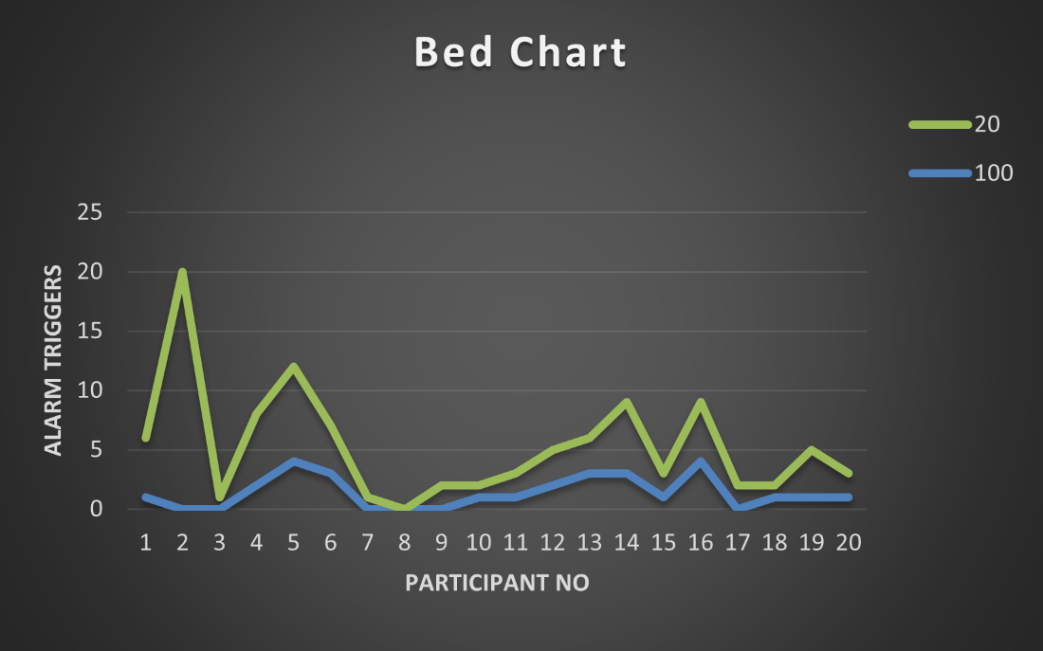

Figure 3:Reading Piece 1 Bed Chart

Figure 3 above is a chart representing the number of times the alarm was triggered when the user was reading while on a bed at 100% monitor brightness and at 20% monitor brightness. The data corresponds to reading piece one at 20pt font. The blue data line represents data where the monitor brightness was at 100%. The alarm was triggered approximately 5 times for the most or not at all. The spikes within this data line are when conducting our tests for the second time, the user started experiencing effects of drowsiness, because of bad posture, sitting on the bed or simply because of dim environmental lighting.

The green data line represents the alarm triggers for each participant at 20% monitor brightness. The alarm was triggered more frequently, because the user was experiencing effects of drowsiness or the user was squinting to read efficiently. The spike within the data at point (x,y)=(2,20) is when the user was unable to read the article. This deemed our results for that specific individual inconclusive. There was only one instance where the results were deemed inconclusive.

### Reading Piece 2

#### Trends from Reading Piece 2 data:

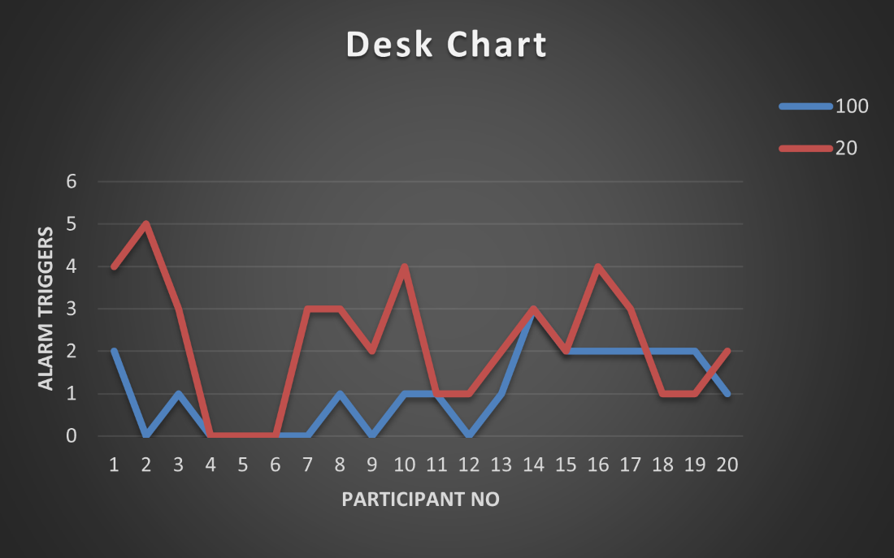

Figure 4:Reading Piece 2 Desk Chart

The above graph shows the number of times the alarm was triggered when the user was reading at a desk with 100% monitor brightness and 20% monitor brightness. The article the user was reading had a font of 14pt. The blue data line represents the number of times the alarm was triggered at 100% monitor brightness.

As you can see, the alarm was triggered about 3 times and less or not at all. This means that the participants were able to read well with this font. Compared to Figure 2, there are more spikes in this data line in Figure 4 for 100% brightness. This could mean that the participants ability to read efficiently corresponds to the size of the font. The bigger the font, the better the user reads and less triggers there would be.

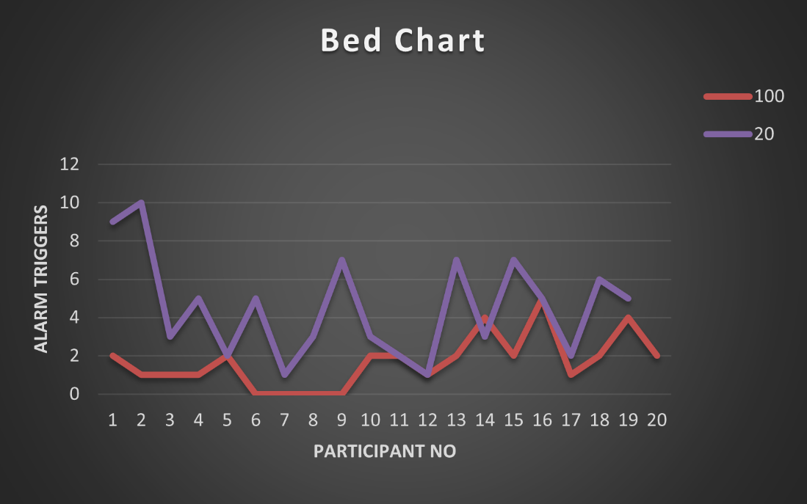

Figure 5:Reading Piece 2 Bed Chart

The above graph shows the number of times the alarm was triggered when the participant read an article with 14pt font at different monitor brightness. The red data line represents the number of times the alarm was triggered when the user read at 100% monitor brightness. The alarm was triggered no more than 5 times or not at all. From this we can see that the user was able to focus better than at 20% brightness.

The purple data line represents the number of times the alarm was triggered at 20% monitor brightness. All the users were able to read this as there are no data values of 20 representing any results that were inconclusive. However, the participants had difficulty reading this article as there are spikes the times the alarm was triggered. For one participant, the alarm was triggered 10 times in one minute of reading. This could be caused by squinting or by the user experiencing effects of drowsiness and struggling to focus on reading. Compared to Figure 3, we can see that the smaller the font size the higher the number of triggers there are. There is a correlation between the font size and the alarm triggers.

We expected the participants to have consistent results since the font was the closer to the average preference of 12pt. The font size largely contributes to how quickly the reader’s eyes move to the bottom of the screen as they near the end of a paragraph, therefore an average font size such 12pt or 14pt would be ideal.

### Reading Piece 3

#### Trends from Reading Piece 3 data:

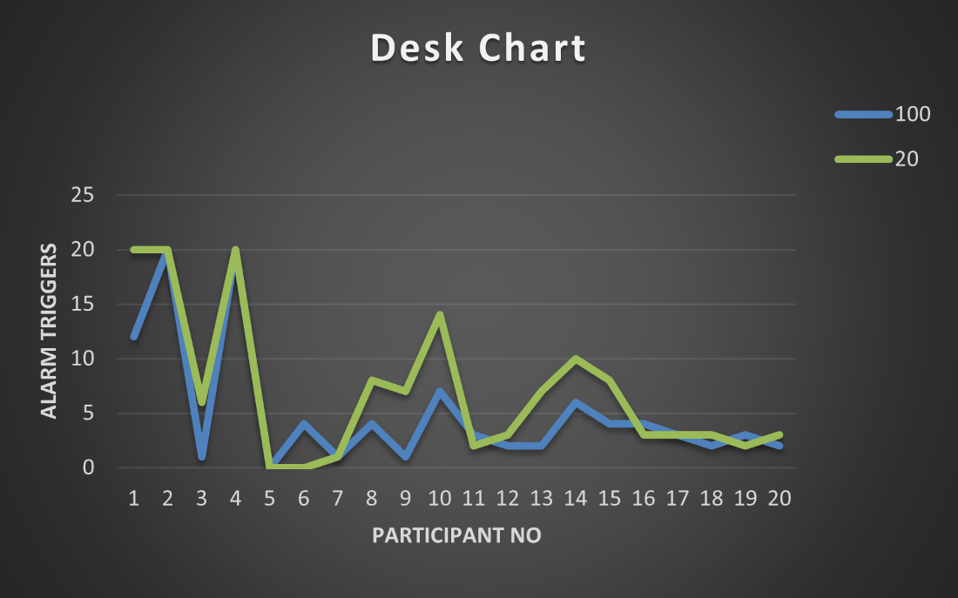

Figure 6: Reading Piece 3 Desk Chart

The above graph shows the number of times the alarm was triggered when the user read an article of 8pt font at 100% monitor brightness and at 20% monitor brightness. The blue data line represents the number of times the alarm was triggered at 100% monitor brightness. The number of times the alarm was triggered are no more than 12 or not at all. The spikes of points (x,y)=(2,20) and (x,y)=(4,20) represents null values where the user was unable to read the article deeming their results inconclusive. There are two instances here where the results were inconclusive.

Compared to Figure 2 and Figure 4, there are a greater number of triggers in Figure 6. There is a correlation between the font size and the number of triggers. The green data line represents the number of times the alarm was triggered at 20% brightness. The alarm was triggered more frequently when the brightness was dimmed. There are also inconclusive data entries where the user was unable to read the article. These occur at points (x,y)=(1,20),(2,20) and (4,20). There were three instances where the results were inconclusive.

It was expected that the alarm would be triggers a lot more when the font size was 8pt in comparison to when it was 14pt and 20pt due to the fact that users would now either move closer or squint to see better and in turn trigger the alarm due to the reduced Eye Aspect Ratio.

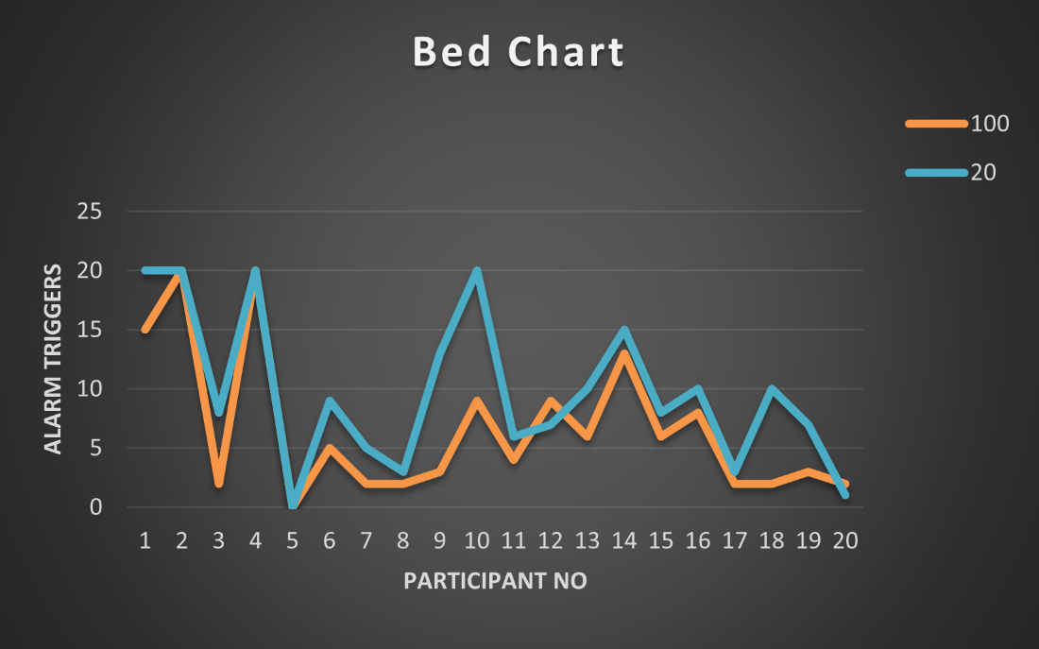

Figure 7: Reading Piece Bed Chart

Figure 7 above shows the number of times the alarm was triggered when the participant read an article of 8 pt font. The orange data line represents the number of times the alarm was triggered at 100% monitor brightness. There are inconclusive data entries at points (x,y)=(2,20) and (4,20). These are where the participant was unable to read the article due to the small font size. The blue data line represents the number of times the alarm was triggered at 20% monitor brightness.

The alarm was triggered more frequently at 20% monitor brightness than at 100% monitor brightness. This could be because the user was having difficulty reading due to the dimmed brightness, small font size or due to the participant feeling the effects of drowsiness. There are a few data entries where the results were inconclusive. These occur at points (x,y)=(1,20),(2,20),(4,20) and (10,20). There were four instances where the results were inconclusive. The smaller the font size and the dimmer the monitor brightness it results in more frequent triggers of the alarm detecting drowsiness.

### Number List 1-20

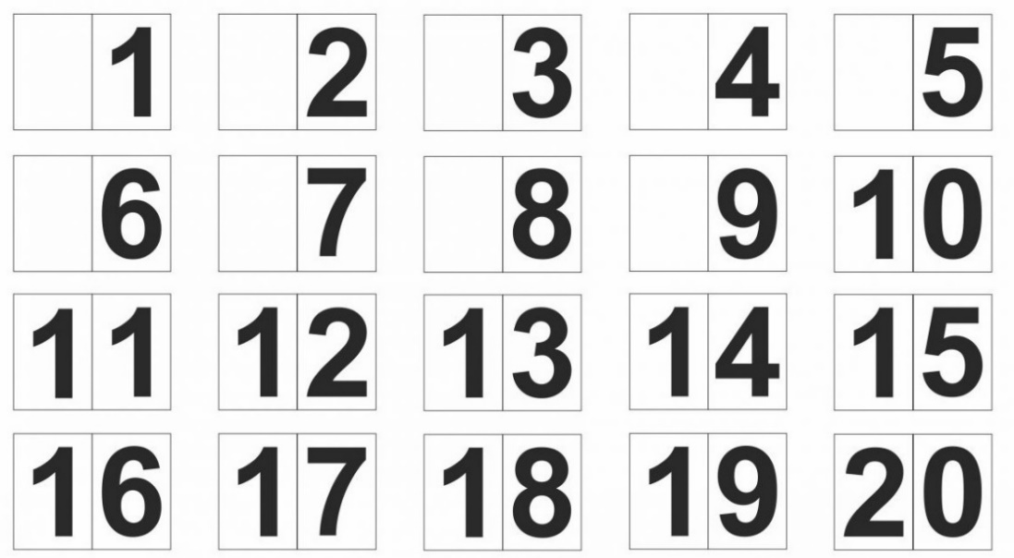

Figure 8: Number List 1-20

The above image is the number chart we used to track the eye movement of the user. This was used to try and spot exactly which numbers on the screen the alarm would be triggered. This could help us determine how accurate the EAR estimate really is. Naturally, the alarm should be triggered when the user looks at the bottom of the screen. When looking at the bottom of the screen, through the webcam it appears that your eyes are partially closed. This is important, because partially closed eyes are a physical sign of drowsiness. We have recorded these numbers where the alarm was triggered. Below we created a bubble scatter plot graph on these results.

#### Trends from Number List 1-20 data:

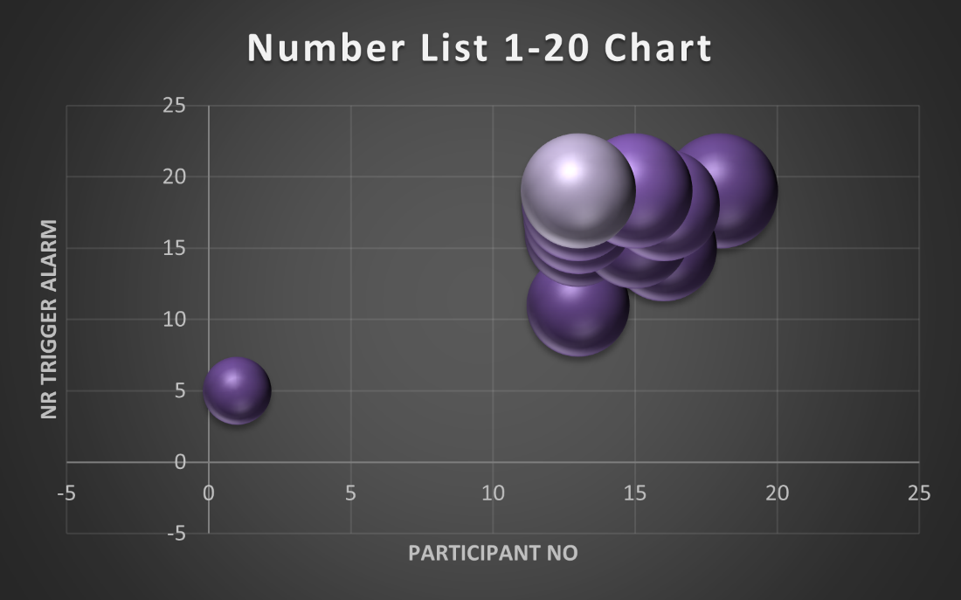

Figure 9:Graph of Number List 1-20

The above graph represents the numbers at which the alarm was triggered when the user looked at the number chart in Figure 8 when it was displayed on the screen. We can see that the alarm was frequently triggered at the numbers ranging from 11 to 20. This is indicated through the cluster at those points. Referring to Figure 8, numbers 11 to 20 are the bottom two rows. This means that the alarm was triggered when the user looked at the numbers placed at the bottom of the screen. When looking at the bottom of the screen, the eyes appear partially closed and the EAR would drop significantly.

### Number List 1-100

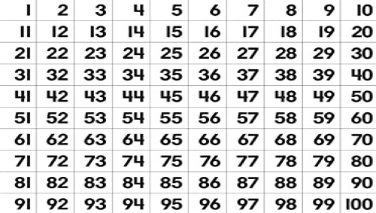

Figure 10: Number List 1-100

Figure 10 shows the number chart we used to keep track of the eye movement of the user when looking at different places on the screen. Naturally, the alarm should be triggered when looking at the bottom of the screen as eyes would appear partially closed. We have recorded all the numbers at which the alarm was triggered. Below is a scatter plot graph of the results.

#### Trends from Number List 1-100 data:

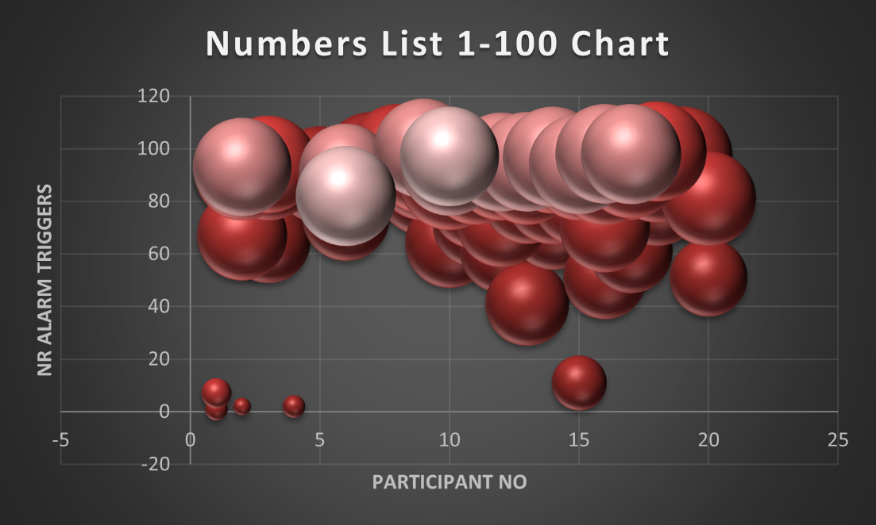

Figure 11: Graph of Number List 1-100

Figure 11 represents the number of times the alarm was triggered when the participant looked at different positions on the screen. The number chart consists of numbers ranging from 1 to 100. However, the graph contains values of 0. We were unable to remove these values. The 0’s in the chart represents times when the alarm was not triggered at all. These values could be ignored and does not affect our results.

There is a cluster of data points between 60 and 100. This means that the alarm was triggered more frequently at those positions on the screen. When referring to Figure 10, these numbers can be found in the bottom four rows. The triggers between the values 1 and 10 could be that the user was squinting when looking at those positions on the screen. The biggest cluster of values are between 80 and 100. This is good, because when looking at the bottom of the screen the eyes would appear partially closed. Partially closed eyes are a physical sign of drowsiness and the alarm would frequently be triggered.

## Findings on the Keras Model

After running some few codes, we find the following outputs

Figure 12: Keras Model Output 1

Given the dataset that we ourselves created which has approximately 261 images, we find that 261 images from both training set and testing set belong to 2 classes. We also run the epochs from 1 to 10 and we find out the loss is 48.75% and accuracy is 81.85% followed by validation loss of 53.51% and validation accuracy of 81.25% after 10/10 epochs have completed.

Model Summary includes the following: an output shape of (None,223,223,32) and with parameters of 416 for the Conv2d layer.

Figure 13: Keras Model Output 2

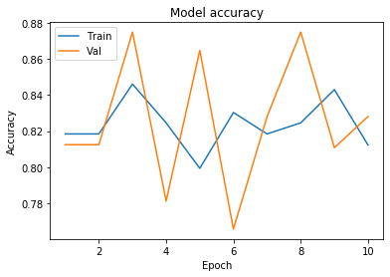

Figure 14: Keras Model Accuracy

Figure 14 displays the output of the learning curve function which shows the epochs against the accuracy percentage. There are several fluctuations between training set and testing set and it is evident that under model accuracy the validation accuracy is greater than the training set after 10 epochs have completed.

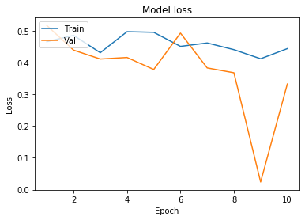

Figure 15: Keras Model Loss

Figure 15 represents the model loss function where we measure the number of epochs against the loss for the Train and Validation sets. Under model loss, we find out that there were less fluctuations compared to model accuracy. Here we saw that training set loss is higher than validation set after 10 epochs

## Comparison with prior studies

Our Drowsiness Detection System results compared to Source 1 are similar when looking at the timer system and EAR drowsiness detection system. The EAR drowsiness detection system constantly checks the EAR of the user within the video frame. When the EAR drops below the threshold, an alarm is triggered to warn the user that they are becoming drowsy and a notification will be displayed that drowsiness is detected. The timer system runs in the background of the users computer. It runs a timer to keep track of the users activity on the computer. If the user was inactive for a set amount of time, it will let the user know that inactivity has been detected. (Wickramasinghe, 2018)

Our Drowsiness Detection System results compared to Source 2 are very similar when looking at the timer system and the screenshot system. The timer system runs in the background of the computer. It runs a timer to keep track of the users activity on the computer. If the user is inactive for a set amount of time, it will let the user know that inactivity has been detected. The screenshot system will be initiated when the timer reaches its set time and a notification has been sent to notify the user that inactivity has been detected. The screenshot system then takes a screenshot of the users screen and saves it in a folder. This will allow the user to keep track where they left off. The screenshot system would put the computer to sleep after inactivity has been detected.

Our Drowsiness Detection System results compared to Source 3 are very similar when looking at the drowsiness detection system. Our system makes use of EAR to detect drowsiness when the eye wideness fluctuates. The system in Source 3 makes use of the EAR as well as the MAR mentioned earlier in the document. They make use of an alarm to alert the driver when they are drowsy. This is similar to our alarm to alert the user that they are drowsy and could cause them to perform less efficiently.

Looking at Source 4, our Drowsiness Detection System is not similar. Initially, we wanted to synchronise our drowsiness detection system with a smart watch. This would allow us to monitor the heart rate of the user while the drowsiness detection system analyses their EAR. This would allow us to see if the users heart rate drops before or exactly when the EAR fluctuates. However, due to lack of resources we could not conduct this test.

Looking at Source 5, our Drowsiness Detection System is not similar. This is similar to Source 4. Initially, we wanted to synchronise our drowsiness detection system with a smart watch. This time we would not make use of the EAR, but we would make use of the heart rate of the user. Most modern smart watches monitors your heart rate while active, when drowsy and when sleeping. There are different stages of sleep. Each stage has its own heart beat range per minute. If we could successfully detect when the users heart rate drops below average, we can assume that the user is in a light sleep. Thereafter a notification would be sent and the user would have to take action to wake themselves up. However, due to lack of resources we could not conduct this test.

## Casual Arguments

When looking at the findings we got from conducting our experiment, there are a few results we can argue. Firstly, there are many signs of drowsiness from yawning to partially closed eyelids. However, laughing is not a sign of drowsiness but it does result in partially closed eyelids. This could be something we could use to argue the accuracy of our model.

Secondly, we could argue that we did not include to record whether the user had problems with their sight or not. We just assumed that the users who wore contacts and or glasses had some type of problem with their sight. This is a fair assumption to make, however it would have improved the accuracy of our results if we knew exactly who had problems with their sight and who did not. However, one could argue that that is confidential information.

The third argument we could make is that our results could have varied if we chose to test on a larger number of participants. Our findings could have been different as well. However, because we tested our model on participants belonging to various age groups, we are convinced that our findings would not have differed greatly.

The participants that had inconclusive readings either wore glasses and contacts or glasses alone. We can safely assume that these participants have problems with their sight. This could be a factor when questioning the accuracy of our model. Participants who have problems with their sight, often squint when they read or cannot read at all are not necessarily experiencing the effects of drowsiness. However, we know that there is a correlation between the font size of the reading material, the number of triggers of the alarm and the brightness of the monitor. The smaller the font and the dimmer the monitors brightness, the more times the alarm would be triggered. This is our fourth argument.

## Limitations

The first limitation we came across was testing the EAR drowsiness detection system at night. It could not estimate the EAR due to bad lighting. Therefore, all our experiments are conducted during the day. For future reference, do make sure that there is a dim light or lamp nearby while conducting the test under dark conditions as the monitors brightness is not enough.

The second limitation is when the threshold is set for the user, they should not move further from the monitor or closer to it. The threshold is the set minimum average EAR for the user. Whenever the EAR is below the threshold, drowsiness would be detected by the system. When the user moves away from the monitor, the eyes appear smaller and the alarm would be triggered. When the user moves closer to the monitor, the eyes would appear larger thus drowsiness would not be detected even when squinting, because the users EAR has increased.

The third limitation is then the alarm is triggered when the user is laughing. Laughing is not a factor for drowsiness.

The fourth limitation is that when the threshold is set too low, drowsiness would not be detected.

The fifth limitation we came across is when the EAR mistakes the users glasses frames as the users eye. The EAR mistakes the users nostrils as eyes when the user lifts their head too high.

## Speculations/Assumptions

We can assume that the has a webcam on their computer, because the system cannot work without it.

## Logical Arguments

The accuracy of our model is debatable. This is because there are many variables that cause the alarm to be triggered for detecting drowsiness that are not factors of drowsiness at all. We are not able to find an exact percentage for our models’ accuracy, but we are able to estimate it. To estimate the accuracy of our model we would make a list of advantages and disadvantages, as shown below:

Advantages:

* The alarm is triggered when the EAR drops below the set threshold when the eyes are partially closed. Partially closed eyes are a sign of drowsiness.
* The threshold can be adjusted to only trigger the alarm when the eyes are closed.

Disadvantages:

* The alarm is triggered when the participant is squinting due to sight problems and when the user laughs.
* The EAR mistakes the nostrils for the eyes when the participant tilts their head to high.
* When the threshold is too high, the alarm would be triggered when the participant looks at the bottom of the screen.
* This EAR does not estimate effectively at night due to the bad lighting.
* The EAR can mistake the participant’s glasses frame for their eye.

We can hereby conclude that our model’s accuracy

# Chapter 5: Conclusion and Recommendations

After testing the model on ourselves, we noticed that the model struggled to detected where the user’s eyes are due to bad lighting, therefore the decision was made to conduct the tests using good lighting within the testing environment which ultimately meant that testing in a dark room was eliminated. In addition to this, future improvements to the model include being able to function effectively in darker environments.

We have drawn direct correlations between the font size and the number of times the alarm was sounded during our tests and can confidently state that the smaller the font size, the more the user will struggle to read what is written on the computer screen. The same applies to the screen brightness. Studies have shown that a concurrent increase of both visual fatigue and arousal under high screen luminance.(Benedetto *et al.*, 2014) therefore even though the participant could see better at a higher screen brightness, it can result in visual eye strain. Similarly, squinting to see smaller fonts also results in visual eye strain. (Rosenfield and Mcoptom, 2016)

After analysing the results of how the participants fared when looking at the number charts, it can be said that there are weaknesses in our model because the alarm was only triggered when the participants looked at numbers in the bottom rows of both sheets of the document. This is due to the fact that the model assumes that the user’s eyes are drowsy instead of recognising that the user has slightly closed their eyes to look lower down on the screen.

Participants who preferred a chair with good back support and sat at a desk performed better than those who preferred working while sitting on their bed. This is because there is less back strain on the user while sitting on a chair therefore the user is able to focus for a longer period of time and is less likely to become drowsy.

The accuracy of our EAR model is more than 80%. Even though the model correctly identifies drowsiness, it has misidentified squinting as drowsiness as well as incorrectly identifying a user reading the bottom of the screen as drowsiness. To counter these effects, the threshold was adjusted to accommodate each user’s eye shape. There were instances where the model recognised the participant’s glasses frame as their eyes which proved problematic.

A study done by Rong-Hwa Huang and Yi-Nuo Shih found that the influence of background music on a listener’s attention increased with the intensity of the listeners feelings regarding the type of music (Huang and Shih, 2011) therefore when selecting music for working environment backgrounds such as offices, stores, factories and therapy rooms, it is very important to avoid music that users dislike. (Huang and Shih, 2011) Choosing subtle, instrumental music can aid both concentration and relaxation however this would not be ideal in the working environment when the aim is maximum productivity by employees. It can therefore be concluded that selective background music does improve concentration but ultimately remains a user preference.

One of the largest contributors to productivity is caffeine.(Caffier, Erdmann and Ullsperger, 2003) 45% of participants preferred drinking tea or coffee while working on their computers. On average, participants spent approximately 6.05 hours on their computers per day. This number can deviate tremendously depending on the target group being tested. For students, this number would be significantly higher due to the fact that the COVID-19 pandemic has resulted in Online learning for many institutions especially in digitally advanced countries.(Adnan and Anwar, 2020)

The biggest improvement to the model would be to combine it with a Mouth Aspect Ratio detector for yawning. This would be the most effective approach for improving the accuracy of our model because one of the biggest signs of drowsiness is yawning. Another addition would be incorporating a heart rate monitor such as a smart watch into the model to detect the user’s heart rate and the determine if they’re drowsy or not. The addition of a raspberry pi would improve the data collection pool and in turn improve the model on the whole because it would be taking for environmental factors into consideration. (Madasamy, 2019)

Nutrition plays a key role in your cognitive levels and concentration levels while working. Substances such as caffeine are scientifically proven to boost energy levels therefore participants who drink tea and coffee are more productive for the earliest period after the initial intake. Wholegrains improve concentration and focus; oily fish promotes brain function; blueberries boost short-term memory; eggs delay brain shrinkage; black currants are known to reduce stress and anxiety; pumpkin seeds enhance memory and act as mood boosters; sage boosts memory and concentration; nuts help prevent cognitive decline and are a good source of vitamin E.(*10 foods to boost your brainpower - BBC Good Food*, 2016)

It is recommended that a person stretches for 5 to 10 minutes for every hour you spend working at your desk or to stretch every 30 minutes to improve blood circulation, ease muscle aches and eye strain. In addition to this, the computer user is encouraged to occasionally focus their eyes on an object far away to trigger depth perception and retina focus of the eye.(CCOHS, 2020)

Our last recommendation is that users should opt to sit on a chair with good back support and work at a desk. This significantly reduces back pain, eye strain and wrist problems due to typing at an angle. The screen brightness shouldn’t be reduced to less than 60% especially while working at night.

# References

Adnan, M. and Anwar, K. (2020) ‘Ed606496’, *Journal of Pedagogical Sociology and Psycholog*, 2(1), pp. 2–8.

Alkire, M. T., Hudetz, A. G. and Tononi, G. (2008) ‘Consciousness and anesthesia’, *Science*. NIH Public Access, pp. 876–880. doi: 10.1126/science.1149213.

Benedetto, S. *et al.* (2014) ‘Effects of luminance and illuminance on visual fatigue and arousal during digital reading’, *Computers in Human Behavior*. Elsevier Ltd, 41, pp. 112–119. doi: 10.1016/j.chb.2014.09.023.

Caffier, P. P., Erdmann, U. and Ullsperger, P. (2003) ‘Experimental evaluation of eye-blink parameters as a drowsiness measure’, *European Journal of Applied Physiology*. Springer Verlag, 89(3–4), pp. 319–325. doi: 10.1007/s00421-003-0807-5.

CCOHS (2020) *Stretching - At the Workstation : OSH Answers*. Available at: https://www.ccohs.ca/oshanswers/ergonomics/office/stretching.html (Accessed: 30 November 2020).

Gupta, V. and Murzova, A. (2017) *Image Classification using CNNs in Keras*, *Learn OpenCV*. Available at: https://www.learnopencv.com/image-classification-using-feedforward-neural-network-in-keras/ (Accessed: 29 November 2020).

Huang, R. H. and Shih, Y. N. (2011) ‘Effects of background music on concentration of workers’, *Work*, 38(4), pp. 383–387. doi: 10.3233/WOR-2011-1141.

Japenga, R. (2011) *How to write a software requirements specification*, *MicroTools inc*. Available at: https://www.perforce.com/blog/alm/how-write-software-requirements-specification-srs-document (Accessed: 29 November 2020).

Jensen, O. and Larsen, R. (2008) *Implementing the viola-jones face detection algorithm*, *Technical Univ. of Denmark, Kongens …*. Available at: https://www.semanticscholar.org/paper/Implementing-the-Viola-Jones-Face-Detection-Jensen/40b10e330a5511a6a45f42c8b86da222504c717f?p2df (Accessed: 30 November 2020).

Jo Lewin (2016) *10 foods to boost your brainpower | BBC Good Food*, *BBC GoodFood*. Available at: https://www.bbcgoodfood.com/howto/guide/10-foods-boost-your-brainpower (Accessed: 30 November 2020).

Madasamy, M. (2019) *Introduction to recommendation systems and How to design Recommendation system,that resembling the Amazon*. Available at: https://medium.com/@madasamy/introduction-to-recommendation-systems-and-how-to-design-recommendation-system-that-resembling-the-9ac167e30e95 (Accessed: 29 November 2020).

Maior, C. B. S. *et al.* (2020) ‘Real-time classification for autonomous drowsiness detection using eye aspect ratio’, *Expert Systems with Applications*, 158. doi: 10.1016/j.eswa.2020.113505.

McCombes, S. (2020) *How to Write a Research Methodology in Four Steps*, *https://www.scribbr.com/*. Available at: https://www.scribbr.com/dissertation/methodology/ (Accessed: 30 November 2020).

Rosenfield, M. and Mcoptom, M. R. (2016) ‘Computer vision syndrome (a.k.a. digital eye strain)’, *Optometry in Practice*, 17(February), pp. 1–10. Available at: https://www.researchgate.net/publication/295902618.

‘The 14 Most Common Causes of Fatigue’ (2018) *Yerepouni Daily News*. Available at: https://www.onhealth.com/content/1/causes_of_fatigue (Accessed: 29 November 2020).

Wickramasinghe, M. (2018) ‘Driver ’ s Drowsiness Detecting and Alarming System’, *ResearchGate*, (March).