Fontys,ZZULI
User Requirements
A software solution for MeítǐShāngchéng

User Requirements Specification
A software solution for MeítǐShāngchéng

Document Change Record
Date | Version | Author | Comments
2026-10-13 | 1.0 | Project Team | Initial URS,aligned with Team23 Project Plan
2026-10-15 | 1.1 | Project Team | Revised user-role definitions per tutor feedback:removed ambiguous"Administrator";defined HR,Supervisor and Ordinary Employee;corrected shift-assignment actor to Supervisor;standardized use-case extension numbering(1A/2A);added Ordinary Employee use case;added include-relationship and System Overall Overview.
2026-10-18 | 1.2 | Projcet Team | Deployment constraint revised: a locally-hosted web application replaces the desktop-only requirement, following confirmation from the supervising teacher that it satisfies the same acceptance criteria.
2026-10-20 | 1.3 | Project Team | Weekly rota revision requested by the client after the demonstration of 2026-10-18. Shift times confirmed: Morning 08:00-12:00, Afternoon 14:00-18:00, Evening 20:00-22:00, none crossing midnight. A rota record now means one employee, one date and one shift, so an employee may work several shifts on the same day. The rota is read as a week with previous/next-week navigation, and the three roles have three different weekly views: personal timetable (employee), grouped by day (Supervisor) and grouped by employee with filters (HR). FR06, FR07, FR08, the role definitions, section 6 and Use Cases 2, 3, 4 and 6 were updated accordingly.

1 Introduction

1.1 Document Purpose
This User Requirements Specification(URS)defines functional and non-functional user requirements for the Employee Management System of MeítǐShāngchéng hardware store in Zhengzhou.
This is an official deliverable of Team23.It serves as reference for system design,development and acceptance testing.Requirements are extracted from client interview with Henriette and the Team23 project plan.This document describes what the system must accomplish,without describing low-level technical implementation.Target readers:development team,Fontys&ZZULI teachers,client representative Henriette.

1.2 Document Overview
-Section 2:Project business background,scope and objectives-Section 3:Stakeholders and user-role analysis-Section 4:Project assumptions and constraints-Section 5:Functional and non-functional requirement list-Section 6:Desktop GUI page descriptions-Section 7:Use-case diagram specification-Section 8:Detailed textual use-case descriptions-Section 9:System overall overview

1.3 Definitions,Acronyms and Abbreviations
Term | Description
Fontys | Fontys University of Applied Sciences,Dutch supervising partner university
GIT | Distributed version-control system for team collaboration
GUI | Graphical User Interface
URS | User Requirements Specification,this requirements document
ZZULI | Zhengzhou University of Light Industry
MoSCoW | Prioritization:Must-have/Should-have/Could-have/Won’t-have

2 Background&Business Context
MeítǐShāngchéng is a new hardware store funded by its parent company Jupiter,preparing to open its first physical shop in Zhengzhou.Existing Jupiter-managed stores rely on Excel spreadsheets and online calendars for employee record-keeping and shift arrangement.
These existing tools are cumbersome,unreliable and fragmented.There is no centralized system to store employee data(name,address,hourly wage)or manage daily work shifts.HR staff and supervisors struggle to add or remove staff,view workforce statistics,search employee records or assign shifts without error-prone manual work.
Client priority:Employee management is the highest-priority objective for this project iteration.Product-stock management will only be considered if the team has remaining spare time.All other advanced features belong to future product versions.Three fixed daily shifts are planned and their times were confirmed with the client after the demonstration:Morning 08:00-12:00,Afternoon 14:00-18:00 and Evening 20:00-22:00.No shift crosses midnight,so every rota record belongs to exactly one calendar date.The rota is planned and read per week(Monday to Sunday),and an employee may work more than one shift on the same day.

2.1 Scope and Objectives
- Employee management module(Must-have,core for current release)Complete employee record management,employee query,manual weekly rota planning,weekly rota viewing and workforce statistics,with role permission separation for HR,Supervisor and Ordinary Employee.The rota is stored per calendar date:one record assigns one employee to one shift on one day,and the same employee may hold several shifts on one day.
- Inventory/stock-management module(Conditional Could-have)Only implemented if employee-management functions are fully finished and extra development time remains.Not mandatory deliverable.
- Advanced functions(Won’t-have for current iteration)Department management,in-store attendance registration,depot restock request handling,management statistics dashboard,employee self-service website are postponed to future versions.

3 Stakeholder and User Analysis

End-user roles
User Role | Permission Description
Human Resources(HR) | Full read-write access to employee records.Create,edit and delete employee records;query employee information and view the weekly rota of the whole store,grouped by employee,with filters by shift and by employee name.Performs recruitment and dismissal-related personnel operations.Cannot plan or change work shifts.
Supervisor | Store team supervisor.Can query employee information and view the weekly rota of the whole store,grouped by day:which employees work the Morning,Afternoon and Evening shift on each day.Responsible for planning the weekly rota of subordinates from the employee detail page,where the same employee may be given several shifts on the same day.No permission to create or delete employee records.
Ordinary Employee | General shop staff.Read-only access:can view only their own weekly timetable,with the three shifts as rows and Monday to Sunday as columns.Cannot modify employee data or rota plans.
Depot worker | Out-of-scope for current iteration,reserved for future stock-management extension.

Project Stakeholders
- Client：Henriette(MeítǐShāngchéng manager).Team representative James handles client communication.
- Team-23 Development Team
Name | ID | Role
Morty | 542512320422 | Team Leader
Dylan | 542512320409 | Member
Spring | 542512320421 | Member
Jensen | 542512320406 | Member
Supervisors：One Fontys teacher and two ZZULI teachers.

4 Assumptions and Constraints

4.1 Constraints
- Time constraint:Waterfall phase runs from Week 4 to Week 9.All deliverables must be completed before Week 9,including mid-term presentation and final go/no-go evaluation.
- Methodology constraint:Follow Waterfall model first,then iterative refinement.
- Version-control constraint:All team members contribute via shared GIT repository from individual devices.
- Functional constraint:Only manual rota planning on a chosen date is supported;automatic shift generation is excluded.
- Performance constraint:Support maximum 10 concurrent logged-in users.
- Scope constraint:Employee management is highest priority;inventory management is optional secondary feature.
- Deployment constraint: Deliver a locally-hosted web application (a service started on the shop computer and reached through a browser; no external internet exposure).Employee self-service web portal will not be delivered.

4.2 Assumptions
- Login accounts for HR,Supervisor and Ordinary Employee are created outside this application.
- Three fixed shift types(Morning/Afternoon/Evening);custom shift creation is not required.
- The rota is planned per calendar date and displayed per week(Monday to Sunday).The shift times are Morning 08:00-12:00,Afternoon 14:00-18:00 and Evening 20:00-22:00;no shift crosses midnight.
- An employee may work several shifts on the same day.The rota therefore holds one record per employee,per date and per shift,and an employee's week may also be empty.
- This software is an internal shop-administration tool;it will not be exposed to public internet.

5 User Requirements

5.1 Functional Requirements
ID | Requirement Description | MoSCoW
FR01 | Human Resources(HR)can add a new employee record storing name,address and hourly wage | Must
FR02 | Human Resources(HR)can delete employee records for resigned,fired or retired staff | Must
FR03 | Human Resources(HR)can edit and update existing employee information | Must
FR04 | HR and Supervisor can search a specific employee and open the employee detail view | Must
FR05 | HR and Supervisor can view the full overview list of all store employees | Must
FR06 | Supervisor can plan the weekly rota:assign the Morning,Afternoon or Evening shift to an employee on a chosen date.More than one shift may be assigned to the same employee on the same day,and single rota entries can be removed again | Must
FR07 | HR and Supervisor can view the weekly rota of one single employee for the whole week,with previous/next-week navigation;an Ordinary Employee can view only their own weekly timetable | Must
FR08 | HR and Supervisor can view the weekly rota of the whole store:the Supervisor view is grouped by day(which employees work each shift on each day),the HR view is grouped by employee with filters by shift and by employee name | Must
FR09 | Supervisor can view the employee list and employee details without any edit or delete permission | Must
FR10 | Supervisor can view the weekly store rota and plan rota entries;cannot create,edit or delete employee records | Must
FR11 | System returns a human-readable error message when invalid employee input data is submitted | Should
FR12 | System supports filtering the employee list by conditions,e.g.hourly-wage range | Could
FR13 | A simple workforce statistic(employee count and the shift counts of the week)is displayed on the employee overview and statistics pages | Could
FR14 | Assign employees to departments | Won’t-have
FR15 | In-store employee attendance registration | Won’t-have
FR16 | Automatically generate work-shift schedules | Won’t-have
FR17 | Product-stock and depot-restock-request management | Won’t-have
FR18 | Full employee self-service website for personal data and shift checking | Won’t-have

5.2 Non-Functional Requirements
ID | Requirement | MoSCoW
NFR01 | Employee-search and list-page loading response time≤ 2 seconds | Must
NFR02 | Role-based access control:only HR can add,edit or delete employee records;only Supervisor can plan rota entries;Ordinary Employees can view only their own weekly timetable | Must
NFR03 | Employee and rota data persist after application restarts | Must
NFR04 | Show user-friendly error prompts;avoid raw technical exception messages for end-users | Should
NFR05 | System supports maximum 10 concurrent logged-in users | Should
NFR06 | Graphical user interface shall be simple and easy-to-use for non-technical shop administrators | Should

6 Application GUI Views
- Login View:Login screen for username-password input.After login,menu options and button visibility change according to the logged-in user role.
- Employee Overview View:Table view listing all employees;includes a search box and the filters by wage range,shift and sort order.A shift column summarises the shifts of the current week for each employee(e.g.'Morning,Evening').HR sees the Add/Edit/Delete action buttons.For Supervisor these modification buttons are hidden.This overview is the main content of the System Home Page for HR and Supervisor,next to the quick actions for adding an employee and opening the store rota or the statistics.Ordinary Employee cannot access this view.
- Employee Detail and Edit View:Displays employee personal data and,for the week being viewed,the rota records of that employee with date,weekday,shift,time,and who confirmed each record.HR can edit the fields and read the rota.For Supervisor the input boxes are disabled,showing read-only data,and the rota panel can add or remove entries.Ordinary Employee cannot access this page.
- Shift Assignment Panel View:Visible only for the Supervisor actor.A working-date field and a selector for Morning(08:00-12:00)/Afternoon(14:00-18:00)/Evening(20:00-22:00)plus a confirm button add one rota record;each row of the week's rota list has its own remove button.Assigning the same employee,date and shift again only refreshes who confirmed it.HR performs personnel-file operations,not daily rota planning.
- My Work Shifts View:Personal weekly timetable for the Ordinary Employee.Rows are the three fixed shifts and columns are Monday to Sunday,each column headed with its date.A tick marks every shift the employee works that day;an empty cell marks a free day.Occupies the whole page,is read-only,and offers previous/next-week navigation.
- Full-Store Shift Overview View:Weekly rota for the whole store,accessible to HR and Supervisor,shown for one week at a time with previous/next-week navigation.The Supervisor view is grouped by day:for each day of the week the three shifts are listed with the employees who work them,including an explicit 'no one assigned' state.The HR view is grouped by employee:one row per employee with the shifts of every day and a week summary,and filters by shift and by employee name.Shift-modification controls are hidden in both views;the rota is changed only from the employee detail page.Ordinary Employee reaches their own timetable through the separate'My Work Shifts'view.

7 Use Case Diagram

Actors
- Human Resources(HR)
- Supervisor
- Ordinary Employee

System Boundary

MeítǐShāngchéng Employee-Management System

Use-cases connected to Human Resources(HR)
-Add new employee-Delete employee-Edit employee information-Search employee(included by detail-view use cases)-View employee details-View single-employee weekly rota-View full-store weekly rota(grouped by employee)

Use-cases connected to Supervisor
-Search employee(included by detail-view use cases)-View employee details-View single-employee weekly rota-View full-store weekly rota(grouped by day)-Plan the weekly rota(add and remove dated shifts)

Use-cases connected to Ordinary Employee
-View own weekly timetable

Diagram notes
1.Shared use-cases:Search employee,View employee details,View single-employee weekly rota and View full-store weekly rota are available to both HR and Supervisor.2.Exclusive to HR:Add new employee,Delete employee and Edit employee information;Supervisor has no permission to create or delete employee records.3.Exclusive to Supervisor:Plan the weekly rota(add and remove dated shifts).HR handles recruitment and dismissal personnel operations,not daily staff scheduling.4.Exclusive to Ordinary Employee:View own weekly timetable only.5.Search employee is a reused basic operation included(<<include>>)by the detail-view use cases.6.The flow starts from Login;after authentication the system enters the System Home Page and branches to different function modules according to the logged-in role.
Text sketch for drawing tool(Draw.io/StarUML):
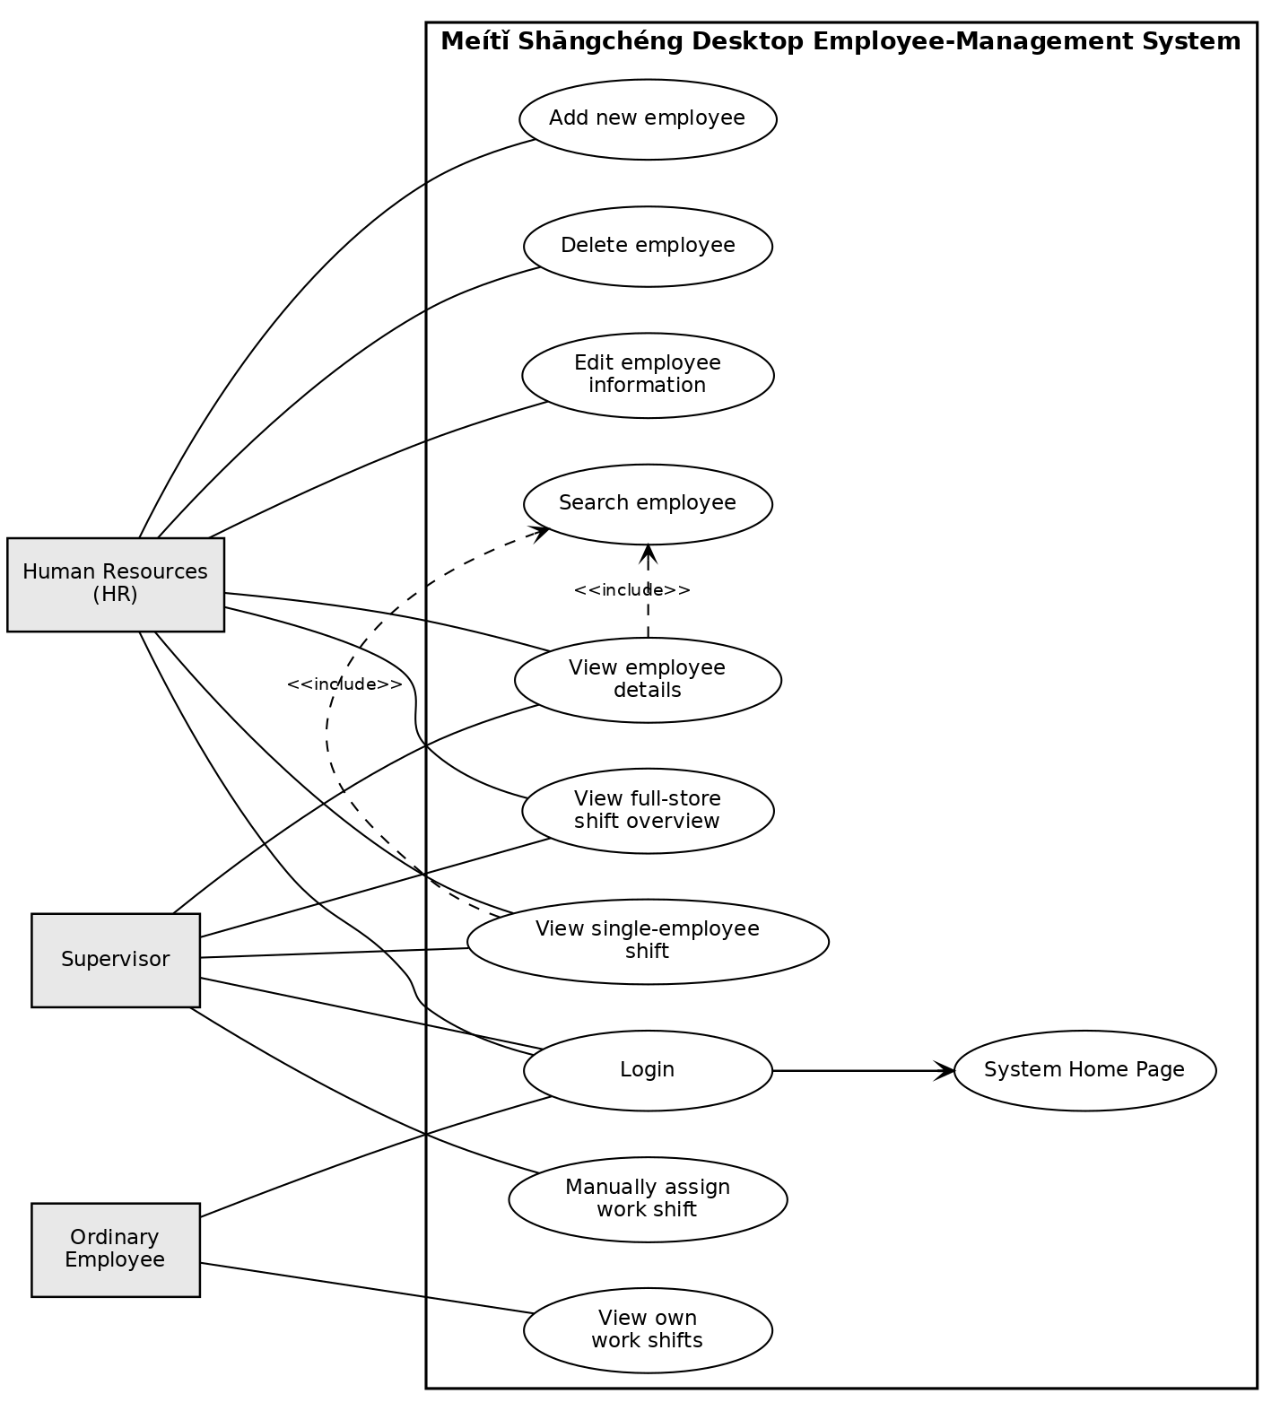

8 Use Case Models

Use Case 1:HR adds new employee(FR01)
Item | Content
Use Case title | HR adds new employee
Actor | Human Resources(HR)
Precondition | HR is logged into the system and holds employee-record management permission.
Trigger | HR clicks the"Add new employee"button on the employee overview page.
Main Success Scenario | 1.System opens the new-employee input form.  2.HR fills in the employee name,address and hourly wage.  3.HR submits the form.  4.System validates the input field contents.  5.System saves the new employee record to the database.  6.System refreshes the employee overview list;the new employee entry is displayed.
Extensions | 1A(Step 4):A mandatory field is left empty or the hourly wage contains an invalid value.  1.System displays a user-friendly error message.  2.The system stays on the input form,preserves the data already entered,and terminates the use case.

Use Case 2:Supervisor plans the weekly rota of an employee(FR06)
Item | Content
Use Case title | Supervisor plans the weekly rota of an employee
Actor | Supervisor
Precondition | Supervisor is logged in;the target employee record exists in the system.
Trigger | Supervisor opens the target employee detail page and uses the rota panel.
Main Success Scenario | 1.System presents a working-date field and the three shift options:Morning(08:00-12:00)/Afternoon(14:00-18:00)/Evening(20:00-22:00). 2.Supervisor selects the date and one shift and confirms. 3.System saves one rota record linked to the employee ID,the date and the shift. 4.System records who confirmed the entry and when. 5.The employee detail page displays the updated week,and the store rota and the employee's timetable reflect the change as well. 6.Supervisor may repeat steps 1-2 for the same employee and date to add a second shift,and may remove a single entry from the week list.
Extensions | 1A(Step 2):The target employee record cannot be found in the system. 1.System pops up an error notification. 2.System returns to the employee overview page and terminates the use case. 2A(Step 2):The working date is missing or not a valid date,or the shift is not one of the three fixed shifts. 1.System displays a user-friendly message. 2.No rota record is written and the use case terminates.

Use Case 3:User views the weekly rota of a single employee(FR07)
Item | Content
Use Case title | View the weekly rota of a single employee
Actor | Human Resources(HR),Supervisor
Precondition | The user is logged in;the target employee record exists in the system.
Trigger | The user opens the detail page of the target employee.
Main Success Scenario | 1.System loads the employee detail view for the current week. 2.System fetches and displays every rota record of that employee for the week,ordered by date and by shift,with date,weekday,shift,time,the confirmation timestamp and the actor. 3.The user may move to the previous or the next week.
Extensions | 1A(Step 2):No rota record exists for this employee in the week shown. 1.System shows the placeholder text"No shifts assigned for this employee"and still offers the week navigation. 2.The use case completes normally.

Use Case 4:User browses the weekly rota of the whole store(FR08,FR10)
Item | Content
Use Case title | View the weekly rota of the whole store
Actor | Human Resources(HR),Supervisor
Precondition | The user is logged into the system.
Trigger | The user navigates to the"Store shift overview"menu page.
Main Success Scenario | 1.System loads the store rota for the current week. 2.For the Supervisor the week is grouped by day:each day lists the employees of the Morning,Afternoon and Evening shift,including an explicit empty state,and every employee name links to that employee's detail page. 3.For HR the week is grouped by employee:one row per employee shows the shifts of each day and a week summary,and HR may filter by shift and by employee name. 4.Both views offer previous/next-week navigation and always hide shift-modification controls;the rota is changed only from the employee detail page.
Extensions | 1A(Step 1):No rota record exists for the week shown. 1.System displays the empty days(groups with"No one assigned")or,when no employee record exists at all,the placeholder text"No employee data available". 2.The use case completes normally.

Use Case 5:HR deletes employee record(FR02)
Item | Content
Use Case title | Delete employee record(for resigned/fired/retired staff)
Actor | Human Resources(HR)
Precondition | HR is logged in;the target employee record exists in the system.
Trigger | HR clicks the delete button on the target employee entry in the overview list.
Main Success Scenario | 1.System pops up a confirmation dialog for the deletion action. 2.HR confirms the deletion. 3.System removes the employee record and every rota record of that employee. 4.The employee overview list refreshes and the target entry disappears.
Extensions | 1A(Step 2):HR cancels the deletion confirmation.  1.System closes the confirmation popup and makes no data modification.  2.System returns to the employee overview page and terminates the use case.

Use Case 6:Ordinary Employee views their own weekly timetable(FR07)
Item | Content
Use Case title | Ordinary Employee views their own weekly timetable
Actor | Ordinary Employee
Precondition | The ordinary employee is successfully logged in.
Trigger | The ordinary employee selects the"My Work Shifts"menu item.
Main Success Scenario | 1.System loads the personal timetable of the current week. 2.Rows are the three fixed shifts and columns are Monday to Sunday,each column headed with its date.A tick marks every shift the employee works that day and an empty cell marks a free day. 3.The employee may move to the previous or the next week.
Extensions | 1A(Step 2):No shift has been assigned to the current employee in the week shown. 1.System shows the placeholder text"You have not been assigned any shifts yet"for the current week,or the empty timetable together with a message for another week. 2.The use case completes.

9 System Overall Overview
This employee-management system is built for MeítǐShāngchéng hardware store in Zhengzhou.It solves the pain point of fragmented,Excel-based manual personnel and shift management.
Three distinct end-user roles are defined,with strict role-based access control.(1)HR takes charge of the employee-record lifecycle:add,edit and delete employee personal records,and cross-check all employee and rota data through the weekly view grouped by employee;HR is not responsible for daily staff scheduling.(2)The Supervisor plans the weekly rota of subordinate staff and reads it day by day,to see who works which shift on each day;the Supervisor can browse employee and rota information but cannot create or delete employee archives.(3)Ordinary store employees can only view their own weekly timetable,without any modification privilege.
System execution flow starts with user Login.After authentication the system enters the System Home Page,then renders different menu sets and function modules according to the user identity.The Search-employee operation is a reused basic function included(<<include>>)within multiple detail-view use cases.
Inventory management is a conditional could-have requirement reserved for future extension.Advanced features such as attendance registration,department management and a full employee self-service web portal belong to later product iterations and will not be delivered in this release.

