XML
<?xml version="1.0" encoding="utf-8"?>
<android.support.constraint.ConstraintLayout xmlns:android="http://schemas.android.com/apk/res/android"
xmlns:app="http://schemas.android.com/apk/res-auto"
xmlns:tools="http://schemas.android.com/tools"
android:layout_width="match_parent"
android:layout_height="match_parent"
tools:context=".MainActivity">
<TextView
android:layout_width="wrap_content"
android:layout_height="wrap_content"
android:text="Hello World!"
app:layout_constraintBottom_toBottomOf="parent"
app:layout_constraintLeft_toLeftOf="parent"
app:layout_constraintRight_toRightOf="parent"
app:layout_constraintTop_toTopOf="parent" />
</android.support.constraint.ConstraintLayout>

mainactivity.java

package com.example.sjcet.myapplication;
import android.support.v7.app.AppCompatActivity;
import android.os.Bundle;
import android.view.Menu;
import android.view.MenuInflater;
import android.view.MenuItem;
import android.widget.Toast;
public class MainActivity extends AppCompatActivity {
@Override
protected void onCreate(Bundle savedInstanceState) {
super.onCreate(savedInstanceState);
setContentView(R.layout.activity_main);
}
public boolean onCreateOptionsMenu(Menu menu) {
MenuInflater inflater = getMenuInflater();
inflater.inflate(R.menu.menu,menu);
return true;
}
@Override
public boolean onOptionsItemSelected(MenuItem item) {
switch (item.getItemId()){
case R.id.open:
Toast.makeText(this,"Open",Toast.LENGTH_SHORT).show();
return true;
case R.id.share:
Toast.makeText(this,"Share",Toast.LENGTH_SHORT).show();
return true;
case R.id.delete:
Toast.makeText(this,"Delete",Toast.LENGTH_SHORT).show();
return true;
case R.id.search:
Toast.makeText(this,"Search",Toast.LENGTH_SHORT).show();
return true;
case R.id.setting:
Toast.makeText(this,"Setting",Toast.LENGTH_SHORT).show();
return true;
default:
return super.onOptionsItemSelected(item);
}
}
}
menu.xml

<?xml version="1.0" encoding="utf-8"?>
<menu xmlns:android="http://schemas.android.com/apk/res/android">
<item android:id="@+id/open"
android:title="Open"/>
<item android:id="@+id/share"
android:title="Share"/>
<item android:id="@+id/delete"
android:title="Delete"/>
<item android:id="@+id/search"
android:title="Search"/>
<item android:id="@+id/setting"
android:title="Setting"/>
</menu>

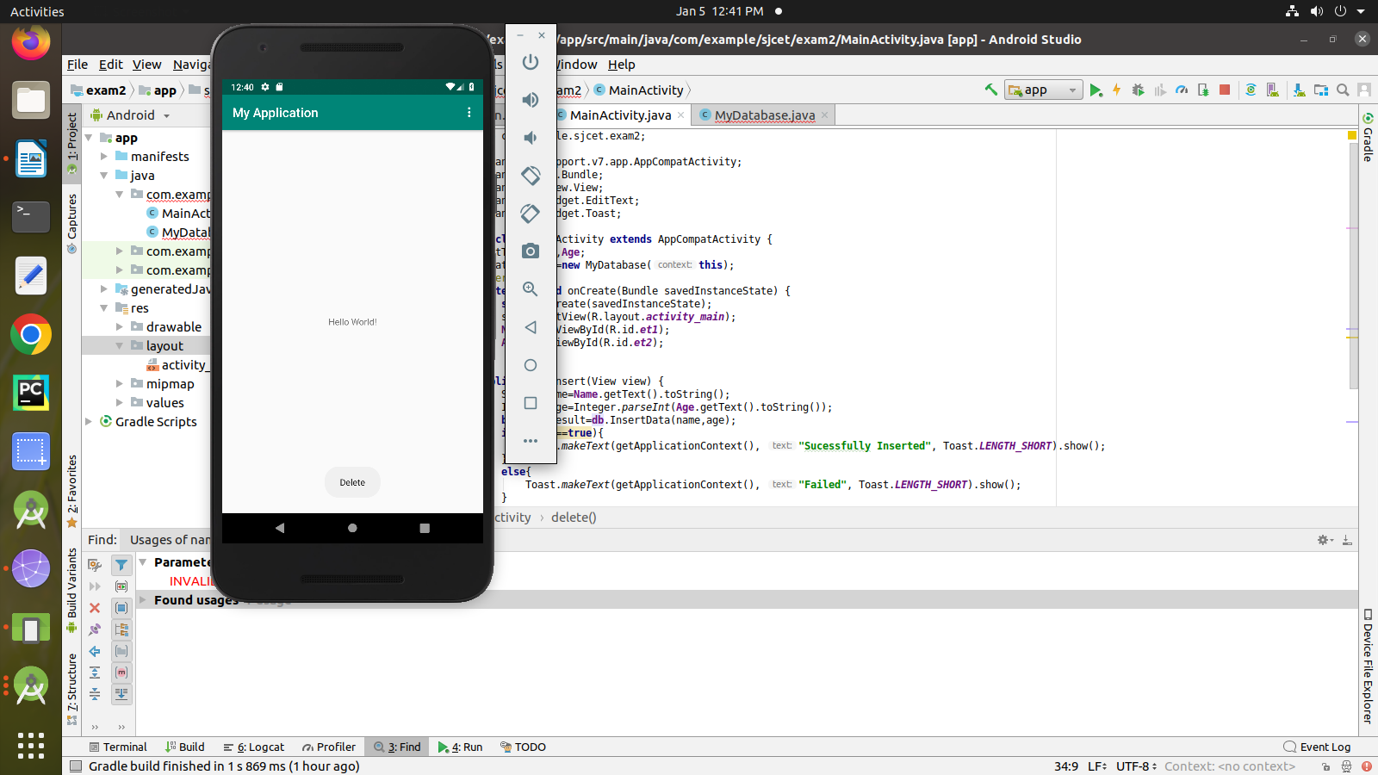
Output

