COMP3522 Real-Life Data Science
2026–27, Semester 1

PROJECT PROPOSAL

How Far Can We Trust the Forecast?
Evaluating the Reliability and Accuracy of the Hong Kong Observatory’s 9-Day Forecasts

Group A1

Name | Student ID
Fong Shu Hung | 3036073077
Li Hao Hua | 3036226698
Liu Yichen | 3035944308
Tang Tsuen Kei | 3036225620

Submission date: ____________________

1. Project Objectives
Objective. We assess the trustworthiness of the Hong Kong Observatory’s (HKO) 9-day forecasts from 2022 to 2025. We measure how stable forecasts are across successive releases and how accurate they are against station observations, and identify the conditions under which they fail. Part 2 objective: ________________________________________
Scope. We complete the compulsory Task 1. Part 2 task chosen (Task 2 or Task 3): ____________________
Deliverables. (1) A database aligning every HKO forecast release with its observations; (2) a verification report on reliability and validity; (3) a data-driven analysis of the factors behind forecast errors; (4) Part 2 deliverable: ____________________
RQ | Task | Research question | Main measure
RQ1 | 1(a)(i) | How much does the forecast for a fixed target day change between successive releases, and does the change shrink as the day approaches? | Mean absolute revision; revision frequency
RQ2 | 1(a)(i) | Do revisions move steadily in one direction, or do they oscillate (“flip-flop”)? | Flip-Flop Index; PSR category changes
RQ3 | 1(a)(i)–(ii) | When HKO revises a forecast, does the revision move it closer to the observed outcome? | Revision usefulness rate
RQ4 | 1(a)(ii) | How large are errors for temperature and relative humidity (RH), and how fast do they grow from lead day 1 to 9? | MAE, RMSE; skill vs climatology and persistence
RQ5 | 1(a)(ii) | Does HKO systematically over- or under-forecast, and does the bias change by season or year? | Mean error with bootstrap CIs
RQ6 | 1(a)(ii) | Is the Probability of Significant Rain (PSR) well calibrated? | Brier score; reliability diagram; hit rate; false alarm ratio
RQ7 | 1(b) | Which conditions (weather regime, day-to-day change, spatial spread, season) explain larger errors and revisions? | Stratified tests; regression; SHAP
RQ8 | Part 2
RQ9 | Part 2

2. Datasets and Preliminary Exploratory Data Analysis

2.1 Datasets
Dataset (source) | Period | Key variables | Role
HKO 9-day forecast archive (DATA.GOV.HK) | 2022–2025; 5,665 releases | Max/min temperature, max/min RH, PSR category, weather description and icon, wind | Forecasts under evaluation
HKO daily station observations (DATA.GOV.HK) | 2022–2025 | Daily max/min/mean temperature, mean RH, rainfall, per station | Ground truth
HKO Warnings and Signals Database | 2022–2025 | Tropical cyclone, rainstorm, strong monsoon, very hot and cold weather warnings | Regime labels (RQ7)
NOAA GFS, 12 UTC runs | 2022–2025 | Mean sea-level pressure, lead days 1–9 | Synoptic factor (RQ7)
Part 2 data:

2.2 Data availability and complexity
- Many forecasts per target day. HKO issues several releases a day, so each target date receives many forecasts at different lead times. Records are keyed by target date, issue time and lead day, which is what makes reliability measurable.
- Schema mismatches. HKO forecasts a territory-wide daily RH range, while stations report a daily mean; HKO forecasts a rain probability category, while stations report rainfall in millimetres. Section 3.1 defines a comparison rule for each.
- Area versus point. Forecasts describe Hong Kong in general; observations come from stations on hilly, coastal and urban sites.
- Quality issues. Duplicated releases, missing days and station outages are detected and handled before any metric is computed.

2.3 Preliminary results
So far we have audited the forecast archive, loaded forecasts and observations into a PostgreSQL database, and completed a first rainfall analysis for 2022–2025. All 1,461 days have complete temperature and rainfall records at HKO Headquarters. For each issue day and valid date we keep the latest bulletin, giving leads 1–9.
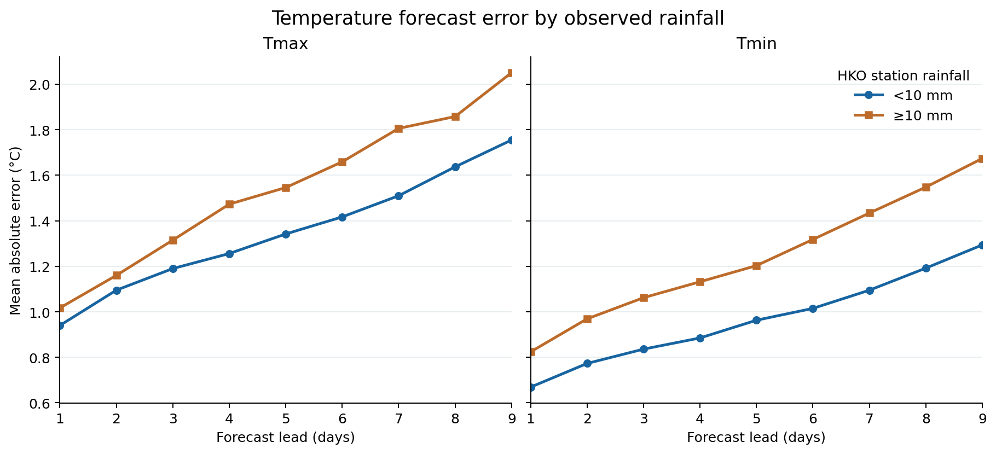
Figure 1. MAE of HKO maximum (Tmax) and minimum (Tmin) temperature forecasts by lead day, split by rainfall observed at HKO Headquarters (13,103 forecasts, 2022–2025).
Finding 1 (validity and factors). Temperature error grows steadily with lead time, from about 0.9 °C at day 1 to 1.8 °C at day 9 for Tmax on days under 10 mm. On days with at least 10 mm of rain, MAE is higher by 0.19 °C for Tmax (95% date-cluster bootstrap interval 0.06–0.34 °C) and 0.27 °C for Tmin (0.15–0.39 °C), in all nine lead days. Forecasts are also too warm on rainy days (bias +0.82 °C Tmax, +1.03 °C Tmin) but slightly too cool on other days (−0.37 °C, −0.24 °C). This is an association, not proof that rain causes the error; season may affect both.
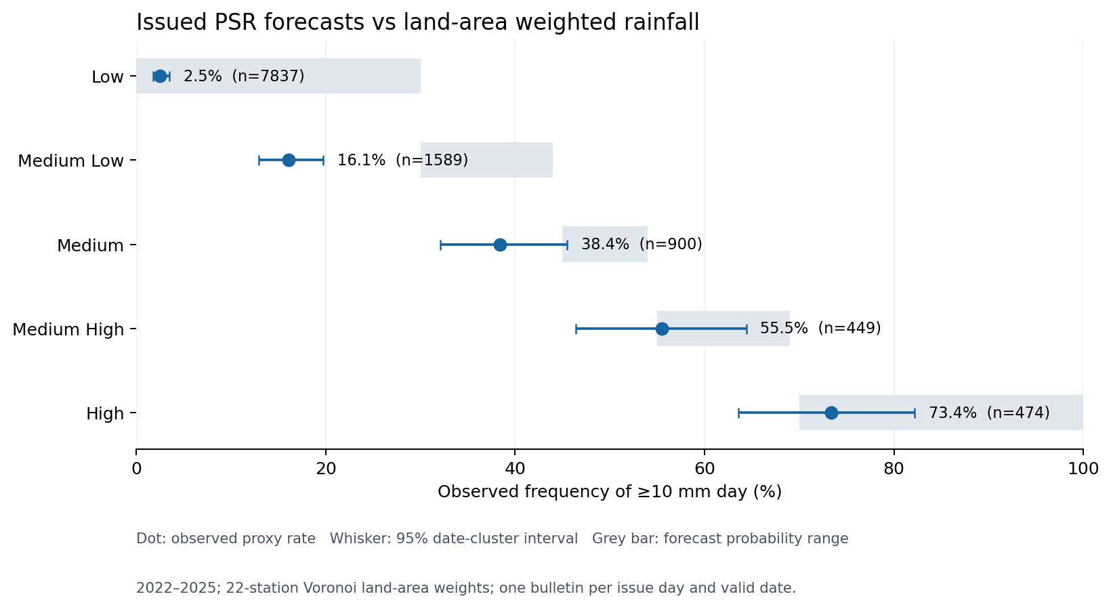
Figure 2. Observed frequency of significant rain (land-area weighted daily rainfall of at least 10 mm) for each issued PSR category; grey bars show HKO’s stated probability range (11,249 forecasts, 1,255 complete days).
Finding 2 (calibration). The observed rain frequency rises with every PSR category, from 2.5% for Low to 73.4% for High, so the categories rank risk correctly. Low, Medium High and High fall inside their stated ranges. Medium Low over-forecasts: rain followed only 16.1% of the time (95% interval 12.9–19.7%) against a stated 30–44%. Medium is also below its range (38.4%), though its interval overlaps it. These results depend on our choice of rainfall proxy (Section 3.1).

3. Methodology

3.1 Data alignment
All forecasts are stored in one long table keyed by (target date, issue time, lead day, variable), where lead day = target date − issue date in Hong Kong Time. Each variable is paired with observations as follows:
Variable | Forecast | Truth and comparison rule
Max/min temperature | Daily value | Daily max/min at HKO Headquarters (primary); other stations as a sensitivity check.
Relative humidity | Daily range [F_{min}, F_{max}] | Observed interval built from station daily means only, [min μ_{i}, max μ_{i}]; the forecast is never used to build the truth. Score (a) whether the cross-station mean lies in the forecast range and (b) the overlap of the two intervals. If hourly RH at HKO Headquarters is available, compare the true daily min/max directly.
Rainfall | PSR category (Low <30%, Medium Low 30–44%, Medium 45–54%, Medium High 55–69%, High ≥70%) | Event “significant rain” = at least 10 mm generally over Hong Kong in a day (HKO definition). We estimate territory-wide rainfall as a land-area weighted average of 22 stations, each weighted by its Voronoi cell clipped to the 1,115.65 km² land area. The unweighted station mean serves as a sensitivity check.

3.2 Reliability metrics (RQ1–RQ3)
For target day d, let f_{d}⁽¹⁾, …, f_{d}^{(K)} be its successive forecasts and o_{d} the observation.
- Mean absolute revision = mean of |f_{d}^{(k+1)} − f_{d}^{(k)}| per lead-day step; revision frequency = share of consecutive releases whose value changes.
- Flip-Flop Index (Griffiths et al., 2019): total variation of the forecast sequence minus its net range; zero for steady one-directional revisions, larger with oscillation. For PSR, the number of category changes per target day.
- Revision usefulness rate = share of revisions with |f^{(k+1)} − o_{d}| < |f^{(k)} − o_{d}|.

3.3 Validity metrics (RQ4–RQ6)
- Continuous variables: MAE, RMSE and bias (mean error). Skill score SS = 1 − MAE_{HKO} / MAE_{ref}, against day-of-year climatology and persistence (previous day’s observation); SS > 0 means HKO beats the reference.
- Rain probability: Brier score and Brier skill score (Brier, 1950) with category midpoints as probabilities, plus a reliability diagram of observed frequency per category, which needs no midpoint assumption. For yes/no rain at “Medium High or above”: hit rate = hits / (hits + misses); false alarm ratio = false alarms / (hits + false alarms).
- Results are stratified by lead day, season and year. Daily errors are autocorrelated, so confidence intervals use a moving-block bootstrap.

3.4 Factor analysis (RQ7)
Candidate factors: (i) weather regime (tropical cyclone signal, strong monsoon signal or rainstorm warning in force); (ii) day-to-day change in observed temperature and sea-level pressure, indicating a regime transition; (iii) spatial spread of station readings; (iv) season, year and lead day. Rainfall is already a confirmed candidate: Figure 1 shows larger and warmer-biased temperature errors on rainy days. We first compare error distributions across strata with Mann–Whitney U tests. We then regress absolute error (and absolute revision) on all factors jointly, with lead day as a fixed effect, so each factor is assessed while holding the others constant. A gradient-boosting model with SHAP values (Lundberg & Lee, 2017) checks for non-linear effects and interactions. Results are reported as associations, not causal effects.

3.5 Part 2 methodology (RQ8–RQ9)

4. Platforms and Tools
Tool | Use
Python (pandas, NumPy, requests) | Collecting data from DATA.GOV.HK and NOAA; cleaning and alignment
PostgreSQL + PostGIS | Central database of aligned records; station geometry for spatial queries
SciPy, statsmodels | Significance tests, bootstrap intervals, regression
scikit-learn, LightGBM, SHAP | Non-linear factor analysis and interpretation
matplotlib, Jupyter, GitHub | Figures, reproducible notebooks and version control

5. Tasks, Timeline and Division of Labour
Week 1 starts on the proposal submission date. Every task has one lead and one reviewer.
Weeks | Dates | Task | Output | Lead | Review
1–2 |  | Build PostgreSQL/PostGIS database; align forecasts and observations | Aligned table
1–2 |  | Part 2 data collection
2–4 |  | Reliability RQ1–RQ3 and validity RQ4–RQ5 (temperature, RH) | Metrics, tables, figures
2–4 |  | Rainfall verification RQ6 (PSR) | Brier scores, reliability diagram
4–6 |  | Factor analysis RQ7 | Tests, regression, SHAP
5–7 |  | Part 2 analysis (RQ8–RQ9)
7–8 |  | Integration, final report and presentation | Report, slides
Milestones: database ready (end of Week 2); Task 1 results (Week 5); Part 2 results (Week 7).

6. Risks and Limitations
- Area-versus-point mismatch: station truth may penalise a territory-wide forecast; alternative-station checks quantify this.
- Few extreme days: regime-level findings rest on small samples and are presented as exploratory.

7. References
Brier, G. W. (1950). Verification of forecasts expressed in terms of probability. Monthly Weather Review, 78(1), 1–3.
Griffiths, D., Foley, M., Ioannou, I., & Leeuwenburg, T. (2019). Flip-Flop Index: Quantifying revision stability for fixed-event forecasts. Meteorological Applications, 26(1), 30–35.
Jolliffe, I. T., & Stephenson, D. B. (2012). Forecast verification: A practitioner’s guide in atmospheric science (2nd ed.). Wiley.
Lundberg, S. M., & Lee, S.-I. (2017). A unified approach to interpreting model predictions. Advances in Neural Information Processing Systems, 30.
Murphy, A. H. (1993). What is a good forecast? An essay on the nature of goodness in weather forecasting. Weather and Forecasting, 8(2), 281–293.
Wilks, D. S. (2019). Statistical methods in the atmospheric sciences (4th ed.). Elsevier.
Data sources
- Hong Kong Observatory. 9-day Weather Forecast. DATA.GOV.HK. https://data.gov.hk/en-data/dataset/hk-hko-rss-9-day-weather-forecast (accessed ____________________)
- Hong Kong Observatory. Daily observation datasets. DATA.GOV.HK. https://data.gov.hk (accessed ____________________)
- Hong Kong Observatory. Warnings and Signals Database. https://www.hko.gov.hk/en/cis/warndb.htm (accessed ____________________)
- Hong Kong Observatory. Q&A for Probability of Significant Rain. https://www.hko.gov.hk/en/education/weather/rain/00568-Q-&-A-for-Probability-of-Significant-Rain.html (accessed ____________________)
- Home Affairs Department. Hong Kong Administrative Boundaries. DATA.GOV.HK. https://data.gov.hk/en-data/dataset/hk-had-json1-hong-kong-administrative-boundaries (accessed ____________________)
- Lands Department. Topographic map data (HYDRPOLY sea-fill layer). CSDI Portal. https://portal.csdi.gov.hk (accessed ____________________)
- NOAA National Centers for Environmental Information. Global Forecast System. https://www.ncei.noaa.gov/products/weather-climate-models/global-forecast (accessed ____________________)

