“The Air Quality Dataset”

Jim Coen

4/28/2020

## Summary of Air Quality Dataset

air quality

This exercise will be working with the built-in air quality dataset.[1] This dataset contains 154 daily air quality measurements in New York from May 1, 1973 (a Tuesday) to September 30, 1973. The dataset contains 6 variables:  
**Ozone:** Mean ozone in parts per billion *ppb* from 1300 to 1500 hours at Roosevelt Island;  
**Solar.R:** Solar radiation in Langleys *lang* in the frequency band 4000–7700 Angstroms from 0800 to 1200 hours at Central Park;  
**Wind:** Average wind speed in miles per hour *mph* at 0700 and 1000 hours at LaGuardia Airport;  
**Temp:** Maximum daily temperature in degrees Fahrenheit *oF* at LaGuardia Airport;  
**Month:** numeric month *1-12*  
**Day:** numeric Day of the month *1-31*

### Table of Top of the Air Quality Dataset

knitr::kable(head(airquality),   
 caption = "Top of the Air Quality Dataset")

Top of the Air Quality Dataset

|  |  |  |  |  |  |
| --- | --- | --- | --- | --- | --- |
| Ozone | Solar.R | Wind | Temp | Month | Day |
| 41 | 190 | 7.4 | 67 | 5 | 1 |
| 36 | 118 | 8.0 | 72 | 5 | 2 |
| 12 | 149 | 12.6 | 74 | 5 | 3 |
| 18 | 313 | 11.5 | 62 | 5 | 4 |
| NA | NA | 14.3 | 56 | 5 | 5 |
| 28 | NA | 14.9 | 66 | 5 | 6 |

### Plot of Ozone by Temperature –Air Quality Dataset

plot(airquality$Temp, airquality$Ozone,   
 main="Airquality: Ozone by Temperature")

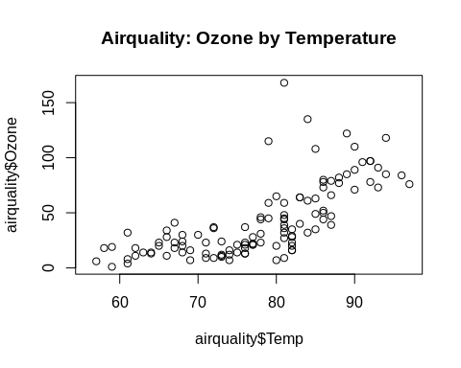

1. Chambers, J. M., Cleveland, W. S., Kleiner, B. and Tukey, P. A. (1983) Graphical Methods for Data Analysis. Belmont, CA: Wadsworth.